FORENSIC ANALYSIS OF HIGH EXPLOSIVE RESIDUES FROM SELECTED CLOTH

(Analisis Forensik Residu Bahan Letupan Berkuasa Tinggi Daripada Kain Terpilih)

Mohamad Afiq Mohamed Huri and Umi Kalthom Ahmad*

Department of Chemistry,
Faculty of Science, Universiti Teknologi Malaysia,
81310 UTM Johor Bahru, Johor Darul Ta’zim

*Corresponding author:umi@kimia.fs.utm.my

Abstract
Increased terrorist activities around the Asian region have resulted in the need for improved analytical techniques in forensic analysis. High explosive residues from post-blast clothing are often encountered as physical evidence submitted to a forensic laboratory. Therefore, this study was initiated to detect high explosives residues of cyclotrimethylenetrinitramine (RDX) and pentaerythritoltetranitrate (PETN) on selected cloth in this study. Cotton swabbing technique was employed as a simple and rapid method in recovering analytes from the sample matrix. Analytes were analyzed using Griess spot test, TLC and HPLC. TLC separation employed toluene-ethyl acetate (9:1) as a good solvent system. Reversed phase HPLC separation employed acetonitrile-water (65:35) as the mobile phase and analytes detected using a programmed wavelength. RDX was detected at 235 nm for the first 3.5 min and then switched to 215 nm for PETN. Limits of detection (LODs) of analytes were in the low ppm range (0.05 ppm for RDX and 0.25 ppm for PETN). Analyte recovery studies revealed that the type of cloth has a profound effect on the extraction efficiency. Analytes were recovered better for nylon as compared to cotton cloth. However, no analytes could be recovered from denim cloth. For post-blast samples, only RDX was detected in low concentration for both nylon and cotton cloth.
Keywords: high explosive residues, RDX, PETN, HPLC-UV, cotton swabbing, cloth

Abstrak
Peningkatan aktiviti keganasan di rantau Asia telah menyebabkan keperluan analisis teknik yang lebih baik dalam analisis forensik. Residu bahan letupan berkuasa tinggi daripada sampel pakaian sering dijumpai sebagai bukti fizikal yang dihantar kepada makmal forensik. Oleh itu, kajian ini telah dimulakan untuk mengesan bahan letupan berkuasa tinggi, siklotrimetilenetrinitramina (RDX) dan pentaeritritol tetranitrat (PETN) pada matriks kain. Kaedah sapuan bebola kapas digunakan sebagai kaedah yang mudah dan pantas dalam mengekstrak analit daripada sampel matriks. Analit dianalisis dengan menggunakan ujian setempat Griess, TLC dan HPLC. Pemisahan TLC menggunakan toluena-etil asetat (9:1) sebagai sistem pelarut. Pemisahan HPLC fasa terbalik dengan menggunakan asetonitril-air (65:35) sebagai fasa bergerak dan analit dikesan menggunakan pengesanan berprogram. RDX dikesan pada panjang gelombang 235 nm dalam masa 3.5 minit yang pertama, dan selepas itu panjang gelombang diubah kepada 215 nm bagi pengesanan PETN. Had pengesanan (LOD) analit berada dalam julat ppm yang rendah (RDX 0.05 ppm dan PETN 0.25 ppm). Kajian pengembalian analit menunjukkan bahawa jenis kain memberi kesan mendalam terhadap kecekapan pengekstrakan. Pengembalian analit bagi nilon lebih baik berbanding dengan kain kapas. Walau bagaimanapun, tiada analit dapat dikesan daripada kain denim. Untuk sampel pasca letupan, hanya RDX telah dikesan dalam kepekatan yang rendah untuk kedua-dua kain nilon dan kapas.

Kata Kunci:residu bahan letupan berkuasa tinggi, RDX, PETN, HPLC-UV, sapuan kapas, kain

Introduction
Media reports of bombing incidents in the South East Asian regions have sparked much interest amongst forensic scientists to embark on the study of explosive residue analysis. Post-explosive residues can provide useful information to investigators such as type of explosives used which can be used as the ultimate evidence in the court of law [1-3].

Post-explosion products collected from bombing activities by terrorists have been the main subject of study in forensic investigations. For example, forensic investigations that were made following the bombing incident in Bali, Indonesia on October 2002 has served as crucial evidence in convicting the responsible criminals [4]. A great number of physical evidence such as post-blast samples can be collected at the crime scene in order to link a suspect to the bombing case. Such physical evidence must be collected and kept well for analysis as the evidence itself holds useful information in order to solve the crime [5].

Generally, explosives can be divided into two groups namely high and low explosive. They are divided based on the velocity or rate of the reaction for explosion to occur. According to Mäkinen et al. [6], explosives are usually classified based on their properties and usage. High explosive is a substance that detonates at very high rate. Applications of high explosives included mining, demolition and military use. High explosives are extremely dangerous as they would produce high amount of gases, high temperature and exothermic reactions. The shock waves that are produced from the explosion can have velocities between 1 - 9 km/s.

Cyclotrimethylenetrinitramine (RDX) and pentaerythritoltetranitrate (PETN) are two chemical compounds that can be classified under organic high explosive components. Both compounds (Figure 1) are among the main components of C4 explosive. RDX is toxic and poisonous as it will give adverse effect if it is ingested by the body. RDX is a major component in C-4 explosive comprising of 91% of the total component. In addition, RDX is also used in Semtex explosive and as booster charges. PETN is also known as Penta or Ten. It is usually in the form of white crystalline explosive. PETN is mixed with RDX in Semtex explosive material. It exists as secondary explosive of the high explosive because of its high stability and the need to be initiated by other impact from primary explosive [7].
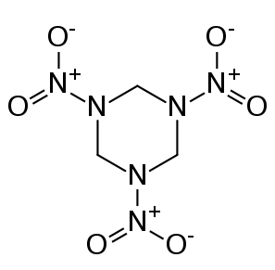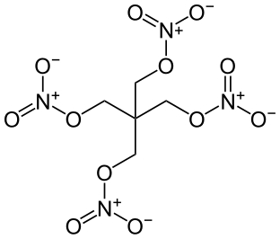
(b)
(a)

Figure 1: Chemical structure of (a) RDX and (b) PETN

Several analytical instrumentations have been used for explosive detection analysis. For inorganic explosive analysis, Varga and Ulbrich employed a combination of gas chromatography (GC) and electron capture detection (ECD) as a highly selective method in trace analysis of organic components of post-blast residues [2]. Furthermore, ECD is more sensitive compared to flame ionization (FID) and thermal conductivity detectors (TCD). Besides, GC-ECD has high sensitivity towards electronegative atoms (nitrogen compounds) and low sensitivity to contaminants as it quite insensitive to hydrocarbons [7]. However, GC-ECD method has a drawback since it is prone to contamination. To overcome this problem, a combination of gas chromatography and solid phase microextraction was employed for removing interfering compounds [8]. Ahmad et al. [9] analysed C4 explosive residue on hair samples by using GC-ECD on a HP5-MS capillary column. RDX and PETN were successfully separated within 10 minutes with good limit of detections (RDX: 10 ppm, PETN: 0.1 ppm). The study concluded that human hairs could be used as important physical evidence to recover explosive residues from post-blast samples.

Micellar electrokinetic chromatography (MEKC) is a modified technique of capillary electrophoresis (CE). This technique has also been widely used for uncharged molecules such as organic explosives. The separation allows a variety of compounds to be separated with high efficiency. In addition, as compared to GC techniques, MEKC has an advantage as the technique permits thermally labile materials to be separated without degradation. Ahmad et al. [10] successfully employed MEKC coupled to solid phase extraction (SPE) to the analysis of post-blast water samples containing explosive residues. Analyte recoveries of >87 % were obtained. RDX was also detected in the water samples in the range of 51.03 – 156.75 μg/L [10].

High performance liquid chromatography (HPLC) is often used for analysis of explosives because it is ideal for the analysis of high molecular weight, low volatility and thermally unstable compounds [6]. This method will overcome the problem of product decompositions in vapours due to unstable explosive residues properties. Furthermore, the wide range of HPLC detection between 190-800 nm will provide a good range of separation.The most common detector for HPLC is ultraviolet detector (UV). It is because many organic compounds will be detected in the range of UV detection region. Miller et al. reported that RDX, PETN and TNT all have strong absorption wavelengths below 260 nm [11]. Both TNT and RDX peaks were resolved at 205, 235 and 254 nm, while PETN was only resolved at 205 nm. Methanol was used as solvent to extract the analytes.

Forensic analyses typically involve numerous physical evidences that can be found at the crime scene, including debris, soil, water, skin and also cloth or fabric. Cloth of different fiber types can became important physical evidence in forensic investigations. Recovery of fibres at crime scene, either natural or man-made fibers may provide individual identification with a high degree of certainty [12]. However, extraction methods and analytical procedures that are suitable for the analysis of explosive residue on fibres have not been extensively reported. This study was therefore undertaken to extract high explosives of RDX and PETN from several cloth types using cotton swabbing. Extracts were analysed using colour spot test, thin layer chromatography (TLC) and HPLC with UV programmed wavelength.

Materials and Methods
Chemical and Materials
Explosive standards of RDX and PETN (1000 ppm solution in acetonitrile) were obtained as gifts from Science & Technology Research Institute for Defense (STRIDE), Batu Arang, Selangor. Cloth samples (denim, nylon and cotton) and cotton balls were obtained from a local store in Taman Universiti, Skudai, Johor. Simulated explosive samples were obtained from a previous sampling exercise made in collaboration with Royal Malaysia Police (RMP).

Screening Test
As a preliminary test, Griess reagent was employed that was made from two different reagents. First reagent consisted of 0.25 g napthol in 80 mL of 30% acetic acid while the second reagent was prepared by adding 0.5 g sulfanilic acid in 50 mL of 30% acetic acid. An orange color observed indicated the presence of explosive material, nitrite. For TLC analysis, aluminium backed silica gel TLC plate was used. The solvent systems used were mixtures of toluene-cylcohexane with ratio 6:4 and toluene-ethyl acetate with ratio 9:1 [13, 14]. The analyte spots were observed under UV lamp at 254 nm.

Instrumentation
HPLC analysis utilized an Agilent 1100 series HPLC that was equipped with a variable wavelength detector (VWD), degasser, quaternary pump and computerized data acquisition employing HPLC Chemstation Software g2170AA. The analytical column used was a Purospher C18 (4.6 x 150 mm, 5 µm). A mobile phase consisting of acetonitrile-water mixture with a ratio of 65:35 (v/v) was used at a mobile phase flow rate of 1.0 mL/min. Analyte detection was at 235 nm and 215 nm for RDX and PETN respectively. UV detection was programmed at 235 nm for the first 3.5 minutes, and then switched to 215 nm for the next 6.5 minutes. An aliquot of 20 µL sample was introduced into the system via a Rheodyne six port injection valve fitted with a 20 µL sample loop [15].

Microscopic Examination
For microscopic examination, a Motic model BA310 stereomicroscope (Xiamen, China) was used. The 30x magnification was used to identify the physical characteristics of both nylon and cotton cloth samples. The thickness of thread and other unique characteristics were also examined.

Standard Solutions
A stock solution comprising of 1000 ppm each RDX and PETN was prepared by adding 0.1000 g each of RDX and PETN with acetonitrile in a 100 mL volumetric flask and diluting to the mark. For the standard mixture, the standard solutions were further diluted by mixing both analytes in 5 mL volumetric flask that resulted in concentration of 100 ppm and 500 ppm of RDX and PETN respectively. A series of standard mixture concentration of RDX:PETN from concentration ratio of 100:500 to 1:5 was produced which were used for the construction of calibration curve.

Sample preparation
For recovery study on cotton ball, direct spiking of analytes onto the cotton ball was carried out in order to determine the efficiency of swabbing techniques. 1 mL of the standard mixture consisting of RDX (100 ppm) and PETN (500 ppm) was spiked onto a pre-cleaned cotton ball. The cotton ball was then allowed to air dry. Three types of cloth samples used were cotton, nylon and denim. All cloths were pre-washed by soaking in water to reduce contamination arising from impurities. The cloths were dried and then cut into pieces of 7 cm x 8 cm size. Each cloth was then hanged vertically using claw clips and spiked with 1 mL standard mixture by using a micropipette. The cloth was then left to dry for about 10 minutes and later kept in a zip-lock plastic bag and stored in a refrigerator.

Sample Swabbing and Extraction
Cotton balls were then subjected to pre-cleaning by soaking the cotton balls overnight in acetone. On the next day, excess acetone was removed by squeezing out the solvent from the cotton balls using a pair of tongs and left to air-dry. The pre-cleaned cotton balls were placed in zip-lock plastic bags and kept in the refrigerator until ready to use. For the swabbing process of the residue, 1 mL of acetone was added to the cotton ball by using a micropipette in order to moisten the cotton ball. By using a rubber glove, the acetone-moist cotton balls were swabbed onto the cloth surfaces in order to extract the residue. The cloth sample was placed on a clean ceramic tile before the cotton ball was swabbed thoroughly across the whole surface of the cloth. Furthermore, the surface of the tile was also swabbed to recover any residual analyte left on the tile. The cotton swabs were then ready for extraction.

The cotton swab was placed in a vial and acetone was added into the vial up to 5-10 mL graduation so as to ensure that the cotton ball was completely covered by the solvent. The vial was then vortex approximately for 1 minute. In order to increase efficiency of filtration process, a filter paper (Whatman, 90 mm) was cut and fitted to the bottom of a 20 mL glass syringe. The extract was then filtered through a syringe that was fitted with filter paper. The extract was poured slowly before the cotton ball was inserted into the syringe. The last few drops were recollected by pressing down the cotton swab tightly to the bottom of the syringe. The extract was collected in a 10 mL vial and then dried gently under a flow of nitrogen gas. Acetonitrile was added to bring the volume to 1 mL [15]. The extract was subjected to color spot test, TLC and HPLC analyses. A blank extraction was also prepared.

Results and Discussions

Spot Test Analysis
Griess reagent provides a visual observation of orange color formation from the reaction between acetic acid vapour, nitrate residues and the chemical content on a filter paper [16]. In this study, explosive standard RDX and PETN of a fixed concentration (1000 ppm) were deposited on a filter paper and then tested with Griess reagent. Both explosives gave a positive orange color spot. Although a positive reaction with Griess test indicated the presence of RDX and PETN, the spot test alone could not differentiate between both explosives. Table 1 shows that the detection limit of Griess spot test on RDX and PETN were both 200 ppm. Lower than this concentration, the orange color could not be positively detected.

Table 1. Griess spot test detection limit of RDX and PETN

Analyte |  | Concentration (ppm) | * Detectability
RDX |  | 1000
 |  | 500
 |  | 200
 |  | 100 | ND
PETN |  | 1000
 |  | 500
 |  | 200
 |  | 100 | ND
* : detectable , ND: not detectable

Thin Layer Chromatographic Analysis
TLC separation employing toluene-cyclohexane (6:4) did not give any significant R_{f} values. Hence, solvent system employing toluene-ethyl acetate was tested [13]. For standard PETN and RDX, both analytes were well separated and observed. For sample extracts, both extracts for cotton and nylon cloth sample revealed analyte spots on the TLC plate when viewed under UV wavelength. This showed that sample extracts contained both PETN and RDX. By using toluene-ethyl acetate as the best solvent system, standard explosives of decreasing concentration were also spotted on TLC plate at a fixed volume of 20 µL. This was done to estimate the detection limit of the TLC analysis. Table 2 shows that RDX could be detected using TLC up to 50 ppm, while PETN could only be observed on the TLC plate at concentration of 500 ppm or more.

Table 2. Detectability of analytes byTLC analysis using solvent system toluene-ethyl acetate (9:1)

Analyte | R_{f} | Concentration (ppm) | * Detectability
RDX | 0.31 | 1000
 |  | 100
 |  | 50
 |  | 10 | ND
PETN | 0.87 | 1000
 |  | 500
 |  | 100 | ND
 |  | 50 | ND
* : detectable , ND: not detectable

HPLC-UV Profile for Standard Mixture
HPLC conditions used in this study were as suggested by Ahmad et al. but with some modifications [10]. UV response for PETN (500 ppm) was found to be much lower than RDX (100 ppm). Thus a mixture of test compounds of unequal analyte concentrations was used. HPLC-UV separation of standard mixture of PETN and RDX gave two resolved peaks that eluted within 5 minutes (Figure 3). RDX eluted earlier than PETN with retention time of 2.5 and 4.3 min respectively. It was not possible to detect both analytes appreciably at a fixed single wavelength. RDX peak gave a good UV response at 235 nm while PETN at 215 nm. Hence UV detection was programmed at 235 nm for the first 3.5 minutes to detect RDX, and then switched to 215 nm for the next 6.5 minutes to detect PETN.
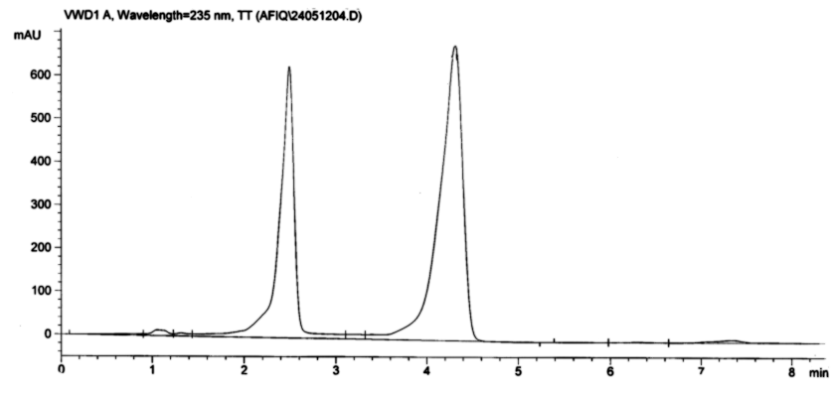
UV
Abs
Retention time
PETN
RDX
Figure 3: Chromatogram of standard mixture solution containing RDX and PETN, with concentration of 100 ppm and 500 ppm respectively. HPLC conditions: Purospher C18 (4.6 x 150 mm, 5 µm), acetonitrile-water mixtures (65:35, v/v), mobile phase flow at rate of 1.0 mL/min. Analytes detection at 235 nm and 215 nm for RDX and PETN respectively. Programmed UV detection at 235 nm for the first 3.5 minutes, and then switched to 215 nm for the next 6.5 minutes.

Calibration Graph and Limit of Detection
Various concentration of standard mixture was injected to obtained chromatograms, which were used to plot calibration graph. The concentrations of standard mixture of RDX and PETN chosen for this analysis were in the range from 10 to 50 ppm for RDX and 100 to 500 ppm for PETN. Linear calibration graphs were obtained for both RDX and PETN with good correlation coefficients (0.99-1.00). The limit of detection (LOD) of an analyte was assessed from a signal to noise ratio (S/N) of 2:1. In this study, the limit of detection for RDX and PETN were 0.05 µg/g and 0.25 µg/g respectively which gave lower LOD compared to previous studies [9,15] (Table 3).

Table 3: Detection limit data of each analyte and comparison of LOD with other study.

 | Limit of Detection (ppm)
Analyte | This study | Ahmad et al. *[9] | Ahmad et al #[15]
RDX | 0.05 | 10 | NR
PETN | 0.25 | 0.1 | 20
NR: Not Reported, * Ref 9: GC-ECD, # Ref 15: HPLC-UV, column: Agilent Zorbax Eclipse XDB-C18 (4.6 x 150 mm, 5 μm), mobile phase: acetonitrile-water (55:45), detection: UV at 230 nm.

Recovery Study
In order to evaluate the efficiency of extraction, recoveries of analyte from cotton ball and spiked samples were determined. Peak areas of spiked cotton ball and spiked samples measured were used to calculate the percentage analyte recovery. The analyte recovery for extraction using cotton ball swabbing technique was found to be 90.05 % and 89.05 % for RDX and PETN respectively (Table 4). This indicated satisfactory recovery. The result of this technique was comparable to an earlier work done by Ahmad et al. who reported recoveries of over 89% for PETN [15]. Meanwhile, recovery for RDX obtained in this study (90.1 %) was much better compared to that in an earlier work by Thompson et al.[17].

Table 4: Recovery of analytes from spiked cotton swab

 |  |  |  |  | Percentage Recovery (%)
Analyte | Spiking Level (ppm) | Concentration ± SD* (μg/g) | This Study |  |  | Ahmad et al. [15] | Thompson et al.  [17]
RDX | 100 | 90.50 ± 3.77 | 90.1 |  |  | NR | 70
PETN | 500 | 445.27 ± 22.27 | 89.1 |  |  | 89.5 | 63
NR: Not Reported, SD: based on triplicate extraction

For spiked sample, the analyte recovery study was done onto three types of cloth which were cotton, nylon and denim. For cotton cloth, mean percentage recovery that has been obtained for RDX and PETN were only 12.7 % and 9.9 % respectively. This shows a very low extraction efficiency was obtained from cotton.This could be due to the physical nature of cotton cloth. Cotton cloths are made up from threads that are spun together causing the analytes to be attached tightly to the threads. Cotton fibres containing cellulose is polar and binds strongly with polar analytes. Cellulose with chemical formula (C₆H₁₀O₅)_{n}, consists of hydroxyl (-OH) groups that would tend to form hydrogen bonds with analytes containing oxygen bond (-O) and nitrogen bond (-N).

For recovery study on spiked nylon cloth, percentage recovery that has been obtained for RDX and PETN were 41.9 % and 34.4 % respectively. Higher percentage recovery obtained for nylon as compared to cotton was possibly due to the smooth nature of the nylon cloth that facilitated the analyte extraction from the matrix. However, no analytes could be recovered from denim. This maybe be due to the thickness of the denim cloth which was thicker compared to other types of cloth analyzed. Table 5 shows the analyte recoveries from cotton, nylon and denim cloth.

Table 5. Analyte recoveries from selected cloth

Cloth  Sample | Analyte | Concentration ± SD*  (μg/g) | % Recovery
Cotton | RDX | 12.71 ± 2.81 | 12.7
 | PETN | 49.71 ± 13.16 | 9.9
Nylon | RDX | 41.94 ± 14.34 | 41.9
 | PETN | 171.78 ± 69.24 | 34.4
Denim | RDX | ND | ND
 | PETN | ND | ND
*ND: Not Detected, SD: Based on triplicate extractions

Microscopic Analysis of Fibers
Physical characteristics of the cloth samples were found to have a profound effect on the extraction of explosives analyzed. From the results of HPLC analysis, different types of cloth gave different recovery of analyte. A few threads of fiber from each cloth (cotton and nylon) were removed and examined under a stereomicroscope. Figure 4 shows the microscopic structure of cloth samples.

(a) | 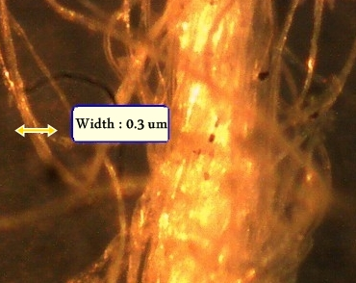 | 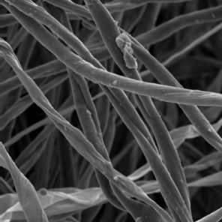
(b) | 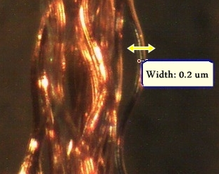 | 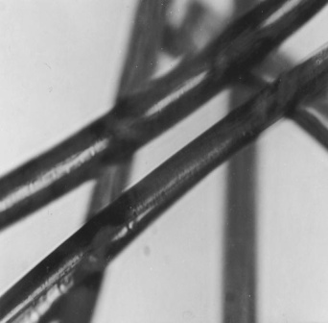
Figure 4. Microscopic structure of (a) Cotton fiber and (b) Nylon fiber using 30X magnifications. Circular inset showing enlarged individual fibers.

Microscopic examination of cotton threads revealed that each thread composed of several strands of cotton fibers that were twisted together to form a thread. Each strand of cotton fiber was observed as highly convoluted and twisted cotton fiber (Figure 4a). Cotton fiber is a natural fiber composed mainly of cellulose that contain hydroxyl (-OH) groups (Figure 5) [18]. In cotton cloth, the fiber matrix is capable of retaining the explosive analytes via ion-dipole and dipole-dipole interactions. Several possible sites within the fiber matrices that can interact with the analytes are depicted in Figure 6.

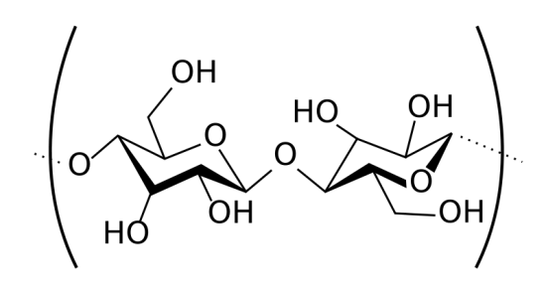
n
Figure 5. Structural formula of cellulose [18].

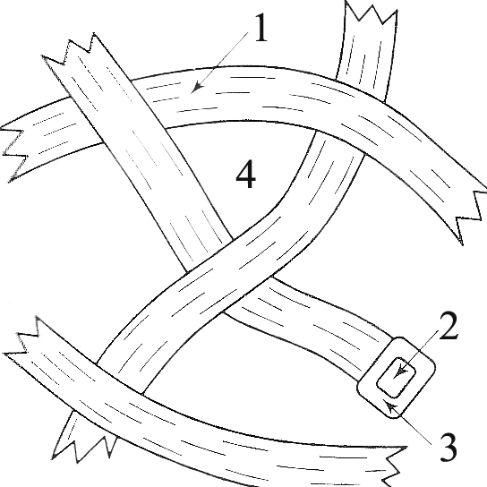

Figure 6. Sites where analyte can interact with cellulose fibers of cotton cloth: (1) on the surface, (2) internally, (3) within the wall of fiber and (4) within spaces between fibers [18].

Nylon fibers are man-made fibers. When these fibers were observed under microscope, they appeared as long strands of fibers and of uniform diameter (0.2 µm). The surface of the nylon fibers appeared smooth and featureless (Figure 4b). The difference in fiber matrix for cotton and nylon accounted for the low analyte recovery from cotton cloth as compared to that from nylon cloth.

Post Blast Sample Analysis
Post blast sample analysis was performed on cloth pieces of nylon and cotton that were exposed to explosive using C4 explosives. Results of the study revealed that extraction of analytes were slightly greater for nylon as compared to cotton cloth (Table 5). From the HPLC profiles of the post blast samples, PETN peak was not detected since it is just a minor component of the C4 explosive and that PETN may be present as the propellant [19]. Other factors such as prolong storage in and degradation process may also contribute to the non detectability of PETN. Concentration of RDX that has been recovered from both nylon and cloth samples is listed in Table 5.

Table 5. Concentration of analytes recovered from post blast cloth samples

 | Concentration ± SD*(μg/g)
Cloth | RDX | PETN
nylon | 4.02±0.16 | ND
cotton | 3.38±0.29 | ND
ND: Not Detected, *SD: Based on triplicate extractions

Conclusions
Simultaneous detection of RDX and PETN explosives have been successfully developed using cotton swabbing technique and HPLC-UV analysis. Reversed phase HPLC separation employed acetonitrile-water (65:35) as the mobile phase and a programmed wavelength for the detection of RDX at 235 nm for the first 3.5 minutes and thereafter for PETN at 215 nm. HPLC separation gave two resolved peaks that eluted within 5 minutes. LODs of analytes were in the low ppm range (0.05 ppm RDX and 0.25 ppm PETN). The extraction of high explosive using cotton swabbing developed in this study shows a relatively high recovery for RDX (90.1 %) and PETN (89.1 %). Analyte recovery studies revealed that the type of cloth has a profound effect on the extraction efficiency. Analytes were recovered better for nylon as compared to cotton cloth. However, no analytes could be recovered from denim cloth. For post-blast samples, only RDX was detected in low concentration (3-4 μg/g) for both nylon and cotton cloth.
Acknowledgement
The authors would like to acknowledge Institut Penyelidikan Sains &Teknologi Pertahanan (STRIDE), Batu Arang, Selangor for their collaboration in providing standard explosives. Thanks are also due to the Department of Chemistry, Faculty of Science, UTM for research facilities and MOHE for financial assistance via FRGS grant R.J130000.7826.4F200.

References
- Ahmad, U. K. and Heng, K. K., (2007). Solid Phase Microextraction-Gas Chromatography for the Analysis of Explosives in Post Blast Water Samples, J. Teknologi C., 46 (c): 59-74.
- Varga, R., and Ulbrich, P. (2004). Some Experience with Trace Analysis of Post-explosion Residues, AARMS 3 (4): 633-646.
- Ladham, S., Koehler A. S., Woods P., Huston R., Dominick J., Fotchman W. F., and Wecht H. C. (2005). A Case Of A Death By Explosives: The Keys To A Proper Investigation. J. Clin. Forensic Med,. 12(2): 85-92.
- Royds, D., Lewis S. W., and Taylor A. M. (2005). A Case Study In Forensic Chemistry: The Bali Bombings. Talanta. 67(2): 262-268.
- Sharma, M., Khajja B. S.,Vashistha, K. N., Bairwa, T., Sharma, S., Srivastava, S., and Mathur, G. K. (2010). Trace Evidence Crack a Suicide Proved Homicide: A Case Study. J. Forensic Res, 1:103.
- Mäkinen, M., Nousiainen M., and Sillanpää M. (2011). Ion Spectrometric Detection Technologies for Ultra-Traces of Explosives: A review. Mass Spectrometry Reviews. 30(5): 940-973.
- Yinon, J. and Zitrin, S. (1981). The Analysis of Explosives. England: Pergamon Press Ltd. 59-118.
- Calderara, S., Gardebas, D. and Martinez, F. (2003). Solid Phase Micro Extraction Coupled With On-Column GC/ECD for the Post-Blast Analysis of Organic Explosives. Forensic Sci. Int.,137: 6-12.
- Umi Kalthom Ahmad, Noor Hidayat Abu Bakar & Shaikh Abdul Adziz Shaikh Abdullah, Analysis of C4 Explosive Residues On Post Blast Hair Samples (2012). Jurnal Teknologi, 57 (Sains & Kej.) Keluaran Khas (1), Mac: 163–171.
- Ahmad, U. K., Rajendran, S., Ling, L. W., and Hooi, Y. C. (2008). Forensic Analysis of High Explosive Residues in Post-Blast Water Samples Employing Solid Phase Extraction for Analyte Pre-Concentration. Malays. J. Anal. Sci., 367-374.
- Miller, C., Elias G., Schmitt N. C., Rae C. (2010). Identification of Explosives from Porous Materials: Applications Using Reversed Phase High Performance Liquid Chromatography and Gas Chromatography. Sensing and Imaging: An Int. J. 11(2): 61-75.
- Saferstein, R. (2004). Criminalistics: An Introduction to Forensic Science, 9th Ed. New Jersey: Prentice Hall.
- Nurul Nuwaida Muhammad Salim (2006). Analisis Forensik bagi Bahan Letupan Menggunakan Ujian PetandaWarna dan Kaedah Kromatografi Lapisan Nipis. UniversitiTeknologi Malaysia: Bachelor of Science (Industrial Chemistry) Project Report.
- Beverige, A. (1998). Forensic Investigation of Explosions. Boca Raton, London: CRC Press.
- Ahmad, U. K., Rajendran, S., and Hassan A. S. (2008). Forensic Analysis of Explosive Residues from Hand Swabs, Malays. J. Anal. Sci., 25-31.
- James S.H. and Nordby J. J., (2005), Forensic Science – An Introduction to Scientific and Investigative Techniques, Boca Raton, Florida: CRC Press.
- Thompson, R. Q., Fetterolf, D. D., Miller, M. L. and Mothershead, R. F. (1998) Aqueous Recovery From Cotton Swabs of Organic Explosives Followed by Solid Phase Extraction, J. Forensic Sci., 795-804.
- Bell, S. (2006). Forensic Chemistry, New Jersey, USA: Prentice Hall.
- Banas, K., Banas, A., Moser, H. O., Bahou, M., Li, W., Yang, P., Cholewa, M., and Lim, S. K. (2010). Multivariate Analysis Techniques in the Forensics Investigation of the Postblast Residues By Means of Fourier Transform-Infrared Spectroscopy. Anal. Chem., 82: 3038-3044.

