TOUGHENING OF EPOXY BY SILANE-TREATED NANOTITANIUM DIOXIDE

(Penguatan Epoksi oleh Silana Terawat Nanotitanium Dioksida)

Phasapan Sanemuang and Jantrawan Pumchusak*

Department of Industrial Chemistry, Faculty of Science,
Chiang Mai University Thailand, 50200 Chiang Mai

*Corresponding author: jantrawan@gmail.com

Abstract

In this research, treated titanium dioxide in the contents of 0.1 - 0.5 wt % was applied into epoxy resin in order to toughen it. Vibracell ultrasonic with various electric power and times was used to disperse the particles successfully. It was found that the epoxy nanocomposites with 0.1 wt % of silane-treated nano titanium dioxide provided the highest impact strength and fracture toughness (K_{IC}) of 69.4 J/m. and 2.18 MPa-m^{1/2}, respectively, while, those properties of the neat epoxy were 41.3 J/m. and 1.16 MPa-m^{1/2}. However, the impact strength and fracture toughness of nanocomposites decreased by about 50 % and 8 %, respectively by further increasing amount of treated Nano titanium dioxide particles 0.2 to 0.5 wt %.

Keywords: epoxy, treated nanotitanium dioxide, nanocomposite, toughening

Abstrak
Dalam kajian ini, sebanyak 0.1 - 0.5wt % titanium dioksida terawat telah dimasukkan ke dalam resin epoksi sebagai penguat. Alat vibracell ultrasonic telah digunakan untuk melarutkan titanium dioksida terawat ke dalam larutan etanol/air dengan memvariasikan masa(t) dan unit kuasa eletrik(watt) yang digunakan. Didapati bahawa nanokomposit epoksi dengan 0.1wt % silane terawat nano titanium dioksida menunjukkan kekuatan impak dan kekuatan patahan (K_{IC}) yang paling tinggi iaitu 69.4 J/m dan 2.18 MPa-m^{1/2}. Epoksi tulen pula adalah masing-masing 41.3 J/m dan 1.16 MPa-m^{1/2}. Namun, kekuatan impak dan kekuatan patahan nanokomposit tersebut menurun sebanyak 50 % dan 8 %, dengan penambahan kandungan partikel nano titanium dioksida terawat daripada 0.2 hingga 0.5 bt %.

Kata kunci: epoksi, nanotitanium dioksida terawat, nanokomposit, penguat

Introduction

Epoxy resins are being extensively used as matrix materials in high performance composites especially in aerospace industry, shipbuilding or electronics devices automobiles, fusion reactors and structural applications [1,2,3]. It is widely used for adhesive, and coating because of when of its less shrinkage [4,5]. However, the brittleness is the weakness of this material. There were several attempts aimed to improve its weak point including the modifying the molecular architecture and structure [6]. However, the easier way to improve the toughness of epoxy is the addition of fillers. Several research studies have found that nanocomposite can improve the mechanical properties of the epoxy. For example, the influence of the insertion of 10% TiO₂-nanoparticles into the epoxy resin on the mechanical performance was examined using three-point bending, Charpy impact and fracture toughness tests. It was demonstrated that the application of TiO₂ nanoparticles lead to a simultaneous improvement of all mentioned properties [7]. Moreover, it was found that the addition of 1 wt % of nano-TiO₂/SiO₂ significantly improved the corrosion resistance of epoxy [4]. Wetzel et al. reported that the addition of 1-2 wt% of Al₂O₃ could increase the wear resistance, stiffness, flexural modulus, flexural strength and impact energy of epoxy [8]. Moreover, the addition of nano-Fe₂O₃ into epoxy matrix was found to improve the thermal stability and viscoelastic properties considerably higher [9]. This research has selected the titanium dioxide nanoparticles to toughen the epoxy for the glass coating application. In this paper, the fracture toughness and impact strength of nanocomposites were investigated.

Materials and Methods

The epoxy resin (NPEL 128) and hardener (H-3839) were kindly supplied by SB United Co., Ltd. The nanoparticle of TiO₂ with diameter of 21 nm was supplied by Sigma Aldrich. 3-aminopropyl triethoxysilane (APTES) was purchased from Sigma Aldrich.

Prior to using, TiO₂nanopowder was dispersed in 400 ml of the media of ethanol/water (19:1 v/v) and 2 vol. % of 3-APTES by ultrasonication for 15 min. Then, the mixture was stirred for 4 h at 70 ºC. After that, the mixture was filtered and washed with acetone and deionized water. The modified particles were dried in an oven at 80 ºC for 24 h.

For the composite preparation, the treated TiO₂ was dispersed in epoxy using vibracell ultrasonic with the electric power of 150, 350 and 750 watts for 1, 3 and 5 min. Ethanol was used as diluent in order to reduce the epoxy viscosity to facilitate the particle dispersion. The sample was cured at 80 ºC for 2 h and at 100 ºC for another 2 h.

The Surface morphology of the materials was observed using a scanning electron microscope (SEM) type JSM-5910LV. The specimen surfaces for the SEM were sputter coated with gold to avoid charging. The impact strength was measured using Cometech Instruments QC-639K testing machine according to ASTM D256 with the single-edge notched bar specimen of 75×12×6 mm. The impact tests were carried out at room temperature and impact energy was reported in J/m. Fracture toughness tests were performed according to ASTM D5045 with single-edge notched bending (SENB) bar specimen of 75×12×6 mm. Cracks were introduced at the bottom of 2 mm deep side notches by scrolling a chilled razor blade. The fracture toughness tests were performed using a Lloyd Instruments (LRX model) with 52 mm of gauge length and the cross-head speed was 50 mm/min.

Results and Discussion
Effect of Dispersion Condition by Vibracell Ultrasonic on Mechanical Properties of Composites
The composites were prepared by mixing the epoxy resin with 0.1 wt% of TiO₂ by vibracell ultrasonic. The effects of electrical power which are 150, 350 and 750 watts on the mechanical properties of the epoxy composites are shown in Figure 1and 2. The results showed that the K_{IC} decreased as the electrical power increased with value of 2.38, 1.95 and 1.61 MPa-m^{1/2}for the 150, 350 and 750 watts, respectively. Moreover, the impact strength of the composites increased with increase of electrical power.
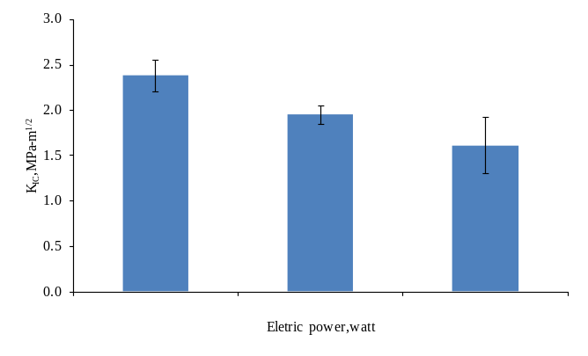

Figure 1: The effect of electrical power on K_{IC} of TiO₂-toughend epoxy.
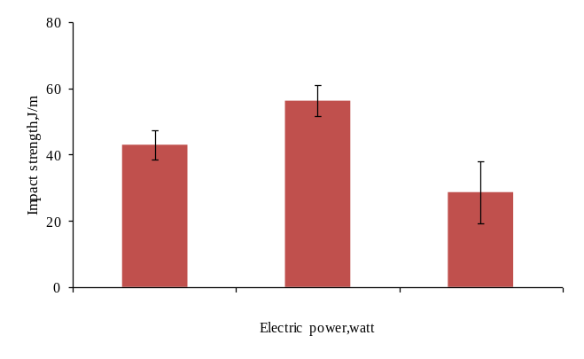

Figure 2: The effect of electrical power on impact strength of TiO₂-toughend epoxy.

The composite which was used the electrical power of 350 watts showed the highest impact strength of 56.4 J/m. However, the impact strength substantially decreased when the electrical power of 750 watts was applied. Thismight causefromthe lower nano-TiO₂ particles dispersion in the epoxy matrix due to the higher viscosity of the mixture. This was the result of the solvent evaporation of the system during dispersion process by vibracell ultrasonic at high power. The high power ultrasonication produced high amount of heat. Thus, the mechanical properties ofcomposites extensively decreased.

Therefore, the electrical power of 350 watts was selected to apply for the suitable dispersion time in the composite preparation process. The effect of dispersion time, which were 1, 3 and 5 min, on the mechanical properties of the epoxy composites are shown in Figure 3 and 4. The results showed that the K_{IC} of the composites which were applied the dispersion time of 1, 3 and 5 min were 1.93, 2.12 and 2.33 MPa-m^{1/2}, respectively and the impact strength of the composites were 47.3, 59.8 and 36.4 J/m, respectively.

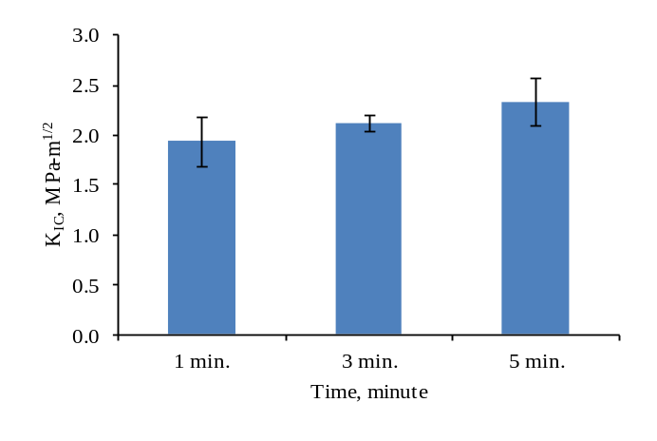

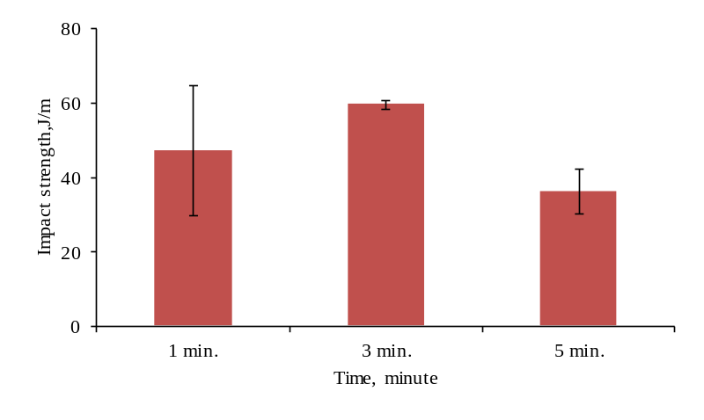
Figure 3: The effect of dispersion time on K_{IC} of TiO₂-toughend epoxy.

Figure 4: The effect of dispersion time on impact strength of TiO₂-toughend epoxy.
The composites which were applied the dispersion timeof 3 min showed the highest impact strength. However, due to the apparatus limitation, the dispersion process was carried out in the opened system. Therefore, the selected condition for the nanoparticle dispersion is based on this opened system. The electrical power of 350 watt and the dispersion time of 3 min were selected to prepare the epoxy composites with different content of treated TiO₂
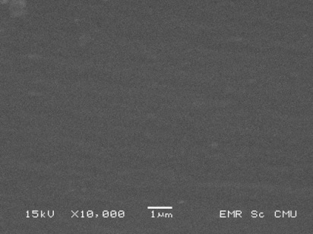

Figure 5: SEM micrograph of neat epoxy

Morphology
The fracture surface of epoxy composites were observed by SEM. The fracture surface of neat epoxy was shown in Figure 5. From the micrograph, it shown that the fracture surface of neat epoxy were smooth which represented the brittleness of epoxy. The fracture surface of epoxy composites with 0.1 wt% of TiO₂ was shown in Figure 6. It was seen that the fracture surface of epoxy composites with TiO₂ was much rougher than neat epoxy and there were a ladder features on the fracture surface (circle area). To create such surface texture, energy is needed, so this is one of the toughening mechanisms for this composite. Figure 7 and 8 show the fracture surfaces of the 0.3 and 0.5 wt % of TiO₂ composites, respectively. It was seen that TiO₂ nanoparticles were agglomerated.
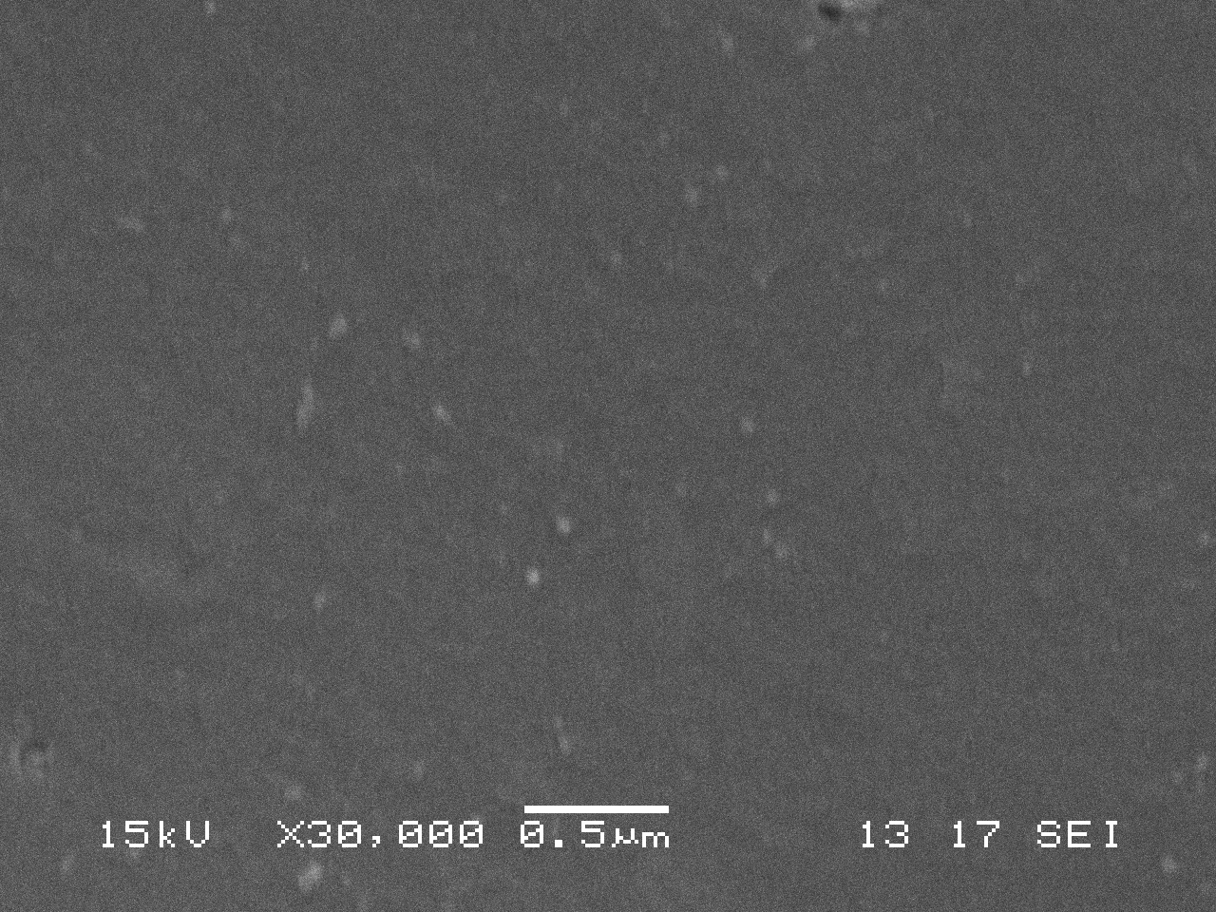
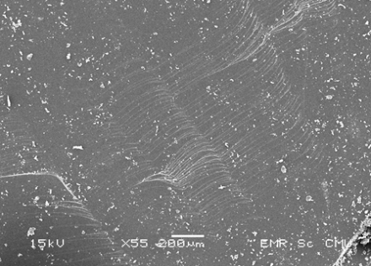
(b)
TiO₂
TiO₂
Ladder features
(a)

Figure 6: SEM micrographs of 0.1 wt % treated TiO₂nanocomposite. a) circle area show much rougher and there were a ladder features on the fracture surface b) show dispersion of TiO₂ nanoparticle into matrix

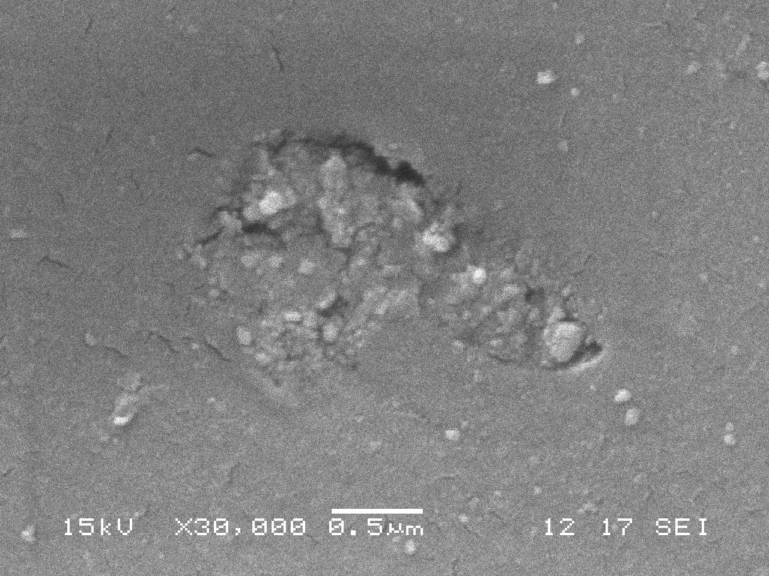
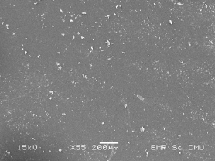
(b)
(a)

Figure 7: SEM micrographs of 0.3 wt% treated TiO₂nanocomposite.
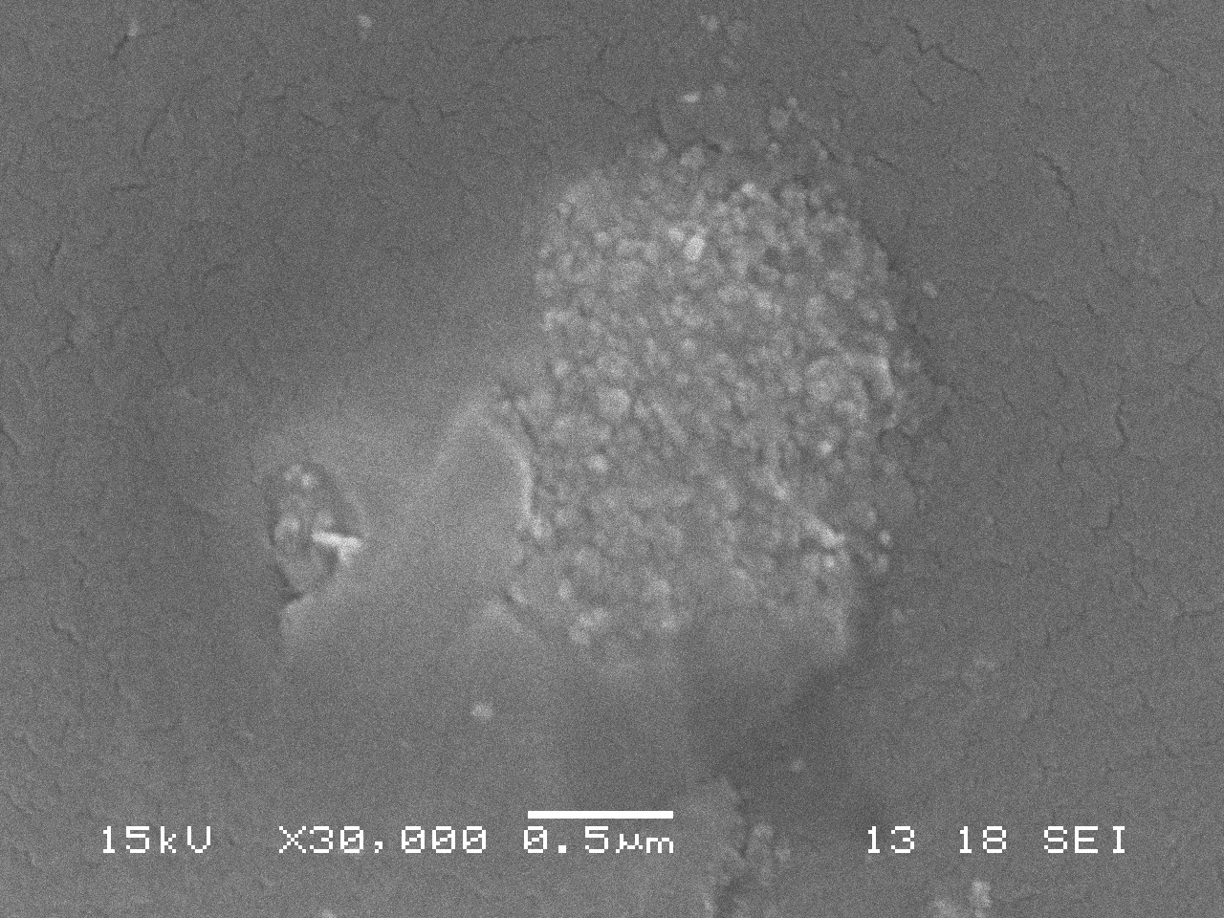
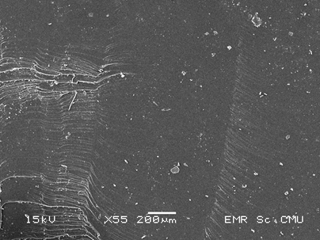
(b)
(a)

(a)
(b)
Figure 8: SEM micrographs of 0.5 wt% treated TiO₂nanocomposite.
Mechanical Properties of Untreated and Treated TiO2 Particles by 3-Aminopropyltriethoxysilane
The K_{IC} and impact strength of the epoxy composites with 0.1 wt% untreated TiO₂ and 0.1 – 0.5 wt% treated TiO₂ are shown in Figure 9 and 10. The results show that the K_{IC} of epoxy composites with 0.1 wt% of untreated TiO₂ were improved by 80 % when compared to the K_{IC} of neat epoxy; however, the impact strength of composites decreased by 32 %.

Comparing the use of 0.1 wt% of untreated and treated TiO₂, it was found that the treating of TiO₂ with silane did not affect the K_{IC}. However, the addition of 0.1 wt% of treated TiO₂ improved the impact strength of the composites. The impact strength of the 0.1 wt% of treated TiO₂ epoxy composites were improved by 60 % when compared to that of 0.1 wt% of untreated TiO₂ epoxy composites. It is known that TiO₂ and silane coupling agent are chemically bonded after the surface modification [9]. In addition, the silane-treated TiO₂ strongly bonded to the epoxy matrix, so the impact strength of the epoxy could be improved.

By using the different content of TiO₂ in the composites, it was indicated that all TiO₂ content did not make a significant difference in the K_{IC} of epoxy composites, but all composites showed the tough character with K_{IC} of about 2MPa-m^{1/2}. However, the impact strength considerably declined, when the TiO₂ content increased due to the agglomeration of TiO₂ particles at the high contents which can be seen in Figure 4 and 5.
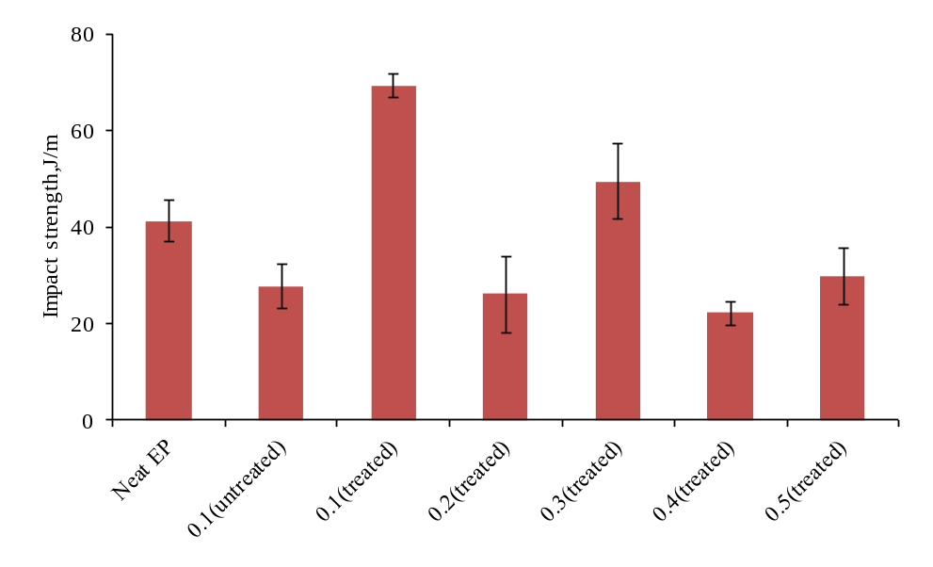

wt% TiO₂

Figure 9 The effect of different weight fraction of TiO₂ on impact strength of TiO₂-toughend epoxy.
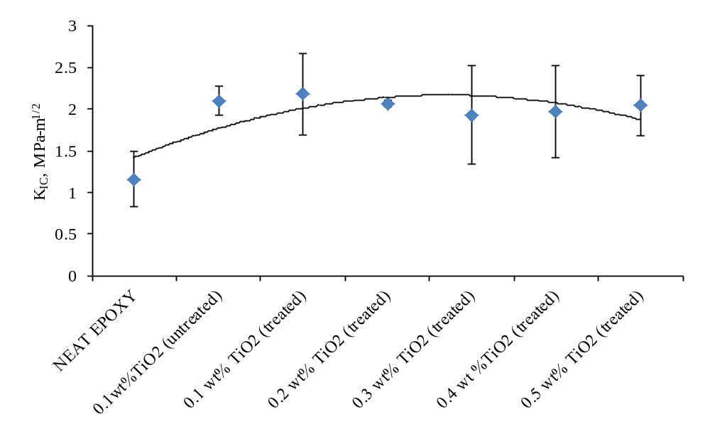
wt% TiO₂

Figure 10 The effect of different weight fraction ofTiO₂on K_{IC} of TiO₂-toughend epoxy.
Conclusion
This research studied the utilization of vibracell ultrasonic to disperse TiO₂ nanoparticles in the epoxy matrix and found that it influenced the dispersion and also the mechanical properties of composites. The used of 350 watt 3 min was found to be a good condition for the preparation. The epoxy composites with 0.1 wt% of treated TiO₂ gave the highest K_{IC} and impact strength of 2.18 MPa-m^{1/2} and 69.4 J/m, respectively. When the electric power of 750 watt was applied, the agglomeration of nano-TiO₂ was found. Therefore, the high fluctuation of results was obtained.

Acknowledgements
This research was financially supported by National Research University (NRU) and the Graduated School, Chiang Mai University.
References
- Hussain, M., Nakahira, A., Nishijima S. & Niihara, K. (1996). Fracture behavior and fracture toughness of particulate filled epoxy composites. Material Letter, 27:21–25.
- Wetzel, B., Rosso, P., Haupert, F. & Friedrich, K. (2006). Epoxy nanocomposites-fracture and toughening mechanisms. Engineering Fracture Mechanics, 73:2375–2398.
- Omrani, A., Simon C.L. &Rostami A.A. (2008). Influences of cellulose nanofiber on the epoxy network formation. Materials Science and Engineering A, 490:131–137.
- Shi, H., Liu F., Yang, L. & Han, E. (2008). Characterization of protective performance of epoxy reinforced with nanometer-sized TiO₂ and SiO₂. Progress in Organic Coating, 62:359–368.
- Chatterjee, A. & Islam, M.S. (2008). Fabrication and characterization of TiO₂-epoxy nanocomposite. Materials Science and Engineering A,487:574–585.
- Sue, H.J., Puckett, P.M., Bertram, J.L. & Walker, L.L. (2000). The Network Structure of Epoxy Systems and Its Relationship to Toughness and Toughen ability. ACS Symposium Series, 759.
- Bittmann, B., Haupert F., &Schlarb, A.K. (2011). Preparation of TiO₂/epoxy nanocomposite by ultrasonic dispersion and their structure property relationship.UltrasonicsSonochemistry, 18: 120 – 126.
- Wetzel, B., Rosso, P., Haupert, F. &Zhang, M.Q. (2003). Epoxy nanocomposites with high mechanical andtribological performance. Composites Science and Technology, 63 :2055–2067.
- Zabihi, O., Hooshafza, A., Moztarzadeh, F., Payravand, H., Afshar, A.&Alizadeh, R. (2012).Isothermal curing behavior and thermo-physical properties of epoxy-based thermoset nanocomposites reinforced with Fe₂O₃ nanoparticles.ThermochimicaActa, 527:190 – 198.
- Zhao, J., Milanova, M., Warmoeskerken, M.M.C.G. &Dutschk, V. (2012). Surface modification of TiO₂ nanoparticles with silane coupling agents. Colloids and Surfaces A: Physicochem. Eng.Aspects, 413:273–279.

