

Oleic Acid based Polyesters of Trimethylolpropane and Pentaerythritol for Biolubricant Application

(Poliester Berasaskan Trimetilolpropana dan Pentaeritritol dengan Asid Oleik untuk Kegunaan Biopelincir)

Hamizah Ammarah Mahmud, Nadia Salih, Jumat Salimon*

School of Science and Food Technology,
Faculty of Science and Technology,
Universiti Kebangsaan Malaysia, 43600 Bangi, Selangor, Malaysia

*Corresponding author: jumat@ukm.edu.my

Abstract
The production of polyesters based on oleic acid and trimethylolpropane (TMP) or pentaerythritol (PE) as potential biolubricant were carried out. The esterification processes between oleic acid with TMP or PE were carried out using sulfuric acid as a catalyst. The esterification process produced high yield between 92%-94% w/w respectively. The formation of polyesters was confirmed using gas chromatography (GC-FID), Fourier Transform Infrared Spectroscopy (FTIR) and Nuclear Magnetic Resonance (NMR). The polyesters were analyzed for basic lubrication physicochemical properties. The results showed that polyesters of both TMP and PE having high viscosity index between 200-309, good pour points ranging from -42°C to -59°C and high flash points of 280°C - 300 °C respectively. The polyesters also showed good thermal oxidative stability with TGA onset temperatures above 180 °C. In general both products are plausible to be used as biolubricant for industrial application.

Keywords: esterification, oleic acid, pentaerythritol, polyhydric alcohol, trimethylolpropane

Abstrak
Penghasilan poliester berasaskan asid oleik dan trimetilolpropana (TMP) atau pentaeritritol (PE) sebagai biopelincir yang berpotensi telah dijalankan. Proses pengesteran asid oleik diantara TMP atau PE menggunakan mangkin asid sulfurik. Sebanyak 92-94 % w/w hasil daripada pengesteran berjaya dihasilakan. Pengesahan dan pengecaman poliester adalah menggunakan Gas Kromatografi(GC-FID), Spektroskopi Inframerah Fourier Transform (FTIR) dan Resonan Magnetik Nuklear (¹H NMR dan ¹³C NMR ). Ujian asas fisiko-kimia sifat pelinciran telah dijalankan keatas poliester. Hasil analisis menunjukkan kedua-dua poliester TMP dan PE mempunyai indeks kelikatan yang tinggi 200-309, takat tuang yang baik dari julat suhu dari -42°C kepada -59°C; takat kilat yang tinggi 280°C - >300 °C. Kesemua poliol ester menunjukkan kestabilan oksidatif termal yang bagus dimana suhu onset TGA melebihi 180 °C. Secara umumnya kedua hasil adalah munasabah untuk digunakan sebagai biopelincir dalam aplikasi perindustrian.

Kata kunci: pengesteran, asid oleik, pentaeritritol, polihidrik alkohol, trimetilolpropana

Introduction
Recently vegetables oil (VO) has gotten very high attention due to the potential of the natural triglycerides, which is biodegradable and their superior lubricity potential is comparable to those mineral oils based lubricants. The natural triglycerides are environmentally friendly with caliber lubricity characteristic such as good anti-wear, antifriction, and load carrying capacity [1]. Also the awareness of environmental pollution that caused by mineral has lead to many researches upon the alternative in using mineral oil as a lubricant which more environment friendly or green lubricant [2]. The used of lubricating oil, which lost to the environment tend to lead the air pollution [3] and also the spill of the oil bring harm to the environment as it is toxic. Hence vegetable oil is found to be the best alternative to replace the depleted mineral oil. The physicochemical properties of vegetable or oleochemical esters can cover the requirements for the development of high performance industrial oils and lubricants. This is due to the superior lubricating properties, good stability, high viscosity index, low volatility and superior shear stability [4]. However, along with the superior lubricity characteristic VO faced several disadvantages which cause instability behavior and tend to easily damaged and will give a limit to lubricant industries application.

The triacylglycerol molecules from VO contains glycerol component which easily damaged at high temperature is one of the most crucial disadvantages have to overcome. The root of this problem is the presence of hydrogen atom at β position of glycerol component. The disadvantages include poor low temperature properties (such as precipitation, poor flow ability and/or solidification at relatively moderate temperatures), capability to undergo hydrolysis in acid media and their potential to oxidative degradation [5]. From the presence of hydrogen atoms at β position will lead to partial fragmentation of molecular hence will form unsaturated compound. The formed compound will undergo polymerization and will increase the liquid’s viscosity that result the formation of precipitate particles [6]. This drawback can be overcome by replacing the glycerol component with a polyhydric alcohol which does not contain β-hydrogen atom such TMP and PE. Although polyhydric alcohols also decompose at high temperatures, its thermal decomposition has a radical character and proceeds slowly [7]. The reaction of various fatty acids with polyol like TMP, PE and neophentyl glycol (NPG) will form polyol esters.

Previous studies showed good feedback on the esterification of VOs with a polyhydric alcohol as it reported 98% of palm oil methyl ester (POME) and palm kernel oil (PKO) was successfully converted into Triester (TE) from the esterification of POME and PKO with TMP [8-9]. A biodegradable polyol ester derived from esterification/transesterification of VOs and branched nebulous such as PE and TMP were developed for various application fields [10]. The unsaturated alkene groups of fatty acid chain in triacylglycerol molecules can be altered to give more complex structure that will improve the drawback by VOs [11-16]. The polyol ester has great potential in overcoming the drawback of VOs. Every formed esters by the esterification/ transesterification will give different properties as it depends on the structured of the respective fatty acid, like number and position of double bonds (unsaturated bonds) also the length of the aliphatic chains. Polyunsaturated fatty acids fond of with lower pour point, but poorly resistant to oxidation at high temperature while saturated acids are greatly resistant to oxidation temperature and poorly with pour point due to the linear structure of acids. High oleic acid content in VOs is considered as potential candidates as supplant to mineral oil based lubricant oils and synthetic esters [17-18]. In this study oleic acid (99.5%) was used in the synthesis of base stock oil for bio-lubricant production. Oleic acid is monounsaturated fatty acid, which contains a single double bond at carbon 9-10 and also known as omega-9 (ω-9) oil. Oleic acid always been the more fatty acids substituted in any modification of lubricating oils. Oleic acid undergoes the esterification reaction with a polyhydric alcohol (TMP and PE) to obtain the sole potential for biodegradable lubricant oils from the esterification without adding other fatty acid. The physicochemical properties of the products are also compared with commercial lubricant oil.

Materials and Methods

Materials
The Oleic acid used in this study was purchased from system with 99.5% purity while the trimethylolpropane (TMP) and pentaerythritol (PE) was purchased from Fluka. Sulphuric acid, sodium chloride, sodium hydrogen bicarbonate, ethyl acetate, toluene and ethanol were purchased from System. The N,O-Bis(trimethylsilyl) trifluoroacetamide (BTSFA) with 1% trimethylsilyl chloride was purchased from Acros Organic.

Esterification of oleic acid with polyhydric alcohol
In this study direct esterification of oleic acid with polyhydric alcohol, which was TMP or PE with sulfuric acid as catalyst [19-21]. The condition of reaction was 5-6 hour, the molar ratio of FA:TMP was 3.9:1 and FA:PE was 4.9:1, temperature 150-180 °C. The esterification process began by adding the Oleic acid (99.5% purity) with TMP/PE at different molar ratio in 250 ml three necks round bottom flask equipped with a thermometer and Dean Stark apparatus. 1.0% - 2.0% (w/w) of sulfuric acid was added based on the weight of mixed of Oleic acid and polyhydric alcohol as the catalyst for esterification and 80 mL-100 ml was added as the isotopic agent. The ester resulted from the esterification then was washed thoroughly with sodium bicarbonate, sodium chloride and ethyl acetate followed by mild-warm distilled water until the ester becomes neutral. The end product of each reaction was analyzed using FT-IR for ester group conformation and GC-FID to calculate the composition percentage of ester. The esterification of oleic acid with TMP and oleic acid with PE is shown in Figure 1 and Figure 2.

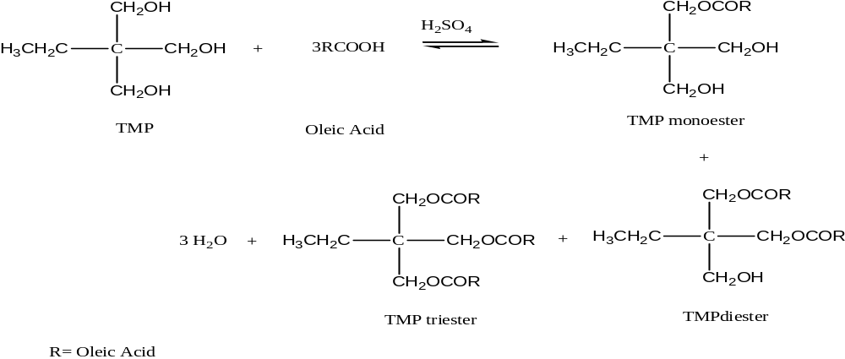
Figure 1. Esterification of Oleic acid with TMP.

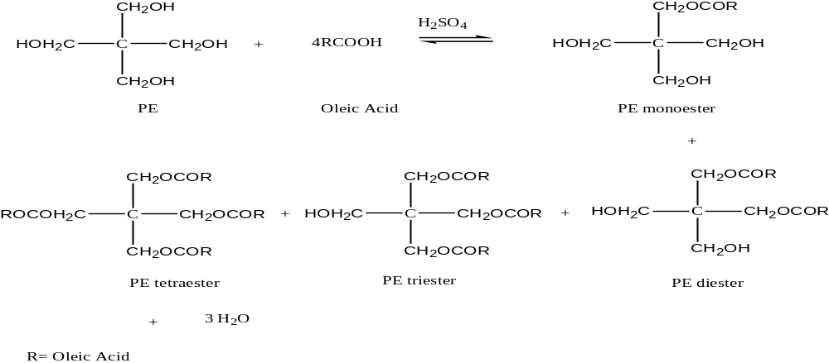

Figure 2. Esterification of Oleic acid with PE.

TMP Ester and PE Ester Analysis
The structure of optimized TMP ester and PE ester were determined and confirmed using Fourier Transform infrared spectroscopy (FTIR). The percentage composition of the resulting esters was determined by using gas chromatography, which equipped with flame ionization detector (GC-FID). The sample was prepared by heating a small portion of the ester that mixed with ethyl acetate (GC grade) and BTSFA in 60 °C water bath for 40-50 minutes. Then the analysis was carried by using DB-5HT (30 m x 0.25mm x 0.1 µm), the injector and detector were set at 380°C - 400°C respectively. For the initial oven temperature is set at 100°C with 1 minute of initial holding time. The ramping rate was increased for 5°C/min until it reached 380°C and held for 20 minutes. To confirm the formation of ester TMP and PE the NMR was carried out to determine the structure of esters.

Lubrication Characteristics
The pour point, the flash point and the viscosity of the ester-TMP and ester-PE were measured according to ASTM D 97-87, ASTM D 92-05a and ASTM D 445 (Brookfield RV-I. A spindle of S0₃ was used at 100 rpm at room temperature) [11]. The oxidative stability was measured using DSC and the viscosity index was measured using Rheometer MCR series Anton Paar.

Results and Discussion
Oleic acid (99.5%) which obtained from System was used as base stock in bio-lubricant production. Oleic acid is monounsaturated chain fatty acid, which contains a single double bond at carbon 9. High oleic acid content is considered to be a very good candidate as substitutes for conventional mineral oil based lubricating oils. From the esterification about 92-94% w/w product yields was obtained. From the esterification process three types of ester present, which are diester (DE), triester (TE) and tetraester (TrE). The structure of the ester TMP/PE was confirmed by NMR and FTIR, while the percentages of TMP trioleat and PE tetraoleat formation was detected using GC-FID. The ester formed by the esterification process of TMP and PE was confirmed by observing the FTIR spectra of the product and oleic acid. The comparison of FTIR spectra of both esters with oleic acid is as shown in Figure 3.

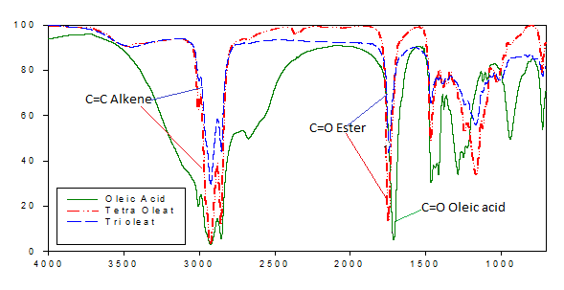
Figure 3. FTIR spectra of oleic acid, ester TMP and ester PE.

According to the comparison of the FTIR spectra showed in Figure 3 the peak appears at wave number of 1710 cm⁻¹ which is for C=O group of carboxylic acids in oleic acid move into wave number of 1745 cm ⁻¹ (TMP ester) and 1746 cm⁻¹ of the C=O group in PE ester. Both Oleic-TMP and Oleic-PE reaction has successfully reacted with each other to form esters as shown from the comparison FTIR spectra.

The NMR spectra confirmed the formation of TMP Trioleat and PE Tetraoleat by determining the molecular structure as a whole. The ¹H NMR spectra for both polyol ester (Figure 2 A and C) shows the existence signals of methylene protons bound to –O of the carboxylic acid group. Signals at 3.99 ppm for TMP ester and 4.07 ppm for PE ester are referring to the methylene protons at the methylene carbon [22]. The ¹³C NMR spectrum (Figure 2 B and D) also plays an important role in displaying the critical features of polyols ester produced. The signals in the range 173-174 ppm, which is for the ester carbonyl signal is very important to prove the molecule structure of both ester. In this study carbonyl of ester signal appears at 173.48 ppm for TMP ester and 173.22 ppm for PE ester. Based on the signals from ¹H NMR and ¹³C NMR spectra which confirm from the references and the merging spectra from FTIR spectroscopy (determining the functional group of a compound) and NMR (offers the information about the number of each type of hydrogen and carbon) showed the expected ester were obtained as shown in Figure 4 and Figure 5.

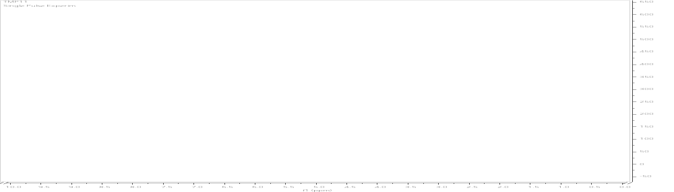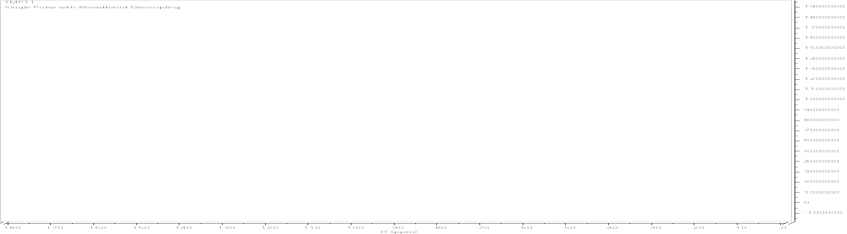
CH₂
C=C
R-COO-R
HC=CH
CH₃
C-O
C
CH₂
CH₃
C-CH₂-O
CH₂-COO-R

C=C-CH₂-
B
A
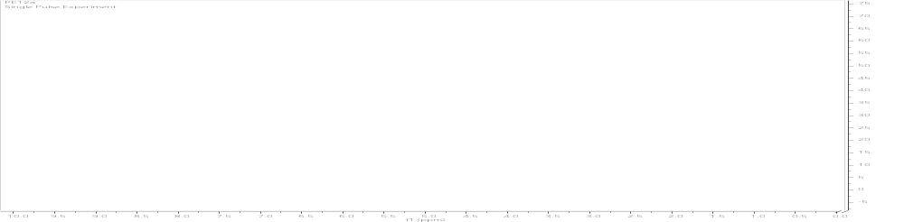
CH₃
C=C-CH₂-
CH₂-COO-R
C-CH₂-O
HC=CH
CH₂
C
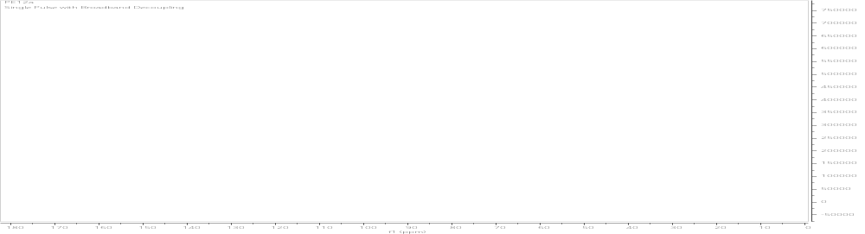
R-COO-R
C=C
C-O
C
CH₃
CH₂
D

Figure 4. (A)¹H NMR spectra TMP ester; (B)¹³C NMR spectra of TMP ester; (C) ¹H NMR spectra PE ester; (D)¹³C NMR spectra PE ester.
¹H NMR tri-ester TMP (400 MHz; CDCl₃) δ_{H} 0.82-0.86 (6H, m, CH₃), 1.23-1.58 (24H, m, -CH₂), 1.90-2.0 (4H, m, CH₂CH=CHCH₂), 2.24-2.31 (2H, m, CH₂C=O), 3.93-3.99 (2H, m, CH₂O) and 5.29-5.31 (2H, m, HC=CH); ¹³C NMR TMP (400 MHz; CDCl₃) δc 7.42-14.18 (2xCH₃), 22.75-31.98 (13xCH₂), 40.64 (C), 63.74 (CH₂O), 129.76-130.24 (2xC=C), 173.24-173.54 (CH₂COO); IR (cm⁻¹) 1162.62 (C-C(=O)-O), 1743.26 (C=O), 2925.53 (C-H); GC-FID conversion yield 91.57 %.

¹H NMR tetra-ester PE (400 MHz; CDCl₃) δ_{H} 0.82-0.85 (3H, m, CH₃), 1.20-1.25 (22H, m, CH₂), 1.97-2.0(4H, m, CH₂C=CCH₂), 2.24-2.28 (2H, m, OCOCH₂), 4.0-4.08 (CH₂O), 5.30-5.31 (2H, m, HCCH); ¹³C NMR PE (400 MHz; CDCl₃) δ_{C} 14.14-14.21 (CH₃), 22.72-31.95 (13xCH₂), 41.90 (C), 60.40-62.38(CH₂O), 129.72-130.20 (2xC=C), 173.22-173.25 (CH₂COO), IR (cm⁻¹) 1165.98 (C-C(=O)-O), 1745.36 (C=O), 2926.02 (C-H); GC-FID conversion yield 99.21%.

GC-FID chromatograms of both polyol esters were shown in Figure 5. The esters formed were identified by making comparison with reference of standard by using the standard of triacylglycerol (TAG), diacylglycerol (DAG) and monoacylglycerol (MAG) [23]. The appeared peaks were identified and labelled based on the number of the alkyl carbon group that attached to the TMP and PE backbones. The composition of both polyols ester is as shown in Table 1. The esters formed were identified by comparing the obtained chromatograms with standard chromatogram of TAG, DAG and MAG.

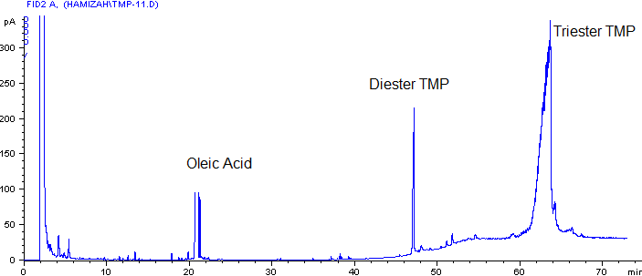
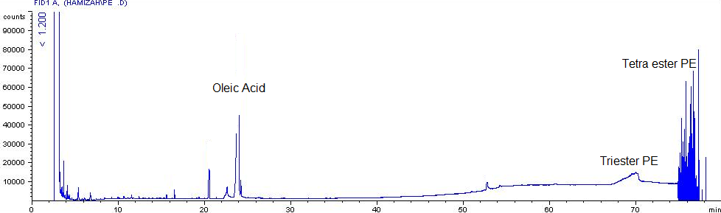

Figure 5. The GC-FID chromatograms of TMP ester and PE ester.

Table 1. The composition of esterification products (%)
Products | Fatty Acid | Monoester | Diester | Triester | Tetraester
TMP Ester | 1.30 | - | 9.60 | 89.10 | -
PE Ester | 4.63 | - | - | 0.14 | 95.23

Both polyesters were characterized for their physicochemical properties such as viscosity, viscosity index (VI), pour point, flash point, and thermal stability (Table 2). Viscosity is the measure of the oil’s resistance to flow (shear stress) under certain conditions. To simplify, the oil’s viscosity represents the measure for which the oil wants to stay put when pushed (sheared) by moving mechanical components. TMP Ester and PE ester exhibit their kinematic viscosity at 40°C at range ISO VG 46 and 68, and at 100 °C the viscosity is in the range 15.32-52.22 cSt. TMP ester and PE ester exhibited similar trend which the viscosity of polyol ester base fluids generally will increase based on the number of acyl functionalities present (Gryglewicz et al. 2003). Both synthesized esters come out with high viscosity index, which is more than 200 and considered as a desirable property for lubricant. High viscosity index is showing a change over wide temperature change behavior. Usually lubricant from plant base is considered as multi range oils as their viscosity index is high.

Table 2. Physicochemical properties of TMP ester and PE ester.
Properties | TMP Oleate | PE Oleate
Viscosity at 40°C, cSt | 80.80 | 52.22
Viscosity at 100°C, cSt | 15.32 | 16.33
Viscosity index | 200 | 309
Pour point (°C) | -59 | -42
Flash Point (°C) | 289 | >300
Oxidative stability (°C) | 189 | 177

The pour point of polyester which has unsaturated fatty acid will be very low. This result is significant with the previous studies which stated that the formation of a complex chain and branched oils have lower pour point [24]. The branched chain can improve the temperature lubricity properties at low temperature and also the hydrolytic stability. At low temperature, oil composition tends to form a uniform micro-crystal chain. Polyester produced in this study has a large molecular chain and branched. Therefore their existence in the fatty acid chain can retard the process of microcrystal formation. The branches are able to create a barrier around the congestion of each molecule and prevent the crystallization. In this study, we estimated PE ester to have lower pour point compare to TMP ester (-59°C) but PE ester pour point has slightly higher pour point (-44°C). The symmetry structure of PE ester cause the molecular configuration less effective in retarding molecule packing compared to TMP ester.

From this study, the flash point of TMP ester was recorded at 289°C and PE ester at > 300°C. Both esters have a higher flash point compared to oleic acid. The number of carbons in that particular molecule plays a big role in influencing the flash point temperature. Higher value indicates that PE ester and TMP ester are plausible as a lubricant. Unsaturated fatty acid is commonly less resistant to oxidation at high temperature, during boundary lubrication. The reaction of unsaturated chain (double bond) with oxygen will form free radical that lead to polymerization and fragmentation of ester into acid an olefin.

The TGA degradation onset temperature indicates the resistance of the oil towards thermal degradation. High onset temperature of the polyester increases the compound endurance towards decomposition. Therefore, its thermal stability increases. TMP ester (189°C) and PE ester (177°C) possess good thermal stability with high onset temperature. However, this result does not follow the decreasing pattern of thermal stability. PE ester was supposed to have higher thermal stability compared to TMP ester. This is due to the symmetrical structure of PE ester which encourages the free radical to undergo cleavage, fragmentation and polymerization.

The results also showed that TMP ester shows more superior properties of lubricity compared to PE ester. TMP ester exhibits better pour point and thermal stability (oxidative stability). These two properties are very importance in determining the lubricity performance. The good results of these two esters prove that they are plausible to be used as superior lubricant base oil.
Conclusion
The esterification of oleic acid and polyhydric alcohols (TMP and PE) has been successfully synthesized with high yields percentage of TMP ester and PE ester. The result of esterification showed complete formation of TMP ester and PE ester were completely formed prove by the high content of trioleate ester and tetraoleate ester. From the results obtain, both TMP ester and PE ester show good lubricity performance. Between the two polyesters, TMP ester has higher potential and quality to be used as a lubricant compared to PE ester.

Acknowledgement
The authors would like to thank the School of Chemistry and Food Technology, Faculty of Science and Technology, Universiti Kebangsaan Malaysia, Bangi for instrumental facilities as well as grants for funding the project DPP-2014-058 and UKM-AP-2011-17 and the Ministry of Higher Education.

References
- Arnsek, A., Vizintin, L., (2000). Lubricating properties of rapeseed based oils. Journal Synthetic Lubricant 16, 281–295.
- Jumat, S., Nadia, S., Emad, Y., (2012). Industrial development and applications of plant oils and their biobased Oleochemicals. Arabians Journal of Chemistry. 5: 135-145
- Erhan, S. Z., Sharman, K. B and Perez, J. M. (2006). Oxidation and low temperature stability of vegetable oil-based lubricant. Industrial Crops and Product 24: 292-299.
- Lathi, P. S and Mattiasson, B. (2007). Green approach for the preparation of biodegradable lubricant base stock from epoxidized vegetable oil. Applied Catalysis 69:207-212.
- Campanella, A., Rustoy, E., Baldessari, A and Baltanás, M. A. (2010). Lubricants from chemically modified vegetable oils. Bioresource Technology 01: 245-254.
- Korlipara, V.P., Bhamidipati, V.S.K.R., Rondla,K.R.,Potula, S.B., Arun, K.S.and Rachapudi, B.N.P. (2011). 10-Undecenoic acid-based polyol esters as potential lubricant base stocks. Industrial Crops and Products 35: 237-240
- Wilson, B., (1998). Lubricants and functional fluids from renewable sources. Ind. Lubr. Tribol. 50, 6-15
- Gryglewicz, S., Piechocki, W and Gryglewicz, G. (2003). Preparation of polyol esters based on vegetable and animal fats. Bioresource Technology 87: 35-39.
- Anita Abu Bakar, Yunus, R., Luqman Chuah and Fakhru’l-Razi, A. (2007).Study on effect of hydroxyl groups on lubrication properties of palm based trimethylolpropane esters: development of synthesis method. Journal of Applied Science 7(5): 2011-2014
- Bongardt, F.B, Bossmann, A., Westfetchetel, W.G. and Giede,W., (1996). Manufacture of synthetic esters from alcohol and high oleic low strearic fatty acid. Ger. Offen., DE 4,444, 137.
- Erhan, S.Z., and Perez, J.M. (2002). Biobased industrial Fluids and Lubricants. AOCS Pres, Champaign, IL.
- Lathi, P.S.and Mattiason, B., (2006) Green approach for the preparation of biodegradable lubricant base stock from epoxidized vegetable Oil. Applied Catalyst Lipid. 77: 155-171.
- Hwang, H.S. and Erhan, S.Z., (2001). Modification of epoxidized soybean oil for lubricant formulations with improved oxidative stability and low pour point. Journal America Chemist Oils Society 78: 1179-1184
- Hwang, H.S., Adhvaryu, A. and Erhan, S.Z., (2003). Preparations and Properties of lubricants base stock from epoxidized soybean oil and 2-ethylhexanol. Journal America Chemist Oils Society. 80: 811-815
- Adhvaryu, A., Liu, Z.S. and Erhan, S.Z., (2005). Synthesis of novel alkoxylated triacylglycerols and their lubricant base oil properties. Ind. Prod. 21:113-119
- Sharma,B.K., Liu, Z., Adhvaryu, A. and Erhan, S.Z., (2008). One pot synthesis of chemically modified vegetable oils. Journal Agriculture Food Chemistry. 56: 3049-3056
- Asadauskas,S.,Perez,J.M. and Duda, J.L. (1996). Oxidative Stability and antiwear properties of high Oleic Acid vegetable oils. Lubr. Eng. 52: 877-882.
- Erhan, S. Z and Asadauskas, S. (2000). Lubricant basestocks from vegetable oils. Industrial Crops and Products 11: 277-282.
- Yunus, R., Fakhru’l-Razi, A., Ooi, T. L., Iyuke, S. E and Idris, A. (2003).Development of optimum synthesis methods for transesterification of palm oil methyl esters and trimethylolpropane to environmentally acceptable palm oil-based lubricant. Journal of Oil Palm Research 15 (2): 35-41.
- Yunus, R., Fakhru’l-Razi, A., Ooi, T. L., Iyuke, S. E and Idris, A. (2003).Preparation and characterization of trimethylolpropane esters from palm kernel oil methyl esters. Journal of Oil Palm Research 15(2): 42-49.
- Yunus, R., Fakhru’l-Razi, A., Ooi, T. L., Iyuke, S. E and Idris, A. (2004). Lubrication properties of trimethylolpropane esters based on palm oil and palm kernel oils. European Journal Lipid Science Technology. 106: 52-60
- Pavia, D.L., Lampman, G.M. and Kriz, G.S. 2009. Introduction to Spectroscopy. 4th ed., United States: Thomson Learning, Inc.
- Robiah, Y., Ooi, T.L., Fakhru’l-Razi, A. and Shahnor, B. (2002.) A Simple Capillary Column GC Method for Analysis. Journal of the American Oil Chemist’s Society 79: 1075-1080.
- Cermak, S.C. and Isbell, T.A. (2003). Synthesis and physical properties of estolide-based functional fluids. Industrial Crops and Products 18:183-196.

