

ANALYTICAL APPROACHES OF DETERMINING MONOSACCHARIDES FROM ALKALINE-TREATED PALM FIBER

(Kaedah Analatikal bagi Penentuan Monosakarida daripada Serabut Sawit Terawat Alkali)

Khairiah Haji Badri^{1,2}*, Cheah Ai Juan¹, Osman Hassan^{1,2}, Wan Aida Wan Mustapha¹

¹School of Chemical Sciences and Food Technology

²Polymer Research Center

Faculty of Science and Technology,

Universiti Kebangsaan Malaysia, 43600 Bangi, Selangor, Malaysia

*Corresponding author: kaybadri@ukm.edu.my

Abstract
Monosaccharides in oil palm empty fruit bunch fiber (EFB) were determined by methanolysis and acetylation. Three types of EFB samples, namely untreated EFB, EFB pretreated with hot water and EFB pretreated with hot water followed by 10% (w/w) sodium hydroxide (NaOH) aqueous solution were used. The FTIR spectrum indicated the disappearance and shifting of aromatic and carbonyl functional groups, syringyl propane unit, guaisacyl propane unit and C-H lignin. The filter cake undergone methanolysis and alditol acetate treatments to detect the composition of reducing sugars. Gas chromatography flame ionization detector (GC-FID) analysis was conducted to determine the type and quantity of reducing sugars produced. Acetylation produced two types of monosaccharides namely glucose and galactose whereas methanolysis detected only one type of monosaccharide, which was xylose. The extracted monosaccharides obtained from hot water pretreatment followed by 10 % (w/w) NaOH aqueous solution treatment analysed by methanolysis and acetylation were 178.4 mg/g xylose and 29.9 mg/g glucose respectively. About 0.76 mg/g xylose was extracted from hot water pretreated EFB fiber by methanolysis. Acetylation detected monosaccharides in untreated EFB and identified as glucose with the amount of 19.15 mg/g, whereas monosaccharides from hot water pretreated EFB fiber were identified as glucose and galactose at 6.32 mg/g and 2.83 mg/g respectively.

Keywords: acetylation, alditol acetate, empty fruit bunch fiber, methanolysis, monosaccharides

Abstrak
Monosakarida di dalam serabut tandan kosong sawit (EFB) ditentukan melalui metanolisis dan pengasetilan. Tiga jenis EFB digunakan iaitu EFB tanpa rawatan, EFB prarawat air panas dan EFB prarawat air panas diikuti 10% (w/w) larutan akueus natrium hidroksida (NaOH). Spektrum FTIR menunjukkan kehilangan dan anjakan kumpulan berfungsi aromatik dan karbonil, Spektrum FTIR menunjukkan kehilangan dan anjakan nombor gelombang bagi puncak gelang aromatik, karbonil, unit siringil propana dan unit guaisasil propana dan C-H lignin. Kek turasan menjalani metanolisis dan pengasetilan untuk memperoleh gula terturun. Kromatografi gas pengesan nyalaan ion (GC-FID) digunakan untuk menentukan jenis dan kuantiti gula terturun yang dihasilkan. Analisis pengasetilan mengenalpasti dua jenis monosakarida iaitu glukosa dan galaktosa, manakala metanolisis hanya xilosa. Monosakarida terekstrak daripada serabut EFB terawat air panas diikuti larutan akues NaOH 10 % (w/w) yang diperoleh daripada analisis metanolisis dan pengasetilan masing-masing adalah 178.4 mg/g xilosa dan 29.9 mg/g glukosa. Sebanyak 0.76 mg/g xilosa ditentukan daripada EFB prarawat air panas melalui metanolisis. Pengasetilan menunjukkan monosakarida yang ditentukan di dalam EFB tanpa rawatan ialah glukosa dengan amaun 19.15 mg/g manakala EFB prarawat air panas mengandungi glukosa dan galaktosa masing-masing 6.32 mg/g dan 2.83 mg/g.

Kata kunci: pengasetilan. alditol asetat, tandan kosong sawit, metanolisis, monosakarida

Introduction
As the largest palm oil producer in the world, Malaysia has approximately 426 palm oil mills, processing 99.85 million tons of fresh fruit bunch per year, and producing an estimated of 91.2 million tons of crop residue per year in the form of empty fruit bunch (EFB), fiber and shell [1]. Researchers have focused their attentions many years ago in converting these biomasses into value-added products. EFB comprises of lignin, hemicellulose and cellulose. Cellulose is a polysaccharides consists of microfibrils. These microfibrils are built from 36 glucan chains and thousand of monosaccharides [2] in linear or helical linear form and normally water insoluble. Hemicellulose comprised of xylan, mannan, galactoglucomanan and arabinan. Xylan is accessible in hemicellulose and consists of xylose type of monosaccharide units. Lignin is a branching polymer consists of phenylpropane derivative units. It works as a binder to hold cellulose and hemicellulose together [3].

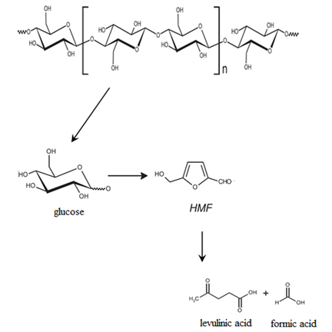
(a)

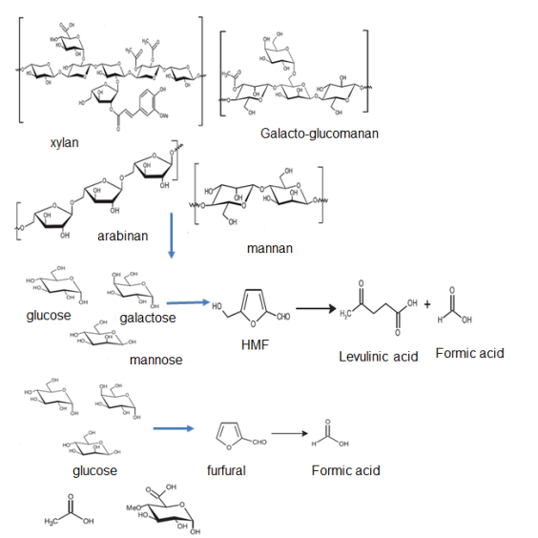
(b)

Figure 1. (a) Cellulose and (b) hemicellulose pathways for bioconversion [9]

It is very important to have the best method of analysis in determining the monosaccharide content in a substrate. This method must be not only efficient in hydrolyzing the cellulose and hemicelluose but also having the lowest risk of monosaccharide degradation. Pessoa and co-workers [4] stated that hydrolysed cellulose produced glucose, xylose, mannose, galactose and arabinose whilst hydrolysed hemicellulose produced 50-70 % xylose and 5-15 % arabinose. Thus, various methods of determining these precious components in fiber have been investigated. Frequent methods used are high performance liquid chromatography (HPLC), anion exchange chromatography (AEC), or column electrophoresis (CE)[5]. Acid hydrolysis has been the most frequently used method to determine monosaccharides in a substrate. However, this method is effective for polysaccharides with furanocyle ring containing glycosidic bond that is easily debonded [6]. However, there is also greater tendency for side reactions that reforms the glycosidic bond to produce high molecular weight disaccharides and oligosaccharides [7]. Thus, this study is looking at the feasibility of utilising methanolysis to carry out this task that involve the pathways as shown in Figure 1. It is then hydrolysed to monosaccharides and further reduced to volatile methyl glycoside derivatives. This is suitable for gas chromatography. Bertaud et al. [8] also showed its suitability to analyse hemicellulose and pectin.

Besides, acetylation was compared to methanolysis. Trifluoroacetic acid (TFA) is a powerful hydrolysing agent where it delignified lignin at the same time. During acetylation, the monosaccharides are reduced to alditol derivatives by means of sodium borohidrite upon hydrolysis with TFA[10]. The advantage of doing this is there is lower risk of having multiple peaks in GC analysis.

Materials and Methods
Materials
Empty fruit bunch fiber (EFB) was kindly supplied by Seri Ulu Langat Palm Oil Mills Sdn Bhd, Selangor, Malaysia. The chemical reagents used were industrial grade ethanol of 95% purity and sodium hydroxide aqueous solution (NaOH) with 10% (w/w) concentration supplied by System, Malaysia. Reagents for methanolysis involved mixture of pyridine/ hexamethyl disilazane/ chlorotrimethylsilane at a ratio of 5:1:1, mannitol in liquid form at a concentration of 10-100 nmol and acetic anhydride which were obtained from Sigma-Aldrich, USA while silver carbonate, hydrochloric acid and methanol were supplied by Fisher Chemical, UK. Chemicals used for acetylation were acetic anhydride/ pyridine at 1:1 ratio supplied by Sigma-Aldrich, USA and BHD, England respectively. Trifluoroacetic acid at a concentration of 4 M was obtained from HmbG Chemicals, Hamburg, Germany while methanol and methanolic acetic acid at a concentration of 1% (w/w) was supplied by Fisher Chemical, Leicestershire, UK.

Preparation of Samples
Dried EFB was immersed in boiling water at a ratio of 1:10 solid to liquid for 3 h [11,12]. After cooling, it was filtered using a Büchner funnel and the filter cake was oven-dried at 105ºC for 24 h following ASTM D2016-65 (Methods of test for moisture content of wood) standard. The procedure was repeated with 60 g dried EFB immersed in NaOH aqueous solution of 10% (w/w) concentration. After 48 h, the EFB was rinsed with distilled water several times followed by few drops of diluted acetic acid to neutralize the samples. It was filtered through the Büchner funnel and the filter cake was oven-dried at 105ºC for 24 h following ASTM D2016-65. The samples were then kept in a screw-capped jar for further analysis.

Methanolysis
The pretreated EFB (0.1- 2.0 mg) was placed in a sugar analysis tube and 10-100 nmol mannitol solution was added as the internal standard. The mixture was lyophilized to dryness and about 0.5 ml of 1.0 M methanolic hydrochloric acid was added to the residue. This tube was heated at 85°C for 24 h and then cooled to room temperature and later neutralized with solid silver carbonate till pH 7. Then 10-50 µl acetic anhydrides were added to remove the N-acetyl sugar. After mixing, the suspension was kept in the dark for another 24 h. It was then centrifuged for 2 min at 1000 rpm and the supernatant was placed in a clean evaporation tube. The precipitate was washed twice with 0.5 ml dry methanol followed by centrifugation. The pooled supernatants were concentrated to dryness using rotary evaporator at 35°C. The residue was dried for 12 h in a vacuum desiccator over P₂O₅. Prior to gas chromatography-flame ionization detection (GC-FID) analysis, the sample was trimethylsilylated with a mixture of pyridine/ hexamethyldisilazine/ chlorotrimethylsilane (5:1:1; 300 µL) for 30 min at room temperature [13].

Hydrolysis procedures/ Alditol acetates
The EFB (0.5 mg) was dissolved in 0.2 ml 4 M trifluoroacetic acid and was heated for 4 h at 100°C. The solution was evaporated with stream of nitrogen gas and the residue was washed twice with methanol followed by evaporation. The residue was dissolved in 0.2 ml water and was treated with 5 mg sodium borohydride, NaBH₄ for 2 h at room temperature. After decomposition of the excess NaBH₄ with a few drops of 20 % (w/w) acetic acid (to pH 4) the solution was evaporated in vacuo. Boric acid was removed as trimethylborate by co-evaporation with 0.2 ml 1 % (w/w) methanolic acetic acid (5 times). The mixture of alditols was acetylated with 0.2 ml acetic anhydride/ pyridine (1:1) for 1 h at 100°C. Finally, the solution was evaporated with a stream of nitrogen in the presence of toluene. Prior to gas chromatography-flame ionization detection (GC-FID) analysis, the residue was dissolved in 0.1 ml methylene chloride.

Characterizations
Fourier Transform Infrared Spectroscopy (FTIR)
A Perkin Elmer FT-IR spectrophotometer was used to verify the functional groups present in the PU chain. The scanning was carried out at wave numbers ranged from 4000 to 650 cm⁻¹ using DATR (Diamond Attenuation Total Reflectance) technique.

Gas Chromatography-Flame Ionization (GC-FID) Analysis
Molar adjustment factors (MAF) of monosaccharides were determined by application of methanolysis and acetylation separately on standard mixtures of free monosaccharides and internal standard (IS). The methanolysis and alditol acetate analysis (injection volume of 1 µl) were performed on a DB-1 (30 m × 0.25 mm) capillary column using flame-ionization detection (FID) with nitrogen as the carrier gas at a flow rate of 2 ml/min. The injection port was set at 230°C, detector temperature of 250°C, while the oven temperature program was at 140-240°C at 4°C/min.

Calculations
Mannitol was used as the IS and the adjustment factor (ISF) for each monosaccharide was calculated by using equation (1):
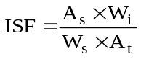 (1)
A_{s} and A_{t} are the area under the peak for IS and area under the peak for total monosaccharides respectively. W_{t} and W_{i} are the mass of IS and mass of monosaccharides in the IS respectively.

The composition of the monosaccharides obtained from methanolysis and acetylation are calculated using equation (2).
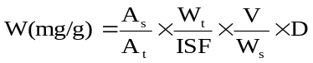 (2)
A_{s} and A_{t} are areas under the peak for IS and total monosaccharides respectively. W_{t} and W_{i} are the mass of IS and EFB respectively. V is the volume of injected sample and D is the dilution factor [14].

Results and Discussion
Fourier Transform Infrared Spectroscopy (FTIR)
The analysis data on FTIR spectrum (Figure 2) of untreated EFB, EFB pretreated with hot water and EFB pretreated with hot water followed by 10% (w/w) NaOH aqueous solution is summarized in Table 1. The peaks compared are C=C of the aromatic ring belongs to lignin at 1508 cm⁻¹ [15] and 1700 cm⁻¹ refers to carbonyl C=O bond from the uronic ester of the hemicellulose and possibly hemicellulose-lignin complex [16]. The disappearance of peak at 1700 cm⁻¹ in the FTIR spectrum of EFB pretreated with hot water and EFB fiber pretreated with hot water followed by 10% (w/w) NaOH indicated the success of delignification. In addition, peaks at 1058 cm⁻¹ and 1377 cm⁻¹ are referred to the syringyl propane and guaiacyl propane units of the lignin [17] and present only in the spectrum of untreated EFB and EFB pretreated with hot water. This is further verified by a peak at 834 cm⁻¹ suggested being the out of plane CH bending of the lignin [18].

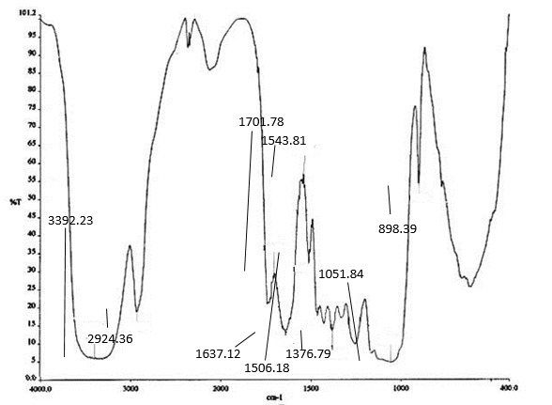
(a)

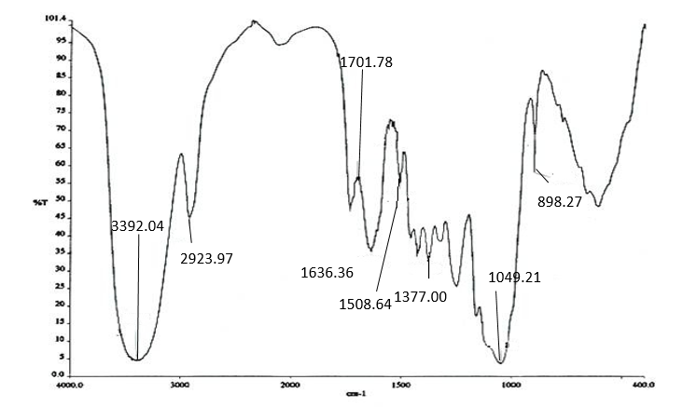
(b)

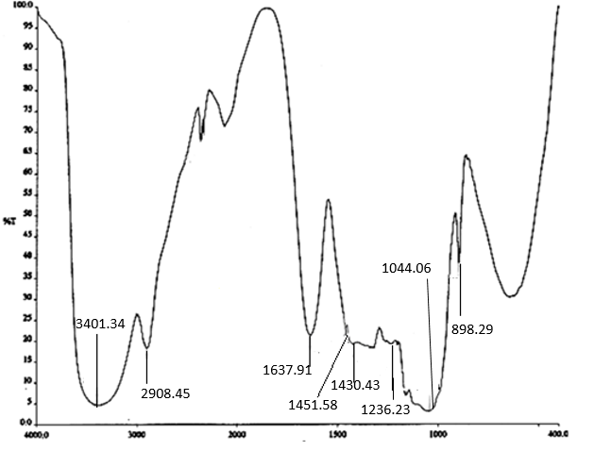
(c)

Figure 2. The FTIR spectrum of (a) untreated EFB, (b) EFB pretreated with hot water and (c) EFB pretreated with hot water followed by 10% (w/w) NaOH aqueous solution

Table 1. FTIR spectrum of untreated EFB, EFB pretreated with hot water and EFB pretreated with hot water followed by 10% (w/w) NaOH aqueous solution
Vibration and stretching peaks | Wavenumber, cm⁻¹
Vibration and stretching peaks | Untreated EFB | EFB pretreated with hot water | EFB pretreated with hot water followed by  10% (w/w) NaOH
OH  -CH  -C=O  -CO  C=C  Syringyl propane unit  Guaiacyl propane unit  β-glycocidic (C-O-C) | 3392  2924  1702  1052  1508  1377  1249  898 | 3392  2924  1702  1049  1508  1377  1250  898 | 3401  2900  -  1044  -  -  1237  898

Gas Chromatography-Flame Ionization (GC-FID) Analysis
The GC-FID analysis was conducted to determine the content of reduced sugar obtained from the hydrolysis through two approaches namely the methanolysis and acetylation. The results from both methods were compared to the GC chromatogram of the standard monosaccharides and the retention times were recorded [9].

The peak of retention for xylose was observed on the chromatogram of the EFB pretreated with hot water followed by 10% (w/w) NaOH aqueous solution as shown in Figure 3. This peak appeared at a very low count/ intensity in the chromatogram of the EFB pretreated with hot water. Alemdar and Sain [19] described this occurrence as the effect of NaOH aqueous solution that has delignified lignin from the surface of EFB, exposing a large area of cellulose to be hydrolyse by TFA. Hemicellulose consists of xylan and upon hydrolysis is converted to xylose [20]. Thus, the peak of this monosaccharide derivative was not detected in the untreated EFB. The identified monosaccharides detected by methanolysis onto the untreated EFB, EFB pretreated with hot water and EFB pretreated with hot water followed by 10% (w/w) NaOH aqueous solutions are summarized in Table 2.

Methanolysis seemed to be unable to detect monosaccharides from hemicellulose like galactose and arabinose. This could be due to low content of both the galactose and the arabinose and thus, undetected by GC-FID. The step of removing the silver salts by adding methanol followed by repeatable centrifugation might result in losing certain amount of soluble monosaccharides. This was also discovered by Dungait et al. [21]. Hemicellulose is amorphous and easily hydrolyzed in acidic medium compared to cellulose. Upon incomplete acid hydrolysis, cellulose becomes cellubiose, cellutriose, cellutetraose and other oligosaccharides. Hon and Shiraishi [2] found that the glycosidic bond in glucose is more stable than any other monosaccharides for this cause.

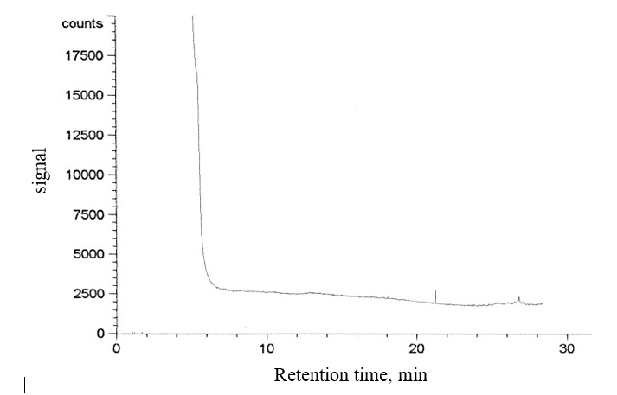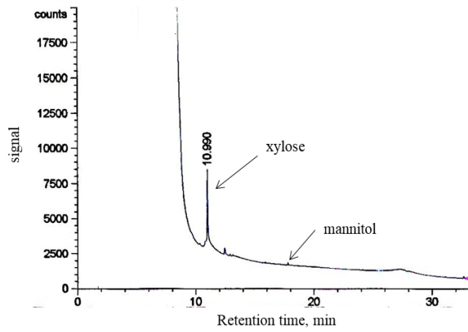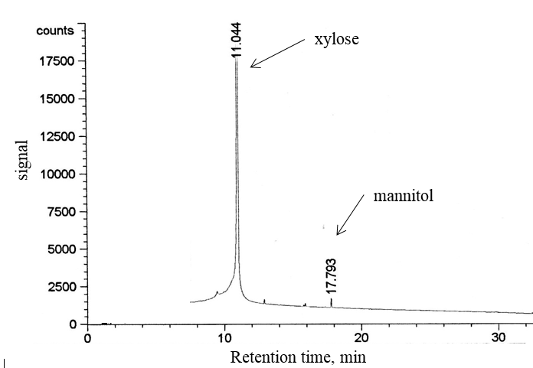
(a)
(b)
(c)

Figure 3. GC-FID chromatograms of monosaccharides obtained from methanolysis of (a) untreated EFB, (b) EFB pretreated with hot water and (c) EFB pretreated with hot water followed by 10% (w/w) NaOH aqueous solution

Table 2. Extracted data from GC-FID chromatograms of the monosaccharides obtained
from the methanolysis of untreated EFB, EFB pretreated with hot water and
EFB pretreated with hot water followed by 10% (w/w) NaOH aqueous solution
Samples | Type of monosaccharide detected | Yield of xylose (mg/g)
untreated EFB | - | -
EFB pretreated with hot water | xylose | 0.76
EFB pretreated with hot water followed by 10% (w/w) NaOH  aqueous solution | xylose | 178.40

Mannitol is treated as the internal standard solution in acetylation method of determination. The monosaccharides present are in the form of alditol acetate derivatives. Acetylation detected glucose in the EFB pretreated with hot water followed by 10% (w/w) NaOH aqueous solution. On the other hand, acetylation gave glucose, galactose and n manitol in EFB pretreated with hot water. These findings are tabulated in Table 3. The untreated EFB has only glucose and mannitol with lesser content than the EFB pretreated with hot water followed by 10% (w/w) NaOH aqueous solution and EFB pretreated with hot water. Steve [6] confirmed that incomplete reduction reaction or acetylation onto the functional groups of the monosaccharides could lessen the possibility to trace other monosaccharide derivatives.

The hot water treatment onto the EFB causes swelling of the cell wall of the fiber. Thus, during hydrolysis with NaOH, higher surface area of the fibrils and microfibrils on the fiber cell wall are exposed to NaOH [22,23]. EFB pretreated with hot water followed by 10% (w/w) NaOH aqueous solution is proven to be effective in weakening the fiber structure and delignification, and as a result increase the chemical reactivity to acid hydrolysis [9]. The reactivity of the EFB in acid hydrolysis is depending on the ring size of those specific monosaccharides where the hydrolysis rate for polysaccharides containing monosaccharide of furanose type is higher than pyranose [2]. It can be concluded that glucose type of monosaccharide is difficult to obtain from acid hydrolysis of cellulose. In addition, hydrolysis of monosaccharides using weak acid is stable but will cause fragmentation and other side reactions, converting glucose to by-products such as hydroxymehylfurfural, lavolic acid and formic acid [2][9]. As a result, acetylation occurs to detect lesser monosaccharides compared to methanolysis.

Table 3. Extracted data from GC-FID chromatograms of the monosaccharides obtained from the acetylation of untreated EFB, EFB pretreated with hot water and EFB pretreated with hot water followed by 10% (w/w) NaOH aqueous solution
Samples | Type of monosaccharide detected | Yield (mg/g)
Samples | Type of monosaccharide detected | glucose | galactose
untreated EFB | glucose | 19.15 | -
EFB pretreated with hot water | glucose , galactose | 6.32 | 2.83
EFB pretreated with hot water followed by 10% (w/w) NaOH aqueous solution | glucose | 29.85 | -

Conclusion
Three types of EFB samples, namely untreated EFB, EFB pretreated with hot water and EFB fiber pretreated with hot water followed by 10% (w/w) NaOH aqueous solution were studied. The disappearance and shifting of aromatic and carbonyl functional groups, syringyl propane unit, guaisacyl propane unit and C-H lignin indicated that delignification has occurred. This eased the extraction of reduced sugar by mean of acid hydrolysis of the cellulose. Acetylation was more efficient in determining the monosaccharide contents qualitatively and quantitatively compared to methanolysis. The hydrolysis with TFA in acetylation detected glucose and galactose, confirming that this method is suitable to scissor the hemicellulose chain and hydrolyze cellulose with arranged structure. The determination of monosaccharide contents was higher in acetylation compared to methanolysis.

References
- Abdullah, N. and Sulaiman, F. Chapter 3: The oil palm wastes in Malaysia. Matovic, M.D. 2013. Eds. Biomass Now -Sustainable Growth and Use, ISBN 978-953-51-1105-4978-953-51-0726-2, New York: InTech Publication
- Hon, D. N. and Shiraishi, N. (1991). Wood and Cellulosic Chemistry. New York, United State of America: Marcel Dekker, INC.
- Wyman, C. E., Decker, S. R., Himmel, M. E., Brady, J. W., Skopec, C. E. and Viikari, L. (2005). Hydrolysis of Cellulose and Hemicellulose. Polysaccharides: Structural Diversity and Functional Versatility, 43(1):1023-1062.
- Pessoa Jr, A., Mancilha, I. and Sato, S. (1997). Acid Hydrolysis of Hemicellulose from Sugarcane Bagasse. Brazilian Journal of Chemical Engineering, 14(3): 291-297.
- Sjöström, E. and Alen, R. (1999). Analytical Methods in Wood Chemistry, Pulping and Papermaking. Germany: Springer.
- Steve, C. (2005). Structural Analysis of Polysaccharides. United States of America: CRC Press Taylor & Francis Group.
- Belitz, H. D., Grosch, W. and Schieberle, P. (2004). Food Chemistry. 3. German: Springer Verlag Berlin Heidelberg.
- Bertaud, F., Sundberg, A. and Holmbom, B. (2002). Evaluation of Acid Methanolysis for Analysis of Wood Hemicelluloses and Pectins. Carbohydrate Polymers, 48(3): 319-324.
- Kamerling, J. P. & Gerwig, G. J. (2007). 2.01 - Strategies for the Structural Analysis of Carbohydrates. Dlm. Editor-in-Chief: johannis, P. K. (pnyt.). Comprehensive Glycoscience, pp 1-68. Oxford: Elsevier.
- Anthony B. Blakaney, Philip J. Harris and Stone, R. J. H. a. B. A. (1982). A Simple and Rapid Preparation of Alditol Acetates for Monosaccharide Analysis. Carbohydrate Research, 113(3):291-299.
- Hasegawa, I., Kazuhide Okuma, Osamu Mae, Kazuhiro. (2004). New Pretreatment Methods Combining a Hot Water Treatment and Water/Acetone Extraction for Thermo-Chemical Conversion of Biomass. Energy & Fuels, 18(3): 755-760.
- Sun, Y. C., and Jiayang. (2002). Hydrolysis of Lignocellulosic Materials for Ethanol Production: A Review. Bioresource Technology, 83(1): 1-11.
- Chambers R.E and J.R., C. (1971). An Assessment of Methanolysis and Other Factors Used in the Analysis of Carbohydrate-Containing Materials. Biochemical Journal, 125(4): 1009-1018.
- Davison, P. and Young, R. (1964). Gas Chromatography of Carbohydrates the Quantitative Determination of the Free Sugars of Plants as Their Trimethylsilyl Ethers. Journal of Chromatography A, 41(4): 12-21.
- Sun, X. F., Xu, F., Sun, R. C., Fowler, P. and Baird, M. S. (2005). Characteristics of Degraded Cellulose Obtained from Steam-Exploded Wheat Straw. Carbohydrate Research, 340(1): 97-106.
- Mingjia, Z., Wei, Q., Rui, L., Rongxin, S., Shaomin, W. and Zhimin, H. (2010). Fractionating Lignocellulose by Formic Acid: Characterization of Major Components. Biomass and Bioenergy, 34(4): 525-532.
- Evtuguin, D. V., Neto, C. P., Silva, A. M., Domingues, P. M., Amado, F. M., Robert, D. and Faix, O. (2001). Comprehensive Study on the Chemical Structure of Dioxane Lignin from Plantation Eucalyptus Globulus Wood. Journal of Agricultural and Food Chemistry, 49(9): 4252-4261.
- Jahan, M. S. and Mun, S. P. (2007). Characteristics of Dioxane Lignins Isolated at Different Ages of Nalita Wood (Trema Orientalis). Journal of Wood Chemistry and Technology, 27(2): 83-98.
- Alemdar, A. and Sain, M. (2008). Isolation and Characterization of Nanofibers from Agricultural Residues–Wheat Straw and Soy Hulls. Bioresource technology, 99(6): 1664-1671.
- Rahman, S., Choudhury, J. and Ahmad, A. (2006). Production of Xylose from Oil Palm Empty Fruit Bunch Fiber Using Sulfuric Acid. Biochemical Engineering Journal, 30(1): 97-103
- Dungait, J. a. J., Docherty, G., Straker, V. and Evershed, R. P. (2008). Interspecific Variation in Bulk Tissue, Fatty Acid and Monosaccharide Δ13c Values of Leaves from a Mesotrophic Grassland Plant Community. Phytochemistry, 69(10): 2041-2051.
- Fatin Afifah binti Ahmad Kuthi. (2012). Penentuan Gula Terturun Daripada Tandan Kosong Kelapa Sawit Melalui Prarawatan Air Panas Oleh Hidrolisis Berasid. Tesis Ijazah Sarjanamuda Sains Dengan Kepujian, Fakulti Sains Dan Teknologi, Universiti Kebangsaan Malaysia.
- Hamzah, F., Idris, A. and Shuan, T. K. (2011). Preliminary Study on Enzymatic Hydrolysis of Treated Oil Palm (Elaeis) Empty Fruit Bunches Fibre (Efb) by Using Combination of Cellulase and Β 1-4 Glucosidase. Biomass and Bioenergy, 35(3): 1055-1059.

