

1-BUTYL-3-METHYLIMIDAZOLIUM CHLORIDE PRETREATMENT ON MALAYSIA LIGNOCELLULOSIC WASTES

(Prarawatan 1-Butil-3-metilimidazolium Klorida pada Sisa Lignoselulosa di Malaysia)

Loh Poh Lee, Nur Hasyareeda Hassan*, Muhammad Rahimi Yusop

School of Chemical Sciences and Food Technology,
Faculty of Science and Technology,
Universiti Kebangsaan Malaysia, 43000 Bangi, Selangor, Malaysia

*Corresponding author: syareeda@ukm.edu.my

Abstract
Ionic liquids (ILs) are of great interest as potential solvents for the production of fuels from lignocellulosic biomass which is a potential source of biofuels. To study the effects of pretreatment, 1-butyl-3-methylimidazolium chloride ([Bmim]Cl) was used to pretreat woody plants, kempas (Koompassia malaccensis) and jelutong (Dyera costulata), and non-woody plants, kenaf (Hibiscus cannabinus) and rice husk (Oryza sativa) at 120$℃$ for 24 h. Cellulose was regenerated by the addition of water. The cell wall composition and structure of the lignocellulosic biomasses before and after the ILs pretreatment were observed and characterized using field emission scanning electron microscopy (FESEM), attenuated total reflectance fourier transform infrared (ATR FT-IR) spectroscopy, and X-ray diffraction (XRD). After the pretreatment, enzymatic hydrolysis was carried out to identify the total reducing sugars (TRS) yields using dinitrosalicyclic acid (DNS) method. Regenerated lignocellulosic biomasses resulted in high TRS yields compared to their counter-parts which are in agreement with the findings of FESEM, ATR FT-IR and XRD that exhibited regenerated cellulose were less crystalline and more amorphous upon IL pretreatment. Therefore, kempas and jelutong can be alternate sources for the biofuels production.

Keywords: [Bmim]Cl, Dyera costulata, enzymatic hydrolysis, Hibiscus cannabinus, Koompassia malaccensis, Oryza sativa

Abstrak
Cecair Ionik (CI) digunakan sebagai pelarut untuk penghasilan biobahan api daripada biojisim lignoselulosa yang merupakan sumber biobahan api berpotensi. Untuk mengkaji kesan-kesan prarawatan, 1-butil-3-metilimidazolium klorida ([Bmim]Cl) telah digunakan untuk merawat pelbagai tumbuhan berkayu, kempas (Koompassia malaccensis) dan jelutong (Dyera costulata), dan tumbuhan tidak berkayu, kenaf (Hibiscus cannabinus) dan sekam padi (Oryza sativa) pada 120$℃$ selama 24 h. Selulosa diperoleh semula dengan penambahan air. Komposisi dinding sel dan struktur biojisim lignoselulosik sebelum dan selepas prarawatan CI diperhatikan dan dianalisis dengan menggunakan mikroskop elektron imbasan medan pancaran (FESEM), spektroskopi inframerah transformasi Fourier pantulan keseluruhan dikecilkan (ATR FT-IR), dan belauan sinar-X (XRD). Selepas prarawatan, hidrolisis enzim telah dijalankan untuk mengenal pasti hasil gula penurun dengan menggunakan kaedah DNS. Biojisim lignoselulosa yang dirawat dengan CI menunjukkan hasil gula penurun lebih tinggi berbanding dengan biojisim lignoselulosa tidak dirawat. Ini juga disokong oleh analisis FESEM, ATR FT-IR dan XRD yang menunjukkan selulosa diperoleh semula adalah kurang berhablur dan lebih amorfus selepas prarawatan dengan CI. Oleh itu, kempas dan jelutong boleh dijadikan sumber sampingan dalam penghasilan biobahan api.

Kata Kunci: [Bmim]Cl, Dyera costulata, hidrolisis berenzim, Hibiscus cannabinus, Koompassia malaccensis, Oryza sativa

Introduction
Fuels such as coal, natural gas, and oil are the main sources of energy for our daily activities. However, burning of these fuels releases greenhouse gases into the atmosphere, which leads to environmental hazards [1]. To resolve these problems, alternative or renewable energy sources needed to replace petroleum as our primary fuel source. New bio-based industries with low production costs as well as environment-friendly green processes are needed to replace petroleum-based industries that we have relied on for the past 50 years [2].

In Malaysia, wood-based products can be produced in a large quantity and average annual production of logs from forest plantation was reported approximately 16 million tons in 2011 according to statistical handbook Malaysia 2012 [3]. Therefore, lignocellulosic biomass residues (kempas, jelutong, jati and etc) are considered as important feedstocks for biofuel applications. Many studies on lignocellulosic biomass for replacing conventional fuel sources have been carried out recently however studies regarding ILs pretreatment on kempas and jelutong have not been reported elsewhere. Pretreatment, which disrupts the structure of the lignocellulosic biomass, is necessary to enhance the enzymatic hydrolysis and increase the yields of the reducing sugars. Different pretreatment methods, including physical, chemical, and a combination of physical/chemical processes commonly used in the pretreatment of lignocellulosic biomass, have been introduced in previous studies. Some of these methods, which require high pressure and temperature, produce corrosive and dangerous wastes, and may cause sugar degradation pretreated at high temperatures [4-5]. Because of these shortcomings, alternative pretreatments are needed, of which, one using ionic liquids (ILs), a class of green solvents, has been reported in this study.

As novel green solvents, ILs have many attractive properties, including negligible vapor pressure, non-flammability, thermal stability, and recyclability, and have been used in organic synthesis, electrochemistry, catalysis, and extraction among others [6-7]. Based on previous studies on its ability to dissolve cellulose, 1-butyl-3-methylimidazolium chloride, [Bmim]Cl, was selected for the pretreatment in the present study [8-10].

Materials and Methods
Reagents and biomass materials
1-butyl-3-methylimidazolium chloride ([Bmim]Cl), Cellulast (cellulase from T. ressei), and Novozyme 188 β-glucosidase (cellobiase from A. niger) were purchased from Sigma-Aldrich and used as received. The ground lignocellulosic biomasses used in this study were kempas (Koompassia malaccensis), jelutong (Dyera costulata), kenaf (Hibiscus cannabinus), and rice husk (Oryza sativa), provided by the Forest Research Institute of Malaysia (FRIM). The lignocellulosic biomass was dried overnight in an oven at 105$℃$ and kept in a dessicator prior to use.

IL pretreatment of lignocellulosic biomass
First, 5.4 g of IL 1-butyl-3-methylimidazolium chloride ([Bmim]Cl) was added to a glass test tube containing 0.5 g of lignocellulosic biomass inside the glove box in the presence of N₂. The biomass/IL suspension was stirred at 500 rpm at 120$℃$ for 6 and 12 h in a temperature controlled heating block on a hotplate-stirrer (Heidolph, MR-Hei Standard) under a nitrogen atmosphere. After the pretreatment, the mixture was cooled to room temperature and mixed with 10 mL of distilled water. After 2 h, the contents of the culture tube were transferred into Eppendorf tubes and centrifuged for 10 min at 10,000 rpm (Scanspeed Mini) to obtain the regenerated biomass. The supernatant was removed and discarded while the suspension was filtered through a cellulose filter paper (Whatman 541 or equivalent) and further washed with 2 × 10 mL of distilled water to remove any remaining ILs. Then, the sample was dried in an oven at 105$℃$ overnight. The dried regenerated biomass was then transferred into re-sealable air-tight sample bags [11].

Structural characterization
Field emission scanning electron microscopy (FESEM) analysis
FESEM was used to monitor the changes in the morphology before and after IL pretreatment. A SUPRA 55VP (CARL ZEISS., Oberkochen, Germany) scanning electron microscope was used to image the samples. Prior to imaging, the samples were sputter-coated with platinum to make the fibers conductive, while avoiding degradation and buildup of charge on the specimen.

Attenuated total reflectance fourier transform infrared (ATR FT-IR) analysis
ATR FT-IR spectroscopy was performed using Perkin Elmer Spectrum 400. About 5 mg of the sample material was placed on the diamond window. The background spectrum of the diamond window without the sample was subtracted from that of each sample spectrum. Scans were conducted in the 650–4000 cm⁻¹ band.

X-ray diffraction (XRD) analysis
X-ray diffraction (XRD) was performed using a D8-Advance (BRUKER, Germany) XRD system. Patterns were collected from 10$°$ to 60$°$ (2$θ$) with step size of 0.025$°$ at 8 deg/min.
Enzymatic hydrolysis
Enzymatic hydrolysis was performed according to LAP “Enzymatic saccharification of lignocellulosic biomass” (NREL/TP-510-42629). First, 150 mg of the dried and pretreated/untreated biomass, 5 mL of 0.1M (pH 4.8) sodium citrate buffer solution, and 100 µL of 2% sodium azide solution were added to a 20 mL scintillation vial. The mixture was heated to 50 $℃$ for specified times in a temperature controlled heating block on a hotplate-stirrer (Heidolph, MR-Hei Standard); 60 µL of Cellulast (cellulase from T. ressei) (Sigma-Aldrich) and Novozyme 188 β-glucosidase (cellobiase from A. niger) (Sigma-Aldrich) each was added and the mixture was stirred at 250 rpm. Distilled water was added to bring the total volume to 10 mL after the addition of the enzymes.

Samples taken at different time intervals were analysed for total reducing sugar (TRS) using DNS method [12]. The DNS solution was prepared according to an IUPAC method [13] (1416 mL distilled water, 10.6 g 3,5-dinitrosalicylic acid, 19.8 g sodium hydroxide, 306 g Rochelle salts/Na-K tartarate, 7.6 mL phenol melted at 50$℃$, and 8.3 g sodium metabisulfite). The absorbance of the solution was read against the reagent blank at 540 nm as measured by a Shimadzu UV-Visible-1650 PC spectrophotometer (UV-VIS). The reducing sugar concentration in the sample was calculated based on a standard curve obtained with D-glucose.

Results and Discussion
Effect of different ILs pretreatment on ground kempas
Field emission scanning electron microscopy (FESEM) analysis
To obtain insights into the effects of [Bmim]Cl pretreatment, studies on the chemical and structural characteristics of regenerated biomass are essential. The structural morphology of the untreated and pretreated lignocellulosic biomass was examined by FESEM (Figure 1 and 2, respectively). It was observed that the physical structure of the untreated lignocellulosic biomass was compact and ordered.

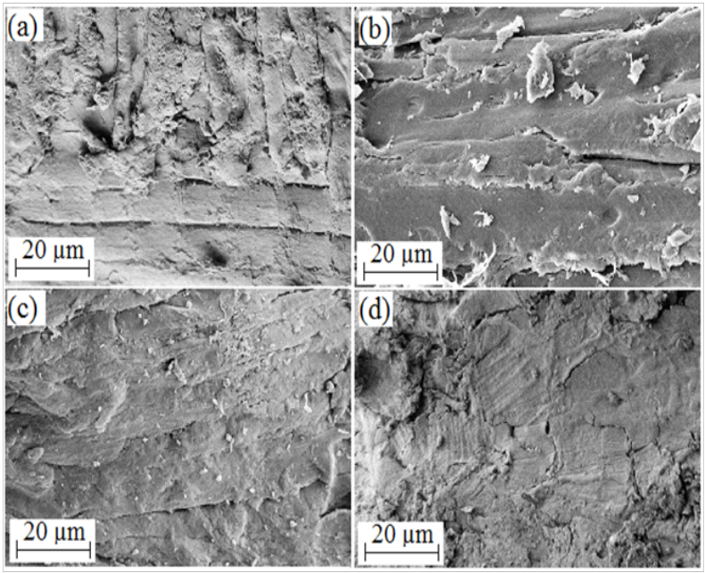

Figure 1. FESEM images of untreated lignocellulosic biomasses (a) kempas, (b) jelutong, (c) kenaf, (d) rice husk
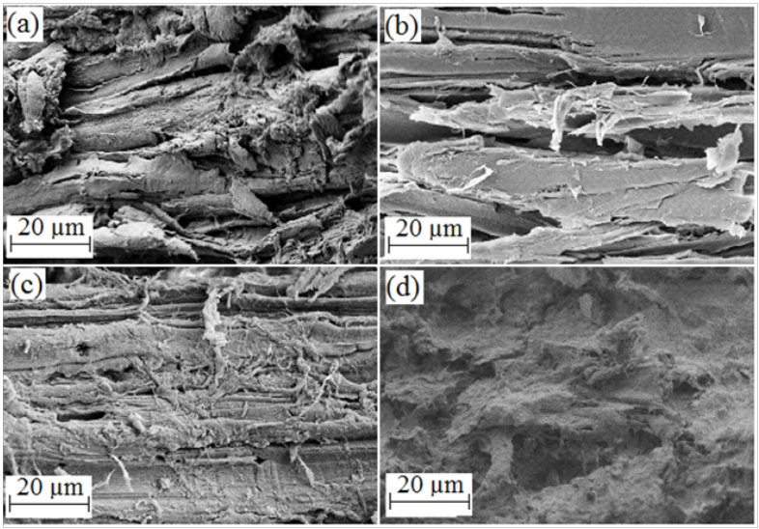

Figure 2. FESEM images of pretreated lignocellulosic biomasses (a) kempas, (b) jelutong, (c) kenaf, (d) rice husk

After pretreatment, it was observed that the surfaces of all the pretreated lignocelluloses changed significantly and became rougher and disordered. The organized structure commonly present in native lignocellulosic biomass was absent, implying that the structure of the regenerated biomass was less crystalline, which was in agreement with previous studies [14-16]. [Bmim]Cl-pretreated rice husk was the most severely distrupted followed by kempas, jelutong and kenaf. This also indirectly shows that the [Bmim]Cl pretreatment can reduce the crystallinity of cellulose compared to the untreated lignocelluloses so that it becomes more accessible to enzymes.

Attenuated total reflectance Fourier transform infrared (ATR FT-IR) analysis
The regenerated biomass from [Bmim]Cl pretreatment altered the chemical and structural characteristics compared to the native biomass. ATR FT-IR spectroscopy was used to determine the structural changes in the lignocellulosic biomass upon pretreatment (Figures 3(a-d)) in the region 800$-$4000 cm⁻¹, which is commonly used to study the fine structural characteristics of cellulose [17].

Native biomass consists of the lignin-carbohydrate matrix since both cellulose/hemicellulose- and lignin-associated bands can be observed in the spectrum of untreated biomass. From the spectra of all the regenerated biomasses, the strongest absorption band was found to be at approximately 1048 cm⁻¹, which corresponds to the C-O stretching vibration in both cellulose/hemicellulose and lignin [18]. The peak at 1732 cm⁻¹ is associated with the C=O stretch in unconjugated ketones, carbonyls and esters groups [19]. The peak at 1457 cm⁻¹ which is corresponding to asymmetric bending of CH₃ and methoxy (-OCH₃) groups present in lignin [18], was present in all spectra, this implying that lignin remained in the matrix. Moreover, a strong absorption band at around 3338 cm⁻¹ (-OH stretching) was observed in the all spectra, which could be due to moisture absorption. According to Ang et al. (2012) [8], the band at around 800 cm⁻¹ is sensitive to the amount of amorphous cellulose present in the regenerated material, and broadening of this band indicates the higher amorphousity of the regenerated cellulose.

The spectra of the regenerated biomasses of kempas, jelutong, and kenaf from [Bmim]Cl pretreatment were almost the same as that of the corresponding untreated/native biomass. This shows that [Bmim]Cl dissolved both cellulose and lignin in the biomass, as was already reported [9-10]. For rice husk, the spectrum of the regenerated biomass was different from that of the untreated/native biomass, where some absorption bands were absent. However, in all the spectra of the regenerated biomasses, the band at around 800 cm⁻¹ was of higher intensity, implying a higher amount of the disordered cellulosic structure. The disordered cellulosic structure is possibly caused by the deformation of the glycosidic linkages and hydrogen$-$bond rearrangement, as reported by Proniewicz et al. (2001) [20]. In the spectrum of the pretreated rice husk, the absorption band at around 1457 cm⁻¹ was absent, which indicates the removal of lignin in the regenerated biomass of rice husk [8]. Moreover, a strong absorption band at around 3338 cm⁻¹ was observed in the spectra of all the pretreated biomasses, which could be due to moisture absorption.

Overall, among the regenerated cellulose, [Bmim]Cl-treated rice husk showed clear changes in the ATR FT-IR spectral pattern, indicating that the [Bmim]Cl pretreatment was more effective in the distruption of hydrogen bonds of cellulose of rice husk [21]. However, due to heterogeneous nature of plant cell wall, direct assessment of chemical changes at the molecular level cannot be accomplished by using ATR FT-IR spectroscopy alone.

(5)
(1)
(2)
(3)
(4)
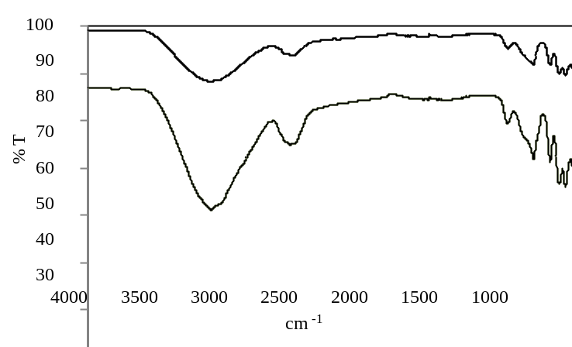
(a)
(1)
(4)
(5)
(2)
(3)
Kempas
Pretreated
Untreated
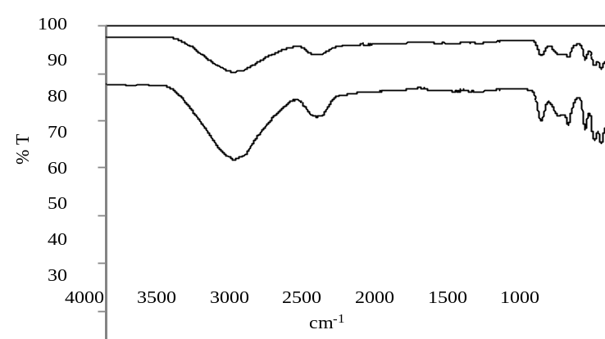
(b)
Pretreated
Untreated
Jelutong
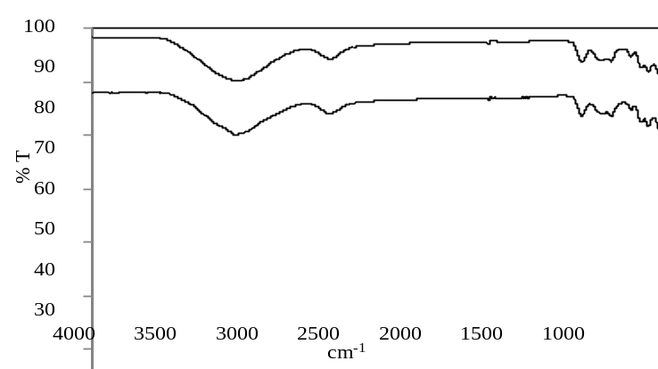
(c)
Kenaf
Pretreated
Untreated
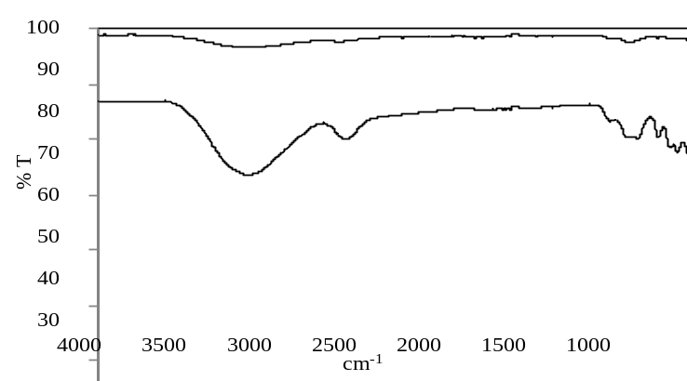
(d)
Rice husk
Pretreated
Untreated
Figure 3. ATR FT-IR spectral analyses of untreated and pretreated lignocellulosic biomasses. FT-IR spectral bands (cm⁻¹): (1)= 3338; (2)= 1732; (3)= 1457; (4)= 1048; (5) 895

X-ray powder diffraction (XRD) analysis
XRD analysis was conducted to further investigate the crystallinity of lignocellulose. Cellulose exists as a semicrystalline polymer in the native state [22]. In the crystalline regions, the cellulose chains form two distinct allomorphs of cellulose I: I_{α} with a triclinic unit cell and I_{β} with a monoclinic unit cell, whose fractional distributions vary among samples of different origin [23]. Cellulose II is most often obtained from cellulose I via either of the two processes: regeneration and mercerization [22].

Figures 4(a-d) show the diffraction patterns of untreated and pretreated kempas, jelutong, kenaf and rice husk. The main peak position is at ~22$°$ and indicates the presence of cellulose I [24]. At this peak, untreated jelutong showed higher and sharper diffraction than the untreated kempas, kenaf and rice husk, implying that the untreated jelutong is qualitatively more crystalline than the other three biomasses.

After the IL pretreatment, the main peak was observed to be broadened and of lower intensity for all the pretreated biomasses except kenaf. The broadening of the peak indicates a decrease in crystallinity upon IL pretreatment [15]. Meanwhile, the intensity of the main peak of the pretreated kenaf seemed to be higher compared to the untreated kenaf. This might be due to the agglomeration of the sample after pretreatment, which affected the analysis; however, the decrease in the crystallinity of the pretreated kenaf is supported by FESEM, ATR FT-IR analysis and enzymatic hydrolysis.

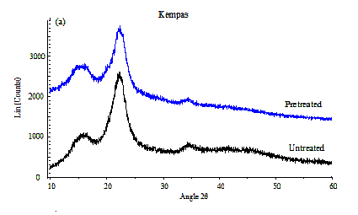
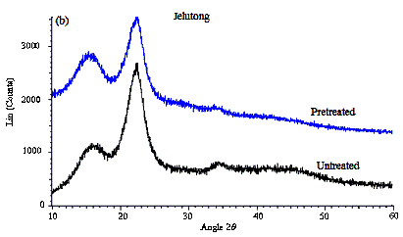

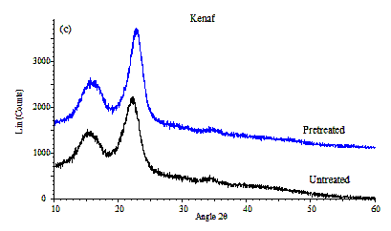

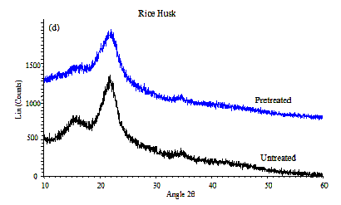

Figure 4. XRD analyses of untreated and pretreated biomasses

Effect of pretreatment on enzymatic hydrolysis
Enzymatic hydrolysis of the regenerated lignocelluloses was carried out to investigate the digestibility of the regenerated biomass from [Bmim]Cl pretreatment. The enzymatic hydrolysis yield for the untreated and pretreated lignocellulosic biomass samples are shown in Figures 5(a-d). Overall, it was observed that the pretreated biomasses exhibited higher total reducing sugars (TRS) yields compared to their counter-parts. At the 48th hour of hydrolysis, among the lignocellulosic biomasses studies, [Bmim]Cl-treated kenaf showed the highest TRS yield (15.4 mg/mL) followed by rice husk (14.3 mg/mL), kempas (11.4 mg/mL) and lastly jelutong (10.6 mg/mL). However, rice husk showed significant difference between TRS yields of untreated and [Bmim]Cl-treated rice husk among the lignocellulosic biomasses, which was in agreement with the findings of FESEM, ATR-IR and XRD.

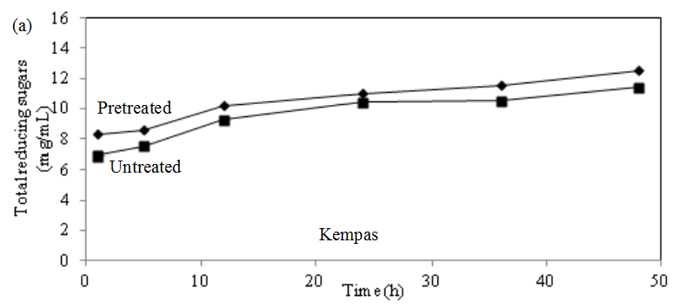

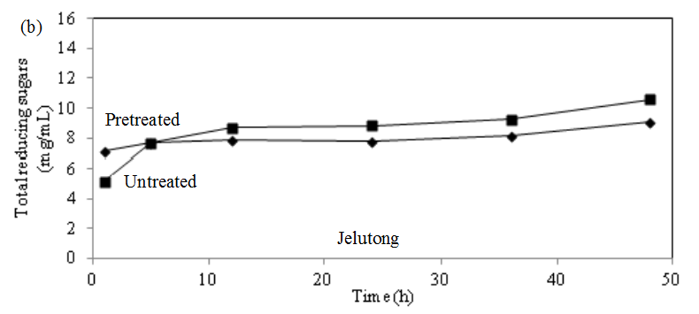

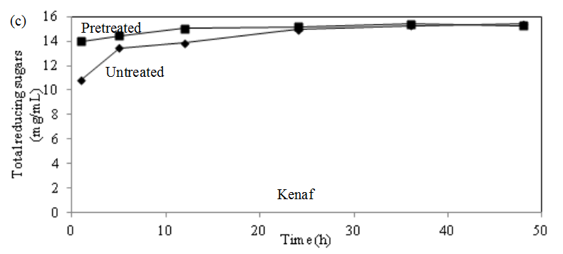
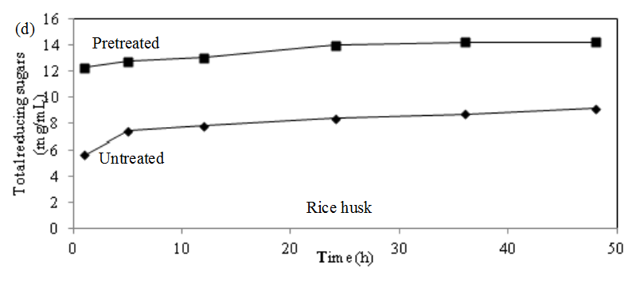
Figure 5. Effect of IL on the enzymatic hydrolysis of untreated and pretreated lignocellulosic biomasses

The [Bmim]Cl-treated kenaf and rice husk showed higher TRS yields than the pretreated kempas and jelutong, because [Bmim]Cl pretreatment promotes a decrease in the degree of polymerization of cellulose, in which the short cellulose chains are easily recrystallized to the thermodynamically favored cellulose II upon regeneration [24].

A study carried out by Ng et al. (2013) [25] showed that the pretreatment of kenaf with 17.5% NaOH solution for 4 h at room temperature followed by hydrolysis for 48 h resulted in a yield of 4.4 mg/mL of the reducing sugars. Ooi et al. (2011) [26] reported that the pretreatment of kenaf with HCl for 15 min at 90 $℃$ and with 25% NaOH solution for 45 min at room temperature resulted in glucose yields of 1.19 mg/mL and 3.21 mg/mL, respectively, after 24 h of hydrolysis. In this study, IL pretreatment was conducted at 120 $℃$ for 24 h, which resulted in yields of 14.9 and 15.4 mg/mL after hydrolysis for 24 and 48 h, respectively, which in terms of yield, is higher than that reported in the previous studies. It cannot be denied that acid or alkaline pretreatment require shorter pretreatment time compared to IL pretreatment. However, acid or alkaline wastes will lead to environmental problems. Therefore, the more environment-friendly IL pretreatment method is a beneficial alternative for conversion of biomass into value-added products.

This study demonstrated that kempas and jelutong which are the main wastes of wood-based production in Malaysia have great potential in biofuel production by using environment-friendly IL preatment method and is a beneficial alternative for conversion of biomass into value added-products.

Conclusion
[Bmim]Cl-treated lignocellulosic biomasses exhibited significantly higher TRS yields compared to their untreated counter-parts. The results were supported by the findings of FESEM, ATR FT-IR and XRD. This study also showed that kempas and jelutong have great potential be used in biofuel production.

Acknowledgement
We acknowledge Universiti Kebangsaan Malaysia for the financial support via the research grants AP/2012/017 and ERGS/1/2013/TK07/UKM/02/4 and the supporting staff of School of Chemical Sciences & Food Technology that has contributed greatly in our research. We are also grateful to Forest Research Institute Malaysia (FRIM) for providing the samples.

References
- Yat, S. C., Berger, A. and Shonnard, D. R. (2008). Kinetic characterization for dilute sulfuric acid hydrolysis of timber varieties and switchgrass. Bioresource Technology. 99:3855-3863.
- Christensen, C. H., Rass-Hansen, J., Marsden, C. C., Taarning, E. and Eqeblad, K. (2008). The renewable chemicals industry. ChemSusChem. 1:283-289.
- Department of Statistics, Malaysia (2012) Statistical Handbook Malaysia. http://www.statistics.gov.my/ portal/download_Handbook/files/BKKP/Buku_Makumat_Perangkaan_2012.pdf. Accessed 15 February 2014
- Chandra, R. P., Bura, R., Mabee, W. E., Berlin, A., Pan, X. and Saddler, J. N. (2007). Substrate pretreatment: the key to effective enzymatic hydrolysis of lignocellulosics. Advances in Biochemical Engineering/Biotechnology. 5: 904–910.
- Sun, Y. and Cheng, J. (2002). Hydrolysis of lignocellulosic materials for ethanol production: a review. Bioresource Technology. 83(1): 1–11.
- Qian, W., Jin, E., Bao, W. and Zhang, Y. G. (2005). Clean and highly selective oxidation of alcohols in an ionic liquid by using an ion-supported hypervalent iodine (III) reagent. Angewandte Chemie International Edition. 44(6): 952-955.
- Dupont, J., Souza, R. F. D. and Suarez, P. A. Z. (2002). Ionic liquid (molten salt) phase organometallic catalysis. Chemical Reviews.102(10): 3667-3692.
- Ang, T. N., Ngoh, G. C., Chua, A. S. M. and Lee, M. G. (2012). Elucidation of the effect of ionic liquid pretreatment on rice husk via structural analyses. Biotechnology for Biofuels. 5: 67-77.
- Lee, S. H., Doherty, T. V., Linhardt, R. J. and Dordick, J. S. (2009).Ionic liquid-mediated selective extraction of lignin from wood leading to enhanced enzymatic cellulose hydrolysis. Biotechnology and Bioengineering. 102(5): 1368-1376.
- Pu, Y. Q., Jiang, N. and Ragauskas, A. J. (2007). Ionic liquid as a green solvent for lignin. Journal of Wood Chemistry and Technology. 27(1): 23-33.
- Brandt, A., Ray, M. J., To, T. Q., Leak, D. J., Murphyb, R. J. and Welton, T. (2011). Ionic liquid pretreatment of lignocellulosic biomass with ionic liquid water mixtures. Green Chemistry. 13(9): 2489-2499.
- Miller, G. L. (1959). Use of dinitrosalicylic acid reagent for determination of reducing sugar. Analytical Chemistry. 31(3): 426–428.
- Ghose, T. K. (1987). Measurement of cellulase activities. Pure and Applied Chemistry. 59(2): 257–268.
- Aita, Z. Q. G. M. and Walker, M. S. (2012). Effect of ionic liquid pretreatment on the chemical composition, structure and enzymatic hydrolysis of energy cane bagasse. Bioresource Technology. 117:251-256.
- Çetinkol, O. P., Dibble, D. C., Cheng, G., Kent, M. S., Knierim, B., Auer, M., Wemmer, D. E., Pelton, J. G., Melnichenko, Y. B., Ralph, J., Simmons, B. A. and Holmes, B. M. (2010). Understanding the impact of ionic liquid pretreatment on eucalyptus. Biofuels. 1(1): 33-46.
- Nikzad, M., Movagharnejad, K., Najafpour, G. D. and Talebnia, F. (2012). Comparative studies on the effect of pretreatment of rice husk on enzymatic digestibility and bioethanol production. International Journal of Engineering. 26:455-464.
- Hurtubise, F. G. and Krassig, H. (1960). Classification of fine structural characteristics in cellulose by infrared spectroscopy. Analytical Chemistry. 32(2): 177-181.
- Labbe, N., Rials, T. G., Kelley, S. S., Cheng, Z. M., Kim, J. Y. and Li, Y. (2005). FT-IR imaging and pyrolysis-molecular beam mass spectrometry: New tools to investigate wood tissues. Wood Science and Technology. 39(1): 61-77.
- Muller, G., Bartholme, M., Kharazipour, A. and Polle, A. (2008). FTIR-ATR spectroscopic analysis of changes in fiber properties during insulating fiberboard manufacture of beech wood. Wood Fiber Science. 40(4): 532-543.
- Proniewicz, L. M., Paluszkiewicz, C., Weselucha-Birczynska, A., Majcherczyk, H., Baranski, A. and Konieczna, A. (2001). FT-IR and FT-Raman study of hydrothermally degradated cellulose. Journal of Molecular Structure. 596(1-3): 163-169.
- Zhang, H., Wu, J., Zhang, J. and He, J. (2005). 1-Allyl-3-methylimidazolium chloride room temperature ionic liquid: a new and powerful nonderivatizing solvent for cellulose. Macromolecules. 38(20): 8272–8277.
- O’sullivan, A. C. (1997). Cellulose: the structure slowly unravels. Cellulose. 4:173–207.
- Sugiyama, J., Vuong, R. and Chanzy, H. (1991). An electron diffraction study on the two crystalline phases occurring in native cellulose from algal cell wall. Macromolecules. 24:4168-4175.
- Cheng, G., Varanasi, P., Li, C., Liu, H., Melnichenko, Y. B., Simmons, B. A., Kent, M. S. and Singh, S. (2011). Transition of cellulose crystalline structure and surface morphology of biomass as a function of ionic liquid pretreatment and its relation to enzymatic hydrolysis. American Chemical Society. 12(4): 933-941.
- Ng, S. H., Paridah Md. Tahir., Rosfarizan Mohamad., Luqman C. Abdullah., Choo, A. C. Y. and Liong, Y. Y. (2013). Effect of pretreatment process on bioconversion of kenaf (Hibiscus cannabinus L.) core to glucose. BioResources. 8:2010-2017.
- Ooi, B. G., Rambo, A. L. and Hurtado, M. A. (2011). Overcoming the recalcitrance for the conversion of kenaf pulp to glucose via microwave-assisted pre-treatment processes. International Journal of Molecular Sciences. 12:1451-1463.

