

SYNTHESIS AND PHYSICOCHEMICAL STUDIES OF SUBERATES AS BIOLUBRICANT BASETOCK

(Sintesis dan Kajian Fiziko-Kimia bagi Suberat sebagai Minyak Asas Biopelincir)

Maratun Najiha Abu Tahari, Salma Samidin, Mohd Ambar Yarmo, Nadia Salih, Jumat Salimon*

School of Chemical Sciences &Food Technology,
Faculty of Science and Technology,
Universiti Kebangsaan Malaysia, 43600 Bangi, Selangor, Malaysia

*Corresponding author: jumat@ukm.edu.my

Abstract
Synthesis of biolubricant through chemically modified suberic acid (SA) with 3 different types of alcohols which are 1-octanol (Oc), 1-decanol (De) and 1-dodecanol (Do) was conducted with presence of 4% p-toluenesulfonic acid (PTSA) as a catalyst. Preparation, characterization and physico-chemical properties of three types diester (suberate) is discussed in this paper. The diester products were confirmed by NMR and FTIR spectroscopic analysis. Addition of alcohols at the side chains of diacid increases the molecular weight and chain length resulted in the increment of viscosity index (VI), oxidative stability (OT) and flash point (FP) of the diesters. The result showed that 1,8-dioctanyl suberate (DOS) exhibited the most favorable low temperature performance (PP -8.5°C) while 1,8-didodecanyl suberate (DDoS) exhibited higher OT (190°C) and higher FP (224°C) than the other diester oils. On the other hand, the highest VI around 197°C was obtained for 1,8-didecanyl suberate (DDS). These diester oils have a good potential in formulation of industrial biolubricants.

Keywords: biolubricant, diester suberic acid, chemically modified

Abstrak
Sintesis biopelincir melalui modifikasi kimia terhadap asid suberik (SA) dengan 3 jenis alkohol iaitu 1-oktanol (Oc), 1-dekanol (De) dan 1-dodekanol (Do) dilakukan dengan kehadiran 4% asid p-toluenasulfonik (PTSA) sebagai katalis. Penyediaan, pencirian dan sifat fisiko-kimia bagi tiga jenis diester (suberat) dibincangkan dalam manuskrip ini. Produk diester yang terhasil ditentusahkan melalui analisis spektroskopi NMR dan FTIR. Penambahan alkohol pada rantai sisi diasid meningkatkan berat molekul dan panjang rantai mengakibatkan peningkatan indeks kelikatan, kestabilan oksidatif dan takat kilat diester. Hasil kajian menunjukkan bahawa 1,8-dioktanil suberat (DOS) mempamerkan prestasi bekerja pada suhu rendah yang baik (PP -8.5°C) dan 1,8-didodekanil suberat (DDoS) memperlihatkan OT yang lebih tinggi (190°C) dan FP yang lebih tinggi (224°C) berbanding minyak diester yang lain. Selain itu, 1,8-didekanil suberat (DDS) memiliki VI yang tertinggi iaitu 197°C. Semua minyak diester ini memiliki potensi yang baik dalam formulasi biopelincir industri.

Kata kunci: biopelincir, diester suberik asid, modifikasi kimia

Introduction
Biolubricant is a fluid used for reducing friction and surface wear of two moving metal surfaces. Million tones of petroleum as lubricant base stocks have been used in industries such as automotive, ships, machines and motors. 40% of that amount has been release to environment which is can increase the atmosphere contamination that already exist [1]. Contamination occurs because of high toxicity and low biodegradability of petroleum based lubricant (conventional lubricant). Due to strict environmental regulation and a concern for diminution of world fossil fuel reserves, there is a rising demand for environmentally friendly lubricants [2-5].

Today, around 2% of these base stocks are plant oil origin [5]. Plant oils known as biolubricants have a capability towards the goal of security and reduction of petroleum energy dependence and able to contribute positive impacts to the environment. Furthermore, biolubricant is biodegradable and renewable [6]. Plant oils offer a number of advantages, including high biodegradability (>95%), reduced environmental pollution [7-11], companionable with additives and lower price production [12].

However, plant oils cannot apply as biolubricant directly. They should undergo chemical modification to improve their properties as potential biolubricant. The presence of carbon double bonds (C=C) and hydroxyl groups (-OH) will contribute negative impacts to the oxidative stability, pour point and flash point of biolubricant. Previous study by Jumat et al. 2010a has focuses on chemical modification of oleic acid to be used as synthetic biolubricant basestocks [13]. Oleic acid undergoes 2 steps of reaction which are epoxidization and esterification to produce monoester, diester and triester biolubricants. This modification is important in order to remove C=C and –OH of oleic acid, resulting polar ester groups. Lubricity properties of esters enable them to meet the vagaries of lubrication challenges posed by modern machines technically and with respect to environmental protection. Ester based biolubricant is chosen because ester groups exhibit strong dipole moments and polar sites. These improve their lubricity by adhering strongly to the moving metal surfaces and form a very thin layer of oil in which to reduce friction and surface wear.

Gryglewicz et al. reported the use of dibasic acid such as didecyl carbonate, didecyl adipate and didecyl sebacate as additives to fully synthetic engine oils [14]. Addition of 10% of the respective esters to oils based on polyalphaoleﬁns led to an improvement of their properties. The results stated that the pour point of diester decrease with mid chain length. Decrease in mid chain length benefits to pour point but detriments to viscosity index. Besides biolubricant, there are several applications of diester adipate including as a plasticizers in plastic which is mainly used to soften PVC, used in polyurethans and cellulose esters (photo film) and as a softener in cosmetics. Adipates have advantageously low melting point, which makes it possible to use the oil at low temperatures without solidifying. According to Gunstone [15], esters from polyacids such as succinic, adipic, azelic, sebasic, mellitic, suberic and dimeric acid bonded with short or long chain alcohols which can be considered as branched chains (C₈-C₁₃). These types of esters consist of saturated fatty acids which able to undergo crystallization easily. However, crystallization is difficult to occur in the presence of branched polyester chains.

In this paper, we present a chemical modification of suberic acid derivatives to improve characterization of vegetable oils as biolubricant. Suberic acid (SA) was chosen because it is diacid molecule (consists of two carboxylic acid groups) and the used as biolubricant base stock is still limited. In order to improve the lubricity properties, pure suberic acid was esterified with three types of alcohols which are 1-octanol (Oc), 1-decanol (De) and 1-dodecanol (Do) in purpose to remove the two hydroxyl groups in the suberic acids. The presence of hydroxyl groups in the molecules encourages formation of hydrogen bonds which is contributes to the increment of pour point. After esterification, diester of suberic formed in which two similar alcohol molecules bonded at both side of suberic acid. There are three products formed with different length of the side chains. Here, we will discuss how the side chains length will influence the properties of biolubricant. Preparation, characterization and physico-chemical properties of these products are discussed within this contribution.

Materials and Methods
Materials
Suberic acid (99%) was obtained from Merck and alcohols (1-octanol, 1-decanol, 1-dodecanol 99%) from Sigma-Aldrich Chemical Company. All other chemicals and reagents were obtained from commercial sources. Solvent were dried and purified with known conventional methods.

Synthesis of suberates
About 12.20g of SA was measured in the three-neck round bottom flask. 27.30 mL of Oc added slowly into the flask that contained SA followed by 1.40 g of PTSA. The amount of PTSA is actually 4% from total amount of both diacid and alcohol. Molecular sieves were added into the mixture to absorb all water molecules that formed during the reaction. The round bottom flask is then fully immersed in oil bath containing silicon oil. Magnetic stirrer was added into the mixture, thermometer 0°C – 250°C was inserted into the flask through one of the neck until contacted with the reaction mixture, reflux condenser was connected to the central neck of flask and another neck was closed with stopper. The reaction proceeded at 120°C-130°C with stirring for 6-9 hours.

After 6-9 hours, the round bottom flask removed from the silicon oil and cooled down until room temperature. The cooled mixture was filtered before poured into separating funnel. Then, flask was washed with diethyl ether and this solvent transferred into separating funnel. 2 mL diethyl ether added into the mixture and two layers formed. The top is diester layer and bottom is aqueous layer. After removal of the aqueous layer, crude diester was washed with 1.5mL of 5% M sodium bicarbonate (NaHCO₃) to neutralize the PTSA catalyst. Carbon dioxide produced and increased the pressure in the funnel. CO₂ removed by slowly rotating the stopcock. This step repeated until no CO₂ gas released. 0.5mL ethanol was added to extract the excess Oc. The mixture washed with water to dissolve all polar compounds. After that, 1.5mL sodium chloride (NaCl) solution added to get rid of any emulsion that formed due to the addition of water. NaCl solution added several times until the emulsion completely removed and two layers is clearly seen. Bottom layer was discarded and top layer was collected in a beaker. Enough amount of sodium sulphate (NaSO₄) powder was added as drying agent in order to dry the oil from any moisture. NaSO₄ powder is then removed and clear oil was rotavap to remove solvent remained. Pure 1,8-dioctanyl suberate (DOS) collected in a bottle sample. This reaction and washing methods was repeated by using different alcohols which are De and Do to produce 1,8-didecanyl suberate (DDS) and 1,8-didodecanyl suberate (DDoS).

Characterization
Fourier Transform Infrared Spectrometer (FTIR) was used to determine functional groups of diesters without further preparation by using infrared light. Diesters in contacted with NaCl plate and was examined on Perkin Elmer Precisely FTIR Spectrometer and scanned from 4000 to 650 cm⁻¹.

The ¹H and ¹³C Nuclear Magnetic Resonance spectra were recorded using JOEL JNM-ECP 400 MHz spectrometer operating at frequency of 400.13 and 100.77 MHz respectively to determine the chemical structure of diesters. About 600 µL deuterated chloroform (CDCl₃) was used as solvent for all types of diesters. Diluted samples in the NMR tubes were placed in between the magnet poles probe and radiate with energy [16].

Low Temperature Operatebility
The pour point is defined as the lowest temperature at which the sample still pours from the tilted u-tube in 5 minutes [17]. ASTM D5949 method using a phase Technology Analyzer, Model PSA-70 S (Hammersmith Gate, Richmond, B.C., Canada) is commonly used to determine the flow properties of fluids is according to [18]. Each sample was run in triplicate and average values rounded to the nearest whole degrees were reported.

Flash Point Values
The flash point is defined as the mimimum temperature at which the liquid produces enough vapor above it surface that able to form ignitable mixture with air [19]. Flash point determination was run according to the American National Standard Method using a Tag Closed Tester (ASTM D5679) [20]. Each sample was run in triplicate and average values rounded to nearest whole degree were reported.
Viscosity Index Measurements
Viscosity index is widely used to measure variation in kinematic viscosity due to changes in temperature by using Rheometer. Kinematic viscosity of diester was measured at 40°C and 100°C. The viscosity and viscosity index were measured using ASTM D2270-93 [21]. Each sample was run in triplicate and average value was calculated.
Oxidative Stability
Oxidative stability of each sample was determined using differential scanning calorimeter (DSC 2910). High oxidative stability is able to prevent any oxidation of free radical or polymerization [22]. About 1.1-1.3 mg of diesters were measured on aluminium pan and oxygen gas (O₂) was purged during heating process with heating rate 10°C/min from 50°C to 240°C. The onset of oxidation temperature (OT, °C) was calculated directly from the plot of heat flow (W/g) versus temperature for each experiment.

Results and Discussion
Synthesis of Suberates
The formation of suberates (diesters) improves the oxidative stability of biolubricant. It has already been established that the presence of multiple C=C in the plant oils accelerates oxidative degradation. The absence of C=C in SA structure could solve the oxidative problem. However, the straight and medium chain of SA will limit its application at low temperature especially as automotive and industrial fluids. A suitable approach to improve the low temperature flow property of SA is to attach the two terminal chains (that consists of –OH groups) with saturated alcohols. This was successfully achieved by esterification to yield DOS, DDS and DDoS.

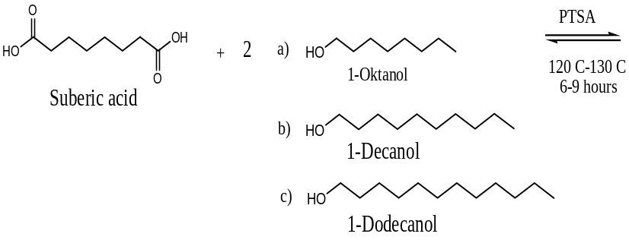
Suberic acid (SA)
1-octanol (Oc)
1-dodecanol (Do)
1-decanol (De)

PTSA
120-130°C
6-9 hours
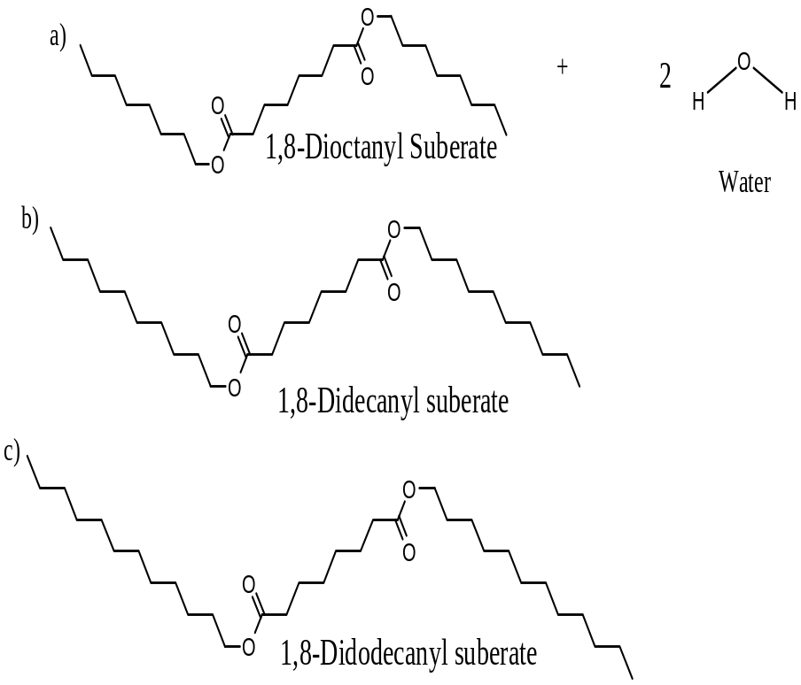
a
b
c

1,8-dioctanyl suberate (DOS)
1,8-didecanyl suberate (DDS)
1,8-didodecanyl suberate
(DDoS)

Figure 1. Esterification of suberic acid

SA was esterified with alcohol with the presence of p-toluenesulfonic acid catalyst (PTSA) to produce diester of suberic acid as shown in Fig. 1. Esterification is a reversible proces that produce diester and water. To maximize the production of diester, this reaction must always direct to right (to the products site). According to Le Chatelier principle, addition of excess reactants to equibrium system, reaction will be direct to the production of diester and water [23]. In this reaction, ratio of diacid to alcohol is 1:2.5. The amount of alcohol is higher than the diacid is purposely to fulfill the Le Chatelier principle and make sure all the diacid molecules reacting with the alcohol and forming diester molecules. PTSA catalyst added about 4% of the total amount of the diacid and alcohol. This catalyst was selected due to mild reaction and producing brighter biolubricant compared to sulfuric acid (H₂SO₄).

Characterization of Suberates
Characterization of products had been done using two instruments which are FTIR and NMR. All three products produced a similar pattern in FTIR and NMR spectrum. However, the number of hydrogen (H) in ¹H NMR and carbon (C) signals in ¹³C NMR were different depending on the chain length of the diesters. Diesters with longer chain length have higher amount of H and C signals in their spectrum. Due to their similarities, we are focusing on the FTIR and NMR spectrum for DDoS in order to discuss the presence of it functional groups and chemical structure as evidence to confirm the production of diesters.

FTIR Characterization
Referring to Fig. 2 and Table 1, the C=O stretching band of (SA) was present at 1695 cm⁻¹. A sharp and clear peak at 1734 cm⁻¹ indicates a C=O stretching band of ester for DDoS. The appearance of this signal prove that the formation of diester. On the DDoS spectrum, the C-O stretching band of SA at 950 cm⁻¹ was disappeared and C-O stretching band of carbonyl ester groups at 1178 cm⁻¹ was appeared after esterification. Other than that, the increasing intensity of long chain –CH₂ on DDoS spectrum was clearly verify the increasing number of –CH₂ which is attributed to the Do molecules that chemically bonded with SA. The disappearance of -OH stretching of Do on the DDoS spectrum gives evidence that the oil was freed from the excess alcohol and moisture.

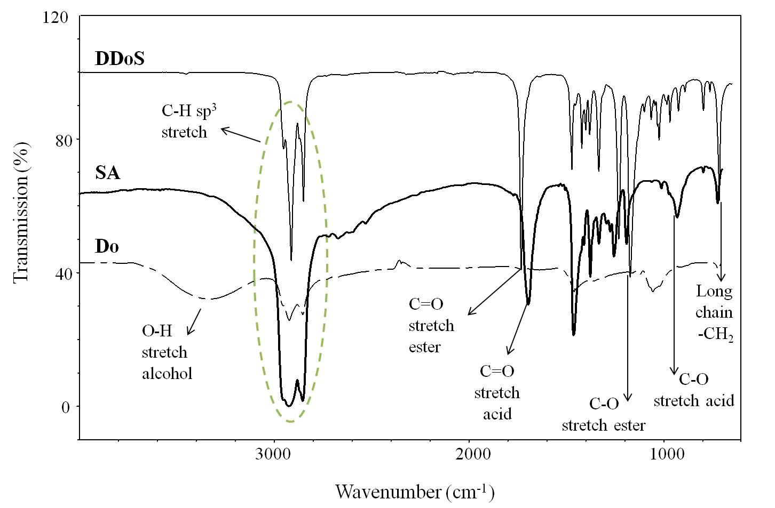

Figure 2. Comparison of FTIR spectra for 1,8-didodecanyl suberate (DDoS), suberic acid (SA) and 1-dodecanol (Do)

Table 1. Summary of FTIR spectrafor DDoS, SA and Do.
Functional Groups | *Reference Wavenumber (cm⁻¹) | Wavenumber of DDoS  (cm⁻¹) |  | Wavenumber of SA (cm⁻¹) |  | Wavenumber of Do (cm⁻¹)
sp³ –CH, stretch  -CH₃, bend  -CH_{2,} bend  -CH_{2,} long chain  C=O, stretch  -OH, stretch  C-O-H, bend  C-O, stretch | 3000-2850  1450-1375  1465  720  1730-1700 ª  1750-1735 ^{b}  3300-2500 ª  3600-3200 ^{c}  1395-1440 ^{c}  1320-1210 ª  1260-1000 ^{b} | 2921 - 2851  1337  1471  716  -  1734  -  -  -  -  1190 | 2924 - 2854  1377  1463  723  1695  -  3220  -  -  950  - |  | 2922 – 2853  1380  1460  721  -  -  -  3350  1050  -  -
ª: acid, ^{b}: ester, ^{c}: alcohol, *: Pavia et al. [16]

NMR Characterization
Table 2 is the summary of the ¹H NMR chemical shifts δ (ppm) for DDoS. Chemical shift at 2.21-2.25 ppm on Fig. 3 is represents methylene proton (-CH₂) bonded to carbonyl (C=O). Signal for methylene proton on carbon directly bonded with oxygen (O-CH₂) was shifted to downfield due to electronegativity effects. Furthermore, signals for methyl (-CH₃) and methylene (-CH₂) of long chain was clearly appeared at 0.80-0.83 ppm and 1.20-1.56 ppm. All present signals proved the formation of diesters.

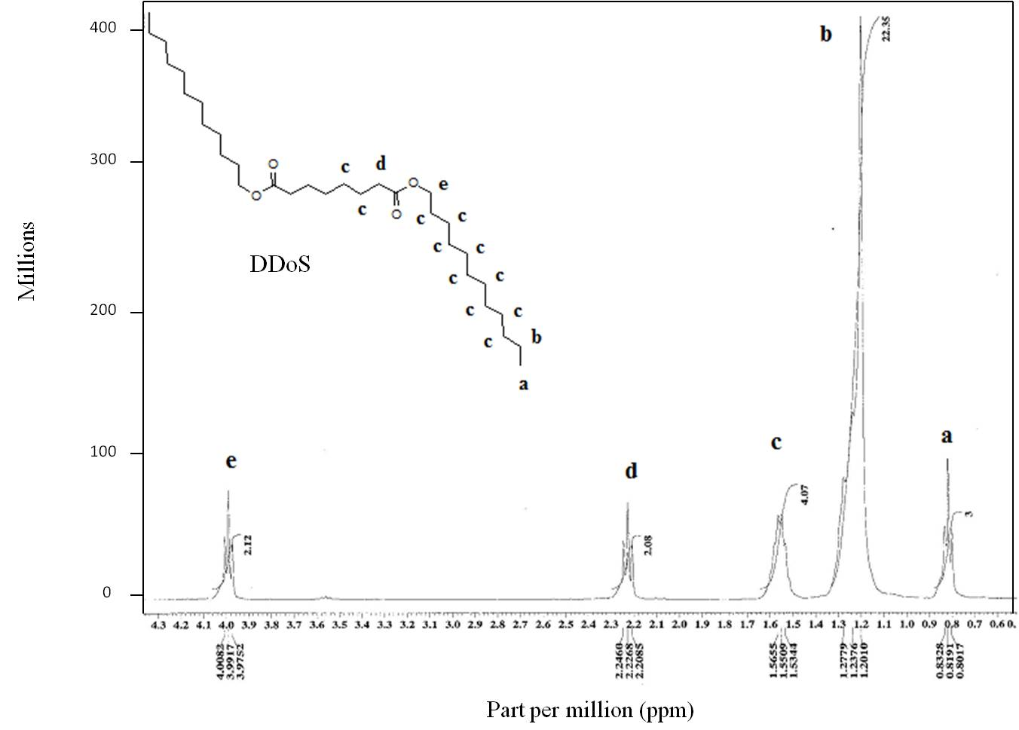

b
c

a
d
c
b
b
b
b
b
b
b
b
b
e
b
b
DDoS

Figure 3. ¹H NMR spectrum for 1,8-didodecanyl suberate (DDoS)
Table 2. Summary of the ¹H NMR chemical shifts δ (ppm) for DDoS
Shift δ (ppm), DDoS | Shift δ (ppm), reference* | Type of Proton (H)
(a) 0.80 - 0.83  (b) 1.20 - 1.28  (c) 1.53 - 1.57  (d) 2.20 - 2.25  (e) 3.98 - 4.01 | 0.7 – 1.3  1.2 – 1.4  1.4 – 1.6  2.1 – 2.5  3.5 - 4.8 | -CH₃  -(CH₂)₉-CH₃  -CH₂-CH₂-COOR  -O-CH₂-CH₂-R  -CH₂-(C=O)-O-R –  (C=O)-O-CH₂-R
*: Pavia et al. [16]

Referring to Fig. 4 and Table 3, formation of ester groups reconfirmed by the significant signals of ¹³C NMR at 173.70 ppm and 64.43 ppm in which attributes to carbonyl ester (CH₂-C=O) and methylene carbon (CH₂-CO-O-CH₂) directly bonded to oxygen. Figure 3 shows carbonyl ester signal was shifted to lowest field (173.70 ppm) due to the effects of electronegative element. Significant signal at 3.97-4.00 ppm in ¹H NMR corresponds to methylene protons on carbon bonded to carbonyl (O=C-O-CH₂). The presence of these two signals clearly showed the esterification was successful and the excess of Do and moisture completely removed. Similar signals appeared on DDS and DOS spectra.

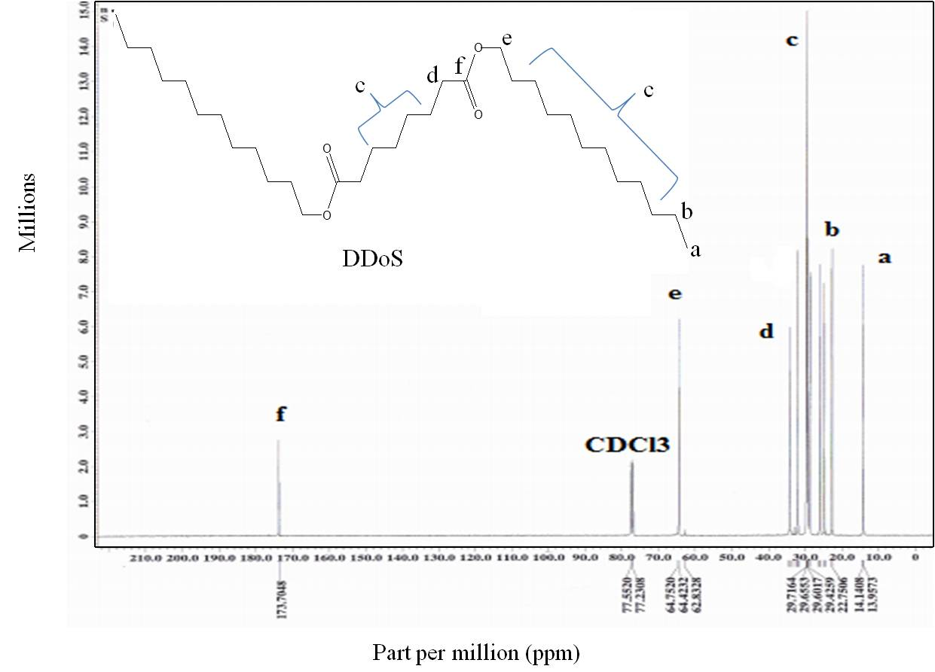
Figure 4. ¹³C NMR spectrum of 1,8-didodecanyil suberate (DDoS).

Table 3. Summary of the ¹³C NMR chemical shifts δ (ppm) for DDoS
Type of Carbon (C) | Shift (ppm)  from Referrnce* | Shift (ppm)  DDoS
(a) R-CH₃  (b) R-CH₂-CH₃  (c) R-(CH₂)₅-CH₂-CH₃  (d) R-CH₂-C=O  (e) CH₂-O=C-O-CH₂  (f) CH₂-C=OOR  CDCl₃ | 14.10  22.80  25.10 - 31.90  33.90  65.30  173.10  - | 14.15  22.76  24.86 – 32.00  34.27  64.43  173.71  76.91 - 77.55
*: Pavia et al. [16]

Physico-chemical Properties of Suberates
Physico-chemical properties of the prepared diesters as biolubricant were summarized in Table 4.

Table 4. Oxidative stability, viscosity index, pour point and flash point of diester suberic acid
and previous study.
Samples | Oxidative stability (OT), °C | Viscosity Index (VI) | Flash point (FP), °C | Pour point (PP), °C
DOS (8:8:8)  DDS (10:8:10)  DDoS (12:8:12)  EHHYOOD* | 183±2  187±2  190±1  131 | 159  197  -  80 | 190±2  209±3  224±2  156 | -8.5±1  7.7±2  24.6±1  -22
DOS: 1,8-dioctanyl suberate, DDS: 1,8-didecanyl suberate, DDoS: 1,8-didodecanyl suberate,
EHHYOOD: ethylhexyl-9-hydroxy-10-octadecanoate, *:Jumat et al. [22]

Low Temperature Operability
Cold flow properties of plant oils is very poor due to their tendency to form macro crystalline structures at low temperature through uniform stacking and higher temperature is needed in order to move the cold fluids. The cold flow trend of DOS, DDS and DDoS was increased with increasing side chains length of diester. DOS has shorter side chains than DDS and managed to flow at lower temperature, -8.5°C compared to DDS. This phenomenon happened due to bending behavior of diester molecules. Bending behavior of diester was contributed by C-O-C bonds. Referring to Figure 1, structure of hydrocarbon chains of diesters are not fully linear but slightly bending due to presence of two lone paired electrons on oxygen atom which always repelled each other and affects the C-O-C angle. Diester with longer side chains formed more or less linear structure compared to the shorter one. DDS with more linear structure led to rearrange their molecules became closer, denser, packer and capable to crystallize and form microcrystals at a temperature which is not too low. This was proved by the formation of semi-solid diester (DDoS) at room temperature. The bending structure behaviour prevents the DOS molecules to do rearrangement as easy as DDS and DDoS and managed to flow at lower temperature. Another reason is that if viscosity of diester is decreased, great ability of the less viscose diester to disrupt crystalline formation at reduced temperature.

Viscosity Index Measurements
The VI data of DOS, DDS and DDoS compounds on Table 4 was increased with chain length (number of carbons) and molecular weight. Viscosity of diester increases with molecular weight of alcohols or number of hydroxyls [24]. A good biolubricant should have high VI. The higher VI means the smaller viscosity changes with temperature [25]. Therefore, DDS had higher VI would expect to be a stable biolubricant and undergo very less viscosity changes with temperature extremes. Two prepared suberates (DOS and DDS) had much better VI compared to EHHYOOD even though EHHYOOD contained one hydroxyl group and higher number of carbons. However, VI for DDoS cannot be calculated because its kinematic viscosity value at 100°C is very small, less than 2.0.

Oxidative Stability
The ability of biolubricamt to resist oxidative degradation is another important property. Therefore, all synthesized diesters screened for oxidative stability using DSC through determination of OT. The OT is the temperature at which the substance undergo rapid rate of oxidation at a constant and high pressure [26]. The high OT indicates the high oxidative stability of the diesters. From the results, DDoS is the most stable diester as biolubricant followed by DDS and DOS. From the trend, it was clearly showed that OT value increases with increases molecular weight and chain length of suberates. DDoS molecules have longer chain of alcohols and higher molecular weight compared to DOS and DDS. The longer the carbon chain, the higher number of methylene (CH₂) groups presence. Methylene (R-CH₂-CH₃) has lower reactivity toward oxygen (RCH₂-H < R₂CH-H < R₃C-H), stronger and stable methylene bonds compared to 3° carbon. Therefore, higher energy is required to oxidize the methylene in the carbon chains. The higher OT was resulted in improvement of the oxidative stability of suberates.

Flash Point Values
Flash point (FP) is another important parameter in determining how good the oil will be as a potential biolubricant. FP values are function as apparatus design, apparatus carried out, temperature determination for storage and transportation. Other than that, FP used to test potential biolubricant contamination [22]. Referring to the FP data in Table 4, there is clearly stated that FP increases with chain length. Diesters with longer carbon chains and bigger molecular weight contribute to more energy consumption for phase changes. Therefore, higher energy is needed for each diester molecule that closed to each other to vibrates, moves freely and be far apart. Overall, suberates which are consist of saturated diacid and straight chain alcohol was considered as a good biolubricant because it FP value is in the range of 190-224°C. However, biolubricant with low FP is too dangerous due to oxidization and ability of settled oxides on the metal surfaces to interfere in engine operation.

Conclusion
In this study we have evaluated the potential of suberates as basestocks for biolubricant applications. Based on the results obtained, increasing the chain length of side chain suberates had a positive influence on OT and FP because individual diester molecules increase the number of stable and strong methylene bonds and inhibits oxidative degradation, resulting in higher oxidative stability. But the OT run counter to that PP, i.e., increasing side chain length benefit to OT, but detriment to PP. It is evidence that side chain length is the critical parameter influencing the cold flow properties and oxidation stability of these compounds. Furthemore, VI values increasing with chain length of alcohols at the side chains. From these results, DOS and DDS have the good biolubricant properties compared to DDoS which is in semi solid form. The semi solid DDoS is not suitable to be applied as biolubricant due to it limitation to cover up the empty space between two metal surfaces. Besides, a future study will aim to beat a balance between OT and PP which are opposing trends through investigation of a greater variety of branched side chain esters.

Acknowledgement
The author acknowledge the Universiti Kebangsaan Malaysia for the funding DPP-2014-058 and the direct contributions of the staff from the School of Chemical Science and Food Technology, the Faculty of Science and Technology, Universiti Kebangsaan Malaysia.

References
- Sharma, B.K., Adhvaryu, A., Liu, Z. and Erhan, S.Z. (2006). Chemical modification of vegetable oils for lubricant applications. Journal of American Oil Chemical Society 83(2): 129-136.
- Rhee, I.S. (1996). Evaluation of environmentally acceptable hydraulic fluids. NLGI Spokesman 60: 5.
- Rudnick, L.R. (2003). Lubricant Additives, Chemistry and Applications. New York: CRC Press Taylor & Francis Group.
- Hwang, H.S. and Erhan, S.Z. (2006). Synthetic lubricant basestock from epoxidized soybean oil and Guerbet alcohols. Industrial Crops and Products 23: 1257-1260.
- Adhvaryu, A. and Erhan. S.Z. (2002). Epoxidiezed soybean oil as a potential source of high temperature lubricants. An International Journal of Industrial of Crops and Products 15: 247-254
- Basiron, Y., Loh, S.K. and Choo, Y.M. (2000). Additive for petroleum fuels and lubricant, biofuels and biolubricant. Oil Palm Bulletin 40: 1-5
- Salunkhe, D.K., Chavan, J.K., Adsulke, R.N. and Kadam, S.S. (1992). Worl Oil Seeds: Chemistry Technology and Utilization. Van Nostrand Reinhold, New York, 1-8.
- Bokish, M. (1998). Fats and Oils Handbook. AOCS Prss, Champaign, IL. pp 838.
- Battersby, N.S. (2000). The biodegradability and microbial toxicity testing of lubricants-Some recommendations. Chemosphere 41(7): 1011-1027.
- Havet, L., Blouet, J., Valloire, F., Brasseur, E., Slomka, D. (2001). Tribology characteristics of some environmentally friendly lubricant. Wear 248: 140-146.
- Walsh, W. (2002). Determination of Triglyceride Composition of Vegetable Oils Using HPLC aand Light Scattering Detection. Annual Meeting and Food Expo, Session 30G, Anaheim, CA.
- Krzan, B. and Vizintin, J. (2003). Tribological properties of environmentally adopted universal tractor transmission oil based on vegetable oil. Tribology Industry 36: 827-833.
- Jumat, S., Nadia, S. and Emad, Y. (2012). Improvement of pour point and oxidative stability of synthetic ester basestocks for biolubricant applications. Arabian Journal of Chemistry 5: 193-200.
- Gryglewicz, S., Oko, F.A., Stankiewicz, M. and Surawska, I. (2006). Esters of dicarboxylic acids as additives for lubricating oils. Tribology International 39: 560–564.
- Gunstone, F.D. (2004). The Chemistry of Oils and Fats: Sources, Compositions, Properties and Uses. U.K: Blackwell Publishing Ltd.
- Pavia, D.L., Lampman, G.M., Kriz, G.S. and Vyvyan, J.R. (2010). Introduction of Spectroscopy. (fourth Ed.). Canada: Nelson Education, Ltd.
- Robiah, Y., Razi, A.F., Ooi, T.L., Iyukie, S.E. and Idris, A. (2003). Development of optimum synthesis method for transesterification of palm oil methyl ester and trimethylpropane to environmentally acceptable palm oil-based lubricant. Journal of Palm Research 15(2): 35-41
- ASTM Standard D5949, Standard test method for pour point of petroleum (automatic pressure pulsing method), ASTM, West Conshohocken, PA, USA.
- Jumat, S., Nadia, S. and Emad, Y. (2012). Synthetic biolubricant basestocks based on environmentally friendly raw materials. Journal of King Saud University – Science 24(3): 221-226.
- ASTM Standard D 56-79, Standard test method for flash point of liquids with a viscosity less than, 45 Saybolt Universal Seconds (SUS) at 37.8 °C (that don’t contain suspended solids and don’t tend to form a surface film under test), ASTM, West Conshohocken, PA, USA.
- ASTM Standard D 2270-93, Standard test method for calculating viscosity index from kinematic viscosity at 40 and 100 °C, ASTM, West Conshohocken, PA, USA.
- Jumat, S. and Nadia, S. and Emad, Y. (2012). Biolubricant basestocks from chemically modified ricinoleic acid. Journal of King Saud University – Science 24(1): 11-17.
- Williamson, K.L. (1994). Synthesis of Isobutyl Propionate via Esterification: Macroscale and Microscale Organic Experiments. (second Ed.). Houghton Mifflin, Boston.
- George, S.A., Swift, E.J., Thompson, J.Y. and Heymann, H.O. (2003). Irradiance effects on the mechanical properties of universal hybrid and flowable resin composites. Dental Materials 19(15): 406-413.
- Jumat, S., Nadia, S. and Emad, Y. (2010c). Biolubricants: Raw materials, chemical modifications and environmental benefits. European Journal Lipid Science Technology 112: 519-530.
- Erhan, S. Z., Sharma, B. K., Adhvaryu, A. and Liu, Z. (2006). Chemical modification of vegetable oils for lubricant applications. Journal of American Oil Chemist Society 83: 129-136.

