OPTIMIZATION OF ELECTROCHEMICAL PARAMETERS FOR LANDFILL LEACHATE TREATMENT USING CHARCOAL BASE METALLIC COMPOSITE ELECTRODE

(Pengoptimuman Parameter Elektrokimia untuk Rawatan Air Larut Lesap Menggunakan Elektrod komposit Logam Berasaskan Arang)

Majd Ahmed Jumaah and Mohamed Rozali Othman*

School of Chemical Sciences and Food Technology

Faculty of Sciences and Technology

Universiti Kebangsaan Malaysia, 43600 Bangi, MALAYSIA

*Corresponding author: rozali@ukm.edu.my

Abstract

Landfill leachate normally contains organic and inorganic pollutants in high concentrations. Electrochemical oxidation technique is an effective method to treat landfill leachate, have high efficiency in organic pollutants degradation and ammonia removal. In this study, a cost effective charcoal base metallic composite electrode to treat landfill leachate by electrochemical oxidation was fabricated. The effects of operational parameters such as supporting electrolyte, applied voltage and electrolysis time on the removal percentage of Color, COD, NH₃-N and total-P (PO₄⁻³) were carried out. The results obtained show that the removal percentage of Color, COD, NH₃-N and total- P (PO₄⁻³) are 70, 89, 73 and 80 % respectively. Under the optimum operating condition, sodium chloride concentration of 1.5 % (w/v), applied voltage of 10 V, operating time 180 min and C₆₀C^{G}₁₅Co₁₀-PVC₁₅ electrode as an anode were used.

Keyword: Landfill leachate, charcoal, electrode, electrochemical.

Abstrak

Air larut lesap dilaporkan mengandungi jumlah bahan pencemaran organik dan bukan organik dalan kuantiti yang tinggi. Kaedah pengoksidaan elektrokimia adalah merupakan satu kaedah yang berkesan dalam merawat air larut lesap kerana kecekapannya yang tinggi dalam pemecahan bahan pencemaran organik dan ammonia. Dalam kajian ini, elektrod logam komposit yang berasaskan arang yang tidak saja murah tetapi berkesan dalam merawat air larut lesap secara elektrokimia telah berjaya difabrikasikan. Kesan parameter pengoperasian seperti kepekatan elektrolit penyokong, keupayaan yang dikenakan dan masa elektrolisis dalam mengurangkan warna, COD, NH₃-N dan jumlah- P(PO₄⁻³⁾ telah dijalankan. Hasil kajian mendapati pada keadaan optimum, peratus penyingkiran warna, COD, NH₃-N dan jumlah-P(PO₄⁻³) masingnya-masingnya ialah 70, 89, 73 dan 80 % telah dicapai. Keadaan optimum yang diguna ialah kepekatan NaCl 1.5 % (w/v) sebagai elektrolit penyokong, keupayaan yang dikenakan 10 V, masa operasi 180 min dan elektrod C₆₀C^{G}₁₅Co₁₀-PVC₁₅ digunakan sebagai elektrod kerja (anod)

Kata kunci: Air larut lesap, arang, elektrod, elektrokimia

Introduction

Landfill leachate is a major source of pollution caused by the wastewater generated from solid waste buried underground [1]. It can readily pollute soil and penetrates into the underground layers of ground water resulting in severe underground water contamination which is one of the major water sources for human societies [2]. Leachate from landfills represents an extreme wastewater which requires intensive treatment before discharge [3]. Leachate can be categorized a liquid waste that contains high chemical oxygen demand (COD), high levels of ammonia and phosphorus as well as elevated values of total dissolved solid (TDS) [4]. In order to reach environmental friendly criteria for landfill leachate, these pollutants level should be minimized to an acceptable discharge limit. Hence, landfill leachate must be collected and treated. Many pre-treatment and combined treatment methods have been proven to treat leachate and being reported elsewhere. One of the methods used was two step methods for the removal of COD and color from sanitary landfill leachates [5]. The first method involved the use of coagulation/flocculation process using FeCl3 as conventional coagulant and Ca(OH) as base–precipitant. The second method involved the interaction and adding of Fenton's reagent into the coagulation/flocculation process. COD and color removal were by 37 and 62%, respectively in first method, while in the second method, COD and color removal were 88 and 98%, respectively [5]. Photo electrochemical process was also effective to reduce COD by 74.1% during 2.5 hours reaction time [6].

There are other several studies exhibited the COD, N-NH₃ and color removal using ozon-GAC adsorbent for treatment of leachate, where the modified treatment has been successfully used for highest removal of COD and N-NH3 at a level of 86% and 92% respectively [7]. Carbon rod electrode in electrocoagulation was more effective where in terms of COD, BOD and color removal, the results were 68, 70 and 84%, respectively and the whole reaction took only 4 hours [8]. Electrochemical oxidation technique is an effective method not only for color removal but also for COD removal, there is a little or no consumption of chemicals, no sludge production and degradation of recalcitrant pollutants can be achieved, including polyaromatic organic compounds. It is considered as one of the advanced oxidation processes, potentially a powerful method of pollution control and offering high removal efficiencies [9, 10]. The organic and toxic pollutants present in treated wastewaters are usually destroyed by a direct anodic oxidation process or by an indirect anodic oxidation via the production of oxidants such as hydroxyl radicals, ozone and etc. Efficiency of the process was determined by type of anode substance, stability, reactivity and their electrocatalytics activity [11]. To date, there are no studies carried out on the use of charcoal base metallic composite electrode which has a high porosity and synergistic effect although the individual (either metals or carbon rod alone) has been successfully designed for decolorizing of textile dyes [12].

Materials and Methods

Sampling and Characterization of Leachate
Leachate samples were collected from Jeram Sanitary Landfill, which is situated in an oil palm plantation near Mukim Jeram, Kuala Selangor. The samples were collected in 1 L amber glass bottles with Teflon lined caps to ensure sample integrity, using a stainless steel bucket previously rinsed with distilled water and methanol. The bottles head space was kept to a minimum by filling the bottles to the top. The bottles were rinsed in the field with sample and filled to the top on the second sampling. The samples were transported in ice cool container to the laboratory and stored in a refrigerator at 4˚C prior analysis in order to keep the wastewater characteristics preserved.

The physicochemical characteristics of landfill leachate were determined on the basis of common physicochemical properties according to the standard methods for analysis of wastewaters and surface water developed by the American Public Health Association [13]. The analysed parameters (COD, color, NH₃-N and total-P) were measured by a spectrophotometer (Hach Odyssey DR/2400). The pH was measured by a pH meter (Metrohm). Total dissolved solids (TDS) and conductivity were measured by using a conductivity meter (Cond 610). The average values of the selected physicochemical parameters of the raw landfill leachate from the Jeram landfill prior to treatment were analysed as listed in Table 1.

Table 1. Characterization of raw leachate samples collected from Jeram Sanitary Landfill
Parameter (Unit) | Value
Color Pt-Co | 14960
COD mgL⁻¹ | 49000
BOD₅ mgL⁻¹ | 14790
NH₃-N mgL⁻¹ | 3800
Total-P mgL⁻¹ | 200
pH | 8.65
TDS ppt | 28.09
Conductivity mScm⁻¹ | 29.67

The Experimental setup

The electrochemical cell is consisted of a DC power supply (CP x200 DUAL, 35 V 10A PSU) and a glass beaker (100 ml) completed with C₆₀C^{G}₁₅ Co₁₀-PVC₁₅ composite electrode as an anode and stainless steel rod (d = 10 mm) as cathode. The electrodes were placed vertically and parallel to each other in the electrolytic reactor, with the distance between the cathode and anode was approximately 1cm. The stirrer was used in electrochemical cell to maintain an unchanged composition (Figure 1).

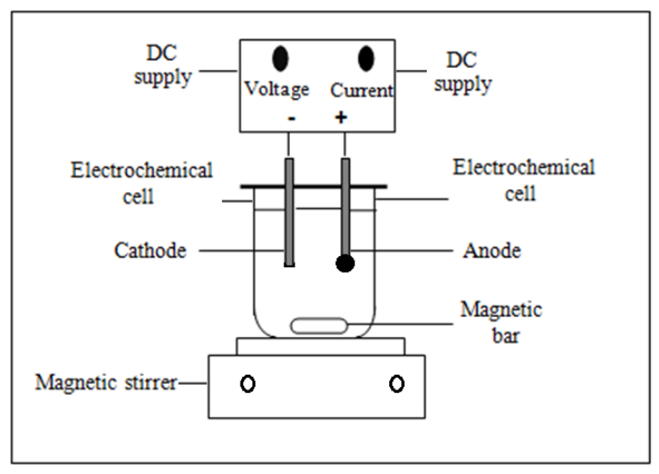

Figure 1. Electrochemical cell setup

Preparation of Electrodes

The electrode was prepared by mixing together a weighed portion of charcoal, graphite and metals powder with PVC (as a binder) in 4 mL tetra hydrofuran (THF) which act as a solvent than swirled flatly to homogeneous followed by drying in an oven at 50 C˚ for 3h. The mixture was placed in 1cm diameter stainless steel mould and pressed at 10 toncm⁻². The total weighed of pellet obtained is approximately 1 gm. The pellets were connected to silver wire with silver conducting paint prior covered with epoxy gum [14]. The ratio of charcoal, graphite, metals and PVC in the prepared electrode are as summarized in Table 2.

Table 2. Ratio and composition charcoal, graphite, metal powder and PVC for electrodes prepared
Electrode | Weight Ratio Percentage  C:C^{G}:metal:PVC |  | Individual weight (g)
Electrode |  |  | Charcoal  (C) | Graphite  (C^{G}) | Metal | PVC
C₆₀C^{G}₁₅Ag₁₀-PVC₁₅ |  | 60:15:10:15 | 0.6 | 0.15 | 0.1 | 0.15
C₆₀C^{G}₁₅Co₁₀-PVC₁₅ |  | 60:15:10:15 | 0.6 | 0.15 | 0.1 | 0.15
C₆₀C^{G}₁₅Cu₁₀-PVC₁₅ |  | 60:15:10:15 | 0.6 | 0.15 | 0.1 | 0.15
C₆₀C^{G}₁₅Al₁₀-PVC₁₅ |  | 60:15:10:15 | 0.6 | 0.15 | 0.1 | 0.15
C₆₀C^{G}₁₅Ni₁₀-PVC₁₅ |  | 60:15:10:15 | 0.6 | 0.15 | 0.1 | 0.15
C₆₀C^{G}₁₅Fe₁₀-PVC₁₅ |  | 60:15:10:15 | 0.6 | 0.15 | 0.1 | 0.15

Note: C=charcoal; C^{G}= graphite

Experimental Procedures

The experiment equipment was consisted of a DC power supply, glass reactor and magnetic stirrer than known amount of supporting electrolyte was added to a 50 ml of leachate. All experiments were carried out at lab scale. Color, COD, BOD₅, NH₃N and total phosphorus PO₄⁻³ of the leachate were measured by using standard method for the examination of water and wastewater [13]. Total Dissolved Solid (TDS) and conductivity were measured by using conductivity meter (Cond 610). The pH value was measured using pH meter (Metrohm). The removal efficiency (%R) of landfill leachate can be obtained at any time, with respect to its initial values using equation 1 below:

R% =[100(A₀ –A_{t})]/A₀ (1)

Where R% is the removal percentage for parameters (Color, COD, NH₃N and Total-P), A₀ is initial value of parameters, A_{t} is the value of parameters at time t.

The energy consumption (E_{sp}) was calculated during the process according to equation 2:

E_{sp} = E I t/ 3600 V (2)

Where E_{sp}, energy consumption (WhL⁻¹), E is the applied voltage (V), I is the current intensity (A), t is the electrolysis or reaction time (s) and V is the volume of the sample (L).

The electrochemical oxidation mechanism

The following equation represents the reaction that occurs in the electrochemical oxidation of landfill leachate at anode, cathode and in the bulk solution. In the electrochemical oxidation, sodium chloride is usually existing or added to landfill leachate to provide conductivity and production of hypochlorite ion. Anodic oxidation of chloride ions Cl⁻ to form chlorine is shown in the reaction (3).

$2Cl^{-} →Cl_{2 }+2e^{-}$ (3)

The resulting chlorine molecules will react with water molecules to form hypochlorous acid (Eq. 4).

$Cl_{2} +H_{2}O→ H^{+}+{Cl}^{-} +HOCl$ (4)

And further partly dissociation of HOCl to form hypochlorite ion (Eq. 5).

$HOCl ↔H^{+}+{OCl}^{-}$ (5)

The generated hypochlorite ions (OCl⁻) or hypochlorous acid (HOCl) act as main oxidizing agent in the pollutant degradation in order to oxidize the organic matter to produce carbon dioxide and water as fully mineralization or produce other products as incompletely mineralization.

The terminal step of oxidation organic pollutants using oxidizing agent OCl⁻or HOCl (Cl₂/H₂O) was as summarized in equations 6 and 7 respectively.

(Fully mineralization)

$R-OH+Cl_{2}/H_{2}O→{CO}_{2}+H_{2 }O$ (6)

(Incompletely mineralization)

$R-OH +{Cl}_{2}/H_{2 }O→ {CO}_{2 }+H_{2 }O+{Cl}^{-}+P$ (7)

Or could be summarized as [15]

O${Cl}^{-}$ + leachate $→$ CO₂ + H₂O + ${Cl}^{-}$ + P (8)

Where R-OH refers to organic pollutants found in landfill leachate, P is the oxidation product.

Results and Discussion

The Electrode Materials

Electrode materials have an effect on the efficiency of the electrochemical process for landfill leachate treatment [16]. In this study, various anode materials consists of charcoal, graphite, metal powder and PVC as binder were fabricated. The best electrode was selected based on the color removal under the operating condition of applied voltage of 10 V, electrolysis time 180 min and NaCl concentration 1.5% (w/v) was chosen base on the results obtained as summarized in Table 3.

Table 3. Electrochemical oxidation of landfill leachate using composite electrodes as an anode and stainless steel as cathode
Electrode composition | Decoloring/electrolysis time (min) | Decoloring percentage (%) | Remarks
Electrode composition | Decoloring/electrolysis time (min) | Decoloring percentage (%) | Electrolysis product | Anode
C₆₀C^{G}₁₅Ag₁₀-PVC₁₅ | 180 | 64 | Yellowish solution | Slightly corroded
C₆₀C^{G}₁₅Co₁₀-PVC₁₅ | 180 | 70 | Yellowish solution | Unchanged
C₆₀C^{G}₁₅Cu₁₀-PVC₁₅ | 180 | 56 | Yellowish solution | Completely corroded
C₆₀C^{G}₁₅Al₁₀-PVC₁₅ | 180 | 35 | Yellowish solution | Unchanged
C₆₀C^{G}₁₅Ni₁₀-PVC₁₅ | 180 | 16 | Color unchanged | Completely corroded
C₆₀C^{G}₁₅Fe₁₀-PVC₁₅ | 180 | 60 | Yellowish solution | Slightly corroded

Note: C=charcoal; CG= graphite

The result as shown in Table 3 shows that the best electrode composition is in the composition of C₆₀C^{G}₁₅Co₁₀-PVC₁₅ which gave 70% color removal without any change in its physical properties. As the electrode used in any electrochemical process should be stable chemically and physically [14, 17]. So based on these criteria, the selection of the best electrode is not only to remove the color, but also on the basis of chemical stability. The best selected electrode composition was then used for further study.

The Effect of Applied Voltage on Color Removal

The applied voltage had a significant influence on the efficiency of electrochemical process [18]. To investigate the effect of voltage on the color removal, different voltage 5, 10 and 15 V were used, and the results obtained are as tabulated are in Figure 2.

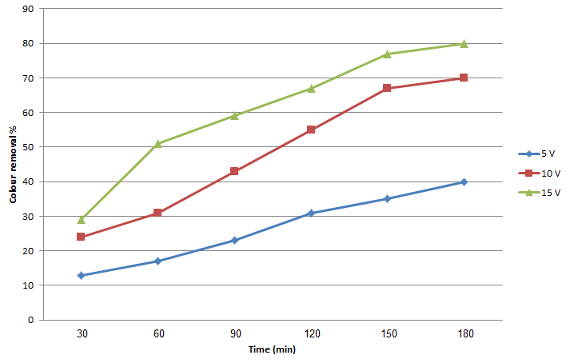

Figure 2. Effect of applied voltage on color removal at difference electrolysis time

When increasing the applied voltage, the percentage of color removal also increases. The rates of color removal for 5, 10 and 15 V were determined to be 40, 70 and 80% respectively after 180 min. of electrolysis time. This is due to production of oxidant such as hypochlorite ion in bulk solution. Increasing generation of oxidant is commensurate with applied voltage, which eventually increases the pollutant degradation [19, 20]. The increase in hypochlorite ion approaches equilibrium with degradation of organics present in the effluent [21]. From the results obtained, shows that a little change in color removal was observed when the voltage applied increased from 10 to 15 V (70 to 80%). At the same times, increasing the energy consumed. The energy consumption as a function of applied voltage was calculated and the results are shown in Figure 3.
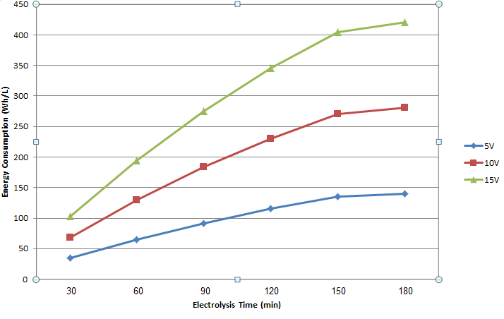

Figure 3. Effect of voltage on energy consumption

Effect of Supporting Electrolyte

NaCl was used as a supporting electrolyte not only to increases the conductivity of solution but also and enhance the degradation efficiency [22]. The effect of supporting electrolyte used on the color removal efficiency at 0.5, 1, 1.5 and 2 % (w/v) of NaCl concentration were 50, 60 ,70 and 78% respectively, and the results obtains are as summarized in Figure 4.

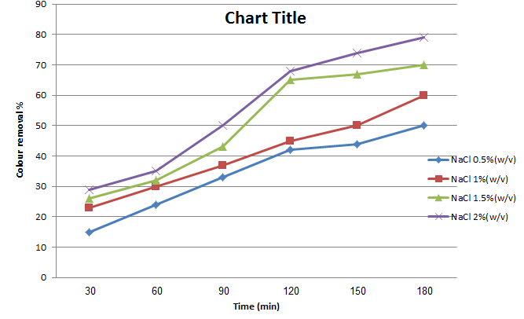

Figure 4. Effect of NaCl concentration on color removal of landfill leachate

Obviously, the increasing in chloride concentration (from NaCl) will generate more amount of hypochlorite ion [23]. Thus, higher concentrations of hypochlorite ion were able to oxidize the pollutants [24]. Increasing of added NaCl as supporting electrolyte from 0.5 – 1.0% (w/v) and 1.5 – 2.0% (w/v) had not significantly effects on the color removal percentage (Figure 4). Supporting electrolyte decreased energy consumption because amounts of ions in solution increased, applied potential decreased and the conductivity of solution increased under constant current density.

Electrolysis Time

The effect of electrolysis time on color removal was studied in the range from 30 min. to 180 min. using this optimum condition; applied voltage 10V, NaCl concentration 1.5% (w/v) and raw pH. The results obtained are as tabulated in Figure 5.

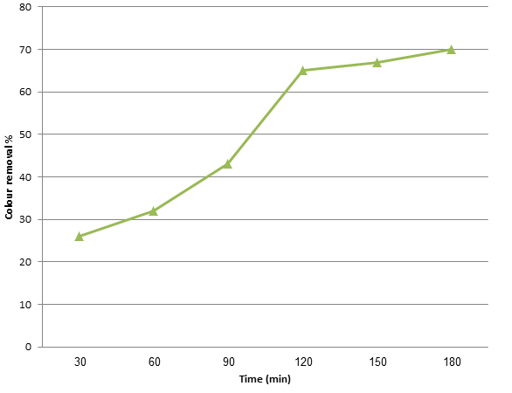

Figure 5. Effect of electrolysis time on color removal

The color removal percentage increases with the increasing of electrolysis time. This is due to the increased generation of hypochlorite ion in bulk solution as a result of oxidation process, thus increased the oxidation processes of organic and inorganic pollutants [6]. In other words, the efficiency removal of pollutants depends on the concentration of hypochlorite ion generated electrochemically in bulk solution. Base on optimization studies for the treatment of landfill leachate, the optimum operating condition selected are as summarized in Table 4.

Table 4. Optimum operating condition for landfill leachate using C₆₀C^{G}₁₅Co₁₀-PVC₁₅ electrode
Electrodes |  | Operating Conditions
Working (anode) | C₆₀C^{G}₁₅Co₁₀-PVC₁₅ | Supporting electrolyte | 1.5% (w/v) NaCl
Counter (cathode) | Stainless steel rod | Applied voltage | 10 V
 |  | Electrolysis time | 180 minutes

Characterization of landfill leachate before and after electrolysis

Analysis on selected water quality parameters (color, COD, NH₃N and total P) values on landfill leachate before and after electrolysis were carried out using the optimum operating conditions as previously determined. The results obtained show that the electrochemical oxidation process is able to reduce the color, COD, NH₃N and total P values in landfill leachate. From those four parameters, color, COD, NH₃N and total P removal percentage were not less than 70, 89, 73 and 80 % respectively (Table 5).

Table 5. Landfill leachate parameters from Jeram Sanitary Landfill before and after at optimum electrochemical treatment

Parameter (Unit) | Value
 | Before | After | Removal Percentage (%)
Color Pt-Co | 14960 | 4540 | 70
COD mgL⁻¹ | 49000 | 5400 | 89
NH₃-N mgL⁻¹ | 3800 | 1000 | 73
Total-P mgL⁻¹ | 200 | 40 | 80

The reduction in these parameters value was due to the breaking of large molecule to a small molecule which is easier to be oxidized chemically or biologically by electrochemical oxidation technique [25]. This breaking process was supported by the existence of self-generated hypochlorite ion which is able to reduce the concentration of organic compound available [26]. Measurement of pH on landfill leachate found that all of the samples were in alkaline conditions and change to neutral upon completion of electrochemical oxidation time due to the formation of carbonate buffer through CO₂ produced at the end of electrolysis process.

Conclusion

The present study explains the most suitable charcoal base metallic composite electrode is C₆₀C^{G}₁₅Co₁₀-PVC₁₅ as anode in electrochemical oxidation process for the treatment of landfill leachate. It was successfully performed for color removal and to reduce COD, NH₃N and total-P level as well. The optimum operating conditions, NaCl 1.5% (w/v), applied voltage of 10 V and electrolysis time is 180 min. However to reduce the power consumption, shorter electrolysis time could be used. It can be conclude that under the optimum experimental condition, the treatment of landfill leachate by electrochemical oxidation process can be carried out not only for color removal but also for COD, NH₃N and total-P removal.

Acknowledgement

The funding from University Kebangsaan Malaysia and Ministry of Higher Education, Malaysia through grants FRGS/2/2013/SG01/UKM/01/1 are gratefully acknowledged.

References
- Ihara, I., Kanamura, N.K., Shimada, E. and Watanabe, T. (2004). High Gradient Magnetic Separation Combined with Electrocoagulation and Electrochemical Oxidation for the Treatment of Landfill Leachate. IEEE Transactions on Applied Superconductivity, 14(2): 1558-1560.
- Masoumeh Moayeri Kashani, Salman Masoudi Soltani and Sobri, S. (2012). Treatment of Malaysian Leachate Sample Using Electrocoagulation. International Journal of Chemical Engineering and Applications, 3(1): 63-66.
- Renou, S., Givaudan, J., Poulain, S., Dirassouyan, F. and Moulin, P. (2008). Landfill Leachate Treatment: Review and Opportunity. Journal of Hazardous Materials, 150(3): 468-493.
- Ni'am, M.F., Othman, F., Sohaili, J. and Fauzia, Z. (2007). Electrocoagulation Technique in Enhancing COD and Suspended Solids Removal to Improve Wastewater Quality. Water Science & Technology, 56(7): 47-53.
- Amuda, O.S. (2006). Removal of COD and Color from Sanitary Landfill Leachate by using Coagulation–Fenton’s Process. Journal of Applied Sciences and Environmental Management, 10(2): 49-53.
- Zhao, X., Qu. J., Liu, H., Wang, C., Xiao, S., Liu, R., Liu, P., Lan, H. and Hu, C. (2010). Photoelectrochemical Treatment of Landfill Leachate in a Continuous Flow Reactor. Bioresource Technology, 101(3): 865-869.
- Kurniawan, T.A., Lo, W.H. and Chan, G.Y.S. (2006). Degradation of Recalcitrant Compounds from Stabilized Landfill Leachate using a Combination of Ozone-GAC Adsorption Treatment. Journal of Hazardous Materials, 137(1): 443-455.
- Bashir, M.J.K., Isa, M.H., Kutty, S.R.M., Awang, Z.B., Aziz, H.A., Mohajeria S. and Farooqi, I.H. (2009). Landfill Leachate Treatment by Electrochemical Oxidation. Waste Management, 29(9): 2534-2541.
- Fátima, E.M. and Dinis, S.J. (2004). Electrochemical Degradation of Reactive Blue 19 Dye in Textile Wastewater. 4th. AUTEX World Textile Conference, June 22-24, 2004 Roubaix, 1-6 pp.
- Chen, X., Shen, Z., Zhu, X., Fan, Y. and Wang, W. (2005). Advanced Treatment of Textile Wastewater for Reuse using Electrochemical Oxidation and Membrane Filtration. Water SA, 31(1): 127-132.
- Ihoş, M., Bocea, G. and Iovi, A. (2005). Use of Dimensionally Stable Anodes for the Electrochemical Treatment of Textile Wastewaters. Chemical Bulletin, 50(64): 1-2.
- Norazzizi Nordin, Siti Fathrita Mohd Amir, Riyanto and Mohamed Rozali Othman. (2013). Textile Industries Wastewater Treatment by Electrochemical Oxidation Technique Using Metal Plate. International Journal of Electrochemical Science, 8: 11403-11415.
- APHA., AWWA. and WPCF. (1981). Standard Methods for the Examination of Water and Wastewater, 15th. ed. Washington, DC: American Public Health Association
- Riyanto, Salimon, J. and Othman, M. R. (2007). Perbandingan Hasil Pengoksidaan Elektrokimia Etanol dalam Larutan Alkali yang Menggunakan Elektrod Platinum Polivinilklorida (Pt-PVC) dan Kepingan Logam Pt. Sains Malaysiana, 36(2): 175-181.
- Mussa, Z. H. Othman, M. R. and Abdullah, M. P. (2015). Electrochemical Oxidation of Landfill Leachate: Investigation of Operational Parameters and Kinetics Using Graphite-PVC Composite Electrode as Anode. Journal of Brazil Chemical Society, 26(5): 939-948.
- Deng, Y. and Englehardt, J.D. (2007). Electrochemical Oxidation for Landfill Leachate Treatment. Waste Management, 27(3): 380-388.
- Riyanto, Mohamed Rozali Othman, Jumat Salimon. (2007). Analysis of Ethanol using Copper and Nickel Sheet Electrodes by Cyclic Voltammetry. Malaysian Journal of Analytical Sciences, 11(2): 379-387.
- Sun Zhao-nan, Huang Yong-gang, Dong Chang-e and Hu Xiao-min. (2012). The Study of Removing the Organic from Wastewater by Periodically Reversing Electrocoagulation. World Automation Congress (WAC), 1-4 pp.
- Raju, G.B., Karuppiah, M.T., Lathaa, S.S., Parvathy, S. and Prabhakar, S. (2008). Treatment of Wastewater from Synthetic Textile Industry by Electrocoagulation–Electrooxidation. Chemical Engineering Journal, 144(1): 51-58
- Wang, C.T., Chou, W.L., Kuo, Y.M. and Chang, F.L. (2009). Paired Removal of Color and COD from Textile Dyeing Wastewater by Simultaneous Anodic and Indirect Cathodic Oxidation. Journal of Hazardous Materials, 169(1-3): 16-22.
- Awad, H. and Galwa, N.A. (2005). Electrochemical Degradation of Acid Blue and Basic Brown Dyes on Pb/PbO₂ Electrode in the Presence of Different Conductive Electrolyte and Effect of Various Operating Factors. Chemosphere, 61: 1327-1335.
- Li-Choung Chiang, Juu-En Chang, Ten-Chin Wen. (1995). Indirect Oxidation Effect in Electrochemical Oxidation Treatment of Landfill Leachate. Water Research, 29(2): 671-678.
- Rajkumar, D. and Jong Guk Kim. (2006). Oxidation of Various Reactive Dyes with in-situ Electrogenerated Active Chlorine for Textile Dyeing Industry Wastewater Treatment. Journal of Hazardous Materials, 136(2): 203-212.
- Yong Kong, Jia Yuan, Zhiliang Wang, Shiping Yao and Zhidong Chen. (2009). Application of Expanded Graphite/Attapulgite Composite Materials as Electrode for Treatment of Textile Wastewater. Applied Clay Science, 46(4): 358-362
- Comninellis, C. and Pulgarin, C. (1993). Electrochemical Oxidation of Phenol for Wastewater Treatment using Tin Dioxide Anodes. Journal of Applied Electrochemistry, 23: 108-112.
- Chen, J., Liu, M., Zhang, J., Xian, Y. and Jin, L. (2003). Electrochemical Degradation of Bromopyrogallol Red in Presence of Cobalt Ions. Chemosphere 53(9): 1131-1136.

