

MALAYSIAN JOURNAL OF ANALYTICAL SCIENCES
ISSN 1394 - 2506

Published by The Malaysian Analytical Sciences Society

DEGRADATION OF METHYLENE BLUE DYE BY CuO-BiVO₄ PHOTOCATALYSTS UNDER VISIBLE LIGHT IRRADIATION

(Degradasi Pewarna Metilena Biru oleh Fotomangkin CuO-BiVO₄ Di Bawah Sinaran Cahaya Nampak)

Abdul Halim Abdullah^{1,2}*, Wan Tze Peng², Mohd Zobir Hussein^{1,2}

¹Institute of Advanced Technology
²Department of Chemistry, Faculty of Science
Universiti Putra Malaysia, 43400 UPM Serdang, Selangor, Malaysia

*Corresponding author: halim@upm.edu.my

Received: 17 August 2015; Accepted: 13 October 2016

Abstract
Bismuth vanadate (BiVO₄) and a series of Cu-loaded BiVO₄ (CuO-BiVO₄) photocatalysts were prepared via precipitation and wet impregnation methods respectively. The samples were characterized by X-ray diffractometry (XRD), transmission electron microscopy (TEM) and the band gap energy was elucidated via UV-visible diffuse reflectance spectroscopy (DRS). Spherically-shaped particles of the photocatalysts were obtained which contained mixtures of monoclinic and tetragonal BiVO₄ phases. The particle sizes of the photocatalysts ranged from 20 to 100 nm and band gap energies varied from 2.47 to 2.53 eV. The photodegradation efficiency of the photocatalysts was evaluated by degrading methylene blue (MB) dye under visible-light irradiation. The optimum conditions for the photocatalytic degradation were determined based on wt% Cu loaded, mass loading, initial dye concentration and pH. 1 wt% CuO-BiVO₄ exhibited the highest photocatalytic activity where the complete removal of 10 mgL⁻¹ of MB was obtained at pH 10 when 0.8 g of the catalyst was used under 4 hours of 18W fluorescent light irradiation.

Keywords: copper oxide-bismuth vanadate, visible light photocatalyst, semiconductor, methylene blue

Abstrak
Bismut vanadat (BiVO₄) dan satu siri fotomangkin CuO-BiVO₄ masing – masing telah disediakan melalui kaedah pemendakan dan impregnasi basah. Pencirian sampel menggunakan pembelauan Sinar-X (XRD), transmisi elektron mikroskopi (TEM) dan tenaga jurang jalurnya melalui spektroskopi UV-Vis pantulan resap (DRS). Fotomangkin yang berbentuk sfera mengandungi campuran fasa monoklinik dan tetragonal BiVO₄ telah dihasilkan. Saiz zarah fotomangkin adalah antara julat 20 – 100 nm dan tenaga jurang jalurnya adalah 2.47 – 2.53 eV. Keberkesanan fotodegradasi pemangkin telah dinilai dengan menyingkirkan pewarna metilena biru (MB) di bawah sinaran cahaya nampak. Keadaan optimum bagi degradasi fotopemangkinan adalah berdasarkan % berat Cu yang dimuatkan, muatan jisim, kepekatan awal pewarna dan pH. 1% berat CuO-BiVO₄ menunjukkan aktiviti fotopemangkinan adalah paling tinggi di mana penyingkiran peratusan MB menghampiri 100% 10 mgL⁻¹ of MB di bawah keadaan optimum iaitu pH 10 dengan 0.8 g pemangkin digunakan yang didedahkan di bawah sinaran 18W cahaya pendarfluor selama 4 jam.

Kata kunci: kuprum oksida- bismut vanadat, fotomangkin cahaya nampak, semikonduktor, metilena biru

Introduction
Photocatalytic degradation is a promising method for the treatment of wastewater containing organic and inorganic pollutants. The process begins with the activation of the photocatalyst by light irradiation followed by the degradation of the pollutants to harmless products. The use of titanium dioxide (TiO₂) as a photocatalyst in this process has been extensively studied [1]. However, TiO₂ is only effective under UV light. Thus, with the intention to utilize solar radiation to degrade wastewater pollutants, the search for efficient visible-light driven photocatalysts has attracted many researchers. Two approaches have been employed; doping of TiO₂ and synthesizing non-TiO₂ based photocatalysts. Several reports have shown that although the band gap of TiO₂ reduced after doping, the quantum efficiency of TiO₂ also reduced due to the formation of recombination centers [2, 3]. Hence there has been renewed interest in producing non–TiO₂ based visible-light photocatalysts with better properties.

Several complexes such as Fe₂O₃, WO₃, BiVO₄, Bi₂WO₆ and Ag₃PO₄ [4-8] have been tested as visible light photocatalysts. Among these complexes, monoclinic scheelite BiVO₄ with a band gap energy of 2.4 eV has been reported to be an effective photocatalyst thus attracting considerable attention [9]. This photocatalyst has been synthesized via several methods including polyol, sol-gel, hydrothermal and polymer assisted co-precipitation methods [10-14]. However, the photocatalytic activity of pure BiVO₄ has been reported to be comparatively low. Several researchers have observed enhanced photocatalytic activity of BiVO₄ when metals such as iron and thallium [15-16], and metal oxides such as Ag₂O, Bi₂WO₆, CuO, Cu₂O and WO₃ [11, 17-20] were doped on the BiVO₄ surface. The enhancement in activity was reported to be due to the suppression of photogenerated electrons and holes recombination at the photocatalyst/co-catalyst interfaces.

In this study, a series of CuO-BiVO₄ photocatalysts were prepared via impregnation to evaluate the effect of CuO loading on the photocatalytic efficiency of the photocatalysts in degrading methylene blue dye (MB) under low-wattage visible-light irradiation. The optimal conditions for the photocatalytic degradation of MB were also determined.

Materials and Methods
Preparation of the photocatalysts
An amount of 0.1 M of bismuth (III) nitrate pentahydrate solution was prepared by dissolving 10 mmol of bismuth (III) nitrate pentahydrate (Acros) in 10 mL of concentrated nitric acid (65%, Fischer Scientific)) and 90 mL of deionized water. Separately, 0.1 M of ammonium metavanadate was prepared by dissolving 10 mmol of ammonium metavanadate (Aldrich) in 100 mL of deionized water at 80 °C. Upon cooling to room temperature, the solutions were mixed and continuously stirred for 30 minutes and left overnight for precipitation to occur. The yellow precipitate that formed was washed with deionized water, collected via centrifugation and oven-dried at 70 °C overnight. The dried sample was ground and calcined in air at 550°C for 1 hour.

The CuO-BiVO₄ catalysts were prepared by suspending 3.962g of BiVO₄ in an ethanolic solution (3:1 ethanol: water) containing copper (II) nitrate trihydrate (Acros) that would yield 0.25 – 1.25 wt % of Cu. The suspension was magnetically stirred until almost all the ethanol evaporated. The slurry obtained was then oven-dried at 70 °C overnight and the resulting powder was calcined at 300 °C for 4 hours.

Characterization of the photocatalysts
X-Ray Diffraction (XRD) analyses of the prepared photocatalysts were performed on a Shimadzu XRD-6000 Diffractometer with Nickel-filtered Cu Kα radiation (λ = 1.5406 Å), over a 2θ range of 10-60º. The diffuse reflectance spectra (DRS) of the photocatalysts were recorded using a UV-Vis spectrophotometer (Lambda 35, Perkin Elmer, USA) equipped with an integration sphere. The microstructure of the photocatalysts was recorded using a transmission electron microscope (Hitachi H-7100). The amount of Cu incorporated into the BiVO₄ catalysts was analyzed using the Thermo Scientific S Series Atomic Absorption Spectrometer.

Photocatalytic activity
The photocatalytic activity of the synthesized photocatalysts was evaluated by analyzing the degradation of methylene blue (MB, BDH) under visible-light irradiation (18-watt Cool Day fluorescent light-bulb, Philips) at room temperature. A desired amount of the photocatalyst was suspended in 1 L of 10 mg/L MB solution. Prior to the visible-light illumination, the suspension was magnetically stirred for 30 min (BiVO₄) or 45 min (CuO-BiVO₄) in the dark, for adsorption-desorption equilibrium. Air was bubbled continuously into the suspension by an aquarium air pump to maintain constant oxygen saturation in the solution throughout the 4 hours reaction period. At specific time intervals, 5 mL of the suspension was drawn and filtered through cellulose nitrate membrane filters (0.45 µm) to separate the photocatalyst from the solution. The concentration of MB was determined at λ_{max} = 664 nm during the photocatalytic degradation process by a Perkin Elmer Lambda 35 UV-Vis spectrophotometer. The percentage of photodegradation of MB was calculated using equation 1:

Photodegradation (%) = (C₀-C)/C₀ х 100% (1)

where C₀ was the initial concentration of MB and C was the concentration of MB at time t.

Results and Discussion
Characteristics of the photocatalysts
Figure 1 shows the XRD patterns of pure BiVO₄ and Cu–BiVO₄ with different Cu contents. Characteristic peaks of the monoclinic scheelite BiVO₄ phase were observed at 2θ = 28.8º, 30.5º, 39.8º and 53.5º with clear splitting peaks at 2θ = 18.8º, 35º, 47º, 58.4º (JCPDS No. 00-014-0688). Weak peaks corresponding to the tetragonal BiVO₄ phase were also observed at 24.4º and 32.7º (JCPDS No. 00-014-0133). This indicated the presence of both BiVO₄ phases with monoclinic scheelite as the dominant phase. No diffractive peaks corresponding to CuO were found for any of the CuO-BiVO₄ photocatalysts in this work due to the low amount of copper used in the synthesis. To ensure the presence of Cu, the CuO-BiVO₄ photocatalysts were digested in aqua regia and analysed by AAS. As listed in Table 1, the Cu content obtained matched well with the calculated values.

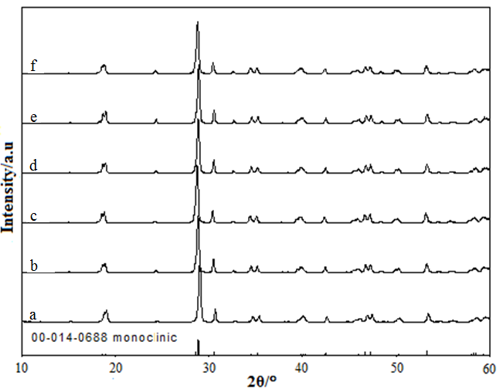

Figure 1. XRD patterns of (a) pure BiVO₄ and CuO-BiVO₄ at different Cu loading; (b) 0.25, (c) 0.50, (d) 0.75, (e) 1 and (f) 1.25 wt %.

Table 1. Physical properties of the synthesized BiVO₄ and CuO-BiVO₄ photocatalysts
Samples | Cu content  (% wt) | Average Particle Size  (nm) | Band Gap Energy  (eV)
BiVO₄ |  | 40.2 | 2.47
0.25 wt% CuO-BiVO₄ | 0.247 | 60.6 | 2.47
0.50 wt% CuO-BiVO₄ | 0.522 | 40.2 | 2.52
0.75 w% CuO-BiVO₄ | 0.808 | 36.3 | 2.52
1 wt% CuO-BiVO₄ | 1.066 | 34.1 | 2.52
1.25 wt% CuO-BiVO₄ | 1.381 | 37.0 | 2.53

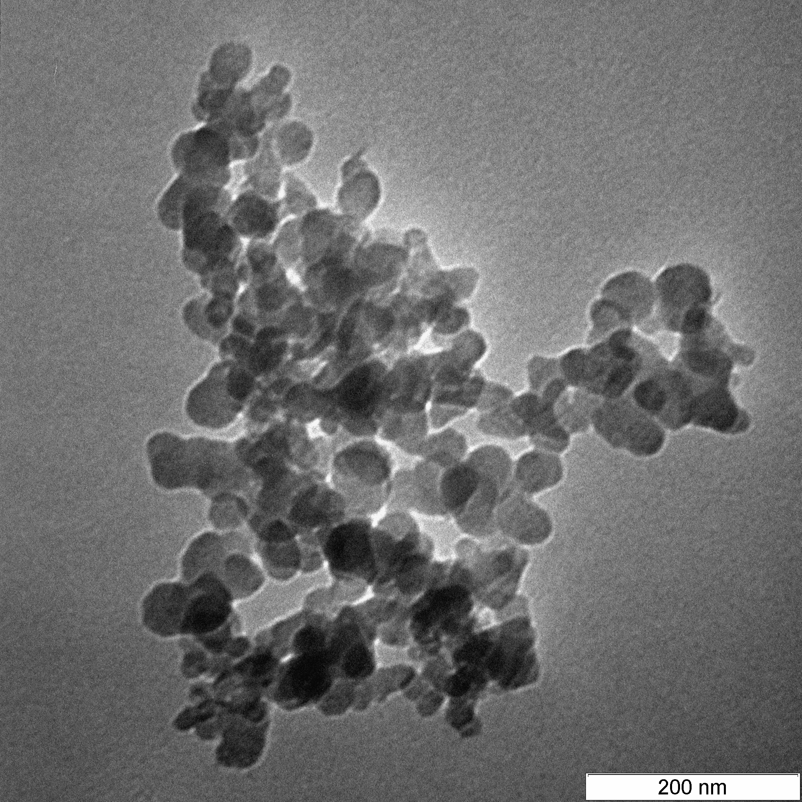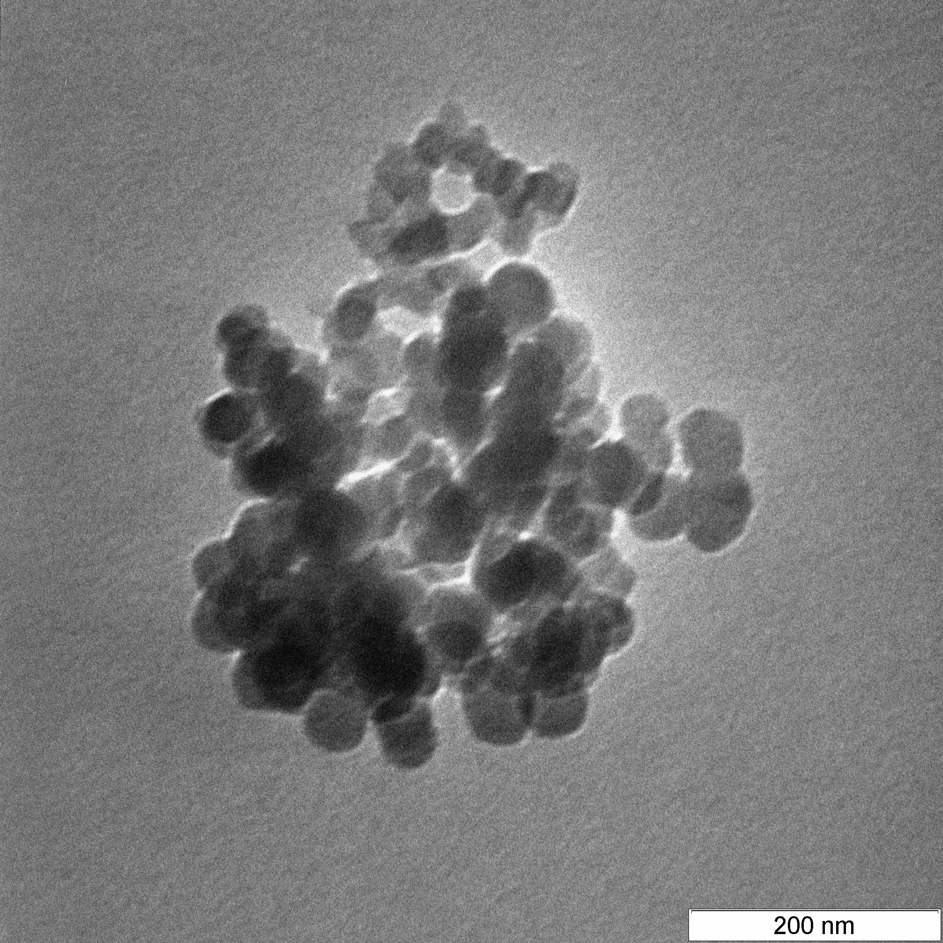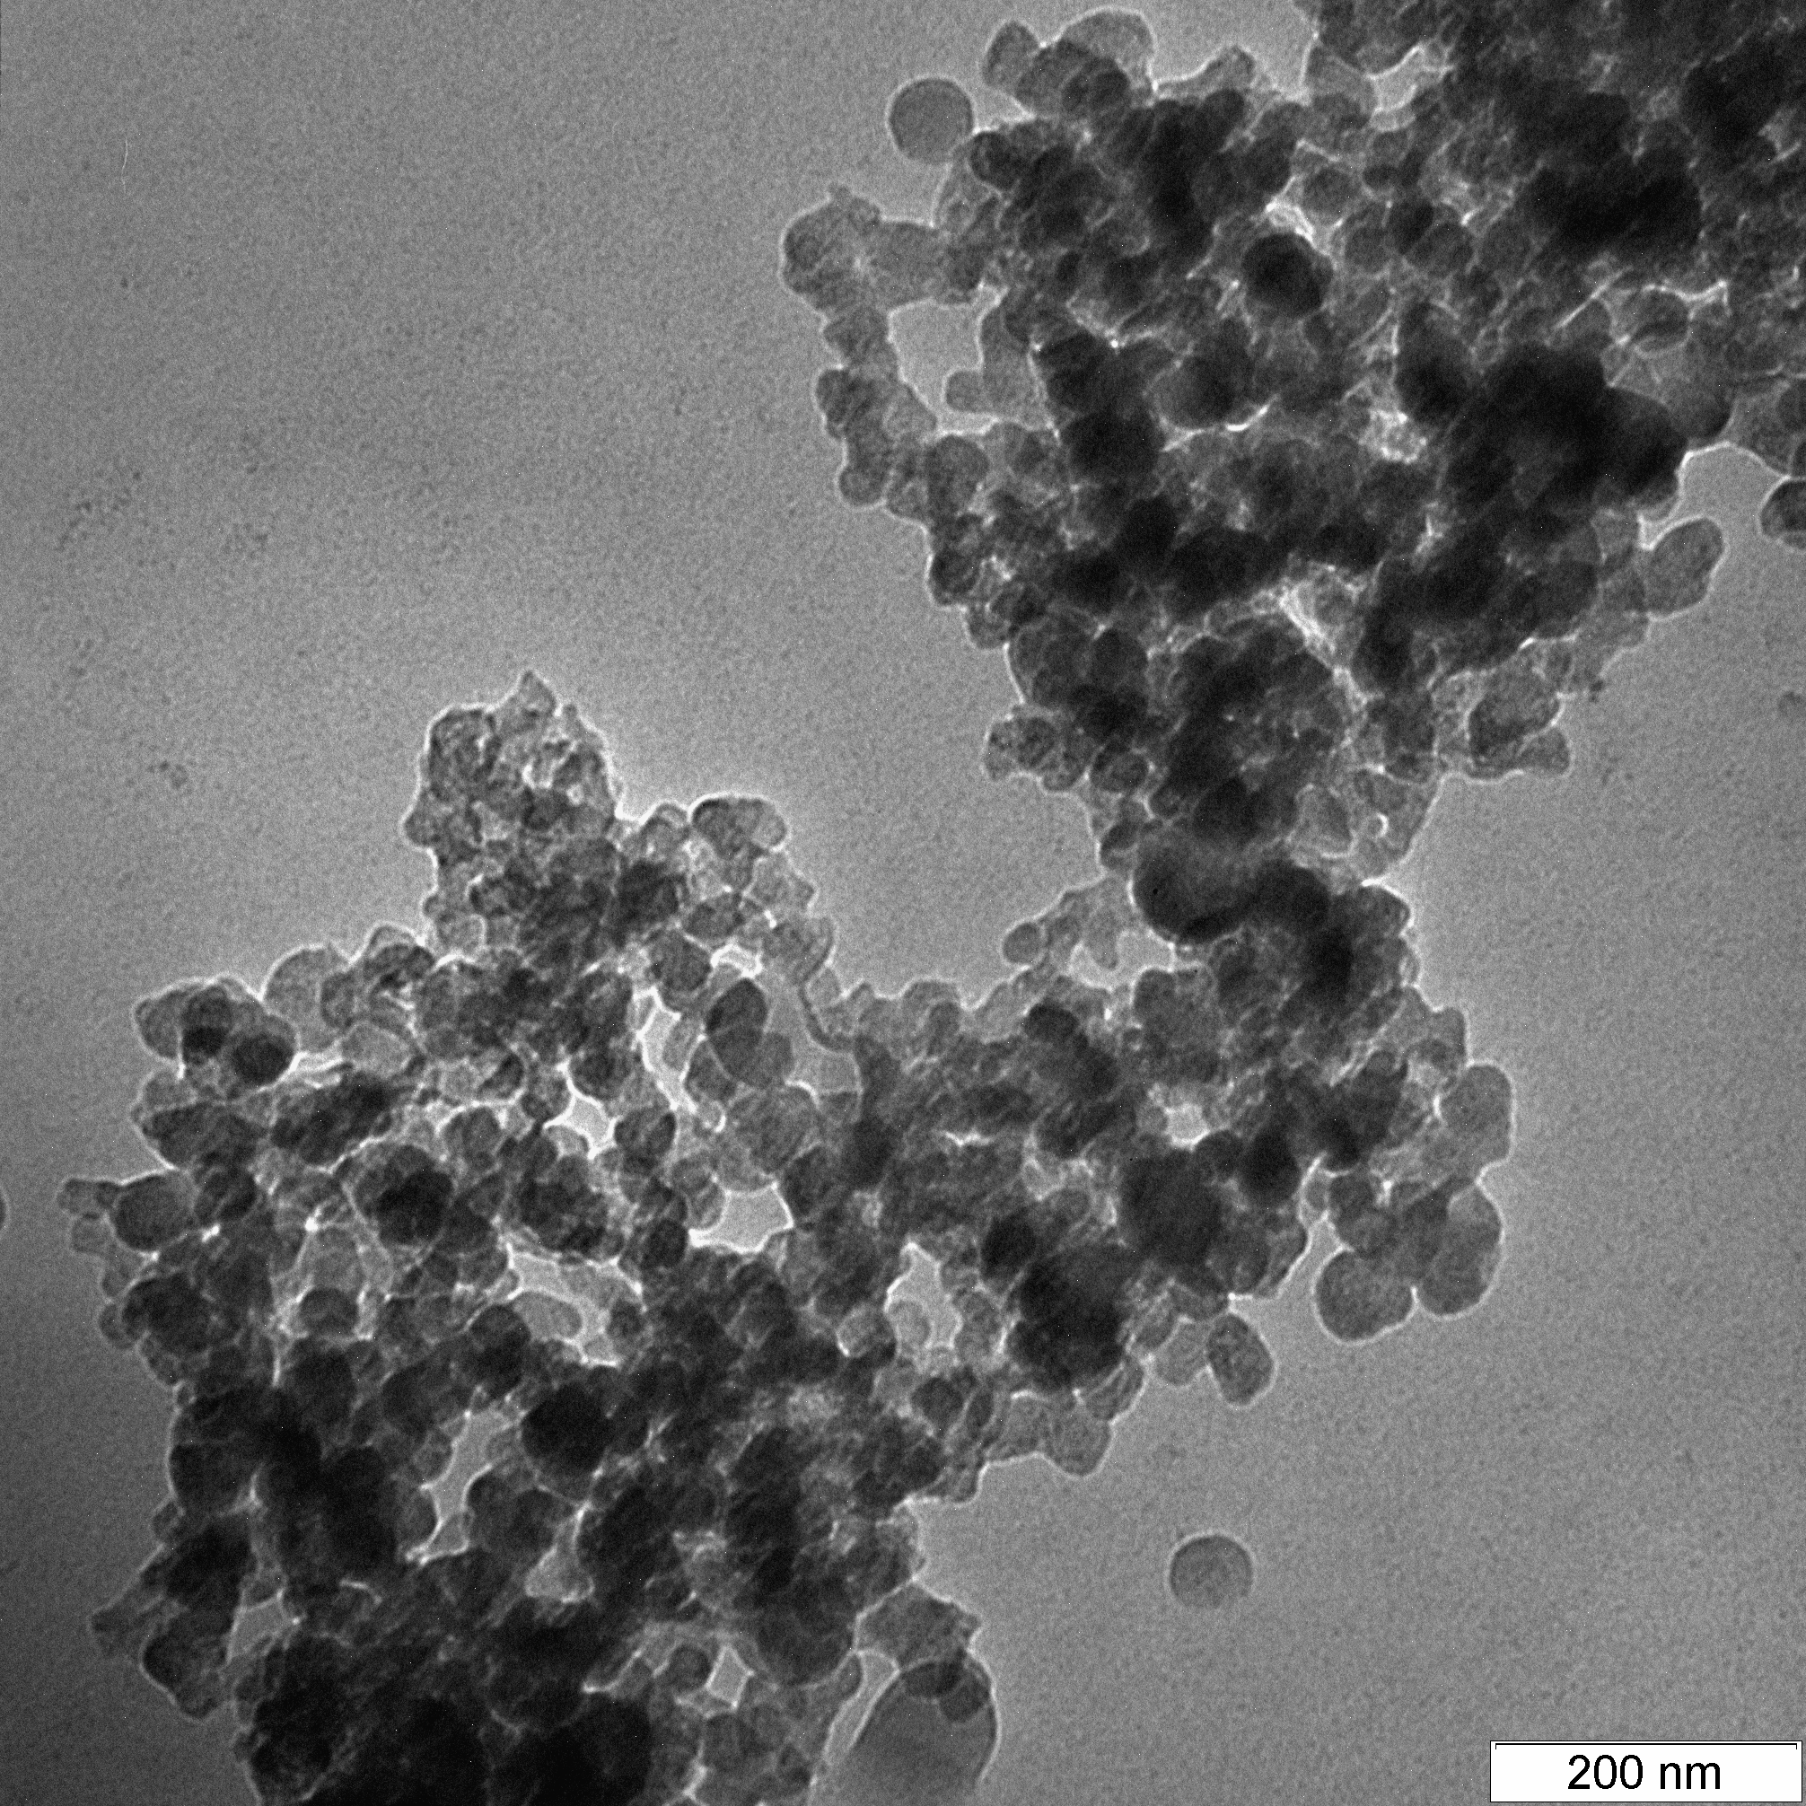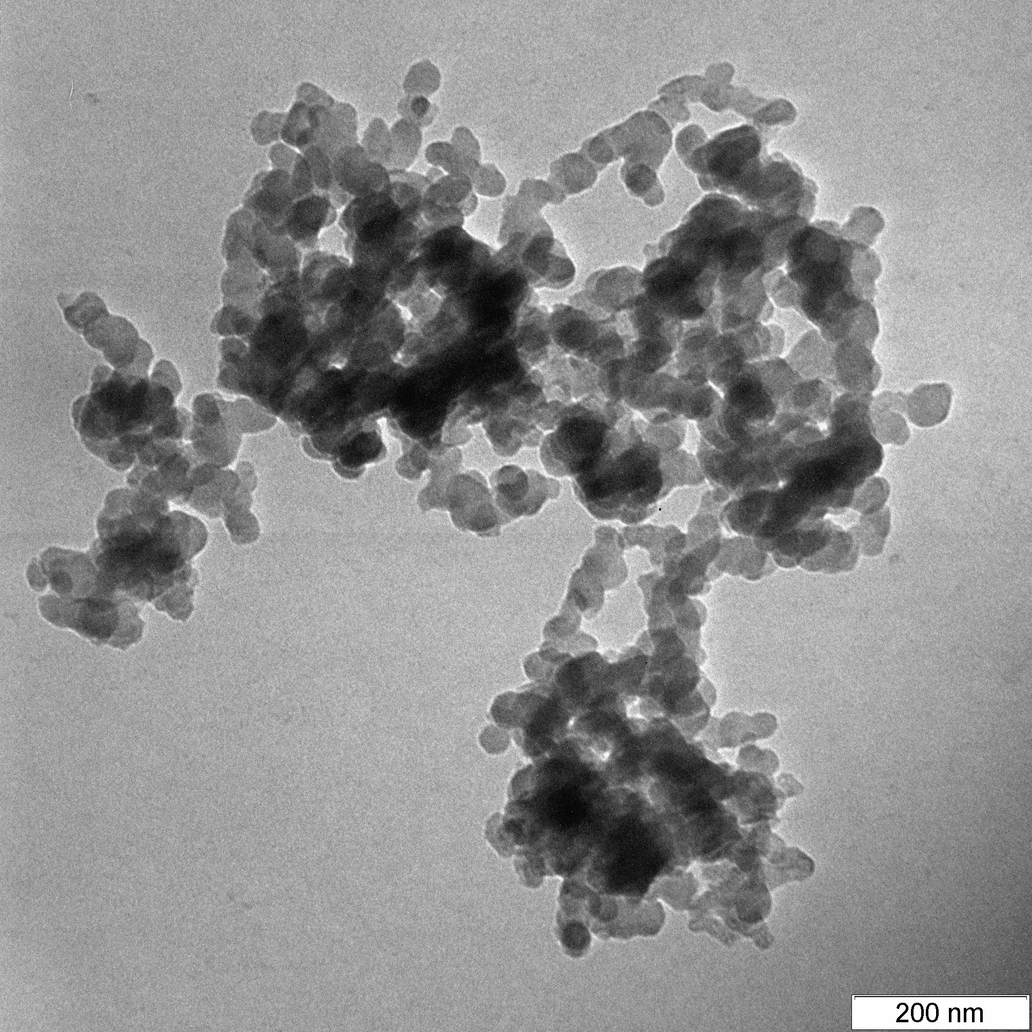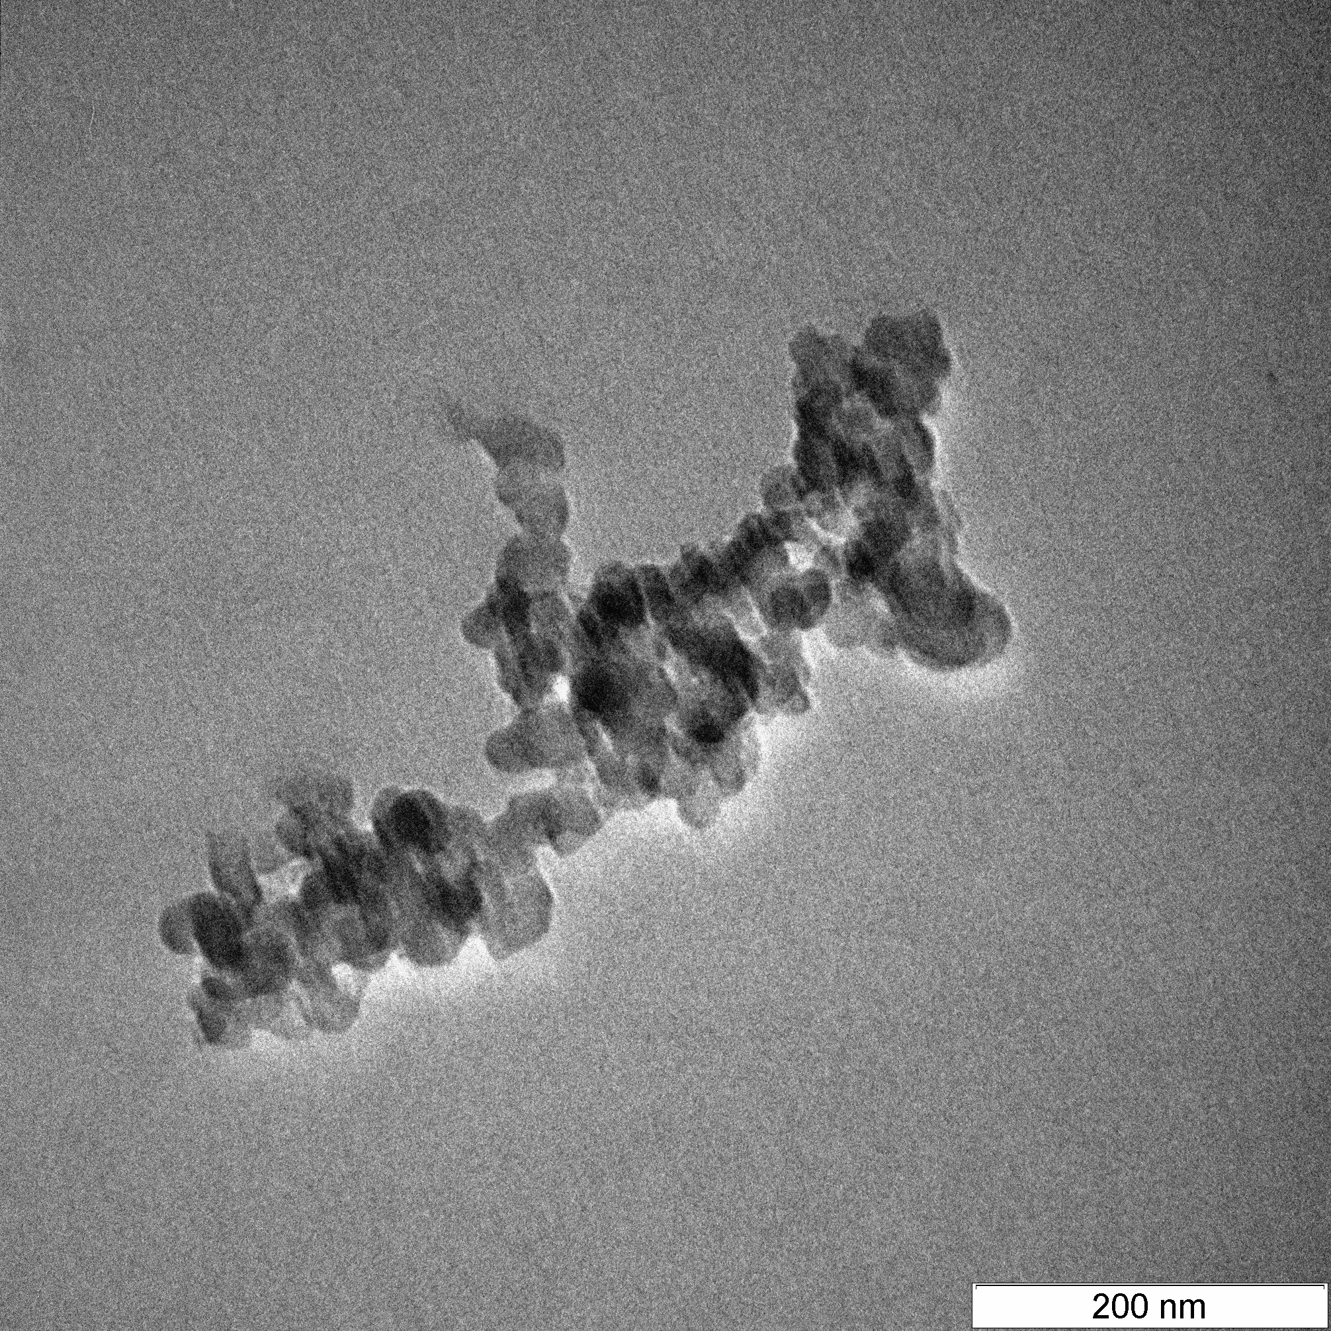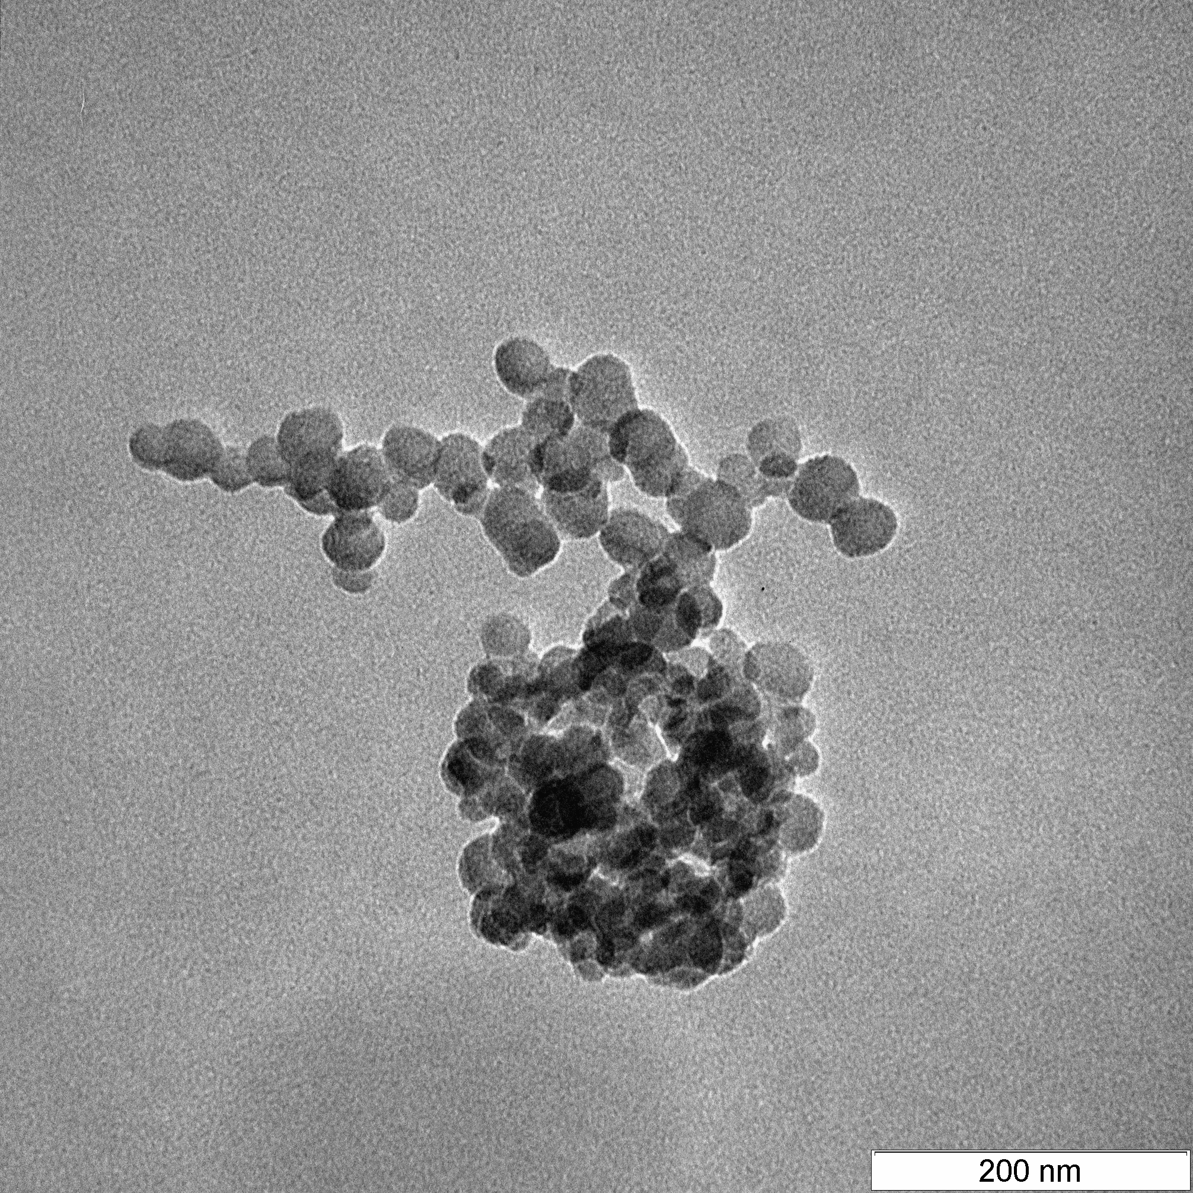
(a)
(b)
(c)
(d)
(e)
(f)

Figure 2. TEM images of (a) pure BiVO₄ and CuO-BiVO₄ at different Cu loading; (b) 0.25, (c) 0.50, (d) 0.75, (e) 1 and (f) 1.25 wt%.

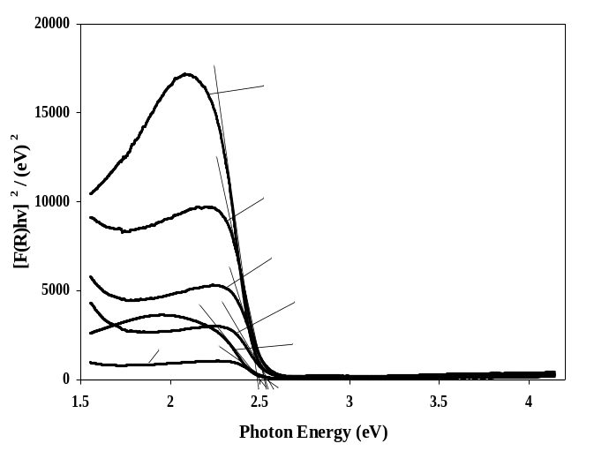

Figure 3. Tauc’s plot of BiVO₄ and CuO-BiVO₄ photocatalysts at different Cu loading; (b) 0.25, (c) 0.50, (d) 0.75, (e) 1 and (f) 1.25 wt% for the determination of optical band gap energy

Photocatalytic degradation of methylene blue
The photocatalytic performance of BiVO₄ and CuO-BiVO₄ photocatalysts in the degradation of MB and their kinetics study are shown in Figure 4. In the absence of a photocatalyst (Figure 4a), 5% of the MB dye was photolysed under visible-light irradiation while in dark conditions; only approximately 5% of the MB dye was adsorbed on the surface of the photocatalysts. The photocatalytic degradation efficiency of MB steadily increased from 40% to 92% when BiVO₄ was doped with increasing amounts of CuO up to 1 wt%. As illustrated in Figure 4b, the photodegradation of MB followed a pseudo first-order reaction. The UV-Vis spectra that displays the progressive degradation of MB by the 1wt% CuO-BiVO₄ photocatalyst, as a function of time are shown in Fig 5. The enhancement in the photoactivity of CuO-BiVO₄ was attributed to efficient separation of the photogenerated electrons and holes. The band gap energy of CuO and BiVO4 has been reported as 1.70 eV and 2.45 eV, respectively. Since the calculated energy level of the conduction band of CuO (0.46 eV) was higher than that of BiVO₄ (0.34 eV), the photoexcited electrons on the conduction band of BiVO₄ were not transferred to the conduction band of CuO. Instead the holes were transferred to the valence band of CuO, resulting in a separation of the electron-hole pairs, thereby subsequently increasing the photocatalytic activity [21]. However, at CuO loading higher than 1 wt%, lower photocatalytic activity was observed because CuO acts as a recombination center of photoinduced electron-hole pairs leading to a reduction in photocatalytic activity [21-22]. Thus, 1 wt% CuO-BiVO₄ was used as the model photocatalyst for the remainder of this study.

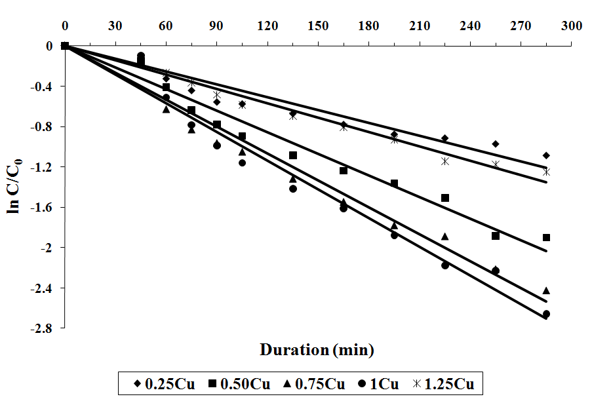
(b)
(a)

Figure 4. (a) Photocatalytic degradation efficiency and (b) kinetics of pure BiVO₄ and Cu-loaded BiVO₄ in the degradation of MB (catalyst dosage = 600 mg, initial MB concentration = 10 mg/L and natural pH)

The effect of mass of the 1 wt% CuO-BiVO₄ photocatalyst, initial concentration and pH of the MB solution on the degradation efficiency of MB is illustrated in Figure 6. Figure 6a showed that the photodegradation of MB increased proportionally with the amount of photocatalyst loading until 800 mg, after which the photodegradation decreased (1000 mg). The increase in the photocatalytic degradation efficiency of MB was due to the increase in the effective surface area of the photocatalyst, consequently enhancing light absorption and generating more surface active sites for the degradation reaction. The decrease in the efficiency beyond the optimum photocatalyst loading (800 mg) might be attributed to the light scattering effect and agglomeration of the photocatalyst particles in the solution [23].

The photocatalytic degradation of MB at various initial concentrations (10 – 30 mg/L) was studied using 800 mg of 1 wt% CuO-BiVO₄. Figure 6b showed that the percentage of degradation decreased with increasing MB concentration. It was also found that the rate of the MB photodegradation was unaffected by change in MB concentration, thus the amount of MB degraded did not change significantly. The maximum amount of MB that could be degraded by 1 wt% CuO-BiVO₄ was 10.5 mg/g at any MB concentration.

0 min

240 min

240 min

Figure 5. UV-Vis spectra of MB recorded at 30 min intervals during the photodegradation using 1 wt% CuO-BiVO₄ photocatalyst. (Catalyst dosage = 600 mg, initial MB concentration = 10 mg/L and natural pH)

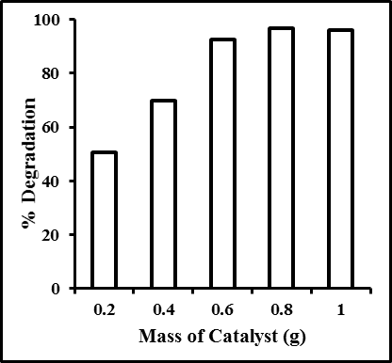
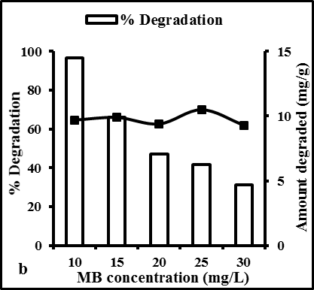
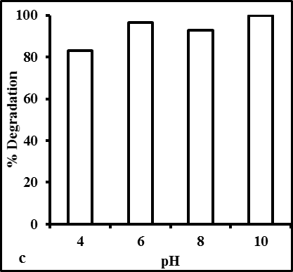
a

Figure 6. Photocatalytic degradation of methylene blue under different (a) mass of catalyst used, (b) concentrations and (c) pH of the methylene blue solution while keeping the other parameters constant. (Catalyst dosage = 800 mg, initial MB concentration = 10 mg/L and natural pH)

Figure 6c shows the photocatalytic efficiency of the CuO-BiVO₄ photocatalyst in the degradation of 10 mg/L MB solution at different initial pH levels. The photocatalytic degradation of MB increased from 83% to 96% when the pH was increased from 4 to 6 but did not show any significant difference after that till a pH of 10. In the photocatalytic mechanism, the holes can react with the added OH⁻, in alkaline conditions, to produce hydroxyl radicals (Equation 2) which subsequently can degrade the pollutant. At the same time the holes themselves can also degrade the pollutant (Equation 4).

h⁺ + HO⁻ •OH (2)
•OH + organic pollutant product of degradation (3)
h⁺ + organic pollutant product of degradation (4)

It was hence expected that the rate constant at pH 10 would be higher than that of pH 6 as more hydroxyl radicals were produced to degrade the MB dye. For confirmation, the rate constant of the reaction, k_{app}, at pH 6 – 10 was determined. It was found that although the degradation of MB reached 100% at pH 10, the calculated rate constant, k_{app}, remained almost constant, with value of 0.011min⁻¹ at pH 6 and 0.012 min⁻¹ at pH 10. This indicated that the photodegradation of the 10 mgL⁻¹ MB was mainly due to the reaction between the holes and the MB molecules.

Conclusion
A series of CuO-BiVO₄ photocatalysts were successfully prepared via impregnation of nanocrystalline BiVO₄. Structural studies indicated that the synthesized photocatalysts were spherical with a particle size range of 20 to 100 nm and were dominated by the monoclinic scheelite crystalline phase. The photocatalytic activity of the pure BiVO₄ photocatalyst, prepared by a simple precipitation method, was enhanced with CuO loading and the highest photodegradation efficiency of MB was obtained at 1 wt% CuO content. The optimized conditions for the photodegradation of MB were catalyst dosage = 800 mg, initial concentration and pH of the MB solution = 10 mg/L and 10, respectively.

Acknowledgement
The authors would like to acknowledge the research grant from the Ministry of Higher Education (FRGS-01-01-07-143FR) and Universiti Putra Malaysia’s Graduate Research Fellowship (T.P. Wan) for supporting this research.

References
- Fujishima, A., Hashimoto, K. and Watanabe, T. (1999). TiO₂ photocatalysis: Fundamentals and applications. BKC, Tokyo.
- Yin, S., Yamaki, H., Komatsu, M., Zhang, Q., Wang, J., Tang, Q., Saito, F. and Sato, T. (2003). Preparation of nitrogen-doped titania with high visible light induced photocatalytic activity by mechanochemical reaction of titania and hexamethylenetetramine. Journal of Materials Chemistry, 13 (12): 2996 – 3001.
- Livraghi, S., Votta, A., Paganini, M. C. and Giamello, E. (2005). The nature of paramagnetic species in nitrogen doped TiO₂ active in visible light photocatalysis. Chemical Communication, 41(4): 498 – 500.
- Cheng, X. L., Jiang, J. S., Jin, C. Y., Lin, C. C., Zeng, Y. and Zhang, Q. H. (2014). Cauliflower like α-Fe₂O₃ microstructures: Toulene-water interface assisted synthesis, characterization and application in wastewater treatment and visible light photocatalysis. Chemical Engineering Journal, 236(1): 139 – 148.
- Sanchez-Martinez, D., Martinez-de la Cruz, A. and Lopez-Cuellar, E. (2011). Photocatalytic properties of WO₃ nanoparticle obtained by precipitation in presence of urea as complexing agent. Applied Catalysis A-General, 398(1-2):179 – 186.
- Sun, J., Chen, G., Wu, J., Dong, H. and Xiong, G. (2013). BiVO₄ hollow spheres: Bubble template synthesis and enhanced photocatalytic properties. Applied Catalysis B-Environmental, 132: 304 – 314.
- Zhang, F. J., Xie, F-Z., Liu J., Zhao, W. and Zhang, K. (2013). Rapid sonochemical synthesis of nano laminar like Bi₂WO₆ as efficient visible light active photocatalyst. Ultrasonics Sonochemistry, 20: 2009 – 2015.
- Bi, Y., Ouyang, S., Umezawa N., Cao, J. and Ye, J. (2011). Facet effect of single-crystalline Ag₃PO₄ sub-microcrystals on photocatalytic properties. Journal of American Chemical Society, 133: 6490 – 6492.
- Wang, F., Shao, M., Cheng, L., Hua, J. and Wei, X. (2009). The synthesis of monoclinic bismuth vanadate nanoribbons and studies of photoconductive, photoresponse and photocatalytic properties. Materials Research Bulletin, 44(8): 1687–1691.
- Abdullah, A. H., Moey, H. J. M. and Yusof, N. A. (2012). Response surface methodology analysis of the photocatalytic removal of methylene blue using bismuth vanadate prepared via polyol route. Journal of Environmental Sciences, 24(9): 1694 – 1701.
- Shan, L., Mi, J., Dong, L., Han, Z. and Liu, B. (2014). Enhanced photocatalytic properties of silver oxide loaded bismuth vanadate, Chinese Journal of Chemical Engineering, 22: 909 – 913.
- Lin, X., Yu, L., Yan, L, Li, H., Yan, Y., Liu, C. and Zhai, H. (2014). Visible light photocatalytic activity of BiVO₄ particles with different morphologies. Solid State Sciences, 32: 61 – 66.
- Bian, Z-Y., Zhu, Y-Q., Zhang, J-X., Ding, A-Z. and Wang, H. (2014). Visible light driven degradation of ibuprofen using abundant metal loaded BiVO₄ photocatalyst. Chemosphere, 117: 527 – 531.
- Garcia-Perez, U. M., Sepulveda-Guzman, S. and Martinez-de la Cruz, A. (2012). Nanostructures BiVO₄ photocatalyst synthesized via polymer assisted co-precipitation method and their photocatalytic properties under visible light irradiation. Solid State Sciences, 14: 293 – 298.
- Chala, S., Wetchakun, K., Panichphant, S., Inceesungvorn, B. and Whetchakun, N. (2014). Enhanced visible-light-response photocatalytic degradation of methylene blue on Fe-loaded BiVO₄ photocatalyst. Journal of Alloys and Compounds, 597: 129 – 135.
- Karunakaran, C. and Kalaivani, S. (2014). Enhanced visible-light photocatalysis by hydrothermally synthesized thallium doped bismuth vanadate nanoparticle. Materials Science in Semiconductor Processing, 27: 352 – 361.
- Ju, P., Wang, P., Li, B., Fan, H., Ai, S., Zhang, D. and Wang, Y. (2014). A novel calcined Bi₂WO₆/BiVO₄ heterojunction photocatalyst with highly enhanced photocatalytic activity, Chemical Engineering Journal, 236: 430 – 437.
- Min, S., Wang, F., Jin, Z. and Xu, J. (2014). Cu₂O nanoparticles decorated BiVO₄ as an effective visible light driven p-n heterojunction photocatalyst for methylene blue degradation, Superlattices and Microstructures, 74: 294 – 307.
- Gao, X. M., Wu, Y. F., Wang, J., Fu, F., Zhang, L. P. and Niu, F. X. (2011). The preparation of CuO-BiVO₄ and its enhanced photocatalytic properties for degradation of phenol. Advanced Materials Research, 356 – 360: 1253 – 1257.
- Cho, S. K., Park, H. S., Lee, H. C., Nam, K. M. and Bard, A. J. (2013). Metal doping of BiVO₄ by composite electrodeposition with improved photoelectrochemical water oxidation. Journal of Physical Chemistry C, 117: 23048 – 23056.
- Jiang, H. Q., Endo, H., Natori, H., Nagai, M. and Kobayashi, K. (2009). Fabrication and efficient photocatalytic degradation of methylene blue over CuO/BiVO₄ composite under visible-light irradiation. Materials Research Bulletin, 44(3): 700 – 706.
- Kohtani, S., Hiro, J., Yamamoto, N., Kudo, A., Tokumura, K. and Nakagaki, R. (2005). Adsorptive and photocatalytic properties of Ag-loaded BiVO₄ on the degradation of 4-n-alkylphenols under visible light irradiation. Catalysis Communications, 6(3): 185 – 189.
- Das, R., Sarkar, S., Chakraborty, S., Choi, H. and Bhattacharjee, C. (2014). Remediation of antiseptic components in wastewater by photocatalysis using TiO₂ nanoparticle. Industrial and Engineering Chemical Research, 53(8): 3012 – 3020.

