

MALAYSIAN JOURNAL OF ANALYTICAL SCIENCES
ISSN 1394 - 2506

Published by The Malaysian Analytical Sciences Society

REDUCTION BEHAVIOUR OF TUNGSTEN DIOXIDE BY VARIOUS CONCENTRATION OF CARBON MONOXIDE

(Kelakuan Penurunan Tungsten Dioksida oleh Kepekatan Karbon Monoksida yang Berbeza)

Fairous Salleh¹*, Alinda Samsuri^{1,2}, Tengku Shafazila Tengku Saharuddin¹,

Mohamed Wahab Mohamed Hisham¹, Rizafizah Othaman¹, Mohd. Ambar Yarmo¹

¹Catalyst Research Group, School of Chemical Sciences and Food Technology,

Faculty of Science and Technology,

Universiti Kebangsaan Malaysia, 43600 UKM Bangi, Selangor, Malaysia

²Centre for Defense Foundation Studies,

Universiti Pertahanan Nasional Malaysia, Kem Sungai Besi, 57000 Kuala Lumpur, Malaysia

*Corresponding author: fairoussalleh@gmail.com

Received: 24 February 2015; Accepted: 27 October 2015

Abstract

The reduction behaviour of tungsten dioxide (WO₂) under both non-isothermal and isothermal conditions in various concentrations of carbon monoxide (CO) were investigated by using temperature-programmed reduction (TPR) and X-ray diffractometry (XRD) techniques. The influences of carbon monoxide concentration (20 and 40% v/v CO in N₂) on the reducibility of WO₂ to tungsten metal W have been investigated in the temperature range 40 – 900 ºC. The TPR profile shows that reduction using 40% CO produce higher thermal conductivity detector (TCD) signal in comparison by using 20 % CO. XRD results show that, by increasing the concentration of CO, the intensity of WO₂ decreases and tungsten carbide (WC) peak appeared. Moreover, holding the reduction time for 30 min in 20 and 40% of CO resulted in the formation of new peak of tungsten hemi carbide (W₂C) and WC, respectively. It can be concluded that by using CO, reduction steps comprise of WO₂ → W → W₂C → WC. The reduction behaviour of WO₂ is strongly dependent on the concentration of CO and hold time of reaction. Furthermore, excess of CO by isothermal reduction results in the formation of WC.

Keywords: tungsten dioxide, tungsten, tungsten carbide, carbon monoxide

Abstrak

Kelakuan penurunan tungsten dioksida (WO₂) melalui penurunan bukan isotermal dan isotermal menggunakan kepekatan karbon monoksida (CO) berbeza telah dikaji dengan menggunakan suhu penurunan berprogram (TPR) dan pembelauan sinar-X (XRD). Kesan kepekatan karbon monoksida (20 dan 40% v/v CO dalam N₂) terhadap kadar penurunan WO₂ kepada W telah dikaji dalam suhu 40 – 900 °C. Profil TPR menunjukkan bahawa penurunan dengan menggunakan 40% CO menghasilkan isyarat TCD lebih tinggi berbanding dengan menggunakan 20% CO. Keputusan XRD menunjukkan bahawa, dengan meningkatkan kepekatan CO, keamatan WO₂ menurun dan puncak tungsten karbida (WC) muncul. Selain itu, dengan penambahan masa tindak balas selama 30 minit menggunakan 20 dan 40% CO menghasilkan puncak baru masing-masing tungsten hemi karbida (W₂C) dan WC. Dapat disimpulkan bahawa dengan menggunakan CO, langkah penurunan terdiri daripada WO₂ → W → W₂C → WC. Tingkahlaku penurunan WO₂ amat bergantung kepada kepekatan CO dan penambahan masa tindak balas. Tambahan pula, pendedahan kepada CO berlebihan daripada penurunan isotermal menyebabkan pembentukan WC.

Kata kunci: tungsten dioksida, tungsten, tungsten karbida, karbon monoksida

Introduction

Tungsten is used in four main different applications that are WC, as an alloy additive, pure tungsten, and tungsten chemicals [1]. Due to superior properties, such as high melting point (3422 °C), high conductivity, thermal and chemical stability, high hardness and strength, etc. Tungsten is widely used in the contemporary industry and especially for high-temperature structural applications [2]. Tungsten is often used because of its superior thermal properties and low vapour pressure. The best known its application is as lamp filament and as electron emitters because it can be used at very high temperature. Furthermore, tungsten also used as organic tungsten dyes and pigments that can be used in variety materials. While, tungsten carbide is the most common hard materials in use today for cutting tools and other high strength application due to its high hardness at high temperatures [1].Tungsten oxides are frequently used as raw materials for recovering metal tungsten powder by reduction process for hardmetal industry and doping process for decades [1].

To further lower the temperature of oxide reduction, a reducing agent can be used [3]. The reducing agent can be hydrogen, carbon, methane, magnesium and carbon monoxide [2,4]. Tungsten oxide having several compositions like WO_{2.9}, WO_{2.72}, WO₂, WO and W₃O [5]. Venables et al. [6] studied the reduction of WO₃ with carbon monoxide using TGA. The intermediate phases W₂₀O₅₈, W₁₈O₄₉ and WO₂ were observed in the reduction, and the final product is WC. Generally reduction of tungsten oxide divided into two stages: (i) a low-temperature stage (< 777 ºC) which reduce WO₃ → WO₂ involving formation and reduction of three intermediate sub oxide of (WO_{2.96}, WO_{2.9} and WO_{2.72}, and (ii) high temperature stage which reduce WO₂ to W at > 777 ºC [5]. Studies on reduction of WO₃ using hydrogen and carbon monoxide as reducing agent have been published. However, there are limited studies were reported on the reduction of WO₂. This work focuses on the reduction of tungsten WO₂ in the presence of different concentration of CO as reducing agent. The effects of isothermal reduction on the formation of the product were also investigated.

Materials and Methods

Chemicals and raw materials

WO₂ ≥ 99% and W ≥ 99% powder Sigma Aldrich was used. The gas mixture CO in N₂ (20, and 40 vol % of CO) from MOX was used as reducing agents.

Reduction of WO₂

Reduction of WO₂ was performed using TPR instrument Micromritics Autochem 2920 Chemisorption Analyzer apparatus. An amount 5 – 8 mg of the samples were introduced in nonisothermal mode up to 900 °C under two different concentration of gas mixture of 20% and 40% of (CO in N₂) with a heating rate of 10 ºC/min with flow rates 20 ml/min. In another experiment, the measurement was carried out using the same method, and continued with isothermal mode at 900 °C for 30 min, under the similar reducing gas.

Characterization method

XRD analysis of samples were performed using XRD’s Bruker AXS D8 Advance type with X-ray radiation source of Cu Kα (40kV, 40 mA) to record the 2θ diffraction angle from 10° to 80° at wavelength (λ = 0.154 nm) of 1 g sample. For identification purposes of crystalline phase composition, diffraction pattern obtained were matched with standard diffraction data (JCPDS) files.

Results and Discussion

Thermodynamic consideration data

Thermodynamic analysis of WO₂ was performed for the reduction as in Equation 1 and CO as a reducing agent. The Gibbs free energy change due to reaction and the equilibrium composition of the oxides were calculated. From the calculation, clearly indicates that the reduction by CO reaction is spontaneous (ΔG_{r} = +6 up to +15 kcal/mol) temperature 400 to 1000 ºC. Enthalpy (∆H_{r}) reduction is endothermic, where the value of ∆H_{r} is +24 kcal/mol.

WO₂ + 2CO → W + 2CO₂ (1)

TPR analysis

The TPR profile obtained for non-isothermal and isothermal reduction of WO₂ under 20% and 40% CO in N₂ as reducing gas shown in Figure 1. Profile (a) indicates that reduction by 20% CO in N₂ of WO₂ up to 900ºC while (b) is reduction by 40% CO in N₂ of WO₂. The shoulder and peaks monitor in the both profile look quite similar. However, for reduction using 40% CO produce higher signal in comparison by using 20% CO. It is due to the low rate of reaction which resulted to low reducibility in 20% CO in N₂. A similar TPR experiment was performed on a sample of WO₂ and continued with isothermal condition at 900 ºC for 30 minutes. According to the profile, no obvious peak was observed upon holding the reaction time for 30 minutes for all the reactions. The residual obtained after reduction were then subjected to XRD analysis for recording XRD pattern.

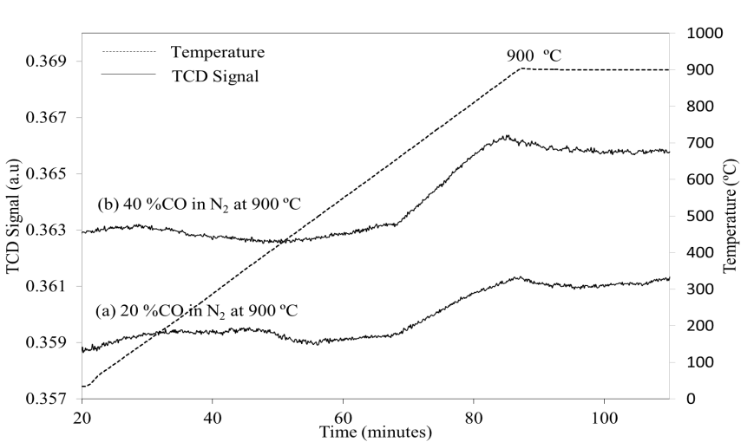

Figure 1. TPR profile obtained for non-isothermal and isothermal reduction of WO₂ by 20% and 40% (CO in N₂) up to 900 ºC and hold for 30 minutes respectively

XRD analysis

The X-ray diffraction patterns of the reduction product were analyzing to study the behavior of WO₂ reduction. The comparison of sample XRD pattern of the non-isothermal reduction under various concentration of CO in N₂ (20% and 40%) was in Figure 2. From the results, the non-isothermal reduction product of WO₂ under 20% and 40% CO in N₂ were rather similar with small reduction which 3 peaks of W metal assigned (JCPDS 04-0806) and major peak of remaining unreduced WO₂ (JCPDS 32-1393) was observed. However, reduction product by 40% CO shown low intensity of crystalline phase of W metal in comparison of reduction product by 20% CO which shown higher intensity of W. Nevertheless, by increasing the concentration of CO lead to the appearance of a new peak of WC (JCPDS 51-0939). From the results, it was obvious shown that by increasing the concentration of CO, the intensity of WO₂ decreases and WC peak appeared due to transformation of W phase to WC [6].

The reduction was continued for isothermal reduction at same temperature for 30 min. The XRD pattern were compared to the various concentration of CO in N₂ (20 and 40%) in Figure 3. From the results, isothermal reduction with 20% CO showed in identifying of higher intensity of W metal in comparison to reduction with 40% CO. The limited formation of W phases may attribute to the excessing CO introduced to the system which results to the formation of carbide. It was in agreement with previous study [6], where the formation of WC was transform from W metal phase. The XRD pattern shows the new peak observed correspond to the W₂C and WC appeared under gas of 20% CO and 40% CO respectively.

It can be concluded that, higher the concentration of CO introduced to the system, lead to the formation of WC. The WC observed in XRD pattern is in agreement to previous study working on VI transition metal carbide catalysts. It is obvious that suitable concentration of CO and reaction time need to consider in order reducing WO₂ to W metal. It is probably since, among phase transitions in the reduction of WO₃ to W, from WO₃→WO_{2.9}, WO_{2.9}→W₁₈O₄₉, and W₁₈O₄₉→WO₂ and WO₂→ W, transition WO₂ to W proceed very limited [7]. It was matched with the thermodynamic calculation in Eq. (1) where the enthalpy value for reduction WO₂ to W and WO₃ to W are endothermic and exothermic respectively in carbon monoxide atmosphere. The traces of WO₃ were observed in the pattern of reduction WO₂ sample; this is probably due to the slight oxidation on the WO₂ commercial sample prior undergoing the reduction process.

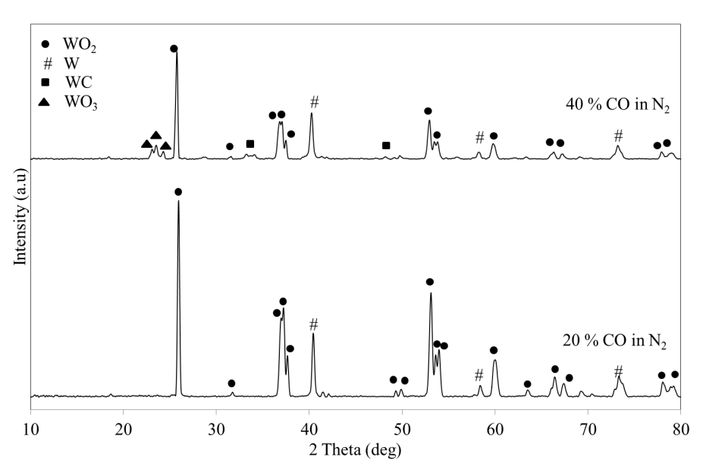

Figure 2. XRD profile obtained for non-isothermal reduction of WO₂ by 20% and 40% (CO in N₂) up to 900 ºC

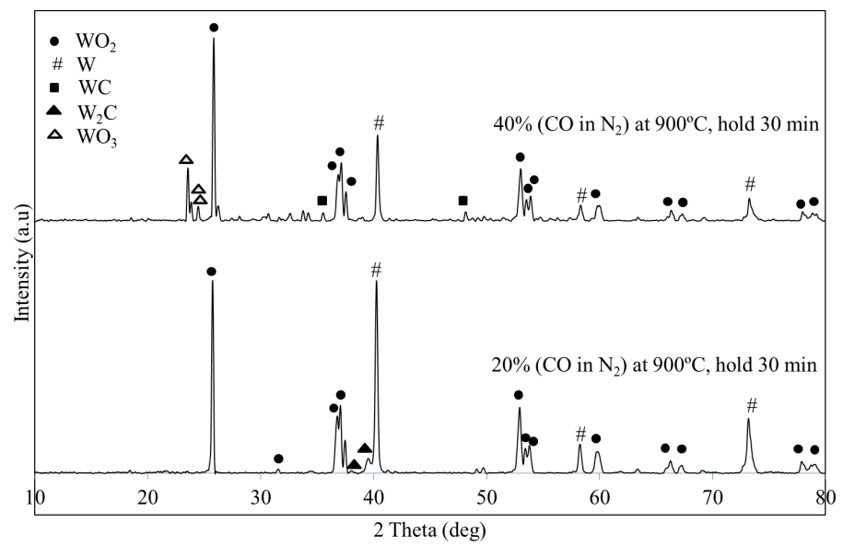

Figure 3. XRD profile for isothermal reduction of WO₂ by 20 and 40 % (CO in N₂) up to 900 ºC and hold for 30 min

Conclusion

Tungsten (IV) oxide (WO₂) samples were characterized using the TPR and XRD methods to investigate the reduction behavior. The WO₂ was reduced to W and some remaining unreduced WO₂ in both concentrations. However, by increasing the concentration of CO to 40%, the remaining WO₂ peaks were decreases and low crystalline phase of W peaks were observed. Furthermore, reduction of WO₂ is improved by hold the reaction at 900 ºC for 30 min. It can be proved by formation of higher peak of W phase for both concentrations compared to nonisothermal reduction. However, excess of CO introduced lead to the formation of tungsten semi carbide (W₂C) and tungsten carbide (WC) under 20% and 40% CO in N₂ respectively.

Acknowledgement

The author s wish to thank Ministry of Higher Education (MOHE) and Universiti Kebangsaan Malaysia (UKM) for funding this project under research grant number LRGS/BU/2011/USM-UKM/PG/02, BKBP-FST-K003323-2014, FRGS/2/2013/TK06/UKM/02/3, ETP-2013-066 and Centre of Research and Innovation Management (CRIM) for the instruments facilities.

References
- Ricceri, R. and Matteazzi, P. (2003). A study of formation of nanometric W by room temperature mechanosynthesis. Journal of Alloys and Compounds, 358: 71 – 75.
- Baghdasaryan, A. M., Niazyan, O. M., Khachatryan, H. L. and Kharatyan, S. L. (2014). DTA/TG study of tungsten oxide and ammonium tungstate reduction by (Mg + C) combined reducers at non-isothermal conditions. International Journal Refractory Metals & Hard Materials. 43: 216 – 221.
- Jiqiao, L., Baiyun, H. and Zhiqiang, Z. (2001). Determination of physical characterization of tungsten oxides. International Journal Refractory Metals & Hard Materials, 19 (2): 79 – 84.
- Kwak, J. H., Han, G. Y. and Yoon, K. J. (2013). Zirconia supported tungsten oxides for cyclic production of syngas and hydrogen by methane reforming and water splitting. International Journal of Hydrogen Energy, 38: 8293 – 8305.
- Zaki, M. I., Fouad, N. E., Mansour, S. A. A. and Muftah, A. I. (2011). Temperature-programmed and X-ray diffractometry studies of hydrogen reduction course and products of WO₃ powder: Influence of reduction parameters. Thermochimica Acta, 523 (1–2): 90 – 96.
- Venables, D. S. and Brown, M. E. (1997). Reduction of Tungsten Oxides with Carbon Monoxide. Thermochimica Acta, 291: 131 – 140.
- Xiang-wei, W. U., Jing-song, L. U. O. and Bi-zhi, L. U. (2009). crystal growth of tungsten during hydrogen reduction of tungsten oxide at high temperature. Transactions of Nonferrous Metals Society of China, 19: 785 - 789.

