

MALAYSIAN JOURNAL OF ANALYTICAL SCIENCES
ISSN 1394 - 2506

Published by The Malaysian Analytical Sciences Society

SEED CULTURE CONDITIONS FOR HIGH YIELD OF CELLULOLYTIC ENZYMES PRODUCTION FROM Pycnoporus sanguineus

(Keadaan Kultur Benih untuk Penghasilan Enzim Selulolitik daripada Pycnoporus sanguineus)

Rafidah Jalil¹, Mohd Sahaid Kalil¹*, Norliza Abdul Rahman¹, Aidil Abdul Hamid², Mohd Farid Ahmad³

¹Department of Chemical & Process Engineering, Faculty of Engineering & Built Environment

²School of Bioscience and Biotechnology, Faculty of Science & Technology

Universiti Kebangsaan Malaysia, 43600 UKM Bangi, Selangor, Malaysia

³Forest Research Institute Malaysia (FRIM), 52109 Kepong, Selangor, Malaysia

*Corresponding author: sahaid@ukm.edu.my

Received: 21 October 2015; Accepted: 14 June 2016

Abstract

Low yields and productivity in fermentation industry usually due to poor quality of seed culture (inoculum). As the first stage in the fermentation process, inoculum consistency in terms of size and quality is clearly important for high yield of enzymes production. Selection of microorganism also plays an important role in improving the productivity. Fungi type of white rot basidiomycetes species is a well-known cellulolytic enzymes producer and capable to degrade many types of lignocellulosic biomass. Cellulolytic enzymes produced from white rot fungi, Pycnoporus sanguineus (PS) were investigated. The PS cultured on different agar media and parameter conditions of seed culture preparation in liquid medium broth were compared. Seed culture conditions of PS were influenced by many factors such as type of medium used for fungal growth, temperature, incubation time in liquid medium and subculture time on agar medium. PS was full-grown on potato dextrose agar (PDA) on day 5 compared to malt extract agar (MEA) on day 7. Seed culture conditions was determined using standard liquid medium, potato dextrose broth (PDB) at constant temperature (30 °C), agitation speed (150 rpm) and pH (4.8) for duration of seven days using two different subculture of PS that were grown for five and seven days. It was found that the five days’ subculture of PS shown 3.93% higher cell dry weight of fungal biomass (3.44 g/L on day 5) and higher cellulolytic enzymes activity; 95.49% (FPase), 3.14% (CMCase), 7.71% (exoglucanases) and 14.93% (xylanases). Maximum cellulolytic enzymes were found after 48 hours’ incubation with filter paper activity (FPase) of 1.79 U/mL, carboxymethyl cellulase activity (CMCase) of 3.36 U/mL, exoglucanase activity (Avicelase) of 0.59 U/mL and xylanase enzymes activity of 0.66 U/mL. Reducing sugars concentration decreased from day 1 to 7 due to consumption of sugars for fungal growth. Seed culture conditions were strongly influenced by subculture and incubation time in liquid medium to produce high yield of cellulolytic enzymes from PS.

Keywords: white rot fungi, Pycnoporus sanguineus, seed culture, cellulolytic enzymes, fermentation

Abstrak

Hasil dan produktiviti yang rendah dalam industri fermentasi biasanya disebabkan oleh kultur benih (inokulum) yang kurang berkualiti. Pada peringkat pertama proses fermentasi, konsistensi inokulum dari segi saiz dan kualiti sangat penting bagi pengeluaran enzim yang tinggi. Pemilihan mikroorganisma juga memainkan peranan penting dalam meningkatkan produktiviti. Jenis kulat pereput putih dari spesies basidiomycetes sangat terkenal sebagai pengeluar enzim selulolitik dan ia mampu untuk mengurai pelbagai jenis bahan lignoselulosa. Dalam kajian ini, enzim selulolitik dihasilkan daripada kulat pereput putih, Pycnoporus sanguineus (PS) yang dihidupkan di atas agar dan perbandingan parameter berbeza penyediaan kultur benih dalam medium cecair dikaji. Kultur benih PS dipengaruhi oleh pelbagai faktor seperti jenis medium yang digunakan untuk pertumbuhan kulat, suhu, masa pengeraman di atas medium agar dan di dalam medium cecair. Pertumbuhan maksimum PS di atas agar kentang dekstrosa (PDA) dicapai pada hari ke-lima berbanding dengan agar ekstrak malt (MEA) pada hari ke-tujuh. Kultur benih ditentukan dengan menggunakan medium piawai iaitu medium kentang dekstrosa (PDB) pada suhu malar (30 °C), kelajuan pengadukan (150 rpm) dan pH (4.8) untuk tempoh masa tujuh hari menggunakan dua kultur PS berbeza yang dieram selama lima dan tujuh hari. Didapati bahawa kultur PS 5 hari menunjukkan berat kering sel kulat yang lebih tinggi iaitu 3.93% (3.44 g/L pada hari ke-lima) dan aktiviti enzim selulolitik lebih tinggi; 95.49% (FPase), 3.14% (CMCase), 7.71% (ekoglukanase) and 14.93% (xilanase). Pengeluaran enzim selulolitik maksimum diperolehi selepas 48 jam pengeraman dengan aktiviti kertas turas (FPase) 1.79 U/mL, aktiviti karboksimetil selulase (CMCase) 3.36 U/mL, aktiviti eksoglukanase (Avicelase) 0.59 U/mL dan aktiviti enzim xilanase 0.66 U/mL. Selain itu, kepekatan gula penurun berkurang dari hari 1-7 disebabkan oleh penggunaan gula untuk pertumbuhan kulat. Ini menunjukkan bahawa keadaan inokulum dipengaruhi oleh jenis kultur dan masa pengeraman dalam medium cecair untuk pengeluaran hasil enzim selulolitik yang tinggi dari PS.

Kata kunci: kulat pereput putih, Pycnoporus sanguineus, kultur benih, enzim selulolitik, penapaian

Introduction

Cellulolytic enzymes productions have been studied extensively throughout the world. These enzymes produced using microorganisms either bacteria or fungi. Commercially, fungi types from Trichoderma species have been used for production of cellulase [1]. Today, studies have been carried out to discover other potential of fungi that can produce high cellulolytic enzymes. These enzymes responsible to convert cellulose into glucose; fermentable sugars that will be used in fermentation industry to produce biofuel and value added products. Cellulolytic enzymes consist of complete cellulase system that classified into three major classes; endoglucanases, exoglucanases and β-glucosidases [2]. All enzymes have their specific roles; endoglucanases act randomly on soluble and insoluble cellulose chains, exoglucanases release the cellobiose from the reducing and non-reducing ends of cellulose chains and β-glucosidases release glucose from cellobiose release by exoglucanases [3].

Pycnoporus sanguineus (PS) is one of basidiomycetes species of white rot fungi also known as wood decaying fungi that has highly potential for lignocellulolytic enzymes production. It could degrade the lignocellulosic component of cellulose, hemicellulose and lignin. It acts as a biological pre-treatment as well as to produce value added products [4]. PS has a promising capacity with multi applications, so that it can be a feedstock bio refinery sector as well as for enzymes industry [5]. PS is also a good and thermostable cellulase producer that can maintain more than 90% of activities above temperature of 90 °C [6]. It can grow at moderately high temperature (37 °C) [1]. This fungus was applied in agro-industrial waste because of their good results in many applications [7].

In fermentation industry, there are a few stages involved in enzymes production starting from subculture of microorganism on agar medium followed by seed culture or inoculum preparation before proceed for the production culture of enzymes production. Efficient enzymes will be the main catalyst for fermentable sugar production in fermentation industry. Since degradation process of lignocellulosic biomass using enzymes is slow and less economical, new methods have been explored to enhance the fermentable sugars for high yield production [8]. One of the factors is during seed culture or inoculum preparation stage that will be the key for the enhancement of product yield. The critical step for enzymes production is seed culture stage and the selection of its correct conditions will influence the yield of cellulolytic enzymes produced. There are many factors influenced the seed culture conditions such as type of medium used for fungal growth, temperature, pH, incubation time in liquid medium and subculture time on medium agar. Production of enzymes using PS at temperature ranging from 30 to 40 ⁰C can maintained its activity up to 85% and the optimum pH is 5 [1]. pH of medium is important since it plays an important role in fungal growth by inducing its morphological structural and enzymes secretion [7].

The aimed of this study is to determine the seed culture conditions of PS as inoculum to produce cellulolytic enzymes. Identification of maximum cellulolytic enzymes activities was carried out using different subcultures of PS to determine the effect of subculture incubation time on product yields.

Materials and Methods
Fungal strain
White rot fungi PS was obtained from the Wood Mycology Laboratory, Forest Research Institute Malaysia. It was collected from a dead tree in the FRIM Campus. In the laboratory, the fungus was firstly grown on Petri dish containing two different agar media namely, Malt extract agar (MEA)(12.75 g/L maltose, 2.75 g/L dextrin, 2.35 g/L glycerol, 0.78 g/L peptone and 15.0 g/L agar) and Potato dextrose agar (PDA)(4 g/L potato starch, 20 g/L dextrose and 15 g/L agar) to determine the mycelia growth diameter at temperature of 30 °C for seven days.

Seed culture condition
For the seed culture preparations, 1 cm³ mycelia disc cut of PS using sterilized cork borer from the petri dish were inoculated into seven shake flasks containing 100 mL of PDB. The experimental works were carried out in triplicates. The liquid medium used for seed culture preparation in this experiments consist of 4 g/L potato and 20 g/L dextrose, with pH of medium is 4.8. The seed culture was incubated at temperature of 30 °C and was shaken at 150 rpm [9]. The sampling of seed culture broth was carried out every day. The flask containing mycelia of fungi was filtered using filter paper to determine the cell dry weight of fungal biomass. The fungal biomass was oven dried at 60 °C in an oven for 24 hours until reached a constant weight. The filtrate collected known as supernatant was further analyzed for its reducing sugars content and cellulolytic enzymes activities.

Reducing sugars and enzymatic assays
Reducing sugars and enzymatic assays were assayed from the supernatant collected from the filtration of seed culture. Reducing sugars released were assayed based on the method described by Miller [10]. 1 mL of sample of supernatant was mixed with 3 mL DNS reagent and boiled for 5 minutes in a water bath. After cooled down, 20 mL of distilled water was added to reaction mixture and the sample was analyzed using UV-Vis spectrophotometer at 540 nm to obtain the absorbance value. The reducing sugar released was calculated based on the standard curves.

Cellulase and xylanase activities were assayed based on the method described by Ghose [11] and Ghose & Bisaria [12], respectively. The activities were measured based on the concentration of reducing sugar released. For cellulase enzymes activities, reaction mixture consists of 0.5 mL substrate solution and 0.5 ml sample. For substrate solution, it consists of 1% of Carboxymethyl cellulose (CMCase assay) and 1% of avicel (Avicelase assay) in 0.05 M sodium citrate buffer. The reaction mixtures were incubated for 30 minutes at temperature of 50 °C. An amount 3 mL of DNS reagent was then added into the mixture and boiled for five minutes before being analyzed using spectrophotometer to determine the absorbance value. For filter paper activity (FPase), the reaction mixture consists of 1 mL 0.05 M sodium citrate buffer, Whatman filter paper (No. 1) strip measuring 1 cm x 6 cm. and 0.5 mL sample. The reaction mixtures were incubated for one hour at 50 °C. For xylanase enzyme activities, similar method as the CMCase was carried out to determine cellulase activities but only 1% xylan was used in 0.05 M sodium citrate buffer as substrate solutions. Enzymes activities for cellulase and xylanase enzymes were measured using standard curve of glucose and xylose respectively.

Results and Discussion
Effect of different agar media on growth of Pycnoporus sanguineus
The growth diameter of PS was studied using different agar media namely; MEA and PDA. It was found that the PS grew faster on PDA compared to MEA as shown in Figure 1. The fungal growth rate on PDA and MEA recorded were 1.27 cm/day and 0.93 cm/day, respectively.

These results could suggest that the fast growth rate of PS on PDA was probably influenced by the present of dextrose in the agar medium. The present observations are in the agreement with a previous report, where dextrose has been proven to be the best carbon source for fungal growth during incubation time compared to maltose [13]. Instead of using PDA as medium for fungal growth, lignocellulosic biomass has been added in medium as substrate for fungal growth. Rice husk as substrate in agar medium can increase the growth rate (1.24 cm/day) of PS at growth conditions of 28 °C for seven days [14]. As compared to this study, using PDA alone and by increasing the incubation temperature (30 °C) can increase the growth rate up to 1.27 cm/day for five days.

Effect of different subculture of pycnoporus sanguineus on cell dry weight (CDW) of fungal biomass
The growth rate of PS was also influenced by the conditions of seed culture. In this study, the PS was grown at two different conditions on agar plate known as subculture five days (Sc PS-5) and subculture seven days (Sc PS-7). It was found that the seed culture using Sc PS-5 produced higher CDW of the fungal biomass 3.44 g/L compared to Sc PS-7 (3.31 g/L) at day five of incubation time (Figure 2). It shows that 3.93% decreased of CDW when the Sc PS-7 was applied for seed culture production. However, the mycelia growth based on CDW of fungal biomass did not have direct correlation with production of cellulolytic enzymes [14]. It has been proven in this study for Sc PS-5. When CDW was 3.44 g/L at day 5, the CMCase was 3.36 U/mL. While at day 2, CDW was only 1.88 g/L with highest activity of CMCase (2.44 U/mL).

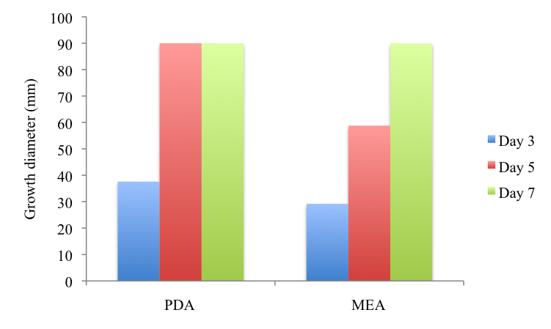

Figure 1. Growth of Pycnoporus sanguineus on MEA and PDA

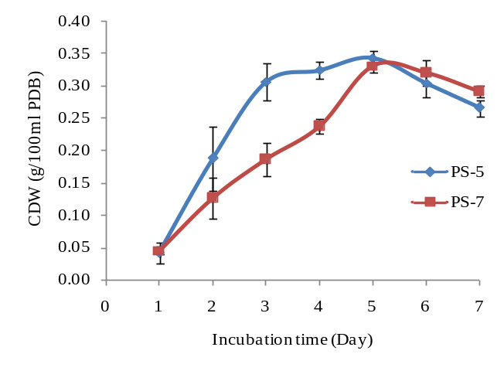

Figure 2. Cell dry weight (CDW) of Pycnoporus sanguineus

Reducing sugars assay of Pycnoporus sanguineus
Reducing sugars (RS) for both subcultures of PS decreased from day 1 to day 7 of incubation time as shown in Figure 3. This is due to the glucose consumption during fungal growth and the initial glucose present in the liquid medium was utilized for fungal growth [15]. Sc PS-7 consumed more glucose (17.75 mg/mL) as compared to Sc PS-5 (16.80 mg/mL) for its growth. It is because older cultures need more nutrients to maintain its further growth.

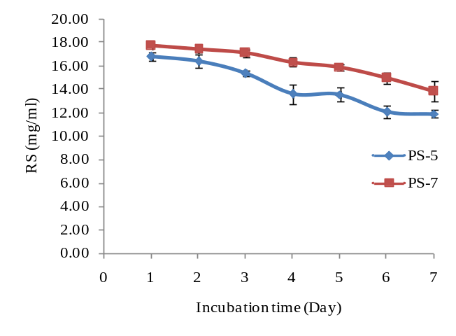

Figure 3. Reducing sugars (RS) of Pycnoporus sanguineus

Cellulolytic enzymes activities of Pycnoporus sanguineus for different incubation time of subcultures
Filter paper assay activities (FPase)
FPase is a total cellulase activities resulting from the combination of different cellulase enzymes in the culture filtrate [2]. Figure 4 shows the comparison of filter paper activities of PS. It is found that the maximum FPase activity obtained using Sc PS-5 was 1.79 U/mL after 48 hours’ incubation time. As compared to other Pycnoporus species; Pycnoporus coccineus produced 0.93 U/mL of FPase after incubated for three days [16].

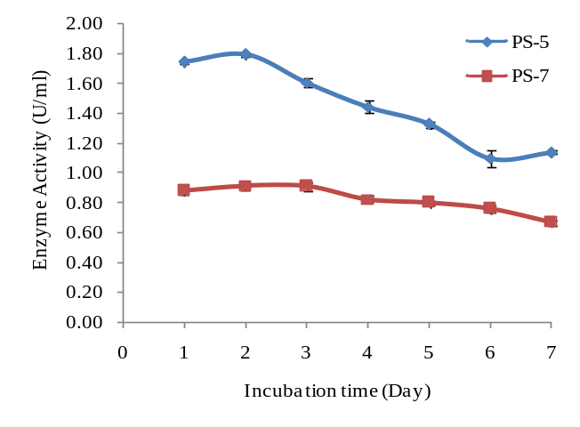

Figure 4. FPase of Pycnoporus sanguineus

Carboxymethyl cellulase @ Endoglucanase enzymes activities (CMCase)

CMCase enzymes activities for both subcultures have been analyzed and compared as shown in Figure 5. It is found that maximum CMCase activity was 3.36 U/ml after 48 hours’ incubation time using Sc PS-5. Previous research reported that PS produced maximum CMCase activity level (1.43 U/mg on 8th day) at pH 5.0 and decreasing or increasing the pH value will decrease the activity level [1]. For Pycnoporus coccineus, it produced 0.95 U/ml of CMCase after incubated for three days [16].

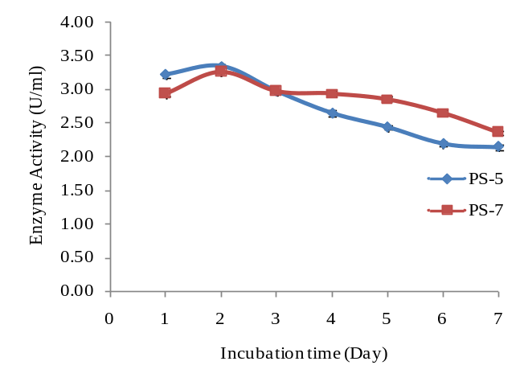

Figure 5. CMCase of Pycnoporus sanguineus

Avicelase @ Exoglucanases activities

Exoglucanase known also as avicelase enzyme activity was measured using microcrystalline cellulose (Avicel) as the substrate. The activities for avicelase enzymes were compared and shown in Figure 6. It is found that the maximum Avicelase activity (0.59 U/ml) was obtained after 48 hours’ incubation time using Sc PS-5. As compared to Sc PS-7, it shows very small significant different with 6.78% of activities decreased. Previous research reported that 0.30 U/mg of Avicelase produced from PS after 8th day [1].

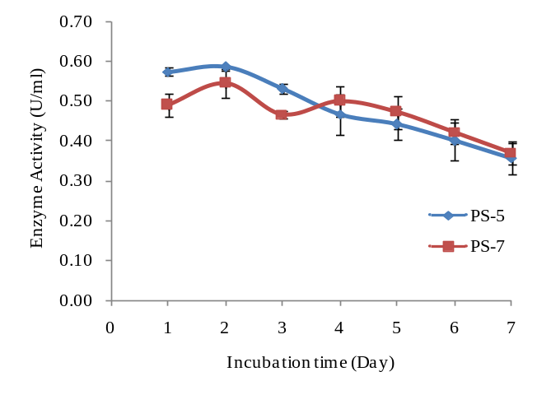

Figure 6. Avicelase of Pycnoporus sanguineus

Xylanase enzymes activities

Maximum xylanase enzymes activities for Sc PS-5 (0.66 U/mL) were higher than Sc PS-7 (0.57 U/mL) after 48 hours’ incubation time (Figure 7). Previous research reported that Aspergillus niger was produced 0.71 U/mL of xylanase activities after 30 hours’ incubation times [17].

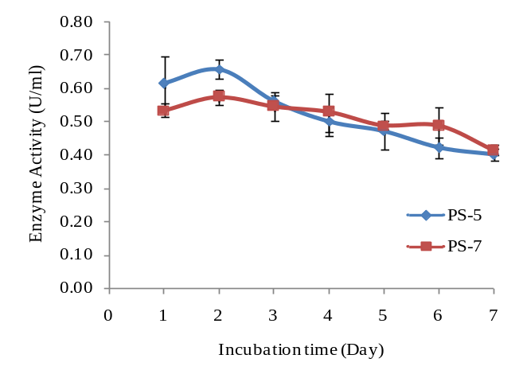

Figure 7. Xylanase of Pycnoporus sanguineus

Comparison of seed culture conditions using different subculture of Pycnoporus sanguineus

Based on the findings, comparisons between both subcultures were analyzed. It was found that the seed culture condition to produce cellulolytic enzymes was obtained using Sc PS-5 on agar medium followed by 48 hours’ incubation time during seed culture or inoculum preparation. These findings were achieved at constant temperature of 30 °C, agitation speed of 150 rpm and pH of 4.8 using 1 cm³ of mycelia disc as fungal inoculum source. Table 1 below shows the summary of cellulolytic enzymes produce at 48 hours’ incubation time using both subcultures.

Table 1. Comparison of Pycnoporus sanguineus cellulolytic enzymes activity at 48 hours’ incubation times
Enzyme | Sc PS-5 | Sc PS-7
FPase (U/mL) | 1.79 | 0.92
CMCase (U/mL) | 3.36 | 3.25
Avicelase (U/mL) | 0.59 | 0.55
Xylanase (U/mL) | 0.66 | 0.57

From Table 1, it shows that all the cellulolytic enzymes activity was higher using Sc PS-5 compared to Sc PS-7. This seed culture conditions can be used as a base-line study for enzymes production from PS. Besides, it can reduce the culture times from seven to five days as commonly applied by other researchers [5,4,18].

Conclusion

The seed culture conditions of PS to produce enzymes was obtained using Sc PS-5 with the highest cellulase; FPase (1.79 U/mL), CMCase (3.36 U/mL), Avicelase (0.59 U/mL) and xylanase enzymes activities (0.66 U/mL) after 48 hours’ incubation time. Results obtained at the constant pH medium (pH 4.8), temperature (30 °C), agitation speed (150 rpm), and mycelium disc size (1 cm³). These findings help to reduce the inoculum preparation time.

Acknowledgement
The authors gratefully acknowledge the Hadiah Latihan Persekutuan (HLP) from Jabatan Perkhidmatan Awam (JPA) of Malaysia, the Research University (RU) Grant provided by University Kebangsaan Malaysia (UKM) (FRGS/2/2013/TK05/UKM/02/1 & UKM-GUP-2013-037) and Forest Research Institute Malaysia (FRIM) to support this research work.

References
      - Quiroz-Castaneda, R. E., Balcazar-Lopez, E., Dantan-Gonzalez, E., Martinez, A., Folch-Mallol, J. and Martinez-Anaya, C. (2009). Characterization of cellulolytic activities of Bjerkandera adusta and Pycnoporus sanguineus on Solid Wheat Straw Medium. Electronic Journal of Biotechnology, 12(4): 1 – 8.
      - Praveen, K., Usha, K.Y., Shanthi, B., Ramanjaneyulu, G., Naveen, M. and Reddy B. R. (2012). Production of cellulolytic enzymes by a mushroom – stereum ostrea. International Journal of Research in Biochemistry and Biophysics, 2(1):1 – 4.
      - Namita, B., Rupinder, T., Raman, S. and Sanjeev, K. S. (2012). Production of cellulases from Aspergillus niger NS-2 in solid state fermentation on agricultural and kitchen waste residues. Waste Management, 32: 1341 – 1346.
      - Teoh, Y. P., Mashitah, M. D. and Salmiah, U. (2011). Media selection for mycelia growth, antifungal activity against wood-degrading fungi and GC-MS study by Pycnoporus sanguineus. Bioresources, 6(3): 2719 – 2731.
      - Pooja, S., Othman, S., Rokiah, H., Leh, C. P. and Rajeev, P. S. (2012). Biodegradation study of Pycnoporus sanguineus and its effect on structural and chemical features on oil palm biomass chips. Lignocellulose, 1(3):210 – 227.
      - Gutierrez-Soto, G., Medina-Gonzalez, G. E., Gracia-Zambrano, E. A., Trevino-Ramirez, J. E. and Hernandez-Luna, C. E. (2015). Selection and characterization of a native Pycnoporus sanguineus as a lignocellulolytic extract producer from submerged cultures of various agroindustrial wastes. BioResources, 10(2):3564 – 3576.
      - Onofre, S. B., Santos, Z. P. Q., Kagimura, F. Y. and Mattiello, S. P. (2015). Cellulases produced by the endo-phytic fungus Pycnoporus sanguineus (L.) Murrill. African Journal of Agricultural Research, 10(13):1557 – 1564.
      - Ibrahim, C.O. (2007). Development of applications of industrial enzymes from Malaysian indigenous microbial sources. Bioresource Technology, 99: 4572 – 4582.
      - Shobana, P. and Maheswari, N. U. (2013). Production of cellulase from Aspergillus fumigatus under submerged and solid state fermentation using agricultural waste. International Journal of Advances in Pharmacy, Biology and Chemistry, 2(4): 595 – 599.
      - Miller, G. L. (1959). Use of dinitrosalicylic acid reagent for determination of reducing sugar. Analytical Chemistry, 13(6): 426 – 428.
      - Ghose, T. K. (1987). Measurement of cellulase activities. Pure & Applied Chemistry, 59:257 – 268.
      - Ghose, T. K. and Bisaria, V. S. (1987). Measurement of hemicellulase activities Part 1: Xylanases. Pure & Applied Chemistry, 59(12): 1739 – 1752.
      - Manjunathan, J. and Kaviyarasan, V. (2010). Studies on the growth requirements of Lentinus tuberregium (Fr.) and edible mushroom. Middle East Journal Science Research, 5(2): 81 – 85.
      - Quiroz-Castaneda, R. E., Perez-Mejia, N., Martinez-Anaya, C., Acosta-Urdapilleta, L. and Folch-Mallol, J. (2010). Evaluation of different lignocellulosic substrates for the production of cellulases and xylanases by the basidiomycete fungi Bjerkandera adusta and Pycnoporus sanguineus. Biodegradation, Springer Science Business Media.
      - Potumarthi, R., Baadhe, R. R., Nayak, P. and Jetty, A. (2013). Simultaneous pretreatment and saccharification of rice husk by Phanerochete chrysosporium for improved production of reducing sugars. Bioresource Techno-logy, 128: 113 – 117.

      - Tomoko, S., Hajime, S., Mitsuro, I., Muneyoshi, Y., Yuko, O., Kazuhiro, M., Tsutomu, I., Kengo, M. and Masanobu, N. (2012). Screening of lignocellulolytic enzyme producers: enzyme system from Aspergillus tubingensis for hydrolysis of sugi pulp. Bulletin of FFPRI, 11(2): 57 – 63.
      - Cunha, F. M., Esperanca, M. N., Z angirolami, T. C., Badino, A.C. and Farinas, C. S. (2012). Sequential solid-state and submerged cultivation of aspergillus niger on sugarcane bagasse for the production of cellulase. Bioresource Technology 112: 270 – 274.
      - Vijya, C.and Reddy, R. M. (2012). Bio-delignification ability of locally available edible mushrooms for the biological treatment of crop residues. Indian Journal of Biotechnology, 11:191 – 196.

