TETRABUTYLPHOSPHONIUM TRIFLUOROACETATE ([P₄₄₄₄]CF₃COO) THERMORESPONSIVE IONIC LIQUID AS A DRAW SOLUTION FOR FORWARD OSMOSIS PROCESS

(Larutan Ionik Responsif Haba Tetrabutilfosfonium Trifluoroasetat ([P₄₄₄₄]CF₃COO)

sebagai Larutan Penarik untuk Proses Osmosis Kehadapan)

Phang Sook Nyan, Syed Mohd Saufi*, Syamsul Bahari Abdullah, Mazrul Nizam Abu Seman,

Malyanah Mohd Taib

Faculty of Chemical & Natural Resources Engineering, Universiti Malaysia Pahang,

Lebuhraya Tun Razak, 26300 Gambang, Pahang, Malaysia

*Corresponding author: smsaufi@ump.edu.my

Abstract

Forward osmosis (FO) is recognized as a potential membrane technology that utilizes low energy for water desalination. It is driven by natural osmotic pressure difference between feed solution and draw solution across semipermeable membrane. Pure water will permeate from the salinity feed water to the draw solution side. In order to produce pure water, it is necessary to find the best draw solute that exhibits high draw ability and can separate the permeated water efficiently from the draw solution. In the current study, lower critical solution temperature (LCST) thermoresponsive ionic liquid (IL) of tetrabutylphosphonium trifluoroacetate ([P₄₄₄₄]CF₃COO) was synthesized as the draw solute for FO process. ([P₄₄₄₄]CF₃COO) is dissolved in water below its critical temperature of 29°C and becomes two layered above this critical temperature. [P₄₄₄₄]CF₃COO IL showed high water flux of 0.44 ± 0.007 LMH compared to the water flux of 0.32 ± 0.049 LMH for the NaCl draw solute at the same draw solution concentration. Applying thermoresponsive IL as the draw solute in FO process has the potential to treat high salinity of feed stream with ease of water recovery and draw solute regeneration.

Keywords: Forward osmosis, draw solution, thermoresponsive ionic liquid

Abstrak

Osmosis kehadapan (FO) diiktiraf sebagai teknologi membran berpotensi yang menggunakan tenaga yang rendah untuk penyahgaraman air. Ia didorong oleh perbezaan tekanan osmosis semula jadi antara larutan suapan dan larutan penarik merentasi membran separa telap. Air tulen akan meresap daripada air suapan ke bahagian larutan penarik. Dalam usaha untuk menghasilkan air tulen, ia adalah perlu untuk mencari bahan penarik terbaik yang mempamerkan keupayaan tarikan yang tinggi dan boleh memisahkan air yang telah meresap daripada larutan penarik dengan cekap. Dalam kajian semasa, suhu larutan kritikal rendah (LCST) larutan ionik (IL) responsif haba tetrabutilfosfonium trifluoroasetat ([P₄₄₄₄] CF₃COO) telah disintesis sebagai bahan penarik untuk proses FO. [P₄₄₄₄] CF₃COO) dilarutkan dalam air di bawahnya suhu kritikal 29 °C dan menjadi dua lapisan di atas suhu kritikal ini. [P₄₄₄₄] CF₃COO IL menunjukkan fluks air yang tinggi iaitu 0.44 ± 0.007 LMH berbanding fluks air 0.32 ± 0.049 LMH untuk bahan penarik NaCl pada kepekatan bahan penarik yang sama. Penggunaan larutan ionik responsif haba sebagai bahan penarik dalam proses FO mempunyai potensi untuk merawat air masin yang tinggi dengan lebih mudah untuk pemulihan semula air dan penjanaan semula bahan penarik.

Kata kunci: Osmosis kehadapan, larutan penarik, larutan ionik responsif haba

Introduction

The rapid increment in world’s population and industrialization resulted in high demand for fresh water. It has been recognized that water scarcity will be the global crisis faced in the future. Supply of fresh water and development of energy source are co-dependent and need to be managed and taken seriously in order to sustain the population. Reverse osmosis (RO) is widely applied for water desalination technology, but the high energy consumption and pressure are the drawbacks and unpreferred. Forward osmosis (FO) has been proposed as a potential energy-input-free desalination technology driven by natural osmosis instead of high hydraulic pressure. The osmotic pressure difference between the feed and draw solutions is used as a driving force across the semipermeable membrane. The selection of optimal draw solute and membrane plays a crucial role for superior FO performance. High reverse flux, concentration polarization, low water permeability flux, and high cost in water recovery are still under further studies for improvement in the FO technology [1].

Although the FO process is a natural process which do not require any external energy input, there is a concern on the energy requirement for the recovery of the permeated water from the draw solution side after the FO process. The selection and regeneration of draw solution is another key factor for advancing FO technology. Ge et al. [2] had summarized various types of draw solute used in FO process in his review paper. Inorganic and organic salts, glucose, polyelectrolytes, and hydroacid complexes can be classified as a non-responsive draw. They normally provide high osmotic pressure for water desalination but they are limited by high energy consumption in water recovery [2–4]. Synthetic materials such as thermoresponsive magnetic nanoparticles (MNPs) and stimuli-responsive polymer hydrogels had been proposed and used as a draw solute in the FO [5, 6]. Temperature stimulus was applied for the regeneration of thermoresponsive MNPs. When heating the thermoresponsive polymer coated on the nanoparticle surface above its critical temperature, agglomeration of nanoparticles occurred and eased the regeneration process using ultrafiltration or low strength magnetic field method [6]. However, nanoparticles possess large size and suspension state characteristic in water and cause low osmotic pressure and severe concentration polarization. Stimuli-responsive polymer hydrogels utilized either temperature or pressure, or light with the combination of light-absorbing carbon particles stimulus to extract or release water. However, the use of this polymer hydrogels as draw solute is restricted by poor performance at room temperature and the requirement of high hydraulic pressure in dewatering process [5].

Recently, thermoresponsive ionic liquid (IL) had been used as a new draw solute in FO process and showed a promising result. The solubility of this IL changed, depending on the critical solution temperature of the IL. There are two main types of thermoresponsive ILs, which are the upper critical solution temperature (UCST) and lower critical solution temperature (LCST) ILs. In LCST type IL, water will dissolve below its critical temperature and will be separated into two phases when heating above its critical temperature. Oppositely, in UCST IL, water will dissolve above its critical temperature. Cai et al. [7] had synthesized and tested three types of LCST ILs, which are tetrabutylphosphonium 2,4-dimethylbenzenesulfonate ([P₄₄₄₄]DMBS), tetrabutylphosphonium mesitylenesulfonate ([P₄₄₄₄]TMBS) and tributyloctylphosphonium bromide ([P₄₄₄₄]Br). These ILs were able to draw water from feed solutions up to a 1.6 M salt concentration at room temperature. Betaine bis(trifluoromethylsulfonyl)imide ([Hbet][Tf2N]), a UCST type IL, was synthesized by Zhong et al. [8] and was able to draw up to 3.0 M NaCl feed solution. Water solubility of IL is mainly affected by anion and varies accordingly. It is important to synthesise the different types of thermoresponsive IL in order to find the best draw solute for FO process.

In this study, tetrabutylphosphonium trifluoroacetate ([P₄₄₄₄]CF₃COO) IL was synthesized as draw solute for FO process. It is an LCST type of thermoresponsive IL with phase critical temperature of 29 °C. Using this IL, the FO process can be performed at room temperature and permeate water recovery, and the regeneration of draw solution can be easily done by heating the solution above 29 °C.

Materials and Methods

Materials

Cellulose acetate (CA) as the polymer for fabrication FO flat sheet membrane was purchased from Sigma-Aldrich. Dimethylformamide and acetone were used as solvents, which were purchased from Fisher Scientific and R & M Chemicals, respectively. Glycerol was purchased from Fisher Scientific. Tetrabutylphosphonium hydroxide and trifluoroacetic acid that were used to synthesize the IL draw solute were purchased from Acros Organics and Merck, respectively. Dichloromethane was provided by Fisher Scientific. NaCl was purchased from Merck and used as feed and draw solutes in FO process.

Fabrication of cellulose acetate flat sheet membrane

Membrane dope solution was prepared based on the following weight composition: 20% CA, 31.66% dimethylformamide and 48.33% acetone. The CA powders were added slowly into the mixture of acetone and dimethylformamide solution under continuous stirring for about 24-48 hours until homogenous solution was obtained. The dope solution was poured onto a glass plate and casted evenly at ambient temperature using semi-automatic casting machine. The membrane thickness and casting speed were adjusted to 200 μm and 6.25 cm/s, respectively. The casted membrane film was immediately immersed into deionized water coagulation bath to form a thin membrane. Lastly, the membrane was washed and transferred into the deionized water bath for temporary storage before undergoing the next heat treatment step.

Heat treatment of cellulose acetate flat sheet membrane

The casted membrane was subjected to the heat treatment by immersing into a water bath at 60 °C for 60 minutes. After that, the membrane was cooled immediately to ambient temperature by pouring ice cube into the water bath. The membrane was then immersed into 50 wt.% glycerol aqueous solution for 48 hours, followed by drying in air at room temperature [9]. Heat treatment can be effectively used to shrink the membrane’s mean pore radius until it is suitable for FO process.

Synthesis of ionic liquid

Tetrabutylphosphonium trifluoroacetate ([P₄₄₄₄]CF₃COO) was synthesized by neutralization of tetrabutylphosphonium hydroxide and trifluoroacetic acid according to the method used by Kohno et al. [10]. The mixed solution was added to a dichloromethane/water biphasic system in separatory funnel for extraction process. The IL product was extracted with dichloromethane. The dichloromethane layer was washed several times with distilled water. Then, the solution was evaporated using rotary evaporator. After evaporation, the left solution was dried in vacuum oven at 70 °C for at least 24 hours.

Forward osmosis process

For the first part of the FO experiment, 500 mL feed solution of 0.6 M NaCl (equivalent to sea water concentration) and the draw solution of 2.0 M NaCl were used. This condition was selected in order to compare the performance of the CA membrane prepared during this study with the performance of commercial FO membrane used in the literature. The FO was run at room temperature. In the second FO experiment, the feed solution was reduced to 0.04 M NaCl and the draw solution was reduced to 0.087 M. The feed volume was reduced to 300 mL. Both feed and draw solutions concentration had to be reduced in order to accommodate the amount of IL synthesized. The performance of two types of draw solution, NaCl and [P₄₄₄₄]CF₃COO, were compared in the second experiment. [P₄₄₄₄]CF₃COO draw solution was immersed in a cold bath to reduce the temperature below its critical temperature of 29°C during the FO process in the second experiment.

The FO experiment was conducted using Sterlitech CF042 acrylic FO membrane cell as shown in Figure 1. The membrane was placed vertically in the membrane cell between two compartments; one containing the feed solution and the other containing draw solution. Draw and feed solutions were flowed concurrently at the rate of 60.36 mL/min. The feed solution was placed on an electronic balance connected to the computer and monitor, and it recorded the change of mass in the feed solution. The initial and final conductivity of the feed solution was measured using conductivity meter. A standard calibration curve was constructed to obtain the NaCl concentration based on the conductivity value measured. The duration for the FO experiment was fixed at one hour.

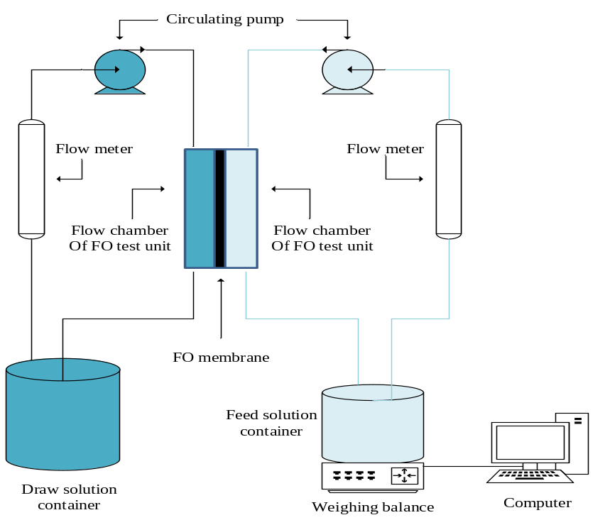

Figure 1. Schematic diagram of the lab-scale FO system

The water flux J_{w} (Lm⁻²h⁻¹ or LMH) was calculated using equation (1)[11].

${ J}_{w}=\frac{∆V}{A∆t}$ (1)

where, ΔV is the volume change (in liter, L) of the feed solution over a time Δt (in hour, h) and A_{m} (in m²) is the effective membrane surface area, which is 0.0042 m².

Thermally stimulated phase separation of ([P₄₄₄₄]CF₃COO)

Thermally stimulated phase separation was employed in order to see the effectiveness of permeated water separated from the ([P₄₄₄₄]CF₃COO) IL draw solution. Diluted ([P₄₄₄₄]CF₃COO) draw solution around 28 mL was transferred into the centrifuge tube and placed in a water bath. The solution was heated at different temperatures of 40 °C, 50 °C and 60 °C. Time taken for complete phase separation at each temperature was determined. The same solution was used in each experiment by cooling the solution to room temperature to dissolve the IL back into the water. When IL has completely dissolved, it was then heated to the new heating temperature for another thermally phase separation.

Results and Discussion

Forward osmosis performances

In FO experiment using 0.6M NaCl feed solution and 2.0M NaCl draw solution, the CA membrane produced in this study showed a flux value of 1.83 ± 0.078 LMH. This value is acceptable compared to the CA hollow fiber membrane reported by Su et al. [9], which showed a value of 1.0 LMH at the same condition used during this study. The performance of FO using ([P₄₄₄₄]CF₃COO) and NaCl draw solution was compared using the same draw solution concentration of 0.0087 M. The NaCl feed concentration of 0.040 M was used. As can be seen in Figure 2, water flux achieved by using ([P₄₄₄₄]CF₃COO) draw solution is higher than that using NaCl draw solution. The water flux for ([P₄₄₄₄]CF₃COO) and NaCl draw solution were 0.44 ± 0.007 LMH and 0.32 ± 0.049 LMH, respectively. Although the water fluxes for both draw solutes were relatively low compared to the value found in the literature, however, it was demonstrated that ([P₄₄₄₄]CF₃COO) had higher draw ability than the NaCl solution. The concept of using LCST type of thermoresponsive IL as draw solute in FO was successfully performed in this study.

Figure 2. FO water flux using different draw solutions of NaCl and ([P₄₄₄₄]CF₃CO). The feed concentrations used were 0.040 M NaCl and 0.087 M draw solute concentrations.

Thermally stimulated phase separation process of ionic liquid solution

After the FO process, the diluted ([P₄₄₄₄]CF₃COO) draw solution was performed on the thermally stimulated phase separation by heating it above its critical temperature of 29 °C in a water bath. This phase change process of ([P₄₄₄₄]CF₃COO) is reversible and fast. ([P₄₄₄₄]CF₃COO) formed homogenous mixtures with water at low temperature. The phase separation temperature of the IL/water mixtures depended strongly on the hydrophobicity of the component ions as well as mixing ratio [10]. Upon gentle heating, it was observed that the clear and diluted IL draw solution turned turbid. When the draw solution was heated above its LCST, a clear liquid-liquid phase separation appeared, which formed an IL-rich phase and water-rich phase, as shown in Figure 3. The IL-rich phase was at the bottom due to its high density property.

The thermally stimulated phase separation behavior of draw solution with different heating temperatures was examined. The time taken used to complete the phase separation by heating at temperatures of 40 °C, 50 °C and 60 °C was shown in Figure 4. In fact, stable phase separation can be achieved readily with a mild temperature stimulus of 34 °C [10]. As the heating temperature increased, the time taken to complete phase separation decreased from 140 minutes to 40 minutes for heating temperatures of 40 °C to 60 °C. This allowed the IL to be efficiently regenerated and reused.

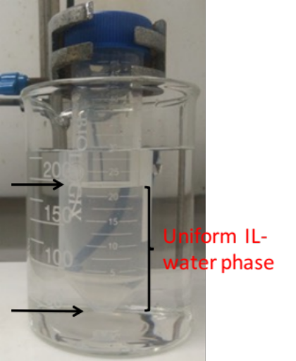  (a) |  | 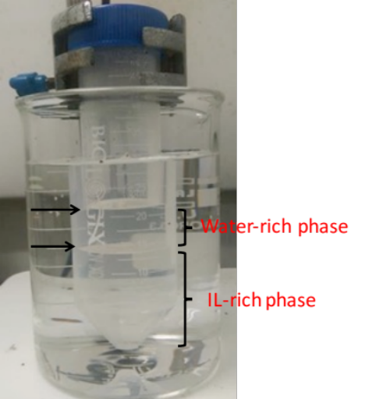  (b)

Figure 3. Water miscibility of ([P₄₄₄₄]CF₃COO) at (a) room temperature, and (b) above the critical temperature of 29 °C during thermally stimulated phase separation process

Figure 4. Time for phase separation of ([P₄₄₄₄]CF₃COO)-water mixture at different heating temperature

Conclusion
([P₄₄₄₄]CF₃COO) is an LCST type of thermoresponsive IL and can potentially be used as draw solute in FO. ([P₄₄₄₄]CF₃COO) IL showed high water flux of 0.44 ± 0.007 LMH compared to the water flux of 0.32 ± 0.049 LMH for the NaCl draw solution at 0.087 M draw solution concentration. The regeneration and recovery of IL draw solution was achieved via an energy-efficient thermally stimulated phase separation process. The time for the phase separation of the ([P₄₄₄₄]CF₃COO)-water mixture was 40 minutes by heating the mixture at a higher temperature of 60 °C.

Acknowledgment
The authors were grateful for the research financial support by the Ministry of Higher Education Malaysia under the Fundamental Research Grant Scheme (FRGS - RDU160128).

References

- Thompson, N. A. and Nicoll, P. G. (2011). Forward osmosis desalination: A commercial reality. IDA World Congress - Perth Convention and Exhibition Centre (PCEC), Perth, Western Australia. pp. 16.
- Ge, Q., Ling, M. and Chung, T. S. (2013). Draw solutions for forward osmosis processes: Developments, challenges, and prospects for the future. Journal of Membrane Science, 442: 225-237.
- Stone, M. L., Wilson, A. D., Harrup, M. K. and Stewart, F. F. (2013). An initial study of hexavalent phosphazene salts as draw solutes in forward osmosis. Desalination, 312: 130-136.
- Tan, C. H. and Ng, H. Y. (2010). A novel hybrid forward osmosis - nanofiltration (FO-NF) process for seawater desalination: Draw solution selection and system configuration. Desalination and Water Treatment, 13(1-3): 356-361.
- Li, D., Zhang, X., Yao, J., Zeng, Y., Simon, G. P. and Wang, H. (2011). Composite polymer hydrogels as draw agents in forward osmosis and solar dewatering. Soft Matter, 7(21): 10048-10056.
- Ling, M. M., Chung, T. S.and Lu, X. (2011). Facile synthesis of thermosensitive magnetic nanoparticles as smart draw solutes in forward osmosis. Chemical Communications, 47(38): 10788-10790.
- Cai, Y., Shen, W., Wei, J., Chong, T. H., Wang, R., Krantz, W. B. and Hu, X. (2015). Energy-efficient desalination by forward osmosis using responsive ionic liquid draw solutes. Environmental Science: Water Research and Technology, 1(3): 341-347.
- Zhong, Y., Feng, X., Chen, W., Wang, X., Huang, K.-W., Gnanou, Y. and Lai, Z. (2016). Using UCST ionic liquid as a draw solute in forward osmosis to treat high-salinity water. Environmental Science and Technology, 50(2): 1039-1045.
- Su, J., Yang, Q., Teo, J. F. and Chung, T. S. S. (2010). Cellulose acetate nanofiltration hollow fiber membranes for forward osmosis processes. Journal of Membrane Science, 355(1-2): 36-44.
- Kohno, Y., Arai, H., Saita, S. and Ohno, H. (2011). Material design of ionic liquids to show temperature-sensitive lcst-type phase transition after mixing with water. Australian Journal of Chemistry, 64(12): 1560-1567.
- Kim, J., Kang, H., Choi, Y. S., Yu, Y. A. and Lee, J. C. (2016). Thermo-responsive oligomeric poly(tetrabutylphosphonium styrenesulfonate)s as draw solutes for forward osmosis (FO) applications. Desalination, 381: 84-94.

