

MALAYSIAN JOURNAL OF ANALYTICAL SCIENCES
ISSN 1394 - 2506

Published by The Malaysian Analytical Sciences Society

OPTIMISATION OF THE COMPOSITION AND PROCESS PARAMETER OF CsH₂PO₄/NaH₂PO₄/SiO₂ SOLID ACID COMPOSITE VIA THE TAGUCHI METHOD

(Pengoptimuman Komposisi dan Parameter Proses Bagi Komposit Asid Pepejal CsH₂PO₄/NaH₂PO₄/SiO₂ Melalui Kaedah Taguchi)

Norsyahida Mohammad¹, Abu Bakar Mohamad^{1,2}, Abdul Amir Hassan Kadhum^{1,2}, Kee Shyuan Loh¹*

¹Fuel Cell Institute
²Department of Chemical and Process Engineering, Faculty of Engineering and Built Environment
Universiti Kebangsaan Malaysia, 43600 UKM Bangi, Selangor, Malaysia

*Corresponding author: ksloh@ukm.edu.my

Received: 13 April 2017; Accepted: 17 April 2018

Abstract
Solid acid composites of CsH₂PO₄/NaH₂PO₄/SiO₂ (CDP/SDP/SiO₂) were synthesised with varied SDP to CDP and SiO₂ to CDP mole fractions. The composites were arranged for optimisation via the Taguchi method with L9 orthogonal array, which manipulates four factors: the amount of SDP, amount of SiO₂, amount of pressure used for pellet production and operating temperature. Responses were recorded as the averaged conductivity value for each experimental set. The composite powders were uniaxially pressed to form pellets of 1 mm thickness for conductivity measurements. Conductivity value was averaged from three readings and used in the signal-to-noise (S/N) ratio formula. The S/N ratio was set such that larger is better and calculated to maximise the response required for the analysis. Operating temperature has the largest effect on the conductivity value of solid acid composites, whereas the amount of SiO₂ has the smallest effect. The amount of SDP in the composite has a larger effect than the pressure applied during pellet production prior to the conductivity measurements. The optimised composite consists of 0.2 mole fraction of SDP to CDP and 0.3 mole fraction of SiO₂ to CDP pressed at 3 tonnes cm⁻² to produce pellets and tested at the temperature of 250 °C. The optimisation was validated by using analysis of variance from the Design-Expert® software.

Keywords: solid acid composite, caesium dihydrogen phosphate, Taguchi

Abstrak
Komposit asid pepejal CsH₂PO₄/NaH₂PO₄/SiO₂ (CDP/SDP/SiO₂) telah disintesis dengan pecahan mol SDP kepada CDP dan SiO₂ kepada CDP yang berbeza-beza. Komposit-komposit ini telah menjalani proses pengoptimuman melalui kaedah Taguchi, dengan susunan ortogonal L9 yang memanipulasi empat faktor iaitu kuantiti SDP, kuantiti SiO₂, kuantiti tekanan yang digunakan untuk penghasilan pelet dan suhu operasi. Output dicatatkan sebagai nilai kekonduksian purata bagi setiap set eksperimen. Serbuk komposit telah dimampatkan untuk membentuk pelet dengan ketebalan 1 mm untuk analisa kekonduksian. Nilai kekonduksian yang diperoleh dijadikan purata daripada tiga bacaan dan digunakan dalam formula nisbah isyarat kepada hingar (S/N). Nisbah S/N telah ditetapkan sebagai ‘lebih besar adalah lebih baik’ dan digunakan untuk memaksimakan tindak balas yang diperlukan untuk analisa. Suhu operasi mempunyai impak terbesar ke atas nilai kekonduksian komposit asid pepejal, manakala kuantiti SiO₂ mempunyai impak yang paling kecil ke atas nilai kekonduksian komposit asid pepejal. Kuantiti SDP dalam komposit mempunyai kesan yang lebih besar berbanding tekanan yang digunakan semasa penghasilan pelet sebelum analisa kekonduksian. Komposit yang telah dioptimumkan terdiri daripada 0.2 pecahan mol SDP kepada CDP dan 0.3 pecahan mol SiO₂ kepada CDP, memerlukan tekanan sebanyak 3 tan cm⁻² untuk menghasilkan pelet dan diuji pada suhu 250 °C. Proses pengoptimuman ini disahkan oleh analisa varians dari perisian Design-Expert®.

Kata kunci: komposit asid pepejal, sesium dihidrogen fosfat, Taguchi

Introduction
The potential of solid acids as alternatives to membrane materials in the proton exchange membrane fuel cell (PEMFC) has been demonstrated [1–3]. Caesium dihydrogen phosphate, CsH₂PO₄ (CDP), is one of the most widely studied solid acids because of its high proton conductivity value of 2.2 x 10⁻² S cm⁻¹ at 240 °C [3, 4], its lack of decomposition or dehydration at intermediate temperatures and its non-production of catalyst poison in hydrogen-rich surroundings [5, 6]. The addition of hygroscopic oxides, such as SiO₂, ZrO₂, TiO₂ and Al₂O₃, generates strong surface interaction and enhances the stabilisation of the composite material, hence reducing the brittleness of solid acids [7, 8]. Sodium dihydrogen phosphate, NaH₂PO₄ (SDP), undergoes dehydration at lower temperatures compared with other solid acids and does not exhibit superprotonic conductivity [9]. Martsinkevich and Ponomareva [10] found that the conductivity of Cs_{1-x}Na_{x}H₂PO₄ composite for x values between 0 and 0.2 increases at about two orders of magnitude in the low temperature region in comparison to CDP.

This study identifies the effect of composition and process parameter on the conductivity value of the mixed-salt solid acid CDP/SDP/SiO₂ via the Taguchi method. This technique reduces the number of experiments required and minimises the variation in a process. Unlike other design of experiments (DOEs), such as factorial design, which requires testing of each possible combination, the Taguchi method tests pairs of combinations. This method produces the optimum combination of solid acid composition and process parameter for further testing and characterisation.

Materials and Methods
Solid acid CDP was synthesised by mixing stoichiometric amounts of caesium carbonate, Cs₂CO₃ (ReagentPlus®, ≥99% Sigma Aldrich) and phosphoric acid H₃PO₄ (≥85wt.% in H₂O, Sigma-Aldrich) according to the following reaction:

Cs₂CO₃ + 2H₃PO₄ → 2CsH₂PO₄ + CO₂ + H₂O (1)

In CDP synthesis, a measured amount of Cs₂CO₃ was dissolved in distilled water. A surfactant powder, cetyltrimethylammoniumbromide, CTAB (BioXtra®, ≥99% Sigma-Aldrich, MO, USA), was dissolved in ethanol separately and added to the Cs₂CO₃ solution to reduce water surface tension and assist in particle dispersion. The mixture was then stirred for 10 minutes until a clear solution was produced. Phosphoric acid was added dropwise into the mixture with continuous stirring for another 10 minutes. Acetone was added excessively to the mixture while stirring for another 30 minutes. The solution was vacuum filtered to produce CDP as a white precipitate. The synthesised CDP was dried at 130 °C for 24 hours and ground to produce white powder CDP.

Mixed-salt solid acid composites CsNa_{x}H₂PO₄/ySiO₂ (where x and y equals 0.1, 0.2 and 0.3) were synthesised by mechanical grinding of individual salts CDP, SDP (ReagentPlus®, ≥99% Sigma-Aldrich, MO, USA) and SiO₂ (purum p.a. powder, Sigma-Aldrich, MO, USA, 63 µm particle size). The composite powders were then pressed at 3, 4 and 5 tonnes cm⁻² to form pellets of 1 mm thickness and 13 mm diameter followed by sintering at 230 °C for 1 hour. The pellets were painted with silver conductive paint to serve as the current collector and then connected to an impedance analyser (Metrohm Autolab B.V., The Netherlands).

Impedance readings were taken at several operating temperatures (210, 230 and 250 °C) with a frequency of 1.0 × 10⁻² to 1.0 × 10⁶ Hz and a current of 0.01 A. The measured data were analysed using the Nova software packaged with the FRA2 module. The resistance value (R) was determined from the impedance data plotted on real and imaginary axes Z’ and Z”, respectively, known as the Nyquist plot. The curve is fitted using the equivalent circuit as in Figure 1. The proton conductivity value σ for each composite is calculated using R and is given by equation 2:

Conductivity, σ (Scm⁻¹) = $\frac{\frac{1}{R(}Ω)}{\frac{A({cm}^{2})}{l(cm)}}$ (2)

where A is the sectional area, and l is the thickness of the pellet.

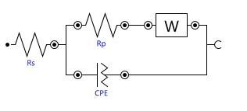
Figure 1. Equivalent circuit used to analyse the impedance data

The Taguchi method was applied to identify the effect of composition and process parameter on the conductivity of mixed-salt composite CDP/SDP/SiO₂. The selected DOE was Taguchi L9 orthogonal array, which manipulates four factors and three levels. DOE calculations were performed manually in an Excel spreadsheet and validated by a DOE software (Design-Expert® Version 6.0.10, Stat-Ease, Inc.).

The selected four factors are the amount of SDP, the amount of SiO₂, the pressure used for pellet production and the operating temperature. Table 1 presents the three levels selected for each of the factors. The amount of SDP in terms of mole fraction to CDP was limited between 0.1 and 0.3. Such limitation was applied because of the findings by Martsinkevich and Ponomareva that solid solutions exist between that range, whereas larger mole fractions resulted in individual SDP properties as measured by X-ray diffraction [10]. SiO₂ mole fraction lower than 0.3 caused higher conductivity for solid acid composites at temperatures higher than 180 °C [11]. Therefore, the SiO₂ range of 0.1 to 0.3 mole fractions was chosen for this study. The pressure applied during pellet production was fixed between 3 to 5 tonnes cm⁻² due to the reproducibility of the pellets in this pressure range. Solid acid CDP is known for its high conductivity at temperatures above 230 °C. Hence, three levels between 210 and 250 °C were selected to observe the conductivity values of the composite around the optimum temperature.

Table 1. Factors, control parameters and levels of each parameter
Factor | Control Parameter | Level
 |  | 1 | 2 | 3
A | Amount of SDP (mole fraction to CDP) | 0.1 | 0.2 | 0.3
B | Amount of SiO₂ (mole fraction to CDP) | 0.1 | 0.2 | 0.3
C | Pressure applied during pellet production (tonnes cm⁻²) | 3 | 4 | 5
D | Operating temperature (°C) | 210 | 230 | 250

Results and Discussion
The Taguchi L9 orthogonal array produced nine sets of level combinations (Table 2). Each set was run three times in randomised order to reduce error. Responses were recorded in Table 2 as the averaged conductivity value for each experimental set. The signal-to-noise (S/N) ratio was fixed to be larger is better and calculated to maximise the response according to the formula below:

S/N ratio $= -10\log_{10} \frac{1}{n}\sum_{i=1}^{n}{}\frac{1}{y_{i}^{2}}$ (3)

where y_{i} is the observed response value, and n is the number of replications.

Table 2. Level combinations of designed experiments and results
Exp. No. | Factor |  |  |  | Conductivity (S cm⁻¹) | S/N
Exp. No. | Amount of SDP (mole fraction to CDP) | Amount of SiO₂ (mole fraction to CDP) | Pressure Applied during Pellet Production (tonnes cm⁻²) | Operating Temperature (°C) | Conductivity (S cm⁻¹)
1 | 0.1 | 0.1 | 3 | 210 | 4.5 x 10⁻⁵ | -90.0
2 | 0.1 | 0.2 | 4 | 230 | 1.3 x 10⁻⁴ | -78.9
3 | 0.1 | 0.3 | 5 | 250 | 3.4 x 10⁻³ | -50.0
4 | 0.2 | 0.1 | 4 | 250 | 7.6 x 10⁻³ | -43.3
5 | 0.2 | 0.2 | 5 | 210 | 1.1 x 10⁻⁴ | -85.5
6 | 0.2 | 0.3 | 3 | 230 | 3.4 x 10⁻³ | -59.9
7 | 0.3 | 0.1 | 5 | 230 | 4.0 x 10⁻⁴ | -77.9
8 | 0.3 | 0.2 | 3 | 250 | 7.2 x 10⁻³ | -43.1
9 | 0.3 | 0.3 | 4 | 210 | 3.8 x 10⁻⁴ | -90.5

The S/N values in Table 2 were used to obtain the averaged S/N values in Table 3. The difference between the highest averaged S/N value and the lowest averaged S/N value for each factor was then calculated (Table 3). The largest difference indicates the most significant factor. Operating temperature (°C) has the largest effect on the conductivity values of solid acid composites, followed by the amount of SDP, the pressure applied during pellet production and the amount of SiO₂. This finding supports the reported property of solid acids, namely, its high dependence on temperature, where the conductivity increases by two to three orders of magnitude at its superprotonic temperature. The amount of SiO₂ has the smallest effect on the conductivity values of solid acid composites. This characteristic enables the addition of SiO₂ to produce solid acid composites that are more robust and less brittle [9, 12] without significantly reducing the conductivity of the composite.

Table 3. Ranking of factors which affect the conductivity of the CDP/SDP/SiO₂ composite
Level | Averaged S/N Value for Each Factor
Level | Amount of SDP (mole fraction to CDP) | Amount of SiO₂ (mole fraction to CDP) | Pressure Applied during Pellet Production (tonnes cm⁻²) | Operating Temperature  (°C)
1 | -72.97 | -70.38 | -64.31 | -88.65
2 | -62.90 | -69.18 | -70.90 | -72.24
3 | -70.49 | -66.80 | -71.14 | -45.46
Difference | 10.08 | 3.57 | 6.83 | 43.20
Rank | 2 | 4 | 3 | 1

This DOE facilitates the identification of the optimum combination of factors to produce the highest conductivity value. For each factor, the optimum level was chosen from the highest averaged S/N value. For example, the optimum level of factor A (amount of SDP) was level 2, which was given by the highest averaged value of -62.90 (Table 3). Level 2 of the said factor also corresponds to 0.2 mole fraction of SDP to CDP, as defined in Table 1. Therefore, the output of this DOE indicates that the optimised composite should consist of 0.2 mole fraction of SDP to CDP and 0.3 mole fraction of SiO₂ to CDP pressed at 3 tonnes cm⁻² during pellet production and tested at the temperature of 250 °C.

Similar results were obtained via Design-Expert® by limiting the factors to three, namely, the amount of SDP, the pressure used for pellet production and the operating temperature. We assume that the effect of SiO₂ is negligible and the factors are independent of each other prior to analysis of variance (ANOVA) in Design-Expert®. The ANOVA resulted in the model F-value of 163.58 and “Prob>F” value of 0.0061, indicating that this model is significant. The model given by Design-Expert® is adequate, as supported by the normality plot in Figure 2. The influence of factors on the conductivity of the composite is shown in Figures 3–5. The optimised solid acid composite (CDP23) was characterised via several methods, including differential scanning calorimetry, thermogravimetric analysis and X-ray diffraction. The findings have been published elsewhere [13].

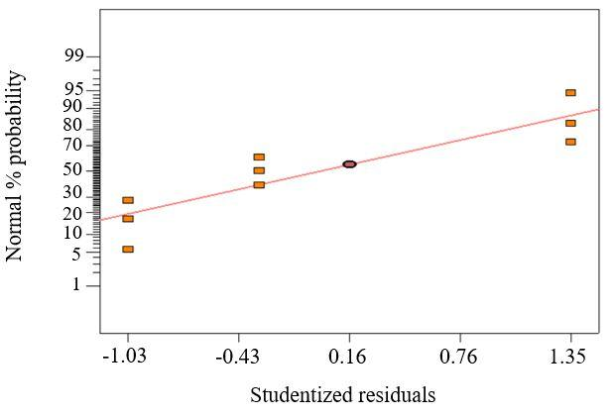
Figure 2. Normal probability plot of residuals for the measured conductivity values

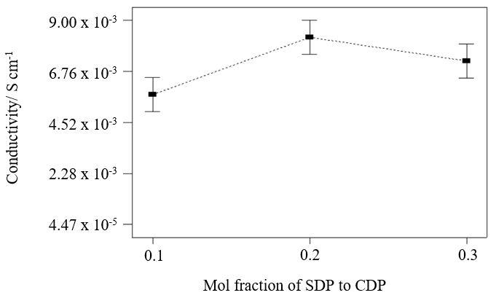
Figure 3. Influence of amount of SDP on the conductivity of the solid acid composite
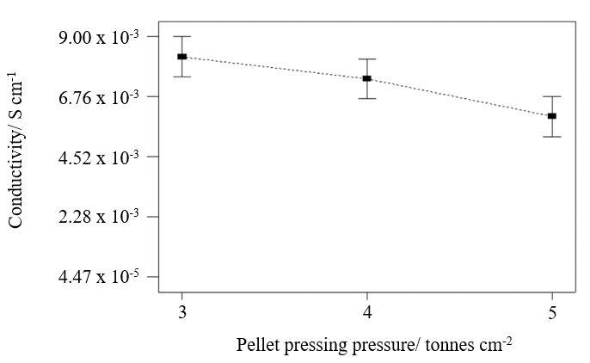
Figure 4. Influence of pellet pressing pressure on the conductivity of the solid acid composite

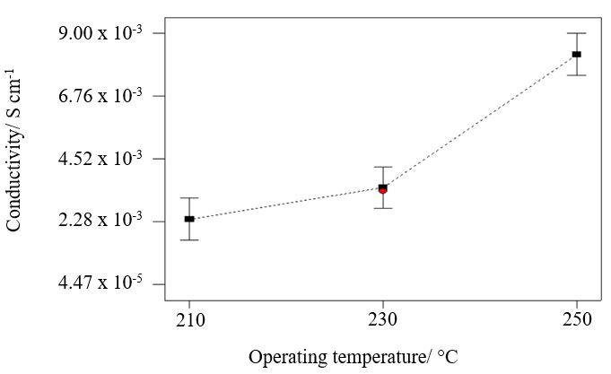
Figure 5. Influence of operating temperature on the conductivity of the solid acid composite

Conclusion
The Taguchi method enables the identification of trends in factors affecting the conductivity values of the solid acid composite CDP/SDP/SiO₂. The four factors selected for the analysis are the amount of SDP, the amount of SiO₂, the pressure used for pellet production and the operating temperature. The averaged conductivity values were recorded as responses and used to obtain the S/N ratio. Operating temperature has the highest influence on the conductivity value, followed by the amount of SDP. The amount of SiO₂ has the smallest effect on the conductivity values of solid acid composites. This characteristic allows for the addition of SiO₂ to enhance the robustness of the solid acid pellet. The calculations agreed with the results obtained by Design-Expert®. This study revealed that the optimised composite consists of 0.2 mole fraction of SDP to CDP and 0.3 mole fraction of SiO₂ to CDP pressed at 3 tonnes cm⁻² during pellet production and tested at a temperature of 250 °C. Future work should focus on the optimisation of membrane–electrode assembly fabrication parameters.

Acknowledgement
This work was financially supported by the Universiti Kebangsaan Malaysia through the University Research Grants (Grant Nos. GUP-2016-038 and DIP-2017-024).

References
- Haile, S. M., Boysen, D. A., Chisholm, C. R. I. and Merle, R. B. (2001). Solid acids as fuel cell electrolytes. Nature, 410: 910-913.
- Boysen, D. A., Uda, T., Chisholm, C. R. I. and Haile, S. M. (2004). High-performance solid acid fuel cells through humidity stabilization. Science, 303(5654): 68-70.
- Haile, S. M., Chisholm, C. R. I., Sasaki, K., Boysen, D. A. and Uda, T. (2006). Solid acid proton conductors: From laboratory curiosities to fuel cell electrolytes. Faraday Discussions, 134: 17-39.
- Taninouchi, Y.-K., Uda, T., Awakura, Y., Ikeda, A. and Haile, S. M. (2007). Dehydration behavior of the superprotonic conductor CsH₂PO₄ at moderate temperatures: 230 to 260 °C. Journal of Materials Chemistry, 17(30): 3182-3189.
- Unnikrishnan, S. (2009). Micromachined dense palladium electrodes for thin-film solid acid fuel cells. (PhD Dissertation), University of Twente, Enschede.
- Dupuis, A.-C. (2011). Proton exchange membranes for fuel cells operated at medium temperatures: Materials and experimental techniques. Progress in Materials Science, 56(3): 289-327.
- Piao, J., Liao, S. and Liang, Z. (2009). A novel cesium hydrogen sulfate–zeolite inorganic composite electrolyte membrane for polymer electrolyte membrane fuel cell application. Journal of Power Sources, 193(2): 483-487.
- Lavrova, G. V. and Ponomareva, V. G. (2008). Intermediate-temperature composite proton electrolyte CsH₅(PO₄)₂/SiO₂: Transport properties versus oxide characteristic. Solid State Ionics, 179(21–26): 1170-1173.
- Boysen, D.A. (2004). Superprotonic solid acids: structure, properties, and applications (PhD Dissertation), California Institute of Technology.
- Martsinkevich, V. V. and Ponomareva, V. G. (2012). Double salts Cs_{1-x}M_{x}H₂PO₄ (M = Na, K, Rb) as proton conductors. Solid State Ionics, 225: 236-240.
- Ponomareva, V.G. and Shutova, E. S. (2007). High-temperature behavior of CsH₂PO₄ and CsH₂PO₄–SiO₂ composites. Solid State Ionics, 178(7–10): 729-734.
- Baranov, A. I., Grebenev, V. V., Khodan, A. N., Dolbinina, V. V. and Efremova, E. P. (2005). Optimization of superprotonic acid salts for fuel cell applications. Solid State Ionics, 176(39–40): 2871-2874.
- Mohammad, N., Mohamad, A. B., Kadhum, A. A. H. and Loh, K. S. (2017). Effect of silica on the thermal behaviour and ionic conductivity of mixed salt solid acid composites. Journal of Alloys and Compounds, 690: 896-902.

