

MALAYSIAN JOURNAL OF ANALYTICAL SCIENCES
ISSN 1394 - 2506

Published by The Malaysian Analytical Sciences Society

SYNTHESIS AND CHARACTERIZATION OF SILICA-SILVER
CORE-SHELL NANOPARTICLES

(Sintesis dan Pencirian Silika-Perak Nanopartikel Teras-Cengkerang)

Nur Kamilah Mohd, Wan Mohd Afiq Wan Mohd Khalik, Alyza A. Azmi*

School of Marine and Environmental Sciences,

Universiti Malaysia Terengganu, 21030 Kuala Nerus, Terengganu, Malaysia

*Corresponding author: alyza.azzura@umt.edu.my

Received: 10 February 2019; Accepted: 30 March 2019

Abstract

Silica-silver core-shell nanoparticles have received tremendous interests in various applications compared to the bare silver nanoparticles due to several important features such as exhibit higher surface area, the existence of a synergistic effect between the core and the shell, stabilize silver nanoparticles against aggregation, and easily control their properties by the changing shell structure and shell geometry. Due to this significance, this study was conducted to synthesis and characterization of silica-silver core-shell nanoparticles using the facile method without any surface modification needed. In the synthesis route, silica particles have been synthesis based on the Stӧber method. The deposition of nanoscales silver layer on silica surface mainly involves the electrostatic attraction between [Ag(NH₃)₂]⁺ions and silanol groups, and the addition of polyvinylpyrrolidone (PVP) has been acted as a reducing agent and stabilizing agent. UV-Vis spectroscopy evidenced the absorption of surface plasmon resonance (SPR) of silver nanoparticles in the range 380-450 nm. The crystallinity of silica-silver core-shell nanoparticles showed the face-centered cubic (fcc) structure by X-ray powder diffraction (XRD) analysis. The spherical shape of silica particles with an average 200-220 nm in size has been determined using scanning electron microscope (SEM). The high resolution-transmission electron microscope (HR-TEM) images visualized the successful formation of spherical silver nanoparticles on the silica surface with the average of size 10-40 nm. X-ray photoelectron spectroscopy analysis revealed the elemental compositions exist in the silica-silver core-shell nanoparticles. The synthesized silica-silver core-shell nanoparticles will be used as a potential catalyst in dye treatment application in the future work.

Keywords: core-shell, nanoparticles, silica-silver core-shell, deposited, Stӧber method

Abstrak
Silika-perak nanopartikel teras-cengkerang telah menarik minat yang besar dalam pelbagai aplikasi berbanding dengan nanopartikel perak disebabkan oleh beberapa kelebihan seperti permukaan kawasannya lebih tinggi, kewujudan kesan sinergi di antara teras dan cengkerang, mengelakkan pengumpulan nanopartikel perak dan memudahkan untuk mengawal ciri-ciri yang dikendaki dalam nanopartikel teras-cengkerang dengan mengubah morfologi dan geometri partikel cengkerang. Sintesis dan pencirian silika-perak nanopartikel teras-cengkerang telah dilakukan tanpa sebarang pengubahsuaian terhadap permukaan partikel. Proses sintesis melibatkan penghasilan zarah silika menggunakan kaedah Stӧber. Pemendapan lapisan perak nano pada permukaan silika melibatkan tarikan elektrostatik antara kumpulan ion [Ag(NH₃)₂]⁺ dan kumpulan silanol, dan penambahan polivinilpirolidon (PVP) akan bertindak sebagai agen penurunan dan agen penstabilan. Pencirian silika-perak nanopartikel teras-cengkerang menggunakan spektroskopi ultra lembayung tampak (UV-Vis) telah menunjukkan penyerapan resonansi plasmon permukaan (SPR) nanopartikel perak dalam lingkungan 380 - 450 nm. Kehabluran silika-perak nanopartikel teras-cengkerang menunjukkan struktur berpusatkan kubik berpusat (fcc) dengan menggunakan pembelauan sinar-X (XRD). Zarah silika berbentuk sfera dengan saiz 200 nm ditentukan dengan menggunakan mikroskop imbasan elektron (SEM). Saiz perak yang telah didepositkan pada permukaan silika telah diukur menggunakan mikroskop transmisi elektron beresolusi tinggi (HR-TEM) dengan ukuran 10-40 nm. Analisis spektrometer fotoelektron sinar-X (XPS) telah mendedahkan komposisi unsur yang ada di dalam silika-perak nanopartikel teras-cengkerang. Nanopartikel teras-petala silika-perak akan digunakan sebagai potensi rawatan pewarna pada masa akan datang.

Kata kunci: teras-cengkerang, nanopartikel, silika-perak nanopartikel teras-cengkerang, deposit, kaedah Stӧber

Introduction
Metal core-shell nanoparticles have received tremendous interest in various fields because of the potential of combining the advantageous properties of two materials into a single constructional unit. It has been applied in such electronic, biomedical, and environmental field as an antimicrobial agent, drug carrier, or catalyst for pollutants removal. Comparing to the traditional nanoparticles, the combination of the two types of materials as a core and a shell into a single structure provides long term stability and flexibility in surface functionalization. Nischala and the co-workers stated that the core-shell nanoparticles offer several advantages such as high surface area, which increase their performance in any applied fields [1]. It also provides an advanced active interface and a potential synergistic effect between the core and shell to gain higher efficiency, especially in catalytic application [2].

The development of core-shell nanomaterials is expanding drastically driven by the demand in industry and society. Up to now, the construction and characterization of various core-shell nanomaterials have been published. For instance, the BaTiO₃-SiO₂ core-shell nanoparticles have been successfully enhancing the energy storage capacity [3], CdS-TiO₂ as a promising candidate for visible light active removal of dye pollutants in water [4], Fe₃O₄-Au as a nontoxic and biocompatible material for biomedical targeted drug delivery [5], Ag-TiO₂ as a gas sensing material [6], Fe-Ni as a catalyst for hydrogen generation [7] and CeO₂-TiO₂ as a catalyst for photoreduction of carbon dioxide under visible light irradiation [8]. Among these materials, the preparation of silica-based core-shell material has attracted our interest of study.

Silica (SiO₂) compound has been explored as a core material in the development of core-shell nanostructures. SiO₂ can be considered cheap and green materials, which can be found abundantly in plant husk and leaves. For example from the sugarcane bagasse [9], rice husk [10], sugar beet bagasse [11], sorghum leaves [12] and lotus flower leaves [13]. Thus, from an economic point of view, the utilization of SiO₂ as a core material may reduce the overall production cost of the metal-core-shell nanostructure. It also exhibits characteristics such as high chemical and thermal stabilities, chemical inertness, large surface areas, good compatibilities with other material and better stability against coagulation [14]. A large number of silanol (Si-OH) groups on the surface of SiO₂ consist of hydrophilic characteristics, which provides a strong interaction with any polar compound through hydrogen bonding interactions [15]. The SiO₂ compound can be synthesized following various methods such as flame synthesis [16], microemulsion modified technique [17] and extraction precipitation [18]. However, these methods suffer certain limitations including costly, produced non-uniform of the particle size and morphology, and the difficulty to remove the surfactant in the end product. Therefore, Stӧber method has been adopted as it is easy to scale up the particle size and possibility effortless to transfer into the aqueous solution [19].‬‬‬‬‬‬‬‬‬‬‬‬‬‬‬‬‬‬‬‬‬‬‬‬‬‬‬‬‬‬‬‬‬‬‬‬‬‬‬‬‬‬‬‬‬‬‬‬‬‬‬‬‬‬‬‬‬‬‬‬‬‬‬‬‬‬‬‬‬‬‬‬‬‬‬‬‬‬‬‬‬‬‬‬‬‬‬‬‬‬‬‬‬‬‬‬‬‬‬‬‬‬‬‬‬‬‬‬‬‬‬‬‬‬‬‬‬‬‬‬‬‬‬‬‬‬‬‬‬‬‬‬‬‬‬‬‬‬‬‬‬‬‬‬‬‬‬‬‬‬‬‬‬‬‬‬‬‬‬‬‬‬‬‬‬‬‬‬‬‬‬‬‬‬‬‬‬‬‬‬

SiO₂ has been used as substrate materials for the immobilization of precious metal such as TiO₂ [20], Au [21], and Ni [22]. The bare metal nanoparticles are active and have a higher tendency to coalesce in solution form due to the van der Waals forces and high surface energy. In our study, the deposition of silver nanoparticles (Ag-Nps) on the SiO₂ core surfaces has been developed for the potential application in catalytic activities.

Herein, silica-silver, (SiO₂-Ag) core-shell nanoparticles were prepared with the addition of polyvinylpyrrolidone as a reducing and stabilizing agent. There were no linkers or metals such as tin(II) chloride, palladium, gold and organosilane added to activate SiO₂ particles prior to load Ag-Nps to the surface of the core. The addition of any linkers will be lead to the existence of impurities in the end product of SiO₂-Ag core-shell nanoparticles. Different concentration of ammoniacal silver nitrate solution which is a source of Ag ions was employed to control the coverage of Ag-Nps on the SiO₂ surface. The presences of surface plasmon resonance of Ag-Nps have been determined by UV-Vis spectroscopy. The crystalline natures were evidenced by X-ray powder diffraction (XRD), while the elemental compositions of SiO₂-Ag were evaluated by X-ray photoelectron spectroscopy (XPS). The size and morphology of core-shell structure were visualized using scanning electron microscope (SEM) and high resolution-transmission electron microscope (HR-TEM).

Materials and Methods

Materials
Absolute ethanol (EMSURE, analytical grade), ethanol (R&M chemical, 95%, analytical grade), ammonium hydroxide (R&M Chemical, 25%, analytical grade), tetraethyl orthosilicate (Sigma-Aldrich, 98%, reagent grade), silver nitrate (Bendosen, analytical reagent), sodium hydroxide (R&M Chemical, analytical reagent), polyvinylpyrrolidone (Sigma Aldrich, average molecular weight 40,000). Deionized water from water purification system Milli-Q integral water system was used throughout the experiment (Merck, 18 ΩM).

Synthesis of silica particles
SiO₂ particles have been synthesized following the Stӧber method. Absolute ethanol (30 mL), water (6 mL), ammonium hydroxide solution (1.5 mL) were mixed in a round-bottom flask at the room temperature under continuously stirring (1000 rpm) for 30 minutes. Next, 2.4 mL of tetraethyl orthosilicate was added and left for 3 hours and the resulting particles were centrifuged at 3600 rpm for 20 minutes. The products were washed for at least 3 times with deionized water and ethanol to separate the particles. The obtained SiO₂ then were dispersed in absolute ethanol for subsequently used.

Synthesis of silica-silver core-shell nanoparticles
Ammoniacal silver nitrate solution, [Ag(NH₃)₂]⁺ was freshly prepared throughout the experiment. The silver nitrate solution was prepared by dissolving silver nitrate into 10 mL of deionized water. Next, 1 mL of sodium hydroxide (0.1 M) was added while slowly swirling. The formation of silver oxide, Ag₂O as the main product caused a color change from colorless to yellowish-brown. The chemical equation for the formation of Ag₂O shown in equation 1.

Next, 4 mL of aqueous ammonia was added slowly to the Ag₂O solution. The color of the solution turned clear indicates the formation of ammoniacal silver nitrate solution and the chemical equation is shown in Equation 2.

For the preparation of SiO₂-Ag core-shell nanoparticles, 5 g of the prepared SiO₂ dispersion was added into 10 mL of [Ag(NH₃)₂]⁺ solution under continuous stirring for at a speed 700 rpm for 2 hours at the room temperature. This process allows an electrostatic attraction between [Ag(NH₃)₂]⁺ ions with the hydroxyl groups on the surface of silica particles. After 2 hours, PVP (5 × 10⁻⁴ moL⁻¹) was added to the solution, followed by stir and reflux at 75˚C for 8 hours. The color of the solution changed darker, which indicates the growth of the outer silver nanoshell on the SiO₂ core surfaces. The solution was then centrifuged at 3600 rom for 20 minutes to remove excess Ag⁺ ions, washed with ethanol and deionized water. The precipitate was redispersed in the deionized water prior to further characterization.

Characterization

SiO₂-Ag core-shell nanoparticles were characterized using standard spectroscopy and microscopy techniques. Spectroscopy study was carried out using UV-Vis spectrophotometer (UV-Shidmazu model 1800 with software UV Probe 2.43) in the wavenumber range from 200 to 800 nm. An amount of 0.01 g of the sample was added to 100 mL of deionized water and sonicated for 20 minutes to form a disperse solution. The samples were placed in a quartz cuvette, and the UV spectrum was recorded. The elemental composition of SiO₂-Ag core-shell nanoparticles was determined using X-ray photoelectron spectroscopy (XPS). It’s were carried out with AXIS ULTRADLD (Shimadzu), equipped with Mg Kα (hʋ=1253.6 eV) X-ray source. The binding energies were referenced to the C1s peak energy at 284.6 eV.

The morphology of SiO₂ particles was observed using a scanning electron microscope (SEM, JEOL model 6360F). A drop of dispersion and also thin film was placed on a sample stub, dried, then sputter-coated with gold prior to examination in order to minimize charging effects. It was operated at an accelerating voltage of 10 and 15 kV with 15,000 magnifications. The morphologies and size of the SiO₂-Ag core-shell nanoparticles were observed using high transmission electron microscope (TECNAI G2 20 S-TWIN, with FEI), 200 kV. An amount of 0.001 g of samples was dispersed with 20 mL of water and ultra-sonicated for 20 minutes. Then, it was dried on the carbon-coated copper grids before measurement. The structural characterizations of prepared samples were carried out using X-ray powder diffraction (XRD) analyzer (X’Pert Pro). X-ray diffractometer with Cu Kα radiation (λ=1.54056 А) at a scanning rate of 0.301 degrees per second in the range 2ϴ ranging from 10˚ to 80˚.

Results and Discussion
SiO₂-Ag core-shell nanoparticles were synthesized via the fabrication of Ag-Nps on the surface of SiO₂ particles with the addition of PVP as a reducing and stabilizing agent. The diagram for complete preparation of the SiO₂-Ag core-shell nanoparticles is shown in Scheme 1.

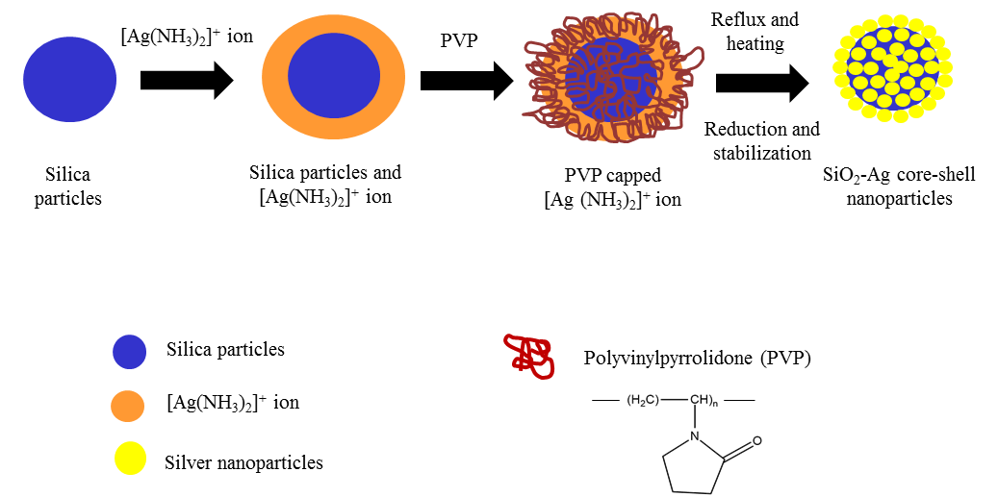
Scheme 1. Schematic representation of the reaction for the synthesis of SiO₂-Ag core-shell nanoparticles

SiO₂ particles were synthesized based on the Stӧber method, with the reaction of TEOS in water-alcohol-ammonia solution. Two main reactions involved, which are the formation of the silanol group by hydrolysis process, followed by the formation of the siloxane bridges through a condensation polymerization reaction. The following reaction (equation 3-5) is proposed for the fabrication of Ag-Nps on the SiO₂ surface:

The formation of [Ag(NH₃)₂]⁺as a source of Ag⁺ is based on the complexation of Ag ions by ammonia hydroxide solution. According to Strzałka and co-workers, the consumption of [Ag(NH₃)₂]⁺ as a Ag ion source can be considered as a rapid and easy pathway in the synthesis of SiO₂-Ag core-shell nanostructure [23]. The deposition of Ag-Nps on the SiO₂ surface is formed based on the activation action of [Ag(NH₃)₂]⁺ with SiO₂ core surfaces. The negatively charged ions of the silanol groups on the SiO₂ core surface will attract the [Ag(NH₃)₂]⁺ ions due to the electrostatic attractive interaction. The addition of PVP will reduce the oxidation state number of Ag⁺, which is from +1 to 0. PVP also prevent aggregation in the dispersion due to the charge neutralization of the silanol group with [Ag(NH₃)₂]⁺ ion [24]. The Ostwald ripening phenomenon where the particles in the reaction redissolve and their solvated species growth become larger particles can be avoided as PVP act as a stabilizer in the solution [25].

UV-Visible analysis
The formation of Ag-Nps loaded on the SiO₂ surface was monitored by UV-Vis spectrophotometer. The reduction of Ag ions (+1) to Ag (0) metal have been evaluated by recording the absorption spectrum of the SiO₂-Ag solution in the range of 200-800 nm. The UV-Visible spectra of SiO₂ particles and SiO₂-Ag core-shell nanoparticles at three different concentrations, which are 0.1 M, 0.2 M, and 0.3 M are depicted in Figure 1.

Figure 1. UV-Vis absorption spectra of SiO₂ dispersion, 0.1 M, 0.2 M and 0.3 M of SiO₂-Ag. (Inset shows the image of 0.1 M, 0.2 M and 0.3 M of SiO₂-Ag solution)

Optical absorption spectra of Ag loading show the presence of surface plasmon resonance (SPR) effect in the visible region. In this specific wavelength of 380 to 450 nm range, the incident light can induce a collective oscillation of the electron on the surface of Ag-Nps. This phenomenon is the main reason behind the color change of the Ag solution from light yellow to brownish as shown in the inset in Figure 1.

The Ag plasmonic properties are strongly correlated with their morphology, such as the size and coverage of the nanoparticles. In this case, the absorption band of SPR shows a red shift and broaden, which is an indication of larger coverage of Ag nanoparticles on the SiO₂ core surfaces as the concentration of [Ag(NH₃)²⁺] increases. The shift magnitude 1.839 is the highest in 0.3 M concentration, compared to 0.557 and 0.433 for 0.2 M and 0.1 M concentrations, respectively. The research conducted by Tzounis et al. demonstrated that the increase Ag-Nps decorated on the SiO₂ spheres enhances the increasing of the absorption peak intensity [26]. On the other hand, no absorbance peak is observed in UV-Vis spectra for bare SiO₂ particles, supporting that no attachment of Ag or any impurities on the SiO₂ surface.

Electron microscopy analysis
Figure 2(a) shows the representative SEM micrograph of the monodispersed SiO₂ particles. The image reveals the spherical shape of SiO₂ particles with a narrow size distribution. The average diameters of 200-220 nm were measured. A smooth edges and bare surface of prepared SiO₂ particles has been observed, which is commonly detected in most SiO₂ particle preparation using the Stӧber method. After Ag adsorption on the SiO₂ surface, the surface morphology of the SiO₂-Ag core-shell nanoparticles roughened (Figure 2b-d). The increase of the SiO₂-Ag surface roughness was due to the increase of Ag nanoparticles loaded on the SiO₂ core surfaces. This is consistent with the formation of a darker color solution when the concentration of [Ag(NH₃)₂]⁺ is increased. A study conducted by Ghosh and Paria supporting our argument on the dependency of nanoshell thickness by the reaction concentration [27]. Another study by Postolache and co-workers [28] suggested that the increase of silver nitrate concentration effectively promotes the distribution of Ag-Nps onto the surface of SiO₂. In addition, there are no Ag-Nps residuals was observed, which indicates a stable Ag-Nps attachment to the SiO₂ spheres. Furthermore, it was found that the Ag-Nps were spherical in shape with the size ranges of 8-20 nm for 0.1 M and 0.2 M of SiO₂-Ag, while it ranges 10-40 nm for 0.3 M of SiO₂-Ag.

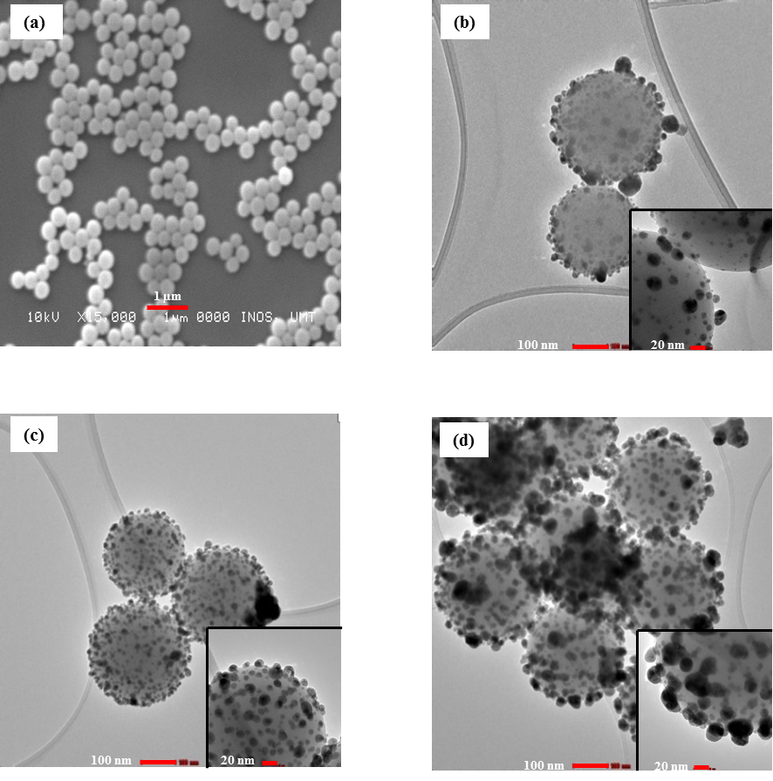
Figure 2. (a) SEM image of SiO₂ particles at 15,000 magnifications, HR-TEM images of (b) 0.1 M of SiO₂-Ag, (c) 0.2 M of SiO₂-Ag, (d) 0.3 M of SiO₂-Ag. Lower right sides images show the individual SiO₂-Ag core-shell HR-TEM images taken of 0.1 M, 0.2 M, and 0.3 M respectively

X-ray powder diffractometer analysis
Figure 3 illustrated the nature characteristic of the XRD pattern for the SiO₂ sphere and SiO₂-Ag core-shell in various concentrations. In the SiO₂ dispersion, broad diffraction peaks in the range of 15 ̊-30 ̊ centered at 22 ̊ correspond to their amorphous structure. A typical XRD pattern of the Ag-Nps was found to possess a face cubic centre (fcc) structure. The Bragg reflections at 2θ = 39.8°, 48.5°, 63.0° and 77.50° can be indexed to the (111), (200), (220) and (311) orientation, respectively. This confirms the deposition of the Ag nanoparticles on the SiO₂ core surfaces. These four peaks were detected which is corresponding to the fcc Ag phase. The fcc pattern of SiO₂-Ag core-shells fcc pattern is consistent with the previous research [29,30]. There are no major diffraction peaks as consequences of crystallographic impurities were found. The relative intensity of the (111) peak is higher compared to other peaks at each concentration indicates the plane orientation preferential to the surface of SiO₂ sphere.
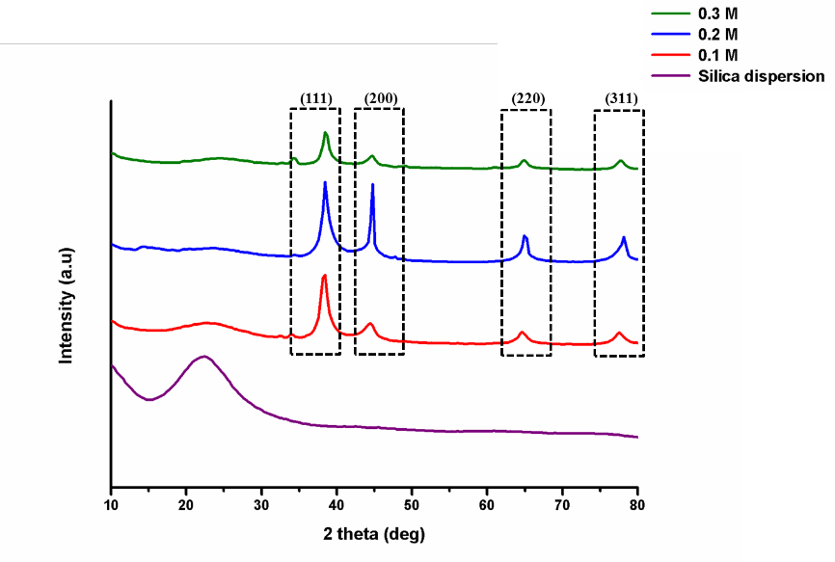
Figure 3. X-ray Powder diffraction patterns of SiO₂ particles, 0.1 M, 0.2 M and 0.3 M of SiO₂-Ag core-shell

X-ray photoelectron spectroscopy
X-ray photoelectron spectra for the SiO₂-Ag core-shell nanoparticles were acquired from binding energy regions containing peak arising from all elements that should be present in the sample, which are C 1s, Si 2p, Ag 3d, N 1s, and O 1s as shown in Figure 4. A survey scan in the region of 0 to 1200 eV indicates neither contribution from impurities nor contamination on the surface of the nanoparticles. The presence of carbon and nitrogen element on the surface of nanoparticles is contributing from PVP, which has been used as a reducing and stabilizing agent in the synthesis procedure. This is consistent with the fitting of three atomic species for C 1s (aromatic carbon, aliphatic and C-N/C=O species), and a single nitrogen species from PVP [31]. The Si 2p peak centered at 102.3 eV binding energy is attributed to Si-O₂ of the core spheres which correspond closely to the previous literature [32]. The Ag 3d peaks are found at 366.81 eV and 372.81 eV can be fitted to the typical spin-orbital-splitting pattern of Ag 3d5/2 and Ag 3d3/2, respectively. This confirms the reduction of Ag(+1) ion to Ag(0) metal, as appearance of the Ag 3d peak in XPS is the nature characteristic for zero-oxidation state. This finding was supported by Sakthisabarimoorthi and co-workers on the successful decoration of Ag element [33].

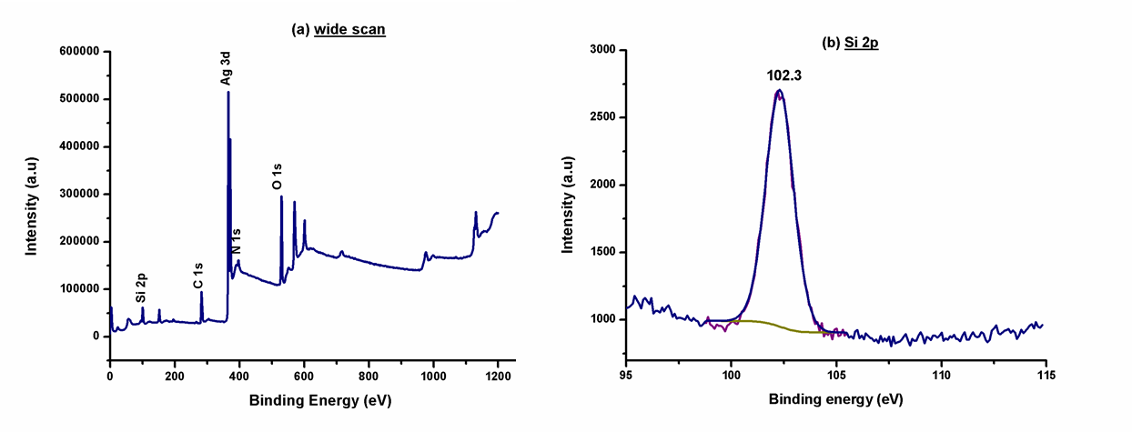

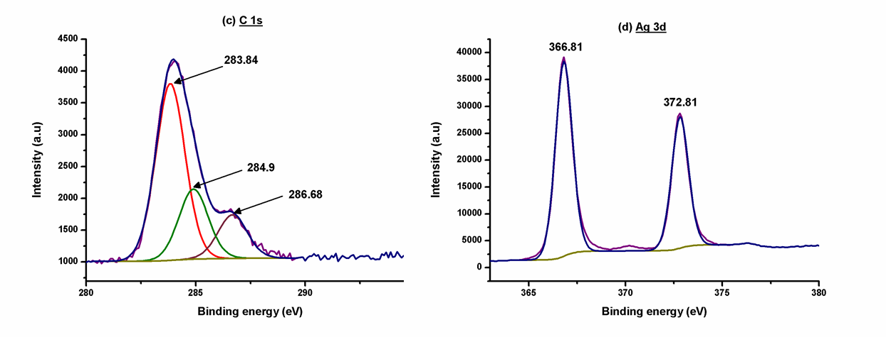
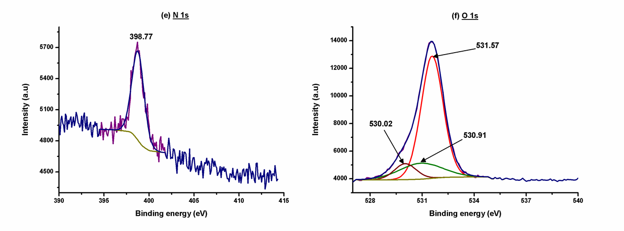
Figure 4. Representative of XPS spectra of (a) wide scan survey, (b) Si 2p, (c) C 1s, (d) Ag 3d, (e) N 1s, and (f) O 1s for SiO₂-Ag core-shell nanoparticles

Conclusion

SiO₂-Ag core-shell nanoparticles were successfully synthesized with the addition of PVP as a reducing and stabilizing agent without any surface modification needed. The increase of concentration ammoniacal silver nitrate solution leads to the increase in thickness of Ag-Nps loaded on the SiO₂ surface. The synthesized SiO₂-Ag core-shell nanoparticles exhibit the surface plasmon resonance wavelength of 380 to 450 nm range, which contributed to the existence of Ag-Nps. SEM images visualized the silica particles with 200-220 nm in size with a spherical shape while HR-TEM images show the Ag-Nps deposited to the surface of SiO₂ spheres with the average of size 10-50 nm. X-ray powder diffraction analysis revealed the crystalline nature of Ag-Nps. The elemental composition of SiO₂-Ag core-shell such as C 1s, Si 2p, Ag 3d, N 1s, and O 1s were established by X-ray photoelectron spectroscopy analysis. The SiO₂-Ag core-shell nanoparticles have been successfully synthesized and it is suggested that it can be used as a potential catalyst in the dye degradation process in future studies.

Acknowledgement
The authors gratefully acknowledge to Central Laboratory, Universiti Malaysia Terengganu for providing research facilities.

References
- Nischala, K., Rao, T. N. and Hebalkar, N. (2011). Silica–silver core–shell particles for antibacterial textile application. Colloids and Surfaces B: Biointerfaces, 82(1): 203 – 208.
- Wang, X., He, B., Hu, Z., Zeng, Z. and Han, S. (2014). Current advances in precious metal core–shell catalyst design. Science and Technology of Advanced Materials, 15(4): 043502.
- Xu, C., Su, R., Wang, Z., Wang, Y., Zhang, D., Wang, J., J., Bian, J., Wu, C., Lou, X. and Yang, Y. (2019). Tuning the microstructure of BaTiO₃@SiO₂ core-shell nanoparticles for high energy storage composite ceramics. Journal of Alloys and Compounds, 784: 173 – 181.
- Kamaruddin, S. and Stephan, D. (2011). The preparation of silica–titania core–shell particles and their impact as an alternative material to pure nano-titania photocatalysts. Catalysis Today, 161(1): 53 – 58.
- Pati, S. S., Singh, L. H., Oliveira, A. C. and Garg, V. K. (2015). Chitosan functionalized Fe₃O₄@ Au core-shell nanomaterials for targeted drug delivery. World Academy of Science, Engineering and Technology, International Journal of Chemical, Molecular, Nuclear, Materials and Metallurgical Engineering, 9(6): 670 – 673.
- Zhu, Z., Kao, C. T. and Wu, R. J. (2014). A highly sensitive ethanol sensor based on Ag@TiO₂ nanoparticles at room temperature. Applied Surface Science, 320: 348 – 355.
- Azizi, M. A. H., Dzakaria, N., Isahak, W. N. R. W. and Yarmo, M. A. (2017). Effect of nickel on bimetallic nanoalloy catalyst for hydrogen generation. Malaysian Journal of Analytical Sciences, 21(4): 901 – 906.
- Abdullah, H., Ismail, N. A., Yaakob, Z., Khan, M. R. and Rahim, S. A. (2017). CeO₂-TiO₂ for photoreduction of Co₂ to methanol under visible light: effect of ceria loading. Malaysian Journal of Analytical Sciences, 21(1): 166 – 172.
- Mohd, N. K., Wee, N. N. A. N. and Azmi, A. A. (2017). Green synthesis of silica nanoparticles using sugarcane bagasse. In AIP Conference Proceedings, 1885(1): 020123.
- Ghorbani, F., Sanati, A. M., and Maleki, M. (2015). Production of silica nanoparticles from rice husk as agricultural waste by environmental friendly technique. Environmental Studies of Persian Gulf, 2(1), 56 – 65.
- San, N. O., Kurşungöz, C., Tümtaş, Y., Yaşa, Ö., Ortac, B. and Tekinay, T. (2014). Novel one-step synthesis of silica nanoparticles from sugarbeet bagasse by laser ablation and their effects on the growth of freshwater algae culture. Particuology, 17: 29 – 35.
- Qadri, S. B., Gorzkowski, E. P., Imam, M. A., Fliflet, A., Goswami, R., Kim, H., Caldwell, J. D., Klemm, F. and Rath, B. B (2013). Production of nanoscale particles and nanorods of SiC from sorghum leaves. Industrial Crops and Products, 51: 158 – 162.
- Landage, S. M., Kulkarni, S. G. and Ubarhande, D. P. (2012). Synthesis and application of silica nanoparticles on cotton to impart superhydrophobicity. International Journal of Engineering Research and Technology, 1(5): 1 – 7.
- Kalele, S. A., Ashtaputre, S. S., Hebalkar, N. Y., Gosavi, S. W., Deobagkar, D. N., Deobagkar, D. D. and Kulkarni, S. K. (2005). Optical detection of antibody using silica–silver core–shell particles. Chemical Physics Letters, 404(1-3): 136 – 141.
- Mansa, R. F., Sipaut, C. S., Rahman, I. A., Yusof, N. S. M. and Jafarzadeh, M. (2016). Preparation of glycine–modified silica nanoparticles for the adsorption of malachite green dye. Journal of Porous Materials, 23(1): 35 – 46.
- Chang, H., Park, J. H. and Jang, H. D. (2008). Flame synthesis of silica nanoparticles by adopting two-fluid nozzle spray. Colloids and Surfaces A: Physicochemical and Engineering Aspects, 313: 140 –144.
- Koźlecki, T., Polowczyk, I., Bastrzyk, A. and Sawiński, W. (2016). Improved synthesis of nanosized silica in water-in-oil microemulsions. Journal of Nanoparticles, 2016: 1 – 9.
- Monshizadeh, M., Rajabi, M., Ahmadi, M. H. and Mohammadi, V. (2015). Synthesis and characterization of nano SiO₂ from rice husk ash by precipitation method. 3rd National Conference on Modern Researches in Chemistry and Chemical Engineering: pp. 1 – 4.
- Gholami, T., Salavati-Niasari, M., Bazarganipour, M. and Noori, E. (2013). Synthesis and characterization of spherical silica nanoparticles by modified Stöber process assisted by organic ligand. Superlattices and Microstructures, 61: 33 – 41.
- Kitsou, I., Panagopoulos, P., Maggos, T., Arkas, M. and Tsetsekou, A. (2018). Development of SiO₂@ TiO₂ core-shell nanospheres for catalytic applications. Applied Surface Science, 441: 223 – 231.
- Kandpal, D., Kalele, S. and Kulkarni, S. K. (2007). Synthesis and characterization of silica-gold core-shell (SiO₂@ Au) nanoparticles. Pramana, 69(2): 277 – 283.
- Gac, W., Zawadzki, W., Słowik, G., Sienkiewicz, A. and Kierys, A. (2018). Nickel catalysts supported on silica microspheres for CO₂ methanation. Microporous and Mesoporous Materials, 272: 79 – 91.
- Zienkiewicz-Strzałka, M., Pasieczna-Patkowska, S., Kozak, M. and Pikus, S. (2013). Silver nanoparticles incorporated onto ordered mesoporous silica from Tollen's reagent. Applied Surface Science, 266: 337 –343.
- Jankiewicz, B. J., Jamiola, D., Choma, J. and Jaroniec, M. (2012). Silica–metal core–shell nanostructures. Advances in Colloid and Interface Science, 170(1-2): 28 – 47.
- Atkins, P., Overton, T., Rourke, J., Weller, M. and Armstrong, F. (2010). Inorganic Chemistry. Oxford. New York : pp. 659.
- Tzounis, L., Contreras-Caceres, R., Schellkopf, L., Jehnichen, D., Fischer, D., Cai, C., Uhlmann, P. and Stamm, M. (2014). Controlled growth of Ag nanoparticles decorated onto the surface of SiO₂ spheres: a nanohybrid system with combined SERS and catalytic properties. RSC Advances, 4(34): 17846 – 17855.
- Ghosh, C. R. and Paria, S. (2011). Core/shell nanoparticles: Classes, properties, synthesis mechanisms, characterization, and applications. Chemical Reviews, 112(4): 2373 – 2433.
- Postolache, P., Petrescu, V., Dumitrascu, D. D., Rimbu, C., Vrînceanu, N. and Cipaian, C. R. (2016). Research regarding a correlation core–shell morphology–thermal stability of silica–silver nanoparticles. Chemical Engineering Communications, 203(5): 649 – 659.
- Din, L. B., Mie, R., Samsudin, M. W., Ahmad, A. and Ibrahim, N. (2015). Biomimetic synthesis of silver nanoparticles using the lichen Ramalina dumeticola and the antibacterial activity. Malaysian Journal of Analytical Sciences, 19(2): 369 – 376.
- Chen, K. H., Pu, Y. C., Chang, K. D., Liang, Y. F., Liu, C. M., Yeh, J. W., Shih, H. C. and Hsu, Y. J. (2012). Ag-nanoparticle-decorated SiO₂ nanospheres exhibiting remarkable plasmon-mediated photocatalytic properties. The Journal of Physical Chemistry C, 116(35): 19039 – 19045.
- Deng, Z., Chen, M. and Wu, L. (2007). Novel method to fabricate SiO₂/Ag composite spheres and their catalytic, surface-enhanced Raman scattering properties. The Journal of Physical Chemistry C, 111(31): 11692 – 11698.
- Das, S. K., Khan, M. M. R., Parandhaman, T., Laffir, F., Guha, A. K., Sekaran, G. and Mandal, A. B. (2013). Nano-silica fabricated with silver nanoparticles: antifouling adsorbent for efficient dye removal, effective water disinfection and biofouling control. Nanoscale, 5(12): 5549 – 5560.
- Sakthisabarimoorthi, A., Dhas, S. M. B. and Jose, M. (2017). Fabrication and nonlinear optical investigations of SiO₂@Ag core-shell nanoparticles. Materials Science in Semiconductor Processing, 71: 69 – 75.

