

MALAYSIAN JOURNAL OF ANALYTICAL SCIENCES
ISSN 1394 - 2506

Published by The Malaysian Analytical Sciences Society

EFFECTS OF SILVER NANOWIRE-BASED POLYMER COMPOSITE MEMBRANE ON THE PHYSICAL AND ELECTROCHEMICAL PROPERTIES OF MALACHITE GREEN SENSOR

(Kesan Nanowayar Perak-Membran Komposit Polimer ke atas Sifat Fizikal

dan Elektrokimia untuk Sensor Malakit Hijau)

Sharifah Nur Atikah Al Yahya¹, Sharina Abu Hanifah^{1,2}*, Normazida Rozi¹, Nurul Huda Abd Karim¹,

Lee Yook Heng¹

¹Center for Advanced Materials and Renewable Resources, Faculty of Science and Technology

²Polymer Research Center (PORCE), Faculty of Science and Technology

Universiti Kebangsaan Malaysia, 43600 UKM Bangi, Selangor, Malaysia

*Corresponding author: sharina@ukm.edu.my

Received: 19 August 2018; Accepted: 18 March 2019

Abstract

Malachite green is widely used in the aquaculture, food, and textile industries. However, malachite green is carcinogenic, mutagenic, and teratogenic. Therefore, a chemical sensor was developed to detect malachite green in water samples. Screen-printed carbon electrode was coated with (p(AAm-co-EMA)/Ru(bpy)₃²⁺/AgNWs to investigate its potential as a membrane for chemical sensor. The membrane was synthesized using the photopolymerization technique and characterized by fourier transform infrared (FTIR), ¹H nuclear magnetic resonance (¹H NMR), swelling test, field emission scanning electron microscopy/electron dispersive X-ray analysis (FESEM/EDX), thermogravimetric analysis (TGA), and cyclic voltammetry (CV). The peak of –CO in the FTIR spectra indicated that the copolymerization was successful. Furthermore, the NMR spectrum confirmed the FTIR result with the presence of peak at 4.2 ppm. Swelling test showed that p(AAm-co-EMA)/AgNWs had a lower swelling percentage than p(AAm-co-EMA) due to AgNWs filling the pores of the membrane, which can be seen in the cross section of the SEM micrograph. Thermal decomposition temperature of the membrane was around 400 °C. Cyclic voltammogram proved that the p(AAm-co-EMA)/Ru(bpy)₃^{2+/}AgNWs film coated on screen-printed carbon electrode which acted as a working electrode was able to detect malachite green by showing anodic peak around 0.25 V and cathodic peak around -1.0 V.

Keywords: malachite green, electrochemical sensor, photopolymerization, silver nanowires

Abstrak

Malakit hijau digunakan secara meluas dalam industri akuakultur, makanan dan tekstil. Walaubagaimanapun, malakit hijau bersifat karsinogenik, mutagenik dan teratogenik. Oleh itu, sensor kimia dibangunkan untuk mengesan malakit hijau dalam sampel air. Skrin bercetak elektrod karbon bersalut (p(AAm-ko-EMA)/Ru(bpy)₃²⁺/AgNWs telah dibangunkan bagi mengkaji potensinya sebagai filem untuk sensor kimia. Membran tersebut disintesis dengan menggunakan teknik fotopempolimeran dan dianalisis menggunakan spektroskopi infra merah tranformasi fourier (FTIR), ¹H resonans magnetik nukleus (¹H RMN), mikroskopi imbasan elektron pancaran medan/penyebaran elektron sinar-X (FESEM/EDX), analisis termogravimetri (TGA) dan voltametri siklik (CV). Puncak -CO yang hadir dalam spektrum FTIR menunjukkan kopempolimeran telah berjaya. Spektrum NMR mengesahkan spektrum FTIR dengan kehadiran puncak pada 4.2 ppm. Ujian penyerapan air pula menunjukkan peratus serapan air p(AAm-ko-EMA)/AgNWs lebih rendah berbanding p(AAm-ko-EMA) kerana AgNWs memenuhi liang–liang yang terdapat dalam filem seperti yang ditunjukkan pada mikrograf keratan rentas SEM. Penguraian terma berlaku pada suhu 400 °C. Voltamogram siklik membuktikan filem p(AAm-ko-EMA)/Ru(bpy)₃^{2+/}AgNWs yang disalut atas skrin bercetak elektrod karbon bertindak sebagai elektrod kerja berupaya mengesan malakit hijau dengan menunjukkan puncak anodik sekitar 0.25 V dan puncak katodik sekitar -1.0 V.

Kata kunci: malakit hijau, sensor elektrokimia, fotopempolimeran, wayar nano perak

Introduction

Malachite green or known as [4-[[4-(dimethylamino)phenyl]-phenylmethylidene]cyclohexa-2,5-dien-1-ylidene]-dimethylazanium (Figure 1) is a type of commercial triphenylmethane dye. Malachite green is widely used in the textile and food industries as dye while in the aquaculture industry, it is used as anti-bacteria, anti-fungi, and anti-protozoa for aquatic life. However, the Food and Drug Association (FDA) has banned its use in aquatic life because malachite green is carcinogenic, teratogenic, and mutagenic; causing cancer, disrupting the growth of embryos, and altering genetics [1]. Malachite green can adversely affect humans if they consume aquatic life that has been treated with malachite green. Due to these effects, several countries such as America, Canada, and China have banned its usage in the aquaculture industry. However, malachite green is widely used because the cost is cheap, it is effective, and easily available in the market. Therefore, the European Commission has determined that only 2 µg/kg of total residue of malachite green and leucomalachite green should be present in aquaculture products as the minimum required performance limits (MRPLs). MRPLs are the minimum analyte needed for any detection method. Various detection methods were introduced by many researchers like high performance liquid chromatography (HPLC), gas chromatography-mass spectrometry (GC-MS), and liquid chromatography-mass spectrometry/mass spectrometry (LC-MS/MS). However, the existing detection methods are time-consuming and have indirect measurements [2]. Therefore, many researchers have started focusing on sensors because they can be used as in-situ detection. Sensor is a device that transmits signals received from an input as the physical stimulus and converts them into data that can be processed [3]. There are many types of sensors that have caught the attention of researchers, for example biosensors, chemical sensors, and optical sensors. For the detection of malachite green, Fatma et al. [4] developed a dual detection sensor using polyvinyl chloride membrane, which showed a linear range at 10 ⁻⁵ to 10⁻³ M malachite green concentration. Meanwhile, Faridah et al. [5] introduced an electrochemical enzyme inhibition sensor by electro-polymerized butyryl-cholinesterase enzyme and polyprrole matrix on a sensor surface, which showed a limit of detection at 0.25 ppb malachite green concentration. Among all these types of sensors, electrochemical sensor has gained the most attention from researchers due to its simplicity and short analysis time.
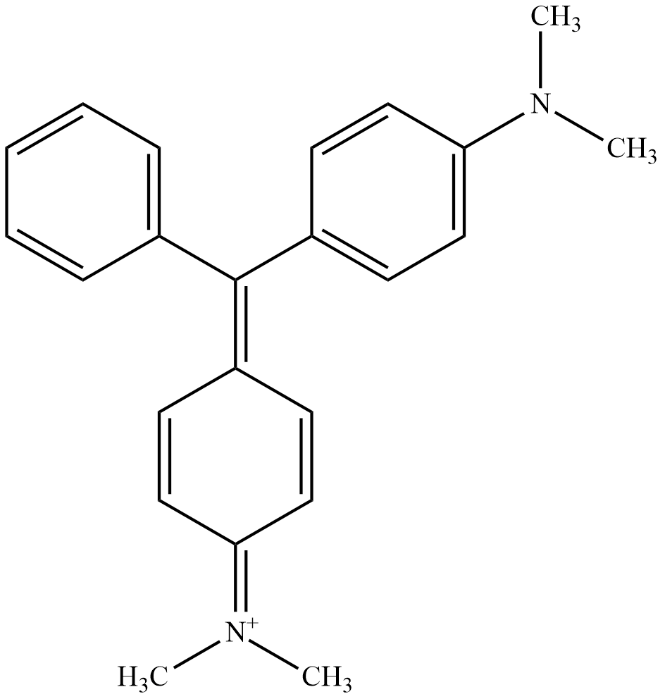

Figure 1. Chemical structure of malachite green

In this work, screen-printed carbon electrode coated with poly(acrylamide-co-ethyl methacrylate)/Ru(bpy)₃²⁺/ silver nanowires (p(AAm-co-EMA)/Ru(bpy)₃²⁺/AgNWs) was used as a working electrode for the detection of malachite green. Poly(acrylamide-co-ethyl methacrylate) in Figure 2 is a polymeric membrane acting as the immobilization matrix for Ru(bpy)₃²⁺. Acrylamide (AAm) monomer is a colorless and odorless crystalline compound and soluble in water. The polymer form of AAm is usually used in the paper, textile, and water treatment industries. AAm monomer is used in polymer form in paper, textile and water treatment industries. AAm consists of the amide group and carbonyl group. The presence of amide group causes the hydrophilicity of AAm, which forms a porous structure when undergoing polymerization [6] and it can provide better absorption capacity with a reduced polymer swelling [7]. The polymerization of AAm forming a porous structure can help in water absorption. Meanwhile, ethyl methacrylate (EMA) is a colorless liquid with a pungent smell that has hydrophobic and peel-able properties. The addition of a peelable property of EMA in copolymer can give an advantage to the non-disposable electrode and is used in the modification of electrode surface such as screen-printed electrode [8]. EMA consists of the carbonyl and ester groups. In this study, AAm acts as a host monomer while EMA acts as the comonomer to form poly(arylamide-co-ethyl methacrylate) (p(AAm-co-EMA)). In this study, only a small ratio of EMA monomer was added to alter the hydrophilicity of copolymer. This was due to the increasing mass percentage of EMA monomer, which can lead to hydrophilicity disruption of membrane, making it not suitable to use as membranes in sensors [9].

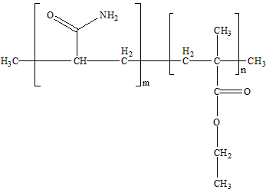

Figure 2. Chemical structure of poly(acrylamide-co-ethyl methacrylate)

Silver nanowires (AgNWs) are silver nanostructure with a diameter of nanometer that has electrical, optical, and thermal properties. AgNWs has the ability to increase the sensitivity of sensors three times compared to other film electrodes [10]. Furthermore, silver has s higher electric conductivity; 6.3 x 10⁷ S/m than other metals [11]. Besides, AgNWs was proven to replace indium tin oxide (ITO) in solar cell applications. According to Lee et al. [12], sensors fabricated from AgNWs to detect hydrogen peroxide showed an acceptable detection limit of 46 µM with a fast response time of 2 s and high sensitivity of 749 µA mM⁻¹ cm⁻². This is due to its nanostructure that assists the electron transfer and enhances the sensitivity of chemical sensor. On the other hand, Ru(bpy)₃²⁺ is one of the ruthenium complexes that can be used to detect the presence of malachite green. Ru(bpy)₃²⁺ has reversibility properties which allows it to develop a portable yet reusable sensor [13]. Besides, its usage with malachite green can form a redox reaction as proposed by Shao et al. [14]. Lan et al. [15] used the adsorption technique to immobilize Ru(bpy)₃²⁺ on conducting polymer, while Liu et al. [16] and Shao et al. [14] used Ru(bpy)₃²⁺ in free solution form to detect malachite green via the electrochemiluminescence technique. The presence of Ru(bpy)₃²⁺ helps to produce z sensor with high sensitivity and low detection limit. Therefore, in this study, silver nanowires and Ru(bpy)₃²⁺ were entrapped in the (p(AAm-co-EMA) to observe their ability to improve the sensitivity of sensors.

Materials and Methods

Chemicals

Chemicals used in this experiment were acrylamide (AAm), ethyl methacrylate (EMA), 2,2-dimethoxy-2-phenyl-acetophenone (DMPP) silver nanowires (AgNWs), and tris(2,2′-bipyridyl)dichloro-ruthenium(II) hexahydrate (Ru(bpy)₃Cl₂.6H₂O) purchased from Sigma Aldrich. Di-potassium hydrogen phosphates (K₂HPO₄) and potassium dihydrogen phosphate (KH₂PO₄) were bought from Nacalai Tesque and malachite green (MG) from R&M Chemical. Hydrochloric acid (HCl) and sodium hydroxide (NaOH) were freshly prepared in the laboratory for pH alteration of buffer. Deionized water was used in every experimental process.

Apparatus

The structural elucidations of samples were analyzed by Perkin Elmer 400 Fourier Transform Infrared Spectroscopy (FTIR) and Bruker 400 MHz Fourier Transform Nuclear Magnetic Resonance (NMR). The micrographs and energy dispersed spectrum were obtained using Zeiss Merlin Compact Field Emission Scanning Electron Microscope (FESEM). The thermal properties of samples were analyzed by Mettler Toledo STGA/SDTA851 Thermogravimetry Analysis (TGA). The cyclic voltammogram was performed by DropSens Portable Potensiostat, µStat400, Spain.

Preparation of polyacrylamide (pAAm), poly ethyl methacrylate (pEMA) and poly(acrylamide-co-ethyl methacrylate) (p(AAm-co-EMA))

Acrylamide solution was prepared by dissolving 1 g acrylamide, AAm and 0.016 g 2,2-dimethoxy-2-phenylacetophenone, (DMPP) in 885 µL of deionized water. Meanwhile, poly(acrylamide-co-ethyl methacrylate), p(AAm-co-EMA) was prepared with the ratio 9:1 by dissolving 0.9 g AAm and 0.016 g DMPP into 796 µL deionized water and 109 µL ethyl methacrylate (EMA). Poly ethyl methacrylate p(EMA) was also prepared by dissolving 0.016 g DMPP into 1091 µL EMA. All three solutions were placed into a sonicator at the temperature range from 30 to 35 °C for about 30 minutes. Membranes were formed after coating 50 µL of each solution on the plastic lids and exposed to ultraviolet in the presence of nitrogen for 10 minutes. These methods referred to Rozi et al. [9].

Swelling test

The p(AAm-co-EMA) and p(AAm-co-EMA)/AgNWs films were immersed in separated petri dishes that contained 10 mL distilled water at room temperature. For every 2 minutes, the membranes were taken out and dried with a tissue before the weight of the swollen membrane was recorded. The swelling percentages were calculated using Equation 1 below.

$\text{Swelling percentage =}\frac{{\text{W}}_{\text{f}}\text{-}{\text{W}}_{\text{i}}}{{\text{W}}_{\text{i}}}\text{×100 \%}$ (1)

where, W_{i} is defined as initial weight of dry membranes and W_{f} is final weight of swollen membranes

Preparation of membranes and nanocomposite membranes

Acrylamide/ethyl methacrylate/silver nanowires, AAm/EMA/AgNWs solution was prepared by mixing it with different volume percentages of AgNWs, which were 0.02, 0.04, 0.06, 0.08, and 0.10 % v/v into AAm/EMA solution. Meanwhile, Ru(bpy)₃²⁺ solution needed to be prepared first to produce poly(acrylamide-co-ethyl methacrylate)/ Ru(bpy)₃²⁺, p(AAm-co-EMA)/Ru(bpy)₃²⁺. The Ru(bpy)₃²⁺ solution was prepared by dissolving 0.0374 g tris(2,2′-bipyridyl)dichlororuthenium(II) hexahydrate into 5 mL of deionized water. Different volume percentages of Ru(bpy)₃²⁺ solution, which were 0.5, 1.0, 1.5, 2.0, and 2.5 %v/v, were mixed with AAm/EMA solution. Poly(acrylamide-co-ethyl methacrylate)/Ru(bpy)₃²⁺/silver nanowires, p(AAm-co-EMA)/Ru(bpy)₃²⁺/ AgNWs were prepared by mixing AAm/EMA solution with the optimized volume percentage of AgNWs and Ru(bpy)₃²⁺. All the three solutions were placed on screen-printed electrodes at 5 µL each. Screen-printed carbon electrodes coated with the solutions were polymerized under nitrogen gas flow for 10 minutes and later used as working electrodes for the electrochemical analysis.

Preparation of electrochemical analysis

Firstly, 0.1 M pH 7 phosphate buffer solution and 1×10⁻⁵ M MG solution were prepared for electrochemical analysis. The buffer solution was prepared by mixing 49.9 mL dipotassium hydrogen phosphate solution (K₂HPO₄) and 0.1 mL potassium dihydrogen phosphate (KH₂PO₄) in 500 mL volumetric flask and the remaining volume was filled with deionized water. The pH of phosphate buffer solution was altered by using HCl and NaOH solutions until its pH reached pH 7. Meanwhile, 1×10⁻⁵ M MG solution was prepared by diluting 100 µL of 1×10⁻³ M MG in a 10 mL volumetric flask. Both solutions were fixed to be used as analyte solution. Then, a voltammetric cell was prepared by arranging three electrodes, which were working electrode, reference electrode, and auxiliary electrode, in a triangular form. The working electrode used was screen-printed carbon electrode coated with poly(acrylamide-co-ethyl methacrylate)/ Ru(bpy)₃²⁺/silver nanowires, p(AAm-co-EMA)/Ru(bpy)₃²⁺/AgNWs. The reference electrode used was silver/silver chloride (Ag/AgCl) electrode and the auxiliary was glassy carbon electrode. The voltage range used was -1.5 V to 1.5 V with a scan rate of 0.1 V/s.

Results and Discussion

Fourier transform infra-red spectroscopy analysis

Figure 3 shows FTIR spectrum for polyacrylamide, pAAm, poly ethyl methacrylate, pEMA and poly(acrylamide-co-ethyl methacrylate), p(AAm-co-EMA).

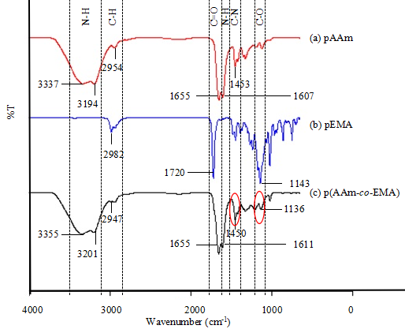

Figure 3. FTIR spectrum from (a) pAAm (b) pEMA and (c) p(AAm-co-EMA)

From Figure 3, pAAm showed strong bands at 3337 cm⁻¹, 3194 cm⁻¹, 1655 cm⁻¹, and 1607 cm⁻¹, due to N-H stretching, C=O stretching, and N-H bending, respectively. The N-H stretching showed two peaks because of the primary amide [17]. Meanwhile, pEMA displayed strong bands at wavenumbers 1720 cm⁻¹ and 1143 cm⁻¹, due to C=O stretching and C-O stretching. The p(AAm-co-EMA) spectrum also revealed strong bands at wavenumbers 3355 cm⁻¹, 3201 cm⁻¹, 1655 cm⁻¹, and 1611 cm⁻¹, due to N-H stretching, C=O stretching, and N-H bending, respectively, which indicated the presence of AAm and EMA. Furthermore, the small peak at wavenumber 1136 cm⁻¹ due to C-O stretching also indicated the presence of EMA. It was found that these spectra were comparable to the findings reported by Ain et al. [18]. These functional groups can be confirmed by NMR spectra.

¹H nuclear magnetic resonance spectroscopy

Figure 4 shows the ¹H NMR spectrum for polyacrylamide, pAAm and poly(acrylamide-co-ethyl methacrylate), p(AAm-co-EMA). NMR spectroscopy was used to analyze the content in the sample and its molecular structure by nuclear spin transition.

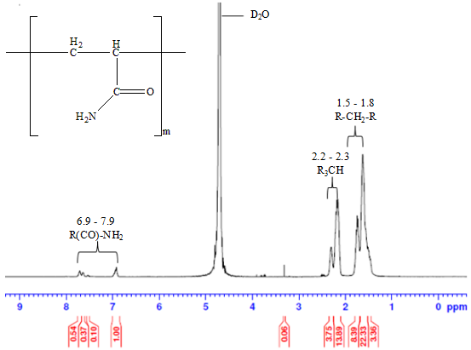
(a)

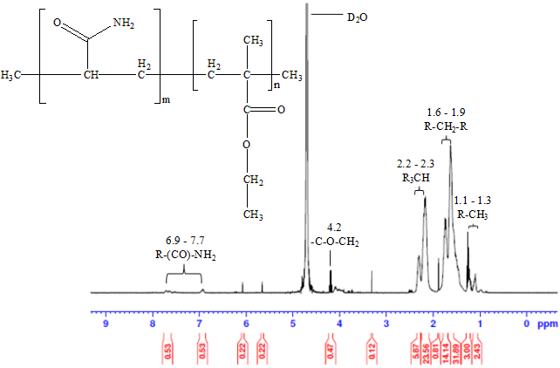
(b)

Figure 4. ¹H NMR spectrum of (a) pAAm and (b) p(AAm-co-EMA)

The presence of peaks at chemical shifts 6.9 ppm and 7.9 ppm in pAAm spectrum indicated that the primary amide group can also be seen in p(AAm-co-EMA) at chemical shifts 6.9 ppm and 7.7 ppm. The two peaks appeared in the spectrum because of the quadrupole broadening of amide group resonance. Furthermore, the nonequivalence of hydrogen on nitrogen happened due to restricted rotation [17]. Besides, the peaks at 2.2 ppm until 2.3 ppm and 1.6 ppm until 1.9 ppm indicated tertiary alkyl group and secondary alkyl group respectively, which represented AAm in p(AAm-co-EMA). Meanwhile, the peak at 4.2 ppm that indicated the ester group showed the presence of EMA in p(AAm-co-EMA). According to Pavia et al. [17], the desheilding effect occurred due to the electronegativity of oxygen atom attached to the carbon, while the peak split into a quartet because the ester group was part of a long polymer chain. The peaks for the primary alkyl group can be seen at chemical shift 1.1 ppm until 1.3 ppm because its hydrogens were a highly shielded type of proton and also showed the presence of EMA in p(AAm-co-EMA). These peaks corroborated the FTIR spectra and proved the photopolymerization of p(AAm-co-EMA).

Swelling test

Figure 5 shows the graph of swelling percentages of poly(acrylamide-co-ethyl methacrylate),p(AAm-co-EMA) and poly(acrylamide-co-ethyl methacrylate)/ silver nanowires, p(AAm-co-EMA)/AgNWs. From the figure below, it can be seen that the swelling ability for p(AAm-co-EMA) and p(AAm-co-EMA)/AgNWs had almost the same pattern for the first 6 minutes. However, after 8 minutes, p(AAm-co-EMA)/AgNWs showed a lower swelling percentage compared to p(AAm-co-EMA). The strong interaction between polymer matrix and AgNWs blocking the formation of pores caused the low diffusion [19]. The micrograph of cross section proved that the addition of AgNWs caused the low swelling percentage.

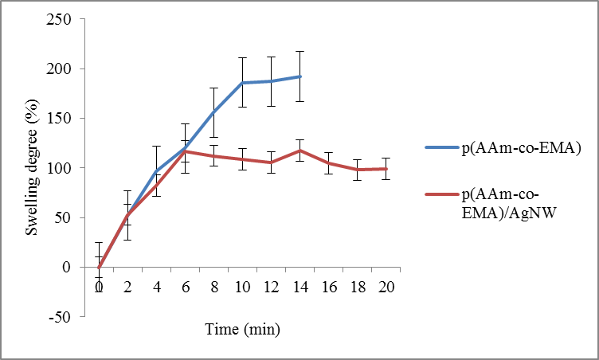

Figure 5. The swelling percentage as a function of time for p(AAm-co-EMA) and p(AAm-co-EMA)/AgNWs

Field emission scanning electron microscopy/electron dispersive X-ray

Figure 6 shows the micrograph of the cross section for poly(acrylamide-co-ethyl methacrylate), p(AAm-co-EMA) and poly(acrylamide-co-ethyl methacrylate)/silver nanowires, p(AAm-co-EMA)/AgNWs. From Figure 6(a), it shows the porous surface of p(AAm-co-EMA), while Figure 6(b) reveals the smooth surface of p(AAm-co-EMA)/AgNWs. This may be due to AgNWs acting as a filler, thus filling the pores on p(AAM-co-EMA). As a result, the swelling percentage of p(AAm-co-EMA)/AgNWs was lower than p(AAm-co-EMA).
(b)
(a)

Figure 6. Cross-section micrograph at magnification 1000x (a) p(AAm-co-EMA) (b) p(AAm-co-EMA)/AgNW

Figure 7(a) shows the EDX spectrum for poly(acrylamide-co-ethyl methacrylate)/silver nanowires, p(AAm-co-EMA)/AgNWs. Meanwhile, Figure 7(b) shows the micrograph of dispersion of AgNW for p(AAm-co-EMA)/AgNWs. From the EDX spectrum, the presence of AgNWs can be seen with weight percentage 0.1%. The result was acceptable due to the presence of 0.06% v/v of AgNWs in p(AAm-co-EMA). The presence of other elements like carbon, C, oxygen, O, and nitrogen, N indicated the presence of p(AAm-co-EMA). From the mapping micrograph, AgNWs were not well distributed because of agglomeration. Therefore, Figure 7(b) shows an empty spot due to the inhomogeneity of AgNWs in p(AAm-co-EMA).
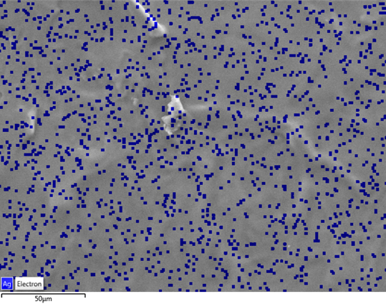
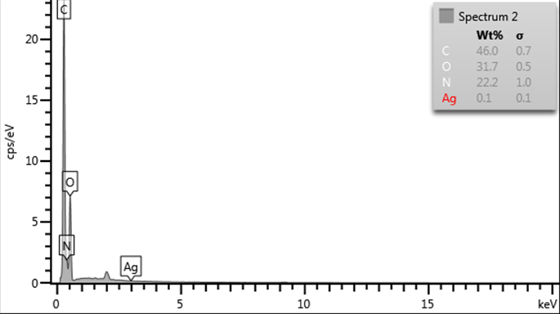
(b)
(a)

Figure 7. (a) EDX spectrum for p(AAm-co-EMA)/AgNWs (b) Mapping of AgNWs of p(AAm-co-EMA)/AgNWs

Thermogravimetry analysis

Figure 8 shows the thermogram of poly(acrylamide-co-ethyl methacrylate), p(AAm-co-EMA) and poly(acrylamide-co-ethyl methacrylate)/silver, p(AAm-co-EMA)/AgNWs. Both thermograms showed one step in the thermal degradation pattern. The degradation started at 322.84 °C and 499.82 °C. The presence of conductive materials like AgNWs was able to increase the heat resistance. Thus, it causes the maximum temperature of thermal degradation reading to increase. The increasing amount of silver nanoparticle showed the increase of maximum temperature of thermal degradation at range 2 °C to 11 °C [20]. However, the maximum thermal degradation temperature in both samples was about 400 °C. This was due to the very small amount of AgNWs present in p(AAm-co-EMA). The p(AAm-co-EMA) lost 69.53% of its weight and p(AAm-co-EMA)/AgNW lost 56.03% of its weight. According to Bihter et al. [20], the increasing amount of conductive material added should increase the loss of weight percentage. However, due to the different weights of samples used in this experiment, the loss of weight percentages differed.
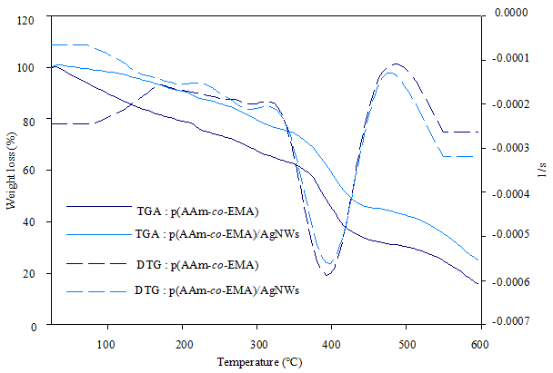

Figure 8. Thermogram for p(AAm-co-EMA) and p(AAm-co-EMA)/AgNWs

Electrochemical behaviors of malachite green

Figure 9 shows different electrochemical behaviors of 1 × 10⁻⁵ M MG solution by using different types of films coated on the screen-printed carbon electrode (SPE) that acted as the working electrode. The p(AAm-co-EMA)/SPE showed neither anodic nor cathodic peak in the cyclic voltammogram. Meanwhile, the p(AAm-co-EMA)/AgNWs/Ru(bpy)₃^{2+/}SPE showed that a small cathodic peak of malachite green can be seen at around -1.0 V and a small anodic peak can be seen at around 0.25 V [21]. The cathodic peak showed that one electron was oxidized to form malachite green cation radical, while the anodic indicated the deprotonated of malachite green cation radical to form malachite green free radical [15]. The schematic reaction for the detection of malachite green can be seen in Scheme 1. Malachite green radical formed with the help of redox reaction of Ru(bpy)₃²⁺. Thus, the cyclic voltammogram showed the reversible reaction of malachite green. The p(AAm-co-EMA)/AgNWs/Ru(bpy)₃^{2+/}SPE showed the highest current values for both cathodic and anodic peaks. Thus, the presence of Ru(bpy)₃²⁺ was able to help the detection of malachite green and AgNWs was able to increase the sensitivity of working electrodes. However, the lack of porosity of p(AAm-co-EMA) as shown in the cross section of SEM micrograph led to low current value.
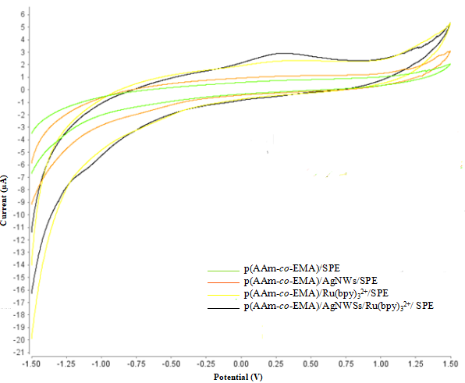

Figure 9. The cyclic voltammogram for different type of film coated on screen printed carbon electrode

Ru(bpy)₃²⁺ - e⁻ → Ru(bpy)₃³⁺
Ru(bpy)₃³⁺ + MG → Ru(bpy)₃²⁺ + ^{●+}MG
MG - e⁻ → ^{●+}MG
^{●+}MG → ●MG + H⁺
Ru(bpy)₃³⁺ + ●MG → Ru(bpy)₃^{2+*} + ⁺MG
Ru(bpy)₃^{2+*} → Ru(bpy)₃²⁺ + hv

Scheme 1. The proposed reaction for detection of malachite green [16]

Conclusion

The p(AAm-co-EMA)/AgNWs film that was characterized by ATR-FTIR showed peaks of –CN and –CO in the spectra, which confirmed that the copolymerization was successful. Besides, ¹H NMR spectrum proved the ATR-FTIR spectrum by showing the peak of carbonyl and amide groups. Meanwhile, the presence of silver nanowire (AgNWs) in poly(acrylamide-co-ethyl methacrylate) (p(AAm-co-EMA)) can be seen in the EDX spectrum and mapping micrograph. Based on the cyclic voltammogram, additions of AgNWs and Ru(bpy)₃²⁺ in p(AAm-co-EMA) had improved the performance of malachite green detection. In conclusion, the p(AAm-co-EMA)/Ru(bpy)₃^{2+/}AgNWs film was suitable to use for developing a malachite green sensor with a need of porosity film modification.

Acknowledgement

The authors would like to extend their gratitude towards Faculty Sciences and Technology Universiti Kebangsaan Malaysia and Centre for Research and Innovation Management (CRIM), Universiti Kebangsaan Malaysia for providing research facilities that were used in this research. This work was supported by the FRGS/1/2016/TK07/UKM/02/2 and GUP-2016-061.

References
- Srivastava, S., Sinha, R. and Roy, D. (2003). Toxological of malachite green. Aquatic Toxological, 66(3): 319 – 329.
- Nurul, H. A. P, Faridah, S., Nur, A. M. S., Gayah, A. R., Othman, M. and Fatimah, A. B. (2013). Malachite green and leuco-malachite green detection in fish using modified enzyme biosensor. Procedia Chemistry, 20: 85 – 89.
- Hahn, Y. B., Ahmad, R. and Tripathy, N. (2012). Chemical and biological sensors based on metal oxide nanostructures. Chemical Communication, 48: 10369 – 10385.
- Fatma, I. K., Safa’a, M. R., Mamdouh, R. R., Mohamed K. A. E. and Hoda, M. M. (2013). A single novel PVC membrane for dual determination of sulphadimethoxine and malachite green in aquatic environment. Arabian Journal of Chemistry, 8: 787 – 792.
- Faridah, S., Nurul, H. A. P., Gayah, A. R., Fatimah, A. B., Nur, A. M. S., Othman, M. and Zamri, I. (2013). Enzyme inhibition sensor for malachite green and leuco- malachite green detection in tilapia fish. Malaysian Journal of Animal Science, 16(1): 1 – 11.
- Kadajji, V. G. and Betageri, G.V. (2011). Water soluble polymers for pharmaceutical applications. Polymer, 3: 1972 – 2009.
- Gupta, I., Tomar, R. S., Nangpal, A. K. and Singhal, R. (2012). Synthesis and characterization of poly(AAm-co-BMA-co-AAc) hydrogels: Effect of acrylamide content on swelling behaviour. Designed Monomers and Polymers, 9(6): 589 – 605.
- Yamashita, K., Matsuki, M., Matsuyama, N., Endo, T., Tojo, H. and Kurota, H. (2000). Composition for peelable coating. European Patent Office, Japan: EP 1 087 000 A1.
- Rozi, N., Hanifah, S. A., Heng, L.Y. and Shyuan. L. H. (2016). Characterization of ultraviolet-photocured acrylamide based polymer. American Institute of Physics, 1784: 1 – 6.
- Chen, S. and Guo, X. (2015). Improving the sensitivity of elastic capacitive pressure sensors using silver nanowire mesh electrodes. IEEE Transactions on Nanotechnology, 14(4): 619 – 623.
- Liu, C. H. and Yu, X. (2011). Silver nano-wire based transparent, flexible, and conductive thin film. Nanoscale Research Letters, 6(1): 75.
- Lee, J. H., Huynh-Nguyen, B. C., Ko, E., Kim, J. H. and Seong, G. H. (2015). Fabrication of flexible, transparent silver nanowire electrodes for amperometric detection of hydrogen peroxide. Sensors and Actuators B: Chemical, 224: 789 – 797.
- Dong, L., Gari, R. R. S., Li, Z., Craig, M. M. and Hou, S. (2009). Graphene-supported platinum and platinum–ruthenium nanoparticles with high electrocatalytic activity for methanol and ethanol oxidation. Carbon, 48: 781 – 787.
- Shao, J., Zhao, Y., Liu, Y. and Gao, Y. (2015). Detrermination of malachite green and leucomalachite green based on alectrochemiluminescence of Ru(bpy)₃²⁺ at grapheme oxide modified glassy carbon electrode. RSC Advances, 5: 14547.

- Lan, Q. F, Wang, W. C, Chen, X. H. and Chen, Z. D. (2017). A novel solid-state electrochemiluminescence sensor based on poly(3-amino-4 hydroxybenzenesulfonic acid) /Ru(bpy)₃ ²⁺ modified electrode for determination of malachite green. International Journal of Electrochemical Science, 12: 6577 – 6587.
- Liu, F., Yang, X., Zhao, Y. and Sun, S. (2013). Detection of malachite green and leucomalachite green based on electrochemiluminescence of mono- and bimetallic ruthenium tris-bipyridyl complexes at an Au electrode. Analytical Methods, 5(3): 660 – 665.
- Pavia, D. L., Lampmam, G. M., Kriz G. S. and Vyvyan J. R. (2015) Introduction to spectroscopy. Cengage Learning, USA: pp. 252 – 269.
- Ain, N. N. and Hanifah, S. A. (2017). Preparation and characterization of poly(acrylamide-co-ethyl methacrylate) nanocomposite membrane and its potential as chemical sensor. Journal of Polymer Science and Technology, 2(1): 56 – 61.
- Hu, W., Niu, X., Li, L., Yun, S., Yu, Z. and Pei, Q. (2012). Intrinsically stretchable transparent electrodes based on silver-nanowire-crosslinked-polyacrylate composites. Nanotechnology, 23: 1 – 9.
- Bihter, Z. and Mehmet, H. M. (2015). Fabrication and characterization of antibacterial polyurethane acrylate-based materials. Materials Research, 18(4): 867 – 872.
- Kusuma, H. S., Sholihuddin, R. I., Harsini, M. and Darmokoesoemo, H. (2016). Electrochemical degradation of malachite green dye using carbon/TiO₂ electrodes. Journal of Material Environmental Sciences, 7(4): 1454 – 1460.

