INSIGHTS OF THE CHEMICAL CONSTITUENTS AND HYDROTHERMAL CARBONIZATION OF Crescentia cujete L.

(Pencirian Jujukan Kimia dan Pengkarbonan Hidrotermal bagi Crescentia cujete L.)

Judith Clarisse Jose¹, Glenn Oyong², Michael Dominic Ajero³, Irving Chiong³, Esperanza Cabrera^{1,2},
Maria Carmen S. Tan^{1*}

¹Biology Department,
²Molecular Science Unit Laboratory Center for Natural Sciences and Environmental Research,
³Chemistry Department,
De La Salle University, 2401 Taft Avenue, Manila 0922, Philippines

*Corresponding author: maria.carmen.tan@dlsu.edu.ph

Abstract
Crescentia cujete L. is an evergreen tree that presents several medicinal and industrial applications. This study primarily aimed to present preliminary characterization of the fruit extracts and fruit pulp of Crescentia cujete L. using several analytical techniques. Characterization of the crude MeOH extract and pure compound, trans-cinnamic acid, isolated from the fruit extract were performed using gas chromatography-electron ionization-mass spectrometry (GC-EI-MS). Lyophilized pulp was characterized by energy dispersive X-ray spectroscopy (EDX). Hydrochar samples resulting from hydrothermal carbonization (HTC) of fruit pulp were characterized using Fourier transform infrared spectroscopy (FTIR), scanning electron microscopy (SEM) and thermogravimetric analysis (TGA). Eight constituents were eluted from the crude MeOH extract which were mainly composed of furan (5-Hydroxymethylfurfural, 53.99%), a pyranone derivative (2,3-dihydro-3,5-dihydroxy-6-methyl-4H-pyran-4-one, 8.68%) and a carboxylic acid (3-phenyl-2-propenoic acid, 7.94% or compound 5). Other notable compounds of the extract include furaneol (0.78% and 1.56%), phenol, 2,4-bis(1,1-dimethylethyl)- (3.73%), benzenepropanoic acid, 3,5-bis(1,1-dimethylethyl)-4-hydroxy-, methyl ester (1.15%) and n-hexadecanoic acid (0.59%). GC-EI-MS confirmed the purity of the isolated compound trans-cinnamic acid (100%). EDX analysis showed high levels of K₂O (79.56%), P₂O₅ (9.925%), and SO₃ (9.131%) from the lyophilized pulp. Aliphatic compounds such as alkanes and alkenes were mostly present in both hydrochars as revealed by FTIR analyses. SEM and TGA analyses showed degradation of the lignin components of both hydrochars after the hydrothermal carbonization process. These results present the chemical characterization of the C. cujete fruit and the HTC of the pulp biomass which exhibited promising properties for applications as solid fuel or as an adsorbent.

Keywords: Crescentia cujete L., hydrothermal carbonization, hydrochar

Abstrak
Crescentia cujete L. ialah tumbuhan yang digunakan dalam perubatan dan aplikasi industri. Kajian ini dijalankan dengan tujuan melakukan saringan pencirian ekstrak buah dan pulpa Crescentia cujete L. menggunakan beberapa teknik analisis. Pencirian esktrak mentah MeOH dan sebatian tulen, trans-asid sinamik, dipencil dari ekstrak buah dilakukan menggunakan kromatografi gas-pengionan elektron-spektrometri jisim (GC-EI-MS). Pulpa liofili dicirikan melalui spektroskopi sinar-X tenaga serakan (EDX). Sampel hidrochar yang terhasil dari pengkarbonan hidrotermal (HTC) pulpa buah telah dicirikan menggunakan spektroskopi infremerah transformasi Fourier (FTIR), mikroskopi imbasan elektron (SEM) dan analisis termogravimetrik (TGA). Lapan jujukan kimia yang terelusi dari ekstrak mentah MeOH terdiri daripada furan (5-hidroksimetilfurfural, 55.99%), terbitan piranon (2,3-dihidro-3,4-dihidroksi-6-metil-4H-piran-4-on, 8.68%) dan asid karbosilik (3-fenil-2-asid propenoik, 7.94% atau sebatian 5). Sebatian lain yang dikenal pasti dari ekstrak termasuklah furaneol (0.78% dan 1.56%), fenol, 2,4-bis(1,1-dimetiletil)- (3.73%), asid benzenapropanoik, 3,5-bis(1,1-dimetiletil)-4-hidroksi-, metil ester (1.15%) dan asid n-heksadekanoik (0.59%). GC-EI-MS telah membantu mengesahkan ketulenan sebatia trans-asid sinamik yang dipencilkan (100%). Analisis EDX menunjukkan aras tinggi bagi K₂O (79.56%), P₂O₅ (9.925%), dan SO₃ (9.131%) dari pulpa liofili. Sebatian alifatik seperti alkana dan alkena paling banyak dikesan dalam hidrochar seperti yang dibuktikan oleh analisis FTIR, Analisis SEM dan TGA menunjukkan degradasi komponen lignin bagi hidrochar selepas proses pengkarbonan hidrotermal. Hasil kajian ini menunjukkan pencirian kimia bagi C. cujete dan HTC bagi biojisim pulpa menjanjikan potensi aplikasi sebagai bahan bakar atau penjerap.

Kata kunci: Crescentia cujete L., pengkarbonan hidrotermal, hidrochar

Introduction
Hydrothermal carbonization is a thermochemical conversion process (wet pyrolysis) that can convert wet biomass into valuable products [1]. It is a process that utilizes high temperature to convert raw biomass into a solid coal-like product called hydrochar characterized by high carbon content and calorific value [2]. It is a carbonaceous solid organic material which can be potentially used as solid fuel, as precursor of activated carbon used in wastewater pollution, or in soil remediation [1, 3, 4].

Crescentia cujete L., also known as calabash (Family Bignoniaceae), is an evergreen tree originating from tropical America but is now widely distributed in tropical regions [5]. This plant is known as Miracle Tree in the Philippines due to its various medicinal properties as reported by several testimonies [6, 7]. Studies have shown the efficacy of the fruit and leaf extracts against cough, cold and other respiratory ailments [8, 9]. Other studies also indicate the potential use of the extracts of this plant against inflammation [10], tumors and cancer [11, 12].

Phytochemical screening of the leaf and fruit extracts obtained from solvent partitioning of this plant has been done through several detection tests. Studies showed presence of secondary metabolites such as flavonoids, alkaloids, glycosides, saponins, tannins and terpenoids [11,12]. However, results of another study showed presence of mostly benzene and its derivatives only. The analyzed extract also eluted other compounds including methyl salicylate and 3-phenyl-2-propenoic acid, also known as trans-cinnamic acid [13]. This trans-cinnamic acid is known for its potential use as an anti-inflammatory agent and in cancer treatment [14]. Despite the reported medicinal uses, the fruit pulp is not considered edible.

In this study, preliminary characterization of the fruit extracts and fruit pulp of C. cujete L. was determined. The crude methanolic (MeOH) extract and pure compound, trans-cinnamic acid isolated from the fruit pulp of C. cujete were characterized using gas chromatography- electron ionization- mass spectrometry (GC-EI-MS). Lyophilized fruit pulp was characterized by energy dispersive X-ray spectroscopy (EDX). The fruit pulp was subjected to hydrothermal carbonization (HTC) and the resultant hydrochars were analyzed using Fourier transform infrared spectroscopy (FTIR), scanning electron microscopy (SEM) and thermogravimetric analyzer (TGA). To the best of our knowledge, this is the first reported study to provide chemical characterization of the fruit pulp of C. cujete L. following these optimized analyses.

Materials and Methods
Materials
The C. cujete L. mature fruits (Figure 1) were gathered from Bocaue, Bulacan (14°48’02” N, 120°56’43” E). The plant identity was confirmed and authenticated by the Plants of the Philippines, De La Salle University Herbarium (DLSUH). A voucher specimen was deposited to the DLSUH with an accession number of DLSUH 6251.
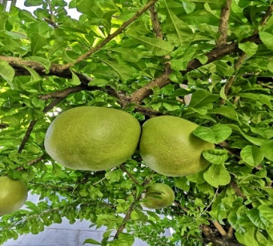
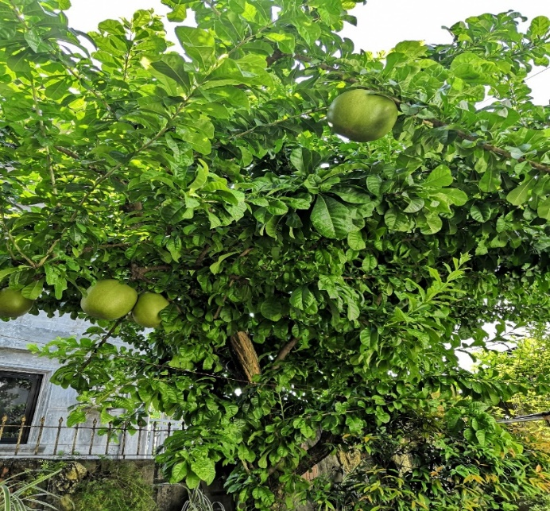
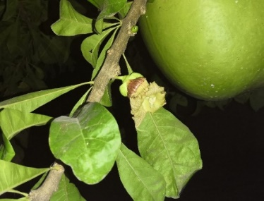

Figure 1. Actual photos of Crescentia cujete L. tree from Bocaue, Bulacan

Preparation of sample
The mature fruit of C. cujete L. was carefully cut into half. The pulp was scraped out and seeds were separated. For the crude extract preparation, 20 g of fresh pulp was extracted using Soxhlet apparatus with 200 mL methanol. The extract was concentrated in vacuo using rotary evaporator (IKA® RV10) at 80 rpm. The collected extract was filtered into a vial using 0.45 µm syringe filter with a final volume of 0.5 mL and was subjected for gas chromatography-electron ionization- mass spectrometry (GC-EI-MS) for phytochemical profiling.

To isolate the pure compound, trans-cinnamic acid, fresh pulp (20 g) was incubated in dichloromethane for 3 hours. The extract was filtered using Whatman filter paper No. 1 (11 µm pore size) and dried by evaporating the solvent. The extract was diluted in methanol and purified by gravity column chromatography using an ExtraBond Cartridge (C₁₈, 500 mg, 6 mL). The eluted extract was purified again by diluting with ethyl acetate and petroleum ether. The extract was filtered into a vial using 0.45 µm syringe filter with a final volume of 0.5 mL and submitted for GC-EI-MS analysis to confirm the purity of the compound.

Gas chromatography – mass spectrometry analysis
Crude extracts from both solvents were scrutinized by GC−EI-MS. An Agilent GC MS7890B, equipped with a HP-5 ms (5% phenyl methylsiloxane) Ultra Inert column (30 m × 250 mm × 0.25 mm) with ultrapure helium gas as the mobile phase, was employed for the analysis of low-boiling-point components. Helium gas was delivered at 1 mL/min, while maintaining pressure at 8.2 psi, with a rate of 36.62 cm/s and holdup interval of 1.37 min. The splitless inlet was held at 250 °C, at 8.2 psi, and an overall stream of 24 mL/min, with a septum purge stream velocity of 3 mL/min. The temperature for the injector was stipulated at 250 °C. The temperature program started at 70 °C with a programmed linear ramp of 2 °C/min until 135 °C and was held at this temperature for 10 minutes. Another temperature increase was achieved at 4 °C/min until 220 °C and was maintained for 10 minutes. The temperature was then increased to 270 °C at a ramp of 3.5 °C/min and was held at 37 minutes. Compound identification was done using the NIST Archive 2.0, and percent peak area average was calculated from the subsequent total ion chromatograms (TIC). The consequential results were authenticated by the evaluation of the constituents corresponding to their elution succession with their comparative retention indices on an intermediate polar gas chromatograph column. The retention indices were computed for the entirety of the compounds using a homologous series of n-alkanes. The experiments were carried out in three replicates.

Energy dispersive X-ray spectroscopy
EDX-7000 (Shimadzu, Japan) was used for elemental analysis of the lyophilized sample of C. cujete fruit pulp prepared in a 3 mm Mylar cup. The collimator was set at 3 mm.

Hydrothermal carbonization
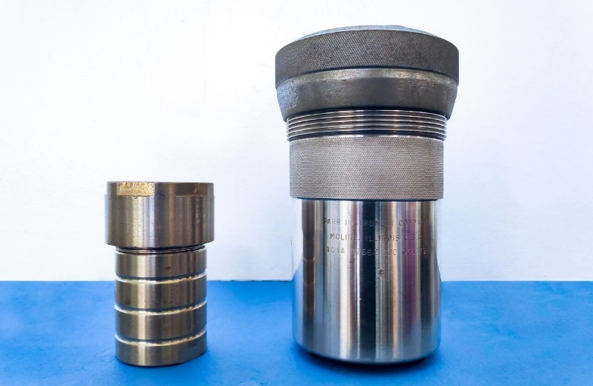
In this study, one gram of fresh pulp of C. cujete was placed inside a hydrothermal autoclave reactor (HAR) with PTFE Liner (Figure 2a) and inside a Parr Oxygen Combustion Vessel (POCV) (Figure 2b). The HAR was heated using a furnace set at 180 °C for two hours; whereas, the POCV was heated using an oven at 220 °C for two hours. The resulting hydrochars were used for thermogravimetric analysis and scanning electron microscopy for further analysis.
b
a

Figure 2. Images of the (a) HAR and (b) POCV used for hydrothermal carbonization

Fourier transform infrared spectroscopy
Characterization of the hydrochar samples was performed using a Thermo Scientific Nicolet 6700 FT-IR (Thermo Fisher Scientific, USA) using a DTGS KBr detector, Csl beamsplitter and transmission accessory. A total of 16 scans from 400-4000 cm⁻¹ with spectral resolution of 4 cm⁻¹ were taken for each sample. KBr was used to collect background to be subtracted by the sample. Analyses were performed using the Omnic Spectra software 8.0.342 (Thermo Fisher Scientific, USA).

Scanning electron microscopy
The morphology of the hydrochar was observed and examined using JSM 5310 Scanning Microscope (JEOL, Japan) which scans the surface of the material with a focused beam of electrons. A trace amount of each hydrochar was mounted to a metal stub, coated with gold ions for 60 seconds to make the sample conducting and be able to observe the morphology of the sample. SemAfore V. 5.2 was used to analyze the image produced.

Thermogravimetric analysis
TGA 55 (TA Instruments®, USA) was used to perform the thermal gravimetric analysis (TGA) of the produced hydrochar. TGA is an analytical technique that can provide analysis on the thermal stability of the sample. It measures the weight of the sample as it is exposed to gradually increasing temperature and records the mass loss over time and/or increase in temperature [15]. In this study, 3 mg of each of the hydrochar samples was placed and spread out evenly in a platinum HT pan of TGA 55. The analysis was performed at a flow rate of 25 mL/min under nitrogen gas with temperature set at 10 °C to 1000 °C, heating rate of 10 °C/min and scans starting at 30 °C. Analyses were done using the built-in TRIOS software V. 4.3.1.39215 TA Instruments-Waters LLC. Combustion behavior is indicated by the weight loss of the sample as a function of temperature.

Results and Discussion
Gas chromatography-mass spectrometry analysis
The plant extracts of C. cujete L. fruit were analyzed using GC-MS for phytochemical characterization. The identification of both extracts was verified and confirmed by the retention index through the NIST library v.2.0. The crude MeOH extract eluted a total of 8 volatile compounds listed in Table 1 and shown in Figure 3a. The GC-MS analysis revealed that the crude MeOH extract mainly composed of furan, 5-Hydroxymethylfurfural (53.99%), a pyranone derivative, 2,3-dihydro-3,5-dihydroxy-6-methyl-4H-pyran-4-one (8.68%) and a carboxylic acid, 3-phenyl-2-propenoic acid (7.94%) or compound 5. Other notable compounds of the extract include furaneol (0.78% and 1.56%), phenol, 2,4-bis(1,1-dimethylethyl)- (3.73%), benzenepropanoic acid, 3,5-bis(1,1-dimethylethyl)-4-hydroxy-, methyl ester (1.15%) and n-hexadecanoic acid (0.59%). The presence of hydrocarbons may indicate the potential application of the fruit as fuels [16].

Table 1. Volatile constituents of the methanolic crude extract of Crescentia cujete L.

 | Compound | RT (min) | RI^{(a)} | % Peak Area | Functionality
1 | 2,5-Dimethyl-4-hydroxy-3(2H)-furanone | 8.53 | 1082 ± 1 | 0.78 ± 0.1 | furanone
2 | 2,5-Dimethyl-4-hydroxy-3(2H)-furanone | 8.83 | 1090 ± 0 | 1.56 ± 0.93 | furanone
3 | 4H-Pyran-4-one, 2,3-dihydro-3,5-dihydroxy-6-methyl- | 12.09 | 1164 ± 1 | 8.68 ± 2.63 | pyranone derivative
4 | 5-Hydroxymethylfurfural | 18.53 | 1289 ± 1 | 53.99 ± 12.33 | furan
5 | 2-Propenoic acid, 3-phenyl- | 29.26 | 1476 ± 1 | 7.94 ± 0.47 | unsaturated carboxylic acid
6 | Phenol, 2,4-bis(1,1-dimethylethyl)- | 31.44 | 1513 ± 0 | 3.73 ± 0.5 | phenol
7 | Benzenepropanoic acid, 3,5-bis(1,1-dimethylethyl)-4-hydroxy-, methyl ester | 55.94 | 1941 ± 0 | 1.15 ± 0.02 | diverse functional group
8 | n-hexadecanoic acid | 56.80 | 1969 ± 0 | 0.59 ± 0.08 | fatty acid
^{(a)} Retention Index (HP-5ms column)

Constituent 5 (Table 2; Figure 3b), with chemical formula C₉H₈O₂ and exact mass of 148.052429 (CAS#: 621-82-9 NIST#: 133307 ID#: 119939), was found in the dichloromethane fraction and purified using reverse phase column chromatography using a C₁₈ column and methanol as the eluting solvent. The fraction found to have compound 5 was dried and reconstituted in ethyl acetate and finally with petroleum ether. The purity of the extract containing only the pure compound, trans-cinnamic acid, was confirmed by the GC-MS analysis percent report verifying that it was of high purity (100%).

Table 2. Phytochemical characterization of pure compound obtained from fruit extract of Crescentia cujete L.

 | Compound | RT  (min) | RI^{(a)} | % Peak Area | Functionality
5 | 2-Propenoic acid, 3-phenyl- | 27.854 | 1452 | 100.00% | unsaturated carboxylic acid
^{(a)} Retention Index (HP-5ms column)
Constituent 5 gave characteristic fragmentation paths of cinnamic acid as reported by Schaldach and Grützmacher [17]. Figure 4 shows the mass spectrum of 5 which shows a base peak of 147 m/z (C₉H₇O₂)⁺ or [M-H]⁺ from the loss of a hydrogen. The [M-OH]⁺ fragment (131 m/z) was derived from the loss of OH from the molecular ion. After the loss of CO from [M-OH]⁺, the fragment (C₈H₇)⁺ was formed. The elimination of C₂H₂ produced [C₆H₅]⁺, 77 m/z and another subsequent loss of C₂H₂ produced [C₄H₃]⁺, 51 m/z. All of the aforementioned peaks were found in the mass spectrum of constituent 5.

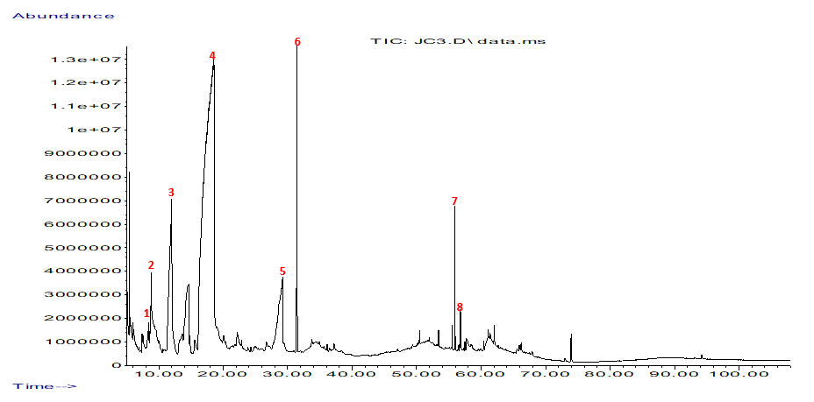
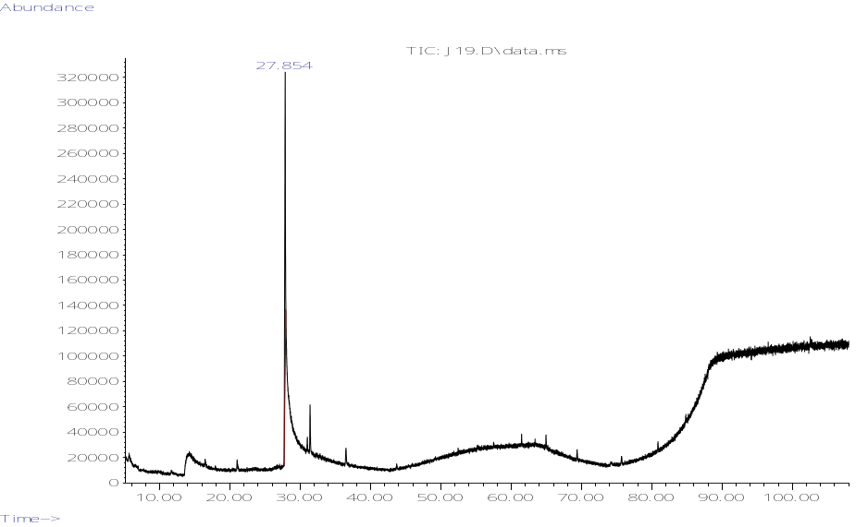
(a)
(b)

Figure 3. Total ion chromatogram of the volatile constituents of (a) crude methanolic extract and (b) pure compound, trans-cinnamic acid, from fruit pulp of C. cujete L.
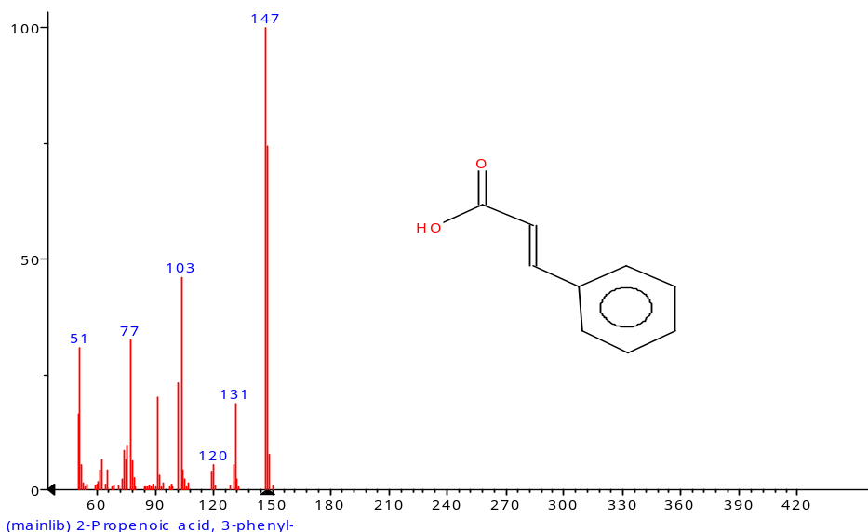

Figure 4. 70 eV mass spectrum of 5 from fruit pulp of C. cujete L.

EDX analysis
The elemental analysis of the lyophilized fruit pulp of C. cujete revealed high percentage composition of K₂O (79.56%), P₂O₅ (9.925%), and SO₃ (9.131%). Fe₂O₃ (0.624%), CuO (0.399%), ZnO (0.301%) and Rb₂O (0.059%) were also found to be present in the sample as shown in Figure 5. Studies revealed that potassium intake in diet is correlated with the reduction of blood pressure and reduces the risk of stroke and coronary heart diseases. Dietary potassium also induces protective effect on age-related bone loss and reduction of kidney stones [18,19]. Phosphorus intake is also necessary in human diet but high levels of phosphorus are associated with chronic kidney disease (CKD). Impaired renal function of CKD patients makes them unable to clear excess phosphorus. High level of serum phosphate is also associated with cardiovascular diseases and all-cause mortality [20]. Dietary supplements with sulfur containing compounds were used to treat diseases of the joints [21]. Copper is also observed to be present in the sample in minute quantities. Copper has been involved in numerous biological processes, including antioxidant defense neuropeptide synthesis and immunological processes. Copper deficiency in utero may lead to impairment in the development of the cardiovascular system, bone malformation and other immunologic and neurologic abnormalities, whereas modification in cholesterol metabolism may be the result of prolonged marginal copper deficiency in adulthood. However, high levels of copper may also induce toxicity resulting in oxidative cell damage and cell death [22].
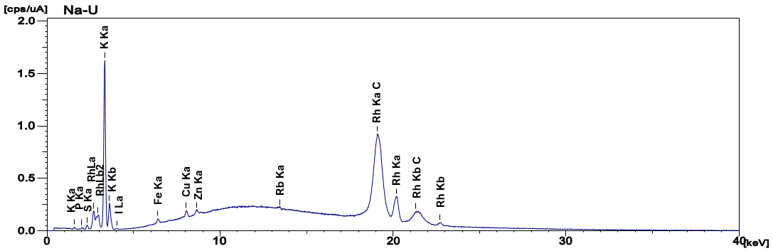
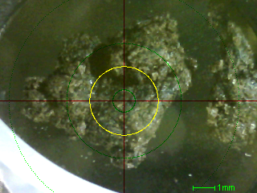

Figure 5. An EDX image and elemental analysis spectrum of lyophilized C. cujete L. fruit pulp
Fourier-transform Infrared Spectroscopy
The FTIR patterns of the hydrochars produced using HAR and POCV are presented in Figure 6. The results of the spectrum of hydrochar produced from HAR are listed on Table 3. The peaks obtained within 3300-2500 cm⁻¹ can be attributed to the stretching of C-H with the presence of aliphatic compounds. The peak at 1711.59 cm⁻¹ corresponds to C=O stretching from cellulose and lignin. Peaks within 1650-1566 cm⁻¹ are attributed to C=C stretching representing cyclic alkenes. The peak at 1454.03 cm⁻¹ corresponds to C-H bending of a methylene group while the peak at 1395.67 cm⁻¹ is attributed to O-H bending of a carboxylic acid. The peak at 1254.65 cm⁻¹ corresponds to C-O stretching vibrations of lignin. The peaks within 1210-1163 cm⁻¹ are attributed to C-O stretching from the vibrations of ester compounds. Peak obtained at 1065.40 cm⁻¹ is attributed to C-O stretching of primary alcohol.

Table 3. Conditions of hydrochar produced using HAR

Wavenumber (cm⁻¹) | Functional Group | Description
2923.32 | C-H stretching | Aliphatic
2855.27 | C-H stretching | Aliphatic
1711.59 | C=O stretching | Carbonyl, ester or carboxyl from cellulose and lignin
1586.49 | C=C stretching | Cyclic alkene
1525.18 | C=C stretching | Cyclic alkene
1454.03 | C-H bending | Methylene group
1395.67 | O-H bending | Carboxylic acid
1254.65 | C-O stretching | Vibrations in lignin
1210.37 | C-O stretching | Ester
1164.29 | C-O stretching | Ester
1065.40 | C-O stretching | Primary alcohol

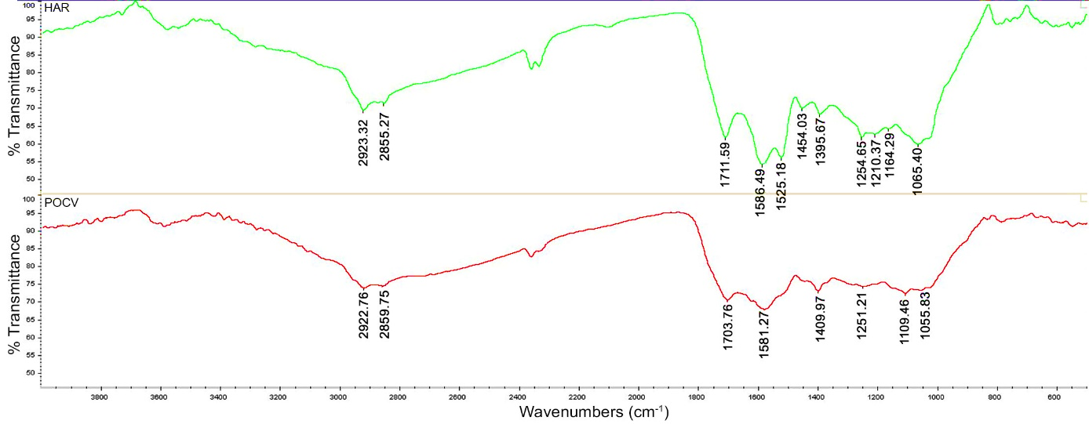

Figure 6. FTIR spectra of hydrochars produced from HAR (top) and POCV (bottom)

Table 4 presents the result of the spectrum of hydrochar produced from POCV. Peaks obtained around 3000-2840 cm⁻¹ are attributed to aliphatic bands, C-H stretching vibrations. The peak at ~1700 cm⁻¹ can be attributed to the stretching of C=O bonds from cellulose and lignin. Peak at ~1580 cm⁻¹ is attributed to C=C stretching representing an aromatic compound. The peak at 1400 cm⁻¹ corresponds to C-H bending. The peak at 1251.21 cm⁻¹ is attributed to C-O stretching vibrations of lignin. The peak obtained around 1109 cm⁻¹ is attributed to stretching of C-O from the vibrations of cellulose and hemicelluloses. After the HTC process, FTIR analysis of the hydrochar produced from both HAR and POCV revealed the possible presence of a complex mixture of aliphatic and olefinic hydrocarbons as seen by the aforementioned C-H stretching and methylene bending.

Table 4. Conditions of hydrochar produced using POCV

Wavenumber (cm⁻¹) | Functional Group | Description
2922.76 | C-H stretching | Aliphatic
2859.75 | C-H stretching | Aliphatic
1703.76 | C=O stretching | Carbonyl, ester or carboxyl from cellulose and lignin
1581.27 | C=C stretching | Cyclic alkene
1400.97 | C-H bending | Methylene group
1251.21 | C-O stretching | Vibrations in lignin
1109.46 | C-O stretching | Vibrations in cellulose and hemicelluloses
1055.83 | C-O stretching | Primary alcohol

Scanning electron microscopy
Biomass morphology can be significantly altered by undergoing thermal pre-treatment, thereby reducing the fibrous nature of the sample. Cell walls degrade as a result of the decomposition of hemicellulose, depolymerization of cellulose, and softening of lignin components [1]. The morphologies of the fruit pulp of C. cujete subjected to thermal pre-treatment at 180 °C and 220 °C using HAR and POCV, respectively, were shown in Figure 7. The SEM results showed that the fruit pulp has been broken down considerably in both thermal pre-treatments. HTC might have caused the degradation of lignin’s appearing as small particles attached to the hemicellulose or fiber-like particles [23] observed in the SEM images (Figure 7). Several small particles like flakes can be observed on the surfaces of both hydrochars making them rough in appearance. Hydrochar produced using HAR was seen with small spherical particles measuring 3.84 ± 1.13 µm and flakes measured at 21.4 ± 10.33 µm attached on fiber-like structures as observed on SEM (Figure 7a). On the other hand, the morphology of the hydrochar produced using a POCV was observed with smaller flakes (0.85 ± 0.11 µm) attached on fiber-like structures on the surface of the sample. Moreover, the surface of POCV hydrochar appeared to be smoother than the hydrochar produced by HAR (Figure 7b).

Research revealed that hydrochar produced under mild conditions (180-250 °C) of HTC is considered as a cost-effective novel material as an alternative adsorbent compared to other carbonaceous materials including activated carbon and biochar. Activated hydrochars have been widely utilized in environmental remediation such as on the adsorption of heavy metals and volatile organic compounds [24]. Thermochemical activation of hydrochar may result to a highly porous activated carbon [25]. This study showed both non-porous non-activated hydrochars produced by HTC under 180 °C and 200 °C similar to raw apple chip pomace and raw grape pomace fruit wastes [1].

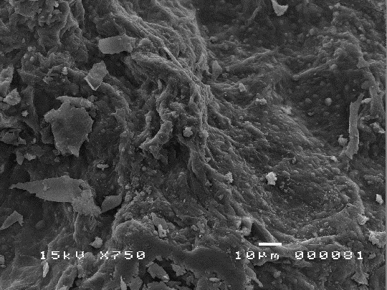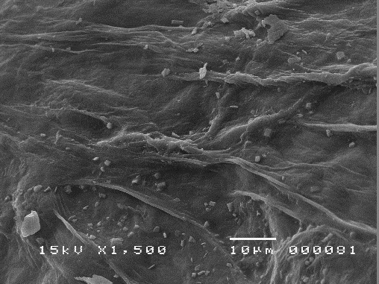
(a)
(b)

Figure 7. Scanning electron microscopy images of Crescentia cujete L. pulp after thermal pre-treatment at (a) 180 °C using HAR and (b) at 220 °C using a POCV
Thermogravimetric analysis
The TGA graphs of the pre-treated pulp samples are presented in Figure 8. It can be observed that the initial weight loss of both hydrochar samples occurred between 30 to 150 °C due to moisture loss. The main weight loss of hydrochar samples occurred in the second stage of TGA with the release of volatile matter content and combustion at temperatures between 290 to 430 °C wherein about 50% of the original weight was lost. This may be caused by the initial pre-treatment of the pulp samples heated at 180 and 220°C that might have reduced the volatile matter content present in the samples. The final stage of TGA analysis which is the fixed carbon content combustion occurred at around 540 °C and ended at 830 °C with inorganic residues collected weighing about 6-8% of the original mass. The results showed similarities in TGA graphs between hydrochar produced using hydrothermal autoclave reactor and hydrochar produced using the oxygen combustion vessel is indicative that the latter may be used as substitute for hydrothermal reactor.
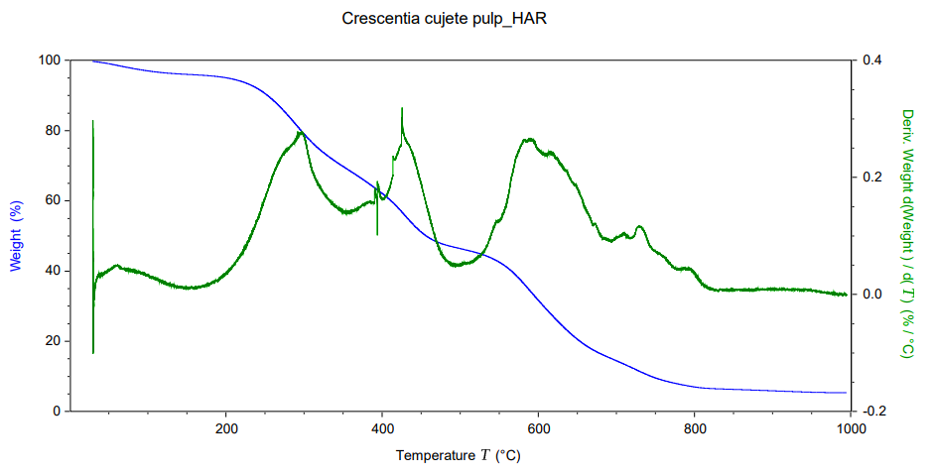
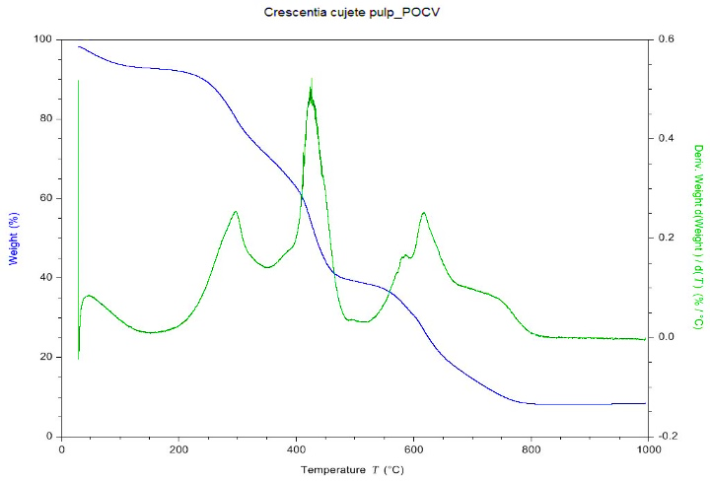
(a)
(b)

Figure 8. Thermogravimetric analysis graphs of the hydrochars produced from the hydrothermal carbonization of the fruit pulp of Crescentia cujete L using (a) HAR and (b) POCV

Conclusion
Crescentia cujete L. fruit presented several potential applications. The methanolic crude extract revealed volatile constituents consisting of mostly furans and unsaturated carboxylic acid, trans-cinnamic acid. The lyophilized pulp sample was found to have high levels of K₂O as revealed by the elemental analysis. Hydrochars produced by HTC under 180 °C and 220 °C showed degradation of cell walls by the decomposition of hemicellulose and lignin components of the samples. HAR and POCV can both be used in producing hydrochars as revealed by similarities between the hydrochar samples in all analyses. Moreover, further studies on these hydrochars are recommended as they may possibly be utilized as solid fuel as revealed by presence of hydrocarbons or as adsorbent of volatile organic compounds but further analyses must be performed.

References

- Zhang, B., Heidari, M., Regmi, B., Salaudeen, S., Arku, P., Thimmannagari, M. and Dutta, A. (2018). Hydrothermal carbonization of fruit wastes: A promising technique for generating hydrochar. Energies, 11(8): 2022-2035.
- Lucian, M. and Fiori, L. (2017). Hydrothermal carbonization of waste biomass: Process design, modeling, energy efficiency and cost analysis. Energies, 10(2): 211-228.
- Kantakanit, P., Tippayawong, N., Koonaphapdeelert, S. and Pattiya, A. (2018). Hydrochar generation from hydrothermal carbonization of organic wastes. IOP Conference Series: Earth and Environmental Science, 159: 1-6.
- Wang, T., Zhai, Y., Zhu, Y., Li, C. and Zeng, G. (2018). A review of the hydrothermal carbonization of biomass waste for hydrochar formation: Process conditions, fundamentals, and physicochemical properties. Renewable and Sustainable Energy Reviews, 90: 223-247.
- Arango-Ulloa, J., Bohorquez, A., Duque, M. and Maass, B. (2009). Diversity of the calabash tree (Crescentia cujete L.) in Colombia. Agroforestry Systems, 76(3): 543-553.
- Tacio, H. (2015). Calabash the miracle fruit. https://businessmirror.com.ph/2015/10/15/calabash-the-miracle-fruit/. [Access online 10 October 2019].
- Agron, E. (2017). Calabash contains active ingredients potential for cancer treatment. http://www.pchrd.dost.gov.ph/index.php/14-r-d-updates/3132-calabash-contains-active-ingredients-potential-for-cancer-treatment. [Access online 10 October 2019].
- Morton, J. (1968). The Calabash (Crescentia cujete) in folk medicine. Economic Botany, 22(3): 273- 280.
- Parvin, M. S., Das, N., Jahan, N., Akhter, M. A., Nahar, L. and Islam, M. E. (2015). Evaluation of in vitro anti-inflammatory and antibacterial potential of Crescentia cujete leaves and stem bark. BMC Research Notes, 8(1): 412-418.
- Jato, J. (2015). Anti-inflammatory, antimicrobial and antioxidant properties of Margaritaria nobilis, Stylochiton lancifolius, Drypetes principum, Crescentia cujete and Albizia glaberrima. Thesis of Master Degree, Kwame Nkrumah University of Science and Technology, Kumasi, Ghana.
- Billacura, M. and Laciapag, G. C. (2017). Phytochemical screening, cytotoxicity, antioxidant, and anthelmintic property of the various extracts from Crescentia cujete Linn fruit. Science International, 29 (2): 31-35.
- Billacura, M. and Pangcoga, K. K. (2017). Phytochemical screening, cytotoxicity, mutagenicity, antimutagenicity, and protective potentials of the different solvent extracts from the air-dried leaves of Crescentia cujete Linn. International Journal of Advanced and Applied Sciences, 4(4): 118-126.
- Rellin, K. F. B., Dasmariñas, D. D. and Junio, H. A. (2018). Untargeted metabolite profiling of Philippine-grown Crescentia cujete and its commercial fruit juice using GC-MS and UPLC-HRMS. Philippine Journal of Science, 147(4): 647-658.
- Liu, L., Hudgins, W., Shack, S., Yin, M. and Samid, D. (1995). Cinnamic acid: A natural product with potential use in cancer intervention. International Journal of Cancer, 62(3): 345-350.
- Rajisha, K., Deepa, B., Pothan, L. and Thomas, S. (2011). Thermomechanical and spectroscopic characterization of natural fibre composites. Interface Engineering of Natural Fibre Composites for Maximum Performance: 241-274.
- Hood, E. (2016). Plant-based biofuels. F1000Research, 5: pp. 1-9.
- Schaldach, B. and Grützmacher, H.-Fr. (1980). The fragmentations of substituted cinnamic acids after electron impact. Organic Mass Spectrometry, 15(4): 175-181.
- Lanham-New, S., Lambert, H. and Frassetto, L. (2012). Potassium. Advances in Nutrition, 3(6): 820- 821.
- Weaver, C. (2013). Potassium and health. Advances in Nutrition, 4(3): 368S-377S.
- Uribarri, J. and Calvo, M. (2013). Dietary phosphorus intake and health. The American Journal of Clinical Nutrition, 99(2): 247-248.
- Nimni, M., Han, B. and Cordoba, F. (2007). Are we getting enough sulfur in our diet?. Nutrition & Metabolism, 4(1): 1-12.
- Bost, M., Houdart, S., Oberli, M., Kalonji, E., Huneau, J. and Margaritis, I. (2016). Dietary copper and human health: Current evidence and unresolved issues. Journal of Trace Elements in Medicine and Biology, 35: 107-115.
- Ghaffar, S. H. and Fan, M. (2013). Structural analysis for lignin characteristics in biomass straw. Biomass and Bioenergy, 57: 264-279.
- Zhang, X., Gao, B., Fang, J., Zou, W., Dong, L. and Cao, C. (2019). Chemically activated hydrochar as an effective adsorbent for volatile organic compounds (VOCs). Chemosphere, 218: 680-686.
- Plavniece, A., Zhurinsh, A., Dobele, G. and Locs, J. (2019). Chemically activated hydrochar flakes from birch wood. Key Engineering Materials, 800: 261-266.

