
S

SOURCE DETERMINATION OF PSEUDOEPHEDRINE USING ATTENUATED TOTAL REFLECTANCE FOURIER TRANSFORM INFRARED SPECTROSCOPY COMBINED WITH CHEMOMETRIC ANALYSIS

(Penentuan Sumber Pseudoephederin Menggunakan Spektroskopi Atenuasi Pembalikan Transformasi Fourier Digabungkan Dengan Analisis Kemometrik)

Ainol Hayah Ahmad Nadzri¹, Saravana Kumar Jayaram², Puteri Nurul Hassanah Anuar¹,

Noor Zuhartini Md Muslim¹, Dzulkiflee Ismail¹, Wan Nur Syuhaila Mat Desa¹*

¹Forensic Science Programme, School of Health Sciences,
Universiti Sains Malaysia, 16150 Kubang Kerian, Kelantan, Malaysia
² Narcotic Section, Forensic Science Unit,
Chemistry Department, Jalan Sultan 46661 Petaling Jaya, Selangor

*Corresponding author: wannurs@usm.my

Received: 20 November 2019; Accepted: 27 March 2020

Abstract
Seizures of pseudoephedrine compound pertaining to clandestine drug laboratories were widely reported since it is abused for illicit amphetamine-type stimulant (ATS) production. In small scale clandestine laboratory, a commercial decongestant tablet is always encountered despite having properties claimed to deter pseudoephedrine extraction as pharmaceutical means to prevent the misuse of the compound. This study aims to investigate the feasibility of discriminating extracted pseudoephedrine powder based on its origin. In this study, five different types in varying strengths and sizes of pseudoephedrine-based tablets samples were extracted with direct and acid-base extraction methods. Identification of extracted pseudoephedrine was done by simple attenuated total reflection Fourier transform infrared spectroscopy (ATR-FTIR). In total, 90 spectra were obtained from 15 batches of samples at six repetitive scans. Spectral selection on characteristic fingerprint regions was performed and subsequently subjected to hierarchical cluster analysis (HCA) and principal component analysis (PCA). In HCA, discrimination among samples was evident at around 77-86% similarity while in PCA, discrimination is presented at 80-93% total variation. Groupings and linkages based on their origin were established. A simple and direct method for identification and source determination of chemically processed pseudoephedrine compounds is demonstrated. This information can be a valuable intelligent tool for forensics and law enforcers to understand precursor material sources hence would be beneficial to disrupt the supply of the compound intended for clandestine operations.

Keywords: pseudoephedrine, clandestine drug laboratory, forensic intelligence

Abstrak

Rampasan sebatian pseudoephedrin daripada makmal dadah haram semakin meluas dilaporkan kerana sebatian tersebut telah disalahgunakan dalam menghasilkan dadah perangsang jenis amfetamin (ATS). Dalam makmal dadah haram berskala kecil, pil dekongestan komersial yang mengandungi pseudoephedrin sering ditemui sebagai bahan prekursor alternatif walaupun formulasinya telah diubahsuai untuk menghalang proses pengekstrakan pseudoephedrin dan seterusnya mencegah daripada penyalahgunaan sebatian tersebut. Kajian ini bertujuan untuk menyiasat kebolehlaksanaan untuk mendiskriminasi serbuk pseudoephedrin yang diekstrak berdasarkan kepada sumbernya. Dalam kajian ini, lima jenis tablet yang mengandungi pseudoephedrin dengan pelbagai saiz dan kekuatan telah diekstrak melalui kaedah pengekstrakan secara langsung dan asid-bes. Pengenalpastian sebatian pseudoephedrin yang diekstrak telah dilakukan melalui spektroskopi atenuasi pembalikan dan transformasi Fourier (ATR-FTIR). Secara keseluruhan, 90 spektra telah diperolehi daripada 15 kelompok sampel pada enam imbasan berulang. Pengujian spektra pada kawasan tertentu telah dilakukan dan spektra daripada kawasan terpilih kemudiannya tertakluk kepada analisis kluster hierarki (HCA) dan analisis komponen prinsipal (PCA). Dalam HCA, diskriminasi di antara sampel telah dibuktikan pada sekitar 77-86% persamaan manakala di PCA, diskriminasi dibentangkan pada 80-93% jumlah variasi. Kajian ini menunjukkan penggunaan kaedah secara langsung dan mudah dalam pengenalpastian dan penentuan asal-usul sebatian pseudoephedrin yang telah diproses secara kimia. Maklumat yang diperolehi melalui kajian ini adalah sangat bernilai sebagai alat perisikan kepada penguasa perundangan dan forensik untuk memahami sumber bahan prekursor dengan itu dapat memberi manfaat dalam mengganggu bekalan pseudoephedrine untuk operasi haram.

Kata kunci: pseudoephedrine, makmal dadah haram, perisikan forensik

Introduction
Ephedrine and its enantiomer, pseudoephedrine (C₁₀H₁₅NO, mwt. 165.23g/mol), are sympathomimetic drugs regulated for medical use [1]. This medication is a known nasal decongestant readily obtained over the counter for temporary relief of stuffy nose and sinus pain/pressure caused by infection (such as the common cold, flu) or other breathing illness such as allergies, bronchitis and hay fever [1]. Pseudoephedrine salts are common active pharmaceutical ingredients (APIs) in numerous cold medications, commonly sold in a fixed-dose combination with additional active ingredients such as acetaminophen, antihistamines, guaifenesin, dextromethorphan and/or ibuprofen [2].

Either in bulk form or chemical preparations, pseudoephedrine is strictly regulated for use in chemical, medical and pharmaceutical industries. Legitimate use, however, is diverted by drug trafficking organizations which utilize the compound as the main precursor for clandestine drug production, therefore has captured forensic investigation interest. This diversion has contributed to the continual increase in the use and seizures of a pharmaceutical preparation containing ephedrine/pseudoephedrine worldwide. Despite being listed under 1988 United Nations Convention Against Illicit Traffic in Narcotic Drugs and Psychotropic Substances [3] which enforces strict regulation in import, export, consumer purchase restriction and behind the counter safe-keeping of pseudoephedrine powder or products, illicit diversion of these precursors is extremely difficult to control. The compound is clandestinely isolated and purified from retail goods to improve batch sizes, yield and purity [4].

Over 65 million tablets were reported to have been seized around the world between to have been seized 2009-2013 [3]. Significant increase within South-East Asia countries is reported. Malaysia is among the countries within this region that have reported significant cases in Malaysia includes ephedrine and pseudoephedrine seizure of 287 kg raw material form originating from India, the seizure of 112 kg in clandestine methamphetamine laboratory in the form of pharmaceutical preparations of unknown origin and 33 kg of ephedrine preparations were also seized in another illicit laboratory [3]. As a precursor, the compound is highly coveted to produce some amphetamine-type stimulants (ATS) through reduction and/or oxidation reactions [5].

Applications of Fourier transform infrared spectroscopy (FTIR) for quality control and identification of solids samples has been established for pharmaceutical sample characterization but has limited application for illicit drug quantitative study [6, 7]. Nonetheless, rapid, direct, non-destructive and on-site detection of chemical evidence is highly warranted in forensic investigation and enforcement intelligence purposes. Several studies [8, 9] have reported the use of FTIR as a conventional approach for comparison and classification of illicit drug substances. Several works have utilized attenuated total reflection Fourier transform infrared spectroscopy (ATR-FTIR) and diffuse reflectance near infrared spectroscopy (NIRS) for quantitative analysis of imitated samples of methylamphetamine and diacetylmorphine (heroin), respectively [10, 11].

Additionally, works on the analysis of real seized samples also were done by applying the vibrational techniques jointly with chemometric analysis. While structural information is most useful for compound identification, spectral fingerprint information could be utilized for determination of sample origin although it may pose challenges for polymorph or mixed samples. Challenges were also observed for non–homogenous mixtures samples. Although FTIR is a very useful technique for extracting structural information from pure substances, IR spectra of complex real matrices that contain a wide range of contaminant/adulterants cannot be satisfactorily analyzed only by simple spectral matching and univariate method. Hence, the use of multivariate chemometric technique is necessary [12, 13].

Chemometric techniques such as principal component analysis (PCA) and hierarchical component analysis (HCA) are powerful tools for compressing multidimensional chemical signal and data into a few variables and presenting them graphically for ease of classification especially when the work involves with high throughput workload. This approach is widely accepted for samples of forensic importance [14]. Despite its potential, application of chemometric methods for the analysis of drugs precursors particularly pseudoephedrine is limited although similar technique is widely applied to other samples of forensic interest [15, 16]. One related work used NIRS to perform analysis of real seized samples, with the aim of discriminating ecstasy tablets [17] while another work determined heroin by using this same analytical technique with partial least-squares (PLS) regression [18].

From a forensic intelligence perspective, investigation on the origin of the precursor used in the manufacturing process is useful to disrupt the diversion of precursors thus may help drug law enforcement authorities obtain other information of strategic relevance. Hence, this work was done to investigate the feasibility of combining non-destructive ATR-FTIR coupled to HCA and PCA as a facile and reliable approach to distinguish among pseudoephedrine samples obtained from different marketed formulations and brands. Specifically, this work presents the benefits originating from both techniques is combined for forensic source determination of precursors.

Materials and Methods

Materials
Sodium hydroxide pellets (NaOH) and 37% hydrochloric acid (HCl) were purchased from Friedman Schmidt, Germany USA. Diethyl ether, ethanol and sodium sulphate anhydrous were purchased from System, Malaysia. Distilled water was obtained from an in-house water purification system.

Samples collection
Decongestant tablets containing pseudoephedrine active compounds at varying strengths and from various manufacturer were purchased from registered pharmacies around Kota Bharu area in Kelantan, Malaysia. Decongestant tablet encountered in pseudoephedrine hydrochloride or sulfate form is a controlled medication. Both types were collected for the discrimination study before and after pseudoephedrine extraction. For security purposes regarding the clandestine operation, the samples were anonymously coded (Table 1). Other declared APIs and excipients of these tablets include loratadine, povidone, triprolidine, paracetamol, polyethylene glycol, wax, talc powder, magnesium stearate, corn starch and calcium phosphate to name a few. Physical descriptions of the samples were noted.

Samples preparation
All samples under study underwent simple preparative means prior to analytical measurement. For each brand, the tablets were divided into three equal portions. Size reduction was done by crushing the tablets using pestle and mortar and the powdered form was homogenized using square and cone technique. The homogenized sample was divided to three portions. The first portion was intended for direct analysis while the second and third portions were subjected to simple extraction and acid-base extraction respectively.

Simple and direct extraction was carried out by dissolving the homogenous sample in ethanol, covered, agitated for 10 minutes and filtered by gravity filtration. The pseudoephedrine–containing solvent was evaporated and the resultant solid was collected for subsequent analysis.

Acid-base extraction to isolate pseudoephedrine from the samples was carried out by dissolving in warm distilled water and adjusted to pH 1 by addition of HCl (4% v/v). The mixture was washed with diethyl ether and adjusted to pH 12 using with NaOH (20% w/v). Diethyl ether (20 mL) was added into the basified mixture and shaken for 10 minutes. This process was repeated for three times. The collected diethyl ether was washed with distilled water and dried using sodium sulfate anhydrous. The pseudoephedrine–containing organic solvent was left to evaporate and the resultant solid was then collected.

Six replicates were performed for each sample, therefore in total, 90 samples were subjected to subsequent analysis. For ease of identification, each prepared sample were given a reference code as displayed in Table 1.

Table 1. Decongestant samples understudy with their respective reference code
Tablets  (API contents) | Physical Description | Preparations
Tablets  (API contents) | Physical Description | Direct | Simple  Extraction | Acid Base  Extraction
A (C₁₀H₁₅NO.SO₄, 120 mg) | White, round, wax-coated | AP | AD | AS
B (C₁₀H₁₅NO.HCl, 60 mg) | White, round, wax-coated | BP | BD | BS
C (C₁₀H₁₅NO.SO₄, 120 mg) | White, round, not coated | CP | CD | CS
D (C₁₀H₁₅NO.SO₄, 240 mg) | White, oval, wax-coated | DP | DD | DS
E (C₁₀H₁₅NO.HCl, 30 mg) | Yellow, orange, oval, not coated | EP | ED | ES

ATR-FTIR analysis
All samples were analyzed using Bruker® TENSOR 27 FTIR spectrometer (Bruker, Germany) equipped with attenuated total reflection (ATR) sampling interface composed of a single reflection of a diamond crystal. Approximately 1 mg sample was mounted on ATR stage for spectra acquisition in absorbance mode that covers the spectral range of between 4000 cm⁻¹ to 600 cm⁻¹ wavenumbers with a resolution of 2 cm⁻¹ and by averaging 16 scans. A reference spectrum of air was taken every time before sample measurements were made to ensure zero interference. The ATR stage was carefully cleaned with acetone before and after each sample was analyzed. Data acquisition and baseline correction were performed with OPUS software version 7.0.122 (Bruker, Germany). Interpretation and the resultant spectra were visually compared and characterized prior to chemometric analysis.

Chemometric analyses
A total of 90 spectra were subjected to HCA and PCA analysis to classify the differences among the sample. HCA and PCA were performed using MINITAB® software version 16.2.3 statistical software (Minitab Incorporated, State College, PA, USA). Prior to chemometrics analyses, the spectral data of all the samples were prepared in the Microsoft® Excel (Version 10, Microsoft, Inc.) spreadsheet. In this work, several IR regions were tested, including the entire spectral region, the functional group region and the fingerprint region.

Results and Discussion
Comparing the spectroscopic features
In forensic analysis, the conventional approach of a direct visual examination of FTIR spectra is often employed to ascertain congruency or correlation between samples or groups of samples. In the examination, the spectrum of the questioned sample is either placed side by side to the FTIR spectrum of reference sample or superimposition by placing the FTIR spectrum of reference sample on top of the questioned sample or vice versa. Differences in term of the chemical composition of the samples are readily noticeable or interpreted by the differences in the pattern of the FTIR spectra of the questioned and reference samples.

A representative ATR-FTIR spectrum of powdered homogenized samples containing pseudoephedrine from different brands is shown in Figure 1. Based on the figure, it is obvious that the spectrum of each brand of the tablet could be clearly discriminated from each other. For pseudoephedrine hydrochloride B and E samples, their FTIR spectra showed the presence of a small doublet band at 2435 and 2477 cm⁻¹ due to excess HCl in the samples [19] while pseudoephedrine sulphate samples showed the presence of very strong characteristic band near 1000 cm⁻¹ for sulfate anions. Sample C and D were from the same manufacturer thus, they can be discriminated from A by referring to the characteristic band between 2800-300 cm⁻¹ which suggest the presence of starch, magnesium stearate and cellulose in its formulation (which is absent in C and D) [19].

It was also noted that spectrum of sample B (that contained the least number of excipients) closely resembled the spectrum of d-pseudoephedrine hydrochloride standard. The prominent N-H peak in the region about 3200-3600 cm⁻¹ was present in all the samples except for sample E tablet which was noticeable as the tablet only contain 30 mg of pseudoephedrine. Presence of colorants in sample E explains the complexity of its spectra. It is important to reiterate that the presence of other active ingredients and excipients of varying quantities and types in the tablet formulations such as loratadine, triprolidine, paracetamol, povidone, talc powder, wax, starch, magnesium stearate and microcrystalline cellulose have contributed to the difference in their FTIR spectra. This is especially evident in the fingerprint region. It is important to note that clandestine settings hardly used raw unprocessed cold tablets as precursors, nonetheless, this result is useful as a reference material for comparison to the processed precursors.

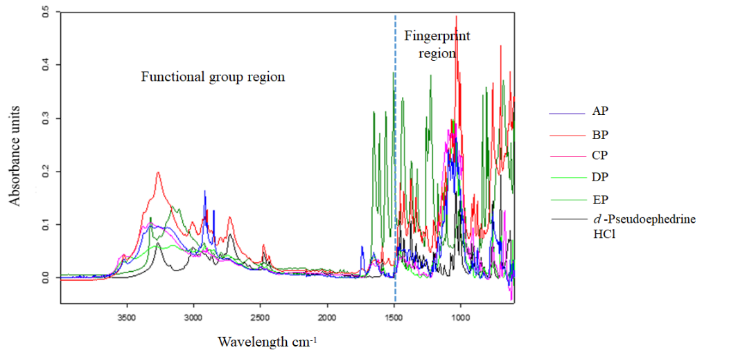

Figure 1. ATR-FTIR spectrum of powdered samples containing pseudoephedrine

The FTIR spectrum of the extracted samples via simple direct extraction method (Figure 2) revealed a slightly better spectra of most samples and the difference between pseudoephedrine sulfate and hydrochloride can be readily observed. Two regions of importance were found in the range of 2500-3000 cm⁻¹`that features the secondary amine hydrochloride and region 750-760 cm⁻¹ that shows the characteristics of monoaromatic ring by simple direct extraction method [19]. Similar infrared spectrum was observed for sample B. This suggested that simple direct extraction would suffice to extract the precursor as sample B did not contain other APIs and has less excipient to begin with. Other samples, however, required a more extensive sample preparation to obtain a considerably ‘cleaner’ pseudoephedrine.

Figure 3 depicts the spectrum of extracted pseudoephedrine samples prepared by acid-based extraction method. Note that, the spectrum from pseudoephedrine acid-base extraction have improved and displayed identical spectra to freebase pseudoephedrine standard from the literature [21]. Similar signal characteristics were observed across all samples which suggested that the samples obtained were in a freebase form with a certain degree of purity. Therefore, results showed that acid-base solvent extraction technique could be used to successfully obtained good pseudoephedrine yield as it diminishes salts and isolates other APIs and excipients initial presence.

A broad O-H stretching at around 2700 cm⁻¹ to 3320 cm⁻¹ was noticeable but this band was not clearly seen because of overlapping with N-H stretching band within the same region. Perhaps, the most distinctive band was around 3317 cm⁻¹, which was attributed to the N-H stretching [19, 20]. The region which was associated to C-H stretching band at around 2950-2850 cm⁻¹ was also evident. The peak attributable to the aromatic =CH band was detected within the region of 3100-3000 cm⁻¹[19, 20].

In fingerprint region, the characteristic peaks for freebase pseudoephedrine were distributed mainly at around 702 cm⁻¹ and 760 cm⁻¹ (torsion vibration of benzene rings), 1022 cm⁻¹ (C-C stretching vibration), 1375 cm⁻¹ (C-H bend vibration), 1428 cm⁻¹ (C-H bend vibration of CH³) and 1453 cm⁻¹ (O-H bend vibration) [21]. Bands at 1071, 1026 and 729 cm⁻¹ represent mono-substituted benzene stretching and the last one an out-of-plane bending [21].

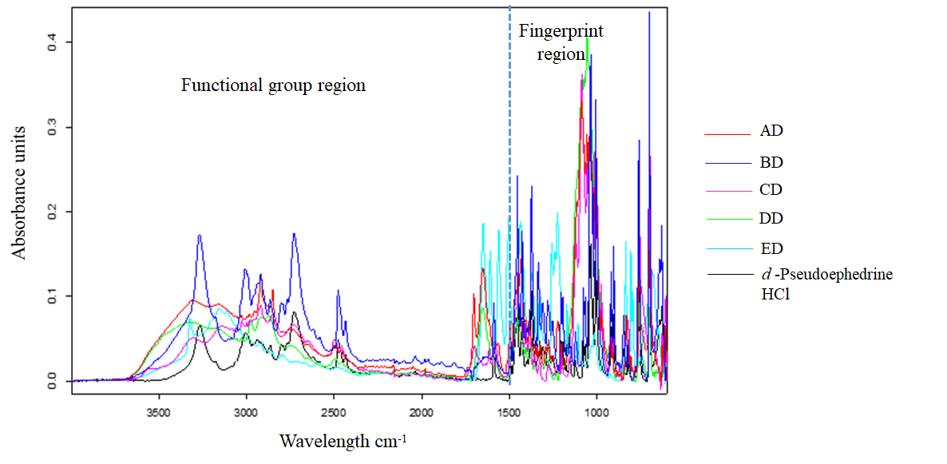

Figure 2. ATR-FTIR spectrum of the extracted sample via direct extraction method

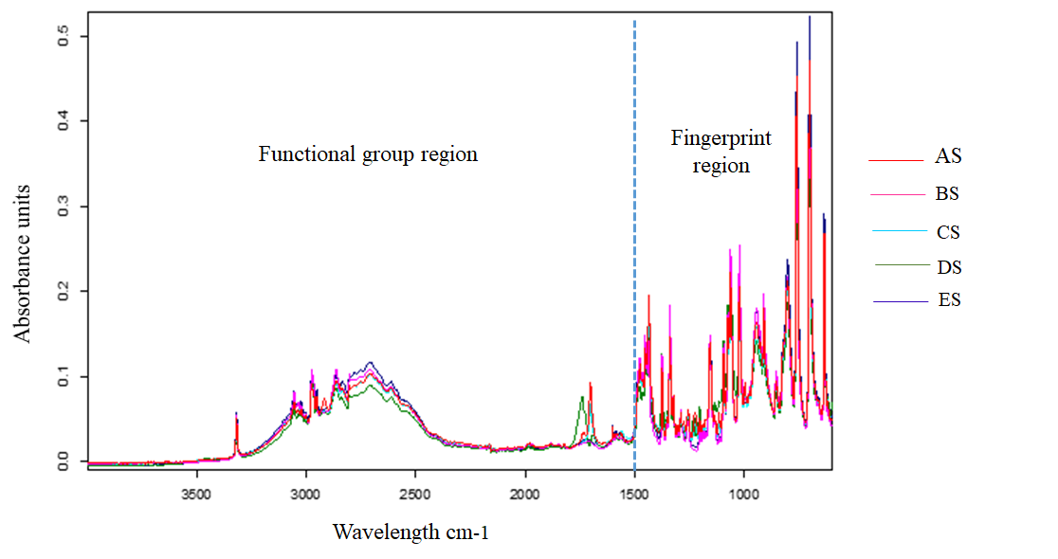

Figure 3. ATR-FTIR spectrum of the extracted sample via solvent extraction method

Statistical analysis
Direct visual examination for linking samples according to their origin using spectral pattern is difficult to carry out especially when dealing with a high number of samples having similar spectral pattern. Consequently, a discussion on the classification of sample from common origin using chemometrics approach is necessary. ATR-FTIR spectral data set showed in previous section (Figures 1-3) was subjected to HCA and PCA statistical package to reveal graphical linkages within and between samples for origin determination [22, 23]. The benefit obtained by performing HCA together with PCA is that they can reveal which clustering techniques could produce the most meaningful outcomes for a given dataset.

Hierarchical cluster analysis
Single linkage technique was utilized to link the clusters and Euclidean distance as the proximity measure between samples because they are among the most common algorithms used for clustering purpose [24, 25]. The resultant HCA dendrogram for each sample preparation type is displayed (Figures 4-6). For the powdered samples, HCA dendrogram in Figure 4 was unable to clearly distinguish the samples according to their brands. The formation of five clusters at around 83% of similarity revealed misclassification among all samples except for sample E. HCA dendrogram of the samples extracted using the simple direct extraction method shown in Figure 5 displays better linkages of samples from the same brands. Except for two misclassifications between sample D and A, other brands were clustered accordingly at approximately 86% similarity level. Meanwhile, for samples extracted using an acid-base method, five clusters were evident at approximately 77% similarity level. Only sample A and D were linked accordingly while sample B,C and E did not reveal any meaningful linkages. The first cluster (represented by the blue line) comprises of samples from a different brand while the other cluster (represented by grey, green and purple lines) were clustered separately as one group.

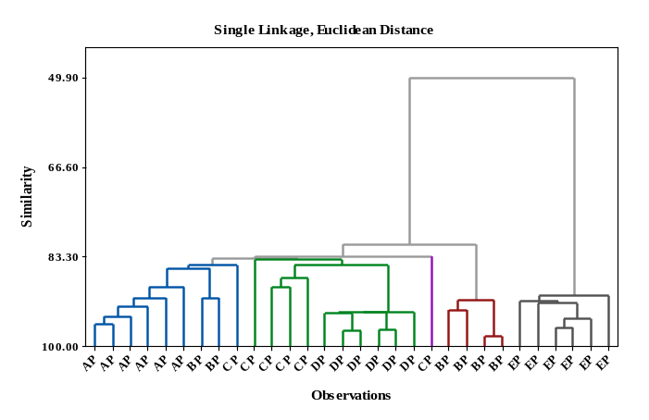

Figure 4. HCA dendrogram of the homogenized powdered samples

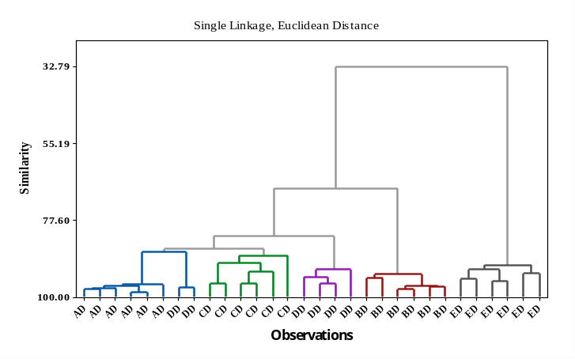

Figure 5. HCA dendrogram of the samples extracted by simple direct extraction method

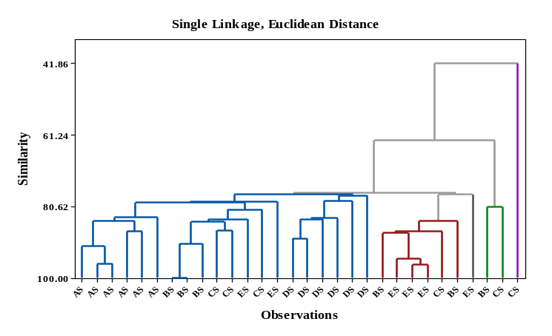

Figure 6. HCA dendrogram of samples extracted by acid-base extraction method

Principal component analysis
PCA was performed using correlation matrix and the clusters in the score plots were examined to reflect the actual information [24, 25]. Figure 7 shows three dimensional (3D) PCA score plot of the powdered samples. The first three PCs used to construct the score plot account for 92.5% of total variation (PC1 = 58.5%, PC2 = 19.9% and PC3 = 14.1%) in the dataset which signifies that PCA captured relevant information within the raw dataset. Contrary to the HCA result, all samples from different origin were well separated from each other in PCA. Despite having similar pseudoephedrine hydrochloride contents, discrimination between sample AP and AC from a different manufacturer is evident. Different pharmaceutical formulation unique to each tablet undoubtedly contribute significantly to the clustering of these samples [13].

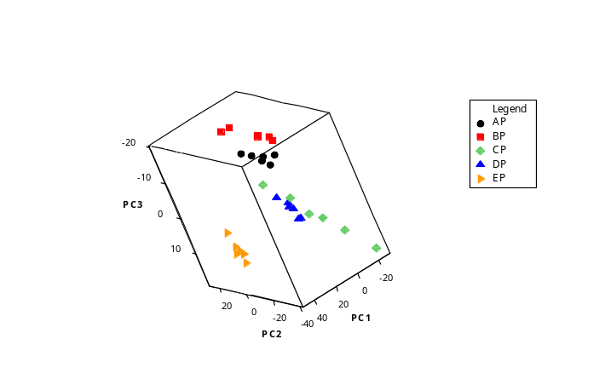
Figure 7. Three dimensional (3D) PCA scores plot for the powdered samples

When the samples were dissolved and filtered to obtain extract with considerably better pseudoephedrine purity, the clustering of the samples has improved tremendously. Dissolution and extraction using ethanol could have removed a substantial amount of bulking agents such as starch, waxes, binders and other excipients reducing redundant information across all samples, hence improving the PCA outcome. The corresponding 3D PCA score plot as shown in Figure 8 represents 92.9% of the total variation (PC1 = 59.4%, PC2 = 24.6% and PC3 = 8.9%) in the dataset. This result has markedly improved in comparison to HCA of a similar dataset as all the samples are successfully grouped according to their brand without misclassification. Additionally, most of the clusters show tight clustering of the samples. Perhaps the presence of other existing APIs that were also soluble in ethanol could have contributed to definite discrimination of the samples. Loratadine, triprolidine, paracetamol or combinations were known to be present in sample A, B, C, D and E.

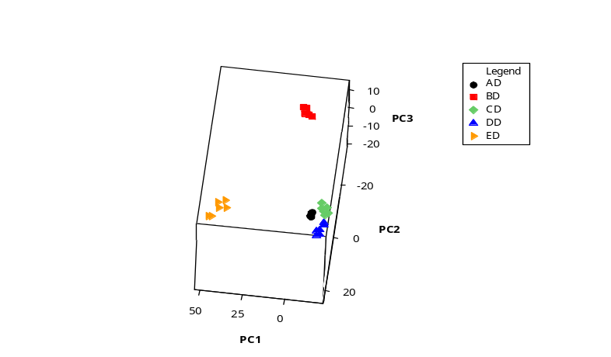
Figure 8. Three dimensional (3D) PCA scores plot for samples extracted by direct extraction method

Infield scenario seized pseudoephedrine from clandestine laboratory is usually of high purity which may suggest the precursor was obtained either from the commercial supplier or it might have undergone extensive chemical purification process such as acid-base extraction from originally innocent sources. The latter is the situation commonly encountered in the kitchen scale clandestine laboratory. PCA analysis for samples extracted by acid-base extraction method (Figure 9) provided a model that accounted for 84.7% of the total data variance (PC1 = 52%, PC2 = 19.3% and PC3 = 13.4%). Sample DS and AS formed two homogenous groups, however sample BS, CS and ES are closely convoluted in one area. To probe whether or not the samples in the convoluted group may be discriminated, further PC analysis was conducted involving only the three samples. The resultant 3D PCA score plot for the convoluted group is displayed in Figure 10.

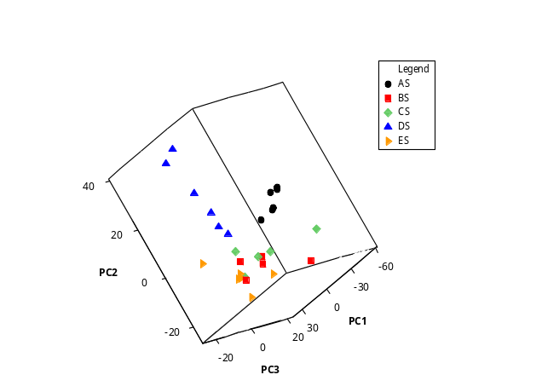

Figure 9. Three dimensional (3D) PCA score plot for samples extracted solvent extraction method

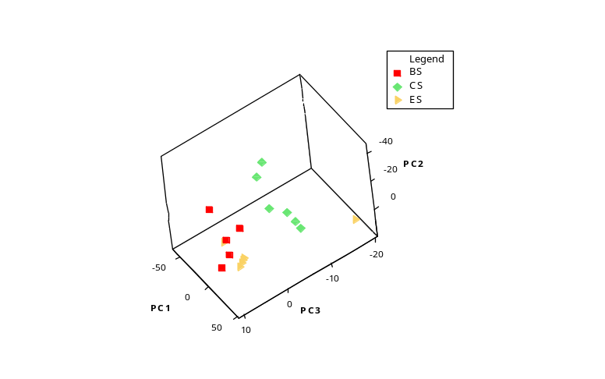

Figure 10. Three-dimensional (3D) score plot for the previously convoluted group comprising of BS, CS and ES samples

Combination of PC1, PC2 and PC3 described 92.4% of the total variation (PC1 = 69.9%, PC2 = 16.5.6% and PC3 = 6.0%) in the dataset. Predominantly, the samples from the three different brands can be separated into three homogenous groups despite the misclassification of one of the ES samples into the BS cluster. The detachment of one ES sample at the far right-hand side of the score plot from the ES cluster confirmed that the sample could be an outlier. Further scrutinization on the ES samples spectrum (Figure 11) confirmed that the sample is in fact an outlier due to sharp bending at around 1400 nm⁻¹ and 1238 nm⁻¹.

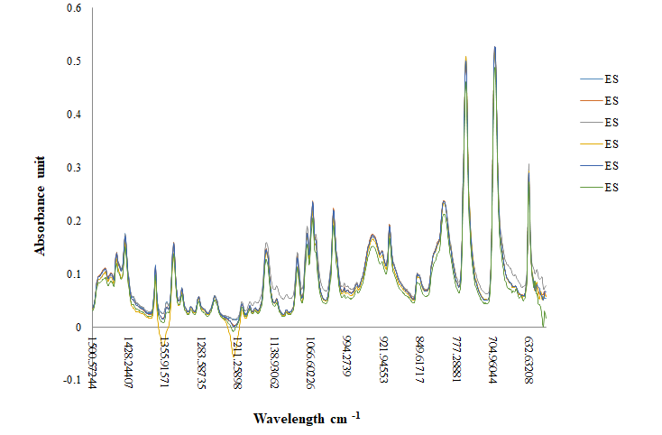

Figure 11. FTIR spectrum of the ES samples. The outlier which is represented by the purple line corresponds to

ES sample detached from the ES cluster in the score plot

Conclusion
Clandestine operators can readily extract pseudoephedrine from over-the-counter cold medication tablet either by simple direct extraction or more complicated chemical purification techniques to use as a precursor for illicit drugs. Acid-base extraction can produce a precursor of considerably high purity when compared to pure standards which would make source determination for forensic intelligence challenging. The applicability of the ATR-FTIR techniques to directly identify suspicious compound or sample is convenient. Interestingly, its use for origin or source profiling by combinatory chemometrics analysis such as PCA and HCA have enabled the extraction of relevant spectral data to give a meaningful association between and among the samples. Considering that these promising results were obtained using raw or untreated FTIR data, work using treated data is actively undergoing. Nonetheless, the output from this work has shown that the ATR-FTIR in combination with chemometrics techniques for chemically processed pseudoephedrine was able to provide a simple, rapid and more importantly non-destructive for linking precursor to their sources of origin.

Acknowledgement

The authors gratefully acknowledged Universiti Sains Malaysia (USM) for funding this study under the Bridging grant scheme (304.PPSK.6316202) and Ministry of Higher Education Malaysia (MOHE) for the MyBrain15 scholarship awarded to Ms. Ainol Hayah Ahmad Nadzri and also technical support provided by the Analytical Laboratory (MAL) staff of the School of Health Sciences, USM Kubang Kerian, Kelantan.

References
- Bryan, J. (2012). Pseudoephedrine is a though product to challenge as a nasal decongestant. https://www.pharmaceutical-journal.com. [Access online 01 July 2019].
- Silverman, B. (2018). Method and formulation for cold treatment in adults and children with increase safety. US Patent App. 10(046): 052.
- International Narcotic Control Board (2015). Precursors and chemicals frequently used in the illicit manufacture of narcotic drugs and psychotropic substances. United Nation, New York: pp. 1-120.
- Brzeczko, A. W., Leech, R. and Stark, J. G. (2013). The advent of a new pseudoephedrine product to combat methamphetamine abuse. The American Journal of Drug and Alcohol Abuse, 39(5): 284-290.
- Maheux, C. R. and Copeland, C. R. (2010). Characterization of three methcathinone analogs: 4 methylmethcathinone, methylone, and bk-MBDB. Microgram Journal, 7(2): 42-49.
- Roggo, Y., Chalus, P., Maurer, L., Lema-Martinez, C., Edmond, A. and Jent, N. (2007). A review of infrared spectroscopy and chemometrics in pharmaceutical technologies. Journal of Pharmaceutical and Biomedical Analysis, 44(3): 683-700.
- Deisingh, A. K. (2005). Pharmaceutical counterfeiting. Analyst, 130(1): 271-279.
- Hodges, C. M. and Akhavan, J. (1990). The use of Fourier transform Raman spectroscopy in the forensic identification of illicit drugs and explosives. Spectrocimica Act, 46(2): 303-307.
- Baran, O. (2005). Determination of narcotic and psychotropic substance by using infrared spectroscopy. Thesis of Master of Science, Middle East Technical University, Turkey.
- Goh, C. Y., Van Bronswijk, W. and Priddis, C. (2008). Rapid non-destructive on-site screening of methylamphetamine seizures by attenuated total reflection Fourier transform infrared spectroscopy. Applied Spectroscopic, 62(6): 640-648.
- Melucci, D., Monti, D., D’Elia, M. and Luciano, G. (2012). Rapid in situ repeatable analysis of drugs in powder form using reflectance near-infrared spectroscopy and multivariate calibration. Journal of Forensic Science, 57(1): 86-92.
- Rodrigues, N. V. S., Cardoso, E. M., Andrade, M. V. O., Donnici, C. L. and Sena, M. M. (2013). Analysis of seized cocaine samples by using chemometric method and FTIR spectroscopy. Journal of the Brazilian Chemical Society, 24(3): 507-517.
- Pereira, L. S. A., Lisboa, F. L. C., Neto, J. C., Valladao, F. N. and Sena, M. M. (2017). Direct classification of new psychoactive substances in seized blotter papers by ATR-FTIR and multivariate discriminant analysis. Microchemical Journal, 133(1): 96-103.
- Calvo, N. L., Kaufman, T. S. and Maggio, R. M. (2015). A PCA-based chemometrics-assisted ATR-FTIR approach for the classification of polymorphs of cimetidine: Application to physical mixtures and tablets. Journal of Pharmaceutical and Biomedical Analysis, 107(1): 419-425.
- Mohamad Asri, M. N., Mat Desa, W. N. S. and Ismail, D. (2017). Raman spectroscopy of ballpoint-pen inks using chemometric techniques. Australian Journal of Forensic Science, 49(2): 175-185.
- Ismail, D., Austada, Z. and Mat Desa, W. N. S. (2014). Ultra-violet and visible (UV-VIS) spectroscopy and chemometrics techniques for forensic analysis of ballpoint pen inks: A preliminary study. Malaysian Journal of Forensic Science, 5(1): 47-52.
- Sondermann, N. and Kovar, K. A. (1999). Screening experiments of ecstasy street samples using near-infrared spectroscopy. Forensic Science International, 106(3): 147-156.
- Moros, J., Galipienso, N., Vilches, R., Garrigues, M. and De La Guardia, S. (2008). Nondestructive direct determination of heroin in seized illicit street drugs by diffuse reflectance near-infrared spectroscopy. Analytical Chemistry, 80(19): 7257-7265.
- Graf, W. F., Pearson, J. R., Appadoo, D. R.T., Robertson, E. G. and Ennis, C. (2020). The prediction of far-infrared spectra for molecular crystals of forensic interest- Phenylethylamine, ephedrine and pseudoephedrine. Forensic Chemistry, 17(1): 1-11.
- Formula, C. and Weight, M. (2005). Scientific working group for the analysis of seized drugs (SWGDRUG. Access from http://forensics.org.my/pdf/fssmVol.6No.1/Article 04.pdf. [Access online 02 July 19].
- Miao, L., Liu, Y., Li, H., Qi, Y. and Lu, F. (2017). Two-dimensional correlation infrared spectroscopy applied to the identification of ephedrine and pseudoephedrine in illegally adulterated slimming herbal products. Drug Testing and Analysis, 9 (2): 221-229.
- Hughes, J., Ayoko, G., Collett, S. and Golding, G. (2013). Rapid quantification of methamphetamine: Using attenuated total reflectance Fourier transform infrared spectroscopy (ATR-FTIR) and Chemometrics. PLoS ONE, 8(7): e69609.
- Nic Daeid, N. and Waddell, R. J. H. (2005). The analytical and chemometrics procedures used to profile illicit drug seizures. Talanta 67(2): 280-285.
- Mat Desa, W. N. S., Nic Daeid, N., Dzulkiflee I. and Savage, K. (2020). Application of unsupervised chemometric analysis and self-organizing feature map (SOFM) for the classification of lighter fuels. Analytical Chemistry 82(1): 6395-6640.
- Mat Desa, W. N. S., Ismail, D. and Nic Daeid, N. (2011). Classification and source determination of medium petroleum distillates by chemometric and artificial neural networks: A self-organizing feature approach. Analytical Chemistry 83(2): 7745-7754.

