
S
DEACIDIFICATION OF NAPHTHENIC ACIDS FROM PETROLEUM CRUDE OILS USING 2-METHYLIMIDAZOLE IN PEG(400) WITH THE AID OF Ni/Ce/Al₂O₃ and Cu/Ce/Al₂O₃ CATALYSTS

(Deasidifikasi Asid Naftenik dari Minyak Mentah Petroleum menggunakan 2-Metilimidazola dalam PEG(400) dengan Bantuan Pemangkin Ni/Ce/Al₂O₃ dan Cu/Ce Al₂O₃)

Norshahidatul Akmar Mohd Shohaimi¹*, Nor Shafira Hassan¹, Ahmad Zamani Ab Halim²,
Nurasmat Mohd Shukri³, Nor Hakimin Abdullah⁴

¹Faculty of Applied Sciences,
Universiti Teknologi MARA Pahang, Bandar Tun Abdul Razak Jengka, Pahang, Malaysia
²Faculty of Industrial Sciences & Technology,
Universiti Malaysia Pahang, 26300 Gambang, Kuantan, Pahang, Malaysia
³School of Health Sciences,
Universiti Sains Malaysia, Health Campus, 16150 Kubang Kerian, Kelantan, Malaysia
⁴Advanced Materials Research Centre (AMRC), Faculty of Bioengineering and Technology,
Universiti Malaysia Kelantan, Locked Bag 100, 17600 Jeli, Kelantan, Malaysia

*Corresponding author: akmarshohaimi@.uitm.edu.my

Received: 20 November 2019; Accepted: 3 March 2020

Abstract
The presence of carboxylic acid derivative compound in crude oil adversely contributes to major corrosion in oil pipelines and distillation units installed in crude oil refineries. The acidity level in crude oil is measured based on the total acid number (TAN). Methods that are commonly used to remove naphthenic acid (NA) from crude oil, such as dilution and caustic washing, have several drawbacks, including emulsion formation, high temperature, and massive use of solvent. In order to overcome these shortcomings, catalytic deacidification method had been developed to reduce the TAN value in acidic crude oil by using basic chemical, along with the aid of metal oxide catalyst. In this study, crude oil from Petronas Penapisan Melaka was evaluated. The parameters studied were reagent concentration, reaction temperature, catalyst loading, calcination temperature, and reusability of potential catalyst. The basic chemical used was 2-methylimidazole in polyethylene glycol (PEG 400) with concentrations of 100, 500, 1000, and 1500 ppm. Next, Ce was used as base for the catalyst with both Ni and Cu serving as dopant. The potential catalysts were characterised via Fourier transform infrared spectroscopy (FTIR) and thermogravimetry analysis (TGA) to determine their physicochemical properties. The outcomes showed that the Cu/Ce catalyst met the Petronas requirement as the TAN value reduced to 0.93 mg KOH/g from the original TAN value of 3.93 mg KOH/g. As for Ni/Ce catalyst, the TAN value reduced to 1.03 mg KOH/g. The TGA results revealed the total weight loss of Cu/Ce = 23.40% and Ni/Ce = 25.22% due to complete removal of impurities from the catalysts. The reaction temperature was set at 27 °C, while the catalyst calcination temperature was fixed at 1000 °C, and seven beads of catalyst loading had been employed. It can be concluded that catalytic deacidification method with the aid of Cu/Ce was indeed efficient in removing NA from the acidic crude oil, thus lowering the TAN value to less than 1 mg KOH/g.

Keywords: deacidification, petroleum crude oil, naphthenic acid, catalyst

Abstrak
Kehadiran sebatian derivatif asid karboksilik dalam minyak mentah boleh menyumbang kepada hakisan utama dalam paip pemproses minyak dan unit penyulingan dalam kilang minyak mentah. Tahap keasidan dalam minyak mentah diukur dengan jumlah nombor asid (TAN). Kaedah-kaedah yang biasanya digunakan untuk mengeluarkan asid naftenik (NA) dari minyak mentah seperti pencairan dan pencuci kaustik mempunyai kelemahan sendiri seperti pembentukan emulsi, suhu tinggi dan penggunaan pelarut yang banyak. Untuk mengatasi masalah ini, kaedah deasidifikasi pemangkin telah dicipta bagi mengurangkan nilai TAN dalam minyak mentah berasid dengan menggunakan bahan kimia asas dengan bantuan pemangkin logam oksida. Dalam kajian ini, minyak mentah dari Petronas Penapisan Melaka digunakan. Parameter yang dikaji adalah kepekatan reagen, suhu tindak balas, jumlah pemangkin, suhu pemangkin dan kebolehgunaan semula pemangkin yang berpotensi. Bahan kimia asas yang digunakan ialah 2-metilimidazola dalam polietilena glikol (PEG 400) dengan kepekatan 100, 500, 1000 dan 1500 ppm. Ce digunakan sebagai asas pemangkin dengan Ni dan Cu bertindak sebagai dopan. Pemangkin berpotensi menjalani kaedah pencirian seperti spekstroskopi inframerah transformasi Fourier (FTIR) dan analisis termogravimetri (TGA) untuk sifat fiziko-kimianya. Hasilnya menunjukkan bahawa pemangkin Cu/Ce memenuhi keperluan Petronas kerana nilai TAN dikurangkan kepada 0.93 mg KOH/g dari nilai TAN asal 3.93 mg KOH/g. Bagi pemangkin Ni/Ce, nilai TAN dikurangkan kepada 1.03 mg KOH/g. Keputusan TGA menunjukkan penurunan berat badan Cu/Ce = 23.40% dan Ni/Ce = 25.22% disebabkan oleh pembuangan lengkap bahan pencemar dalam mangkin. Suhu tindak balas yang digunakan adalah 27 °C dengan suhu pembakaran pemangkin 1000 °C dan 7 biji jumlah pemangkin. Dapat disimpulkan bahawa kaedah deasidifikasi pemangkin dengan bantuan Cu/Ce adalah cekap dalam menghilangkan NA dari minyak mentah berasid sehingga menurunkan nilai TAN kurang dari 1 mg KOH/g.

Kata kunci: deasidifikasi, minyak mentah petroleum, asid naftenik, pemangkin

Introduction
Petroleum crude oils have a complex hydrocarbon mixture that represents high concentrations of heteroatoms, for example sulphur and metals. These two heteroatoms are united by either covalent or non-covalent bond into molecules with high boiling points and high polarity. The compound that causes petroleum crude oils to become more acidic is naphthenic acid (NA). The minor acidic classes found in crude oil are aromatic, olefinic, hydroxyl, and dibasic acid, whereas NAs are composed of complicated and a variety of structure [1].

Total acid number (TAN) describes the amount of potassium hydroxide in milligrams required to neutralise the acid present in a gram of oil. According to Shah et al. [2], if the concentration of TAN is 1.5 mg KOH/g and above, corrosion can occur and lead to trouble, especially damages to oil and gas industry equipment, decrease in production quality, and frequent turn around, to name a few. The two methods that can effectively minimise TAN are destructive methods (thermal cracking and hydrogenation process) and non-destructive methods (adsorption and solvent extraction) [2]. Many studies have proposed a range of methods to discard NAs from petroleum crude oil, including neutralisation, adsorption, thermal decomposition, catalytic decarboxylation, esterification, and liquid-liquid extraction using organic solvents, whereby all the methods have some drawbacks.

The primary objective of this study is to overcome the weakness of previous method by introducing a combination of acid removal agent of 2-methylimidazole in polyethylene glycol, as well as heterogeneous catalysts of Ni/Ce and Cu/Ce with alumina beads as catalyst support.

Materials and Methods
Material and feedstock
Feedstock used for this study refers to high crude oil from the Petronas Penapisan Melaka with a TAN value of 3.93 mg KOH/g. A phenolphthalein solution 1% (w/v) was used as an indicator in the deacidification process. A 40 mL mixture of 2-propanol, toluene, and distilled water with ratio of (49.5:50:0.5) was used as titration solvent. Potassium hydroxide pellets and barium hydroxide were used as the titrants in this study.

Catalyst preparation
Cerium was used as a catalyst and supported with alumina beads using nickel and copper as dopants at a ratio of 90:10 (base:dopant). Five g of metal salt, Ce(NO₃)₂, was weighed in a beaker and dissolved in 5 mL of distilled water. The solution was mixed and stir continuously by using a magnetic bar for 10 minutes. After the solution had dissolved, 0.92 g dopants of Ni(NO₃)₂ based on the mol ratio was added. This solution was stirred again until it was fully dissolved. The process was performed at room temperature to homogenise the mixture [3].

The catalyst was prepared by using aqueous incipient wetness impregnation (IWI) method. The Al₂O₃ beads (diameter: 3-5 mm) were used as support material and dipped in the catalyst solution for 1 hour to allow good coating of the catalyst solution on the surface of the alumina support. Next, the supported material was transferred onto an evaporating dish with glass wool placed on it. The solution was aged in an oven at 80-90 °C for 24 hours to eliminate excess water. The prepared catalyst was placed in furnace at 800 °C for 24 hours by using a ramp rate of 5 °C/min to discard impurities and metal precursor. The procedure was repeated by using different dopants with Cu(NO₃)₂ 0.82 g and the calcination temperatures of the catalysts were set at 900 °C and 1000 °C [3].

The potential catalysts were characterised by applying several techniques to study their chemical and physical properties. The characterisation techniques used in this research were thermogravimetry analysis (TGA) and Fourier transform infrared spectroscopy (FTIR).

Total acid number (TAN) determination
Approximately 0.2 g of crude oil sample was weighed in a 100 mL beaker and diluted with 40 mL of titration solvent mixture of 2-propanol, toluene, and distilled water with a ratio of (49.5:50:0.5) [4]. The 2-methylimidazole in PEG with a concentration of 100 ppm was added, along with the catalyst loading of three beads. Next, the mixture of the solution was stirred for 5 minutes until it dissolved. The TAN value was determined by using the semi-micro colour indicator titration method, where 0.1 mL of phenolphthalein solution was used as an indicator, whereby the end-point for the titration method was observed by a stable red colour. The titration method was repeated by using 2-methylimidazole in PEG concentrations of 500, 1000, and 1500 ppm, as well as catalyst loading of four, five, and seven beads. As for the titrant, potassium hydroxide solution (0.01 mol/L) and barium hydroxide were used in adherence to standard method of ASTM D664. The TAN value was calculated in milligrams of potassium hydroxide per gram of sample (mg KOH/g) by using the following equation:

TAN = 56.1 x c x (V_{KOH}−V_{B})/m (1)

where c is define as concentration in mole/L of standard volumetric KOH solution, V_{KOH} is volume in mL of titrant required for the determination, V_{B} is volume in mL of titrant required for the blank test, M is mass in grams of the test portion and 56.1 is molecular weight of KOH in g/mol.

Results and Discussion
Fourier transform infrared spectroscopy
Figure 1 illustrates the FTIR results of fresh and spent bimetallic catalyst of Cu/Ce/Al₂O₃ and Ni/Ce/Al₂O₃. The catalysts were tested with the best optimum parameter, whereby calcination temperature at 1000 °C was efficient in removing NA. The catalyst loading of seven beads had been added to the solution with 1000 ppm of reagent concentration. Both Ni/Ce/Al₂O₃ and Cu/Ce/Al₂O₃ catalysts underwent four catalytic cycles to obtain the optimum cycle for reusability testing. Comparison between both peaks was made to detect the presence of impurities at the catalyst surface after reaction.

The FTIR spectra for both catalysts prior to reaction (fresh) showed a peak at wavelength ranging at 820-563 cm⁻¹. The observed peak could be ascribed to the stretching mode of metal oxide group. According to Shohaimi et al. [5], the stretching mode of metal oxide group was present at 1029-563 cm⁻¹ and this stretching mode served as an indicator for the formation of metal oxide catalyst, as all impurities were removed prior to heating at high temperature.

The FTIR band for Ni/Ce catalyst with support of Al₂O₃ after the reaction (spent) displayed emergence of new peaks ranging at 2920-2850 cm⁻¹, which represented the C-H (sp³, stretching) of the alkane group that may derive from the NA chain or the component of the crude oil itself. The Cu/Ce also generated many peaks after the reaction, signifying that impurities from NA or reagent had bound to the catalyst surface. Catalyst offers a basic surface site for the reagent to react with NA in the catalytic reaction [6]. As NA was bound to the catalyst, the catalyst degenerated and deteriorated the efficiency of the catalysts in reducing the TAN value.

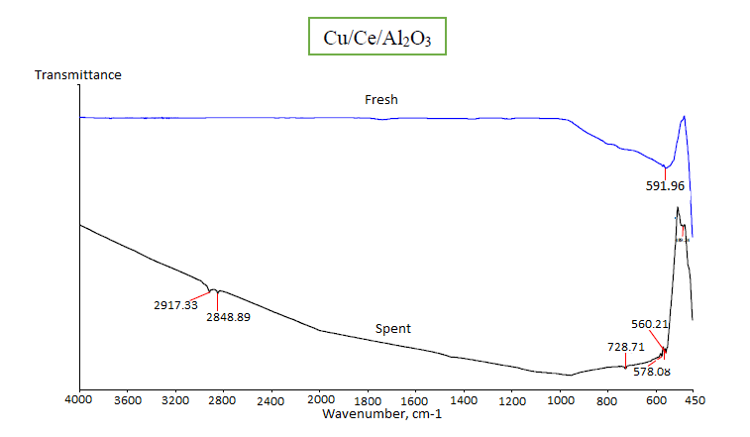
(a)

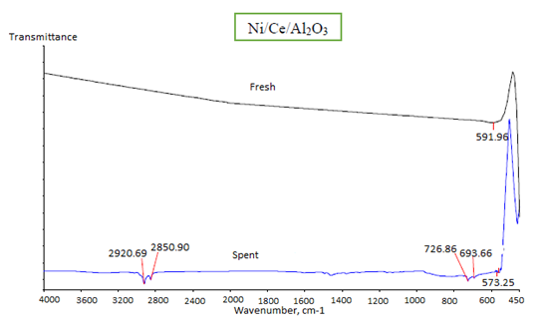
(b)
Figure 1. FTIR spectra of fresh and spent (a) Cu/Ce/Al₂O₃ and (b) Ni/Ce/Al₂O₃ catalysts at calcination temperature of 1000 °C (Spent condition: after 4 consecutive cycle, optimum condition for both catalyst: 1000 ppm of 2-methylimidaozle in PEG, reaction time of 5 minutes)

Thermogravimetry analysis
Thermogravimetric analysis was performed on the samples of both Cu/Ce/Al₂O₃ and Ni/Ce/Al₂O₃ catalysts, wherein Figure 2 displays their profiles. The total weight loss for Cu/Ce/Al₂O₃ catalyst was 23.40%, whereas 25.22% for Ni/Ce/Al₂O₃ catalyst. This stemmed from the complete removal of impurities from the catalysts at calcination temperature of 1000 °C. Based on the outcomes, the Cu/Ce/Al₂O₃ catalyst underwent three phases of thermal event. The first stage of thermal event was due to loss of surface water and crystal water molecule at temperatures ranging at 80-180 °C. As the temperature escalated from 180 to 430 °C, the complete removal of water led to 12.48% weight loss. The thermal third stage was continued until the temperature hit 1000 °C, while the result of weight loss was 4.98% due to loss of nitrate compound and surface of hydroxyl molecule. Loss of water molecules occurred mainly due to the hygroscopic property of the supported catalyst sample, as well as the preparation of the method employed.

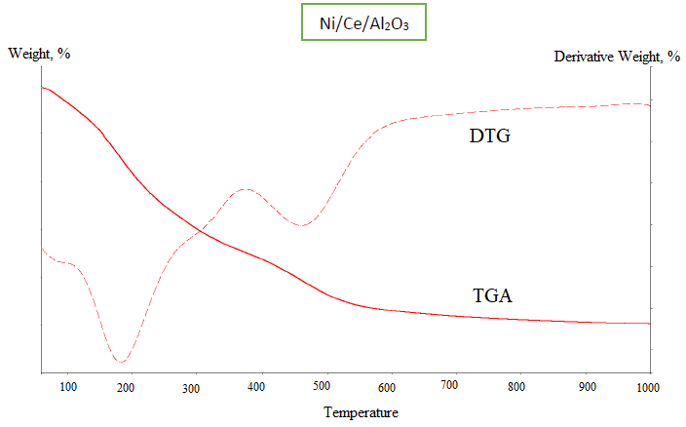
(a)

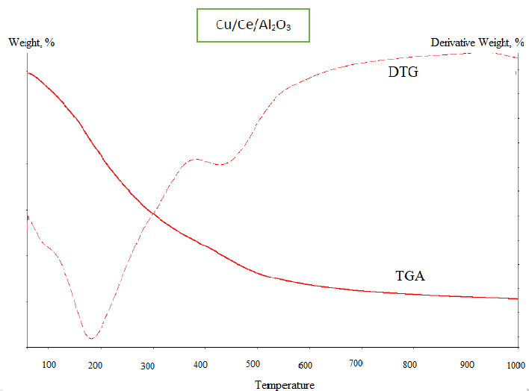
(b)
Figure 2. TGA-DTG thermogram of (a) Ni/Ce/Al₂O₃ and (b) Cu/Ce/Al₂O₃ catalysts after aging in oven for 24 hours at 80-90 °C (non-calcined catalyst before reaction)

As for the Ni/Ce/Al₂O₃ catalyst, four stages of thermal event had occurred. The first stage of weight loss took place at 80-180 °C due to loss of crystal water and surface water molecule. The second thermal treatment occurred at 180-320 °C due to complete removal of water. The next stage of thermal treatment happened at 320-450 °C, which could be attributed to decomposition of hydroxyl and carbonyl groups formation of pure metal oxide [7]. In the final stage, loss of nitrate compound and surface hydroxyl molecule had been detected.

Overall, the outcomes of thermogram for both TGA-DTG of Ni/Ce/Al₂O₃ and Cu/Ce/Al₂O₃ were completely obtained. It can be concluded that both impurities and water from the materials of weight loss in 14 mg for both catalysts were successfully removed by the thermal treatment and after heating until 700 °C, which yielded pure metal oxide. All nitrate compounds that originated from the metal precursor were discarded.

Total acid number for untreated crude oil
The untreated crude oil from Petronas Penapisan Melaka was analysed and the TAN value was found to be 3.93 mg KOH/g. This untreated crude oil was directly tested without any addition of reagent and catalyst by using the semi-micro colour titration method. The colour changed and the value was calculated to determine the original TAN value. The original TAN value is essential to serve as a reference in comparing with the value obtained for treated crude oil. This method was used to identify the effectiveness and the efficiency of both the reagents and catalysts used.

Effect of different reagent concentration
Figure 3 portrays various concentrations of 2-Methylimidazole in PEG (400) that had been used to further investigate the deacidification process, as well as to study the effectiveness of the reagent in reducing the TAN value. The concentrations of reagent added to the solution of crude oils were 100, 500, 1000, and 1500 ppm. Nevertheless, only a small amount of TAN value had been reduced. Despite the decrease in TAN value, it failed to meet the PETRONAS requirement, as the TAN value should be less than one [4]. According to Shohaimi et al. [8], the value of TAN reflects the amount of NA present in crude oils, whereby increment in TAN value signifies increased amount of NA.

Based on the figure above, the TAN value decreased with the increasing concentration of 2-methylimidazole in PEG. The most effective reagent concentration used was 1000 ppm at reaction temperature of 27 °C, whereby the TAN value could be lowered to 1.40 mg KOH/g. At 35 °C, the decreased TAN value did not differ much, but it could still lower the value of the original TAN. Upon hitting 40 °C with varying reagent concentrations, the TAN value turned constant after 500 ppm. Crude oils need an appropriate amount of dosing to react with NA, primarily because excessive reagent concentration could lead to stable emulsion. Hence, it could stabilise the NA in crude oils and automatically reduce the deacidification reaction. Therefore, the use of 1000 ppm of 2-methylimidazole concentration seemed adequate to reduce the NA in crude oils. If the reagent concentration of 2-methylimidazole in PEG used is too high, it could lead to operational constrictions [9]. The optimum reagent concentration, which is 1000 ppm at reaction temperature of 27 °C, was selected for further analysis since it could reduce the value of TAN to 1.40 mg KOH/g. The reagent concentration was deemed suitable for further investigation as it is cost efficient.

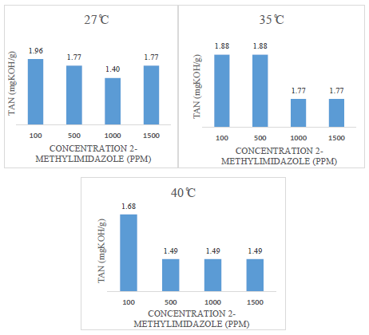
Figure 3. Effect of different reagent concentrations on TAN value without catalyst

Effect of Ni/Ce/Al₂O₃ and Cu/Ce/Al₂O₃ catalyst loading
This parameter was assessed to continue observing the efficiency of the catalysts, along with the reagents, on the TAN value. Monometallic of Ce/Al₂O₃ was used and Cu(NO₃)₂ and Ni(NO₃)₂, which served as a metal precursor due to its high solubility in water. According to Shukri et al. [4], cerium is a good metal to act as base catalyst for catalytic deacidification of NA in crude oil. This is because; cerium oxide is composed of a unique acid-base property and a strong metal-support interaction that can improve catalytic activity [7,10].

Figure 4 shows the three calcination temperatures used to obtain the best TAN value; 800, 900, and 1000 °C. Varied catalyst loading of three, four, five, and seven beads had been evaluated with different catalyst calcination temperatures. Inclusion of the catalyst into the crude of Petronas Penapisan Melaka had successfully reduced the TAN value, in comparison to that without catalyst. The NA from the crude oils reacted with the reagent on the surface of the catalyst. The NA compound was bound on the surface of the catalyst, thus reducing the TAN value.

The purpose of adding catalyst into the crude oils solution is to obtain the optimum TAN value, which should be lower than 1, as required by PETRONAS. Based on the result of Ni/Ce catalyst calcined at 800 °C, increasing the amount of catalyst had slightly enhanced the reduction of TAN. The lowest TAN value obtained was 1.32 mg KOH/g by using seven beads of catalyst loading. For further reduction of TAN value, the calcination temperature was increase to 900 °C, along with the use of seven beads of catalyst loading. The TAN value slightly reduced from 1.32 mg KOH/g to 1.21 mg KOH/g. Upon increasing the calcination temperature to 1000 °C, the Ni/Ce/Al₂O₃ catalyst still failed to reduce the value of TAN to below 1, despite using the highest catalyst loading.

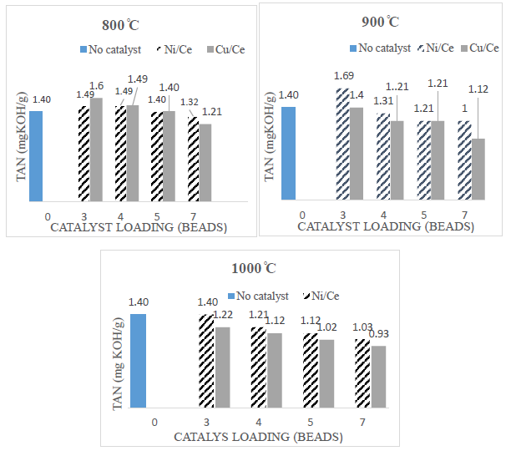
Figure 4. The effect of catalyst loading Ni/Ce/Al₂O₃ and Cu/Ce/Al₂O₃ on TAN value in crude oils

Nonetheless, the use of Cu/Ce catalyst with seven beads of catalyst loading at 1000 °C calcination temperature had successfully decreased the TAN value to 0.93 mg KOH/g. This was ascribed to the metal Cu that served as dopant in being the best promoter that increased the catalytic activity, as it increase the surface area of the active site [4]. The presence of Cu enhanced synergism between the metal and the cerium oxide, thus assisting in the cleavage of C-C bonds. Based on the outcomes, the trend of TAN value decreased as the catalyst loading of Cu/Ce/Al₂O₃ increased. Nevertheless, the results obtained by using Cu/Ce/Al₂O₃ catalyst calcined at 800 °C and 900 °C displayed a slight decrease with increment in catalyst loading. Here, cerium had been identified as amphoteric in nature. The addition of basic dopant led to the formation of basic catalyst, as it is superior to reduce NA in crude oils since NA is a weak acid [4].

As a conclusion, the optimum catalyst loading preferable for Cu/Ce/Al₂O₃ catalyst was seven beads as it had managed to reduce the TAN value to below 1. Upon comparing Ni/Ce/Al₂O₃ with Cu/Ce/Al₂O₃ catalysts, the Cu/Ce/Al₂O₃ catalyst appeared to be more effective and essential in discarding NA from crude oils, as it successfully reduced the original TAN value to 0.93 mg KOH/g with seven beads of catalyst loading at the calcination temperature of 1000 °C.

Catalyst reusability
Catalysts Ni/Ce/Al₂O₃ and Cu/Ce/Al₂O₃ calcined at 1000 °C were tested for several catalytic cycles under optimum reaction conditions. The primary aim of this study is to test the reusability of the potential catalysts. Hence, the catalysts were tested for their reusability until they were fully deactivated. Both catalysts of Ni/Ce/Al₂O₃ and Cu/Ce/Al₂O₃, along with the lower TAN value, had been analysed to determine the number of cycle(s) the catalysts could be used after reaction. The best TAN values of Ni/Ce/Al₂O₃ and Cu/Ce/Al₂O₃ catalysts from the previous results were 1.03 mg KOH/g and 0.93 mg KOH/g, respectively. Catalyst loading of seven beads was applied along with the calcination temperature of 1000 °C at a reaction temperature of 27 °C.

Figure 5 illustrates the reusability of catalysts in light of TAN value with the constant temperature of 27 °C and the concentration of 2-methylimidazole at 1000 ppm. Based on the findings, the first catalytic cycle generated the TAN values of 0.93 KOH/g and 1.03 mg KOH/g for Cu/Ce/Al₂O₃ and Ni/Ce/Al₂O₃ catalysts, respectively. Upon completing the first catalytic cycle, the catalysts were rinsed with 2-propanol to release the adsorbed naphthenic compound, if any was present [9]. Next, the catalysts were dried in an oven at 80 °C and were reused for the next reaction. After the second catalytic cycle, the TAN values for both catalysts increased to 1.40 mg KOH/g and continued to increase until 1.68 mg KOH/g.

As the value of TAN increased at the second catalytic cycle, the catalyst had begun to deactivate. This indicates that the catalysts no longer can be used after the second cycle. Shukri et al. [9] claimed that as the catalyst starts to deactivate (spent catalyst), it produces higher TAN value as the catalyst slightly decreases in its activity. Studied that had assessed the Ni/Ce/Al₂O₃ catalysts displayed similar TAN values. Hence, both catalysts could only be used for a single reaction cycle. Upon continuation of use, the catalysts deactivated.

The catalysts used in the second catalytic cycle, which produced a TAN value of 1.40 mg KOH/g, were characterised via FTIR. Therefore, reduction of catalyst activity could be associated with the presence of impurities of C-H stretching that was noted in the spectra illustrated in Figure 1.

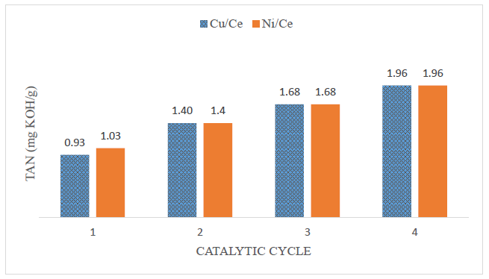
Figure 5. Catalysts reusability towards TAN value at constant temperature (27 °C) and concentration of 2-methylimidazole (1000 ppm)

Conclusion
This study reveals that Cu/Ce/Al₂O₃ catalyst had successfully reduced the TAN value to below 1; from 3.93 mg KOH/g to 0.93 mg KOH/g. The optimum parameter for calcination temperature used for both catalysts was 1000 °C with 1000 ppm reagent of 2-methylimidaozle in PEG. The reaction time used throughout this study was 5 minutes for both catalysts at room temperature. Upon using the Ni/Ce/Al₂O₃ catalyst, the value of TAN can only be reduced from the original TAN value of 3.93 mg KOH/g to 1.03 mg KOH/g. This signified that Cu/Ce/Al₂O₃ is more effective in reducing the TAN value.

Acknowledgement
We gratefully acknowledged the financial support by the Research Grant, FRGS with Grant No.: 011000190001 (File no.: 600 IRMI/FRGS 5/3 (108/2019)).

References
- Najmuddin, R. A., Mutalib, M. A., Shah, S. N., Suleman, H., Lethesh, K. C., Pilus, R. B. M. and Maulud, A. S. (2016). Liquid-liquid extraction of naphthenic acid using thiocyanate based ionic liquids. Procedia engineering, 148: 662-670.
- Shah, S. N., Chellappan, L. K., Gonfa, G., Mutalib, M. I. A., Pilus, R. B. M. and Bustam, M. A. (2016). Extraction of naphthenic acid from highly acidic oil using phenolate based ionic liquids. Chemical Engineering Journal, 284: 487-493.
- Shohaimi, N. A. M., Bakar, W. A. W. A., Jaafar, J. and Shukri, N. M. (2013). Treatment of acidic petroleum crude oil utilizing catalytic neutralization technique of magnesium oxide catalyst. Modern Chemistry & Applications, 1(3): 1-5.
- Shukri, N. M., Bakar, W. A. W. A., Jaafar, J. and Majid, Z. A. (2015). Removal of naphthenic acids from high acidity Korean crude oil utilizing catalytic deacidification method. Journal of Industrial and Engineering Chemistry, 28: 110-116.
- Shohaimi, N. A. M., Bakar, W. A. W. A. and Jaafar, J. (2014). Catalytic neutralization of acidic crude oil utilizing ammonia in ethylene glycol basic solution. Journal of Industrial and Engineering Chemistry, 20(4): 2086-2094.
- Shohaimi, N. A. M., Jaafar, J. and Bakar, W. A. W. A. (2015). Catalytic deacidification optimization of Korean crude oil based on response surface methodology. Clean Technologies and Environmental Policy, 17(6): 1513-1522.
- Wang, Y., Chu, Z., Qiu, B., Liu, C. and Zhang, Y. (2010). Removal of naphthenic acids from a vacuum fraction oil with an ammonia solution of ethylene glycol. Fuel, 85(17-18): 2489-2493.
- Shohaimi, N. A. M., Bakar, W. A. W. A. and Jaafar, J. (2017). The catalytic deacidification of acidic crude oil using Cu-doped alkaline earth metal oxide catalysts. Petroleum Science and Technology, 35(11): 1097-1103.
- Shukri, N. M., Jaafar, J., Bakar, W. A. W. A., and Majid, Z. A. (2017). Characterization and deacidification of acidic petroleum crude oil utilizing metal oxide catalyst supported on alumina and ammoniated polyethylene glycol solution. Malaysian Journal of Analytical Sciences, 21(4): 830-838.
- Toemen, S., Bakar, W. A. W. A., and Ali, R. (2014). Investigation of Ru/Mn/Ce/Al₂O₃ catalyst for carbon dioxide methanation: Catalytic optimization, physicochemical studies and RSM. Journal of the Taiwan Institute of Chemical Engineers, 45(5): 2370-2378.

