
S

ELECTROSYNTHESIS OF SILVER OXIDE DEPOSITED ONTO

HOT SPRING MUD WITH ENHANCED DEGRADATION OF CONGO RED

(Elektrosintesis Perak Oksida Disokong Pada Lumpur Air Panas Dengan Peningkatan Degradasi Congo Merah)

Muhammad Farhan Hanafi, Ahmad Norsyazwan Mustafa, Norzahir Sapawe*

Universiti Kuala Lumpur Branch Campus

Malaysian Institute of Chemical and Bioengineering Technology, Lot 1988 Vendor City, Taboh Naning, 78000 Alor Gajah, Melaka, Malaysia.

*Corresponding author: norzahir@unikl.edu.my

Received: 28 April 2019; Accepted: 18 February 2020

Abstract

AgO-supported hot spring mud (AgO-HSM) catalyst was prepared by introducing AgO onto HSM support through electrochemical method. The effect of preparation methods on the physical properties of the catalyst was studied. The interaction between silver species and HSM during the electrochemical process affected the AgO-HSM structure. The amount of 0.2 g L⁻¹ of 11 wt.% AgO-HSM was the optimum dosage for 10 mg L⁻¹ Congo red (CR), which resulted in 98.2% of maximum degradation after 2 hours of contact time at pH 5 under fluorescent light. This study showed that the kinetics followed a pseudo-first order Langmuir–Hinshelwood model with the calculated values of K_{r} and K_{LH} were 172.41 mg L⁻¹ h⁻¹ and 0.005 L mg⁻¹, respectively. The measurements of the mineralization of CR by COD and BOD₅ analysis were 38.4% and 61.1%, respectively, before and after reaction. Therefore, AgO-HSM could be a promising catalyst for the degradation of various dyes in wastewater.

Keywords: AgO-HSM, electrochemical, degradation, Congo red, light irradiation

Abstrak

Mangkin AgO yang disokong pada lumpur air panas (AgO-HSM) telah disediakan dengan memperkenalkan AgO ke atas sokongan HSM melalui kaedah elektrokimia. Kesan kaedah penyediaan sifat fizikal mangkin telah dikaji. Interaksi antara spesis perak dan HSM semasa elektrokimia didapati mempengaruhi struktur AgO-HSM. Sejumlah 0.2 gL⁻¹ dari 11% berat AgO-HSM didapati sebagai dos optimum untuk 10 mgL⁻¹ Congo merah (CR), yang mengakibatkan 98.2% degradasi maksimum selepas 2 jam masa sentuhan pada pH 5 di bawah cahaya pendarfluor. Kajian ini menunjukkan bahawa kesan kinetik mengikut model Langmuir-Hinshelwood dengan pseudo-pertama dengan nilai kiraan Kr dan K_{LH} masing-masing ialah 172.41 mgL⁻¹h⁻¹ dan 0.005 Lmg⁻¹. Pengukuran mineralisasi CR oleh COD dan BOD₅ adalah 38.4% dan 61.1%, sebelum dan selepas tindak balas. Oleh itu, AgO-HSM boleh menjadi mangkin yang menjanjikan degradasi pelbagai pewarna dalam air kumbahan.

Keywords: AgO-HSM, elektrokimia, degradasi, Congo merah, penyinaran cahaya

Introduction
Synthetic dyes are used almost in all branches of the consumer goods industry. About 10,000 tons of dyes are produced per year. Inevitably, there are dye losses (approximately 12% of used amount) during manufacturing and processing operations [1]. Azo dyes are characterized by the presence of N=N groups; methyl orange is a common water-soluble azo dye. The removals of these non-biodegradable organic chemicals from the environment are a crucial ecological problem and are suspected to be carcinogenic and mutagenic to humans, in addition to reducing light penetration in bodies of water, which is harmful to aquatic life.

Several methods for the removal of dyes have been reported, including adsorption, coagulation and flocculation, and membrane separation. However, these methods have their own limitations of being time consuming, expensive, and commercially unattractive, as well as resulting in the generation of secondary waste [2]. Photocatalysts have become important because advanced oxidation processes (AOPs) can convert a wide range of harmful dyes into non-toxic products, CO₂, and water at ambient temperature. The abundance of hydroxyl radicals generated by the AOPs plays an important role in oxidizing the organic species present in the wastewater into harmless species. Other than that, this reaction also has simple design and operation. It is also non-conventional, low cost, and a highly efficient method [3]. The photocatalytic detoxification of wastewater is a process that combines heterogeneous catalysis with solar technologies. Heterogeneous photocatalysis by semiconductor materials, such as TiO₂, ZnO, Fe₂O₃, CdS, GaP, and ZnS, has been widely used in photocatalytic degradation [2].

Hot spring mud is one of the clays that are widespread, easily available, and low-cost chemical substances. Both in their native state and in numerous modified forms, clays are versatile materials that catalyze a variety of chemical reactions. Clays are nanoparticles with layered structures that possess net negative charge neutralized by cations, such as Na⁺, K⁺, and Ca²⁺, which occupy the interlamellar space. The amazing amenability of clays for modification lies in the fact that these interlamellar cations can be very easily replaced by other cations or molecules [4].

Most of the previous studies involving the degradation of dyes using Ag are outstanding with their unique optical, electrical, thermal, and electromagnetic properties [5]. For instance, silver nanoparticles have been investigated in fields such as high-density information storage, photoluminescence and electroluminescence devices, surface-enhanced Raman scattering, heterogeneous catalysis, photocatalysis, and disinfection [6]. Therefore, as an extension of the previous study, the present study intends to synthesize AgO supported on HSM by the electrochemical method and study the photoactivity in the decolorization of Congo red. The physical property of the catalyst was studied in detail via Fourier transform infrared spectroscopy (FTIR). Kinetic studies of photo decolorization and biodegradability of the catalysts were also discussed.

Materials and Methods
Congo red (CR) and N,N-dimethylformamide (DMF) were purchased from Merck, Malaysia. Naphthalene and tetraethylammonium bromide solution were purchased from Fluka Chemical whereas methanol was purchased from RPE Reagent Pure Erba. The hot spring mud was collected from Cherana Putih, Malacca. Silver and platinum plates of greater than 99% purity were used as electrodes and obtained from Nilaco, Japan. Tetraethylammonium perchlorate (TEAP) that was used as a supporting electrolyte in electrolysis was prepared in accordance with the procedure reported in the literature [2, 3, 7-16].

In this study, for the in-situ preparation technique, 10 ml of DMF solution was added to a one-compartment cell fitted with a platinum plate cathode (2 cm × 2 cm) and a silver plate anode (2 cm × 2 cm) containing TEAP, naphthalene, and HSM. Naphthalene was used as a mediator in the system to produce radical anions, which then reduced iron cations to give much smaller iron nanoparticles [2]. Then, the electrolysis was conducted at a constant current of 60 mA/cm² and 30 °C under N₂ atmosphere and continuous stirring (150 rpm). The required iron loading on the HSM support was calculated based on Faraday's law of electrolysis, as shown in the following equation 1:

$n=\left(\frac{It}{F}\right)\left(\frac{1}{z}\right)$ (1)

where n is the number of moles of Ag, I is constant current of electrolysis (A), t is the total time the constant current was applied (s), F is the Faraday constant (96,487 C mol⁻¹), and z is the valency number of ions of the substance (electron transferred per ion). The number of moles of Ag required was calculated based on the total time t of the electrolysis. For example, 5520 s is the time required to produce 11 wt.% of Ag in 15 g HSM. After electrolysis, the mixture was impregnated at 80 °C in an oil bath before being dried overnight at 100 °C and calcined for 3 hours at 550 °C to give a green-colored AgO-HSM catalyst.

UV-Vis was recorded at room temperature over a range of wavelengths from 400 to 850 nm using a UV-Vis spectrophotometer with an integrating sphere. FTIR spectroscopy was performed to identify the chemical functional groups present in the catalysts. IR absorbance data were obtained over a range of wavenumbers from 650 to 3850 cm⁻¹. The photoactivity of the catalysts was tested for the decolorization of CR. The photocatalytic experiments were performed in batches consisting of 250 mL Pyrex conical flasks placed on a magnetic stirrer to uniformly disperse the catalyst into the solution. A fluorescent lamp (20 W) light source was mounted 10 cm above the solution. The initial pH of the solution was 5 and the reaction was carried out at room temperature. Then, the reaction was carried out for another 2 hours under light irradiation under continuous stirring. The concentration of CR dye in the solution prior to irradiation was used as the initial value for the CR decolorization measurements. Each set of experiments was performed three times. The adsorption band of CR was taken at 498 nm and the decolorization percentage was calculated using the following equation 2:
$Decolorization\left(\%\right)= \frac{C_{0}-C_{t}}{C_{0}}×100$ (2)
where C₀ and C_{t} are the initial concentration of CR and the concentration at time t, respectively. BOD was measured using a YSI model 3100 in which BOD bottles were incubated at 20 °C for 5 days, and the difference in the dissolved oxygen was used to calculate BOD₅. A HACH DR4000 spectrometer was used for COD measurements.

In addition, the kinetic study was determined using Langmuir–Hinshelwood model, which will fit by pseudo first-order kinetics. The line with an intercept of 1/k_{r} and 1/k_{r}K_{LH} was obtained from the Langmuir–Hinshelwood (L–H) kinetic formula (Eq. 3):
$$\frac{1}{k_{app}} =\left[\frac{1}{K_{r}K_{LH}}\right]+\frac{C_{0}}{K_{r}} \left(3\right)$$
where K_{r} is the reaction rate constant (mg L⁻¹ h⁻¹), K_{LH} is is the Langmuir–Hinshelwood adsorption equilibrium constant (L mg⁻¹) and C₀ is the initial concentration of CR (mg L⁻¹).

Results and Discussion
Functional group determination
The details of the functional groups involved in the catalyst structure under varying metal loading were measured via FTIR and the results are shown in Figure 1. The peak at 3745 cm⁻¹ could be attributed to the hydroxyl groups of the terminal and internal framework defects of the SiOH groups [2]. The sharp peak at 1080 cm⁻¹ might correspond to the asymmetric Si-O-Si vibration. This peak decreased with increasing silver loading, possibly indicating Ag with the silicon of the Si-O-Si groups [17].

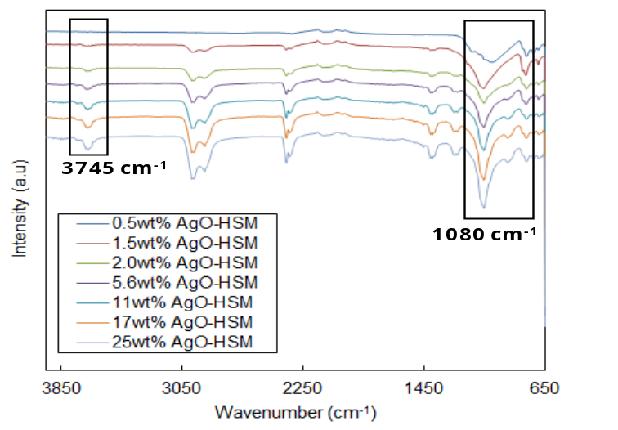
Figure 1. FTIR patterns of AgO catalysts with varying metal loading

Performance of the prepared catalysts
The performance of the prepared catalysts was examined by the decolorization of CR, and the results are shown in Figure 2. The result showed that complete decolorization of CR was achieved within a very short contact time (2 hours) under visible light conditions when using AgO-HSM at 480 mA cm⁻². It may be attributed to the narrower band gap of this catalyst, which facilitates excitation of electrons from the valence band to the conduction band, leading to the production of hydroxyl radicals. Therefore, the compatibility of AgO catalyst for the application in wastewater treatment of textile industry effluents is always at low concentration [18].

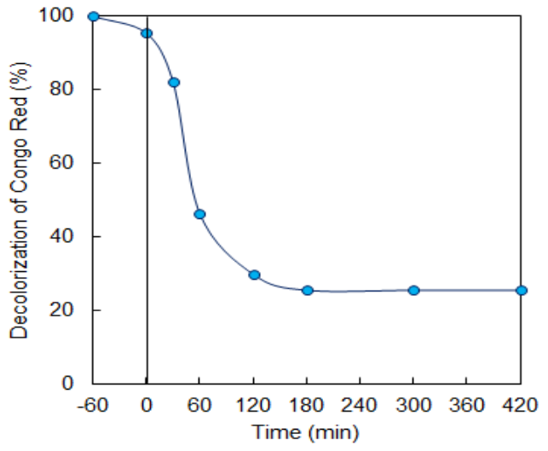
Figure 2. Performance of the AgO catalysts on the decolorization of CR (pH = 5, AgO loading = 2 wt.%, catalyst dosage = 0.3 g L⁻¹, temperature = 30 ºC, and initial concentration = 10 ppm)

Effect of pH
pH solution plays an important role in the photodecolorization of a dye as shown in Figure 3. Semiconductor oxides usually exhibit an amphoteric behavior, which influences the surface-charge properties of the photocatalysts when the reactions occur on the surface of the semiconductor [21]. In this study, the effect of pH on the removal of CR was examined over a pH range from 3 to 11 using AgO-HSM. The highest decolorization was obtained at pH 5 with decolorization of 70.2%. The activities of the catalysts may have been affected by the existence of a strong electrostatic field between the positively charged catalyst surface and the negatively charged CR, as well as the activity of Ag cations inside the framework of the mud [2]. The increase in the pH value did not seem to favor photodecolorization, which may be due to the reduction in the amount of positive charges on the surface of the catalyst, which in turn decreased the attraction of CR towards the surface. The reaction was not performed in alkaline conditions due to the competition between the hydroxyl ions and CR ions in the system. However, lowering the pH to acidic conditions made the surface of AgO-HSM became positively charged and this inhibited the dye cations from approaching the catalyst surface, thus reducing the efficiency of the reaction to 36.4% [19].

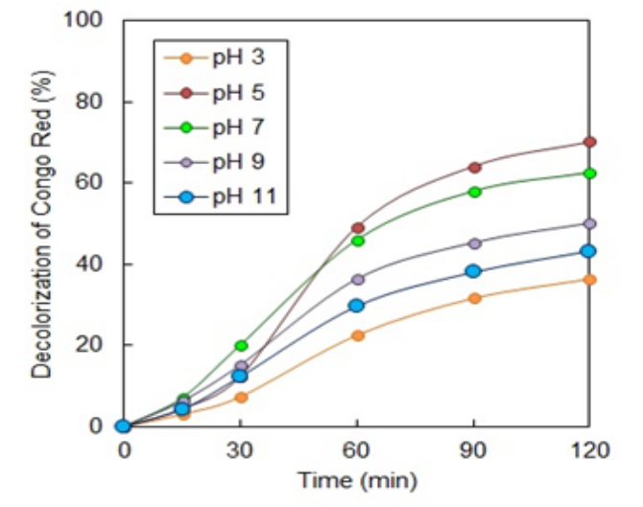
Figure 3. Effect of pH on the decolorization of CR (AgO loading = 2 wt.%, catalyst dosage = 0.3 g L⁻¹, temperature = 30 ºC, and initial concentration = 10 ppm)

Effect of metal loading
The effect of AgO content in HSM was studied for the decolorization of CR in the range of 0.5–25 wt.% loading using 0.2 g L⁻¹ AgO-HSM for a 2 hours irradiation time and shown in Figure 4. The decolorization increased with the increasing silver loading up to 11 wt.%, yielding a maximum decolorization percentage of 77.1%. Further addition of AgO most probably resulted in more agglomeration of silver oxide on the surface of HSM, which then reduced the surface area for CR attraction and light penetration for an efficient photocatalytic reaction. A similar observation was reported on the photocatalytic degradation of C.I. basic violet 10 using TiO₂ catalysts supported on Y-zeolites [20].

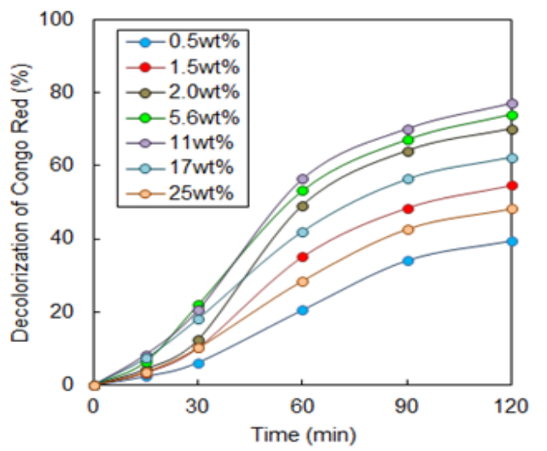
Figure 4. Effect of metal loading on the decolorization of CR (pH = 5, catalyst dosage = 0.3 g L⁻¹, temperature = 30 ºC, and initial concentration = 10 ppm)

Effect of catalyst dosage
In order to study the effect of catalyst dosage, a 10 mg L⁻¹ CR solution was studied at pH 5 under various catalytic doses ranging from 0.1 to 0.5 g L⁻¹. Figure 5 shows a plot of the decolorization percentage of CR for AgO-HSM. The decolorization increased with increasing catalyst dosage up to 0.2 g L⁻¹, but further addition of the catalyst did not produce any significant effect on the decolorization. This result could be due to the increased turbidity of the suspension, which reduced light penetration and inhibited photodecolorization [8, 16]. The increase in the catalyst dosage led to an increase in the active surface area and enhanced the decolorization up to 80.2% for AgO-HSM [2].

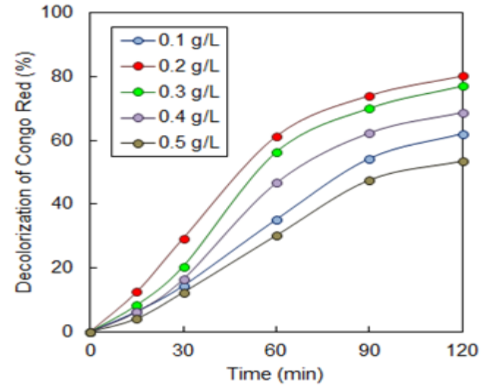
Figure 5. Effect of catalyst dosage on the decolorization of CR (pH = 5, AgO loading = 11 wt.%, temperature = 30 ºC, and initial concentration = 10 ppm)

Effect of initial concentration
Initial concentration is a very important aspect to be considered because the photocatalytic reaction rate depends on the substrate concentration. Figure 6 shows the effect of initial concentration, ranging from 10 to 100 mg L⁻¹, on the decolorization of CR using AgO-HSM. The catalyst demonstrated a decrease in the decolorization with the increase of the initial concentration. The increase in the concentration of CR caused the saturation of active sites on the catalyst surface with organic species, thus reducing light penetration and hydroxyl radical formation [2, 15, 16]. Lowering dye (pollutant in wastewater) concentration reduced the time of decomposition of the wastewater. This could be described when the concentration of the real industrial wastewater is less than its original concentration, then the catalyst active sites are probably completely exposed to dye ions. Further increase in dye concentration may also be responsible for screening the exposed light, so light intensity will be reduced [16].

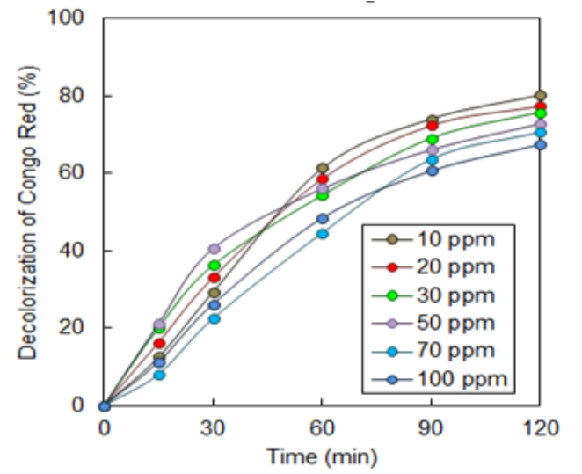
Figure 6. Effect of initial dye concentration on the decolorization of CR (pH = 5, AgO loading = 11 wt.%, catalyst dosage = 0.2 g L⁻¹, and temperature = 30 ºC)

Kinetic study
The kinetic decolorization of CR for 11 wt.% AgO-HSM was studied using the Langmuir–Hinshelwood (L–H) kinetic model at different initial concentrations, and the results are shown in Figure 7. Higher concentrations showed lower efficiency of photocatalytic decolorization due to the formation of several layers of adsorbed dye on the catalyst surface. In addition, large amounts of adsorbed dye were found to inhibit the reaction with the dye molecules, since there was no direct contact of the catalyst with photogenerated holes or hydroxyl radicals [11]. The calculated values of K_{r} and K_{LH} were 172.41 mg L⁻¹ h⁻¹ and 0.005 L mg⁻¹, respectively, for 11 wt.% AgO-HSM. The values of k_{r} were greater than those of K_{LH} for catalysts, indicating dye adsorption was the controlling step of the process. A similar phenomenon was reported on the degradation of Orange G using nano-sized Sn (IV)/TiO₂/AC as a photocatalyst [23].

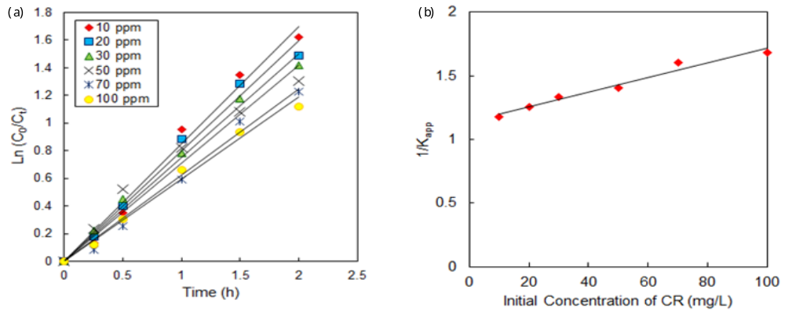
Figure 7. (a) Photodecolorization kinetics of CR using AgO-HSM at different CR concentrations; (b) Relationship between 1/K_{app} and 1/C₀ at different initial concentrations of CR: 11 wt.% AgO-HSM

The values of k obtained from Figure 7 are listed in Table 1, which revealed a significant and favorable effect of catalysts on the photodecolorization of CR. A lower concentration of CR results in a higher first-order rate constant, demonstrating the suitability of the system for low dye concentrations. Indeed, the concentrations of dyes in the wastewater from textile industry effluents are always low, in the range of 10-50 mg L⁻¹ [18].

Table 1. Pseudo first-order apparent constant value for CR decolorization
Initial Concentration,  (mg L⁻¹) | Reaction Rate,  kₐᵨᵨ (h⁻¹) | R² | Initial Reaction Rate,  r₀ (mg L⁻¹ h⁻¹) | Decolorization  (%)
10 | 0.8496 | 0.9848 | 8.496 | 80.23
20 | 0.7976 | 0.9853 | 15.952 | 77.41
30 | 0.7497 | 0.9888 | 22.491 | 75.84
50 | 0.7101 | 0.9539 | 35.505 | 72.82
70 | 0.6235 | 0.9876 | 43.645 | 70.70
100 | 0.5936 | 0.9886 | 59.36 | 67.45

Investigation on biodegradability
The degree of mineralization during photocatalytic decolorization was determined in order to confirm whether the final solution of CR was less toxic than the initial solution. COD and BOD₅ analysis were used to monitor the mineralization of the dyes. Figure 8 shows the COD and BOD₅ levels of CR solutions with 11 wt.% AgO-HSM. The results indicated that the COD and BOD₅ levels after reaction decreased to 38.4% and 61.1%, respectively. A significant change in BOD₅ proved that the biodegradability of the CR solution can be enhanced by this photo-oxidation system, by converting non-biodegradable organics into biodegradable forms. In addition, the BOD₅/COD ratio after reaction was 0.526, indicating that some non-biodegradable organic part of the CR molecule was destroyed, decomposed, and even mineralized in the photocatalytic process during the irradiation time [2, 15, 16].

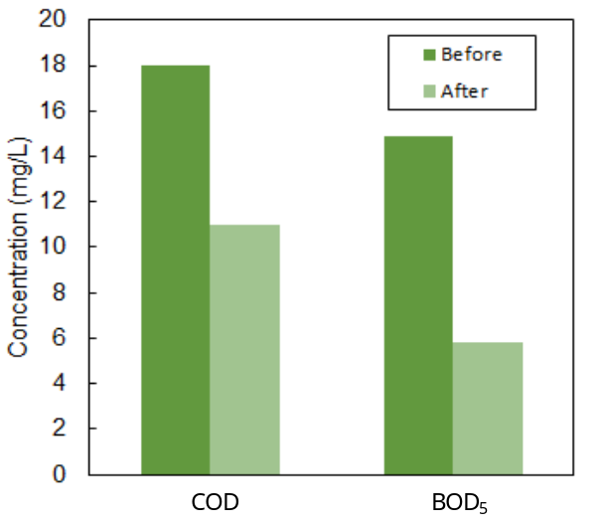
Figure 8. BOD₅ and COD levels before and after reaction (pH = 5, AgO loading = 11 wt.%, catalyst dosage = 0.2 gL⁻¹, initial concentration = 10 mgL⁻¹, and temperature = 30 ºC)

Conclusion
AgO supported hot spring mud (AgO-HSM) catalysts were prepared using electrochemical methods. The physical properties of the catalyst were studied via FTIR. The interaction between silver species and HSM support during the electrosynthesis was found to affect the AgO-HSM structure. The photodecolorization percentage of 80.2% in 10 mg L⁻¹ CR was obtained for 11 wt. % AgO-HSM. The kinetic studies showed that the reaction rate was pseudo-first order as determined by the Langmuir–Hinshelwood model, where the value of K_{r} was higher compared to K_{LH}, indicating dye adsorption was the controlling step of the process. The COD and BOD₅ levels, used to determine the mineralization of CR, were 38.4% and 61.1%, respectively, before and after reaction. Moreover, the BOD₅/COD ratio after reaction was 0.526, indicating that some non-biodegradable organic parts of the CR molecules were destroyed, decomposed, and even mineralized in the photocatalytic process. Therefore, AgO has a great potential to be used as a catalyst for the photocatalytic decolorization of various dyes in wastewater.

Acknowledgements
The authors are grateful for the financial support by the Short Term Research Grant (STRG) from Universiti Kuala Lumpur (Grant No. 17004 & 17029), Majlis Amanah Rakyat Malaysia (MARA), the awards of Yayasan Tengku Abdullah Scholarship (YTAS-Muhammad Farhan bin Hanafi), and also the Malaysian Institute of Chemical and Bioengineering Technology, Universiti Kuala Lumpur for their support.

References
- Sima, J. and Hasal, P. (2013). Photocatalytic degradation of textile dyes in a TiO₂/UV system. Chemical Engineering Transactions, 32: 79-84.
- Sapawe, N., Jalil, A. A., Triwahyono, S., Adam, S. H., Jaafar, N. F. and Satar, M. A. H. (2012). Isomorphous substitution of Zr in the framework of aluminosilicate HY by an electrochemical method: Evaluation by methylene blue decolorization. Applied Catalysis B: Environmental, 125: 311-323.
- Sapawe, N., Jalil, A. A., Triwahyono, S., Sah, R. N. R. A., Jusoh, N. W. C. and Hairom, N. H. H. (2013). Electrochemical strategy for grown ZnO nanoparticles deposited onto HY zeolite with enhanced photodecolorization of methylene blue: Effect of the formation of Si-O-Zn bonds. Applied Catalysis A: General, 456: 144-158.
- Gopalpur, N. (2011). Organic synthesis using clay and clay-supported catalysts. Applied Clay Science, 53: 106-138.
- Kumar, P., Govindaraju, M., Senthamilselvi, S. and Premkumar, K. (2013). Photocatalytic degradation of methyl orange dye using silver (Ag) nanoparticles synthesized from Ulva lactuca. Colloids and Surfaces B: Biointerfaces, 103: 658-661.
- Albiter, E., Valenzuela, M. A., Alfaro, S., Valverde-Aguilar, G. and Martı´nez-Pallares, F. M. (2015). Photocatalytic deposition of Ag nanoparticles on TiO₂: Metal precursor effect on the structural and photoactivity properties. Journal of Saudi Chemical Society, 19: 563-573.
- Sapawe, N., Rustam, M. A., Mahadzir, M. H. H., Lani, M. K. E. M., Raidin, A. and Hanafi, M. F. (2019). A novel approach of in-situ electrobiosynthesis of metal oxide nanoparticles using crude plant extract as main medium for supporting electrolyte. Materials Today: Proceedings, 19(4): 1441-1445.
- Hanafi, M. F., Sapawe, N., Rahim, M. Z. A., Rahman, N. N., Rahman, A. H. A. and Ahmad, A. A. (2016). Performance of EGZrO₂-EGFe₂O₃/HY as photocatalyst and its efficacy in decolorization of dye-contaminants. Malaysian Journal of Analytical Sciences, 20(5): 1052-1058.
- Hanafi, M. F. and Sapawe, N. (2018). Remarkable degradation of methyl orange by tetragonal zirconia catalyst. Materials Today: Proceedings, 5(10): 21849-21852.
- Hanafi, M.F. and Sapawe, N. (2019). The potential of ZrO₂ catalyst toward degradation of dyes and phenolic compound. Materials Today: Proceedings, 19(4): 1524-1528.
- Hanafi, M. F. and Sapawe, N. (2019). Electrosynthesis of ZrO₂ nanoparticles with enhanced removal of phenolic compound. Materials Today: Proceedings, 19(4), 1529-1532.
- Hanafi, M. F. and Sapawe, N. (2019). Effect of calcination temperature on the structure and catalytic performance of ZrO₂ catalyst in phenol degradation. Materials Today: Proceedings, 19(4): 1533-1536.
- Hanafi, M. F. and Sapawe, N. (2019). Electrogenerated zirconia (EGZrO₂) nanoparticles as recyclable catalyst for effective photocatalytic degradation of phenol. Materials Today: Proceedings, 19(4): 1537-1540.
- Sapawe, N. and Hanafi, M. F. (2015). Facile one-pot electrosynthesis of high photoreactive hexacoordinated Si with Zr and Zn catalyst. RSC Advances, 5(92): 75141-75144.
- Sapawe, N. (2015). Hybridization of zirconia, zinc and iron supported on HY zeolite as a solar-based catalyst for the rapid decolorization of various dyes. New Journal of Chemistry, 39(6): 4526-4533.
- Sapawe, N. (2015). Effective solar-based iron oxide supported HY zeolite catalyst for the decolorization of organic and simulated dyes. New Journal of Chemistry, 39(8): 6377-6387.
- Purkait, M. K., Maiti, A., Das Gupta, S. and De, S. (2007). Removal of Congo Red using activated carbon and its regeneration. Journal Hazardous Materials, 145: 287-295.
- Grzechulska, J. and Morawski, A.W. (2002). Photocatalytic decomposition of azo-dye acid black 1 in water over modified titanium dioxide. Applied Catalysis B: Environmental, 36: 45-51.
- Bokare, A. D., Chikate, R. C., Rode, C. V. and Paknikar, K. M. (2008). Iron-nickel bimetallic nanopartilcles for reductive degradation of azo dye Orange G in aqueous solution, Applied Catalysis B: Environmental, 79: 270-278.
- Wang, C.C., Lee, C.K., Lyu, M.D., & Juang, L.C (2008). Photocatalytic degradation of C.I. basic violet 10 using TiO₂ catalysts supported by Y zeolite: an investigation of the effects of operational parameters. Dyes Pigments, 76, 817-824.
- Sapawe, N., Jalil, A. A. and Triwahyono, S. (2013). One-pot electro-synthesis of ZrO₂–ZnO/HY nanocomposite for photocatalytic decolorization of various dye-contaminants. Chemical Engineering Journal, 225: 254-265.
- Sun, J., Wang, X., Sun, J., Sun, R. and Qiao, L. (2006). Photocatalytic degradation and kinetic of Orange G using nano-sizes Sn(IV)/TiO₂/AC photocatalyst. Journal Molecules Catalysis A: Chemical, 260: 241-246.

