

VORTEX-ASSISTED SUPRAMOLECULAR-BASED DISPERSIVE LIQUID PHASE MICROEXTRACTION FOR SPECTROPHOTOMETRIC DETERMINATION OF RHODAMINE B IN CHILI POWDER

(Supramolekul Berasaskan Serakan Cecair Fasa Pengekstrakan Mikro Berbantu-Vorteks untuk Penentuan Spektrofotometrik Rhodamin B dalam Serbuk Cili)

Renitha Harikrishnan¹, Kavisha Sundraraj², Boon Yih Hui³, Nur Nadhirah Mohamad Zain³, Noorfatimah Yahaya³, Kavirajaa Pandian Sambasevam⁴, Sharifah Mohamad^{5.,6}, Yatimah Alias^{5,6}, Muggundha Raoov^{5,6}*

¹ School of Distance Education,
Universiti Sains Malaysia, 11800, Pulau Pinang, Malaysia
² Department of Chemical Science, Faculty of Science,
Universiti Tunku Abdul Rahman, Kampar 31900, Malaysia
³ Integrative Medicine Cluster, Advanced Medical & Dental Institute,
Universiti Sains Malaysia, Pulau Pinang 13200, Malaysia
⁴ School of Chemistry and Environment,
Universiti Teknologi MARA, Kuala Pilah, Negeri Sembilan, Malaysia
⁵ Department of Chemistry, Faculty of Science
⁶ Universiti Malaya Centre for Ionic Liquids (UMCiL), Department of Chemistry, Faculty of Science
Universiti Malaya, Kuala Lumpur 50603, Malaysia

*Corresponding author: muggundha@um.edu.my

Received: 16 December 2019; Accepted: 8 March 2020

Abstract
A vortex-assisted supramolecular-based dispersive liquid phase microextraction technique was established to detect trace quantities of Rhodamine B (RhB) in chili powder prior to its determination by ultraviolet-visible spectrophotometry. The supramolecular solvent, which was made of reverse micelles of 1-pentanol created through self-assembly processes, was injected into the aqueous sample solution as fine droplets and assisted by vortexing, which accelerated the mass transfer of target analyte into the supramolecular solvent phase. Five important parameters (type and volume of the extraction solvent, extraction time, sample pH, and ionic strength) were investigated, and the optimum conditions were as follows: 400 µL of 1-pentanol as the supramolecular solvent; 30 min extraction time; pH 5; and 15% salt addition. Under optimum conditions, linearity was in the range of 0.1 to 2.5 mg kg^{–1}. The detection limit was 0.008 mg kg^{–1} with pre-concentration factor of 16, and the relative standard deviation (n = 5) was < 1.48%. The method was successfully applied to detect and measure RhB in selected chili powder samples, and good spiked recoveries in the range of 95.0 to 115.2% were obtained. This method has direct applications for monitoring the presence of potentially harmful dyes in processed foods.

Keywords: rhodamine B, UV-Vis spectrophotometry, supramolecular solvent, chili powder

Abstrak
Supramolekul berasaskan serakan fasa cecair pengekstrakan mikro berbantu vorteks (VASM-DLPME) telah dibangunkan untuk mengesan kuantiti Rhodamin B (RhB) dalam serbuk cili dengan menggunakan spektrofotometrik UV-Vis. Pelarut supramolekul adalah misel songsang yang dihasilkan daripada 1-pentanol melalui proses pemasangan kendiri dan disuntik ke dalam larutan sampel akueus sebagai titisan halus dibantu oleh vorteks, yang mempercepatkan masa pemindahan daripada analisis sasaran ke dalam fasa pelarut supramolekul. Lima parameter penting seperti jenis dan isipadu pelarut pengekstrakan, masa pengekstrakan, sampel pH dan kekuatan ionik telah dikaji dan keadaan optimum yang diperoleh adalah seperti berikut: 400 µL 1-pentanol sebagai pelarut supramolekul, masa pengekstrakan selama 30 minit pada pH 5 dengan penambahan garam sebanyak 15%. Di bawah keadaan yang optimum, kelinearan didapati dalam julat 0.1 hingga 2.5 mg kg⁻¹. Had pengesanan yang diperolehi adalah 0.008 mg kg⁻¹ dengan faktor pra-kepekatan 16 dan sisihan piawai relatif (RSD, n = 5) kurang daripada 1.48% telah dicapai. Kaedah ini telah berjaya diaplikasikan untuk penentuan RhB dalam sampel serbuk cili terpilih dan kadar pemulihan berada pada julat 95.0-115.2% diperolehi. Kaedah ini mempunyai aplikasi langsung untuk pemantauan pewarna berbahaya dalam makanan yang diproses.

Kata kunci: rhodamin B, spektrofotometri UV-Vis, pelarut supramolekul, serbuk cili

Introduction
Chili powder is a popular spice due to its beneficial health properties and the pungency and flavour it adds to dishes. Chili powder also is an ingredient utilized by the pabulum manufacturing industry in the formulation of a wide range of products, including oriental dishes, curries, sauces, and pickles. To meet the worldwide demand for chili powder, artificial food colorants are often added to it to preserve its natural colour during food processing and to create the desired coloured appearance [1].

Thus, the quality of chili powder is measured by the brightness and intensity of the spice’s colour, and this affects its economic value. Colour additives are widely used in the food industry to make food more attractive, appealing, and appetizing [2]. Rhodamine B (RhB), which belongs to the class of synthetic azo dyes, was used commercially in chili powders to intensify their colour, but its use was prohibited more than 50 years ago. Nevertheless, spices from Vietnam and paprika and chimi churri from Argentina have been found to contain RhB [3].

RhB consists of xanthene rings and aromatic compounds that are an important source of environmental pollution. Their metabolites are considered to be carcinogenic and to have reproductive and developmental toxicity as well as neurotoxicity towards humans and animals [4, 5]. Consequently, most countries have banned and controlled its usage as a food additive. Therefore, monitoring of RhB, particularly in food samples, has become a great concern, and an improved, easy method for detection of RhB in various samples is needed.

Numerous analytical techniques to detect RhB have been developed, including ultraviolet spectrophotometry [6], fluorescence spectrophotometry [7], capillary electrophoresis, and high performance liquid chromatography [8]. Among these methods, ultraviolet-visible (UV-Vis) spectrophotometry is an attractive method due to its simplicity of operation and low cost. However, this method has two major limitations: (i) co-elution effects from samples influence the signal of analytes and (ii) low concentration of analytes likely leads to unsatisfactory quantitative results [9]. To overcome these issues, different sample preparation techniques can be used to isolate, clean-up, and pre-concentrate the target analytes before their measurement to increase the sensitivity and accuracy of the method.
Different sample preparation methods used to preconcentrate different organic pollutants include dispersive liquid–liquid microextraction (DLLME) [10], solid-phase extraction (SPE) [11], magnetic solid phase extraction [12, 13], solid-phase microextraction [14, 15], and supramolecular based dispersive liquid phase microextraction (SM-DLPME) [16-18].

SM-DLPME uses supramolecular solvents (SUPRAS) as an extractant. Their principle is based on partitioning of an analyte between an alkyl-based nano-structured solvent and a bulk aqueous sample. SUPRAS are water-immiscible liquids widely used in extraction and pre-concentration techniques due to their excellent ability to extract various types of compounds, including organic and inorganic species [19]. SUPRAS can provide different types of interaction (e.g. hydrophobic, ionic, and hydrogen bonding) with the organic compounds and hydrophobic complexes of metals with ligands [20]. These interactions are important for extracting analytes from the water phase to the supramolecular solvent phase to increase the extraction efficiency [21-23].

The aim of this research was to develop a new and fast microextraction method using dispersion of SUPRAS as the extractant phase into the aqueous phase, yielding a mild emulsification procedure, under vortex conditions. The resulting methodology, called vortex-assisted supramolecular-based dispersive liquid-phase microextraction (VASM-DLPME), was used to extract trace amounts of RhB from chili powder samples. The fine droplets formed sped up the adsorption equilibrium process due to the shorter diffusion distance and larger specific surface area of the SUPRAS. The developed method was successfully applied to assess the content of RhB in a variety of commercial chili powders available in Malaysia.

Materials and Methods
Instrumentation
A Shimadzu UV-1800 spectrophotometer (Torrance, CA, USA) with 3 mL quartz cuvettes and wavelength of 553 nm was used for all sample analyses. pH measurements were performed using a pH meter (Hanna Instruments, Woonsocket, RI, USA). A tabletop centrifuge (Kubota, 4200, Osaka, Japan) (16000 rpm) was applied during the phase separation, and a digital control ultrasonic bath with adjustable temperature (Thermo-10D, Thermoline Scientific, Wetherill Park, Australia) was used for the sample preparation.

Chemicals and reagents
RhB standard (molecular weight: 479.02 g mol^{–1}) with > 95% purity was purchased from Sigma Aldrich (Milwaukee, WI, USA). High performance liquid chromatography (HPLC) grade methanol was supplied by Merck (Darmstadt, Germany). Ultrapure water was produced using the Sartorius Milli-Q system (Aubagne, France). The sample supernatant was filtered through 0.45 μm membrane filters before analysis. A 1 mL syringe needle was used to collect the upper layer of the extractant. SUPRAS (i.e., 1-octanol, 1-undecanol, and 1-dodecanol) were purchased from Merck, and 1-pentanol, 1-hexanol, and 1-heptanol were purchased from Sigma-Aldrich (St. Louis, MO, USA). All other reagents were of analytical grade and used without further purification.

The stock solutions of 100 mg L^{–1} for RhB were made using methanol. Ultrapure water was used to prepare the working standard solutions by diluting them to desired concentrations. All standard solutions were stored in the refrigerator (4 °C) to avoid degradation.

Sample preparation
Chili powders used for this study were purchased from a local market in Kuala Lumpur, Malaysia. Briefly, 0.5 g of chili powder was precisely weighed and quantitatively transferred into a 15 mL centrifuge tube containing 10 mL of methanol. The mixture was sonicated for 30 minutes at room temperature to homogeneously agitate the chili powder. Thereafter, the sample mixture was centrifuged at 4000 rpm for 10 minutes. The supernatant was collected and filtered using a 0.45 µm membrane filter immediately to remove suspended particulate matter.

VASM-DLPME procedure
A 0.2 mL aliquot of sample solution containing the analyte was transferred into a centrifuge tube. Adjustment of the sample solution to pH 5 was carried out by dropwise addition of 0.1 M of HCl or NaOH solutions before subjecting the sample to the VASM-DLPME procedure. Next, 0.4 mL of SUPRAS as the extractant was injected into the sample solution, followed by addition of deionized water up to 5 mL. This contact with water is a crucial step that allows the formation of amphiphilic structures such as micelles. The solution was then vortexed for 30 s, followed by centrifugation for 5 minutes at 4000 rpm to facilitate phase separation.

Next, 0.3 mL of the extractant-rich phase was collected and diluted to 4 mL in methanol. This step was to ensure that the final volume was viable for transfer into the optical cell for UV measurement at the respective absorption wavelength and to reduce the viscosity of the extractant phase. Figure 1 illustrates the absorbance of the diluted extractant-rich phase measured at 553 nm, and Figure 2 shows the proposed VASM-DLPME procedure in schematic form.

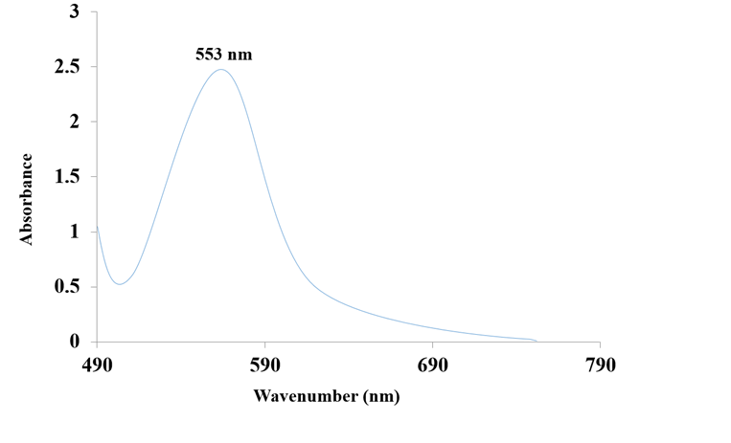
Figure 1. Absorbance of the diluted extractant-rich phase measured at 553 nm

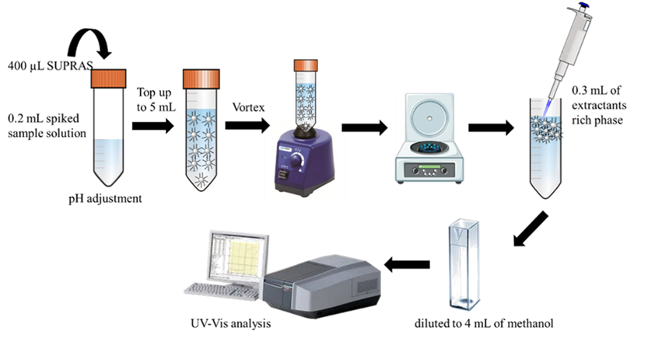
Figure 2. The proposed VASM-DLPME procedure

Optimization and validation of the VASM-DLPME procedure
One-variable-at-a-time analysis was employed for the optimization procedures (i.e. one variable was manipulated while the other variables were kept constant). For the optimization, 1.0 mg kg^{–1} of the spiked blank chili powder was used, and all measurements were conducted in triplicate using the UV-Vis spectrophotometer. The extraction efficiency, EE (expressed in %), was calculated using the following equation 1.

EE = $\frac{V_{f}}{V_{i}}$ x $\frac{C_{f } x D_{f}}{C_{i}}$ x 100 % (1)

where V_{f} is the final volume of the sample, V_{i} is the initial volume of the sample, C_{f} is the concentration in the spiked sample, C_{i} is the spiking concentration of RhB, and D_{f} is the dilution factor.

Validation to assess the viability of the method included measurement of linearity, repeatability, relative recovery, limit of detection (LOD), and limit of quantification (LOQ). The latter were calculated using the following formulas:

LOD = $\frac{3 x Sd}{b}$ (2)

LOQ = $\frac{10 x Sd}{b}$ (3)

where Sd is the standard deviation of 10 replicate measurements of blank samples and b is the slope of each calibration curve.

The enrichment factor (EF) was calculated as the ratio of the slope of the calibration curve of the RhB after pre-concentration to that prior to pre-concentration. The precision of the developed procedure was evaluated as intra-(repeatability) and inter- (reproducibility) day precision, which were analysed using five replicates (n =5) each.

Results and Discussion
Effect of type of SUPRAS
The extraction solvent should have several characteristics, such as low volatility, low toxicity, low solubility in water, and low amounts of interfering agent present in the sample matrix [24]. Furthermore, the desired analytes should have high solubility in the selected solvent for better extraction performance. Short-chain alkanols are better proton donors than longer ones, hence they are more capable of forming hydrogen bonding, whereas hydrophobic interactions dominate in the case of long-chain alkanols [25]. For this reason, six different types of alkanol-based SUPRAs (C5–C11) were studied. Figure 3 shows that extraction efficiency decreased with the increasing chain length of alkanols. This revealed that hydrogen bonding between the RhB and SUPRASs was the dominant interaction during the extraction. Subsequently, 1-pentanol with medium alkyl chain length was selected as the suitable SUPRAS for the developed technique, as it provided a compromise between the stability and polarity of RhB and the extractant.

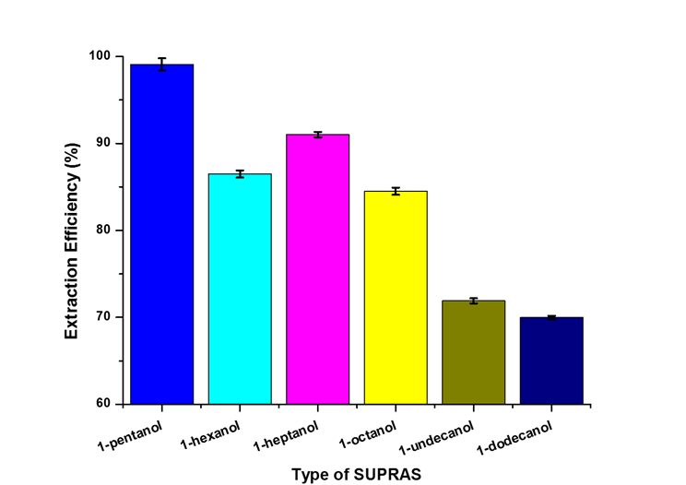
Figure 3. Effect of the type of SUPRAS on the extraction efficiency of RhB. Conditions: 5.0 mL of sample volume spiked with 1.0 mg kg^{–1} of RhB and 0.5 mL of SUPRAS

Effect of the volume of the SUPRAS
Selection of the optimum volume for the extraction solvent is another important factor in microextraction because it influences the extraction recovery [26]. To examine this effect, different volumes of SUPRAS from 200 to 750 µL at 50 μL intervals were investigated. As the extraction solvent volume increased, the final solvent volume collected after centrifugation also increased; however, this also led to reduction of the analyte signals. This result shows that it is essential to keep the volume of extraction solvent as low as possible to achieve maximum signals [27]. A larger volume of SUPRAS makes the collected final rich phase more dilute, and consequently decreases the extraction efficiency [16]. Unfortunately, it is not always possible to reduce the solvent volume as desired because a sufficient volume of solvent is needed for the analysis. The obtained results (Figure 4) demonstrated that the extraction efficiency was high in the SUPRAS volume of 400 µL and decreased thereafter. Therefore, considering the high repeatability, 400 µL was selected as the optimum SUPRAS volume.

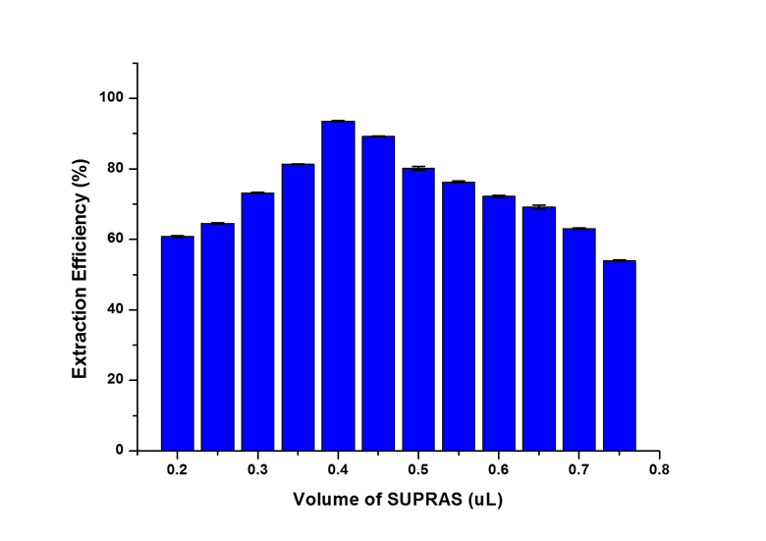
Figure 4. Effect of the volume of SUPRAS on the extraction efficiency of RhB. Conditions: 5.0 mL of sample volume spiked with 1.0 mg kg^{–1} of RhB and the SUPRAS 1-pentanol

Effect of extraction time
Sufficient extraction time is essential to ensure the formation of a homogeneous cloudy solution, which influences the complete transfer of analytes from the sample solution to the extractant phase [24]. The effect of extraction time on the extraction efficiency of RhB was evaluated from 10 to 30 minutes, and the results demonstrated that 30 minutes was adequate to reach the equilibrium between both phases (Figure 5). Hence, 30 minutes of extraction time was selected for subsequent analysis.

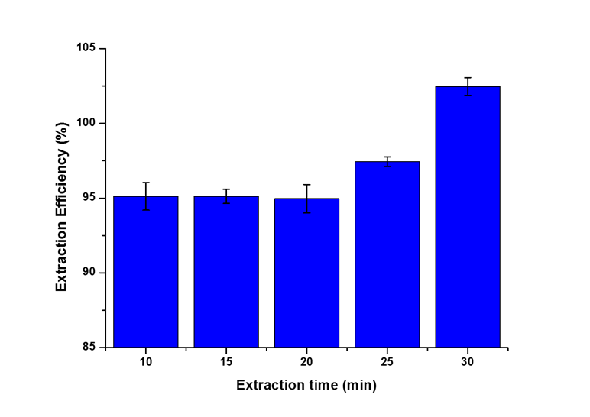
Figure 5. Effect of extraction time on the extraction efficiency of RhB. Conditions: 5.0 mL of sample volume spiked with 1.0 mg kg^{–1} of RhB and 0.4 mL of the SUPRAS 1-pentanol
Effect of pH
The sample pH can control the dissociation of target analytes with acid-base characteristics, thus it is another important factor that needs to be considered [16]. pH values ranging from 3 to 9 were evaluated, and the optimum analytical signal for RhB extraction was achieved at pH 5.0 (Figure 6). This can be explained by the molecular or ionic forms of RhB that were created during weak base protonation (or weak acid deprotonation), which usually interacted weakly with the SUPRAS micellar aggregate compared to the neutral form, thereby resulting in a lower extraction efficiency (Table 1). Therefore, pH 5.0 was selected as the optimum pH for the extraction of RhB in this study.

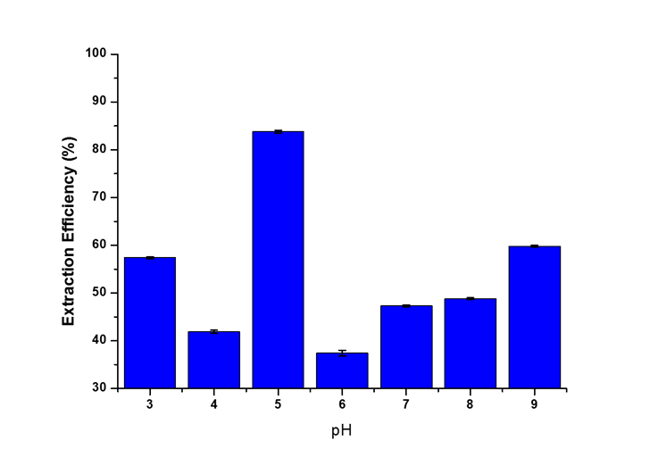
Figure 6. Effect of pH on the extraction efficiency of RhB. Conditions: 5.0 mL of sample volume spiked with 1.0 mg kg^{–1} of RhB and 0.4 mL of the SUPRAS 1-pentanol as SUPRAS and extraction time of 30 minutes

Table 1. Molecular structure of RhB under different pH conditions
pH < 5  Protonated | pH 5  Neutral | pH ˃ 5  Deprotonated
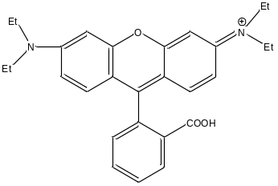 | 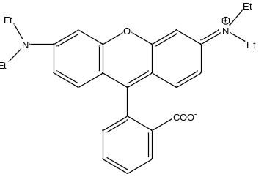 | 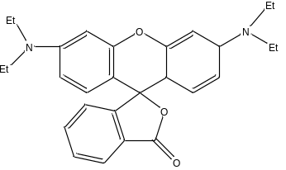

Effect of ionic strength
Salt addition reduces the solubility of analytes in a sample solution, which can improve the extraction efficiency [24]. It also can increase the viscosity of the sample solution at higher concentrations, thereby affecting the physical properties of the extraction film and reducing the transfer of analytes towards the extractant phase [28]. To test the effect of ionic strength, 0–25% of NaCl was added to the sample solution. Extraction efficiency increased as salt concentration increased to 15% (w/v), but it decreased thereafter (Figure 7). This result can be explained by the fact that higher ionic strength caused the sample solution to become more viscous, which likely restrained the transport of the analytes to the extractant phase, leading to lower extraction performance.

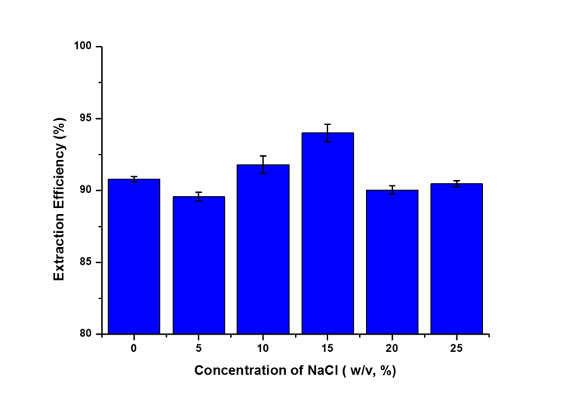
Figure 7. Effect of ionic strength on the extraction efficiency of RhB. Conditions: 5.0 mL at pH 5 of sample volume, spiked with 1.0 mg kg^{–1} of RhB and 0.4 mL of the SUPRAS 1-pentanol, and extraction time of 30 minutes

Analytical performance
Under optimum conditions, the calibration curve was linear over the range of 0.1 to 2.5 mg kg^{–1} with a coefficient of determination (R²) of 0.9983. The precision of the method was evaluated by analysing 0.5 mg kg^{–1} of RhB five times continuously, and the RSD was 1.5%. The LOD and LOQ were 0.008 mg kg^{–1} and 0.03 mg kg^{–1}, respectively. The EF after pre-concentration was 16 at 1.0 mg kg^{–1}. The intra- (repeatability) and inter- (reproducibility) day precision were 0.82% and 1.05%, respectively (Table 2). To investigate the accuracy of the proposed method, blank chili powder was spiked with three different concentration of RhB (0.1, 0.5, and 1.0 mg kg^{–1}), and the recoveries of RhB ranged between 95.0% and 117% (Table 3).

Validation Parameter | Result
Linearity range (mg kg^{–1}) | 0.1–2.5
Coefficient of determination (R²) | 0.9983
Regression equation | y = 0.4057x + 0.0245
LOD (mg kg^{–1}) | 0.008
LOQ (mg kg^{–1}) | 0.030
Enrichment factor at 1.0 mg kg^{–1} | 16
Intra-day, RSD (%) at 0.5 mg kg^{–1} | 0.82
Inter-day, RSD (%) at 0.5 mg kg^{–1} | 1.05
Table 2. Validation parameters of the developed VASM-DLPME procedure

Table 3. Recovery obtained from the measurement of RhB in spiked organic chili powder
Sample | Spiked Level  (mg kg^{–1}) | Found  (mg kg^{–1}) | Relative Recovery, RSD  (%, n = 3)
Organic chili powder | 0.1 | 0.095 | 95.00 ± 3.0
Organic chili powder | 0.5 | 0.587 | 117.47 ± 3.8
Organic chili powder | 1.0 | 1.152 | 115.23 ± 4.0

Analysis of real samples
To evaluate the feasibility of using the developed method to test real matrices, 10 different chili powders that are commercially available were purchased from a local market (Kuala Lumpur, Malaysia) to determine the contents of RhB. RhB was detected in several chili powder samples, which showed that the procedure was satisfactory for genuine food applications. Figure 8 shows the UV-Vis spectra of a real sample with detected RhB, and Table 4 tabulates the results of the detected RhB in real samples after analysis using the VASM-DLPME microextraction technique.

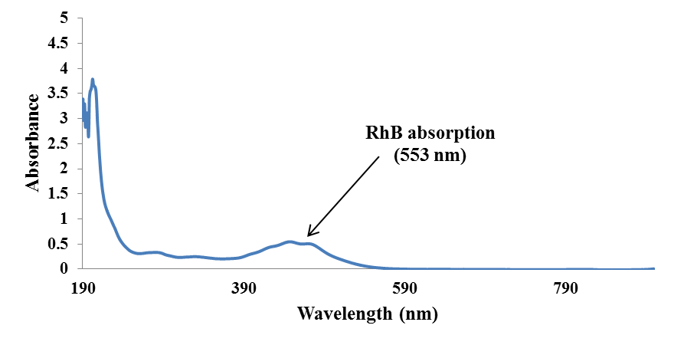
Figure 8. UV-Vis spectra of a real sample with detected RhB after analysis using the VASM-DLPME microextraction technique

Table 4. Results of the detected RhB in real samples after analysis using the VASM-DLPME procedure
Chili Powder | Concentration of RhB Residues (mg kg^{–1})
Sample 1 | < LOQ
Sample 2 | 0.05
Sample 3 | 0.44
Sample 4 | 0.16
Sample 5 | < LOQ
Sample 6 | 0.32
Sample 7 | 0.15
Sample 8 | < LOQ
Sample 9 | 0.27
Sample 10 | < LOQ
< LOQ = less than limit of quantification
Comparison with other reported methods
The analytical performance of the present method was compared with those reported in the literature for other methods, including SPE-UV spectrophotometry, SPE-HPLC, SPE-fluorescence spectrophotometry, liquid-liquid extraction-HPLC, and DSPE-HPLC (Table 5). Overall, the proposed VASM-DLPME produced results comparable to other methods in terms of LODs. It also is superior to the others because it uses SUPRAS that form micelle aggregates, and therefore it does not require the use of a dispersant solvent. Additionally, no heating is required during the extraction process, which greatly simplifies the operation.

Table 5. Comparison with results in the literature for RhB determination
Method | Limit of Detection  (mg kg^{–1}) | Linear Range  (mg kg^{–1}) | Reference
MIP-SPE-UV-Vis | 2.57 | 0-12 | [9]
SPE-UV | 0.00746 | 0.02–51 | [29]
HPLC-CL | 0.0078 | 0.02–1.4 | [30]
Fe₃O₄@ILs-β-CDCP | 0.0052 | 0.1–9.0 | [5]
VASM-DLPME/UV-Vis | 8.0 | 0.1-2.5 | This method

Conclusion
In the present study, a rapid and simple VASM-DLPME/UV-Vis spectrophotometric method for pre-concentration and measurement of RhB in chili powder samples was developed. The developed method is solvent minimized, cost-efficient, eco-friendly, and simple to operate. This study also successfully showed the great potential of SUPRAS as extractants for the determination of RhB in chili powder. Overall, the proposed SUPRAS-based microextraction is an attractive method that can be used as an alternative technique for extraction and off-line pre-concentration, and it is suitable for routine lab analysis and surveillance programs. This is important for the control of the presence of dyes in domestic and imported chili powders.

Acknowledgments
The authors would like to express their gratitude for a University Malaya Faculty Research Grant (GPF058B-2018). The authors acknowledge the Department of Chemistry, Faculty of Science, University of Malaya for the facilities provided.

References
- Tsai, C.F., Kuo, C.H. and Shih, D.Y.C. (2015). Determination of 20 synthetic dyes in chili powders and syrup-preserved fruits by liquid chromatography/tandem mass spectrometry. Journal of Food and Drug Analysis, 23:453–462.
- Vachirapatama, N., Mahajaroensiri, J. and Visessanguan, W. (2008). Identification and determination of seven synthetic dyes in foodstuffs and soft drinks on monolithic C₁₈ column by high performance liquid chromatography. Journal of Food & Drug Analysis, 16:77–82.
- Xu., X, Zhang, M., Wang, L., Zhang, S., Liu, M., Long, N., Qi, X., Cui, Z. and Zhang, L. (2016). Determination of rhodamine B in food using ionic liquid–coated multiwalled carbon nanotube–based ultrasound-assisted dispersive solid-phase microextraction followed by high-performance liquid chromatography. Food Analytical Methods, 9:1696–1705.
- Jieping, C. and Zhu, X. (2016). Magnetic solid phase extraction using ionic liquid-coated core-shell magnetic nanoparticles followed by high-performance liquid chromatography for determination of rhodamine B in food samples. Food Chemistry, 200:10–15.
- Ahmed Bakheet, A. A. and Zhu, X. S. (2017). Determination of Rhodamine B in food samples by Fe₃O₄@ionic liquids-β-cyclodextrin cross linked polymer solid phase extraction coupled with fluorescence spectrophotometry. Journal of Fluorescene, 27:1087–1094.
- Sun, W. J., Li, J., Mele, G., Zhang, Z. Q. and Zhang, F. X. (2013). Enhanced photocatalytic degradation of rhodamine B by surface modification of ZnO with copper (II) porphyrin under both UV-Vis and visible light irradiation. Journal of Molecular Catalysis A: Chemical, 366: 84–91.
- Ahmed Bakheet, A. A. and Zhu, X. S. (2017). Determination of rhodamine B pigment in food samples by ionic liquid coated magnetic core/shell Fe₃O₄@SiO₂ nanoparticles coupled with fluorescence spectrophotometry. Science Journal of Chemistry, 5:1–7.
- Santiago Valverde, R., Sánchez Pérez, I., Franceschelli, F., Martínez Galera, M. and Gil García, M. D. (2007). Determination of photoirradiated tetracyclines in water by high-performance liquid chromatography with chemiluminescence detection based reaction of rhodamine B with cerium(IV). Journal of Chromatography A, 1167:85–94.
- Liu, X., Zhang, X., Zhou, Q., Bai, B. and Ji, S. (2013). Spectrometric determination of rhodamine B in chili powder after molecularly imprinted solid phase extraction. Bulletin of the Korean Chemical Society, 34:3381–3386.
- Souza, A. S., Siqueira, R.P., Prates, R. F., Bezerra, V. M., Rocha, D. da. S., Oliveira, M. V. and Santos, D. B. (2017). A dispersive liquid–liquid microextraction based on solidification of floating organic drop and spectrophotometric determination of uranium in breast milk after optimization using Box-Behnken design. Microchemical Journal, 134: 327–332.
- Pichon, V. (2000). Solid-phase extraction for multiresidue analysis of organic contaminants in water. Journal of Chromatography A, 885: 195–215.
- Tahmasebi, E., and Yamini, Y. (2012). Facile synthesis of new nano sorbent for magnetic solid-phase extraction by self assembling of bis-(2,4,4-trimethyl pentyl)-dithiophosphinic acid on Fe₃O₄@Ag core@shell nanoparticles: Characterization and application. Analytical Chimica Acta, 756: 13–22.
- Zheng, H., Ding, J., Zheng, S., Zhu, G. and Yuan, B. (2016). Facile synthesis of magnetic carbon nitride nanosheets and its application in magnetic solid phase extraction for polycyclic aromatic hydrocarbons in edible oil samples. Talanta, 148: 46–53.
- Rubio, L., Sanllorente, S., Sarabia, L. A. and Ortiz, M. C. (2014). Optimization of a headspace solid-phase microextraction and gas chromatography/mass spectrometry procedure for the determination of aromatic amines in water and in polyamide spoons. Chemometrics and Intelligent Laboratory Systems, 133: 121–135.
- Trujillo-Rodríguez, M. J., Yu, H., Cole, W. T. S., Ho, T. D., Pino, V., Anderson, J. L. and Afonso, A. M. (2014). Polymeric ionic liquid coatings versus commercial solid-phase microextraction coatings for the determination of volatile compounds in cheeses. Talanta, 121: 153–162.
- Scheel, G. L., and Tarley, C. R. T. (2017). Feasibility of supramolecular solvent-based microextraction for simultaneous preconcentration of herbicides from natural waters with posterior determination by HPLC-DAD. Microchemical Journal, 133: 650–657.
- Ballesteros-Gómez, A., Sicilia, M. D. and Rubio, S. (2010). Supramolecular solvents in the extraction of organic compounds. A review. Analytical Chimica Acta, 677: 108–130.
- Moradi, M., Kashanaki, R., Borhani, S., Bigdeli, H., Abbasi, N. and Kazemzadeh, A. (2017). Optimization of supramolecular solvent microextraction prior to graphite furnace atomic absorption spectrometry for total selenium determination in food and environmental samples. Journal of Molecular Liquids, 232: 243–250.
- Seebunrueng, K., Dejchaiwatana, C., Santaladchaiyakit, Y., and Srijaranai, S. S. (2017). Development of supramolecular solvent based microextraction prior to high performance liquid chromatography for simultaneous determination of phenols in environmental water. RSC Advances, 7: 50143–50149.
- Yilmaz, E. and Soylak, M. (2014). Development a novel supramolecular solvent microextraction procedure for copper in environmental samples and its determination by microsampling flame atomic absorption spectrometry. Talanta, 126: 191–195.
- Shamsipur, M., Zohrabib, P., and Hashemi, M. (2015). Application of a supramolecular solvent as the carrier for ferrofluid based liquid-phase microextraction for spectro fluorimetric determination of levofloxacin in biological samples. Analytical Methods, 7: 9609–9614.
- Ballesteros-Gomez, A., Rubio, S. and Perez-Bendito, D. (2009). Potential of supramolecular solvents for the extraction of contaminants in liquid foods. Journal of Chromatography A, 1216: 530–539.
- Rezaei, F., Yamini, Y., Moradi, M. and Daraei, B. (2013). Supramolecular solvent-based hollow fiber liquid phase microextraction of benzodiazepines. Analytical Chimica Acta, 804: 135–142.
- Ezoddin, M., Majidi, B. and Abdi, K. (2015). Ultrasound-assisted supramolecular dispersive liquid–liquid microextraction based on solidification of floating organic drops for preconcentration of palladium in water and road dust samples. Journal of Molecular Liquids, 209: 515–519.
- López-Jiménez, F. J., Rosales-Marcano, M. and Rubio, S. (2013). Restricted access property supramolecular solvents for combined microextraction of endocrine disruptors in sediment and sample cleanup prior to their quantification by liquid chromatography – tandem mass spectrometry. Journal of Chromatography A, 1303: 1–8.
- Yang, D., Li, X., Meng, D., Wang, M. and Yang, Y. (2017). Supramolecular solvents combined with layered double hydroxide-coated magnetic nanoparticles for extraction of bisphenols and 4-tert- octylphenol from fruit juices. Food Chemistry, 237: 870–876.
- Dursun, G., Yildiz, E., and Cabuk, H. (2018). Supramolecular solvent-based microextraction of propachlor and prometryn herbicides in soil samples prior to liquid chromatographic analysis. Cumhuriyet Science Journal, 39:833–841.
- Rezaei, F., Yamini, Y., Asiabi, H., and Moradi, M. (2015). Determination of diphenylamine residue in fruit samples by supercritical fluid extraction followed by vesicular based-supramolecular solvent microextraction. Journal of Supercritical Fluids, 100:79–85.
- Soylak, M., Unsal, Y. E., Yilmaz, E. and Tuzen, M. (2011). Determination of rhodamine B in soft drink, waste water and lipstick samples after solid phase extraction. Food Chemical Toxicology, 49:1796–1799
- Zhang, Q., Cui, H., Myint, A., Lian, M. and Liu, L. (2005). Sensitive determination of phenolic compounds using high-performance liquid chromatography with cerium (IV)-rhodamine 6G-phenolic compound chemiluminescence detection. Journal of Chromatography A, 1095: 94–101.

