

CONTROLLED CONCENTRATION OF Mn SALT FOR THE SYNTHESIS OF MANGANESE OXIDE/MESOPOROUS CARBON FILM AS POTENTIAL ELECTRODES FOR SUPERCAPACITOR

(Kepekatan Garam Mn Terkawal terhadap Sintesis Mangan Oksida/Karbon Filem Berliang Meso sebagai Elektrod Berpotensi bagi Superkapasitor)

Mahanim Sarif @ Mohd Ali^{1,3}, Zulkarnain Zainal^{1,2}*, Mohd Zobir Hussein¹, Mohd Haniff Wahid²,
Noor Nazihah Bahrudin²

¹Materials Synthesis and Characterization Laboratory, Institute of Advanced Technology
²Department of Chemistry, Faculty of Science
Universiti Putra Malaysia, 43400 UPM Serdang, Selangor, Malaysia
³Forest Product Division,
Forest Research Institute Malaysia, 52109 Kepong, Selangor, Malaysia

*Corresponding author: zulkar@upm.edu.my

Received: 15 December 2019; Accepted: 11 March 2020

Abstract

Manganese oxide (Mn₂O₃) mesoporous carbon (MPC) was synthesized by the incipient wetness of impregnation at room temperature and followed by calcination of 300 °C. The structure and morphology of Mn₂O₃/MPC were characterized by Fourier transform infrared (FTIR) spectrum, atomic force microscopy (AFM) and field emission scanning electron microscopy (FESEM). The electrochemical performance of synthesized composites was evaluated by cyclic voltammetry (CV), galvanostatic measurement of charge-discharge (GCD) as well as power and energy density characteristics. The specific capacitance of the composite electrode when 10 wt.% Mn salt was coated on the surface of MPC film could reach 53.59 mF cm⁻² as compared to MPC film at only 15.23 mF cm⁻². These are in good agreement with the electrochemical performance improvement results of the energy and power density recorded for Mn₂O₃/MPC, which lead to higher specific capacitance as supported by the CV and GCD results in 1 M potassium chloride (KCl) of electrolyte. This enhanced capacitance was attributed to the outstanding electric properties of MPC film as well as the faradaic redox reactions of manganese oxide as proven by FESEM and EDX analysis. The results indicate the promising application of the fabricated Mn₂O₃/MPC composite as electrodes for supercapacitors.

Keywords: manganese oxide, mesoporous carbon, composite, specific capacitance, supercapacitor

Abstrak

Mangan oksida (Mn₂O₃) karbon filem berliang meso (MPC) telah disintesis melalui kaedah serapan basah pada suhu bilik dan diikuti oleh proses pengkalsinan pada suhu 300 °C. Struktur dan morfologi Mn₂O₃/MPC dicirikan oleh spektrum inframerah transformasi Fourier (FTIR), mikroskop kekuatan atom (AFM) dan mikroskop pengimbasan elektron serta pelepasan medan (FESEM). Prestasi elektrokimia komposit yang disintesis telah dinilai oleh kitaran voltammetri (CV), pengukuran pelepasan galvanostatik (GCD) juga ciri-ciri kuasa dan ketumpatan tenaga. Kapasitan khusus elektrod komposit apabila garam 10 wt.% Mn dilapisi pada permukaan MPC filem boleh mencapai 53.59 mF cm⁻² berbanding dengan MPC filem hanya 15.23 mF cm⁻². Ini menyamai dengan peningkatan prestasi elektrokimia terhadap tenaga dan ketumpatan kuasa yang dicatatkan untuk Mn₂O₃/MPC, yang membawa kepada kapasitan khusus yang lebih tinggi, disokong oleh keputusan CV dan GCD dalam elektrolit 1 M kalium klorida (KCl). Peningkatan kapasitan ini adalah disebabkan oleh sifat-sifat elektrik yang cemerlang dari MPC filem serta tindak balas redoks faradaik dari mangan seperti yang dibuktikan juga dalam analisis FESEM dan EDX. Keputusan menunjukkan fabrikasi komposit Mn₂O₃/MPC mempunyai potensi aplikasi sebagai elektrod bagi superkapasitor.

Kata kunci: mangan oksida, karbon berliang meso, komposit, kapasitan khusus, superkapasitor

Introduction

Supercapacitors are widely used for electrochemical energy storage devices that are specifically tailored for rapid storage and energy release. Supercapacitors store energy using either electron/ electrolyte interface ion adsorption (electric double-layer capacitors) or rapid redox reactions in electrode materials (pseudocapacitors) [1-4]. Specific supercapacitors store energy much greater than conventional capacitors. A significant number of electrode materials have been widely used to create high-performance supercapacitors using different carbonaceous materials such as graphene [5], graphene oxide [6] and carbon nanotube [7].

In fact, transition metal oxide and conducting polymer were also used to improve the specific capacitance and power density of the supercapacitors by taking benefit of their pseudocapacitive behaviour [1-2]. Conventional carbon materials, including mesoporous carbon do not only have small electrical double layer capacitors (EDLC) surface area but also restricted power and energy density. Carbon material modification techniques have been suggested to solve these issues [4, 8-12]. A nanosized, high-capacitance MnO_{x} composite electrode embedded in an extremely conductive carbon material support would be advantageous in the design of supercapacitor electrodes. For instance, manganese oxide (MnO₂)/carbon aerogel [13], manganese oxide (Mn₂O₃)/mesoporous carbon [14-17], manganese oxide (MnO₂)/carbon nanotube, ruthenium oxide (RuO₂)/carbon nanotube and nickel oxode (NiO)/carbon nanotube [18] for the manufacturing of composite electrode materials, have been commonly used. The composites demonstrate enhanced capacitive behaviour due to their double-layer capacitance charge storage mechanisms [4, 9]. This has resulted in the development of composite materials for electrochemical condensers based on a mixture of carbon products and metal oxide.

Therefore, carbon material of MPC film through sol gel polymerization and self-assembly of resorcinol and formaldehyde under ambient conditions is developed in the present study. In order to combine outstanding electrochemical efficiency of MPC with pseudocapacitive properties of MnO, the latter was doped on the MPC film by incipient impregnation at different concentrations of Mn (0 – 15 wt.%). The composites were calcined at 300 °C for 2 hours under nitrogen atmosphere to become the Mn doped MPC films. These composite films were manufactured as electrodes for supercapacitors and their electrochemical performance was investigated.

Materials and Methods

Synthesis of Mn₂O₃/MPC composites film

The fabrication of MPC carbon film was carried out by polymerization of Resorcinol (R) and Formaldehyde (F) with triblock copolymer Pluronic F127 (F127) as a pore forming agent and hydrochloric acid (HCl) as a catalyst [16]. Prior to the incorporation of metal oxide by the incipient wetness impregnation method, the optimized carbon film MPC was prepared. A different concentration ranging from 0, 5, 10 and 15 wt.% of manganese (II) acetate tetrahydrate salt precursor was dissolved in deionized (DI) water and the titanium (Ti) foil was impregnated at room temperature for 150 minutes in the solution so that (CH₃COO)₂Mn.4H₂O was completely adsorbed on the MPC surface. The resulting mixtures were dried for 12 hours at 80 °C and then calcined at 300 °C for 2 hours in the nitrogen atmosphere before the composite film Mn₂O₃/MPC was finally obtained.

Characterization

IR measurements of the samples were carried out with a Fourier transform infrared (FTIR) spectrometer (Perkin Elmer Spectrum 100) in the range of wave numbers from 4000 to 500 cm⁻¹. FESEM images were obtained using a field emission scanning electron microscope in combination with an energy dispersive X-ray (EDX) (FESEM-EDX, JEOL JSM-7600F) to analyse the morphology of the surface and the elemental composition of synthesised sample. The surface roughness of the prepared samples was investigated using an Atomic Force Microscopy (AFM). The AFM analysis was recorded using AFM unit, Brunker Crest, Dimension Edge. The data processing was performed using NanoDrive Dimension Edge software (version 8.06).

Electrochemical measurement

All electrochemical analyses were carried out using a three-electrode cell system. Tests consisting of cyclic voltammetry tests (CV), galvanostatic charge-discharge testing (GCD) and electrochemical impedance spectroscopy (EIS) were carried out using the Autolab PGSTAT204/FRA32 M module, Metrohm. The counter, reference and working electrode were used as a platinum wire, an electrode Ag/AgCl (3 M KCl) and the prepared samples, respectively. The prepared MPC film was measured with a potential range of -0.2 to 0.8 V. The specific capacitance of the supercapacitor can be calculated from the galvanostatic charge/discharge profile using Equation 1:

$C_{m}= \frac{I∆t}{∆V x A}$ (1)

where C_{m} is the specific capacitance in farads (F) per area (cm²), I is the current of charge/discharge current, Δt is the discharging time, A is the area of the material of the electrode and V is the potential window. Using equations 2 and 3, the energy density and power density of the supercapacitor, respectively can be calculated:

$E= \frac{1}{2} C({∆V)}^{2}$ (2)

$P= \frac{E}{∆t}$ (3)

where E is the density of energy in Wh/kg, C is the specific capacitance of an electrode obtained from CV, V is the potential window, P is the density of power in W/kg, and Δt is the discharge time.

Results and Discussion

Figure 1 shows the FTIR spectrum of the sample at various concentrations of Mn salt. The large absorption band centred at 3160 - 3384 cm⁻¹ corresponds to the stretching vibration of the adsorbed water in the samples. The absorption bands for all samples at 1391-1620 cm⁻¹ can also be assigned to the bending vibrations of adsorbed water molecules that were linked to the aromatic ring structure that was replaced by the C-C bond. In the Mn₂O₃/MPC composites, a significant difference can be observed in comparison to the FTIR spectrum of 0 wt.% of Mn salt. Below 1400 cm⁻¹, the peaks attributed to the octahedral vibrations of basic MnO₆. Vibrations of Mn-O stretching and bending can be assigned to peaks from 630 cm⁻¹ and 523 cm⁻¹. All the corresponding peaks seen on the Mn₂O₃/MPC spectra show that the composites were successfully prepared. Here, it should be noted that the stretching of aliphatic C-H at approximately 2900 cm⁻¹ for composites and pure Mn₂O₃ can also be attributed to atmospheric CO₂ [4].

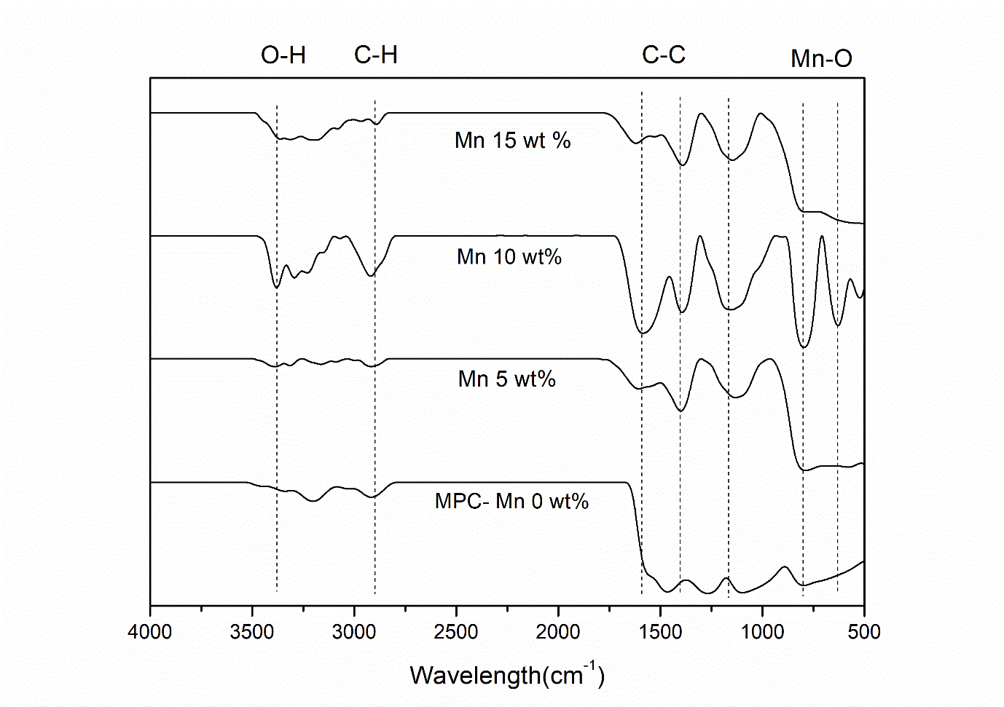

Figure 1. FTIR spectrum of composite film Mn₂O₃/MPC at different concentrations of Mn salt

Figure 2 (a)-(d) show the FESEM images of Mn₂O₃/MPC composite film samples at different concentrations of Mn salt. The FESEM images of 100,000 x magnification reveal that the concentration of Mn salt could increase the amount of deposited Mn₂O₃ nanoparticles. The EDX results in Figure 2 (e)-(g) and Table 1 show that the main composite elements are C, Mn, Ti and O. Mn can be considered to exist on the MPC surface in the form of Mn₂O₃ compared to FTIR results. According to the Mn salt content from 5 to 15 wt.%, the content of Mn₂O₃ in the Mn₂O₃/MPC composite film increased from 6.58 wt.% to 27.06 wt.%. It was believed that lower and optimized concentration contributed to better ion diffusion in the material leading to the formation of a uniform deposition and enhancement of the capacitive performance of the samples [4].

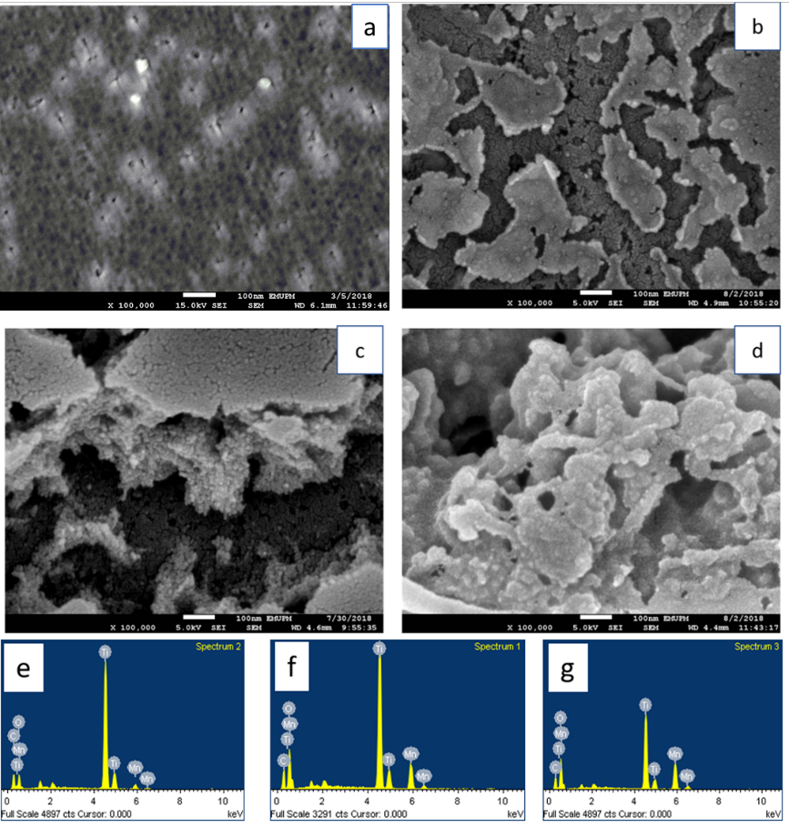

Figure 2. FESEM images of composite film samples of Mn₂O₃/MPC at different concentrations of Mn salt: (a) 0 wt.% (b) 5 wt.% (c) 10 wt.% (d) 15 wt.% (e-g) EDX of Mn₂O₃/MPC with Mn salt from 5 wt.% to 15 wt.%

Table 1. Elemental analysis (EDX) for composite film Mn₂O₃/MPC based on the concentration of Mn salt.
Mn Salt Concentration  (wt.%) | Weight %
Mn Salt Concentration  (wt.%) | C | O | Ti | Mn | Total
5 | 25.95 | 36.18 | 35.58 | 2.29 | 100
10 | 20.23 | 46.01 | 26.13 | 7.63 | 100
15 | 18.95 | 50.53 | 21.11 | 9.42 | 100

The thickness was one of the beneficial properties for enhancing the surface contact and electrical conductivity of the film and the electrolyte ions at the electrode-electrolyte interface [19]. The surface profiler confirmed this results that the thickness increased when Mn₂O₃ was deposited at MPC samples (Table 2).

Table 2. Average thickness of MPC and Mn₂O₃/MPC composite film
Samples | Average Thickness (nm)
MPC | 229.3
Mn₂O₃/MPC-300 | 2046

The surface morphology of the MPC and Mn₂O₃/MPC films was observed by atomic force microscopy (AFM) topographic as depicted in Figure 3(a) and 3(b), respectively. The MPC films are seen flat and uniform based on the analysis. The surface is also covered with open pores that are likely stripe pattern on the surface [20-22]. The surface topology of the composite film as observed clearly from AFM images shows that the mean square surface roughness is 2.36 which is higher compared with the MPC which is 1.22. The deposition of Mn₂O₃ on the MPC exhibited extra layer making the surface of the composite high in thickness as well as roughness. The specific surface morphologies and large surface areas of materials are necessary for potential applications in supercapacitors [19].

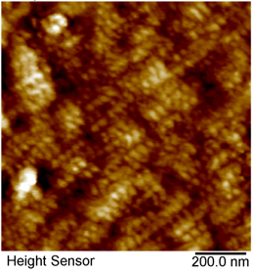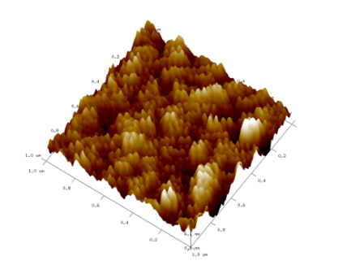

(a)

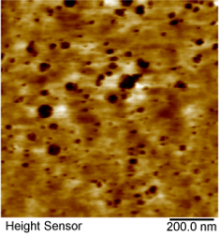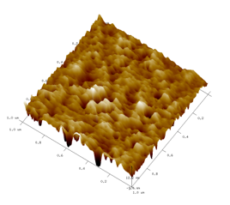

(b)

Figure 3. AFM images 2D and 3D of (a) MPC (b)Mn₂O₃/MPC composite film

Figure 4(a) shows the cyclic voltammetry (CV) curves for optimized Mn₂O₃/MPC composite film that was calcined for 2 hours at a temperature of 300 °C. This sample was observed in the potential range of 0.8 to-0.2 V at different scanning rates ranging from 5 mV s⁻¹ to 200 mV s⁻¹. The CV curves for the composite electrodes showed significant redox peaks, indicating that there were Faradic reactions during the charge-discharge process. The composite materials of Mn₂O₃ had a combination of EDLC and pseudocapacitance [2, 9]. The specific capacitance decreased gradually from 53.59 mF cm⁻² at 5 mV s⁻¹ to 21.35 mF cm⁻² when the scan rate increased. It was noted that the capacitance decreased as the potential scan rate increased, suggesting a diffusion limitation process in the porous structure of the composite. Figure 4(c) shows the CV plots at different Mn salt concentration 0, 5, 10 and 15 wt.%, showing the typical pseudocapacitive behaviour of the Mn₂O₃/MPC electrodes. Samples calcined at 300 °C, however, show the highest current response with changing scanning potential, indicating the highest electrochemical activity and the highest specific capacitance at the lowest scanning rate of 5 mV s⁻¹. The specific capacitance for the optimum sample was 53.59 mF cm⁻², compared with the values of 15.23, 20.1 and 30.24 mF cm⁻² for the sample calcined at 0 wt.%, 5 wt.% and 15 wt.%, respectively.

Figures 4(b) and 4(d) show the galvanostatic charge-discharge (GCD) curves for optimal sample at different current densities and different concentrations of Mn salt at the lowest current density of 400 μA cm⁻² in 1 M KCl, respectively. All samples show the charging and discharging curve. The basic symmetrical triangular shapes in the charge/discharge curve further validate the ideal pseudocapacitive behaviour of the Mn₂O₃ electrodes which correlates well to the CV discussions. The optimum sample showed a longer duration over the other six current densities due to a higher specific capacitance of 23.14 mF cm⁻², before the specific capacitance gradually reduced to 15.79 mF cm⁻². Highest electrochemical activity and specific capacitance is indicated by the longer charge/discharge process of the sample [19]. The specific capacitance calculated were 12.96 mF cm⁻² and 17.13 mF cm⁻² at 5 wt.% and 15 wt.%, respectively. As the concentration of Mn salt increased, the specific capacitance also decreased. Owing to the uniformity of pores and the larger pores at an optimal Mn salt concentration, a very good pathway can be set up for electrolyte to flow all over the samples. This led to a longer discharge time resulting in a higher specific capacitance. As compared to other samples, the calcined samples with a concentration of 10 wt.% Mn showed the highest specific capacitance value. This proved that lower Mn salt concentration could provide a larger area for effective ion diffusion in the samples, which could lead to greater capacitance of the prepared samples. It can be assumed that the superiority of the calcined sample at 10 wt.% of the Mn salt concentration was largely due to its optimal surface morphology. The large area of the composite surface can effectively enhance the pseudocapacitance due to the increase in the interface electroactive sites for the Faradaic reactions. The enhanced pseudocapacitance performance can be also achieved via a high mesoporosity composite since it can promote the penetration of the electrode/electrolyte interface [19].

Figure 4(e) and 4(f) show the correlation between the specific capacitance based on the scan rate and the current density, respectively. The results implied that the insufficient response time for electrolyte ions to diffuse at high scanning rates and current densities for samples calcined at 5, 10 and 15 wt.% of Mn salt concentration throughout the sample surface [9]. The specific capacitance was strongly influenced by the scanning rate and the current density applied, in which the capacitance decreased with increasing scanning rates and current densities.

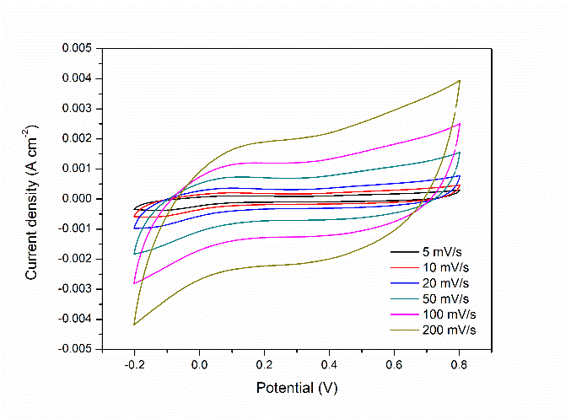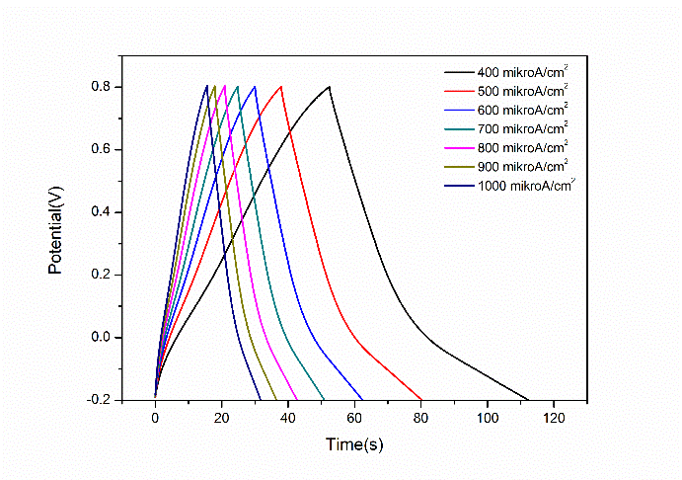
(b)
(a)

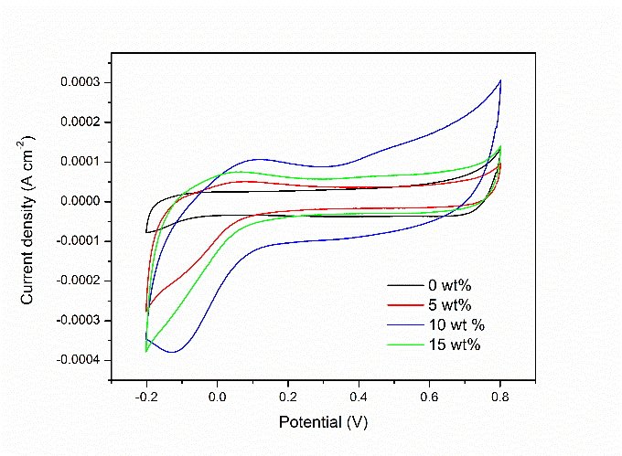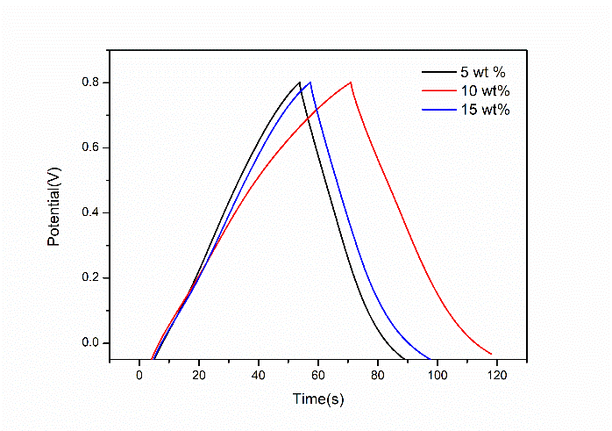
(d)
(c)

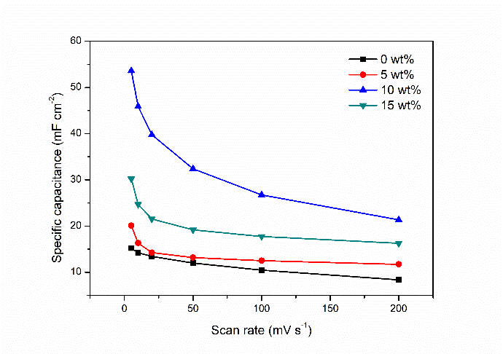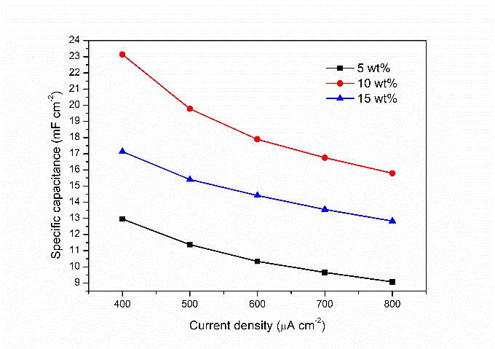
(e)
(f)

Figure 4. Optimum Mn₂O₃/MPC composite film prepared at 10wt% Mn (a) CV at different scan rates (b) GCD at various current densities (c) CV at different Mn salt concentration (d) GCD at different Mn salt concentration at lowest current density of 400 µA cm⁻² (e) Specific capacitance as a function of scan rates (f) Specific capacitance as a function of current density

The efficiencies of the optimized samples MPC and Mn₂O₃/MPC supercapacitors were examined and predicted using equations 2 and 3, as shown in Figure 5. The Mn₂O₃/MPC supercapacitor initially has an energy density of 10.68 mWh cm⁻² and 0.20 mW cm⁻², respectively, at 200 mV s⁻¹ scanning rate. At a scan rate of 5 mV s⁻¹ for the same material, the energy density and power density were 26.80 mWh cm⁻² and 0.10 mW cm⁻², respectively that are in opposite to the 200 mV s⁻¹ scan rate. The difference was probably due to internal losses of a higher scan rate [23]. After modification and incorporation of metal oxides, the Ragone plot clearly shows electrochemical performance improvement for Mn₂O₃/MPC which has higher energy and power density, 26.80 mWh cm⁻² and 0.10 mW cm⁻² as compared to MPC that has a very low energy density of 7.62 mWh cm⁻² and 0.010 mW cm⁻². The significant improvement demonstrates the contribution of metal oxides to the MPC film. Based on the electrochemical performance, it can be confirmed that the Mn₂O₃/MPC composite film was more outstanding than MPC film in terms of power density and energy density characteristics.

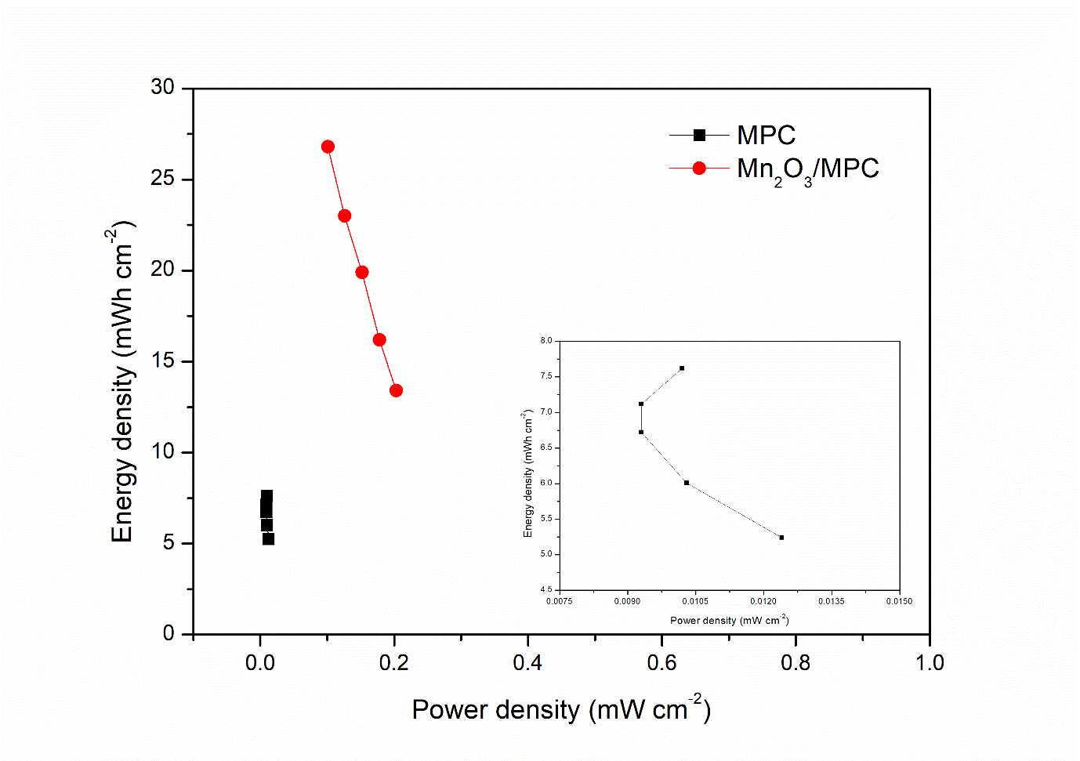

Figure 5. Ragone plot of optimised MPC and Mn₂O₃/MPC composite film at various current densities in 1.0 M KCl between -0.2 to 0.8 V. Inset shows the magnified version of the MPC plot

Conclusion

The Mn₂O₃/MPC composite film with different Mn content was successfully synthesized using a simple method based on the incipient wetness impregnation method followed by calcination to improve the supercapacitive behavior of the composites. It was impregnated with MPC film to purposely combine the excellent electrochemical performance of MPC film with the MnO pseudocapacitive properties. For the optimal sample of 10 wt.% Mn in composite, the specific capacitance was 53.59 mF cm⁻². Due to the excellent electrical properties of the MPC film and the faradaic redox reactions of Mn₂O₃, the specific capacitance was increased for the optimum sample. In this analysis, the Mn₂O₃/MPC composite film showed a relatively stable capacitance of approximately 71 % of the initial capacitance with an increase in cycle numbers up to 1000. Mn₂O₃/MPC has displayed the highest energy and power density characteristics of 26.80 mWh cm⁻² and 0.10 mW cm⁻², respectively while MPC obtained lower energy density of 7.62 mWh cm⁻² and 0.010 mW cm⁻² at a scan rate of 5 mV s⁻¹. Therefore, incorporation of metal oxides in Mn₂O₃/MPC composite film is an effective way to increase the electrochemical performance in terms of specific capacitance, power density and energy density characteristics of carbon materials for supercapacitor application.

Acknowledgement

Universiti Putra Malaysia (UPM) supported this work under grant no.: GP/IPS/2017/9548000. JPA scholarship is recognized for the doctoral program for Mahanim Sarif @ Mohd Ali.

References
- Li, Y. H., Li, Q. Y., Wang, H. Q., Huang, Y. G., Zhang, X. H., Wu, Q., Gao, H. Q. and Yang, J. H. (2015). Synthesis and electrochemical properties of nickel–manganese oxide on MWCNTs/CFP substrate as a supercapacitor electrode. Applied Energy, 153: 78-86.
- Zhang, Y., Xuan, H., Xu, Y., Guo, B., Li, H., Kang, L., Han, P., Wang, D. and Du, Y. (2016). One-step large scale combustion synthesis mesoporous MnO₂/MnCo₂O₄ composite as electrode material for high-performance supercapacitors. Electrochimica Acta, 206: 278-290.
- Lokhande, V. C., Lokhande, A. C., Lokhande, C. D., Hyeok, J. and Ji, T. (2016). Supercapacitive composite metal oxide electrodes formed with carbon, metal oxides and conducting polymers. Journal of Alloys Compound, 682: 381-403.
- Wang, X., Liu, L., Wang, X., Yi, L., Hu, C. and Zhang, X. (2011). Mn₂O₃/carbon aerogel microbead composites synthesized by in situ coating method for supercapacitors. Materials Science and Engineering: B, 176(15): 1232-1238.

- Worsley, M. A., Pauzauskie, P. J., Olson, T. Y., Biener, J., Satcher Jr, J. H. and Baumann, T. F. (2010). Synthesis of graphene aerogel with high electrical conductivity. Journal of the American Chemical Society, 132(40): 14067-14069.
- Liu, R. and Lee, S. B. (2008). MnO₂/poly (3, 4-ethylenedioxythiophene) coaxial nanowires by one-step coelectrodeposition for electrochemical energy storage. Journal of the American Chemical Society, 130 (10): 2942-2943.
- Yu, D. and Dai, L. (2009). Self-assembled graphene/carbon nanotube hybrid films for supercapacitors. The Journal of Physical Chemistry Letters, 1(2): 467-470.
- Yang, J., Yang, X., Zhong, Y. L. and Ying, J. Y. (2015). Porous MnO/Mn₃O₄ nanocomposites for electrochemical energy storage. Nano Energy, 13: 702–708.
- Li, L., Wei, T., Wang, W. and Zhao, X. S. (2009). Manganese oxide–carbon composite as supercapacitor electrode materials. Microporous Mesoporous Material, 123(1–3): 260–267.
- Lee, Y. J., Park, H. W., Park, S. and Song, I. K. (2012). Electrochemical properties of Mn-doped activated carbon aerogel as electrode material for supercapacitor. Current Applied Physics, 12(1): 23-237.
- Hu, C. C., Liu, M. J. and Chang, K. H. (2008). Anodic deposition of hydrous ruthenium oxide for supercapacitors: Effects of the AcO−concentration, plating temperature, and oxide loading. Electrochimica Acta, 53 (6): 2679-2687.
- Gujar, T. P., Kim, W. Y., Puspitasari, I., Jung, K. D. and Joo, O. S. (2007). Electrochemically deposited nanograin ruthenium oxide as a pseudocapacitive electrode. International Journal of Electrochemical Science, 2: 666-673.
- Li, G. R., Feng, Z. P., Ou, Y. N., Wu, D., Fu, R. and Tong, Y. X. (2010). Mesoporous MnO₂/carbon aerogel composites as promising electrode materials for high-performance supercapacitors. Langmuir, 26(4): 2209-2213.
- Jiang, H., Yang, L., Li, C., Yan, C., Lee, P.S. and Ma, J. (2011). High–rate electrochemical capacitors from highly graphitic carbon–tipped manganese oxide/mesoporous carbon/manganese oxide hybrid nanowires. Energy & Environmental Science, 4 (5): 1813-1819.
- Wang, T., Peng, Z., Wang, Y., Tang, J. and Zheng, G. (2013). MnO nanoparticle@ mesoporous carbon composites grown on conducting substrates featuring high-performance lithium-ion battery, supercapacitor and sensor. Scientific Reports, 3: 2693.
- Mitome, T., Hirota, Y., Uchida, Y. and Nishiyama, N. (2016). Porous structure and pore size control of mesoporous carbons using a combination of a soft-templating method and a solvent evaporation technique. Colloids and Surfaces A: Physicochemical and Engineering Aspects, 494: 180-185.
- Wang, Q., Zhang, W., Mu, Y., Zhong, L., Meng, Y. and Sun, Y. (2014). Synthesis of ordered mesoporous carbons with tunable pore size by varying carbon precursors via soft-template method. Microporous and Mesoporous Materials, 197: 109-115.
- Fisher, R. A., Watt, M. R. and Ready, W. J. (2013). Functionalized carbon nanotube supercapacitor electrodes: a review on pseudocapacitive materials. ECS Journal of Solid State Science and Technology 2(10): 3170-3177.
- Yang, J. and Zou, L. (2014). Graphene films of controllable thickness as binder-free electrodes for high performance supercapacitors. Electrochimica Acta, 130: 791-799.
- Li, H., Zhang, X., Ding, R., Qi, L. and Wang, H. (2013). Facile synthesis of mesoporous MnO₂ microspheres for high performance AC//MnO₂ aqueous hybrid supercapacitors. Electrochimica Acta, 108: 497-505.
- Zhang, C, Zhen G. and Jianxin M. (2013). Self-assembly synthesis of ordered mesoporous carbon thin film by a dip-coating technique. Microporous and Mesoporous Materials, 170: 287-92.
- Kataoka, S., Yamamoto, T., Endo, A., Nakaiwa, M. and Ohmori, T. (2009). Synthesis and characterization of mesoporous carbon thin films from phloroglucinol/surfactant self-assembly. Colloids and Surfaces A: Physicochemical and Engineering Aspects, 347(1-3): 142-145.
- Wang, Y. T., Lu, A. H. and Li, W. C. (2012). Mesoporous manganese dioxide prepared under acidic conditions as high performance electrode material for hybrid supercapacitors. Microporous and Mesoporous Materials, 153: 247-253.

