IONOTHERMAL SYNTHESIS OF ZN-BASED METAL ORGANIC FRAMEWORKS IN PYRIDINIUM IONIC LIQUID

(Sintesis Ionotermal Kerangka Logam-Organik Berasaskan Logam Zink
Menggunakan Cecair Ionik Piridinium)

Haslina Ahmad^{1,2*}, Nur Aininie Yusoh¹, Khairulazhar Jumbri^{3,} Mohd Basyaruddin Abdul Rahman^{1,2}

¹Chemistry Department,
²Integrated Chemical Biophysics Research,
Faculty of Science, Universiti Putra Malaysia, 43400 UPM Serdang, Selangor, Malaysia
³Department of Fundamental and Applied Sciences,
Universiti Teknologi Petronas, Bandar Seri Iskandar, 32610, Perak, Malaysia

*Corresponding author: haslina_ahmad@upm.edu.my

Abstract
Metal organic frameworks (MOFs) are crystalline porous frameworks which have been investigated as absorbent for removing dye, metal ion, drug contaminant, and organic solvent from water. However, the traditional synthesis of MOF involves the use of organic solvents and also requires high temperature; termed solvothermal reaction. This study aimed to synthesis MOF in a rather mild condition (room temperature) using ionic liquids (ILs) instead of organic solvents. Theoretically, high ionic conductivity of cetyl pyridinium bromide (C₁₆PyBr) ionic liquid can develop novel MOF compounds thus, this study also aimed to investigate the possible effects of using ionic liquid in MOF synthesis. Zinc nitrate hexahydrate (Zn(NO₃)₂.6H₂O) was used as the metal precursor and was reacted with the organic ligands, which is either benzene-1,3,5-tricarboxylic acid (H₃BTC) or benzene-1,4-dicarboxylate (H₂BDC), at 6:1 ratio in C₁₆PyBr ionic liquid at room temperature. We hope to fabricate Zn-BDC and Zn-BTC MOFs with the same compositions, and thus recognize the effects of ILs. The powder X-ray diffraction (PXRD) and Fourier Transform Infrared Spectroscopy (FTIR) spectra of both newly synthesized MOFs showed that both Zn-BDC and Zn-BTC MOFs can be reproduced with these conditions. ILs have also been found to significantly accelerate the formation of MOFs at room temperature as the reaction time is shortened to 6 hours in IL, meanwhile the organic solvent DMF needs at least 120 hours.

Keywords: metal organic frameworks, ionic liquids, zinc, pyridinium

Abstrak

Kerangka logam-organik (MOF) adalah kerangka kristal berliang yang telah disiasat sebagai penyerap untuk mengeluarkan perwarna, logam ion, bahan pencemar daripada ubat-ubatan, dan pelarut organik daripada air. Walau bagaimanapun, sintesis tradisional MOF melibatkan penggunaan pelarut organik dan juga memerlukan suhu yang tinggi; dipanggil tindak balas solvotermal. Kajian ini bertujuan untuk mensintesiskan MOF dalam keadaan yang agak ringan (suhu bilik) menggunakan cecair ionik (ILs) dan bukan pelarut organik. Secara teori, kekonduksian ionik yang tinggi di dalam cecair ionik piridinium bromida (C₁₆PyBr) boleh membangunkan perkembangan sebatian MOF yang baharu, oleh itu, kajian ini juga bertujuan untuk mengkaji kemungkinan pengaruh menggunakan cecair ionik dalam sintesis MOF. Zink nitrat heksahidrat (Zn(NO₃)₂.6H₂O) digunakan sebagai pelopor logam dan di campur dengan ligan organik, sama ada asid benzena-1,3,5-trikarbosilik (H₃BTC) atau benzena-1,4-dikarbosilat (H₂BDC), pada nisbah 6:1 menggunakan pelarut cecair ionik C₁₆PyBr pada suhu bilik. Kami berharap dapat menghasilkan MOF Zn-BDC dan Zn-BTC dengan komposisi yang sama, dan dengan itu dapat mengiktiraf pengaruh ILs. Pembelauan serbuk sinar-X (PXRD) dan spektroskopi inframerah transformasi Fourier (FTIR) daripada kedua-dua MOF yang di sintesis menunjukkan bahawa kedua-dua MOF Zn-BDC dan Zn-BTC boleh dihasilkan semula dengan keadaan ini. IL juga didapati dengan ketara dapat mempercepat pembentukan MOF pada suhu bilik apabila masa tindak balas dipendekkan kepada 6 jam apabila menggunakan IL, di mana pelarut organik, DMF memerlukan sekurang-kurangnya 120 jam.

Kata kunci: kerangka logam-organik, cecair ionik, zink, piridinium

Introduction
Metal organic frameworks (MOFs) are porous materials that have been studied widely in the present days due to their possible applications in various fields such as in adsorption study, catalysis, sensors, and as drug delivery agents [1]. MOFs have been proven to have diverse and unique structures when synthesized under different reaction conditions, for example, changes in metal and ligand sources, temperature, and also solvents [2]. Ionothermal synthesis has been successfully applied since 2002, where ionic liquids (ILs) are used as the solvent instead of the conventional solvents (water or organic solvents). It is considered as an environmentally-friendly route and was used to get the desired structures and physiochemical properties in the design of MOFs [3]. The main reason for this is because ILs possessed many distinguished features and intriguing physicochemical properties compared to traditional solvents, i.e., negligible vapor pressure, high ionic conductivity, non-flammability, and tunable properties. The large temperature windows and high ionic conductivity of ILs make them a suitable solvent to provide different reaction environments involving reactions between metal ions and organic ligands, particularly in producing new MOF compounds [5]. It is also considered to be safer and has more advantages than the traditional solvothermal reactions which involves using traditional organic solvent, usually contains formamide functionality and involves heating the reaction mixture over 100°C for days. Solvothermal method is widely used in MOF synthesis as it can gives crystal product which is suitable for single crystal XRD analysis thus, its structure can be determined. However, this method is relatively slow, where the product takes hours to days to form [4].

In the present days, enormous effort has been devoted in applying this route, particularly to tailor the physical properties of MOFs by using various ILs with different structures. For example, using ILs with different alkyl group lengths with different anions [3]. In study done by others showed that the anions and cations of ILs play an important role in the structural development of MOF compounds in which the cations act as the template for the main structure, meanwhile the anionic parts determine the level of the deprotonation event of the ligands through their behaviors, particularly nucleophilicity. Therefore, tuning ILs properties becomes an important plan in designing MOF [2]. Furthermore, room temperature synthesis is more desirable and from previous studies done by others, ILs have also been found to significantly accelerate the formation of MOFs at room temperature [1]. Therefore, the main objective of this study is to develop a rapid, low energy and environmentally friendly method for MOFs synthesis.

We aimed to synthesis MOFs with a novel synthesis method which involves using ILs as the solvent at room temperature. The most commonly used IL in the MOF synthesis is the imidazolium-based IL, but here we tried to tackle this using IL which consists of pyridine group. The most interesting parts regarding ILs is different combination of cations and anions will change the ILs’ properties. Therefore, by changing the cations from imidazolium to pyridinium, there is a possibility of obtaining MOFs with different morphologies. We have reported previously the utilization of 1-hexadecylpyridinium bromide ionic liquid (C₁₆PyBr) IL as a template for mesoporous silica nanoparticles (MSN) formation [6] thus, in this study, we are trying to see whether this particular IL can also be used as a template for MOF synthesis. This pyridinium-based IL consists of pyridinium cation; with long alkyl chain and a bromide anion. We have presented zinc-based MOF (Zn-MOF) systems to study the effects of IL on MOF synthesis. Zn-MOFs are one of the most widely studied systems in the field of synthesizing new MOF compounds, mainly because of its simple configuration which will eliminate the effect of the metal source and ligands. The metal source used is Zn²⁺ from zinc nitrate hexahydrate (Zn(NO₃)₂.6H₂O) and the ligands are H₃BTC (benzene-1,3,5-tricarboxylic acid) and H₂BDC (benzene-1,4-dicarboxylic acid) to produce Zn-BTC and Zn-BDC systems.

In this study, we hope to produce MOFs with the same composition and thus recognize the effect of IL. Zn-based MOFs that have been previously published are used as the marker to study the Zn-MOF system. We believe this system should be a promising strategy in order to study the effects of ILs as solvent [4]. Triethylamine (TEA) is added as a weak base to deprotonate the acidic ligand. These compounds were then characterized by powder X-ray diffraction (PXRD) and Fourier Transform Infrared Spectroscopy (FTIR) [5]. Here, we found that when IL was used as solvent, the formation of Zn-MOFs at room temperature can be accelerated. The reaction duration was significantly shortened to 6 hours in IL, while the most widely used solvent system, dimethylformamide (DMF) needs at least 120 hours to complete [1].

Materials and Methods

Materials
All reagents and solvents were commercially purchased and used without further purification.

Synthesis of ILs

40 mmol of 1-bromohexadecane and 33 mmol of pyridine were mixed and the mixture was added into 10 mL of 95% ethanol. The mixture was then refluxed at 170°C for 24 hours. The resulting mixture was cooled below freezing point to allow precipitation and the precipitate was dissolved in a small amount of acetonitrile, before reforming again the solid by adding diethyl ether. The final product was filtered and dried at room temperature for several days. (Product = white solid, Yield = 96%)

Synthesis of Zn-BTC and Zn-BDC

Zinc nitrate hexahydrate (Zn(NO₃)₂.6H₂O) was mixed with benzene-1,3,5-tricarboxylic acid (H₃BTC) ligand, with and without the addition of TEA in 10 ml of 1-hexadecylpyridinium bromide IL media. The ratio used for the reaction mixture was 6:1 of metal to ligand ratio. The mixture was then stirred at room temperature for 6 hours and washed with methanol twice to remove the unreacted solvent and precursors. The white solid product was collected by centrifugation and dried at room temperature for several days.

For the synthesis of Zn-BDC

The organic ligand was changed to benzene-1,4-dicarboxylic acid (H₂BDC) and other experimental conditions were the same with those above. Table 1 shows the list of starting materials used in the synthesis and the metal: ligand ratio for all compounds.

Table 1. Starting materials and metal: ligand ratio for each compound

Compound | Metal Source | Ligand | Metal: Ligand  Ratio | Addition of *TEA
1 (Zn-BDC) | Zn(NO₃)₂.6H2O | H₂BDC | 6:1 | Yes
2 (Zn-BDC) | Zn(NO₃)₂.6H2O | H₂BDC | 6:1 | No
3 (Zn-BTC) | Zn(NO₃)₂.6H2O | H₃BTC | 6:1 | Yes
4 (Zn-BTC) | Zn(NO₃)₂.6H2O | H₃BTC | 6:1 | No

For the synthesis of compounds 2 and 4 (without the addition of TEA), no solid product formed after washing with methanol, indicating the importance of TEA to facilitate the reaction. Yield for 1, 67%, and for 3, 75% (based on the organic ligand used).

Characterizations

Powder X-ray Diffraction (PXRD) data were recorded at ambient temperature on a Shimadzu-600 diffractometer with Cu Kα radiation (λ=15406Å, 30kV, and 40 mA) with a scan speed of 2° min⁻¹ and a step size of 0.02° in 2theta. Fourier Transform Infrared Spectroscopy (FTIR) spectra were obtained using IRTracer-100 by Shimadzu FTIR spectrometer with sample powders in the range of 4000-400 cm⁻¹.

Results and Discussion
Ligands with simple configurations were used in this study to eliminate the effects on the structure and by fixing the experimental conditions of the starting materials, the reaction temperatures and time, we successfully synthesized Zn-BDC and Zn-BTC compounds. Both were obtained from the reactions between Zn²⁺, and BTC³⁻ or BDC²⁻ in ILs. A white precipitate was observed almost immediately when all of the materials were mixed and stirred rapidly at room temperature. They were synthesized through similar synthesis conditions at room temperature with the only differences were the ligands used and whether there is an addition of TEA. Figure 1 showed the organic ligands used in this study.
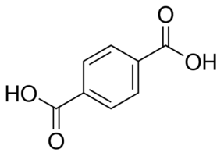
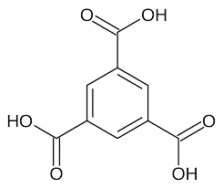
(a)
(b)

Figure 1. a) benzene-1,3,5-tricarboxylic acid (H₃BTC) and b) benzene-1,4-dicarboxylate (H₂BDC)

Fourier transform infrared spectroscopy spectra of Zn-BDC and Zn-BTC
Figure 2 shows the FT-IR spectra of both newly synthesized Zn-based MOFs. Two sharp peaks were obtained at 1551 cm⁻¹ and 1360 cm⁻¹ in sample Zn-BDC and 1602 cm⁻¹ and 1370 cm⁻¹ in sample Zn-BTC. Several small peaks were seen in the range of 1130-900 cm⁻¹ and 570-850 cmˉ¹ in both samples. A broad peak at around 3200 cm⁻¹ in sample Zn-BDC and small peaks at 2917 and 2965 cmˉ¹ in sample Zn-BTC were also seen. The characteristic absorption peaks of the main functional groups for these compounds are listed in Table 2.
(b)
(a)
Figure 2. FTIR spectra a) the overlap between ligand BDC and Zn-BDC and b) the overlap between ligand BTC and Zn-BTC

The FTIR spectra (Figure 1) confirm the presence of all the functional groups present in Zn-BDC and ZN-BTC, respectively. The two sharp intense peaks at 1551 cm⁻¹ and 1360 cm⁻¹ are characteristic of the symmetric and asymmetric stretching of C-O bonded to benzene ring present in the ligand [4, 11]. The above stretching was shifted to lower wave numbers, compared to carbonyl frequencies of free BDC ligand (1680 cmˉ¹). The shifting of COOˉ stretching was around 200 cm⁻¹, the characteristic for coordinated carboxylate groups. Several small peaks in the region of 570-850 cmˉ¹ are because of the in-plane and out of the plane stretching of the aromatic C-H groups of the benzene ring present in BDC ligand [4,11]. The broad peak around 3200 cm⁻¹ also are because of the adsorbed moisture content on the MOF structure, probably coming from the water used to dissolve IL. For Zn-BTC, the sharp intense peaks at 1602 cm⁻¹ and 1370 cm⁻¹ are characteristic of the symmetric and asymmetric stretching of C-O bonded to benzene ring present in the ligand, corresponds to the characteristic of published Zn-BTC [4]. The above stretching was shifted to lower wave numbers, compared carbonyl frequencies of free BTC ligand (1636 cm⁻¹). The difference was around 200 cm⁻¹, which is the characteristic for coordinated carboxylate groups. Several small peaks in the region of 570-1000 cm⁻¹ are because of the in-plane and out of the plane stretching of the aromatic C-H groups of the benzene ring present in BTC ligand.

Table 2. The main IR characteristic absorption peaks for both compounds

Compound | δ(C=O), cmˉ¹ | δ(O-H), cmˉ¹ | δ(C-H), cmˉ¹
Zn-BDC | 1551,1360 | 3500-2700 | 980,519
Zn-BTC | 1602,1370 | 3100-2700 | 950,514
BDC | 1680 | 3200-2700 | 991,554
BTC | 1636 | 3200-2600 | 899,584

Powder X-ray diffraction pattern of Zn-BDC and Zn-BTC

The X-ray diffractograms of the samples are shown in Figure 3. Zn-BDC product was observed as a single-phase, meanwhile Zn-BTC gave two phases under the conditions given in the experimental section as shown in the PXRD patterns in Figure 3. However, the experimental PXRD patterns of both compounds matched well with the simulated PXRD obtained from the single crystal structure data of published Zn-BDC and Zn-BTC, where the well-characterized peaks can be seen in the experimental pattern. Sample of the newly synthesized Zn-BDC and Zn-BTC showed a sharp intense peak at 8.94° and 9.89°, respectively. The spectra correspond with that of the pattern obtained by [11]. It is evident that both the samples are highly crystalline in nature thus, showed that in order to produce highly crystalline MOFs, heating is not required [4, 11].

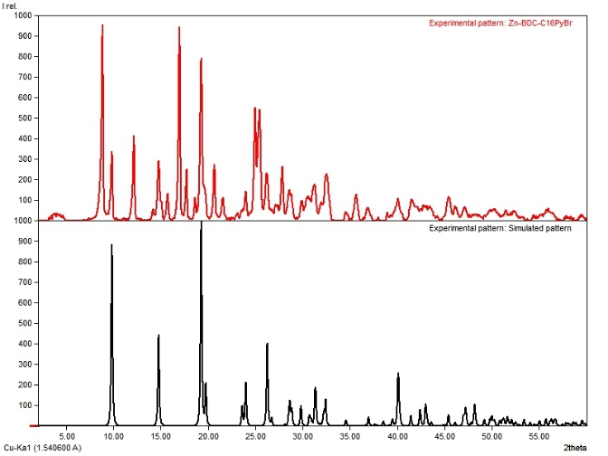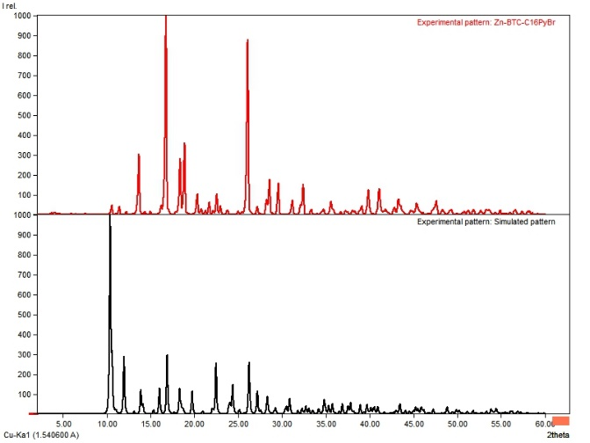

Figure 3. The comparison of the experimental PXRD patterns, in red of as-synthesized a) Zn-BDC and b) Zn-BTC to those simulated patterns, in black

Addition of the weak base, triethylamine (TEA) to deprotonate the organic ligands in order to precipitate MOF is required as without the addition of base, products were not formed. This showed that the use of TEA as a base is necessary when zinc nitrate is used as the metal source of Zn²⁺ in the Zn-MOF synthesis [4]. In this study, ILs have been found to significantly accelerate the MOFs formation at room temperature as the reaction duration is significantly reduced to 6 hours in IL for MOF formation, meanwhile the organic solvent DMF needs at least 120 hours [1]. Further nucleation and crystallization studies need to be done to understand how IL affects the reaction time.

Conclusion

In this study, we have explored another efficient method that respects the principle of green chemistry using a new solvent system to synthesis Zn-MOFs at room temperature. The FTIR and PXRD results demonstrate that Zn-BDC and Zn-BTC can be reproduced using this environmental-friendly method. This rapid, and low energy method was proven to provide a way of accelerating the formation of MOF. Further studies are currently undergoing to investigate whether this system of using IL has effects on the structure of MOFs or may even give new MOF compounds with desired structures and properties. Another study to produce MOF compounds with higher yields and better thermal stability can also be done to investigate its functions in various fields or applications.

Acknowledgement

The authors gratefully acknowledge the Putra Grant (UPM/700-2/1/GBP/2018/9598600) from Universiti Putra Malaysia (UPM).

References
- Sang, X., Zhang, J., Xiang, J., Cui, J., Zheng, L. and Zhang, J. (2017). Ionic liquid accelerates the crystallization of Zr-based metal-organic framework. Nature Communications, 8(175): 1-7.
- Zhang, Z. H., Liu, B., Xu, L. and Jiao, H. (2015). Combination effect of ionic liquid components on the structure and properties in 1,4-benzene-dicarboxylate based zinc metal-organic frameworks. The Royal Society of Chemistry. Dalton Transactions, 44: 17980-17989.
- Xu, L., Choi, E. Y. and Kwon, Y. U. (2007). Ionothermal synthesis of six three-dimensional zinc metal-organic frameworks with 1-alkyl-3-methylimidazolium bromide ionic liquids as solvents. Inorganic Chemistry, 46(25): 10670-10680.
- Tranchemontagne, D. J., Hunt, J. R. and Yaghi, O. M. (2008). Room temperature synthesis of metal-organic frameworks: MOF-5, MOF-74, MOF-177, MOF-199 and IRMOF-0. Elsevier, Tetrahedron, 64: 8553-8557.
- Gao, J., Ye, K., Tang, L., Xiong, W. W., Ye, L., Wang, Y. and Zhang, Q. (2014). Growing crystalline zinc-1,3,5-benzenetricarboxylate metal-organic frameworks in different surfactants. American Chemical Society. Inorganic Chemistry, 53: 691-693.
- Mohamed Isa, E. D., Abdul Rahman, M. B. and Ahmad, H. (2018). Monodispersed mesoporous silica nanoparticles based on pyridinium ionic liquids. Journal of Porous Materials, 25(5): 1439-1446.
- Vaid, T. P., Kelley, S. P. and Rogers, R. D. (2017). Structure-directing effects of ionic liquids in the ionothermal synthesis of metal-organic frameworks. Topical Reviews, IUCrJ, 4: 380-392.
- Sang, X., Zhang, J., Peng, L., Liu, C., Ma, X., Han, B. and Yang, G. (2015). Assembly of mesoporous metal-organic framework templated by an ionic liquid/ethylene glycol interface. Wiley, ChemPhysChem Communications, 16: 2317-2321.
- Eddaoudi, M., Moler, D. B., Li, H., Chen, B., O’Keeffe, M. and Yaghi, O. M. (2000). Modular chemistry: Secondary building units as a basis for the design of highly porous and robust metal-organic carboxylate frameworks. American Chemical Society, Accounts of Chemical Research, 34(4): 319-330.
- Chen, R., Zhang, J., Chelora, J., Xiong, Y., Kershaw, S. V., Li, K. F., Lo, P., Cheah, K. W., Rogach, A. L. Zapien, J. A. and Lee, C. (2017). Ruthenium(II) complex incorporated UiO-67 metal-organic framework nanoparticles for enhanced two-photon fluorescence imaging and photodynamic cancer therapy. American Chemical Society, Applied Material and Interfaces, 9: 5699-5708.
- Iswarya, N., Kumar, M. G., Rajan, K. S. and Balaguru, R. J. B. (2012). Synthesis, characterization and adsorption capability of MOF-5. Science Alert, Asian Journal of Scientific Research, 5(4): 247-254.

