ENZYME CATALYZED ESTERIFICATION OF SUGAR BY THERMOSTABLE T1 LIPASE FROM Geobacillus zalihae

IN IONIC LIQUID

(Pengesteran Berenzim Gula oleh Lipase Termostabil T1 dari

Geobacillus zalihae dalam Cecair Ionik)

Emilia Abdulmalek^{1,2*}, Hanim Salami Mohd Saupi¹, Syarilaida Zulkefli¹,

Raja Nor Zaliha Raja Abd Rahman³, Mohd Basyaruddin Abdul Rahman^{1,2}

¹Integrated Chemical BioPhysics Research,

²Department of Chemistry,

Faculty of Science

³Enzyme and Microbial Technology Research,

Department of Microbiology, Faculty of Biotechnology and Biomolecular Science

Universiti Putra Malaysia, 43400, UPM Serdang, Selangor, Malaysia

*Corresponding author: emilia@upm.edu.my

Abstract

Thermostable T1 lipase from Geobacillus zalihae strain was utilized in esterification of various sugars with fatty acids to form fatty acid sugar esters. Fatty acid sugar esters (FASE) are an important class of non-ionic surfactant which possesses good emulsifying, stabilizing and conditioning properties. In this work the esterification reaction was done in [Bmim][BF₄] ionic liquid with dimethylsulfoxide (DMSO) as co-solvent. Esterification of galactose with oleic acid was initially screened by varying the conditions (temperature, time, enzyme loading and the fatty acid chain length). It was found that the reaction was optimum at the following conditions: temperature (65 °C), time (120 minutes) and enzyme loading (2% (w/w)) when carried out in mixture of DMSO: [Bmim][BF₄] (1:20). Interestingly, the percentage of conversion was not affected by the chain length of the acyl donor (C8 – C18) or the unsaturation degree. When the reaction was repeated with linoleic acid as acyl donor and different acyl acceptor (galactose, glucose, fructose, sucrose, maltose, trehalose and xylitol), sucrose gave the best conversion at 65%. In conclusion, TI lipase showed broad substrate specificity either for the acyl donor or acyl acceptor during the esterification of sugars in ionic liquid.

Keywords: T1 lipase, fatty acid sugar ester, ionic liquid, esterification, [Bmim][BF₄]

Abstrak

Lipase termostabil T1 dari strain Geobacillus zalihae telah digunakan dalam pengesteran pelbagai gula dengan asid lemak untuk membentuk ester gula asid lemak. Ester gula asid lemak (FASE) adalah kelas surfaktan bukan ionik yang penting yang mempunyai sifat pengemulsi, penstabilan dan penyesuaian yang baik. Dalam kerja ini tindak balas pengesteraan dilakukan dalam cecair ionik [Bmim][BF₄] dengan dimetilsulfoksida (DMSO) sebagai pelarut bersama. Pengesteran galaktosa dengan asid oleik pada mulanya disaring dengan mempelbagaikan keadaan (suhu, masa, muatan enzim dan panjang rantai asid lemak.) Ia didapati bahawa tindak balas adalah optimum pada keadaan berikut: suhu (65 °C), masa (120 minutes) dan muatan enzim (2% (w/w)) apabila dijalankan dalam campuran DMSO:[Bmim][BF₄] (1:20). Menariknya, peratusan penukaran tidak terjejas oleh panjang rantai asil dari C8 – C18 atau darjah ketaktepuan. Apabila tindak balas diulang dengan asid linoleik sebagai penderma asil dan penerima asil yang berbeza (galaktosa, glukosa, fruktosa, sukrosa, maltosa, trehalosa dan xilitol), sukrosa memberikan penukaran terbaik pada 65%. Kesimpulannya, lipase TI menunjukkan kekhususan substrat yang luas sama ada untuk penderma asil atau penerima asil semasa pengesteran gula dalam cecair ionik.

Kata kunci: lipase T1, ester gula asid lemak, cecair ionik, pengesteran, [Bmim][BF₄]

Introduction

Thermostable T1 lipase from Geobacillus zalihae sp. strain was first introduced and isolated by Leow and his co-workers [1, 2] with an aim to produce excellent thermostable lipase which can retain its activity and stability at higher temperature. Thermal stability is one of the important features of successful commercial biocatalyst as it would allow the reaction to be conducted at high temperature and in turn improve substrate solubility, increase conversion rates, reduce viscosity of reaction medium and lower microbial growth prospect [3]. Although, the thermostable T1 lipase has been discovered since 2004, to date there are still limited reports on the utilization of this enzyme in organic reactions that little is known about its substrate specificity and selectivity.

Fatty acid sugar ester (FASE) is widely known as non-toxic, odorless and biodegradable surfactant [4] which has good emulsifying, stabilizing, conditioning effect and antimicrobial properties [5]. This result in widespread usage of sugar ester in food, cosmetics, pharmaceutical and detergents [6]. Current commercial FASE is typically obtained via chemical synthesis but enzymatic synthesis of FASE catalyzed by free or immobilized lipase has become more prominent recently [7, 8]. The biocatalytic production of sugar ester is favored over the conventional process due to its advantages in term of mild reaction conditions, better regioselectivity and easy product separation to name a few [9, 10].

In large industrial scale organic solvent offers many advantages such as low price and viscosity. However, esterification of sugars in organic media suffers from low solubility of the highly polar sugars. Although polar solvent like dimethysulfoxide (DMSO) and dimethylformamide (DMF) can fully dissolve most sugars, their usage in enzymatic reaction is limited as they caused enzyme deactivation. Ionic liquid (IL) is a good alternative media for biocatalytic reactions and had been extensively studied for lipase-catalyzed esterification reaction of sugars [11]. It is an organic molten salt consists of pure ions that remains as liquid at room temperature [12]. Ionic liquid showed excellent potential in biocatalytic production of sugar ester due to higher sugar solubility, excellent enzymatic activity and selectivity [13]. Our previous work on the enzymatic esterification of galactose [14] and xylose [15] in ILs and organic solvents respectively, showed that small amount of DMSO for initial solubilization of the sugars was beneficial to get a good conversion. Other works have also demonstrated the utility of polar solvent like DMSO as co-solvent in sugar ester synthesis [16]. Similarly, super saturated sugar solution has been utilized for the same purpose [17, 18, 19].

In this work, we aim to investigate the utility of thermostable T1 lipase in esterification of sugars with fatty acids in order to further understand the lipase selectivity and specificity. The initial screening of the reaction conditions was done using the esterification of galactose with oleic acid in DMSO:[Bmim][BF₄] (1:20) mixture followed by reaction of galactose with various fatty acids to see the lipase preference, if any. The sugar preference of the lipase was also studied. This report is one of the earliest reports on T1 lipase as enzyme for biocatalysis reaction. This could be one of the main references for application of T1 lipase.

Materials and Methods

Materials

Crude free lipase from Geobacillus zalihae strain T1 was obtained from UPM, Selangor, Malaysia. 1-butyl-3-methylimidazolium tetrafluoroborate ([Bmim][BF₄]), DMSO, caprylic acid and lauric acid were purchased from Merck, Germany. Oleic acid was obtained from TCI Tokyo Kasei. All sugars (galactose, glucose, fructose, sucrose, maltose, trehalose and xylitol) and linoleic acid were purchased from Sigma Aldrich, USA.

Lipase-catalyzed esterification and parameter screening

The reactions were carried out in Eppendorf microcentrifuge tube (2 mL) and incubated in Eppendorf Thermomixer. Sugar (galactose, glucose, fructose, sucrose, maltose, trehalose or xylitol; 0.05 mmol) was dissolved in DMSO (50 µL) at 60 °C for 30 minutes until homogenous solution was observed by visual. Fatty acid (oleic, caprylic, lauric or linoleic acid; 0.10 mmol) and [Bmim][BF₄] (1.0 mL) were then added into homogeneous solution and stirred. The reaction was incubated after the addition of 2% (w/w) of total amount mixture except for enzyme loading study. The reaction was conducted at different temperature within a range of 50-80 °C for 2 hours and stirred at 250 rpm. Sample (20 µL) was taken after 2 hours for all experiments except for reaction profile experiment where sample was taken in 5 minutes interval. All reactions were conducted in triplicates. Determination of remaining fatty acid by high performance liquid chromatography (HPLC) was then conducted on the sample and was used to calculate the percentage of conversion.

Analysis and characterization

Sample for HPLC analysis was prepared by dilution of 20 µL of reaction mixture into 40 µL of acetonitrile: methanol (1:1) and centrifuged at 4000 rpm for 15 minutes. The clear supernatant was filtered into micro volume vial inserts and injected to HPLC (Agilent 1200 series) equipped with an Evaporative Light Scattering Detector (ELSD) and an eclipsed XDB-C₁₈, 5 µm column (150 mm x 4.6 mm). The HPLC conditions were as follows: mobile phase (acetonitrile: water with ratio of 80:20 (v/v)), flow rate (0.5 mL/min) and injection volume (10 µL). The sample was analyzed for 25 minutes. Percentage of conversion was calculated by observing the concentration of remaining free fatty acid.

Results and Discussion

Effect of temperature

The effect of temperature on the activity of T1 lipase in the esterification reaction was studied at 50-80 °C. Initially, the percentage conversion increased as the temperature was raised and the highest conversion (67%) was recorded at 65 °C (Figure 1), the same optimum temperature that was reported for T1 lipase by Leow et al. [2]. However, the conversion began to slowly decrease when the temperature exceeded 65 °C which could be caused by thermal denaturation of T1 lipase. Temperature is crucial parameters in an enzymatic reaction as it can affect the stability and activity of enzyme used. In addition, the solubility of reactants and reaction rate will also be influenced [3]. Candida antarctica lipase B (CALB) immobilized within a macroporous resin (Novozyme 435) was reported to exhibit its highest conversion at 50 °C in the esterification of glucose with lauric acid in mixture of [Bmim][TfO] and [Omim][Tf₂N] (1:1) [19] and at 60 °C in the synthesis of propyl caffeate via transesterification reaction in ILs [20]. Immobilized Thermomyces lanuginose lipase (Immozyme TLL) was shown to be optimum at 50 °C during the synthesis of temsirolimus in methyl tert-butyl ether [21]. This shows that at 65 °C optimum temperature, T1 lipase was able to surpass the thermal stability of commercial enzymes. Although T1 lipase can maintain its activity and stability at 65 °C, the rest of the parameter study were done at 60 °C for comparative purposes since most lipase catalyzed reaction rarely goes beyond 60 °C. It was also the same temperature used in our previous report using Lipozyme RMIM [14].

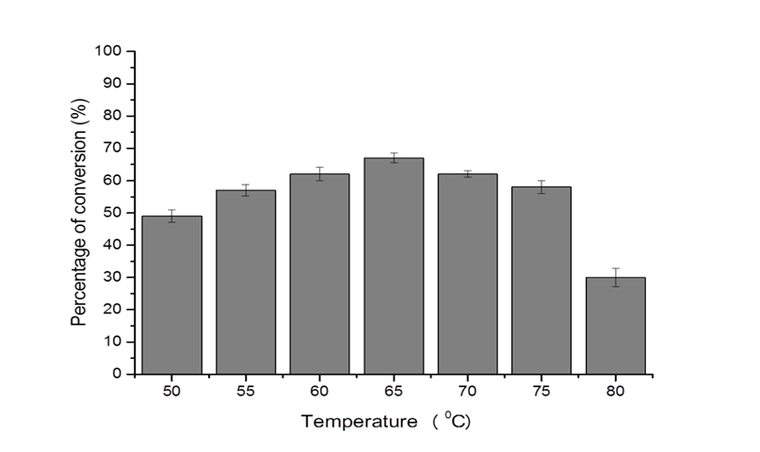

Figure 1. Effect of reaction temperature on percentage of conversion in esterification of galactose with oleic acid. Conditions: galactose (0.05 mmol), oleic acid (0.1 mmol), DMSO:[Bmim][BF₄] (1:20, 50 μL:1 mL), T1 lipase (2%, w/w), 2 hours.

The time profile of the esterification reaction

The time profile of the reaction was studied in the range of 0-240 minutes. Previously, we reported that for esterification of galactose in DMSO:[Bmim][BF₄] (1:20) mixture, the maximum conversion can be achieved within 2 hours and the reaction was followed for up to 4 hours only compared to the usual 72 hours when the reaction was carried out in organic solvent [14]. The percentage of conversion steadily increased as the reaction progress and achieved the maximum conversion at 120 minutes (Figure 2). After 2 hours the conversion started to decrease probably due to the deactivation of the lipase in the presence of very polar DMSO. Various factors affecting enzymes’ activity in organic media have been previously reported such as loss of critical water, decrease flexibility, distortment of active site and disruption of quaternary structure of protein complexes, to name a few [22]. A short reaction time is not only advantageous in term of conserving the catalytic activity of the lipase but at the same time it would provide huge saving in production cost. At only 2 hours reaction time, these conversion rates are very promising as almost all reported enzymatic esterification of sugar ester were done at much longer period. Enzymatic transesterification of vinyl linoleate ester with trehalose was reported to give 64% yield of the sugar ester after 12 days using protease (Bioprase) enzyme in DMF [23] Whereas, glucose palmitate preparation using Novozyme 435 in [Bmim][PF₆] (with 0.1% water) achieved the best conversion of 77% after 48 h [24].

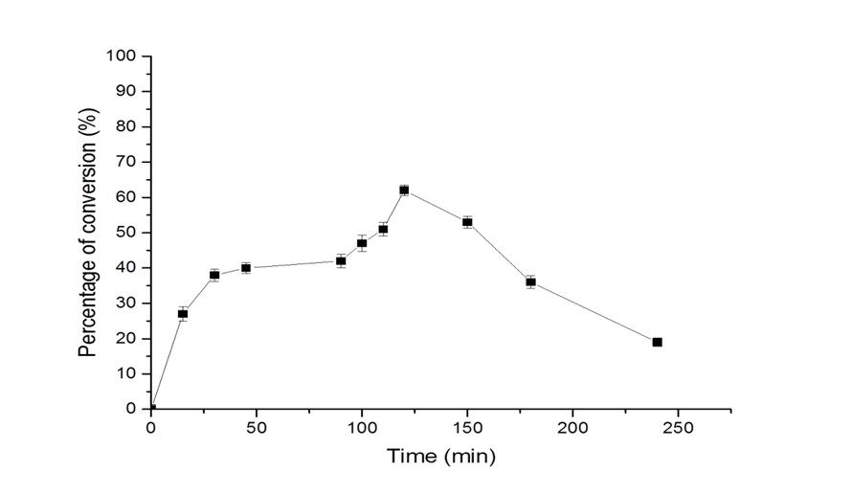

Figure 2. The time profile of esterification of galactose with oleic acid. Conditions: galactose (0.05 mmol), oleic acid (0.10 mmol), DMSO:[Bmim][BF₄] (1:20, 50 μL:1 mL), T1 lipase (2%, w/w), 60 °C.

The effect T1 lipase loading

The effect of T1 lipase loading amount was studied by varying the amount of T1 lipase from 1-5% (w/w). It was found that at low loading amount, 1-3% (w/w), the conversion was already optimum in the range of 60-63%. However, when the enzyme loading was increased to 4-5%, the conversion rapidly decreased. As the amount of enzyme is increased more active sites becomes available to accommodate the substrates which resulted in rate increase. However, above certain value, the number of active sites would exceed the number of available substrates. As a result, further increase in the amount of enzyme would not yield higher rate of conversion [25,26]. It has also been known that at high enzyme loading the reaction mixture can be quite viscous that enzyme tends to aggregate, and this will reduce the accessibility of the enzyme’s catalytic site to the reactants. The mass transfer limit may have been reached at 3% enzyme loading. Thus, further increase resulted in the decrease of conversion [27]. For the rest of the study, the optimum enzyme loading of 2% (w/w) was used.

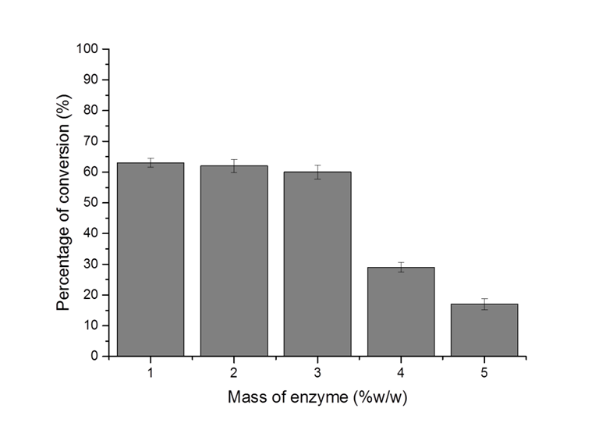

Figure 3. Effect of enzyme loading on percentage of conversion in esterification of galactose with oleic acid. Conditions: galactose (0.05 mmol), oleic acid (0.10 mmol), DMSO:[Bmim][BF₄] (1:20, 50 μL:1 mL), 60 °C, 2 hours.

The effect of fatty acids chain length

In the galactose esterification reaction, different aliphatic fatty acids with varying length and unsaturation level [levulinic acid (C5), caprylic (C8), lauric (C12), oleic (C18:1) and linoleic acid (C18:2)] were utilized to investigate the selectivity and specificity of T1 lipase. It was found that esterification with the shortest fatty acid, levulinic acid was the least favored at only 28% conversion (Figure 4). The conversions were more favorable for longer chain acids, C8 – C18 at 51 – 62%. However, lower conversion for lauric acid (C12) at 51% compared to caprylic (C8, 62%), oleic (C18:1, 62%) or linoleic acid (C18:2, 64%) was more likely due to high viscosity of the reaction mixture as lauric acid exist as solid at room temperature (m.p. 44-45°C) [28] while the other fatty acids are liquids. Higher viscosity may result in higher friction against enzymes molecule and decrease motion thus inhibiting catalysis [29]. Similarly, levulinic acid also exists as solid at room temperature which may also account for the low conversion. Previous work has reported that when comparing the activity of various lipases (Novozyme 435, Lipozyme TL IM, Lipozyme RM IM, and immobilized CRL) for esterification of levulinic acid in [Bmim][PF₆], only Novozyme 435 showed good activity [30]. This suggests that levulinic acid is not a favorable substrate for many lipases and not just T1 lipase. Although, levulinic acid as a keto acid, did not really fit well as substrate of choice to investigate the effect of acid’s length, we were interested to see whether enzymatic esterification of levulinic acid can be done using T1 lipase in IL as part of our study on production of biofuel [31]. For its hydrolytic activity, T1 lipase has been shown previously favor medium to long chain fatty acids (C10 – C14) [32] and it seemed that for esterification the chain length can be extended further.

Figure 4. Effect of acyl donor on percentage of conversion in esterification of galactose with oleic acid. Conditions: galactose (0.05 mmol), oleic acid (0.10 mmol), DMSO:[Bmim][BF₄] (1:20, 50 μL:1 mL), T1 lipase (2% (w/w), 60 °C, 2 hours.

The effect of acyl acceptor

In order to investigate the sugar preference of T1 lipase, esterification of linoleic acid with various sugars (glucose, fructose, sucrose, maltose, trehalose, xylitol and galactose) were carried out. Linoleic acid was chosen as the acyl donor in this study as it gave the best conversion in the study of the effect of fatty acid length previously. All monosaccharide’s (glucose, fructose and galactose) gave moderate conversion at above 54%. The non-reducing disaccharides, sucrose and trehalose, gave better conversion than maltose (a reducing disaccharides), with sucrose exhibited the best conversion at 65%. Xylitol (a sugar alcohol) which would have better solubility in ILs than mono- and disaccharides, gave moderate conversion of 57%. These results showed that T1 lipase has no specificity for monosaccharides, disaccharides or sugar alcohol as the conversions were all above 45%. T1 lipase has also exhibited broad substrate specificity for its hydrolytic ability that it was able to degrade amorphous plastics as well as oils [33]. Only maltose gave slightly poorer conversion.

Enzymatic transesterification of maltose has previously been achieved in good yield in organic solvents and using various lipases; tert-butanol/DMSO, lipase from Humicola lanuginosa (immobilized on Celite) [34]; tert-butanol, C. antarctica lipase [35]; acetone/n-hexane, C. antarctica lipase B (Novozyme 435) [36]. Poorer yield for maltose esterification (21.9%) with acrylic acid in tert-butanol was reported by Tsukamoto et al. when glucose (80.3%) and fructose (64%) fared better using immobilized C. antarctica lipase B [37]. However, there is limited report on enzymatic esterification or transesterification of maltose in ILs. Most enzymatic preparation of sugar esters utilized immobilized lipase and it is useful to note that we are reporting the use of free lipase for similar work. This shows that T1 lipase has good stability for organic transformation on par with commercial immobilized lipase.

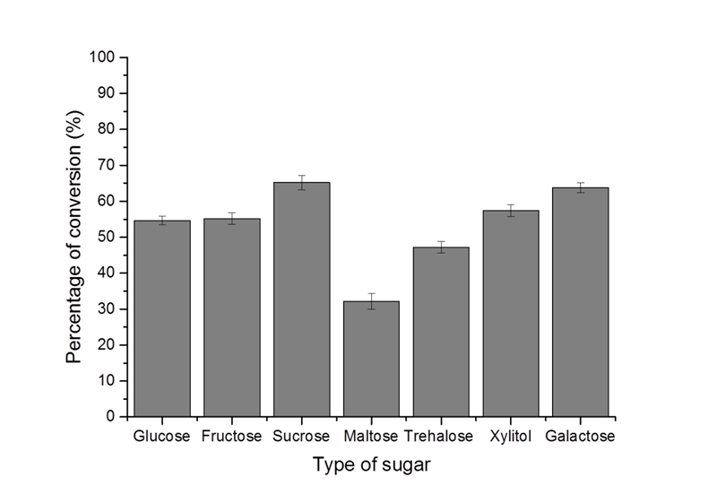

Figure 5. Effect of acyl donor on percentage of conversion in esterification of linoleic acid with various sugars. Conditions: sugar (0.05 mmol), oleic acid (0.10 mmol), DMSO:[Bmim][BF₄] (1:20, 50 μL:1 mL), T1 lipase (2% (w/w), 60 °C, 2 hours.

Conclusion

Successful enzymatic esterification of sugars in IL using thermostable T1 lipase with various fatty acid has been reported. Optimum temperature for T1 lipase in this work was like previous report. We can conclude that T1 lipase has the potential to synthesize sugar ester at or above 60 °C for short time incubation in ILs as reaction media, and T1 lipase exhibited broad specificity either for the sugars or fatty acids which is good for future commercial application of T1 lipase.

Acknowledgement

This project was supported by the Ministry of Science, Technology and Innovation, Malaysia under Exploratory Research Grant Scheme ERGS/1/11/STG/UPM/03/11 with Vot. number 5527054.

References

- Leow, T. C., Rahman, R. N. Z. R. A., Basri, M. and Salleh, A. B. (2004). High level expression of thermostable lipase from Geobacillus sp. strain T1. Bioscience, Biotechnology, and Biochemistry, 68(1): 96-103
- Rahman, R. N. Z. R. A., Leow, T. C., Salleh, A. B. and Basri, M. (2007). Geobacillus zalihae sp. nov., a thermophilic lipolytic bacterium isolated from palm oil mill effluent in Malaysia. BMC Microbiology, 7: 77.
- Mozhaev, V. V., Berezin, I. V., and Martinek, K. (1988). Structure-stability relationship in proteins: Fundamental tasks and strategy for the development of stabilized enzyme catalyst for biotechnology. CRC Critical Review in Biochemistry, 173: 147-154.
- Baker, I. J. A., Matthews, B., Suares, H., Krodkiewska, I., Furlong, D. N., Grieser, F. and Drummond, C. J. (2000). Sugar fatty acid ester surfactants: Structure and ultimate aerobic biodegradability. Journal of Surfactants and Detergents, 3(1): 1-11.
- Staroń, J., Dąbrowski J. M., Cichoń, E. and Guzik, M. (2018) Lactose esters: synthesis and biotechnological applications. Critical Reviews in Biotechnology, 38(2): 245-258
- Pyo, S.-H., Chen, J., Ye, R. and Hayes, D. G. (2019). Chapter 10 - Sugar Esters, Editors: Hayes, D. G., Solaiman, D. K. Y. and Ashby, R. D. Biobased Surfactants (Second Edition), AOCS Press, Urbana, USA: pp. 325-363.
- Chang, S. W. and Shaw, J. F. (2009). Biocatalysis for the production of carbohydrate esters. New Biotechnology, 26(3–4): 109-116.
- Yoo, I. S., Park, S. J. and Yoon, H. H. (2007). Enzymatic synthesis of sugar fatty acid esters. Journal of Industrial and Engineering Chemistry, 13(1): 1-6.
- Gumel, A. M., Annuara, M. S. M., Heidelberg, T. and Chisti, Y. (2011). Lipase mediated synthesis of sugar fatty acid esters. Process Biochemistry, 46: 2079-2090.
- Kennedy, J. F., Kumar, H., Panesar, P. S., Marwaha, S. S., Goyal, R., Parmar, A. and Kaur, S. (2006). Enzyme-catalyzed regioselective synthesis of sugar esters and related compounds. Journal of Chemical Technology & Biotechnology, 81: 866-876.
- Kobayashi, T. (2011). Lipase-catalyzed syntheses of sugar esters in non-aqueous media, Biotechnology Letters, 33: 1911-1919.
- Hallett, J. P. and Welton, T. (2011). Room-temperature ionic liquids: solvents for synthesis and catalysis. 2. Chemical Reviews, 111: 3508-3576.
- Yang, Z. and Huang, Z. L. (2012). Enzymatic synthesis of sugar fatty acid esters in ionic liquids. Catalysis Science & Technology, 2: 1767-1775.
- Abdulmalek, E., Mohd. Saupi, H. S., Tejo, B. A., Basri, M., Salleh, A. B., Rahman, R. N. Z. R. A. and Abdul Rahman, M. B. (2012). Improved enzymatic synthesis of galactose oleate ester in ionic liquid. Journal of Molecular Catalysis B: Enzymatic, 76: 37-43.
- Abdulmalek, E., Hamidon, N. F. and Abdul Rahman, M. B. (2016) Optimization and characterization of lipase catalysed synthesis of xylose caproate ester in organic solvents. Journal of Molecular Catalysis B: Enzymatic, 132: 1-4.
- Lee, K. P. and Kim, H. K. (2016). Antibacterial effect of fructose laurate synthesized by Candida antarctica B lipase-mediated transesterification. Journal of Microbiology and Biotechnology, 26(9): 1579-1585.
- Shin, D. W., Mai, N. L., Bae, S.-W. and Koo, Y. (2019). Enhanced lipase-catalyzed synthesis of sugar fatty acid esters using supersaturated sugar solution in ionic liquids. Enzyme and Microbial Technology, 126: 18-23.
- Sang, H. L., Dung, T. D., Sung, H. H., Chang, W.-J. and Koo, Y.-M. (2008). Lipase-catalyzed synthesis of fatty acid sugar ester using extremely supersaturated sugar solution in ionic liquids. Biotechnology and Bioengineering, 99(1): 1-8.
- Ha, S. H., Hiep, N. M., Lee, S. H. and Koo, Y.-M. (2009). Optimization of lipase-catalyzed glucose ester synthesis in ionic liquids. Bioprocess and Biosystems Engineering, 33(1): 63-70.
- Pang, N., Gu, S.-S, Wang, J., Cui, H.-S., Wang, F.-Q., Liu, X., Zhao, X.-Y. and Wu, F.-A. (2013). A novel chemoenzymatic synthesis of propyl caffeate using lipase-catalyzed transesterification in ionic liquid. Bioresource Technology, 139: 337-342.
- Ju1, X., Li, J., Hou, M. and Tao, J. (2015). A lipase-catalyzed process for green synthesis of temsirolimus. Engineering in Life Sciences, 15: 229-233.
- Kumar, A., Dhar, K., Kanwar, S. S., Arora, P. K. (2016), Lipase catalysis in organic solvents: Advantages and applications. Biological Procedures Online, 18: 1-11.
- Raku, T., Kitagawa, M., Shimakawa, H. and Tokiwa, Y. (2003). Enzymatic synthesis of trehalose esters having lipophilicity. Journal of Biotechnology, 100(3): 203-208.
- Findrik, Z., Megyeri, G., Gubicza, L., Bélafi-Bakó, K., Nemestóthy, N. and Sudar, M. (2016). Lipase catalyzed synthesis of glucose palmitate in ionic liquid. Journal of Cleaner Production, 112(1): 1106- 1111.
- Wang, X., Li, D., Qu, M., Durrani, R., Yang, B. and Wang, Y. (2017). Immobilized MAS1 lipase showed high esterification activity in the production of triacylglycerols with n-3 polyunsaturated fatty acids. Food Chemistry, 216: 260-267.
- Onoja, E., Chandren, S., Razak, F. I. A. and Wahab, R. A. (2018). Enzymatic synthesis of butyl butyrate by Candida rugosa lipase supported on magnetized-nanosilica from oil palm leaves: Process optimization, kinetic and thermodynamic study. Journal of the Taiwan Institute of Chemical Engineers, 91: 105-118.
- Yadav, G. D. and Devendran, S. (2012). Lipase catalyzed synthesis of cinnamyl acetate via transesterification in non-aqueous medium. Process Biochemistry, 47(3): 496-502.
- ChemSpider (Royal Society of Chemistry) http://www.chemspider.com/Chemical-Structure.3756.html [Access online 19th July 2019].
- Uribe, S. and Sampedro, J. G. (2003). Measuring solution viscosity and its effect on enzyme activity. Biological Procedures Online, 5(1): 108-115.
- Di, X., Zhang, Y., Fu, J., Yu, Q., Wang, Z. and Yuan, Z. (2019) Biocatalytic upgrading of levulinic acid to methyl levulinate in green solvents. Process Biochemistry, 81: 33 – 38
- Lee, A., Chaibakhsh, N., Rahman, M. B. A., Basri, M. and Tejo, B. A. (2010). Optimized enzymatic synthesis of levulinate ester in solvent-free system. Industrial Crops and Products, 32(3): 246-251.
- Leow, T. C., Rahman, R. N. Z. R. A., Basri, M. and Salleh, A. B. (2007) A thermoalkaliphilic lipase of Geobacillus sp. T1. Extremophiles, 11(3): 527-535.
- Mohamed, R. A., Salleh, A. B., Leow, A. T. C., Yahaya, N. M. and Abdul Rahman, M. B. (2017). Ability of T1 lipase to degrade amorphous P(3HB): Structural and functional study. Molecular Biotechnology, 59: 284.
- Ferrer, M., Cruces M. A., Plou, F. J., Bernabé, M. and Ballesteros, A. (2000). A simple procedure for the regioselective synthesis of fatty acid esters of maltose, leucrose, maltotriose and n-dodecyl maltosides. Tetrahedron, 56(24): 4053-4061
- Woudenberg-van Oosterom, M., van Rantwijk, F. and Sheldon, R. A. (1996). Regioselective acylation of disaccharides in tert-butyl alcohol catalyzed by Candida antarctica lipase. Biotechnology and Bioengineering, 49: 328-333.
- Jia, C., Zhao, J., Feng, B., Zhang, X. and Xia, W. (2010). A simple approach for the selective enzymatic synthesis of dilauroyl maltose in organic media. Journal of Molecular Catalysis B: Enzymatic, 62(3–4): 265-269.
- Tsukamoto, J., Haebel, S., Valença, G. P., Peter, M. G. and Franco, T. T. (2008). Enzymatic direct synthesis of acrylic acid esters of mono- and disaccharides. Journal of Chemical Technology and Biotechnology, 83: 1486-1492.

