ELECTROBIOSYNTESIS OF NiO USING RAMBUTAN LEAVES FOR PHOTODEGRADATION OF REMAZOL BRILLIANT BLUE DYE

(Elektrobiosintesis NiO Menggunakan Ekstrak Daun Rambutan
Untuk Fotodegradasi Pewarna Remazol Brilliant Biru)

Muhammad Farhan Hanafi, Noor Faizah Che Harun, Norzahir Sapawe*, Azizzami Raidin

Universiti Kuala Lumpur Branch Campus
Malaysian Institute of Chemical and Bioengineering Technology,
Lot 1988 Vendor City, Taboh Naning, 78000 Alor Gajah, Melaka, Malaysia

*Corresponding author: norzahir@unikl.edu.my

Abstract
NiO catalyst was prepared through electrochemical method with rambutan (Nephelium lappaceum) leaves as an electrolyte. The effects of the preparation methods on the physical properties of the catalyst were studied via Fourier transform infrared spectroscopy (FTIR). The interaction between nickel species and bio-active compounds of rambutan leaves crude during the electrochemical was found to affect the NiO structure. An amount of 3.0 g L⁻¹ of NiO was found to be the optimum dosage for 10 mg L⁻¹ of Remazol Brilliant Blue (RBB) dye, which resulted in 83.7% of maximum degradation after 1 hour of contact time at pH 3 under fluorescent light. This study showed that the kinetics followed a pseudo-first order Langmuir–Hinshelwood model with the calculated values of K_{r} and K_{LH} at 1.38 mg L⁻¹ h⁻¹ and 0.03 L mg⁻¹, respectively. Measurements of the mineralization of RBB by COD and BOD₅ analysis were 66.6% and 73.4%, respectively, before and after reaction. Therefore, the effectiveness of synthesized NiO by the electrobiosynthesis method was established and confirmed through this study. The synthesized NiO has a great potential as a photocatalyst in photocatalytic reaction for wastewater treatment.

Keywords: electrobiosynthesis, nickel, remazol brilliant blue dye, degradation, light irradiation

Abstrak
Mangkin NiO disediakan melalui kaedah elektrokimia dengan ekstrak daun rambutan (Nephelium lappaceum) sebagai elektrolit. Kesan kaedah penyediaan ke atas sifat fizikal mangkin telah dikaji melalui spektroskopi inframerah transformasi Fourier (FTIR). Interaksi antara spesies nikel dan sebatian bio-aktif dari ekstrak daun rambutan semasa elektrokimia didapati mempengaruhi struktur NiO. Sejumlah 3.0 gL⁻¹ NiO didapati sebagai dos optimum untuk 10 mgL⁻¹ pewarna Remazol Brilliant Biru (RBB), yang menghasilkan 83.7% degradasi maksimum selepas 1 jam masa kontak di pH 3 di bawah lampu pendarfluor. Kajian ini juga menunjukkan bahawa kinetik mengikuti model Langmuir-Hinshelwood dengan pseudo pertama dengan nilai kiraan K_{r} dan K_{LH} masing-masing adalah 1.38 mgL⁻¹h⁻¹ dan 0.03 Lmg⁻¹. Pengukuran mineralisasi RBB oleh COD dan BOD₅ adalah 66.6% dan 73.4%, sebelum dan selepas tindak balas. Oleh itu, keberkesanan sintesis NiO dengan kaedah elektrobiosintesis telah ditubuhkan dan disahkan melalui kajian ini. NiO yang disintesis mempunyai potensi besar sebagai fotokatalis dalam tindak balas fotokatalitik untuk rawatan air sisa.
Kata kunci: elektrobiosintesis, nikel, pewarna remazol brilliant biru, degradasi, penyinaran cahaya

Introduction
Access to sufficient water sources is a noteworthy issue that concerns countries everywhere throughout the world. While the specific issue differs in every country, it is conceivable to classify the main issue as having either limited access or substandard access to this indispensable asset. Moreover, this circumstance is foreseen to wind up being noticeably more extreme as environmental change and water shortage are happening around the world [1]. Wastewater treatment is thought to be a traditional way to deal with confronting deficient water supply [2]. In the last few decades, the structure of wastewater streams has changed because of the introduction of new chemicals. One of the examples is a synthetic dye. It is estimated that 90% of the total dyes produced will end up in fabrics, while the remaining portion will be used in leather, paper, plastic, and chemical industries. It is also estimated that 280,000 tons of textile dyes are discharged as industrial effluents every year worldwide [3].

Man-made textile fibre is a very popular industry in Malaysia, especially in the East Coast of Peninsular Malaysia. Recently, this industry has contributed to the economic growth, especially in the states of Kelantan and Terengganu. Malaysia has produced close to 400,000 tons of man-made fibres which consist of nylon, polyester filament and staple in 2008. Malaysia was the fifteenth largest producer of textile fibre in 2008 and ninth largest in the Asian region. Malaysia’s textile industry had exports and imports valued at RM 10.8 billion (US$ 3.6 billion) and RM 6.6 billion (US$ 2.2 billion), respectively. At the same time, the huge amount of textile fibres produced by the textile industry in Malaysia has significantly affected the environmental quality, especially with respect to the liquid effluent [3]. Fortunately, a sustainable solution to this challenge is being developed in the form of photocatalytic reaction.

Photocatalytic is an advanced oxidation process (AOP) alternative that uses natural sunlight to activate a metal oxide catalyst which in turn generates oxidizing agents, able to degrade pollutants and inactivate pathogens typically resistant to traditional treatments [4]. This process is non-selective in regards to target pollutant, does not require the addition of extra chemicals (the catalyst can be reused and does not leave the system) and is expected to demand low operational costs; therefore, it has created high expectations among environmental scientists and engineers [4]. Many studies have attempted to use other semiconductors, such as nickel oxide (NiO) as a potential photocatalyst for synthetic dye degradation. NiO is the alternative semiconductor which is a transition metal oxide widely used as a catalyst with extraordinary electrical, thermal, catalytic and redox properties [5]. The most attractive features of NiO are excellent durability and electrochemical stability. Reported band gap energy value for the NiO is in the range of 3.4-3.8 eV. This suggests that the optical transition in NiO takes place through direct inter-band transition [6]. Also, NiO can act as a promoter for the generation of OH radicals [7].

In recent years, biological synthesis has emerged as an attractive alternative to traditional synthesis methods for producing nanoparticles of photocatalysts. Synthesizing nanoparticles via biological entities acting as biological factories offers a clean, nontoxic and environment-friendly method of synthesizing nanoparticles with a wide range of sizes, shapes, compositions and physicochemical properties [8]. Synthesizing nanoparticles via plants is a relatively straightforward and advantageous approach. The plant approach is more advantageous since it does not need any special, complex and multi-step procedures, such as isolation, culture preparation, and culture maintenance. Furthermore, synthesis in plants tends to be faster than microorganisms, is more cost-effective and is relatively easy to scale up for the production of large quantities of nanoparticles [9]. Therefore, in this study, the electrobiosynthesis of NiO using rambutan leaves extract as an alternative electrolyte was carried out and used for the removal of Remazol Brilliant Blue (RBB) dye in an aqueous solution.

Materials and Methods
Remazol Brilliant Blue (RBB) was purchased from Merck, Malaysia. Ethanol was purchased from RPE Reagent Pure Erba. Nickel and platinum plates with 99% purity were used as electrodes and were obtained from Nilaco, Japan. Tetraethylammonium perchlorate (TEAP), which was used as a supporting electrolyte in electrolysis, was prepared in accordance with the procedure reported in literatures [10-20]. In this study, the rambutan leaves were extracted using ethanol. The ratio of rambutan leaves to ethanol was 1:10. It was then left for 3 days to let the ethanol extract the bio-active compounds in the rambutan leaves completely. The mixture was filtered using a filter paper and the filtered solution was placed in the rotary evaporator to remove the ethanol and obtain the crude. Then the electrolysis was conducted at a constant current of 480 mA/cm² and at 0 ˚C with continuous stirring. The rambutan crude was used as an electrolyte. It was diluted with a certain amount of distilled water to get the concentration of 50 mgL⁻¹ and 1000 mgL⁻¹, which were used to synthesize NiO₅₀ and NiO₁₀₀₀, respectively. After electrolysis, the mixture was dried at 100 ºC overnight and calcined for 3 hours at 550 ˚C to get a pure NiO catalyst.

FTIR spectroscopy was performed to identify the chemical functional groups present in the catalysts. IR absorbance data were obtained over a range of wavenumbers from 550 to 3500 cm⁻¹. The performance of the catalysts was tested for the degradation of RBB. It was conducted in a photoreactor where a florescent lamp (20W) as a light source was mounted 15 cm above the solution. A 50 ml Pyrex conical flask was placed on a magnetic stirrer to uniformly disperse the catalyst into solution. The initial pH of the solution was 5 and the reaction was carried out at 30 ˚C. The reaction of degradation of RBB was carried out for 2 hours under light irradiation and continuous stirring. The concentration of RBB dye in the solution prior to irradiation was used as the initial value for the RBB degradation measurements. Each set of experiments was performed three times. The adsorption band of RBB was taken at 600 nm and the degradation percentage was calculated using the following equation 1:
$$Decolorization\left(\%\right)=\frac{C_{0}-C_{t}}{C_{0}}×100 \left(1\right)$$
where C₀ and C_{t} are the initial concentration of RBB and the concentration at time t, respectively. The mineralization (BOD) was measured using a YSI model 3100 in which BOD bottles were incubated at 20 ^{º}C for 5 days; the difference in the dissolved oxygen was used to calculate BOD₅. A HACH DR4000 spectrometer was used for COD measurements.

Results and Discussion
Identification of functional group
The details of the functional groups involved in the catalyst structure prepared under varying electrolyte (rambutan leaves extract) concentrations were measured using FTIR, and the results are shown in Figure 1. The peak at 2360 cm⁻¹ could be attributed to the hydroxyl groups [21]. The sharp peak at 668 cm⁻¹ and 405 cm⁻¹ might correspond to the Ni-O-H stretching bond and Ni-O bond vibration, respectively [21]. This peak decreased with increasing electrolyte concentration, possibly indicating the Ni groups [22].

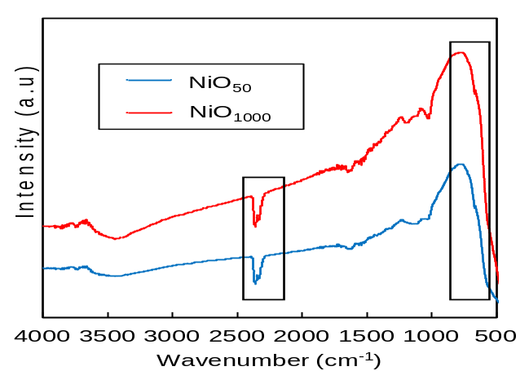

Figure 1. FTIR patterns of NiO catalysts synthesized using 50 mgL⁻¹ (NiO₅₀) and 1000 mgL⁻¹ (NiO₁₀₀₀) of Nephelium lappaceum extract

Performance of the prepared catalysts
The performance of the prepared catalysts was examined by the degradation of RBB, and the results are shown in Figure 2. The results show that complete degradation of RBB was achieved within a very short contact time (2 hours) under visible light conditions when using NiO₅₀ and NiO₁₀₀₀ at 480 mA cm⁻². By comparing the percentage of RBB degradation using both NiO, it is believed that the NiO₁₀₀₀ is more favourable to decolorize RBB in high percentage, which leads to high efficiency in treating dyes. It is attributed to the increasing amount of bio-active compound in the Nephelium lappaceum extract which will enhance the morphology of the synthesized NiO [22].

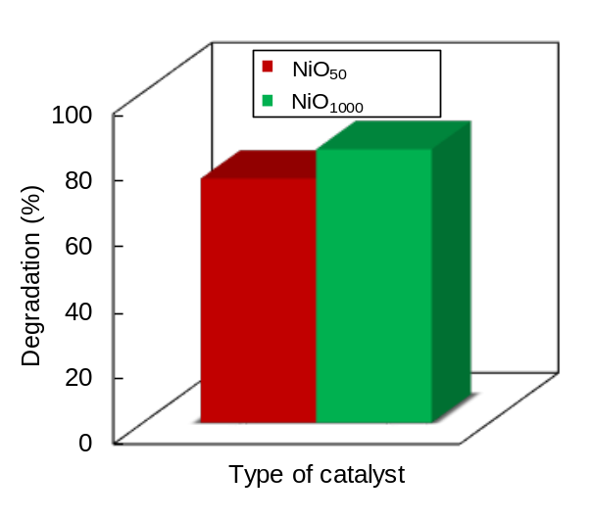

Figure 2. Performance of NiO on degradation of RBB [C = 10 mgL⁻¹, pH = 5, W = 1.0 gL⁻¹, t = 2 h, T = 303K]

Effect of pH
The pH value is one of the main factors influencing the rate of degradation of some organic compounds since it dictates the surface charge properties of the photocatalyst and the size of aggregates it forms [23]. In this study, the effect of pH on degradation of RBB was conducted with pH values of 3, 5, 7, 9 and 11, and illustrated in Figure 3. The highest performance of degradation of RBB was at pH 3 with an RBB degradation percentage of 89.1%. As the pH value increased, the percentage of RBB degradation decreased. Reactive dyes like RBB will release coloured negatively charged anions in the solution [24]. A metal oxide semiconductor usually exhibits an amphoteric behaviour, which influences the surface-charge properties of the photocatalyst when the reactions occur on the surface of the semiconductor [25]. Therefore, when the pH of the solution was low, more positively charged cations appeared on the surface of the NiO photocatalyst. Hence, it increased the electrostatic force of attraction between NiO photocatalyst and dye molecules of RBB, which consequently caused an increase in degradation of dye at low pH values.

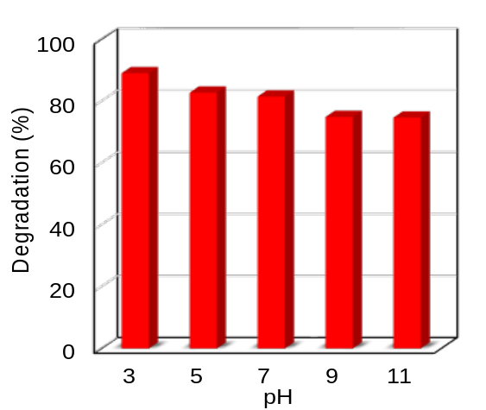

Figure 3. Effect of pH [W = 1.0 gL⁻¹, C = 10 mgL⁻¹, t = 2 h, T = 303K]

Effect of catalyst dosage
The effect of catalyst dosage on the degradation of RBB was carried out by varying the catalyst dosages (0.5, 1.0, 1.5, 3.0 and 5.0 gL⁻¹) to decolorize 10 mgL⁻¹ of RBB. A plot of percentage degradation of RBB using different dosages of NiO is shown as in Figure 4. Increase in the dosage of NiO showed an increase in the degradation efficiency of RBB. This is because of the increase in the number of binding sites with increasing NiO dosage. About 3.0 gL⁻¹ and 5.0 gL⁻¹ of NiO showed the highest percentages of degradation of RBB, which were 83.7% and 83.8%, respectively. In addition, there was no drastic change between 3.0 gL⁻¹ and 5.0 gL⁻¹ of NiO as the increase in catalyst dosage may lead to higher turbidity of the suspension, hence reducing light penetration and inhibiting the degradation process. The increase in the catalyst dosage led to an increase in the active surface area and enhanced the photodegradation reaction [25]. Moreover, the increase in degradation was most likely due to the increase in the number of photons and dye molecules absorbed [24]. Increasing the number of photons will increase the number of free radical. These free radicals will attack the RBB dye molecule by breaking the structure of the RBB dye molecule and convert it into oxidative products and carbon dioxide gases.

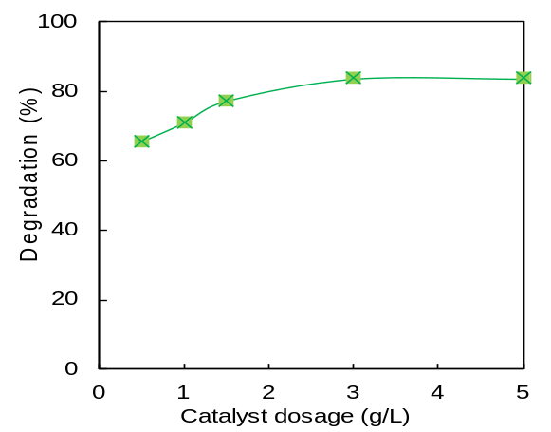

Figure 4. Effect of catalyst dosage [pH = 3, C = 10 mgL⁻¹, t = 1 h, T = 303K]

Effect of Initial Concentration
The effect of initial dye concentrations on degradation of RBB in this study was investigated by varying the RBB concentrations (10, 20, 30, 50, 70 and 100 mgL⁻¹). Figure 5 illustrates the changes in degradation of RBB as photodegradation has taken place. The degradation efficiency was decreased with increase in the initial concentration of RBB dyes. The initial concentration of 10 mgL⁻¹ of RBB showed the highest percentage of degradation of RBB, which was at 83.7%. The decrease in degradation efficiency on increasing initial dye concentration may be due to the lack of available active sites required for the high initial concentration of dye [24]. At the same time, when the RBB dye concentration was increasing, higher particle concentration became present in the aqueous solution and led to a higher turbidity of the solution. Hence, it reduced the penetration of light to the photocatalyst. When a low amount of light intensity approached the surface of the photocatalyst, low amount of free radical is produced, therefore inhibiting the photodegradation process [25]. However, lowering the RBB dye molecule concentration will enhance the photocatalytic reaction because less RBB dye molecule will be degraded with enough active sites on the surface of the catalyst. At the same time, it will reduce the time of degradation of substrate molecule. The active sites of photocatalyst are probably completely exposed to the substrate ions [25] which will make the substrate molecule easier to degrade.

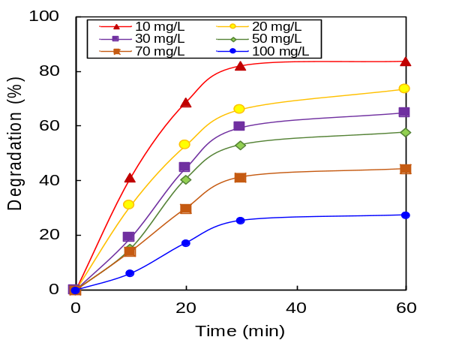

Figure 5. Effect of initial concentration [pH = 3, W = 3.0 gL⁻¹, t = 1 h, T = 303K]

Kinetic study
The kinetic degradation of RBB using NiO was studied by applying the Langmuir–Hinshelwood (L–H) kinetic model at different initial concentrations, and the results are shown in Figure 6. Higher concentrations showed lower efficiency of photocatalytic degradation due to the formation of several layers of adsorbed dye on the catalyst surface, which increased at higher dye concentrations. In addition, large amounts of adsorbed dye were found to inhibit the reaction with the dye molecules, since there was no direct contact of the catalyst with photogenerated holes or hydroxyl radicals [25]. The line with an intercept of 1/k_{r} and 1/k_{r}K_{LH} was obtained from the Langmuir–Hinshelwood (L–H) kinetic formula (equation 2):

$$\frac{1}{k_{app}}=\left[\frac{1}{K_{r}K_{LH}}\right]+\frac{C_{0}}{K_{r}} \left(2\right)$$

where K_{r} is the reaction rate constant (mg L⁻¹ h⁻¹), K_{LH} is the Langmuir–Hinshelwood adsorption equilibrium constant (L mg⁻¹) and C₀ is the initial concentration of CR (mg L⁻¹). The calculated values of K_{r} and K_{LH} were 1.38 mg L⁻¹ h⁻¹ and 0.03 L mg⁻¹, respectively, for NiO₁₀₀₀. The values of k_{r} were greater than those of K_{LH} for catalysts, indicating the dye adsorption was the controlling step of the process.

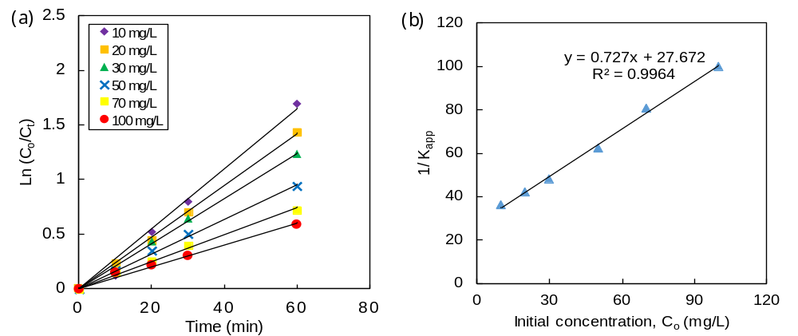

Figure 6. (a) Photodegradation kinetics of RBB by NiO at different RBB initial concentration; (b) the relationship between 1/K_{app} and 1/C₀ at different initial concentrations of RBB

The values of k_{app} obtained from Fig. 6 are listed in Table 1. Higher values were obtained with lower concentrations of RBB, which illustrated the favourable system of low dye concentrations [25].

Table 1. Pseudo first-order apparent constant value for RBB degradation

Initial Concentration, C₀ (mgL⁻¹) | Reaction Rate Constant,  K_{app} (min⁻¹) | R² | Initial Reaction Rate  (mgL⁻¹min⁻¹) | Percentage of Degradation  (%)
10 | 0.0275 | 0.985 | 0.275 | 83.69
20 | 0.0238 | 0.999 | 0.476 | 73.53
30 | 0.0208 | 0.997 | 0.624 | 65.07
50 | 0.0160 | 0.997 | 0.800 | 57.69
70 | 0.0124 | 0.993 | 0.868 | 44.38
100 | 0.0100 | 0.983 | 1.000 | 39.75

Investigation on biodegradability
The biodegradability of RBB solution was conducted by performing the BOD₅ and COD analyses before and after the photocatalytic process. The purpose of this study is to determine the toxicity of final RBB solution produced after the process. Figure 7 shows the values of BOD₅ and COD of RBB solution before and after being treated via photocatalytic degradation, which were 66.7% and 73.4%, respectively. There was a significant change in BOD₅ and COD, where the biodegradability of the RBB solution can be enhanced by this photocatalytic process. By calculating the ratio of BOD₅ to COD before and after treatment, the value was 0.47 and 0.60, respectively. The ratio before being treated showed that the dye solution was non-biodegradable. However, it became biodegradable after undergoing the photocatalytic process by referring to the ratio value obtained after being treated. This stipulated that the final RBB solution can be treated because some non-organic components that had less biodegradability contained in the RBB molecule were decomposed during the photocatalytic process [25].

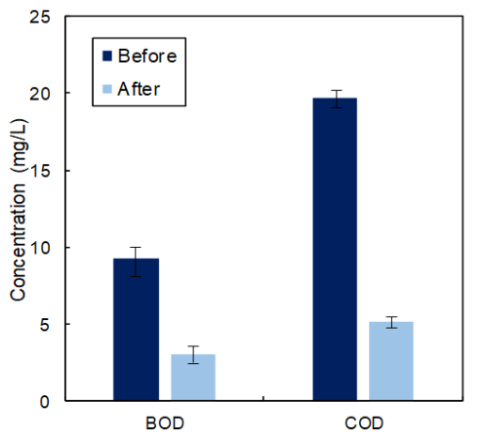

Figure 7. Concentrations of BOD₅ and COD levels before and after photocatalytic process [pH = 7, W = 1.0 gL⁻¹, C = 10 mgL⁻¹, t = 1 h, T = 303K]

Conclusion
The performance of NiO synthesized using 50 mgL⁻¹ and 1000 mgL⁻¹ of Nephelium lappaceum extracts were conducted to compare the performance of the photodegradation of RBB. NiO synthesized using 1000 mgL⁻¹ of Nephelium lappaceum showed the highest percentage of RBB degradation which was 82.7%. The photocatalytic degradation of RBB was tested using several parameters, such as pH of solution, dosage of catalyst, and initial concentration of RBB dye solution. The degradation of RBB was more favourable in acidic conditions which was at pH of 3. A higher amount of catalyst dosage gave a higher degradation percentage of RBB. 10 mgL⁻¹ of initial concentration of RBB is shown to be the most effective in photodegradation reaction due to high availability of active site on the surface of catalyst.

The photodegradation of RBB by NiO catalyst obeyed the pseudo first-order reaction because the apparent first-order rate constant (k_{app}) obtained from the graph of ln (C_{o}/C_{t}) with a function of time gave a higher value as the concentration of RBB decreased. There was a significant change in BOD₅ and COD at 66.5% and 73.3%, respectively, showing that the biodegradability of the RBB solution can be enhanced by the photocatalytic process. The ratio of BOD₅ to COD after being treated was 0.60. It stipulated the ability of the final RBB solution to be treated via the photocatalytic method. Furthermore, more instrument was needed in order to examine the pathway mechanism of catalyst synthesized using the electrolysis system and to explore new structural models of the catalyst. For the extension of this work, the system should be applied for degradation of other synthetic dyes and real wastewater should be employed.

Acknowledgements
The authors are grateful for the financial support by the Short Term Research Grant (STRG) from Universiti Kuala Lumpur (Grant No. 17004 & 17029), Majlis Amanah Rakyat Malaysia (MARA), the awards of Yayasan Tengku Abdullah Scholarship (YTAS-Muhammad Farhan bin Hanafi), and also the Malaysian Institute of Chemical and Bioengineering Technology, Universiti Kuala Lumpur for their support.

References

- Li, X. K., Ji, W. J., Zhao, J., Wang, S. J. and Au, C. T. (2005). Ammonia decomposition over Ru and Ni catalysts supported on fumed SiO₂, MCM-41 and SBA-15. Journal of Catalysis, 236(2): 181-189.
- Singh, A., Kumar, V. and Srivastava, J. N. (2013). Assessment of bioremediation of oil and phenol contents in refinery wastewater via bacterial consortium. Journal Petroleum Environment Biotechnology, 4: 145-151.
- Sapawe, N., Jalil, A. A., Triwahyono, S., Sah, R. N. R. A., Jusoh, N. W. C. and Hairom, N. H. H. (2013). Electrochemical strategy for grown ZnO nanoparticles deposited onto HY zeolite with enhanced photodecolorization of methylene blue: Effect of the formation of Si-O-Zn bonds. Applied Catalysis A: General, 456: 144-158.
- Sapawe, N., Jalil, A. A. and Triwahyono, S. (2013). One-pot electro-synthesis of ZrO₂-ZnO/HY nanocomposite for photocatalytic decolorization of various dye-contaminants. Chemical Engineering Journal, 225: 254-265.
- Venu, G. D. and Sahle, E. E. (2008). Catalytic oxidation of dimethyl sulfide with ozone: effects of promoter and physico-chemical properties of metal oxide catalysts. Applied Catalyst A: General, 348(1): 86-93.
- Bokare, A. D., Chikate, R. C., Rode, C. V. and Paknikar, K. M. (2008). Iron-nickel bimetallic nanopartilcles for reductive degradation of azo dye Orange G in aqueous solution. Applied Catalysis B: Environmental, 79: 270-278.
- Petya, K., Naydenov, A., Christoskova, S. and Mehandjiev, D. (2006). Alumina-supported nickel oxide for ozone decomposition and catalytic ozonation of CO and VOCs. Journal of Chemical & Engineering, 122: 41-46.
- Xinyu, Z., Li, X. and Qin, W. (2009). Investigation of the catalytic activity for ozonation on the surface of NiO nanoparticles. Chemical Physics Letter, 479(4): 310-315.
- Swami, A., Selvakannan, P. R., Pasricha, R. and Sastry, M. (2004). One-step synthesis of ordered two-dimensional assemblies of silver nanoparticles by the spontaneous reduction of silver ions by pentadecylphenol Langmuir monolayers. The Journal of Physical Chemistry B, 108: 19269-19275.
- Sapawe, N., Jalil, A. A., Triwahyono, S., Adam, S. H., Jaafar, N. F. and Satar, M. A. H. (2012). Isomorphous substitution of Zr in the framework of aluminosilicate HY by an electrochemical method: Evaluation by methylene blue degradation. Applied Catalysis B: Environmental, 125: 311-323.
- Sapawe, N., Rustam, M. A., Mahadzir, M. H. H., Lani, M. K. E. M., Raidin, A. and Hanafi, M. F. (2019). A novel approach of in-situ electrobiosynthesis of metal oxide nanoparticles using crude plant extract as main medium for supporting electrolyte. Materials Today: Proceedings, 19(4): 1441-1445.
- Hanafi, M. F., Sapawe, N., Rahim, M. Z. A., Rahman, N. N., Rahman, A. H. A. and Ahmad, A. A. (2016). Performance of EGZrO₂-EGFe₂O₃/HY as photocatalyst and its efficacy in decolorization of dye-contaminants. Malaysian Journal of Analytical Sciences, 20(5), 1052-1058.
- Hanafi, M. F. and Sapawe, N. (2018). Remarkable degradation of methyl orange by tetragonal zirconia catalyst. Materials Today: Proceedings, 5(10), 21849-21852.
- Hanafi, M.F. and Sapawe, N. (2019). The potential of ZrO₂ catalyst toward degradation of dyes and phenolic compound. Materials Today: Proceedings, 19(4): 1524-1528.
- Hanafi, M. F. and Sapawe, N. (2019). Electrosynthesis of ZrO₂ nanoparticles with enhanced removal of phenolic compound. Materials Today: Proceedings, 19(4): 1529-1532.
- Hanafi, M. F. and Sapawe, N. (2019). Effect of calcination temperature on the structure and catalytic performance of ZrO₂ catalyst in phenol degradation. Materials Today: Proceedings, 19(4): 1533-1536.
- Hanafi, M. F. and Sapawe, N. (2019). Electrogenerated zirconia (EGZrO₂) nanoparticles as recyclable catalyst for effective photocatalytic degradation of phenol. Materials Today: Proceedings, 19(4): 1537-1540.
- Sapawe, N. and Hanafi, M. F. (2015). Facile one-pot electrosynthesis of high photoreactive hexacoordinated Si with Zr and Zn catalyst. RSC Advances, 5(92): 75141-75144.
- Sapawe, N. (2015). Hybridization of zirconia, zinc and iron supported on HY zeolite as a solar-based catalyst for the rapid decolorization of various dyes. New Journal of Chemistry, 39(6): 4526-4533.
- Sapawe, N. (2015). Effective solar-based iron oxide supported HY zeolite catalyst for the decolorization of organic and simulated dyes. New Journal of Chemistry, 39(8): 6377-6387.
- Rahdar, A., Aliahmad, M. and Azizi, Y. (2015). NiO nanoparticles: Synthesis and characterization. Journal of Nanostructures, 15: 145-151.
- Yuvakumar, R., Suresh, J., Joseph, A. N., Sundrarajan, M. and Hong, S. I. (2014). Rambutan (Nephelium lappaceum L.) peel extract assisted biomimetic synthesis of nickel oxide nanocrystals. Material Letters, 128(1): 170-174.
- Algubili, A. M., Alrobayi, E. M. and Alkaim, A. F. (2015). Photocatalytic degradation of remazol brilliant blue dye by ZnO/UV process. International Journal Chemistry and Science, 13(2): 911-921.
- Das, D. P., Baliarsingh, N. and Parida, K.M. (2007). Photocatalytic decolorisation of methylene blue (MB) over titania pillared zirconium phosphate (ZrP) and titanium phosphate (TiP) under solar radiation. Journal of Molecular Catalysis A: Chemical, 261: 254-261.
- Sapawe, N., Jalil, A. A., Triwahyono, S., Adam, S. H., Jaafar, N. F. and Satar, M. A. H. (2012). Isomorphous substitution of Zr in the framework of aluminosilicate HY by an electrochemical method: Evaluation by methylene blue degradation. Applied Catalysis B: Environmental, 125: 311-323.

