EFFICIENT REMOVAL OF LEAD FROM AQUEOUS USING HYBRID GRAPHITE NANOFLAKES/MESOPOROUS SILICA NANOPARTICLES, AMINE FUNCTIONALIZED MESOPOROUS SILICA AND GRAPHITE NANOFLAKES AS ADSORBENTS

(Penyingkiran Berkesan terhadap Plumbum dari Cecair Menggunakan Kepingan Nano Grafit Hibrid/ Silika Partikel Nano Berliang-Meso, Silika Partikel Nano Berliang-Meso Berfungsi Amin dan Kepingan Nano Grafit Sebagai Penyerap)

Haslina Ahmad,^{1,2*} Vilander Vince Laini,¹ Tan Zhi Qian,¹ Radhiah Mohd Jelani¹, Fatin Ahza Rosli¹,

Sazlinda Kamaruzaman¹

¹Department of Chemistry,
²Integrated Chemical Biophysics Research Centre,
Faculty Science, Universiti Putra Malaysia, 43400 UPM Serdang, Selangor, Malaysia

*Corresponding author: haslina_ahmad@upm.edu.my

Abstract
Noxious heavy metal ions contamination has become a serious environmental problem nowadays. Among all the toxic heavy metal ions, lead(II) ion, is the most commonly encountered in industrial and agricultural wastewater and in acidic wash-away from landfills site. Hence, the removal of lead traces from the environment has gained a special concern due to their persistence. In this study, batch experiments were conducted to study the capability of hybrid graphite nanoflakes/mesoporous silica nanoparticles (GNP-MSN), amine functionalized mesoporous silica (NH₂-MSN) and pristine graphite nanoflakes (GNP) as adsorbents for removal of lead from aqueous. The influence of several parameters such as pH of the aqueous sample, amount of adsorbent, initial concentration of the lead(II) ions and contact time were examined to optimize the adsorption efficiency of the adsorbents under study. Lead(II) ion can be extracted at pH 4 from sample volume of 10 mL with concentration of 10 ppm by utilizing 10 mg of each respective adsorbent. The analysis of the sample was done by using Flame Atomic Absorption Spectroscopy (FAAS). Furthermore, GNP-MSN also has greatly reduced the aggregation of pristine graphite in water in which GNP-MSN is more easily to be removed from tested sample by centrifugation process compared to pristine graphite. In term of consistency and selectivity of the lead(II) ions removal, GNP-MSN show the highest efficiency since it is able to remove lead(II) ions with higher adsorption capacity (23.940 mg/g) compared to NH₂-MSN (9.230 mg/g) and GNP (1.113 mg/g). Based on kinetic study, both GNP and NH₂-MSN were best-fitted with pseudo-second order while GNP-MSN fitted well with pseudo-first order.

Keywords: adsorption, mesoporous silica nanoparticles, graphite nanoflakes, lead, hybrid nanoparticles

Abstrak
Pencemaran ion logam berat secara tidak sengaja telah menjadi isu alam sekitar yang serius pada masa kini. Di antara semua ion logam berat toksik, ion plumbum(II), adalah yang paling biasa ditemui dalam air kumbahan perindustrian dan pertanian dan dalam cucian berasid dari tapak pelupusan. Oleh itu, penyingkiran plumbum dari alam sekitar telah mendapat keprihatinan khusus kerana masih berterusan. Dalam kajian ini, eksperimen berkumpulan dijalankan untuk mengkaji kemampuan kepingan nano grafit hibrid/ silika partikel nano berliang-meso (GNP-MSN) untuk penyingkiran plumbum, terhadap silika partikel nano berliang-meso berfungsi amin (NH₂-MSN) dan kepingan nano grafit asli (GNP) untuk penyingkiran plumbum dari akueus. Faktor beberapa parameter seperti pH sampel, jumlah penjerap, kepekatan awal ion plumbum(II) dan masa sentuhan telah dikaji untuk mengoptimumkan kecekapan penjerapan untuk menyerap di dalam kajian. Ion plumbum(II) boleh disingkirkan pada pH 4 dari jumlah sampel 10 mL dengan kepekatan 10 ppm dengan menggunakan 10 mg bagi setiap penyerap. Analisis sampel dilakukan dengan menggunakan spektroskopi penyerapan atom bara (FAAS). Selain itu, GNP-MSN juga telah mengurangkan pengagregatan grafit asli di dalam air di mana GNP-MSN lebih mudah dikeluarkan daripada sampel yang diuji dengan proses sentrifugasi berbanding dengan grafit asli. Dari segi konsistensi dan pemilihan penyingkiran ion (II) ion, GNP-MSN menunjukkan kecekapan tertinggi kerana ia dapat menyingkirkan ion-ion plumbum (II) dengan kapasiti penjerapan yang lebih tinggi (23.940 mg/g) berbanding dengan NH₂-MSN (9.230 mg/g) dan GNP (1.113 mg/g). Berdasarkan kajian kinetik, kedua-dua GNP dan NH₂-MSN sangat sesuai dengan perintah pseudo-kedua manakala GNP-MSN sesuai dengan perintah pseudo-pertama.

Kata kunci: penjerapan, silika partikel nano berliang-meso, kepingan nano grafit, plumbum, partikel nano hibrid

Introduction
Due to the rapid growth of industrialization, discharge of untreated heavy metals into the water increased and caused a serious threat to the environment and living organisms. Unlike organic contaminants, heavy metals are not biodegradable and may bioaccumulate in living tissues in a similar way as other toxic heavy metal ion. Long-term consumption of water containing high level of lead ion would cause serious disorders, such as anemia, kidney disease, nausea, convulsions, coma, renal failure, and cancer, along with subtly negative effects on metabolism and intelligence. There are two main sources of heavy metals in wastewater effluents which are natural and anthropogenic [1]. Lead is a toxic metal, persistent, and it can bio-accumulate in the body over time. Once they enter the food chain, they may accumulate in the human body in high concentration which can cause serious health disorders [2]. The presence of excess lead in water may cause food poisoning, vomiting, diarrhea and stomach discomfort if it is being consumed.

There are several techniques used for heavy metal removal such as nanofiltration, osmosis, ion exchange, coagulation and flocculation, and adsorption. Adsorption is one of the effective methods to eliminate the metal ions especially when porous materials are being utilized [3, 4]. Due to the instability of the mesoporous silica shells under basic condition and its inability to adsorb heavy metal ions, hence this study was conducted to enhance its adsorption ability by hybridization with a low cost, high thermal stability and environmentally friendly material. Graphite nanoparticles was chosen to be hybridized with mesoporous silica nanoparticles due to its high surface area and high thermal stability which are excellent properties to withstand the high temperature during the hybridization process [5]. Moreover, the tendency of pristine graphite to aggregates in water also becomes one of the reasons for it to be hybridized with a material that able to provide good supporting framework to prevent the aggregation. Another approach is to functionalize the MSN by using the post-grafting method where the synthesized nanoparticles were grafted with organosilanes bearing amino group to produce NH₂-MSN. It is done under a basic condition.

In this study, three different nanoadsorbents; hybrid graphite nanoflakes/mesoporous silica (GNP-MSN) synthesized with ionic liquid template, NH₂-MSN and GNP were utilized as the adsorbent for the adsorption of lead (II) ions form an aqueous sample. The adsorption kinetic, isotherm and the effects of different adsorption conditions were studied: solution pH, initial concentration, adsorbent amount and contact time.

Materials and Methods

Chemicals and Materials
Lead nitrate, Pb(NO₃)₂ (99% purity) was purchased from BDH Chemicals Ltd, England. Graphene nanoplatelets (GNP-C750) were purchased from XG Sciences. Ionic liquid, hexadecylpyridinium bromide, C₁₆PyBr was synthesized by using toluene that was purchased from Fischer Chemical with 1-bromohexadecane, C₁₆Br (97%, Acros Organics) and pyridine (79.10 g/mol) which was supplied by Univar. Diethylether were purchased from Fischer Chemical and acetonitrile was purchased from J. Kollin Chemicals. Tetraethoxysilane, TEOS (99%, Merck KGaA, Germany) which is the source of silica; triethanolamine, TEA (98%, ChemPur®) as the catalyst; grade C graphite nanoplatelets (xGNP®, Inc) as the graphite coating; concentrated hydrochloric acid, HCl (37%, Fisher Chemical); ethanol, EtOH (99%, J. Kollin Chemicals).

Synthesis of Functionalized MSNs: Synthesis of GNP-MSN
The synthesis of GNP-MSN was done by using the hydrothermal process [6]. Firstly, 0.50 g of ionic liquid (C₁₆PyBr) and 0.05 g of GNP was dissolved in 20.0 mL of distilled water then sonicated for 90 minutes. Then, it was heated at 90 °C and stirred at 750 rpm for one hour. This solution was denoted as solution A. In the meantime, preferred amount of TEA (0.05 mL) and TEOS (1.5 mL) were heated at 180 °C for 30 minutes. This second solution was denoted as solution B. After 30 minutes, the solution B premix was added in drop-wise manner into solution A. The solutions were mixed homogeneously with vigorous stirring at 90 °C for another 60 minutes. A black solution was formed. After sitting for a while, the cooled solution was then centrifuged and rinsed with ethanol twice to remove unreacted reagents. Black precipitates of GNP-MSN were observed. Finally, solvent-acid washing extraction method was employed to remove the template. The GNP-MSN precipitates were re-dispersed in 20.0 mL of 95% ethanol solution mixed with concentrated hydrochloric acid (2.0 mL) and refluxed at 90 °C with stirring at 750 rpm for overnight. Then, the solution containing GNP-MSN was centrifuged and rinsed twice with ethanol to obtain the purified products. The purified GNP-MSN precipitates were dried in oven at 55 °C.

Synthesis of NH₂-MSN
To enhance the adsorption of lead(II) ions, mesoporous silica nanoparticles (MSN) were functionalized with amine group using a post-grafting method [7]. 0.1 g of MSNs were grinded to get a fine form of MSN and then transferred to a 250 mL round-bottomed flask containing 20 mL of ethanol. 2 mL of (3-aminopropyl) triethoxysilane (APTES) was added dropwise into the mixture. A rubber stopper with needle was inserted. In a silicone oil bath, the mixture was stirred at 750 rpm for 6 hours at 70°C. The product was extracted using centrifuge with ethanol wash twice after being cooled to room temperature. Each extraction involved a sonication step of 2 to 3 minutes at room temperature before drying in oven. The dried white powder is the amine functionalized mesoporous silica nanoparticle (NH₂-MSN).

Characterization of the Nanoadsorbents
The chemical functional groups in the nanoadsorbents were determined by Fourier transform infrared (FTIR; IRTracer-100, SHIMADZU, Japan) spectroscopy. Approximately 0.10 mg of each of the nanoparticles was separately ground and placed into a KBr pellet. Then, the infrared spectra for each of the nanoparticles were measured in the range of 200 cm־¹ to 4000 cm־¹. The surface area, pore volume and pore size distribution of nanoadsorbents were measured using Brunner-Emmett-Teller (BET) and Barrett-Joyner-Halenda (BJH) which the samples were degassed with nitrogen gas at about 50 °C with saturation pressure of approximately 756 mmHg overnight before analysis.

Batch Adsorption experiments and FAAS determination method
The adsorption process of lead(II) ions on nanoadsorbents were investigated by performing batch adsorption experiments as shown in Figure 1. 10.0 mg of nanoadsorbents were added to 10.0 mL of 10 mg/L lead solution while the pH of the solution was adjusted to 4.0 by adding 0.01 M HCl. The pH of the solution was measured with Eutech pH 5+ meter. The mixture was then stirred within 2 hours with magnetic stirrer at 600 rpm under normal room temperature. The flasks were plugged air-tight to avoid the pH fluctuation due to the gases exchange during the experiment. Then, the solid adsorbent was removed from each sample by centrifugation before the supernatant was collected and analyzed with Thermo Scientific iCE 3300FL Flame Atomic Absorption Spectrometer to determine the lead(II) ions residual. Then, the percentage removal of lead(II) ions was calculated using the equation (1):

$\% Removal=\frac{\left( Co-Ce \right)}{Co} ×100$ (1)

To be more precise, the amount of lead(II) ions adsorbed at equilibrium, $q_{e}$ (mg/g) and amount of adsorbate at time t, $q_{t}$(mg/g) were calculated using the material balance of the adsorption system, by assuming the lead(II) ions, which has disappeared from the solution, must be in the adsorbent. The related equation used to calculate the amount of lead(II) ions was shown as follow:

$q_{e}=\left(\frac{C_{o}- C_{e}}{m}\right)$V (2)

$q_{t}=\left(\frac{C_{o}-C_{t}}{m}\right)$V (3)

where $C_{o}$ (mg/L), $C_{e}$ (mg/L) and $C_{t}$ (mg/L) are the initial concentration, equilibrium concentration and equilibrium concentration at time t of adsorbate in solution, respectively. The dried mass of used adsorbent is denoted by m (g) and V (L) is the volume of the adsorbate solution.

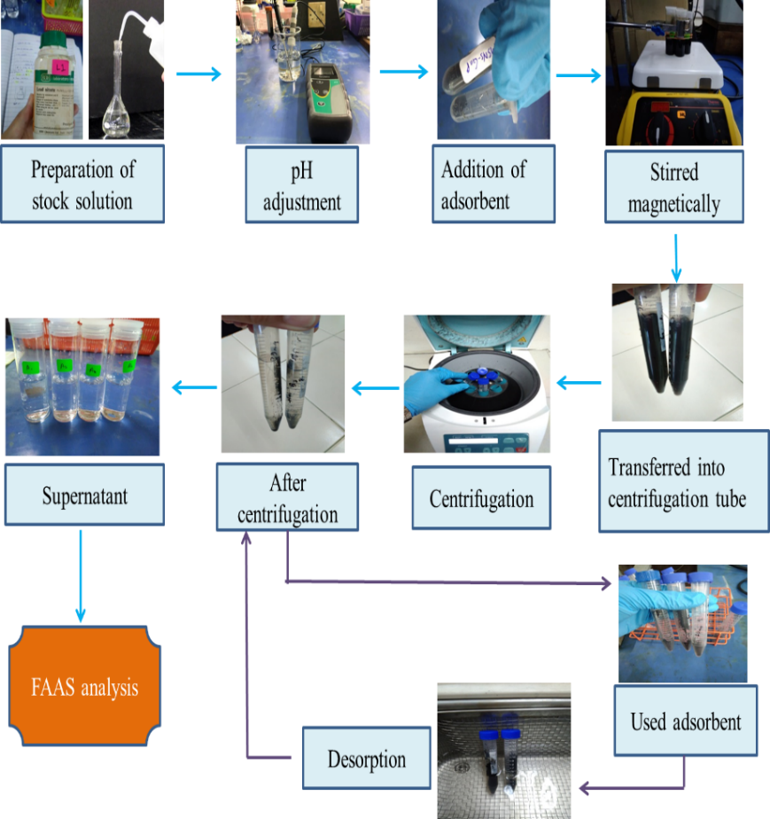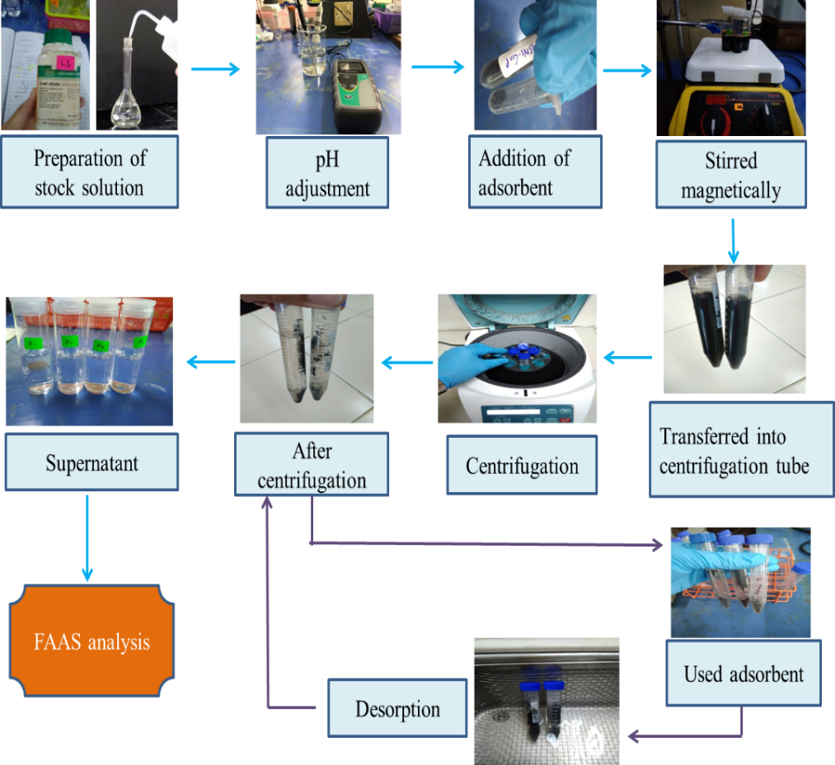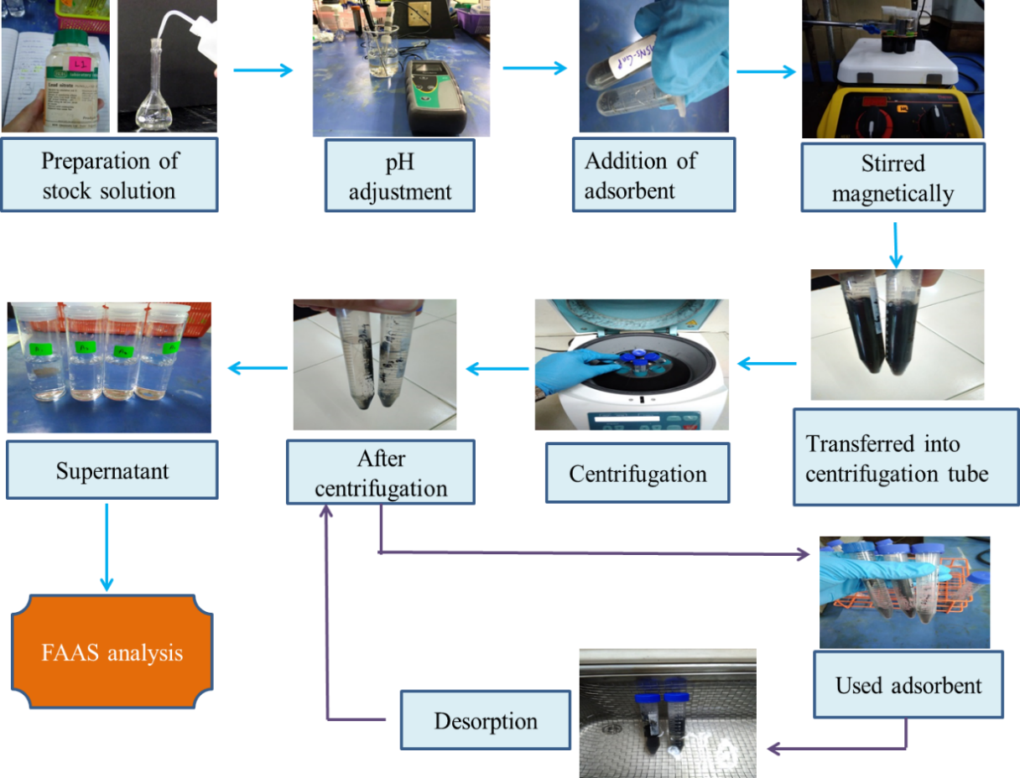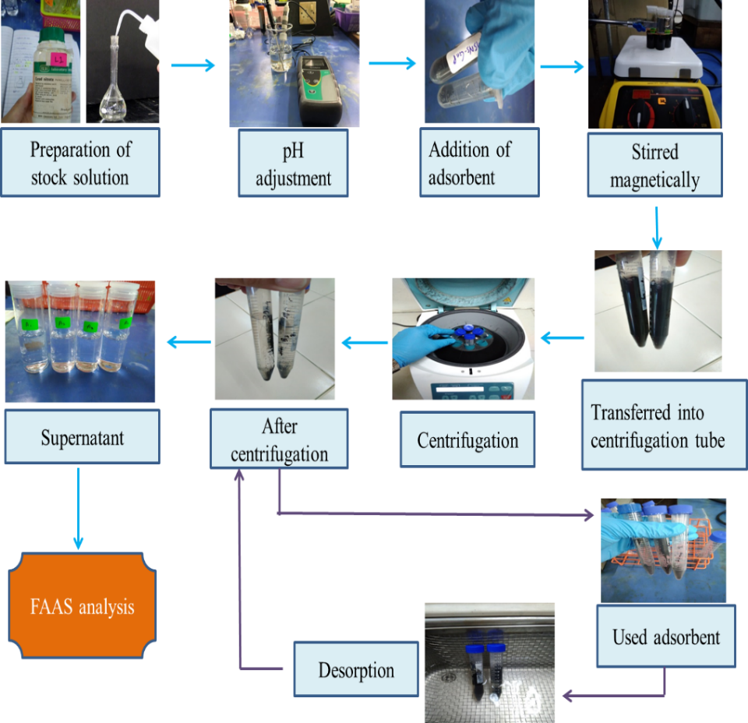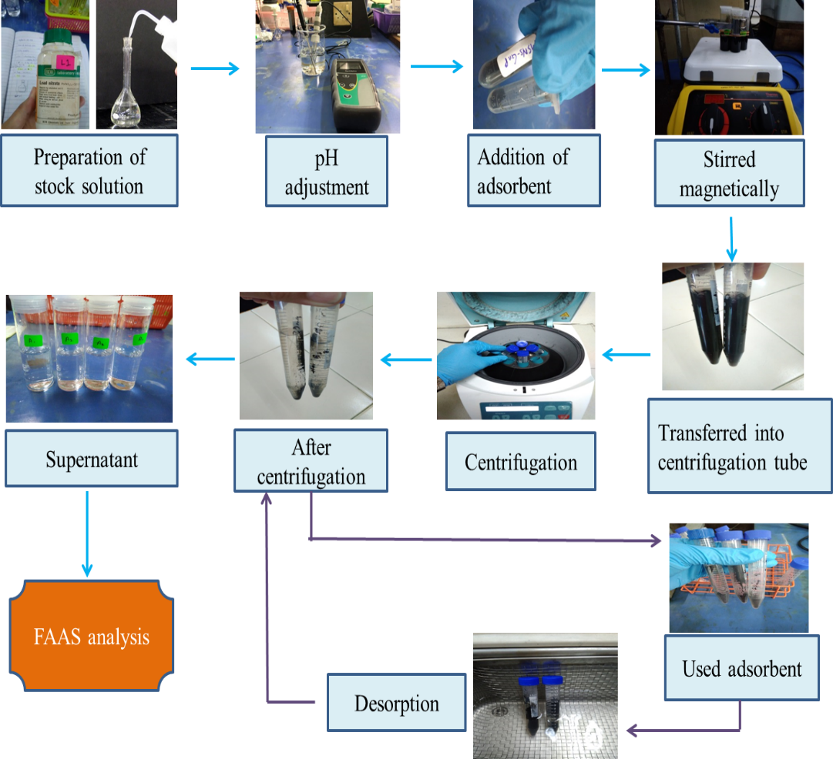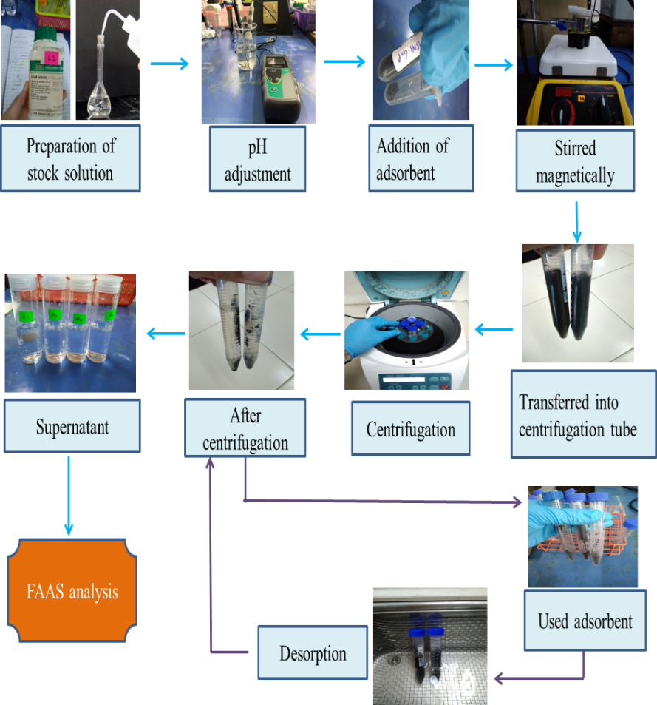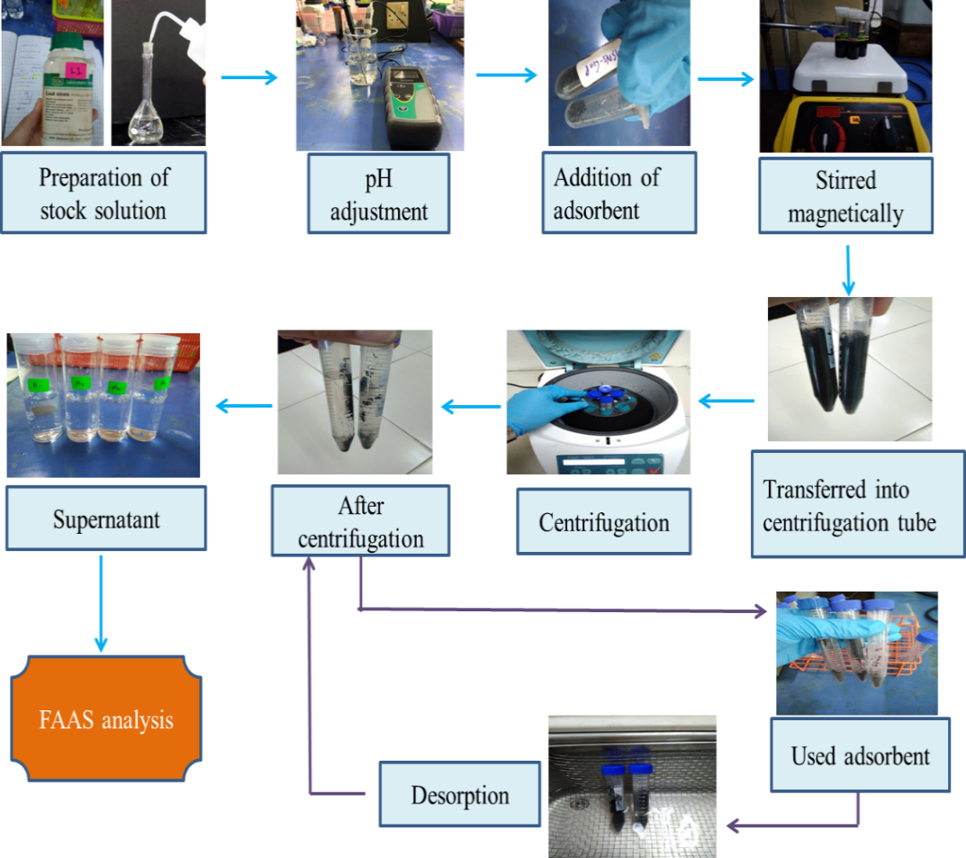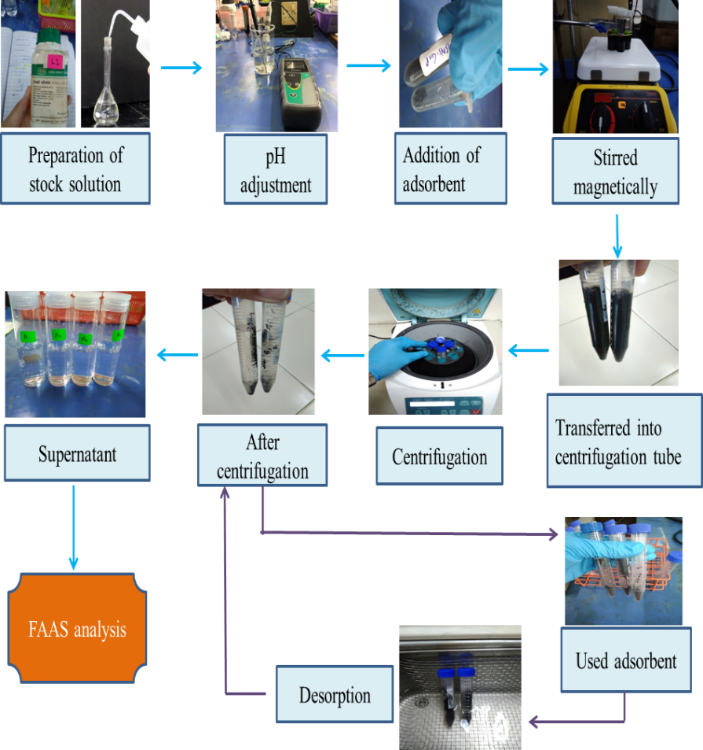
Preparation of
stock solution
pH adjustment
Addition of
adsorbent
Stirred magnetically
Transferred into
centrifugation tube
Centrifugation
After
centrifugation
Supernatant
FAAS analysis

Figure 1. General procedures of batch adsorption study

Results and Discussion

Characterization of the nanoadsorbents
As shown in Figure 4, the chemical functional groups in MSN, GNP, NH₂-MSN and GNP-MSN were determined by FTIR. GNP spectrum has peaks at 3350 cm⁻¹ (O-H stretch), 2800 to 3000 cm⁻¹ (C-H characteristic band due to aliphatic vibrations) and 1710 cm⁻¹ (C=O stretch), whereas aromatic C=C bending at 1540 cm⁻¹, and around 1000 to 1100 cm⁻¹ (C-O stretch). Hence, the chemical functional groups present in GNP were hydroxyl, carboxyl and alkoxy groups. Based on the spectrum analysis shown, both MSN and NH₂-MSN showed peaks at 1060 cm⁻¹ and at 793 cm⁻¹ that indicates the asymmetric vibration and symmetric stretching for Si-O-Si group for both MSN and NH₂-MSN. At 2934 cm⁻¹, stretching vibration of CH₂ appeared due to introduction of methyl group between silylation [10]. Additional band for NH₂-MSN at 1638 cm⁻¹ is the vibration of aliphatic NH₂ bending which indicates the presence of amine group.

According to Mehdinia et al. [8], the presence of amino groups in the adsorbent structure can also cause hydrophilic property of the adsorbent thus increase the removal efficiency. There are several peaks that represent the existence of silica and graphite components in GNP-MSN. The weak peak found on GNP-MSN line graph at 3300 to 3500 cm⁻¹ (-OH antisymmetric stretching vibration) can be deduced that GNP is not reduced completely and still withhold traces of hydroxyl during the hybridization process. Next, a small characteristic band in the range of 2800 to 3000 cm⁻¹ due to (C-H aliphatic) vibrations was observed. The indicators that proved the successful attachment of graphite onto silica was the present of aromatic C=C stretch due to the carbon ring of graphite structure on the GNP-MSN line (1350 to 1550 cm⁻¹), the formation of C-H group in GNP-MSN was found after the bonding of Si-O group from SiO₂ with the epoxide group of the graphite. The breaking of the epoxide group creates a carbanion which was filled with H₊ ions produced from water molecules. The present of C-H group indicated that silica has effectively attached to graphite and the preparation of SiO₂-graphite through hydrothermal method was successful [9]. Moreover, the presence of a broad peak at approximately 1000 to 1250 cm־¹ on the GNP-MSN line attributed to Si-O-C group proved the binding of graphite onto silica. Although this characteristic band also observed on the MSNs line, the band formed on GNP-MSN shows a shift toward the presence of C-O group which happen to be in the same wavelength range. Moreover, the presence of a broad peak at approximately 1000 to 1250 cm־¹ on the GNP-MSN line attributed to Si-O-C group proved the binding of graphite onto silica.

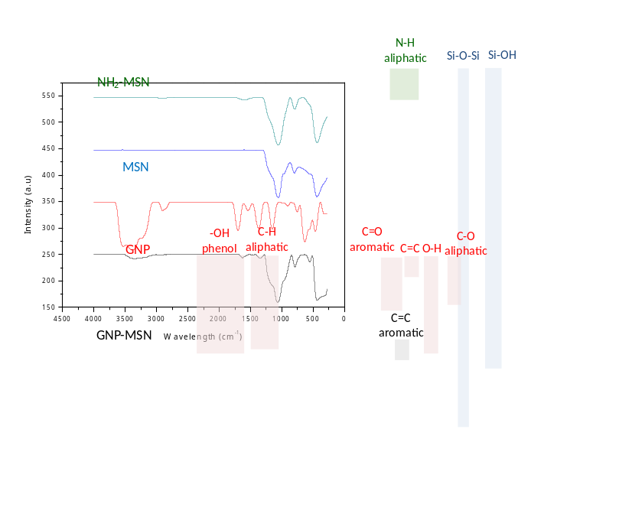

Figure 2. FTIR spectrums of NH2-MSN, MSN, GNP and GNP-MSN

By using Brunner-Emmett- Teller (BET), the surface area, pore size and pore volume of adsorbent was analyzed and summarized in the Table 1.

Table 1. Summary of BET analysis for MSN, NH2-MSN, GNP and GNP-MSN

 | BET Surface Area  (m²/g) | Pore Volume  (cm³/g) | Pore Size (Å)
MSN | 730.50 | 1.44 | 143.47
NH₂-MSN | 258.00 | 0.85 | 78.00
GNP | 741.31 | 1.03 | 67.80
GNP-MSN | 128.41 | 0.19 | 88.12

The decrease in surface area of the hybridized GNP-MSN was probably due to the coating effect of silica onto GNP surface. Moreover, the pore size of GNP-MSN was slightly bigger than the pore size of GNP. This might be due to the effect of MSNs which was able to preserve its pores size and structure due to the existence of the ionic template, C₁₆PyBr. In addition, the decreases in the surface area and pore volume of GNP-MSN also related to the larger particle size of GNP-MSN. The surface area of MSN decreased from 730 m²/g to 258 m²/g and the pore size also decreased from 131 Å to 78 Å after the functionalization on amine group onto the surface of the MSN. This also can be seen in the experiment conducted by He et al. [10] which found that, the surface area, pore size and pore volume of NH2-MSN were lower than that in MSN. This is due to integration of amine groups onto the surface of the pores making the pore size smaller and decrease in surface area [10, 11].

Batch adsorption experiments: Effect of pH on the removal of lead(II) ions
Maximum adsorption was detected at pH 4 for all three nanoadsorbents; GNP, NH₂-MSN and GNP-MSN. At pH values of 1-3, adsorption was unfavorable. Mehdinia et al. [12] claimed that the surface of the GNP could be surrounded by the hydronium ions (H₃O⁺) that hinder lead(II) ions from reaching the binding site on the surface of the GNP. Hence, there is competition between metal cations and hydronium ions (H₃O⁺) or proton (H⁺) on the surface of the adsorbent. As repulsive force present due to like charges, the mentioned ions will be hindered from achieving the adsorbent connection sites [13]. The high concentration of H⁺ and H₃O⁺ protonated from the hydroxyl and carbonyl could out-compete aqueous heavy metal ions for the available adsorbent binding sites at low solution pH, resulting in little or no adsorption [14]. As for higher pH, the precipitation of metal cations in basic medium occur due to formation of metal hydroxides that reduces the adsorption efficiency [3]. For the pH values greater than 4 were not favorable until pH 8, it is because Pb species in water solution could be present in the forms of Pb²⁺, Pb(OH)⁺, Pb(OH)² and Pb(OH)³⁻ which disturb the binding of lead species with GNP [15]. The possibility of precipitation of lead(II) ions as lead hydroxide would occur.

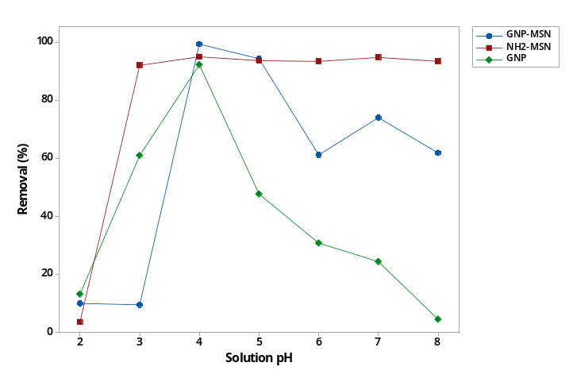

Figure 3. The effect of solution pH on the removal of lead(II) ions by different nanoadsorbents; GNP, GNP-MSN and NH₂-MSN

Effect of adsorbent amount on the removal of lead(II) ions
The adsorption studies of lead(II) ions was then further studied using different amount of adsorbent used with metal solution pH = 4.0. The amount of adsorbent used were 10 mg, 30 mg, 50 mg, 70 mg and 90 mg. According to the trend shown, the removal efficiency was higher and remained constant from 10.0 mg to 30.0 mg. However, the removal efficiency decreases when the amount of both GNP and GNP-MSN at range of 50.0 mg to 90.0 mg. This is due the strong repulsion of the negatively charged adsorbent surface which hindered the proper attachment of lead(II) ions on the active surface. Thus, it can be concluded that the most effective amount of GNP-MSN for the removal of lead(II) ions was in the range of 10.0 mg to 30.0 mg. Since the removal of lead is constant between 10.0 mg to 30.0 mg, therefore, 10.0 mg of GNP and GNP-MSN was further used to carry out the next parameters. The result shown as in Figure 6, the increase in adsorbent amount has increased the adsorption percentage of lead(II) ions for NH₂-MSN. As the adsorbent amount increased, the lead(II) ions removal increases. This is because of the increase of available binding site on the adsorbent. With the increase of amount of adsorbent, available surface area that exposed to active sites for binding metal ions will increased [16]. This would enable more lead(II) ions to be adsorbed by adsorbent, hence resulting in a higher removal percentage. The maximum adsorption was detected which is 98.36% when 50 mg of adsorbent is used the removal of lead(II) ions and decreases gradually to 90 mg.

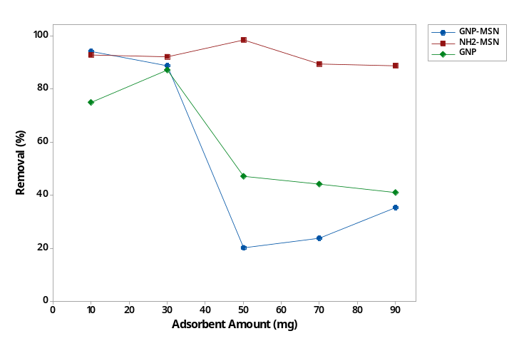

Figure 4. The effect of adsorbent amount on the removal of lead(II) ions by different nanoadsorbents; GNP, GNP-MSN and NH₂-MSN

Effect of initial lead concentration on the removal of lead(II) ions
To study the effects of initial heavy metal ions concentration on the removal efficiency of lead(II) ions, experiments were further carried out at different lead(II) ions concentration of 10, 30, 50, 70, and 90 mg/L under the previously determined optimum conditions. The outcome of the experiments was shown in Figure 7. It was observed that the removal efficiency of lead(II) ions gradually decreases with the increase of the initial concentration of lead(II) ions. At lower concentration of metal ions, the removal efficiency was higher due to the low interaction between ions present in the solution and on the nanoadsorbents surface. Furthermore, at low concentration of the metal ions, the ratio of the lead(II) ions initial mole for the available adsorbent surface area was large. However, at higher concentration, the available adsorption sites decrease. Hence, the ions removal efficiency becomes lesser. Another possible reason for the lower removal efficiency at high concentration of metal ions was the lead(II) ions form outer-sphere complexes with the adsorbent sites, which favor the adsorption when the concentration of the competing ions is decreased. This might indicate that adsorption between the adsorbent and the metal cations were mainly of ionic interaction nature [9]. Thus, the optimal initial concentration of lead(II) ions was selected as 10 mg/L for GNP and GNP-MSN while 30 mg/L for NH₂-MSN.

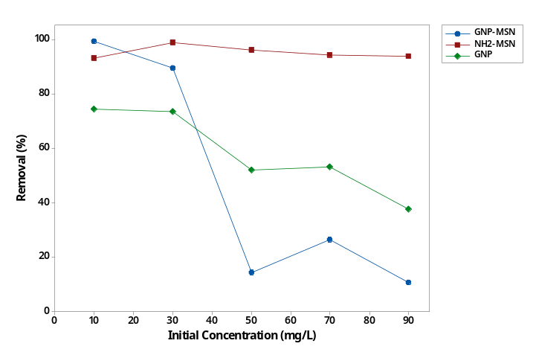

Figure 5. The effect of initial concentration on the removal of lead(II) ions by different nanoadsorbents; GNP, GNP-MSN and NH₂-MSN

Effect of contact time on the removal of lead(ii) ions
The effect of contact time between lead(II) ions and nanoadsorbents was studied with several set of batch adsorption experiment using the previously optimized condition at different time of 20 to 120 minutes. Figure 8 reveals that the percentage removal of lead(II) ion decreased when the contact time increased. The optimum contact time is 20 minutes as the removal was highest at 84.6% for GNP while NH₂-MSN have higher removal (98.74%). In the initial stages of removal efficiency of metal ion by nanoadsorbents increased rapidly due to the abundant availability of active binding sites on the adsorbent, and with gradual occupancy of these sites, the adsorption became less efficient in the later stages [12]. Hence, that means the equilibrium status can be achieved after 20 minutes. The rate of lead(II) ions removal was slow at the first 60 minutes of adsorption process for GNP-MSN. As the stirring time was increased, the removal efficiency of GNP-MSN significantly increases. After 80 min, the removal percentage of lead(II) ions decreased may be caused by desorption process.

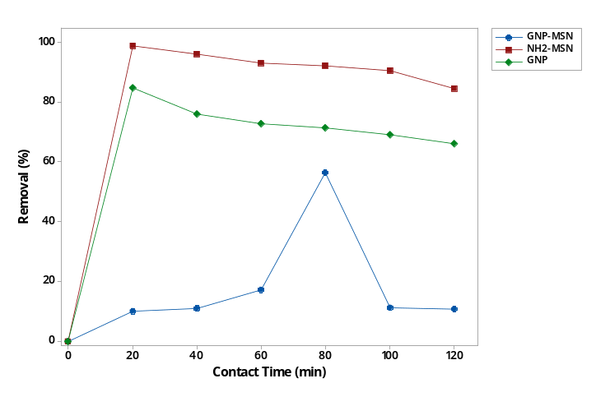

Figure 6. The effect of contact time on the removal of lead(II) ions by different nanoadsorbents; GNP, GNP-MSN and NH₂-MSN

Adsorption kinetic and isotherm studies: Adsorption kinetics
Adsorption kinetic study determines the optimum condition of adsorption and quantify uptake. To determine the adsorption kinetic and rate limiting step, kinetic models which are pseudo-first kinetic order and pseudo-second kinetic order have been proposed to explain the mechanism of lead(II) ions adsorption from aqueous solution onto nanoadsorbents. The adsorption kinetics of lead(II) ions by GNP, NH₂-MSN and GNP-MSN are shown in Table 2. To better understand the adsorption mechanisms involved at different time intervals, pseudo-first-order (PFO) model and pseudo-second-order (PSO) model are used to fit kinetic data [17]. The non-linearized pseudo-first-order rate equation is defined by:

$q_{t}$ = $q_{e}$(1 - $e^{{-k}_{1}t}$ ) (4)

and the non-linearized pseudo-second-order rate equation is:

$q_{t}=\frac{q_{e}^{2}k_{2}t}{1+ k_{2}q_{e}t}$ (5)

where $q_{t}$and $q_{e}$are the equilibrium adsorption amounts of lead(II) ions adsorbed at time t and at equilibrium (mg g־¹) respectively. $k_{1}$ (min־¹) is the constant of PFO rate. Meanwhile, $k_{2}$ (g mg־¹ min) represents the PSO rate constant for the kinetic model. Furthermore, the correlation coefficient, R² values were calculated by using equation (6) in order to determine the best-fitting of the data with the model.

$R²=\frac{∑(q_{e. cal} -{ q}_{e.mean})²}{∑{\left(q_{e,cal} - q_{e.mean}\right)²}^{ }+ ∑(q_{e.cal} - q_{e.exp})²}$ (6)

where $q_{e. exp}$ (mg g־¹) is the amount of ${Pb}^{2+}$ ions adsorbed at equilibrium obtained from Eq. (3). $q_{e.cal}$ (mg g־¹) is the amount of ${Pb}^{2+}$ ions adsorbed determined from the model after using the Solver add-in, and $q_{e.mean}$ (mg g־¹) is the mean value of $q_{e.exp}$values.

Based on Table 2, R² of pseudo-second order for both GNP and NH₂-MSN are 0.9978. Therefore, it can be concluded that the pseudo-second order was preferred to be chosen as the adsorption kinetic model for adsorption of lead(II) ions for both nanoadsorbents which proves that the adsorption occur is chemisorption rather than physisorption. Both PFO and PSO model show a calculated R² value of 0.5298 and 0.5264 for GNP-MSN respectively which suggest the adsorption could be controlled either by physical adsorption or chemical adsorption involving weak intermolecular forces or strong surface complexation of metal ions with oxygen-containing groups on the surface of GNP-MSN [18]. Besides, the rate of the reaction calculated by PFO model is slightly higher compared to the rate of the reaction calculated by PSO model. These outcomes suggest that the adsorption onto GNP-MSN occur through physisorption process rather than chemisorption.

Table 2. Pseudo-first order and pseudo-second order kinetic model for GNP, NH₂-MSN and GNP-MSN

 |  | Pseudo-First Order |  |  | Pseudo-Second Order
 | q_{e} (mg g־¹) |  | K₁ (min־¹) | R² |  |  | q_{e} (mg g־¹) | K₂ (min־¹) | R²
GNP | 0.3975 |  | 0.0068 | 0.8264 |  |  | 0.7306 | 0.1128 | 0.9978
NH₂-MSN | 1.3478 |  | 0.0136 | 0.5956 |  |  | 0.2333 | 0.1247 | 0.9978
GNP-MSN | 6.8100 |  | 0.9900 | 0.5298 |  |  | 7.2000 | 0.1900 | 0.5264

Adsorption isotherm
To determine the adsorption capacity of nanoadsorbents, a constant amount of the adsorbent was equilibrated with various concentrations of lead(II) ions until saturation was achieved. Adsorption isotherms were obtained at 25 °C using an adsorbent amount of 10.0 mg and initial concentration of lead ranging from 10 to 90 mg/L. Langmuir and Freundlich adsorption isotherms were applied to study the adsorption process of the adsorbent. Langmuir isotherm is an empirical model that assumes monolayer formation with adsorption can only occur at a finite number of definite localized site, that are identical and equivalent, with no lateral interaction and steric hindrance between the adsorbed molecules, even on adjacent sites [18]. The non-linear formula of the Langmuir model is defined as follow:

$q_{e}= \frac{q_{m} K_{L}C_{e}}{1+ K_{L}C_{e}}$ (7)

where $q_{m}$ is the maximum monolayer adsorption capacity (mg/g), $q_{e}$ is the equilibrium adsorption amount at heavy metal equilibrium concentration (mg/g), $C_{e}$ is the equilibrium concentration of metals in the solution (mg/L), and $K_{L}$ is the Langmuir adsorption constant (L/mg).

Next, to describe the equilibrium on the heterogeneous surfaces, Freundlich model was used. Freundlich assumed the multilayer adsorption where the non-linearized form of the Freundlich isotherm was calculated by the following equation:

$q_{e}= K_{F}C_{e}^{n}$ (8)

where $C_{e}$ and $q_{e}$ are calculated as above, n is the heterogeneity factor and $K_{F}$ describes the Freundlich constant (L/mg). The values of n can indicate whether the adsorption process is favorable or unfavorable. According to the Freundlich theory, the adsorption isotherm becomes linear when n = 1, favorable when n < 1, and unfavorable when n > 1.

Table 3. Langmuir and Freundlich adsorption isotherm for GNP, NH₂-MSN and GNP-MSN

 |  | Langmuir Adsorption Isotherm |  |  |  | Freundlich Adsorption Isotherm
 | q_{m} (mg/g) |  | K_{L} (mg/L) |  | R² |  |  | K_{F} (mg/g) | 1/n | R²
GNP | 1.113 |  | 2.759 | 0.9995 |  |  |  | 2.718 | 1.739 | 0.9988
NH₂-MSN | 9.230 |  | 0.116 | 0.9997 |  |  |  | 14.320 | 0.032 | 0.9532
GNP-MSN | 33.300 |  | 3.360 | 0.5000 |  |  |  | 23.940 | 0.100 | 0.9800

As shown in Table 3, higher correlation coefficient, R² for Langmuir isotherm was observed, which reflect that Langmuir model was better represent the adsorption of lead(II) ions by GNP and NH₂-MSN over the entire solute concentration range as compared to Freundlich isotherm. Hence, suggesting that the lead(II) ion formed a monolayer coverage on the surface of GNP and NH₂-MSN. This probably due to a homogenous distribution of active site on the GNP, since Langmuir equation assumes that the surface is homogenous [12]. The monolayer coverage of lead(II) ions on the surface of NH₂-MSN increased with increasing lead(II) ions concentration. When the surface of NH₂-MSN was fully covered by lead(II) ions, maximum adsorption capacity was achieved. The correlation coefficient, R² is much higher for Freundlich model compared to Langmuir model which suggested the multilayer formation of the adsorbate on the surface of GNP-MSN. Hence, this result supported the pseudo-second-order kinetic model which suggested that the adsorption of lead(II) ion occur through physisorption process where the interaction between GNP-MSN and the adsorbate are held by Van der Waals forces or dipole-dipole forces. It was found that GNP-MSN performed better as the maximum adsorption capacity for GNP-MSN (23.940 mg/g) was higher compared to NH₂-MSN (9.230 mg/g) and GNP (1.113 mg/g).

Conclusion
Amine-functionalized mesoporous silica nanoparticle (NH₂-MSN) was successfully synthesized using ionic liquid template and post-grafting method while hybrid graphite nanoflakes/mesoporous silica nanoparticles (GNP-MSN) produced via hydrothermal process. GNP, NH₂-MSN and GNP-MSN were able to remove lead(II) ions from aqueous sample as nanoadsorbents. The crucial parameters such as; pH, adsorbent amount, initial concentration and contact time were optimized by batch adsorption study. From the adsorption study, adsorption kinetic and isotherm were then applied to understand the adsorption mechanism of GNP, NH₂-MSN and GNP-MSN. For further research, desorption study and application towards real water samples should be done to determine the reusability of the nanoadsorbents.

Acknowledgement
The authors gratefully acknowledge Universiti Putra Malaysia for the funding through the High Impact Putra Grant (UPM/700-2/1/GBP/2018/9598600).

References

- Ali, I., Basheer, A. A., Mbianda, X. Y., Burakov, A., Galunin, E., Burakova, I. and Grachev, V. (2019). Graphene based adsorbents for remediation of noxious pollutants from wastewater. Environment International, 127(1): 160-180.
- Barakat, M. A. (2011). New trends in removing heavy metals from industrial wastewater. Arabian Journal of Chemistry, 4(4): 361-377.
- Burakov, A. E., Galunin, E. V, Burakova, I. V, Kucherova, A. E., Agarwal, S., Tkachev, A. G. and Gupta, V. K. (2018). Adsorption of heavy metals on conventional and nanostructured materials for wastewater treatment purposes: A review. Ecotoxicology and Environmental Safety. Elsevier Inc.
- Cheah, W. K., Sim, Y. L. and Yeoh, F. Y. (2016). Amine-functionalized mesoporous silica for urea adsorption. Materials Chemistry and Physics, 175: 151-157.
- Deliyanni, E. A., Kyzas, G. Z., Triantafyllidis, K. S. and Matis, K. A. (2015). Activated carbons for the removal of heavy metal ions: A systematic review of recent literature focused on lead and arsenic ions. Open Chemistry, 13(1): 699-708.
- Firdaus, M., Rahman, A., Zaharudin, N. S., Ahmad, H. and Zulkepli, N. N. (2019). Synthesis of hybrid graphite-mesoporous silica nanoplatelet using 1-hexadecylpyridinium bromide ionic liquid as novel template, Journal of Advanced Research in Materials Science, 1(1): 6-14.
- Hao, L., Song, H., Zhang, L., Wan, X., Tang, Y. and Lv, Y. (2012). SiO₂/graphene composite for highly selective adsorption of Pb(II) ion. Journal of Colloid and Interface Science, 369(1): 381-387.
- He, Y., Luo, L., Liang, S., Long, M. and Xu, H. (2017). Amino-functionalized mesoporous silica nanoparticles as efficient carriers for anticancer drug delivery. Journal of Biomaterials Applications, 32(4), 524-532.
- Isa, E. D. M., Ahmad, H. and Rahman, M. B. A. (2019). Optimization of synthesis parameters of mesoporous silica nanoparticles based on ionic liquid by experimental design and its application as a drug delivery agent. Journal of Nanomaterials, 2019: 1-8.
- Karnib, M., Kabbani, A., Holail, H. and Olama, Z. (2014). Heavy metals removal using activated carbon, silica and silica activated carbon composite. Energy Procedia, 50: 113-120.
- Mehdinia, A., Akbari, M., Baradaran Kayyal, T. and Azad, M. (2015). High-efficient mercury removal from environmental water samples using di-thio grafted on magnetic mesoporous silica nanoparticles. Environmental Science and Pollution Research, 22(3): 2155-2165.
- Mehdinia, A., Shegefti, S. and Shemirani, F. (2015). Removal of lead(II), copper(II) and zinc(II) ions from aqueous solutions using magnetic amine-functionalized mesoporous silica nanocomposites. Journal of the Brazilian Chemical Society, 26(11): 2249-2257.
- Mohan, S., Kumar, V., Singh, D. K. and Hasan, S. H. (2017). Effective removal of lead ions using graphene oxide-MgO nanohybrid from aqueous solution: Isotherm, kinetic and thermodynamic modeling of adsorption. Journal of Environmental Chemical Engineering, 5(3): 2259-2273.
- Peng, W., Li, H., Liu, Y. and Song, S. (2017). A review on heavy metal ions adsorption from water by graphene oxide and its composites. Journal of Molecular Liquids, 230: 496-504.
- Taman, R., Ossman, M. E., Mansour, M. S. and Faraj, H. A. (2015). Metal oxide nano-particles as an adsorbent for removal of heavy metals. Journal of Advanced Chemical Engineering, 5(3): 1-8.
- Sheet, I., Kabbani, A. and Holail, H. (2014). Removal of heavy metals using nanostructured graphite oxide, silica nanoparticles and silica/graphite oxide composite. Energy Procedia, 50: 130-138.
- Vojoudi, H., Badiei, A., Bahar, S., Mohammadi Ziarani, G., Faridbod, F. and Ganjali, M. R. (2017). A new nano-sorbent for fast and efficient removal of heavy metals from aqueous solutions based on modification of magnetic mesoporous silica nanospheres. Journal of Magnetism and Magnetic Materials, 441(5): 193-203.
- Zhang, L., Luo, H., Liu, P., Fang, W. and Geng, J. (2016). A novel modified graphene oxide/chitosan composite used as an adsorbent for Cr(VI) in aqueous solutions. International Journal of Biological Macromolecules, 87: 586-596.

