SCREENING OF NATURAL COLOURS FROM VARIOUS NATURAL RESOURCES AS POTENTIAL REUSABLE VISUAL INDICATORS

FOR MONITORING FOOD FRESHNESS

(Saringan Pewarna Semula Jadi Daripada Pelbagai Sumber Semula Jadi Sebagai

Indikator Visual Guna-Semula Untuk Pemantauan Kesegaran Makanan)

Mohd. Zulkhairi Abdul Rahim^{1*}, Nurdiyana Husin², Mohd. Azizan Mohd Noor²,

Zaida Rahayu Yet¹, Mohammad Rashedi Ismail-Fitry³

¹Section of Technical Foundation,

²Section of Bioengineering Technology,

Universiti Kuala Lumpur Malaysian Institute of Chemical & Bioengineering Technology,

Lot 1988, Bandar Vendor, 78000 Alor Gajah, Malacca, Malaysia

³Faculty of Science and Food Technology,

Universiti Putra Malaysia, Serdang, 43400 Seri Kembangan, Selangor

*Corresponding author: mohd.zulkhairi@unikl.edu.my

Abstract

Natural colours have emerged as an alternative source of colours due to the high demand and public sensitivity towards the risk of using synthetic colours. Natural colours are non-hazardous and made from renewable resources, in which the supply is abundant and not harmful to the environment. This study aims to screen naturally-derived colours from butterfly pea, red cabbage, turmeric, and beetroot as visual indicators in monitoring food freshness. The study was carried out in three stages: the extraction of natural colours, the absorption of natural colours on the indicator paper, and the application of visual indicators on the real sample. The results showed that all visual indicators changed their colours towards the spoilage of meat in 24-h monitoring at room temperature. The most significant colour change was observed on the natural colour from butterfly pea compared to other natural resources. HS-SPME-GC-FID analysis confirmed the presence of methylamine as the main volatile compound from the spoiled meat, which contributed to the colour change of the visual indicators. FTIR analysis of useable indicators indicated the presence of amine compound (N-H) that aligned with the result of HS-SPME-GC-FID. The used visual indicators returned to their initial colours and characteristics, which provide the possibility for the fabrication of reusable visual indicators in the future.

Keywords: natural colour, visual indicator, meat freshness

Abstrak

Penggunaan warna semula jadi telah berkembang pesat disebabkan kesedaran pengguna terhadap bahaya pewarna sintetik. Pewarna semula jadi tidak berbahaya dan boleh diperbaharui selain sumber yang mudah didapati serta tidak membahayakan alam sekitar. Kajian ini bertujuan menyaring pewarna semula jadi daripada pelbagai sumber seperti bunga telang, kubis merah, kunyit, dan ubi bit untuk digunakan sebagai indikator visual bagi mengukur kesegaran makanan. Kajian dijalankan dalam tiga peringkat: pengekstrakan pewarna semula jadi, penyerapan pewarna semula jadi ke atas kertas penunjuk, dan penggunaan indikator visual ke atas sampel sebenar. Keputusan kajian menunjukkan kesemua indikator visual berubah warna apabila terdedah kepada daging yang rosak ketika dianalisis pada suhu bilik selama 24 jam. Perubahan warna indikator visual yang paling jelas adalah pada indikator visual yang menggunakan pewarna semula jadi bunga telang. Analisis HS-SPME-GC-FID yang dijalankan menunjukkan kehadiran metilamina yang terhasil ketika proses kerosakan daging. Metilamina menjadi penyebab utama terhadap perubahan warna indikator visual. Analisis FTIR ke atas indikator visual yang baru selesai digunakan menunjukkan kehadiran sebatian amina yang mana selari dengan keputusan analisis HS-SPME-GC-FID. Indikator visual yang telah digunakan menunjukkan perubahan warna kepada warna asal membuktikan kemungkinan fabrikasi indikator visual secara guna-semula pada masa akan datang.

Kata kunci: pewarna semula jadi, indikator visual, kesegaran daging

Introduction

Nowadays, natural colour is important to enhance consumer acceptability as synthetic colour may cause serious health problems and hazardous effect. Natural colours are usually extracted from flowers, leaves, fruits and vegetables, seeds, insects, or algae. A few commonly used natural colours are annatto (seed), turmeric, beet juice (root), bell pepper, red cabbage (vegetable), spinach (leaf), and many more [1]. Other natural foods, such as carrots, pomegranates, grapes, mulberries, spinach, beets, parsley, and flowers are also used as food colouring agents.

The principal natural colours, most of which are used as additives, are carotenoids that give yellow to red colours, green pigment chlorophyll, and also anthocyanins, the pigments responsible for the shiny orange, pink, red, violet, and blue colours in flowers and fruits of some plants. Anthocyanins can be found in different chemical forms depending on the pH of the solution [2]. Beetroot pigments are collectively known as betalains and available in two classes: red betacyanins and yellow betaxanthins, in which both are very water soluble. Over thousands of years, natural colours (saffron, turmeric, and paprika) are used as traditional food colourants. Turmeric is a popular spice and until today it is still one of the principal ingredients in curry powder [1]. The principal colour present in the rhizome of the turmeric plant is curcumin, which is responsible for the yellow colour.

The incorporation of colours as changing indicators or sensing elements into food packaging materials is a new method to alert consumers to the conditions inside a food package. These indicators can facilitate the identification of products that are progressing towards spoilage or that have lost their quality and wholesomeness.

The quality and safety of a food product can be affected at various points during its distribution and transportation. Thus, any mishandling of the food product can have a significant impact on its safety and overall quality. For many consumers, the freshness and quality of a food is determined by the “use by” or “sell by” date that is printed on the package. The insertion of these indicators into packaged food products can help food regulatory bodies to identify the freshness of food products that are unsafe for consumption. Consumers are also beneficiaries of this technology since they will be alerted to the presence of an unsafe product.

Intelligent packaging systems can be helpful to communicate with consumers and provide information about the conditions of the food through a direct visual change. However, the usefulness of the device can be limited if the method of intelligent packaging used to communicate with consumers is not easily recognised. Time-temperature indicators, gas leakage indicators, toxin indicators, and spoilage detectors/freshness indicators are different types of intelligent packaging systems.

One method of communication that seems to work well with consumers is a change in colour in response to a change within the product itself. This change in colour should be sufficiently intense that it is easily recognised by consumers, processors, or government regulatory personnel.

In this study, naturally-derived colours from butterfly pea, red cabbage, turmeric, and beetroot were applied as the visual indicators in monitoring food freshness. Delphinidin, the major blue pigment extracted from butterfly pea, cyanidin from red cabbage, curcumin from turmeric, and betanin from beetroot were extracted using ultrasonic method. The natural colours were subjected for the screening study of the possibility for the fabrication of reusable visual indicators, which are promisingly indicating the freshness of a beef sample. This study used the pH of beef as the indication of freshness, in which the beef is considered fresh at pH 5.8 to 6.2. At pH above 6.5, the beef is considered spoiled, and this pH is a favourable growth condition for microorganisms to decompose the beef [3, 4].

Materials and Methods

Preparation of natural sources

Natural sources (i.e., butterfly pea, red cabbage, turmeric, and beetroot) were dried in an oven at 40 °C for 24 hours. Then, the sources were ground using a grinder and sieved. Powdered natural sources were stored in an air-tight container and kept in desiccators prior to the analysis [5].

Extraction of natural colours using ultrasonic method

10 g of powdered samples was added to 150 mL of water and placed in a beaker. The beaker was placed in an ultrasonic bath and sonicated for 30 minutes at 27–30 MHz and 160 V. After sonication, the contents of the beaker were filtered through a filter cloth to remove solid materials. Then, the filtered extract was centrifuged at 2,000 rpm for 10 minutes and at 4 °C [6]. The extract obtained was stored in a chiller at 4 °C for further analysis.

Analysis of pH on natural colour extracts

1 ml of each extract was added to 5 ml of buffer solutions of pH 1 to 14, and the colour change was observed [7] using a tintometer (Lovibond PFX880) to determine the CIE colour space coordinates, i.e. colour visible to the human eye, as specified by the International Commission on Illumination (Commission Internationale d’Eclairage, CIE) using L*, a*, and b* values. The values of L*, a*, and b* represent lightness, redness, and yellowness, respectively.

Ultraviolet-visible spectra measurement

The absorption spectra of the natural colours were studied using an ultraviolet-visible (UV-Vis) spectrophotometer (Varioskan LUX, ThermoFisher Scientific) for determining the wavelength and absorbance responsible for the difference in the colour of indicator solutions.

Fabrication of anthocyanin-based visual indicator

A visual indicator was made of filter paper (Whatman 42) with the dimension of 4.2 cm × 1.5 cm. The extracts from natural resources were immobilised on the indicator paper using spin-coated method. Seven strips of indicator paper were centrifuged with 15 mL of extracts at 3,000 rpm for 15 minutes and at 4 °C [8]. Then, the indicator was dried using a hair dryer for 15 minutes.

Fourier transform infrared analysis

The Fourier transform infrared (FTIR) spectra of the extracts were determined using the attenuated total reflection (ATR) method [6].

Preparation of beef sample

The semimembranosus muscle was taken from the top (inside) round of a cow carcass with insignificant fat content. The round portion obtained from the carcass was immediately kept in a cooler box and transported to the laboratory. Each portion obtained from the carcass was divided into 20 g of beef sample and placed in a sealed container.

Response of anthocyanin visual indicators towards beef

The visual indicators were placed inside the container of the beef sample, where the indicators were in direct contact with the atmosphere inside the container and then stored at room temperature (25 ± 1°C) for 24 hours. This method was used to make sure that there would be no effect from external atmospheric conditions. For the control, the visual indicator was placed inside a container without the beef sample. The distinct colour change of the indicator from the initial to the final stage was used as the measurable response of change. The colour changes on the indicator were checked using a hand-held colorimeter (Chroma Meter CR-10, Minolta Inc., Japan) to determine the CIE colour space coordinates (L*, a*, b*, and ΔE*). Here, ΔE* (i.e., colour change) was used as the indicator response for the colour changes of the visual indicator (in arbitrary units) that was calculated as [(a*2+b*2)0.5] [9].

Extraction of volatile compounds by headspace solid-phase microextraction-gas chromatography-flame ionisation detector

The volatile extraction by HS-SPME-GC-FID was carried out according to the modified method of Ma [10]. The volatile components in the beef sample were adsorbed onto a 50/30 μm layer of divinylbenzene-carboxen-polydimethylsiloxane (Supelco Co., Bellefonte, USA) fibre that was exposed to the sample headspace for 30 minutes. After extraction, the SPME device was removed from the headspace vial and inserted directly into the injection port of the GC-FID. The SPME fibre was immediately thermally desorbed for 3 minutes at 250 °C in the SPME specific liner of the injector port of GC-FID and a HP-Innowax column. The oven temperature was held for 2 minutes at 40 °C, increased to 250 °C at 5°C/min, and held again for 3 minutes at this temperature, with nitrogen as the carrier gas.

Measurement of pH on beef sample

The pH of the beef sample was measured using a potable pH meter (LAQUAtwin, Horiba) with a flat sensor as the electrode. The beef sample was placed on the measuring electrode and the pH values were recorded.

Statistical analysis

The results from multiple samples were reported using analysis of variance (ANOVA) from Minitab software by means of the average values ± standard deviation. The data were analysed and the differences among mean values were processed by the Duncan's multiple range tests. The significance was defined at p < 0.05.

Results and Discussion

Extraction of natural colours

Figure 1 shows the colours of Clitoria ternatea (CT), Brassica oleracea (BO), Curcuma longa (CL), and Beta vulgaris (BV) extracted using water. The pH of the natural colours was observed at pH 5.93, 6.40, 7.55, and 4.85, respectively. The colour space value for each extract is tabulated in Table 1. The colour values of CT, BO, CL, and BV are different as shown by the L*, a*, and b* values. BV extract was the lightest among all extracts whereas CT extract was the most concentrated extract, as indicated by the L* value. The L* coordinate indicates the darkness or lightness of a colour and ranges from black (0) to white (100). The coordinates a* and b* indicate colour directions: +a* is the red direction, -a* is the green direction, +b* is the yellow direction, and -b* is the blue direction. Based on the values of a* and b*, the colours observed were purple, light purple, yellow, and light red for CT, BO, CL, and BV, respectively.

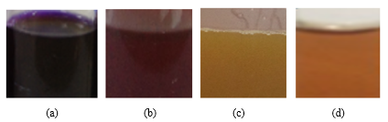

Figure 1. Natural colours for (a) CT, (b) BO, (c) CL, and (d) BV

Table 1. Values of colour space coordinates of the extracts

Extracts | Colour Value
Extracts | L* | a* | b*
C. ternatea | 17.78 ± 0.16 | 32.15 ± 0.16 | -25.53 ± 0.11
B. oleracea | 28.14 ± 0.01 | 42.58 ± 0.04 | 46.11 ± 0.13
C. longa | 41.57 ± 1.44 | 13.82 ± 0.35 | 50.88 ± 0.28
B. vulgaris | 43.13 ± 0.03 | 50.80 ± 0.06 | 40.12 ± 0.16

Characterisation study: pH analysis

Figure 2 shows the colour of CT, BO, CL, and BV extracts at distinct pH. The extracts from CT and BO showed a very significant colour change over the pH range. The trend of colour change was similar for CT and BO extracts; at pH 1–2, the colour was red, which then shifted to purple at pH 3–6, followed by blue at pH 7, turned to green at pH 8–10, and above pH 11, the colour changed to yellow. Specifically, for the CL extract, the colour maintained in yellow at acidotic pH and became brown at a higher degree of alkalinity. On the other hand, the BV extract showed colour change from brown at low pH and gradually turned to light yellow at alkaline pH. This pH analysis demonstrated the possibility of the extracts to respond towards beef freshness, which require detection towards pH changes.

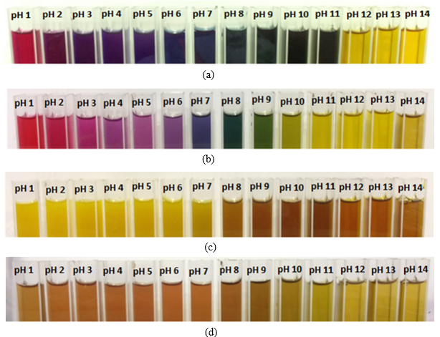

Figure 2. Natural colours of (a) CT, (b) BO, (c) CL, and (d) BV at different pH values

Characterisation study: UV-Vis analysis

The UV-Vis spectra of natural colours from CT, BO, CL, and BV are shown in Figure 3. Different levels of absorption are shown along the spectrum of wavelengths. The maximum wavelengths at the maximum absorbance (λ_{max}) obtained were at 568, 540, 419, and 540 nm for CT, BO, CL, and BV, respectively. The lambda maximum refers to the wavelength along the absorption spectrum where the substance has its strongest photon absorption. The wavelength at which the absorbance is highest is the wavelength in which the solution is most sensitive to concentration changes. The absorbance measurements are made at the lambda maximum because this is where the standard calibration is linear and where the element is identified.

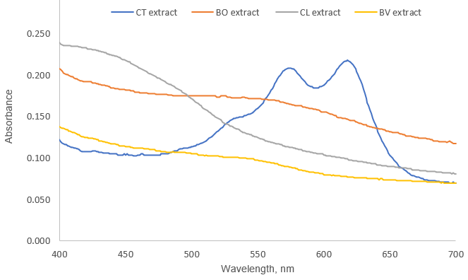

Figure 3. UV-Vis spectra of all extracts

Characterisation study: IR spectra of anthocyanin extracts

In the FTIR spectra of anthocyanin extracts (Figures 4 and 5), broad peaks appeared at 3100–3600 cm⁻¹, which are assigned to the fundamental stretching vibration of O-H hydroxyl groups. The absorption bands observed at 1640 cm⁻¹ correspond to aromatic C=C. In the FTIR spectra of anthocyanin compounds (i.e. delphinidin and cyanidin), obvious peaks appeared at 1000–1300 cm⁻¹, which belong to ether C-O. The same trend of FTIR spectroscopy was described on the anthocyanin study by Wahyuningsih [11]. These FTIR peaks are indicative of anthocyanins like cyanidin and delphinidin [6, 11]. Besides, the FTIR spectrum of BV extract showed an amine peak at 1650–1580 cm⁻¹ and carboxylic acid at 1440–1395 cm⁻¹, which reflect the compounds in betanin.

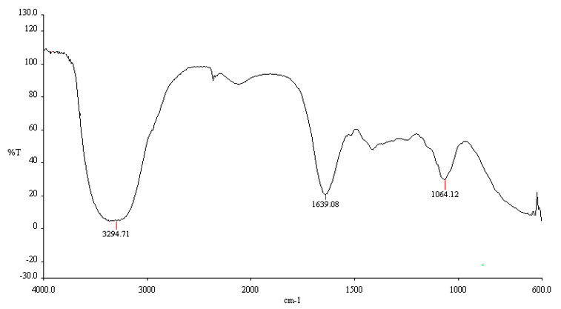
(a)

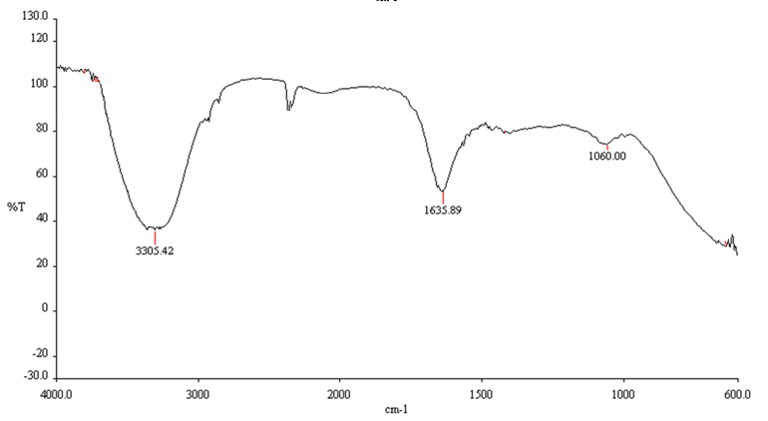
(b)

Figure 4. FTIR spectra of CT extract (a) and BO extract (b)

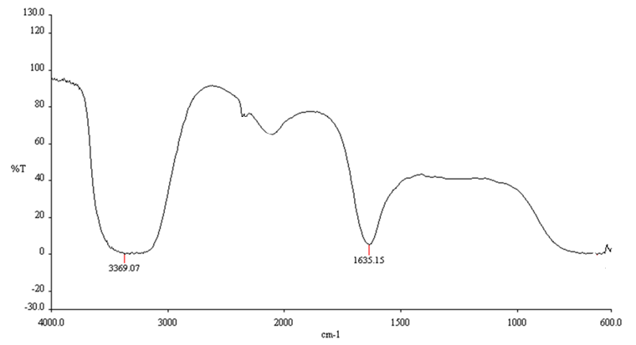
(a)

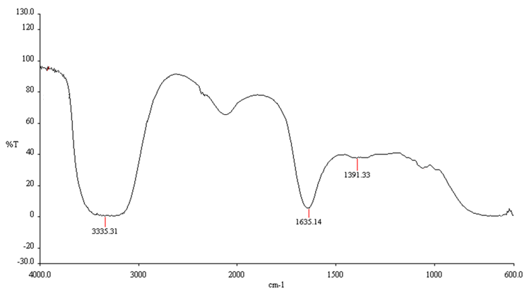
(b)

Figure 5. FTIR spectra of CL extract (a) and BV extract (b)

Response of visual indicators towards the freshness of beef sample

The response of the indicators towards a beef sample is shown in Figure 6. The results showed that at room temperature, the visual indicators changed their initial colour (purple for CT and light purple for BO) to green when the pH of the meat exceeded pH 6.5. Meanwhile, the visual indicators for CL and BV changed the initial colour from yellow and light pink to reddish orange and dark pink, respectively. The developed visual indicators were found sensitive to volatile compounds in the air since the indicators were not in direct contact with the beef sample and successfully indicated the freshness levels of the beef sample from the beginning (fresh) to spoiled beef. The change in colour is due to the increased concentration of volatile compounds released by the spoiled beef [9, 12]. The indicator response for CL followed a similar trend observed by Kuswandi [13] on a spoiling shrimp sample.

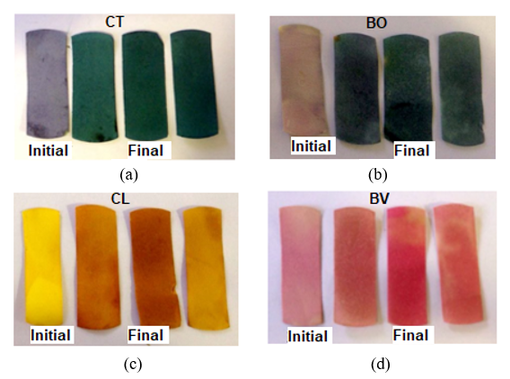

Figure 6. Initial and final indicator response towards beef spoilage: (a) CT indicator, (b) BO indicator, (c) CL indicator, and (d) BV indicator

Analysis on volatile compounds released from spoiled beef using HS-SPME-GC-FID

HS-SPME-GC-FID was successfully applied to extract the volatile compounds from a beef sample. A complete extraction was achieved after 30 minutes of exposure. Figure 7 shows a chromatogram of the volatile compounds of beef sample after 24 hours at room temperature. The compounds were identified by comparing their retention time with those of pure standards. Both results recorded a main peak at the same retention time (i.e. at 1.2 minutes), which indicated the presence of the same compound. The main volatile compound released by beef was detected as methylamine. Methylamine is produced by the microbial activity that contributes to beef spoilage [14].

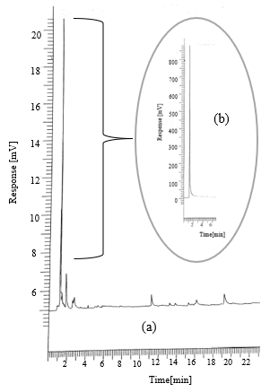

Figure 7. GC chromatogram of volatile compounds from (a) beef sample and (b) standard methylamine

IR spectra of visual indicators

Figure 8 presents the FTIR spectra of visual indicators for CT, BO, CL, and BV. The result was compared between (a) a plain indicator (i.e., without colour), (b) initial visual indicators (i.e. immobilised with colours), (c) final visual indicators after exposure on the beef sample (i.e. at room temperature), and (d) used visual indicators (i.e. after 24 hours removed from the beef container and exposed to air). It was found that all spectra (c) for CT, BO, CL, and BV showed the appearance of a broad peak at 3100–3600 cm⁻¹, which is assigned to the fundamental stretching vibration of O-H hydroxyl groups together with the N-H group. Besides, the spectra (c) for all types of indicators (CT, BO, CL, and BV) also showed another peak of the N-H group at 1633 cm⁻¹. These results are aligned with the HS-SPME-GC-FID analysis that detected the presence of methylamine as the volatile compound released from the beef sample. Subsequently, the used visual indicators (spectra (d) for all natural sources of CT, BO, CL, and BV) were observed without the presence of any N-H group and the indicators returned to their initial colour (dark purple, purple, yellow, and pink, respectively). These results indicate the possibility for the fabrication of reusable visual indicators in the future.

Overall colour values of visual indicators

The colour values for all visual indicators are tabulated in Table 2. The comparison of colour difference was done using Tukey's multiple comparison test, which is one of the several tests that can be used to determine which means amongst a set of means differ from the rest [15]. The Tukey's test showed that the initial colour values for all visual indicators were significantly different (p < 0.05) with the final colour values of the visual indicators. However, all colour values turned to insignificant difference (p > 0.05) after the indicators were removed from the container, except for BV. The visual indicator made of BV showed a significant difference (p < 0.05) with the initial visual indicator due to the faded colour of BV. These results provide the possibility for the visual indicators (CT, BO, and CL) to be reusable and can be recycled after the first use.

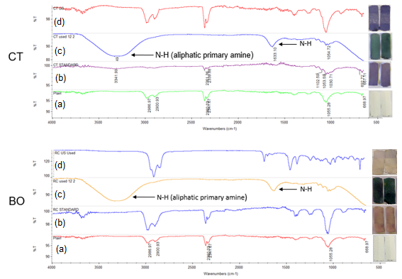

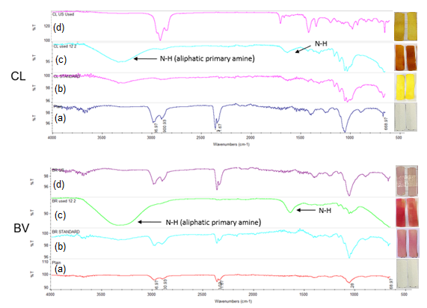

Figure 8. FTIR spectra of the visual indicators from CT, BO, CL, and BV. [(a) a plain indicator (i.e. without colour), (b) initial visual indicators (i.e. immobilised with colours), (c) final visual indicators after exposure on the beef sample (i.e. at room temperature), and (d) used visual indicators (i.e. after 24 hours removed from the beef container and exposed to air)]

Table 2. Colour values of the visual indicators of CT, BO, CL, and BV (Different superscripts in the same line indicate significant differences (p < 0.05) according to the Tukey's test)

Natural Colour | Colour Value
Natural Colour | Initial Visual Indicator | Final Visual Indicator | Used Visual Indicator
CT | L* 47.99 ±1.30ª    a* 16.15 ± 1.15ª  b* -24.59 ± 0.44ª | L* 41.99 ± 1.69^{b}    a* -9.52 ± 0.40^{b}  b* -24.44 ±0.43^{a,b} | L* 53.32 ± 0.69^{a,c}  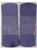  a* 11.86 ± 1.19^{a,c}  b* -22.18 ± 0.61^{a,c}
BO | L* 84.26 ± 0.58ª    a* -4.87 ± 1.69ª  b* 53.93 ± 1.05ª | L* 77.80 ± 0.28^{b}  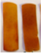  a* 1.1 ± 0.29^{b}  b* 41.2 ± 0.59^{b} | L* 81.68 ± 1.69^{a,c}  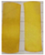  a* -6.29 ± 0.96^{a,c}  b* 49.4 ± 1.15^{c}
CL | L* 65.00 ± 1.29ª    a* 16.60 ± 0.64ª  b* -13.08 ± 0.27ª | L* 41.59 ± 1.13^{b}  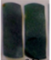  a* 4.35 ± 0.31^{b}  b* -12.75 ± 0.56^{b} | L* 70.00 ± 1.29^{a,c}    a* 15.40 ± 0.40^{a,c}  b* -10.75 ± 0.25^{a,c}
BV | L* 64.11 ± 0.68ª    a* 27.33 ± 0.94ª  b* 4.55 ± 0.43ª | L* 55.88 ± 1.09^{b}  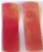  a* 20.84 ± 1.18^{b}  b* 12.97 ± 0.46^{b} | L* 80.24 ± 0.24^{c}  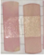  a* 30.35 ± 0.69^{a,c}  b* 2.69 ± 0.87^{a,c}

Conclusion

This work employs natural colours from butterfly pea, red cabbage, turmeric, and beetroot as sensing elements for the detection of volatile compounds produced during the spoilage of beef sample. The natural colour visual indicators successfully displayed the progress of deterioration of beef sample in terms of colour changes. The visual indicators using CT and BO colours demonstrated the most significant colour change during spoilage detection. The amine compound released from the beef sample was detected on all visual indicators during spoilage detection and disappeared when the visual indicators were exposed to the environment without the amine compound. The disappearance of amine compound from the visual indicators made it possible for the indicators to be reusable as the colours of visual indicators returned to their initial colour. The proposed visual indicators could offer an extra analytical device to both meat industries and retailers that are interested in approaches and devices that are reusable, safe, low-cost, simple, rapid, disposable, non-destructive, and with real-time applications.

Acknowledgement

The authors gratefully thank Majlis Amanah Rakyat (MARA) for the funding under “Skim Geran Penyelidikan Inovasi MARA” and Universiti Kuala Lumpur Malaysian Institute of Chemical and Bioengineering Technology (UniKL Micet) for supporting this project.

References

- Sharma, D. (2014). Understanding biocolour- A review. International Journal of Scientific & Technology Research, 3(1): 294-299.
- Suppadit, T., Sunthorn, N. and Poungsuk, P. (2011). Use of anthocyanin extracted from natural plant materials to develop a pH test kit for measuring effluent from animal farms. African Journal of Biotechnology, 10(82): 19109-19118.
- Kim, H. J., Kim, D., Kim, H. J., Song, S. O., Song, Y. H. and Jang, A. (2018). Evaluation of the microbiological status of raw beef in Korea: Considering the suitability of aerobic plate count guidelines. Korean Journal for Food Science of Animal Resources, 38(1): 43-51.
- Meat & Livestock Australia (2011). Meat standards australia beef information kit. Access from https://www.mla.com.au/globalassets/mla-corporate/marketing-beef-and lamb/msa_tt_beefinfokit_jul13 _lr.pdf [Access online on 9 October 2017].
- Rabeta, M. S. and Nabil, Z. A. (2013). Total phenolic compounds and scavenging activity in Clitoria Ternatea and Vitex Negundo Linn. International Food Research Journal, 20(1): 495-500.
- Mishra, P. K., Singh, P., Gupta, K. K., Tiwari, H. and Srivastava, P. (2012). Extraction of natural dye from Dhalia variabilis using ultrasound. Chemical Engineering, 37: 1-18.
- Saptarini, N. M., Suryasaputra, D. and Nurmalia, H. (2015). Application of butterfly bea (Clitoria ternatea Linn) extract as an indicator of acid-base titration. Journal of Chemical and Pharmaceutical Research, 7 (2): 275-280.
- Shukla, V., Kandeepan, G. and Vishnuraj, M. R. (2015). Development of on-package indicator sensor for real-time monitoring of buffalo meat quality during refrigeration storage. Food Analytical Methods, 8(6): 1591-1597.
- Kuswandi, B., Jember, U., Jayus, J. and Jember, U. (2015). Simple and low-cost on-package sticker sensor based on litmus paper for real-time monitoring of beef freshness. Journal of Mathematical and Fundamental Sciences, 47(1): 236-251.
- Ma, Q. L., Hamid, N., Bekhit, A. E. D., Robertson, J. and Law, T. F. (2013). Optimization of headspace solid phase microextraction (HS-SPME) for gas chromatography mass spectrometry (GC-MS) analysis of aroma compounds in cooked beef using response surface methodology. Microchemical Journal, 111: 16- 24.
- Wahyuningsih, S., Wulandari, L., Wartono, M. W., Munawaroh, H. and Ramelan, A. H. (2017). The effect of pH and color stability of anthocyanin on food colorant. IOP Conference Series: Materials Science and Engineering, 193(1): 012047.
- Shukla, V., Kandeepan, G., Rajan, M. and Arvind, V. (2016). Anthocyanins based indicator sensor for intelligent packaging application. Agricultural Research, 5(2): 205-209.
- Kuswandi, B., Jayus, Larasati, T. S., Abdullah, A. and Heng, L. Y. (2012). Real-time monitoring of shrimp spoilage using on-package sticker sensor based on natural dye of curcumin. Food Analytical Methods, 5 (4): 881-889.
- Dave, D. and Ghaly, A. E. (2011). Meat spoilage mechanisms and preservation techniques: A critical review. American Journal of Agricultural and Biological Science, 6(4): 486-510.
- Bland, J. M. and Altman, D. G. (1995). Tukey multiple comparison test. British Medical Journal of Clinical Nursing, 310(8): 299-304.

