COMPUTATIONAL STUDIES ON NONLINEAR OPTICAL PROPERTIES OF METAL COMPLEXES CONTAINING AZOBENZENE

(Kajian Pengkomputeran Sifat Optik Tidak Linear Terhadap Sebatian Komplek

Logam yang Mengandungi Azobenzena)

Pang Siew Woon¹, Suhaila Sapari², Juan Matmin¹, Fazira Ilyana Abdul Razak^{1*}

¹ Faculty of Science,

Universiti Teknologi Malaysia,

81200 Skudai, Johor Bahru, Malaysia

²Centre for Advanced Materials and Renewable Resources,

Faculty of Science and Technology,

Universiti Kebangsaan Malaysia,

43600 UKM Bangi, Selangor, Malaysia

*Corresponding author: fazirailyana@utm.my

Abstract

Ruthenium complexes containing different azobenzene derivatives with different substituents provide different nonlinear optical (NLO) properties. A computational study through the Hartree-Fock (HF) method based on a 3-21G level and the density functional theory (DFT) methods based on LANL2DZ/6-31G level were used in the investigation to reduce cost and time of the experimental investigation. It was discovered that DFT-based calculations were more accurate than the HF method based on the result of bond length and bond angle obtained after the geometry optimization of three ruthenium-azobenzene complexes; complex A, complex B, and complex C. The investigation through the DFT method revealed that the three complexes possess a high NLO property based on the value of total frequency-dependent first hyperpolarizability, β_{tot} obtained at the wavelength of 1064 nm contributed by the electron delocalization effect, due to the presence of a strong electron donating and withdrawing group in the azobenzene derivatives. It was revealed that Complex C possessed the highest NLO property with a β_{tot} value of 12414.87 x10⁻³⁰ esu followed by complex A (11828.63x10⁻³⁰ esu) and Complex B (3372.10 x10⁻³⁰ esu). The influence of the different structures of azobenzene containing metal to enhance the strength of nonlinear optical properties through NLO calculation has been successfully performed by the DFT method. The high NLO property of complex C was contributed by the -O(C=O)R group, which is a moderate electron-donating group (EDG) and an amine group, which is a strong EDG especially when its hydrogen group is replaced by the alkyl group.

Keywords: nonlinear optic property, ruthenium complex, azobenzene, Hartree Fock, density functional theory

Abstrak

Komplek ruthenium yang mengandungi terbitan azobenzena pada kumpulan pembolehubah yang pelbagai memberikan sifatoptik tidak linear yang berbeza. Kajian pengkomputeran menggunakan kaedah Hartee-Fock (HF) dengan set asas 3-21G dan teori fungsi ketumpatan (DFT) dengan set asas LANL2DZ/6-31G telah dijalankan bagi mengurangkan kos dan masa yang digunakan dalam kaedah experimen. Hasil pengiraan menunjukkan pengiraan menggunakan kaedah DFT adalah lebih tepat berbanding menggunakan kaedah HF, berdasarkan nilai panjang ikatan dan sudut ikatan yang diperolehi untuk tiga sebatian komplek ruthenium-azobenzena; komplek A, B, dan C. Pengiraan menggunakan DFT menunjukkan ketiga-tiga sebatian ini memberikan sifat optik tidak linear (NLO) yang tinggi berdasarkan nilai jumlah dinamik kebergantungan frekuensi pertama, β_{tot} pada panjang gelombang 1064 nm yang berpunca daripada kesan penyahsetempatan elektron dengan kehadiran kumpulan penderma yang kuat dan kumpulan penarik yang kuat pada terbitan azobenzena. Sebatian komplek C memberikan nilai β_{tot} tertinggi iaitu 12414.87x10⁻³⁰ esu diikuti dengan sebatian A (11828.63x10⁻³⁰ esu) dan B (3372.10 x10⁻³⁰ esu). Perubahan pada perbezaan struktur terbitan azobenzene yang mengandungi logam dapat dilihat meningkatkan sifat optik tidak linear sebatian berdasarkan pengiraan NLO yang telah dijalankan menggunakan kaedah DFT. Dapat dilihat sebatian komplek C menunjukkan sifat optik tidak linear (NLO) yang tinggi disebabkan kehadiran kumpulan -O(C=O)R yang merupakan kumpulan penderma elektron dan kumpulan amina sebagai kumpulan penderma eletron yang kuat terutamanya setelah kumpulan hidrogen digantikan dengan kumpulan alkil.

Kata kunci: sifat optik tidak linear, komplek ruthinium, azobenzena, Hartree Fock, teori fungi ketumpatan

Introduction
In a nonlinear optic material (NLO), the oscillation of electrons will eventually become anharmonic as an intense light source travels through the material, thus causing changes in the properties of light, such as frequency, amplitude, or polarization [1]. This situation is due to the distortion of the spatial distribution between the electrons and the nucleus in the materials [2]. NLO materials are widely used in various types of applications, such as data storage, processing of information, and medical diagnostics such as the use of second harmonic imaging microscopy (SHIM) [3]. Second harmonic generation (SHG) is based on the second order NLO effect, which can be related to the frequency-dependent first hyperpolarizability, β. It is also called frequency doubling, a nonlinear optical process, in which photons interacting with a nonlinear material are effectively combined to form new photons having twice the frequency of the initial photons [4].

Hyperpolarizability is normally shown by the compound with a high charge transfer and strong electron delocalization effect, such as azobenzene with an electron-donating or accepting substituent. Although organic materials have fast and large non-linear responses over a broad frequency range, inherent synthetic flexibility, and large optical damage threshold, they have weaknesses such as volatility and low thermal stability [2]. Inorganic materials with a good chemical and mechanical property usually show a lower NLO efficiency; hence, metal complexation is needed to overcome this weakness. Ruthenium complex has been studied widely in NLO investigations due to its strengths, such as synthetic accessibility, chemical and thermal stability, and the reversibility of the Ru(II)/Ru(III) redox couple [5]. The electron-rich d⁶ of Ru(II) centers are especially well-suited to be used as NLO materials due to the high polarizable d orbitals and effective π-electron-donating properties [6]. This study shows the medium that can convert new photons at an excitation wavelength of 532 nm as NLO materials.

Materials and Methods
The experiment was divided into two stages. The first step was the determination of the potential of Hartree-Fock (HF) and density functional theory (DFT) method for computational investigation. The software GaussView5 was used to draw and visualize the complexes, while Gaussian16 was used to perform calculations. Geometry optimization was done on the three surveyed azobenzene-ruthenium complexes by using the unrestricted HF method at the basis set of 3-21G, and unrestricted DFT method at the level of B3LYP/LANL2DZ/6-31G (B3LYP/GENECP) with the keyword “OPT”. The three complexes were formed through the combination of Ru complex, L with three azobenzene derivatives, and X (Figure 1). For the DFT method, the LANL2DZ basis set was used for ruthenium metal, while 6-31G was used for the other atoms in the complex.

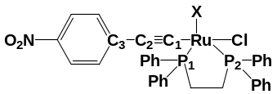 | 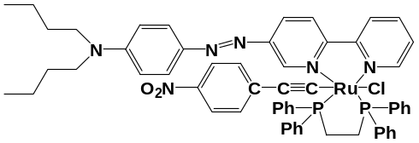
Complex L | Complex A
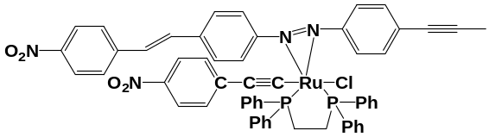 | 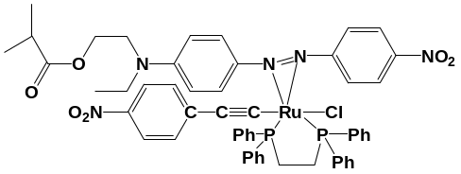
Complex B | Complex C
Figure 1. Studied Complexes

After geometry optimization, the bond length, bond angle, and bond energy of the complexes were analysed. The second stage was determining the influence of the different structures of azobenzene containing metal to enhance the strength of NLO properties through NLO calculation. All three optimized complexes obtained through the method that could provide a more accurate geometry structure were used to perform the first hyperpolarizability calculation at 1064 nm with the level of B3LYP/LANL2DZ/6-31G. This step was done by using the keyword “polar=gamma” with the combination of “CPHF=RdFreq” in the job tab [7]. After the calculation, information such as dipole moment (µ), total frequency-dependent first hyperpolarizability, β_{tot} for SHG (2ω; ω, ω) at the wavelength of 1064 nm, and energy for HOMO and LUMO were extracted. The β_{tot} was calculated by using the following equation [8]:

β_{tot} = (β_{x}² + β_{y}² + β_{z}²)^{0.5} (1)

β_{tot} = [(β_{xxx} + β_{xyy} + β_{xzz})² + (β_{yyy} + β_{yxx} + β_{yzz})² + (β_{xxx} + β_{xyy} + β_{xzz})² + (β_{zxx} + β_{zyy} + β_{zzz})²]^{0.5} (2)

Results and Discussion

Geometry Optimization
The selected bond length (Table 1) and bond angle (Table 2) for the optimized ruthenium complexes were elucidated by using numbering, and the label of the atom is shown in Figure 1. From this study, all the bond length calculated by the HF method had a percentage deviation of 0.21% to 11.18%, and for those calculated by the DFT method, the percentage deviation was between 0.37% and 7.48%. From the average percentage deviation calculated using equation 3, it was found that the DFT (2.42%) method provided a more accurate bond length as compared to HF (4.07%). The average percentage deviation of bond angle obtained after the optimization process done by the HF method (2.26%) was slightly lower than the DFT method (2.34%). The percentage deviation of bond angle obtained through the HF method was between 0.01% and 4.68%, whereas for the DFT method, the percentage deviation was between 0.23% and 7.46%. The higher deviation of bond angle calculated by DFT method from the experimental value mainly presented by the Cl-Ru-C₁ angle in Complex B was presumably due to the steric effect of the large molecular azobenzene derivative. The accuracy of the bond angle obtained from HF and DFT methods were in agreement with literature study, and further calculations for non-linear optic (NLO) properties were performed using the DFT method at a wavelength of 1064 nm [9].

Percentage deviation = | Calculated value - Experimental value | X 100 % | (3)
Percentage deviation = | Experimental value | X 100 % | (3)

Table 1. Selected bond length (Å)
Bond | Complex A |  | Complex B |  | Complex C |  | Exp [10]
Bond | HF | DFT | HF | DFT | HF | DFT | Exp [10]
Ru-Cl | 2.622 | 2.619 | 2.601 | 2.556 | 2.627 | 2.607 | 2.500
Ru-C₁ | 2.100 | 1.993 | 2.085 | 1.993 | 2.088 | 1.995 | 1.986
C₁-C₂ | 1.211 | 1.242 | 1.209 | 1.240 | 1.209 | 1.240 | 1.206
C₂-C₃ | 1.423 | 1.416 | 1.424 | 1.418 | 1.424 | 1.417 | 1.442
Ru-P₁ | 2.612 | 2.488 | 2.490 | 2.455 | 2.563 | 2.468 | -
Ru-P₂ | 2.650 | 2.501 | 2.594 | 2.359 | 2.524 | 2.404 | -
Ru-P_{ave}ª | 2.631 | 2.495 | 2.542 | 2.407 | 2.544 | 2.436 | 2.367

ªRu-P_{ave} is the average value of angle of Ru-P₁ and Ru-P₂

Table 2. Selected bond angle (º)

Bond | Complex A |  | Complex B |  | Complex C |  | Exp [8]
Bond | HF | DFT | HF | DFT | HF | DFT | Exp [8]
Cl-Ru-C₁ | 171.22 | 169.71 | 167.96 | 163.05 | 169.08 | 170.17 | 176.20
Ru-C₁-C₂ | 173.84 | 172.80 | 176.03 | 173.97 | 175.27 | 174.84 | 175.30
C₁-C₂-C₃ | 178.41 | 178.74 | 179.85 | 179.48 | 179.52 | 178.45 | 174.40
P₁-Ru-P₂ | 79.17 | 81.22 | 82.68 | 83.79 | 81.87 | 83.10 | 82.91
P₁-Ru-C₁ | 87.65 | 87.36 | 86.17 | 85.62 | 86.83 | 86.94 | -
P₂-Ru-C₁ | 89.00 | 89.09 | 88.10 | 89.17 | 88.22 | 87.28 | -
P_{ave}-Ru-C₁ª | 88.32 | 88.23 | 87.14 | 87.40 | 87.52 | 87.11 | 89.63

ªP_{ave}-Ru -C₁ is the average value of angle of P₁-Ru -C₁and P₂-Ru -C₁.

For both HF and DFT methods, the molecular energy of complex B (-8242.67 a.u for HF method and -3954.84 a.u for DFT method) was the highest, followed by complex A (-8246.97 a.u and -3959.45 a.u) and complex C (-8336.86 a.u and -4049.93 a.u.). The huge difference obtained between DFT and HF was due to the DFT method provide a greater number of Gaussian functions that were used to describe the inner shell orbital [11]. Besides that, the ability of DFT to include a large part of the dynamic electron correlation function allowed the processing of an accurate result in the evaluation of molecular properties [12]. Generally, a higher-energy molecule is a molecule with a high number of atoms. However, complex B that had a smaller number of atoms, which was 114, had a higher energy value than complex A (127) and complex C (121). This was presumably due to the presence of three benzene rings in the azobenzene derivative of complex A and complex B that resulted in both compounds having a similar value of molecular energy as compared to complex C, which had only 2. The higher energy of complex B may also be due to its smaller angle of N-Ru-N’ (26.82° for HF method; 28.42° for DFT method) as compared to complex C (30.47°; 34.52°) and A (76.72°; 78.20°).

The higher molecular energy calculated by the DFT method was due to the principle of DFT theory where the total energy of a molecule is a function of an electron density surrounding the nuclei. Also, the contribution of total energy is based on five properties, which are kinetic and potential energy, the Coulomb repulsion among the electrons, exchange energy due to the Pauli exclusion principle, and correlation energy [13].The higher accuracy based on the result of bond length and bond angle was also due to the inclusion of correlation energy in the DFT method and the use of a higher basis set.

NLO calculation
The complexes used in this calculation were chosen from those optimized by the DFT method since it was able to provide a more accurate geometry structure. Based on the result as shown in Table 3, the higher the dipole moment of the complexes, the higher the total frequency-dependent first hyperpolarizability, which indicates a higher NLO property. This is because a molecule with a higher dipole moment has a higher redistribution of electron density, which leads to a greater charge transfer [14]. Dipole moment in a molecule is generally due to the separation of charge and the difference of electronegativities in the structure; hence, a molecule with a high dipole moment has a higher redistribution of electron density and greater charge transfer. From the result, all three complexes can be predicted as possessing a high NLO property when compared to other ruthenium complexes in which study by Karakas et al. (2013) provided the value of β_{tot} is 957 x 10⁻³⁰ esu. [15]. Complex C had the highest NLO property and an almost similar NLO property as complex A, while complex B had the lowest NLO property. However, this property can be related to the HOMO-LUMO energy gap and the dipole moment of the molecules.

Table 3. The dipole moment and the value of first hyperpolarizability
Property | Complex
Property | A | B | C
Dipole moment, µ (D) | 11.39 | 6.37 | 16.34
First hyperpolarisability, β (x10⁻³⁰esu)
β_{xxx} | -13.76 | -255.84 | 699.28
β_{xyy} | -44.43 | -68.62 | -4422.28
β_{xzz} | -294.53 | -77.27 | 235.86
β_{yyy} | -38.07 | 200.05 | 326.25
β_{yxx} | 32.01 | 142.72 | -38.32
β_{yzz} | 5.99 | 259.95 | -17.66
β_{zxx} | -982.07 | -520.69 | 540.44
β_{zyy} | -472.28 | 82.74 | -6280.57
β_{zzz} | -2777.19 | -641.68 | -1165.16
β_{x} | -807.38 | -1695.73 | -3931.73
β_{y} | -355.05 | 2371.33 | -2116.38
β_{z} | -11795.70 | -1694.80 | -11584.10
β_{tot} | 11828.63 | 3372.10 | 12414.87

It is hypothesized that the high NLO property calculated for the three complexes can be contributed by the presence of phosphine ligand and carbon-carbon triple bond in the ruthenium complex. The presence of this ligand has caused the formation of back donation of the ruthenium metal and metal-to-ligand charge transfer effect (MLCT). The presence of azobenzene further enhanced the NLO property of the complex. The remaining valence electrons from the σ orbital of nitrogen can be donated to the metal to form a σ bond, whereas the non-bonding d-orbitals of the metal can be donated to the π* orbitals of the nitrogen molecules in the azobenzene group to form π bond [16]. The electron delocalization and resonance effect in the aromatic system of the azobenzene is high, and it can be strengthened by the introduction of a suitable group inside the system.

Complex C with a high NLO property consisted of -O(C=O) R group, a moderate electron-donating group (EDG), and an amine group, which is a strong EDG, especially when its hydrogen group is replaced by the alkyl group. Another benzene ring of the azobenzene group was bonded to a strong electron-withdrawing group (EWG), which is the nitro group. Hence, the pull-and push electron effect in this azobenzene is very high. For complex A, there was a strong EDG bonded to one side of the azobenzene, which was a tertiary amine that consisted of two linear butyl substituents, whereas another side was a bipyridine group. The benzene group usually serves as the weak EDG group. The nitrogen atom in the aromatic system also induced an electron-withdrawing effect. This smaller NLO property of complex B was presumably due to the presence of two alkyl groups, which was a weak EDG on each side of the azobenzene derivatives. Although there was a strong presence of EWG of nitro group in one of the benzene groups, the effect on electron delocalization of the azobenzene group was small as it was too far from the azobenzene.

Figure 2 shows the HOMO (highest occupied molecular orbital) and LUMO (lowest unoccupied molecular orbital) energy level of the complexes. The LUMO and HOMO energy of complex A (-0.09827 and -0.17047), complex B (-0.11408 and -0.19018), and complex C (-0.12662 and -0.18347) obtained was used to calculate the HOMO-LUMO energy by calculating their difference. Based on the results, as the value of energy gap (E_{gap}) decreases, the NLO properties increases. This is because a smaller HOMO-LUMO energy gap (E_{gap}) enables a higher charge transfer within the electron delocalization system. Besides, the frontier molecular analysis shows that the charge transfer of the complexes happened from the push azobenzene derivatives to pull the ruthenium linear fragment. This is indicated by the higher electron density at the donor part in HOMO and the acceptor part in LUMO. The electron density is higher at the azobenzene derivatives in HOMO distribution and at the linear fragment of Cl-Ru-aryl alkynyl in LUMO distribution.

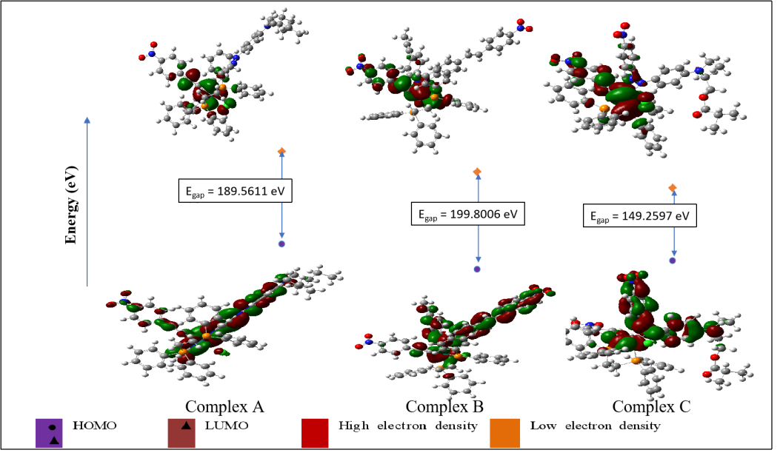
Figure 2. The HOMO and LUMO energy level of the studied complex

Conclusion

The geometry optimization of the studied complexes was successfully done for both methods. It is found that the DFT method provided a more accurate result based on the result of bond length and bond angle as compared to the HF method, as the DFT method includes electron correlation in the calculation. Through the DFT method, it is found that complex C had the highest NLO property, followed by complex A and complex B. This property can be related to the HUMO-LUMO energy gap and the dipole moment of the molecules. The formation of MLCT effect in the complexes and the presence of EDG and EWG in the azobenzene derivative enhance the NLO property of the complex.

Acknowledgement

The authors acknowledge the Faculty of Science, UTM, and the Centre for Information and Communication Technology (CICT), UTM for supporting and providing facilities and services of high-performance computing to reduce the investigation time. Funding from Universiti Teknologi Malaysia under the grant of Tier 1 (Vot Q.J130000.2526.20H08) and the Fundamental Research Grant Scheme (FRGS, Vot R.J130000.7826.4F957) from the Ministry of Higher Education, Malaysia supported this work. We also would like to acknowledge the valuable help and suggestions provided by our colleagues.

References
- Lind, P. (2007). Organic and organometallic compounds for nonlinear absorption of light. Phd Thesis, Umeå University, Sweden.
- Suresh, S., Ramanand, A., Jayaraman, D. and Mani, P. (2012). Review on theoretical aspect of nonlinear optics. Review Advance Material Sciences, 30: 175-183.
- Adur, J., Carvalho, H. F., Cesar, C. L., and Casco, V. H. (2014). Nonlinear optical microscopy signal processing strategies in cancer. Cancer Informatic,13: 67-76.
- Li, A. D. and Liu, W. C (2010). Optical properties of ferroelectric nanocrystal/polymer composites. Physical Properties and Applications of Polymer Nanocomposites, 108-158.
- Sahraoui, B., Luc, J., Meghea, A., Czaplicki, R., Fillaut, J. L. and Migalska-Zalas, A. (2009). Nonlinear optics and surface relief gratings in alkynyl–ruthenium complexes. Journal of Optics A: Pure and Applied Optics, 11(2) :1-26.
- Papadopoulos, M. G., Sadlej, A. J. and Leszczynski, J. (2006). Non-linear optical properties of matter. Springer, Dordrecht.
- Foresman, J. B. and Frisch Æ. (2015). Exploring chemistry with electronic structure methods. Gaussian Inc., Wallingford, CT.
- Baseia, B., Osório, F., Lima, L., and Valverde, C. (2017). Effects of changing substituents on the non-linear optical properties of two coumarin derivatives. Crystals, 7(6): 158-172.
- Jamaludin, R. (2018). Nonlinear optical properties investigation of ruthenium arylalkynyl complexes via Hartree-Fock and density functional theory methods. PhD Thesis, Universiti Teknologi Malaysia, Skudai.
- Younus, M., Long, N. J., Raithby, P. R., Lewis, J., Page, N. A., White, A. J., Williams, D. J., Colbert, M. C.B., Hodge A. J., Khan, M. S. and Parker, D. J. (1999). Synthesis and characterisation of mono-acetylide and unsymmetrical bis-acetylide complexes of ruthenium and osmium: X-ray structure determinations on [(dppe)₂Ru(Cl)(C≡C–C₆H₄-p-NO₂)],[(dppe)₂Ru(Cl)(C≡C–C₆H₃-o-CH₃-p-NO₂)] and [(dppm)₂Os (C≡C–C₆H₄-p-CH₃)(C≡C–C₆H₄-p-NO₂)]. Journal of Organometallic Chemistry, 578(1-2) :198-209.
- Lewars, E. G. (2010). Computational chemistry: Introduction to the theory and applications of molecular and quantum mechanics. New York: Springer Science & Business Media.
- Oprea, C. I. (2007). Density functional response theory with applications to electron and nuclear magnetic resonance. Doctoral dissertation. KTH Royal Institute of Technology, Sweden.
- Chachiyo, T. and Chachiyo, H. (2017). Simple and accurate exchange energy for density functional theory. Cornell University, New York.
- Bartashevich, E. and Tsirelson, V. (2013). Atomic dipole polarization in charge-transfer complexes with halogen bonding. Physical Chemistry Chemical Physics, 15(7): 2530-2538.
- Karakas, A., Dag, T., Taser, M., Fillaut, J., Migalska-Zalas, A. and Sahraoui, B. (2013). Second-order hyperpolarizability and susceptibility calculations of a series of ruthenium complexes. 15th International Conference on Transparent Optical Networks (ICTON). 23-27 June. Cartagena, Spain: ICTON, pp. 1-4.
- Chatt, J. (1969). Nitrogen complexes of the platinum metals. Platinum Metals Review,13: 9-14.

