THE INFLUENCE OF Pd NANOPARTICLE SIZE ON Pd/TiO₂ CATALYSTS FOR CINNAMALDEHYDE HYDROGENATION REACTION

(Pengaruh Saiz Nanopartikel Pd pada Pemangkin Pd/TiO₂ untuk Tindak Balas

Hidrogenasi Sinnamaldehid)

Norli Abdullah¹*, Hasliza Bahruji², Fadhlina Che Ros³, Imran Syakir Mohamad⁴

¹Department of Chemistry and Biology,

Centre for Defence Foundation Studies,

National Defence University of Malaysia,

Sungai Besi Camp, 57000 Kuala Lumpur, Malaysia

²Centre of Advanced Material and Energy Sciences,

Universiti Brunei Darussalam,

Jalan Tungku Link, BE 1410, Brunei Darussalam

³Department of Physics,

Centre for Defence Foundation Studies,

National Defence University of Malaysia,

Sungai Besi Camp, 57000 Kuala Lumpur, Malaysia

⁴Faculty of Mechanical Engineering,

Universiti Teknikal Malaysia Melaka,

Hang Tuah Jaya, 76100 Durian Tunggal, Melaka, Malaysia

*Corresponding author: norli.abdullah@upnm.edu.my

Abstract

Palladium nanoparticles (PdNP) supported onto the anatase phase of TiO₂ were successfully synthesised using a colloidal method. This synthesis method involved the reduction of K₂PdCl₄ solution by NaBH₄ at different temperatures (1, 25, 50, 75 ºC) and stabilised with PVA ligand. Transmission electron microscope (TEM) was used to determine the particle size of PdNP on the TiO₂. Colloidal synthesis at 1 ºC and 25 ºC produced PdNP with less than a 3 nm diameter, whereas when the synthesis temperatures were higher than 25 ºC, PdNP were produced with a size larger than 4 nm. The catalytic activity of Pd/TiO₂ was significantly improved when palladium (Pd) was produced at 1 ºC with high selectivity towards the hydrogenation of cinnamaldehyde to hydrocinnamaldehyde. The conversion and selectivity trends from the cinnamaldehyde hydrogenation reaction demonstrated the influence of Pd nanoparticle size to provide active sites for the reduction of C=C and C=O bonds. Pd with a diameter of 2.58 nm favoured hydrogenation of C=C bond to produce high selectivity towards hydrocinnamaldehyde, meanwhile a large Pd diameter > 4 nm allowed simultaneaous reduction of C=C and C=O bonds to give comparable selectivity between hydrocinnamaldehyde and hydrocinnamylalcohol.

Keywords: palladium nanoparticles, cinnamaldehyde hydrogenation

Abstrak

Nanopartikel palladium (PdNP) yang disokong pada fasa anatase TiO₂ telah berjaya disintesis dengan kaedah koloidal. Kaedah sintesis ini melibatkan penurunan larutan K₂PdCl₄ oleh NaBH₄ pada kumpulan suhu yang berbeza (1, 25, 50, 75 ºC) dan distabilkan menggunakan ligan PVA. Mikroskop elektron transmisi (TEM) digunakan untuk mengukur saiz partikel PdNP di atas pemangkin. Sintesis koloid pada suhu 1 ºC dan 25 ºC menghasilan PdNP kurang daripada 3 nm, manakala suhu lebih tinggi dari 25 ºC menghasilkan PdNP lebih besar daripada 4 nm. Aktiviti pemangkinan Pd/TiO₂ meningkat dengan ketara apabila palladium (Pd) dihasilkan pada 1 ºC dengan pemilihan yang tinggi terhadap hidrogenasi sinamaldehid ke hidrosinamaldehid. Trend penukaran dan pemilihan dalam tindak balas hidrogenasi sinamaldehid menunjukkan pengaruh diameter saiz nanopartikel dalam menyediakan tapak aktif untuk penurunan ikatan C=C dan C=O. Pd dengan diameter 2.58 nm lebih menyukai hidrogenasi ikatan C=C untuk menghasilkan pemilihan tinggi terhadap hidrosinamaldehid, manakala saiz Pd berdiameter > 4nm membenarkan penurunan ikatan C=C dan C=O secara serentak untuk memberikan persamaan pemilihan antara hidrosinamaldehid dan hidrosinamilalkohol.

Kata kunci: palladium nanopartikel, hydrogenasi sinamaldehid

Introduction
Noble metal nanoparticles deposited on metal oxide support (TiO₂, Al₂O₃, ZrO₂, CeO₂) exhibit a huge role as heterogenous catalysts for various industrial applications. Heterogeneous catalysts based on metal nanoparticles contribute towards the production of commercially valuable products such as environmental remediation, synthesis of fine chemicals, hydrogen gas production, and biomass processing [1, 2]. Palladium (Pd) metal nanoparticles show high catalytic ability towards hydrogenation reaction, whereas TiO₂ is widely utilised as heterogenous support due to its pysical and chemical stability in acidic and oxidative environments [3]. TiO₂ exists in three different phases, namely anatase, rutile, and brookite. With anatase, TiO₂ has been frequently utilised as a catalyst support due to strong interaction with metal nanoparticles [4]. Supported metal nanoparticles (NPs) have attracted huge interests in the field of heterogeneous catalysis due to their unique optical, electronic, and catalytic properties in comparison with their larger counterparts. Tailoring metal NPs allow the optimisation of catalytic performance for a given process, with the metal particle size, shape, and structure dictating the overall catalytic performances [5].

A colloidal method for the preparation of NPs provides a reliable pathway to control the nanoparticles’ growth and improve the dispersions of nanoparticles.The colloidal method involves metal reduction using reduction agents such as hydrazinem sodium borohydride and sodium citrate with the addition of stabilisers to avoid particle agglomeration [6, 7]. Polyvinylpyrrolidone (PVP) is used to stabilise palladium (Pd) nanoparticles to form different shapes and sizes; for example, the octahedrons (24 nm), tetrahedrons (22 nm), and cubes (20 nm) nanoparticles are obtained by reducing Pd in ethanol with the addition of hydrochloric acid. High concentration of inorganic ligand stabliser to control the size and shape of Pd nanoparticles leads to the appearance of various irregular sizes and shapes of Pd [8]. Many attempts have been made to develop suitable catalysts for selective hydrogenation of α, β-unsaturated aldehydes and the challenge is not only faced by the industrial sector but also the scientific communities.

Hydrogenation of cinnamaldehyde (CAL) produces variations of products resulting from the hydrogenation of olefin bond (C=C) and/or aldehyde functionality (C=O). Hydrogenation at the C=C bond leads to the formation of hydrocinnamaldehyde (HCALD), meanwhile hydrogenation at the C=O site produces cinnamyl alcohol (COL). Further hydrogenation of these two partially hydrogenated products produces hydrocinnamyl alcohol (HCALC) [9]. Small Pd particles shows high selectivity towards C=C hydrogenation reaction to HCALD, while large Pd particles catalyse the reduction of C=O to produce HCALC [10]. In the early work by Xu Yang et al. [11], they successfully obtained nearly 100% conversion with 80% selectivity towards HCALD using Pd nanoparticles entrapped in titanate nano-tubes. On the other hand, Arai et al. [12] obtained 87% HCA selectivity and 100% CA conversion using Pd/C catalyst. The small diameter of Pd granules over the multiwalled carbon nanotubes (MWCNTs) leads to a high catalyst activity, and results in a better hydrogenation performance for C═O bonds than that for C═C bonds.

In this study, the influence of Pd nanoparticles supported on the anatase phase of TiO₂ was investigated as catalysts for the hydrogenation reaction of cinnamaldehyde. PdNP were prepared using the colloidal method with in-situ reduction of Pd carried out at different reaction temperatures. The effect of temperature variation on the distribution of nanoparticles was correlated with the catalytic activity of cinnamaldehyde hydrogenation.

Materials and Methods

Potassium tetrachloropalladate (II) K₂PdCl₄ (99.99% purity) was purchased from Johnson Matthey. Cinnamaldehyde C₉H₈O (>99% purity), Sodium borohydrate NaBH₄ (>96% purity), Polyvinylalcohol (80% hydrolysed), and TiO₂ anatase phase were supplied by Sigma-Aldrich. Toluene as solvent for the catalytic reaction was purchased from MERCK. Deionised water was used in all of the experiments. Supported Pd/TiO₂ were prepared using a modified colloidal method with various reduction temperatures in order to tune the Pd particle size diameter. In a beaker, a 500 mL aqueous solution of K₂PdCl₄ of the desired concentration was stirred for 15 minutes at different temperatures (1, 25, 50, 75 ºC). Then, freshly prepared aqueous solutions of PVA were added into the beaker and continued to be stirred for 10 minutes. This was followed by adding drop-wise freshly prepared 0.1 M aqueous solutions of NaBH₄. The reduction of Pd occured when the solution turned dark brown upon 30 minutes of stirring. After completion of reduction, TiO₂ powder was added to the above mixture under vigorous stirring at 900 rpm. The amount of support TiO₂ required was calculated to achieve final metal loadings of 1 wt.%. The mixtures were acidified to pH 1-2 by sulphuric acid before they were stirred for 60 minutes to accomplish immobilisation of the PdNP onto the Titania support. The colloid was washed with distilled water and dried overnight prior to analysis and catalytic reaction.

Table 1. Experimental conditions for the synthesis of Pd/TiO₂ catalysts

Temperature  (°C) | Solvent | Theoretical wt.%  Pd loading | Sample  Coding
1 | H₂O | 1 | PdA1
30 | H₂O | 1 | PdA2
50 | H₂O | 1 | PdA3
75 | H₂O | 1 | PdA4

Catalysts characterisation
Formation of the colloidal-reduced Pd was analysed by a UV-Vis spectroscopy. UV-Vis spectra (200-800 nm, Shimadzu UV-1800 spectrometer) of the Pd precursor and corresponding reduced Pd solution were recorded in a quartz cuvette after 15 and 30 minutes of process generation. Samples for examination by a transmission electron microscope (TEM) were prepared by first dispersing the catalyst powder in ethanol using ultra-sonication for 30 minutes before dropped on to a holey carbon film supported by a 300 mesh copper TEM grid where the solvent was allowed to evaporate. The samples for TEM were then examined using a JEOL JEM 2100 TEM model operating at 200 kV.

Catalytic activity
Catalytic hydrogenation of cinnamalydehyde was carried out in 50 ml autoclave. The reactor pot was added with 50 mg of catalyst, 5 mg of trans-cinnamalydehyde (purity >98%, Aldrich), and 20 mL toluene used as solvent. The reactor was flushed three times with He gas and repeated using pure H₂ gas before it was pressurised to the desired pressure of 9 bars. The reaction time was taken once the reactor reached 323 K. The reaction was allowed for 2 hours. Product analysis was performed using a Shimadzu gas chromatography (GC) equipped with a flame ionisation detector. The calculation of cinnamaldehyde conversion and the product selectivity are defined respectively in the following equations:

$Conversion \left(\%\right)= \frac{{[Cal]}_{0}-{\left[Cal\right]}_{t}}{{[Cal]}_{o}} ×100$ (1)

$Selectivity of product X \left(\%\right)=\frac{{[X]}_{t}}{{[X]}_{t}}×100$ (2)

Results and Discussion
The UV-Vis spectrometer was used to monitor the transition of metal precursor salt, K₂PdCl₄ to Pd metal nanoparticles during the colloidal synthesis with NaBH₄ as the reduction agent. Figures 1(a)-(b) show the UV-Vis spectra of the aqueous solution of K₂PdCl₄ as well as the Pd colloidal suspension after reduction with NaBH₄ at 1, 25, 50, and 75 ºC. Figure 1 (a) presents the UV-Vis spectra of Pd aqeuous solution prepared at 1ºC and 25 ºC that exhibited absorption band at 208 nm (peak) and 236 nm (shoulder). This indicates the adsorption of ligand to the metal via charge transfer between the halide-metal and the metal halide in [PdCl₄]²⁻, respectively [13,14]. The disappearance of these two bands in the colloidal solution specified the reduction of Pd²⁺ precursor to Pd⁰. The K₂PdCl₄ solution prepared at 50 ºC and 75 ºC showed the formation of broad adsorption band at low energies, 286 nm corresponded to d-d transition. After 30 minutes of stirring with NaBH₄, PVA-stabilised Pd nanoparticles were formed, and the total reduction of the Pd metal precursor was confirmed by the disappearance of the band, as illustrated in Figure 1(b).

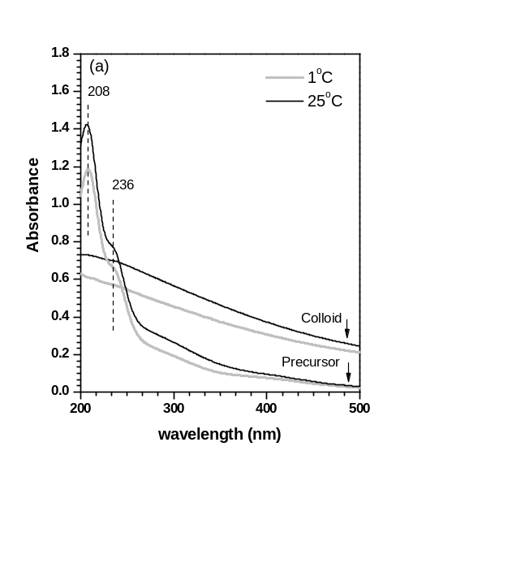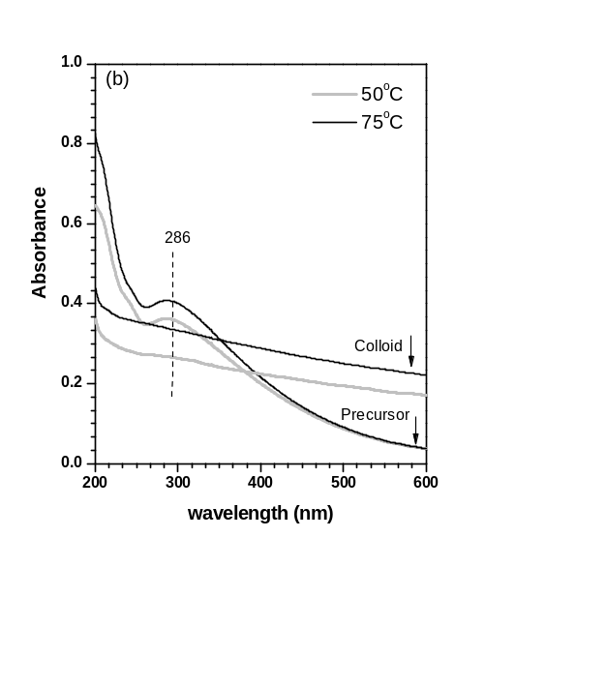

Figure 1. UV-Vis spectra of precursor and colloidal Pd nanoparticles on anatase prepared at different tenperatures

TEM analysis was performed on the Pd/TiO₂ catalysts to determine the particle size distribution of PdNP. The representative TEM images and the derived histograms of the Pd catalysts are presented in Figures 2 and 3, respectively. It is apparent that increasing the reduction temperatures during the syntehsis of colloidal Pd increased the average diameter of Pd nanoparticles. Pd produced using water as solvent formed the smallest average of Pd particle diameter at 2.66 nm with a very narrow particle size distribution. The catalyst also showed a very homogenous Pd distribution on the anatase support as indicated in Figures 2(a-b) and 3(a). As the temperature was increased to 25 ºC, the particle size of Pd was slightly increased to 2.88 nm as shown in Figures 2(c-d). Pd with large particle sizes of 4.1 nm and <5.5 nm were observed when the synthesis temperatures were increased at 50 ºC and 75 ºC, respectively. Reduction of Pd²⁺ to form Pd nanoparticles during the colloidal synthesis was significantly influenced by the temperatures of the solution [15]. High temperatures accelerated the nucleation process and strengthened the interaction between Pd nanoparticles, resulting in agglomeration and non-uniformed distribution of Pd nanoparticles [16] as shown in Figure 3(c). Analysis on the particle size distribution of Pd when the synthesis was carried out at 75 ºC was unable to be performed due to the agglomeration of the particles. Reducing the synthesis temperature below room temperature formed colloidal PdNP that was stable towards agglomeration.

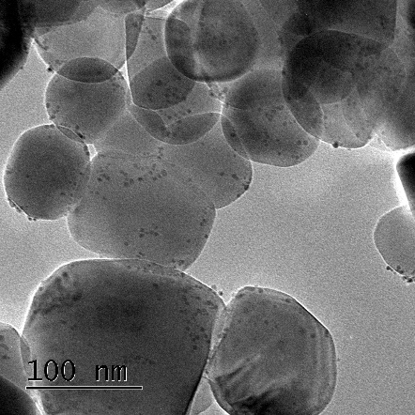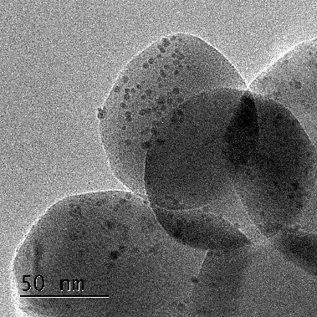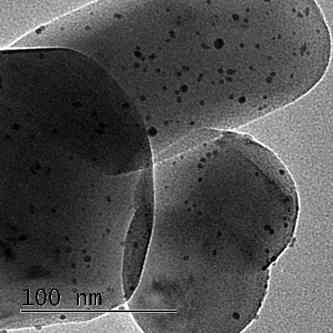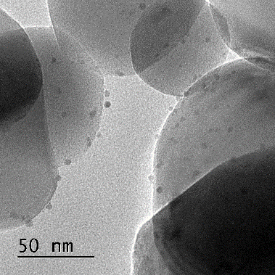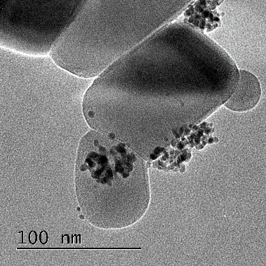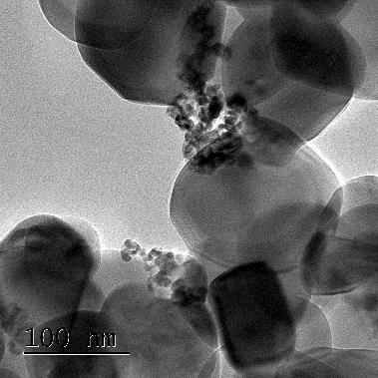
(d))
(e))
(f))
(c))
(b)
(a)
Pd
Pd
TiO₂

Figure 2. TEM images for the Pd/TiO₂ catalysts prepared at different temperatures; (a)-(b) 1 °C, (c)-(d) 25 °C, (e) 50 °C, (f) 75 °C

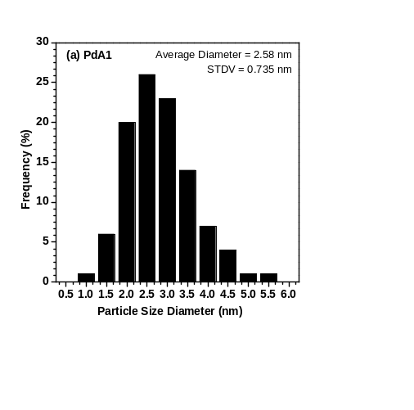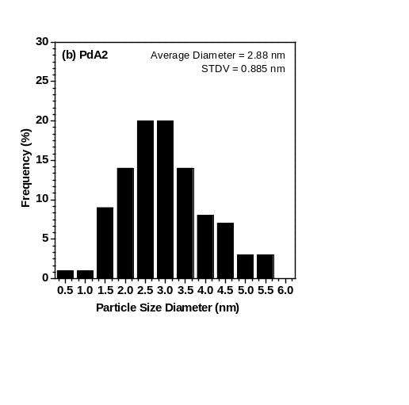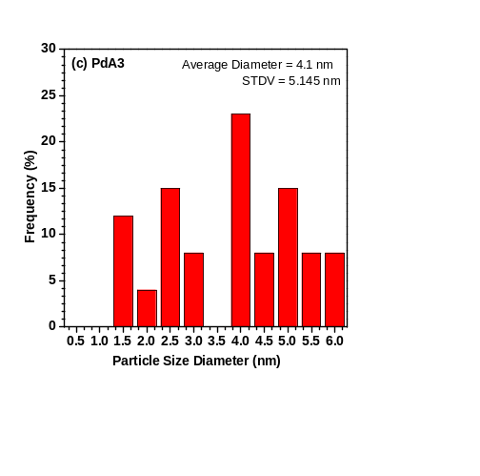

Figure 3. Particle size histogram for the Pd/TiO₂ catalysts prepared at different temperatures; a) 1 °C, b) 25 °C, and c) 50 °C

Figure 4 presents the variations of Pd/TiO₂ activity as catalysts for cinnamaldehyde hydrogenation reaction using toluene as solvent at 50 ºC under 9 bars of hydrogen gas pressure. The liquid product was analysed using gas chromatography and the two main products observed were HCALD and HCALC. There were no products detected from selective hydrogenation to cynnamalalcohol, which were consistent with the results reported by others [17, 18]. The catalytic activity of PdA1 that contained the smallest Pd particle size exhibited high conversion (48%) of cinnamaldehyde with the selectivity of 60%, 27%, and 13% towards HCALD, HCALC, and other products, respectively. Pd/TiO2 catalyst with a slightly bigger particle size (PdA2) resulted in 43% conversion with the selectivity to HCALD that was reduced to 51%. However, the catalysts produced at 25 ºC showed enhanced selectivity of HCALC at 41%. As the particle size of PdNP became larger >4.0 nm (PdA3 and PdA4), the conversion of cinnamaldehyde was significantly reduced to give less than 5% conversion. Apparently, the selectivity to HCALD was similar in comparison to the PdA2 catalyst. The distribution of products from α, β-unsaturated aldehydes hydrogenation was influenced by several factors such as the dispersion of metal on the support, the metal particle size, and also the type of support [19, 20].

Therefore, in the current case, there was a trend in the product distribution from the hydrogenation of cinnamaldehyde, in which Pd/TiO2 catalyts with narrow Pd size distribution showed the domination of CAL hydrogenation to HCALD as compared to the hydrogenation of HCALC, to give high selectivity ratios between HCALD/HCALH. However, the ratio between the selectivity of HCALD/HCALC was reduced as the PdNP particle size increased. Pd with larger particles favoured hydrogenation to both HCALD and HCALC. Linear reduction of conversion was also contributed from the enlargement of Pd particle size and the reduction of homogenous distribution of PdNP on the anatase support. Small PdNP provided more available sites for the hydrogenation of C=C that led to high selectivity towards HCALD. Fast hydrogenation reaction promoted further hydrogenation of HCALD to HCALC at C=O sites [21]. The finding was consistent with the results from other researchers that showed Pd nanoparticles were prone to catalyse hydrogenation reaction of C=C bond in cinnamaldehyde [22]. Increasing the temperature of the synthesis of Pd colloidal exhibited agglomeration of Pd nanoparticles to form larger particles, which consequently reduced the available actives sites for hydrogenation reaction. Small Pd also allowed simultaneous adsorption at both C=C and C=O sites on the metal surface and therefore enhanced the selectivity for both HCALD and HCALC products. The suggested schematic reaction of cinnamaldehyde hydrogenation on Pd is presented in Figure 5. This schematic reaction was based on the reaction graph for all samples.

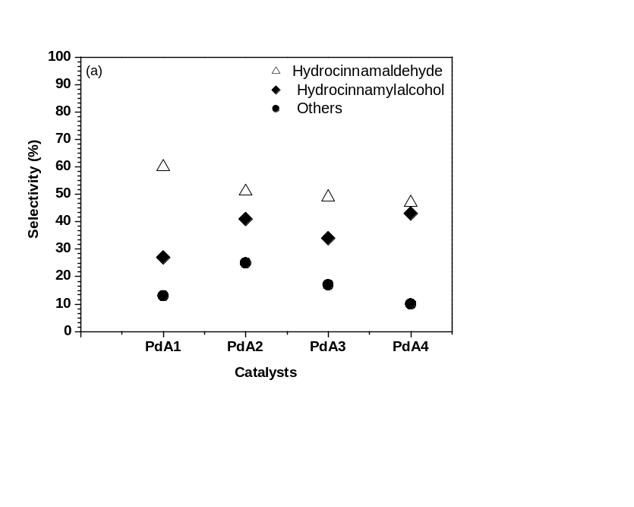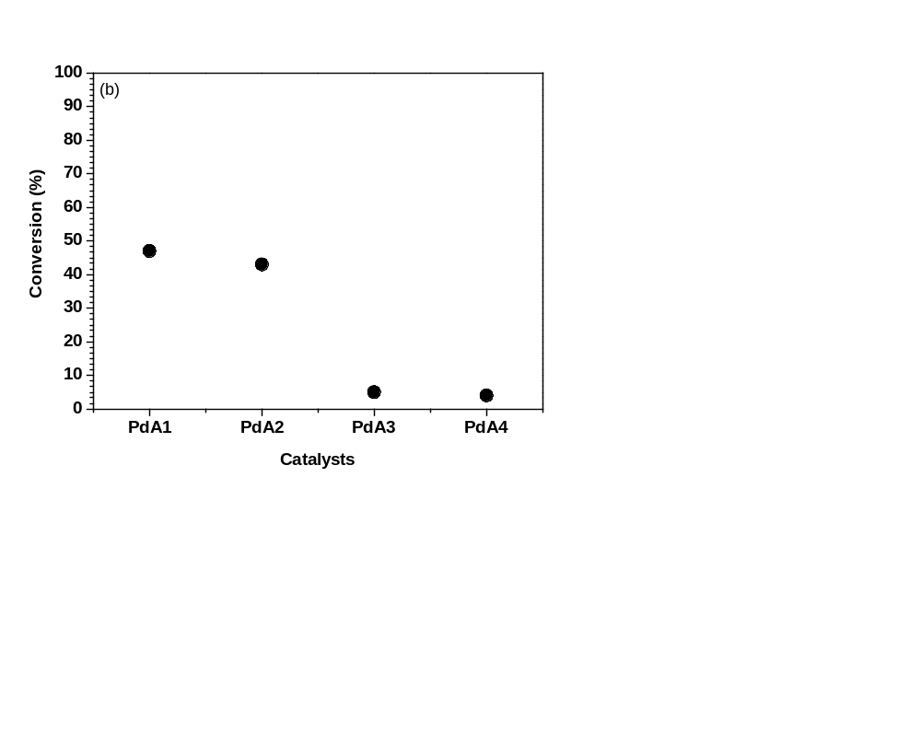
Figure 4. Plot of selectivity to hydrocinnamaldehyde and hydrocinnamyl alcohol (a) as a function of conversion (b) of Pd/TiO₂ prepared at 1ºC

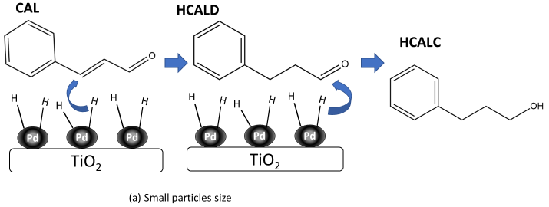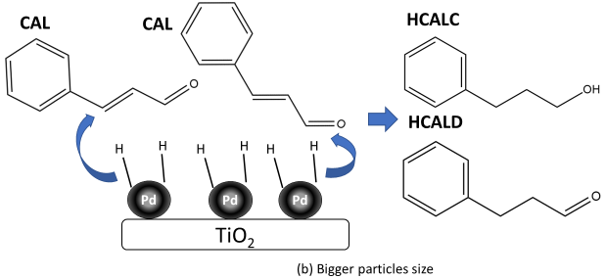

Figure 5. Schematic process of cinnamaldehyde hydrogenation on Pd/TiO₂ catalysts

The schematic reaction herein was formed by two types of pathways. Hydrogenation at C=C bond that led to HCALD and futher hydrogenation to form HCALC occurred on smaller particle size as seen in Figure 5(a). Meanwhile, for bigger particle size, both C=C and C=O bonds were preferred, leading to the production of HCALC and HCALD.

Conclusion

The colloidal method for the synthesis of Pd nanoparticles on TiO₂ anatase with the various reduction temperatures produced Pd nanoparticles with tailored particle sizes in the range of 2.5 nm to 6 nm. Reducing the synthesis temperatures to 1 ºC produced a narrow size of Pd nanoparticles, which exhibited high cinnamaldehyde conversion towards hydrocinnamaldehyde. Significant Pd particles agglomeration occurred when the synthesis was carried out at elevated temperatures. The enlargement of PdNP on TiO₂ reduced the conversion of cinnamaldehyde and the selectivity towards hydrocinnamaldehyde. Tailored synthesis of Pd nanoparticles controlled the active sites of Pd that allowed selective hydrogenation of cinnamaldehyde.

Acknowledgement

This work is supported by the National Defence University of Malaysia under the internal research grant SF0067-UPNM/2019/SF/SG/4. The authors are particularly grateful to the Ministry of Education Malaysia (MOE) for the financial support given in the form of a post-doctoral award to Norli Abdullah. The authors would also like to thank Prof C. Richard A. Catlow and Dr. Scott. M. Rogers from University College London, UK, Dr. Peter P. Wells from Southampton University, UK, and Dr. Nikolaus Dimitratos from University of Cardiff, UK for their fruitful discussions. Additional appreciation is given to the Research Complex at Harwell (RCaH), UK for the research facilities and assistance.

References

- Lichen, L. and Avelino, C. (2018). Metal catalysts for heterogeneous catalysis: From single atoms to nanoclusters and nanoparticles. Chemical Reviews, 118(10): 4981-5079.
- Solsona, B. E., Edwards, J. K. and P. Landon. (2006). Direct synthesis of hydrogen peroxide from H2 and O₂ using Al₂O₃ supported Au-Pd catalysts. Chemistry of Materials, 18(11): 2689-2695.
- Tapin, B., Epron, F., Especel, C., Ly, B. K. and Pinel, C. (2013). Study of monometallic Pd/TiO2 catalysts for the hydrogenation of succinic acid in aqueous phase. American Chemical Society, 3(10): 2327-2335.
- Bagheri, S., Julkapli, M., Nurhidayatullaili, and Abd Hamid, S. B. (2014). Titanium dioxide as a catalyst support in heterogeneous catalysis. The Scientific World Journal, 2014: 727496.
- Kaden, W. E., Kunkel, W. E., Roberts, F. S., Kane, M., and Anderson, S. L. (2014). Thermal and adsorbate effects on the activity and morphology of size-selected Pdn/TiO₂ model catalysts. Surface Science, 621; 40-50.
- Kim, B. H., Hackett, M. J., Park, J. and Hyeon, T. (2014). Synthesis, characterization, and application of ultrasmall nanoparticles. Chemistry of Materials, 26(1): 59-71.
- Cao, A.-M., Cao, A.-M., Lu, R., Veser, G. and Veser, G. (2010). Stabilizing metal nanoparticles for heterogeneous catalysis. Physical Chemistry Chemical Physics, 12(41): 13499-13510.
- Long, N. T., Nguyen, C., Hirata, H., Ohtaki, M., Hayakawa, T. and Nogami, M. (2010). Chemical synthesis and characterization of palladium nanoparticles. Advances in Natural Sciences: Nanoscience and Nanotechnology, 1(035012): 1-5.
- Espro, C., Donato, A. and Galvagno, S. (2016). On the formation of cinnamyl alcohol during the hydrogenation of cinnamaldehyde under mild conditions on supported palladium catalysts. Reaction Kinetic, Mechanisms and Catalysis, 118: 223-233.
- Feng, J., Jian, C., Bing, L., Yuebing, X. and Xiaohao, L. (2016). Particle size effects in the selective hydrogenation of cinnamaldehyde over supported palladium catalysts. Royal Society of Chemistry Advanced, 6: 75541-75551.
- Yang, L. W., Longlong, M., Xinjun, L., Tiejun W. and Shijun, Liao. (2015). Pd nano-particles (NPs) confined in titanate nanotubes (TNTs) for hydrogenation of cinnamaldehyde. Catalysis Communications, 59: 184-188.
- Zhao, B. N., Chen, J. G., Liu, X., Liu, W., Hao, Z., Xiao, J. and Liu Z, T. (2012). Selective hydrogenation of cinnamaldehyde over Pt and Pd supported on multiwalled carbon nanotubes in a CO₂-expanded alcoholic medium. Industrial & Engineering Chemistry Research., 51(34): 11112-11121.
- Mehri A, Kochkar H, Daniele S, Mendez V., Ghorbel A. and Berhault G. (2012). One-pot deposition of palladium on hybrid TiO₂ nanoparticles and catalytic applications in hydrogenation. Journal of Colloidal Interface Science, 369(1): 309-316.
- Ansari, P., Kizhakoottu, K. J., Sanchita, Sil. and Nallaperumal, S. K. (2018). A facile green tea assisted synthesis of palladium nanoparticles using tecovered palladium from dpent palladium impregnated carbon. Johnson Matthey Technology Review, 62(1):60-73.
- Norli, A., Hasliza, B., Michael, B., Scott M. R., Peter P. W. and C. Richard A. C. (2019). Efficient electronic transfer on palladium/TiO₂ for hydrogen production from photocatalytic reforming of methanol. Physical Chemistry Chemical Physic, 21:16154-16160.
- Nguyen T. K., Thanh, N., Maclean. and Mahiddine, S. (2014). Mechanisms of nucleation and growth of nanoparticles in solution. Chemical Reviews, 114(15):7610-7630.
- Kahsar, K. R., Johnson, S. and Schwartz, D. K. (2014). Hydrogenation of cinnamaldehyde over Pd/Al₂O₃ catalysts modified with thiol monolayers. Topic in Catalysis, 57: 1505-1511.
- Cabiac, A., Cacciaguerra, T., Trens, P., Durand, R., Delahay, G., Medevielle, A., Plee, D. and Coq. B. (2008). Influence of textural properties of activated carbons on Pd/carbon catalysts synthesis for cinnamaldehyde hydrogenation. Applied Catalysis A: General, 340: 229-235.
- Gallezot, P. and Richard, D. (1998). Selective hydrogenation of α,β-unsaturated aldehydes. Catalysis Reviews-Science and Engineering, 40: 81-126.
- Ma, Y., Feng, Lu., Guo, Z., Deng, J., Pham-Huu, C., and Liu, Y. (2019). Palladium supported on calcium decorated carbon nanotube hybrids for chemoselective hydrogenation of cinnamaldehyde. Frontiers in Chemistry, 7(751):1-10.
- Maki-Arvela, P., Hajek, J., Salmi, T. and Yu, M. (2005). Chemoselective hydrogenation of carbonyl compounds over heterogeneous catalysts. Applied Catalysis A: General, 292:1-49.
- Kołodziej, M., Drelinkiewicz, A., Lalik, E., Gurgul, J., Duraczyńska, D., and Kosydar, R. (2016). Activity/selectivity control in Pd/HxMoO₃ catalyzed cinnamaldehyde hydrogenation. Applied Catalysis A: General, 515: 60-71.

