
POLYMELAMINE/GOLD NANOPARTICLE-MODIFIED CARBON PASTE
ELECTRODE AS VOLTAMMETRIC SENSOR OF URIC ACID

(Elektrod Pes Carbon Terubahsuai Polimelamin/Partikel Nano Emas sebagai Sensor Voltametrik bagi Asid Urik)

Muji Harsini¹*, Erna Fitriany^{1,2}, Ainy Nur Farida¹, Dianita Suryaningrum¹, Dimas Noor Asy’ari¹,
Bernadeta Ayu Widyaningrum^{1,3}, Denok. Rizky Ayu Paramita^{,4}, Afaf Baktir¹, Fredy Kurniawan⁵

¹Department of Chemistry,
Faculty of Science and Technology,
Universitas Airlangga, Surabaya, Indonesia
²Akademi Farmasi Mitra Sehat Mandiri, Sidoarjo, Indonesia
⁴Akademi Farmasi Jember, Jember, Indonesia
⁵Department of Chemistry,
Faculty of Natural Science,
Institut Teknologi Sepuluh Nopember, Surabaya, Indonesia

*Corresponding author: muji-h@fst.unair.ac.id

Received: 18 July 2019; Accepted: 20 July 2020; Published: xx December 2020

Abstract
Uric acid (UA), a vital biological substance, should be accurately detected in clinical monitoring and diagnosis. An electrochemical sensor was developed for UA determination based on polymelamine/gold nanoparticle-modified carbon paste electrode (AuNPs/PM/CPE). Carbon paste electrode (CPE) was made by mixing carbon and paraffin powder at a ratio of 7:3. PM/CPE was made using 1 mM melamine electropolymerisation in 0.1 M NaOH solution on the CPE surface with the cyclic voltammetry (CV) technique with a potential range of 0 to +1.6 V, and a scan rate of 100 mV/s. AuNPs/PM/CPE electrodes were made using Au electrodeposition on the PM/CPE surface using a 1 mM HAuCl₄ solution containing 0.1 M Na₂SO₄. Electrodeposition was performed by CV in the potential range of -0.6 to +1.5 V, with a scan rate of 50 mV/s. The electrocatalytic activity towards UA was systematically studied by CV techniques on the surface of CPE, PM/CPE, AuNPs/CPE, and AuNPs/PM/CPE in phosphate-buffered solution (PBS) at pH 7 with the potential of 0 V to + 1 V, and a scan rate of 100 mV/s. The effect of pH and the analysis of real samples using baby urine that had been diluted and spiked with UA were also studied. The results for bare CPE, and AuNPs/PM/CPE showed a 5-fold increase in anodic peak currents for UA. The optimum conditions were pH 5 (PBS 0.1 M) with the scan rate of 100 mV/s. Under this optimised condition, the modified electrode demonstrated high catalytic activity of UA oxidation. The differential pulse voltammetry (DPV) technique was used for quantitative analysis. The performance of AuNPs/PM/CPE electrodes has a linearity range, detection limit, sensitivity, precision, and accuracy of 0.1-11 µM, 0.0647 µM, 7.8592 µA/µM, 0.1107-0.3930%, and 82.45-107.23%, respectively. The results of the UA analysis in the baby urine show that the recovery of the disposed sample was 99.41 ± 0.06%, indicating that these electrodes have good accuracy.

Keywords: voltammetry, uric acid, polymelamine, gold nanoparticles, modified carbon electrode

Abstrak
Asid urik (UA), bahan biologi penting, mesti dikesan dengan tepat dalam pemantauan dan diagnosis klinikal. Penderia elektrokimia telah dibangunkan untuk pengesanan UA berdasarkan elektrod pes karbon terubahsuai nano partikel emas/polimelamin (AuNPs/PM/CPE). Elektrod pes karbon (CPE) disediakan dengan mencampurkan karbon dan serbuk parafin pada nisbah 7:3. PM/PCE dihasilkan menggunakan 1 mM elektropolimerisasi melamin dalam larutan 0.1 M NaOH pada permukaan CPE melalui teknik voltametri berkitar (CV) pada julat potensi 0 hingga +1.6 V dan kadar imbasan 100 mV/s. Elektrod AuNPs/PM/CPE dihasilkan menggunakan pengelektroendapan Au pada permukaan PM/CFE menggunakan larutan 1 mM HAuCl₄ yang mengandungi 0.1 M Na₂SO₄. Pengelektroendapan dilakukan menggunakan CV dalam julat potensi −0.6 hingga +1.5 V, dengan kadar imbasan 50 mV/s. Aktiviti elektropemangkinan UA dikaji secara sistematik menggunakan teknik CV pada permukaan CPE, PM/CPE, AuNPs/CPE, dan AuNPs/PM/CPE dalam larutan penimbal fosfat (PBS) pada pH 7 dengan julat potensi 0 hingga +1 V dan kadar imbasan 100 mV/s. Kesan pH dan analisis sampel sebenar menggunakan air kencing bayi yang dicairkan dan dicampur dengan UA juga dikaji. Keputusan bagi CPE terdedah dan AuNPs/PM/CPE menunjukkan peningkatan 5 kali ganda dalam arus puncak anodik bagi UA. Keadaan optimum adalah pada pH 5 (PBS 0.1 M) dengan kadar imbasan 100 mV/s. Pada keadaan optimum tersebut, elektrod terubah suai menunjukkan aktiviti pemangkinan pengoksidaan UA yang tinggi. Teknik voltametri denyut pembezaan (DPV) digunakan untuk analisis kuantitatif. Prestasi elektrod AuNPs/PM/CPE masing-masing mempunyai julat kelinearan, had pengesanan, kepekaan, kejituan, dan ketepatan pada 0.1–11 µM, 0.0647 µM, 7.8592 µA/µM, 0.1107%–0.3930%, dan 82.45%–107.23%. Keputusan analisis UA dalam bayi air kencing menunjukkan bahawa perolehan sampel dilupuskan pada 99.41 ± 0.06%, menunjukkan elektrod ini mempunyai ketepatan yang baik.

Kata kunci: voltametri, asid urik, polimelamin, nano partikel emas, elektrod karbon terubahsuai

Introduction
Uric acid (UA) is the main product of purine metabolism in the human body [1]. The normal UA content in healthy human blood serum is in the range of 1.5 to 6.0 mg/dL for women and 2.5 to 7.0 mg/dL for men [1, 2]. Normal UA levels in human urine ranged from 1400-4000 µM [3]. Abnormalities of UA levels in the body can be used as an indication of various diseases such as gout, hyperuricemia, Lesch-Nyhan, arthritis, kidney, neurological, cardiovascular, and kidney disease [4, 5]. Therefore, research analysis and monitoring of UA levels in biological fluids are vital.

Various UA analysis methods and techniques have been developed, including the UV-Vis technique [6-8], chromatography [9-11], and voltammetry with modified electrodes [12-19]. Although some work has been performed on the development method of the UA voltammetry analysis, it is still necessary to innovate the modification of electrodes that are easy to produce, low-cost, but still prioritise excellent electrode performance. Compared to other analytical techniques, the advantages of voltammetry include instrumentation and cost analysis of inexpensive, fast, sensitive, and broad linear concentration ranges for simultaneous determination of analyte mixtures. Meanwhile, the basic principles involved are oxidation and reduction processes, surface adsorption processes, electron transfer, and reaction mechanisms [20].

Modification of carbon paste electrodes (CPE) is very extensive in its use to increase its sensitivity, selectivity, and reproducibility. Various conductive polymers have been developed as voltammetry sensor modifiers [18-28]. In addition, electrode modification can also be done using gold nanoparticles (AuNPs). Gold nanoparticles have good electrocatalytic activity, conductivity, and biocompatibility for electrochemical applications, allowing them to be used as chemical and biochemical sensors [32, 33]. The combination of polymelamine (PM) with gold nanoparticles (AuNPs) on the surface of CPE has been used as a dopamine sensor (DA) [34], ascorbic acid sensor (AA) [35], and hydroquinone (HQ) [36], with all three compounds, provide different anodic peak potential (Epa). In this study, these electrodes were used as voltammetric UA sensors in the hope of obtaining different peak potentials from the two previous analytes, so that they are selective, sensitive, and accurate. The following Scheme 1 is the preparation of AuNPs/PM/CPE electrodes and their use as UA sensors. In Step 1, CPE is prepared from a mixture of carbon powder and 7:3 (w/w) solid paraffin. The surface of CPE is coated with PM using melamine (M) electropolymerisation by cyclic voltammetry (CV) with 0.1 M NaOH solution as supporting electrolyte, to form PM/CPE. In the final step, AuNPs are coated on the surface of PM/CPE with sodium sulphate (Na₂SO₄) and sulfuric acid (H₂SO₄) as an electrolyte supporting material by electrodeposition of HAuCl₄ solution, so that AuNPs/PM/CPE will be formed. In Stage 2, AuNPs/PM/CPE electrodes are used as UA sensors, in both CV and differential pulse voltammetry (DPV).

Materials and Methods
Materials and instrumentation
The main materials used in the study were carbon (obtained from the Bogor Research Centre for Forest Products, Indonesia), uric acid (Fluka), melamine (Aldrich), and tetrachloroauric acid (HAuCl₄; obtained by dissolving 0.1 g of 24-carat pure gold in aqua regia, then diluted with ultra-high water to obtain the desired concentration). Other chemicals were sodium hydroxide (NaOH, Merck), sulfuric acid (H₂SO₄, Merck), sodium sulphate (Na₂SO₄, Merck), and phosphate-buffered solution (PBS, pH 3-9) made from a mixture of phosphoric acid (H₃PO₄), sodium dihydrogen phosphate (NaH₂PO₄), and disodium hydrogen phosphate (Na₂HPO₄) solution. These materials have a degree of pro-analysis purity (p.a.). The water used was ultra-high pressure (UHP) water.

The main instrument used in this study was a set of Edaq e-corder 201 (Model ed 201) potentiostats with Echem software version 1.5 and equipped with three electrodes, namely working electrodes AuNPs/PM/CPE, Ag/AgCl as reference electrodes, and platinum wire as auxiliary electrodes.

Preparation of AuNPs/PM/CPE electrode
Carbon paste electrode (CPE) is made by mixing carbon powder and solid paraffin with a ratio of 7:3. These electrodes were activated by cleaning the surface using CV in the potential range of 0 to 1.0 V by 30 cycles, with a scan rate of 100 mV/s using a 0.5 M H₂SO₄ solution. PM/CPE was made using 1 mM melamine electropolymerisation in 0.1 M NaOH solution on the CPE surface with CV technique of 0 to +1.6 V, a scan rate of 100 mV/s in 20 cycles [1].

AuNPs/PM/CPE electrodes were made using Au electrodeposition on the PM/CPE surface using a 1 mM HAuCl₄ solution containing 0.1 M Na₂SO₄. Electrodeposition was performed by CV in the potential range of -0.6 to +1.5 V, with a scan rate of 50 mV/s, in as many as 12 cycles. Furthermore, the surface of the AuNPs/PM/CPE was rinsed using ultra-high pressure (UHP) water and dried at room temperature [2].

Voltammetric analysis of UA by using AuNPs/PM/CPE
Qualitative analysis of UA was determined by CV technique using 3 μM UA solution in PBS pH 7 at a potential of 0 V to + 1 V, with a scan rate of 100 mV/s. Quantitative analysis was carried out by DPV technique with variations in UA concentration in the potential range of +0.1 V to +0.7 V and scan rate of 100 mV/s.

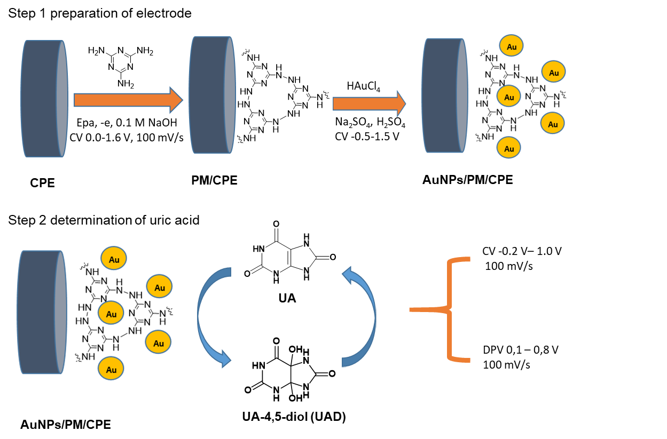
Scheme 1. Proposed electropolymerisation of melamine and electrodeposition of AuNPs on the surface of CPE as UA sensor

Results and Discussion
Cyclic voltammogram of UA
Figure 1 shows a cyclic voltammogram of a 3 µM UA solution that has higher anodic peak currents (Ipa) than a cathodic peak, indicating that UA is easier to undergo an oxidation reaction than a reduction. The Ipa are 3.292, 9.134, 10.491, and 15.041 µA on the surface of CPE electrodes, PM/CPE, and AuNPs/PM/CPE, respectively. This shows that the modification of electrodes can improve catalytic activity. The highest UA current peak is obtained using AuNPs/PM/CPE electrodes with increasing current approximately five times greater than the CPE electrode.

AuNPs/PM/CPE electrodes provide the highest current response due to the synergistic effect of PM, which is rich in amine groups and AuNPs with high surface area and excellent catalytic activity[3]. PM can prevent aggregation of gold nanoparticles because N atoms surround gold nanoparticles; therefore, avoiding gold aggregation process [4].

The effect of pH was studied using PBS with a concentration of 0.1 M, which varied with a pH range of 3 to 9. Besides assisting in maintaining the pH of the solution, buffer solution also functions as electrolyte support to reduce current migration, so that high peak current values will be obtained. The analysis was carried out using a scan rate of 100 mV/s and the potential range between 0 V to + 1.0V. Figure 2 is a curve of the relationship between the pH of the solution and the value of anodic peak current (Ipa) UA. Based on Figures 2 and 3, the UA analysis at various pH has the optimum anodic peak value at pH 5.

Based on these images, the anodic peak currents increase to pH 5 and then decreased sharply at pH 6, before appearing to be flat towards pH 9. UA has the pKa of 5.4, in the pH range 3 to 4. At this point, UA is in the form of a neutral molecule that is difficult to be oxidised, causing a small peak current. Whereas at pH 5, this value is almost close to the pKa value, so the character of UA at this pH will increase, whereby it is easier to experience a redox reaction. Decreasing peak currents occurs in the pH range 6 to 9, where UA will be in the form of a salt (anionic), and more challenging to experience an oxidation reaction. Hence, the decrease of the peak current value [5]. Figure 4 is a UA redox reaction that is influenced by the pH of the solution.

Differential pulse voltammogram of UA
Quantitative analysis was carried out by varying dopamine concentrations from 0.1 to 11 μM in PBS pH 5 and the scan rates of 100 mVs⁻¹. The DPV UA voltammogram at various concentrations can be seen in Figure 5, while the linear curve is shown in Figure 6.

Based on the curve of the relationship between concentration and anodic peak current in the UA analysis, R² was obtained at 0.9998, which approached the value of 1. The concentration that gave linear relations was in the concentration range of 0.1 µM to 11 µM. The slope produced from the UA standard curve shows the sensitivity of the analysis method. Based on the standard curve obtained a slope value of 7.8592, which indicates that the sensitivity of the UA analysis used AuNPs/PM/CPE electrodes of 7.8952 µA/µM. The limit of detection (LOD) was calculated statistically through the regression equation from the standard curve obtained 0.0647 μM (6.5×10⁻⁸ M). Table 1 is a comparison of UA detection limits in some literature. AuNPs/PM/CPE electrodes in references [14, 16, 18, 19] have lower LOD. However, when compared to the electrodes in references [12, 15], and [17] which have lower LOD, AuNPs/PM/CPE electrodes have the advantage of being easy to produce, cheaper, and nontoxic.

Determination of method accuracy was carried out at a concentration of 0.1 µM to 11 µM with three replications of measurements. The error range permitted in analysing 1 µA was 80-110% [12], while the accuracy value obtained in the UA analysis in this study is 82.45-107.23%, indicating an accurate method.

Precision is determined as the coefficient of variation, with good accuracy being ≤2%. In this study, the precision values meet the acceptability requirements for concentrations of 0.1 µM and 11 µM at 22.6% and 11.3%. Based on the calculation results, the value of KV in the UA analysis was 0.1107-0.3930%, indicating that this method has a good precision value.

The analysis of real samples utilised the urine of 21-day-old infants. Urine samples were diluted 50 times using PBS pH 5 solution. The determination of UA was checked by adding UA compounds to ensure the concentration in urine as 1 µM, which is the minimum level in infants [13]. The results of the UA analysis in the baby urine are shown in Table 2, with the disposed sample recovery of 99.41 ± 0.06%. This shows that the AuNPs/PM/CPE electrode can be used as a sensor in the UA analysis of urine samples with good accuracy.

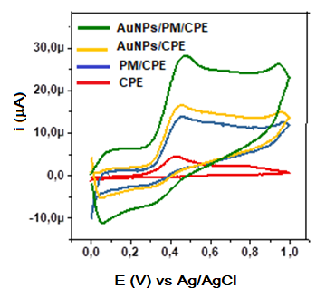
Figure 1. Cyclic 3 μM UA voltammogram in the scan rate of 100 mV/s using various electrodes

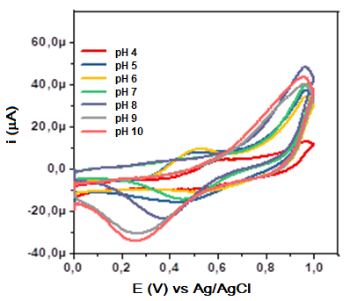
Figure 2. Cyclic voltammograms of 2 µM UA with pH variation using PBS with scan rate of 100 mV/s

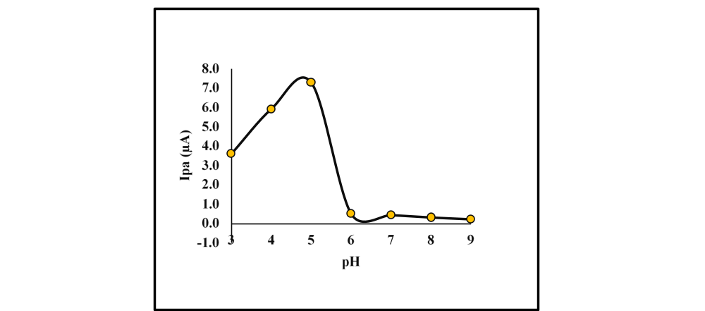
Figure 3. Relationship curve between pH vs. Ipa UA cyclic voltammogram

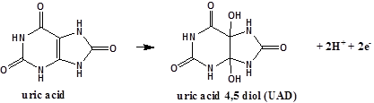
Figure 4. Oxidation-reduction reaction of UA

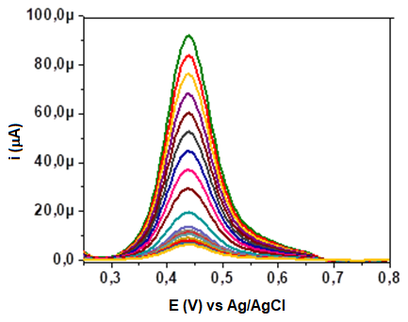
Figure 5. Differential pulse voltammogram of UA in PBS pH 5 with the scan rate 100 mV/s

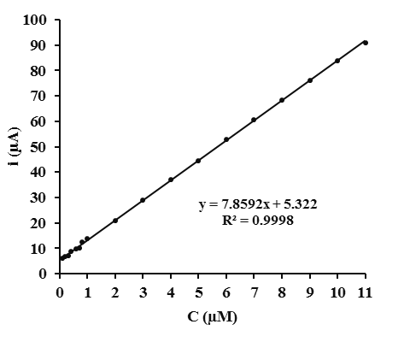
Figure 6. Calibration curve of UA from the DPV voltammogram

Table 1. Comparison of UA detection limit data in several literature
Electrode | Limit of Detection (M) | References
Diamond Film | 1.5 × 10⁻⁸ | [12]
Poly(p-toluene sulfonic acid) Modified Electrode | 5.0 × 10⁻⁷ | [14]
MIP/HMDE | 6.0 × 10⁻¹⁰ | [15]
Poly(p- Aminobenzene Sulfonic Acid)-Modified Glassy Carbon Electrode | 5.0 × 10⁻⁷ | [16]
Carbon paste/cobalt Schiff base composite electrode | 8.0 × 10⁻⁹ | [17]
Fe₃O₄/Graphene | 7 × 10⁻⁵ | [18]
SPCEs | 1.9 × 10⁻⁷ | [19]
AuNPs/PM/CPE | 6.5 × 10⁻⁸ | This work

Table 2. Analysis of UA in infant urine samples using AuNPs/PM/CPE electrodes
Sample | UA Concentration Added  (µM) | Concentration Obtained  (µM) | Average Recovery  (%)
 | 0.00 | - | -
Urine | 1.00 | 0.9947 | 99.41±0.06
 | 1.00 | 0.9934
 | 1.00 | 0.9942

Conclusion
Voltammetric analysis of UA has been developed using CPE modified with PM and AuNPs. The synergistic effect of PM, which is rich in amine groups and AuNPs with a high surface area and excellent catalytic activity, can increase the anodic peak current approximately five times greater than the bar electrode. These electrodes have excellent performance, including accuracy, precision, and detection limits. The results of the UA analysis in the baby urine showed that these electrodes have good accuracy. However, these electrodes still need to be improved for the analysis of UA samples in blood.

Acknowledgement
The authors gratefully acknowledge the financial support of this work by the Directorate of Research and Community Service of the Republic of Indonesia and the Ministry of Research, Technology and Higher Education in the 2019 fiscal year.

References
- Maiuolo, J., Oppedisano, F., Gratteri, S., Muscoli, C. and Mollace, V. (2016). Regulation of uric acid metabolism and excretion. International Journal of Cardiology, 213: 8-14.
- Atta, N. F., El-kady, M. F. and Galal, A. (2010). Simultaneous determination of catecholamines, uric acid and ascorbic acid at physiological levels using poly (N-methylpyrrole)/Pd-nanoclusters sensor. Analytical Biochemistry, 400(1): 78-88.

- Kong, D., Zhuang, Q., Han, Y., Xu, L., Wang, Z. and Jiang, L. (2018). Simultaneous voltammetry detection of dopamine and uric acid in human serum and urine with a poly (procaterol hydrochloride) modified glassy carbon electrode. Talanta, 185(3): 203-212.

- Rana, L., Gupta, R., Tomar, M. and Gupta, V. (2018). Highly sensitive Love wave acoustic biosensor for uric acid. Sensors & Actuators: B. Chemical, 261: 169-177.
- El, R. and Tallima, H. (2017). Physiological functions and pathogenic potential of uric acid: A review. Journal of Advanced Research, 8(5): 487-493.
- Norazmi, N., Rasad, Z. R. A., Mohamad, M. and Manap, H. (2017). Uric acid detection using UV-Vis spectrometer. IOP Conference Series: Materials Science and Engineering, 257(1): 1-6.
- Norazmi, N., Rasat, Z. R. A., Mohamad, M. and Manap, H. (2018). UV detection on artificial uric acid using UV-Vis spectrometer. Journal of Lasers, Optics & Photonics, 5(179): 2.
- Jeliki, M., Djurdjevi, P. and Stankov, D. (2003). Determination of uric acid in human serum by an enzymatic method using N-methyl-N-(4-aminophenyl)-3-methoxyaniline reagent. Journal Serbian Chemical Society, 68: 691-698.
- Kock, R., Seitz, S., Delvoux, B. and Greiling, H. (1995). A method for the simultaneous determination of creatinine and uric acid in serum by high-performance-liquid-chromatography evaluated versus reference methods. Clinical Chemistry and Laboratory Medicine, 33(1): 23-30.
- Wijemanne, N., Soysa, P., Wijesundara, S. and Perera, H. (2018). Development and validation of a simple high performance liquid chromatography/UV method for simultaneous determination of urinary uric acid, hypoxanthine, and creatinine in human urine. International Journal of Analytical Chemistry, 2018: 1-7.
- Honeychurch, K. (2018). The Determination of uric acid in human saliva by liquid chromatography with electrochemical detection. Journal of Analytical, Bioanalytical and Separation Techniques, 2(1): 47-51.
- Popa, E., Kubota, Y., Tryk, D. A. and Fujishima, A. (2000). Selective voltammetric and amperometric detection of uric acid with oxidized diamond film electrodes. Analytical Chemistry, 72(7): 1724-1727.
- Kumar, S. S., Mathiyarasu, J., Phani, K. L., Jain, Y. K. and Yegnaraman, V. (2005). Determination of uric acid in the presence of ascorbic acid using poly (3, 4‐ethylenedioxythiophene)‐modified electrodes. Electroanalysis: An International Journal Devoted to Fundamental and Practical Aspects of Electroanalysis, 17(24): 2281-2286.
- Wang, L., Huang, P., Bai, J., Wang, H., Wu, X. and Zhao, Y. (2006). Voltammetric sensing of uric acid and ascorbic acid with poly (p-toluene sulfonic acid) modified electrode. International Journal of Electrochemical Science, 1: 334-342.
- Khasanah, M., Mudasir, M., Mada, U. G. and Kuncaka, A. (2012). Development of uric acid sensor based on molecularly imprinted polymethacrylic acid-modified hanging mercury drop electrode. Journal of Chemistry and Chemical Engineering, 6: 209-214.
- Sadikoglu, M., Taskin, G., Demirtas, F. G., Selvi, B. and Barut, M. (2012). Voltammetric determination of uricacid on poly (p-aminobenzene sulfonic acid)-modified glassy carbon electrode. International Journal of Electrochemical Science,7: 11550-11557.
- Amiri, M. and Bezaatpour, A. (2012). Simultaneous voltammetric determination of uric acid and ascorbic acid using carbon paste/cobalt Schiff base composite electrode, Journal Solid State Electrochemistry, 16: 2187-2195.
- Movlaee, K., Norouzi, P., Beitollahi, H., Rezapour, M. and Larijani, B. (2017). Highly selective differential pulse voltammetric determination of uric acid using modified glassy carbon electrode. International Journal of Electrochemical Science,12: 3241-3251.
- Metto, M., Eramias, S., Gelagay, B. and Washe, A. P. (2019). Voltammetric determination of uric acid in clinical serum samples using DMF modified screen printed carbon electrodes, International Journal of Electrochemistry, 2019: 1-8.
- Kounaves, S. P. (1997). Voltammetric techniques, handbook of instrumental techniques for analytical chemistry: pp. 709-726.
- Sroysee, W., Chairam, S. and Amatatongchai, M. (2016). Poly (m-ferrocenylaniline) modified carbon nanotubes-paste electrode encapsulated in nafion film for selective and sensitive determination of dopamine and uric acid in the presence of ascorbic acid. Journal of Saudi Chemical Society, 22(2): 173-182.

- Chitravathi, S., Swamy, B. E. K., Mamatha, G. P. and Sherigara, B. S. (2012). Electrochemical behavior of poly (naphthol green B)-film modified carbon paste electrode and its application for the determination of dopamine and uric acid. Journal of Electroanalytical Chemistry, 667: 66-75.
- Atta, N. F. and El-kady, M. F. (2010). Novel poly (3-methylthiophene)/Pd, Pt nanoparticle sensor: Synthesis, characterization and its application to the simultaneous analysis of dopamine and ascorbic acid in biological fluids. Sensors & Actuators: B. Chemical, 145(1): 299-310.
- Wang, C., Li, J., Shi, K., Wang, Q., Zhao, X., Xiong, Z. and Wang, Y. (2016). Graphene coated by polydopamine/multi-walled carbon nanotubes modified electrode for highly selective detection of dopamine and uric acid in the presence of ascorbic acid. Journal of electroanalytical Chemistry, 770: 56-61.
- Chandrashekar, B. N., Lv, W. and Jayaprakash, G. K. (2019). Cyclic voltammetric and quantum chemical studies of a poly (methionine) modified carbon paste electrode for simultaneous detection of dopamine and uric acid. Chemosensors, 7(24):1-18.
- Hou, S., Zheng, N., Feng, H., Li, X. and Yuan, Z. (2008). Determination of dopamine in the presence of ascorbic acid using poly (3, 5-dihydroxy benzoic acid) film modified electrode, 179: 179-184.
- Xiongwei, X. U., In, Q. L., Iu, A. L., Hen, W. C., Eng, X. W. and Ang, C. W. (2010). Simultaneous voltammetric determination of ascorbic acid, dopamine and uric acid using polybromothymol blue film-modified glassy. Chemical and Pharmaceutical Bulletin, 58(6): 788-793.
- Baskar, S., Liao, C., Chang, J. and Zen, J. (2013). Electrochemical synthesis of electroactive poly (melamine) with mechanistic explanation and its applicability to functionalize carbon surface to prepare nanotube – nanoparticles hybrid. Electrochimica Acta, 88: 1-5.
- Goyal, R. N. (2015). Gold nanoparticles decorated poly-melamine modi fi ed glassy carbon sensor for the voltammetric estimation of domperidone in pharmaceuticals and biological fl uids. Talanta, 141: 53-59.
- Peng, J., Feng, Y., Han, X. and Gao, Z. (2016). Simultaneous determination of bisphenol A and hydroquinone using a poly (melamine) coated graphene doped carbon paste electrode. Microchimica Acta, 183: 2289-2296.

- Gupta, P., Yadav, S. K. and Goyal, R. N. (2015). A sensitive polymelamine modified sensor for the determination of lomefloxacin in biological fluids. Journal of The Electrochemical Society, 162(1): 86-92.
- Tadayon, F., Vahed, S. and Bagheri, H. (2016). Au-Pd/reduced graphene oxide composite as a new sensing layer for electrochemical determination of ascorbic acid, acetaminophen and tyrosine. Materials Science & Engineering C, 68: 805-813.
- Amidi, S., Ardakani, Y. H., Amiri-Aref, M., Ranjbari, E., Sepehri, Z. and Bagheri, H. (2017). Sensitive electrochemical determination of rifampicin using gold nanoparticles/poly-melamine nanocomposite. RSC Advances, 7(64): 40111-40118.
- Widyaningrum, B. A. (2018). Modifikasi elektroda pasta karbon dengan polimelamin/nanopartikel emas secara elektrokimia sebagai sensor voltammetri dopamin. Tesis Magister, Universitas Airlangga, Surabaya-Indonesia.
- Farida, A. N., Fitriany, E., Baktir, A., Kurniawan, F. and Harsini, M. (2019). Voltammetric study of ascorbic acid using polymelamine/gold nanoparticle modified carbon paste electrode. IOP Conference Series: Earth and Environmental Science, 217(1): 012004.
- Paramita, D. R. A. (2018). Modifikasi elektroda pasta karbon menggunakan polimelamin/nanopartikel emas secara elektrokimia sebagai sensor voltammetri hidrokuinon. Tesis Magister, Universitas Airlangga, Surabaya-Indonesia.
- Zen, J. and Chen, P. (1997). A selective voltammetric method for uric acid and dopamine detection using clay-modified electrodes. Analytical Chemistry, 69(24): 5087-5093.
- Harmita (2004). Petunjuk pelaksanaan validasi metode dan cara perhitungannya, Majalah Ilmu Kefarmasian, 1(3): 117-135.
- Association for Clinical Biochemistry (2013). Dopamine (plasma, urine). Retrieved from http://www.acb.org.uk/Nat Lab Med Hbk /Dopamine.pdf.

