CHARACTERIZATION OF INCLUSION COMPLEX OF
β-CYCLODEXTRIN/ISONIAZID USING
SPECTROSCOPIC METHOD

(Pencirian Kompleks Kemasukan β-Siklodektrin/Isoniazid
Menggunakan Kaedah Spektroskopi)

Nurul Yani Rahim* and Nurul Ain Elmira Elleas

School of Chemical Sciences

Universiti Sains Malaysia, 11800 Gelugor, Pulau Pinang, Malaysia

*Corresponding author: nurulyanirahim@usm.my

Abstract
The inclusion behavior of isoniazid with β-cyclodextrin (β-CD) in the liquid and solid state were investigated. The absorption spectral of UV-Vis was used to determine the inclusion behavior in the liquid state. Fourier Transform Infrared (FTIR) spectrometer, Thermogravimetric Analysis (TGA), and Nuclear Magnetic Resonance (NMR) were used to investigate the inclusion behavior in the solid state. The kneading between isoniazid and β-CD was performed to produce the inclusion complex. The formation constant (K) of the inclusion complex (β-CD/isoniazid) was calculated using Benesi-Hildebrand. The results of ˡH NMR and NOESY indicated that β-CD formed hydrophobic interaction with isoniazid. The values of formation constant for the complex of β-CD/isoniazid at pH 4 and 9 were 17.15 and 9.86, respectively. Meanwhile, the value of formation constant for the complex at the natural condition was 25000. The stoichiometry ratio obtained for the complex of β-CD/isoniazid in acidic and basic conditions are 1:1. Meanwhile, 1:2 ratio of β-CD and isoniazid was found at natural condition.

Keywords: β-cyclodextrin, tuberculosis drug, isoniazid, formation constant, inclusion complex

Abstrak
Sifat kemasukan di antara isoniazid dengan β-siklodektrin (β-CD) dalam keadaan cecair dan pepejal telah disiasat. Spektrum penyerapapan UV-Vis telah digunakan untuk mengenal pasti sifat kemasukan dalam keadaan cecair. Spektrometer Inframerah Transformasi Fourier (FTIR), Analisis Termogravimetrik (TGA) dan Resonan Magnetik Nuklear (NMR) telah digunakan untuk menyiasat sikap kemasukan dalam keadaan pepejal. Pengulian antara isoniazid dan β-CD telah dilakukan untuk menghasilkan kompleks kemasukan. Pemalar pembentukan (K) komplek kemasukan (β-CD/isoniazid) telah kira menggunakan Benesi-Hildebrand. Keputusan ˡH NMR dan NOESY menunjukkan β-CD membentuk interaksi hidrofobik dengan isoniazid. Nilai pemalar pembentukan bagi kompleks β-CD/isoniazid pada pH 4 dan 9 adalah masing-masing 17.15 dan 9.86. Sementara itu, pada keadaan semula jadi nilai pemalar pembentukan kompleks ialah 25000. Nisbah stoikiometri yang diperolehi untuk kompleks β-CD/isoniazid dalam keadaan asid dan bes ialah 1:1. Sementara itu, 1:2 adalah nisbah untuk β-CD dan isoniazid pada keadaan semula jadi.

Kata kunci: β-siklodektrins, ubat anti tuberculosis, isoniazid, pemalar pembentukan, kompleks kemasukan

Introduction
Host guest systems have performed in supramolecular chemistry to introduce the broad idea of intermolecular interactions. The interaction between host and guest relies on non-covalent bonding. The common types of non-covalent interactions are hydrogen bonding, dipole-dipole, van der Waals and π-π interaction. An inclusion complex is a type of host-guest system in which one compound (the host) contains a cavity or spaces where another molecular entity (the guest) is located. Therefore, the understanding of non-covalent interactions is important in the inclusion complex formation. Towards this goal, the application of simple hosts such as cyclodextrin, crown ether and calix [n] arena is gaining attention [1-3].

Tuberculosis (TB) is a global pandemic disease caused by Mycobacterium tuberculosis (MTB) that has been a scourge for humanity over thousands of years [4]. According to the World Health Organization (WHO), a quarter of the global population infected by TB with had reported with 9 million cases in 2010, and the number of new cases of infected people is increasing yearly [5]. Therefore, the continuous phase for TB treatment is essential to kill the persistent or slow-growing strains of MTB [6]. Thus, the development of new drugs and strategies for eradication of TB disease and tackle the dormant MTB needs to be a concern.
Isoniazid is one of first-line drugs to treat TB initiated in 1951 [6] to stop the growth of bacteria. Isoniazid penetrated and activated the encoding catalase-peroxidase gene. The peroxidase catalase activity induced the interaction of isoniazid with toxic reactive species [7] such as oxides, hydroxyl radicals, and organic moisture to rupture the cell wall components causing the cellular integrity completely lost and lead to the death of bacterial [8].
The supramolecular cyclodextrins (CDs) are well known non-toxic cyclic oligosaccharides consist of (α-1, 4)-linked α-_{L}-glucopyranose units with a hollow hydrophobic central cavity and a hydrophilic outer surface. This characteristic served as fundamental for various applications of CD in pharmaceuticals, foodstuffs, host-guest chemistry, textile processing, models for studying enzyme activity, molecular encapsulation, and chemical stabilization [9]. There are α-, β- and γ- denoted for six to eight α-_{L}-glucopyranose unit in cyclodextrins. Among these types of cyclodextrins, β-cyclodextrin (β-CD) is widely used due to its structural orientation that favorable for inclusion complex formation. The toxicological profile of β-CD consists of physicochemical features that adapted for therapeutic demands [10, 11]. Previously, Razak et al. had demonstrated the experimental and theoretical study of isoniazid and β-CD complex [12, 13]. The host-guest inclusion complex of isoniazid with β-CD derivatives was explored well experimentally and theoretical [14].
In this context, the current study aimed to investigate the inclusion complex of isoniazid with β-CD. The inclusion complex was analyzed by FTIR, TGA, UV-Vis and NMR. To the best of our knowledge, in this study, there are liquid and solid-state studies about the complexation of isoniazid and β-CD. This integrated experimental method shows the host-guest mechanism between β-CD and isoniazid will benefit to the future formulation development of the drug delivery system.

Materials and Methods

Materials
β-CD (>97%) was purchased from Sigma Aldrich Company and used without further purification. Isoniazid (99%) was obtained from Across Organic and used without further purification. Methanol (LC grade), ethanol (95%) and hydrochloric acid (37%) were purchased from QRec. Sodium hydroxide (99%) and dimethyl sulfoxide (99.8%) were obtained from R&M Chemical and MagniSolv, respectively. Ultra-pure water was used to dilute the solutions.

Preparation β-CD/isoniazid complex
Kneading method was used to prepare the β-CD/isoniazid complex by grinding β-CD and isoniazid with molar ratio of 1:1 [15-18]. A few drops of ethanol were added to form homogeneous paste. The mixture was ground for 30 minutes. The sample was then kept in a desiccator.

Characterization of complex in solid state
The structural information for inclusion complexes was studied using FTIR. The absorption spectra were obtained using FTIR Perkin-Elmer 2000 system in the range from 400 to 4000 cm⁻¹. The thermal stability was studied through the Thermogravimetric Analysis (TGA) using Perkin Elmer Thermal Analysis. The analysis was done at ambient temperature from 30 to 900 °C in N₂ atmosphere to determine the weight loss profile and decomposition temperature of β-CD, isoniazid, and β-CD/isoniazid complex. The Bruker Advance spectrometer 500 MHz was used to determine ¹H NMR and NOESY of the β-CD, isoniazid, and β-CD/isoniazid complex using DMSO-d₆ as a solvent. The measurements of absorption spectra in the range of 200-400 nm were carried out using Shimadzu UV2600 spectrometer.

Characterization of complex in liquid state: Determination of formation constant and stoichiometry ratio
Firstly, the stock solutions of isoniazid (0.01mM) and β-CD (0.002 M) were prepared. Then, 2.0 mL of isoniazid (0.01 mM) and 3.2 mL of β-CD (0.002 M) solutions were pipetted into 10.0 mL of volumetric flask to produce the solution of β-CD/isoniazid. Ultra-pure water was added to the calibration mark. The absorption spectra for β-CD (0.002M), isoniazid (0.01mM) and β-CD/isoniazid were recorded using UV-Vis. The series of β-CD/isoniazid solution without pH adjustment (natural) and with pH adjustment (pH 4 and pH 9) were prepared. The natural condition was checked to be at pH 6.8 which closed to the neutral pH. Each series consist fixed concentration of isoniazid (0.01mM) and varied concentration of β-CD (0.002, 0.004, 0.005, 0.006 and 0.007 M). From the spectra, the plot of Benesi-Hildebrand was generated using eq (1). The slope eq (2) and coefficient of determination (r² near to 1) obtained from the plot was applied to determine the formation constant (K) and stoichiometry ratio of complex.

$\frac{1}{A-A_{0}}=\frac{1}{(A'-A_{0})}+\frac{1}{K(A'-A_{0})[β-CD]}$ (1)

$K=\frac{1}{Slope (A-A_{0})}$ (2)

where A₀ and A attributed to the absorbance of the isoniazid and β-CD, respectively. A’ is referring to the absorbance of β-CD at maximum concentration.

Results and Discussion

Characterization of inclusion complex in solid state: FT-IR
FT-IR spectroscopy was successfully provided some significant evidence about the structure of the solid state, which used to study the host-guest interaction [9]. The FT-IR spectra for β-CD, isoniazid, and complex of β-CD/isoniazid were shown in Figure 1. The FT-IR spectrum of β-CD (Figure 1(a)) was characterized by absorption bands at 3450 cm⁻¹ (stretching vibration of -OH), 2936 cm⁻¹ (stretching vibration of -C-H) and 1483 cm⁻¹ (stretching vibration of -OH deformation). The isoniazid was characterized by the FT-IR (Figure 1(b)) with the absorption bands at 1326 cm⁻¹ and 3296 cm⁻¹, which corresponds to N-H stretching vibration, 1030 cm⁻¹ (C-N stretching vibration), 1617 cm⁻¹ (aromatic C=C stretching vibration), and 1738 cm⁻¹ (C=O stretching vibration). Upon complexation, the absorption band of the β-CD/isoniazid complex was dominated by the absorption vibrations of β-CD due to presence of seven repeated D-glucopyranose unit in the β-CD structure [12]. Hence, the recorded FT-IR spectrum of complex in Figure 1(c) was quite similar to the FT-IR spectrum of β-CD. This is due to the similar chemical bonding characteristics owned by the complex with the host molecule. Therefore, the spectrum of β-CD/isoniazid complex resulted in strong absorption vibration of polar functional groups such as C=O stretching vibration at 1738 cm⁻¹ and -OH stretching vibration at 3450 cm⁻¹. The broad -OH band found in the complex is a regular phenomenon reported for β-CD inclusion complex [19]. There also absorption at 2936 cm⁻¹ showing the stretching vibration of -C-H presented in β-CD/isoniazid. Meanwhile, the absorption at 1326 cm⁻¹ (N-H stretching vibration) and 1030 cm⁻¹ (C-N stretching vibration) in β-CD/isoniazid complex are represented the functional group from isoniazid.

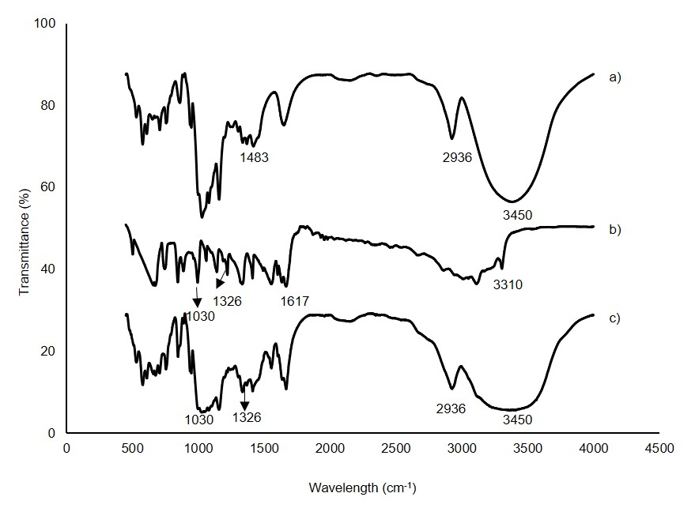
Figure 1. FTIR spectra of (a) β-CD, (b) Isoniazid and (c) β-CD/isoniazid

Thermal analysis
The thermal stability of isoniazid, β-CD, and β-CD/isoniazid complex were investigated using TGA analysis at temperature range of 30 °C - 900 °C, as shown in Figure 2. The TGA curve of pure isoniazid exhibited a single weight loss at 207 °C region. On the other hand, pure β-CD showed weight losses in two regions. The first weight loss at 67 °C was due to the dehydration of water, and another weight loss at 311 °C due to the decomposition of macrocycles. The TGA curve of the β-CD/isoniazid complex exhibited a weight loss at 265 °C. The TGA result showed the β-CD/isoniazid inclusion complex exhibited higher thermal stability compared to the pure isoniazid. These results confirmed the interaction between isoniazid and β-CD.

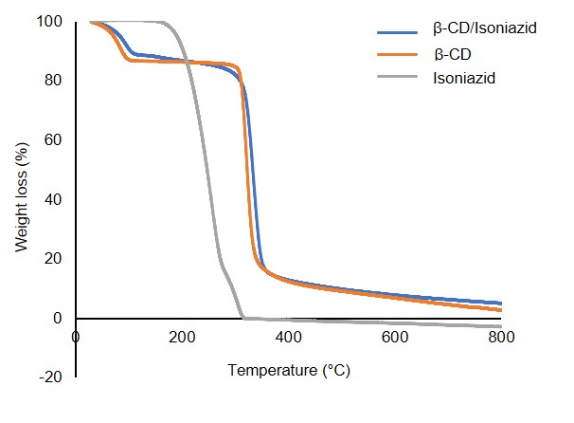
Figure 2. TGA for β-CD/isoniazid

ˡ H NMR
The convincing evidence for the formation of host-guest interaction in inclusion complex was confirmed using ¹H NMR spectroscopy by observing the chemical shift (δ) variations [20]. The spectra and values of chemical shifts for isoniazid, β-CD, and complex of β-CD/isoniazid are shown in Figure 3 and Table 1, respectively. The changes in chemical shift for the protons of β-CD and isoniazid in their inclusion complexes were defined as induced shift (Δδ). The induced shift was gained using eq (3):

Δδ=δ (complex)-δ (free) (3)

The positive and negative signs in Table 1 were denoted as upfield and downfield, respectively. The ¹H NMR spectrum for β-CD (Figure 3(a)) consists six varieties of protons (H1-H6), as illustrated in Figure 4 (a). The upfield and downfield shifts were obtained for H1, H2, and H4 protons and H3, H5, and H6 protons, respectively. Besides, the ¹H NMR spectrum of isoniazid (Figure 3(b)) contains four varieties of protons (Ha-Hd), as illustrated in Figure 4 (b). Normally, upon complexation, the Δδ values of protons H3 and H5 of β-CD are slightly higher compared to other protons. However, the ¹H NMR spectrum of β-CD/isoniazid (Figure 3(c)) showed the appreciable Δδ values only for H4 and H5 protons, as listed in Table 1. The changes of chemical shift (Δδ) for H5 indicating the consequences of isoniazid penetration into the hydrophobic cavity of β-CD, due to the magnetic anisotropy effects. It can be seen the Δδ values of protons Ha and Hb of isoniazid were the highest compared to the other protons upon the formation of the inclusion complex. These large chemical shift changes suggesting that Ha and Hb protons of isoniazid are located inside cavity of β-CD. However, a small Δδ value of Hc proton suggesting that isoniazid also interacted with H4 proton of β-CD, which is located outside the cavity.

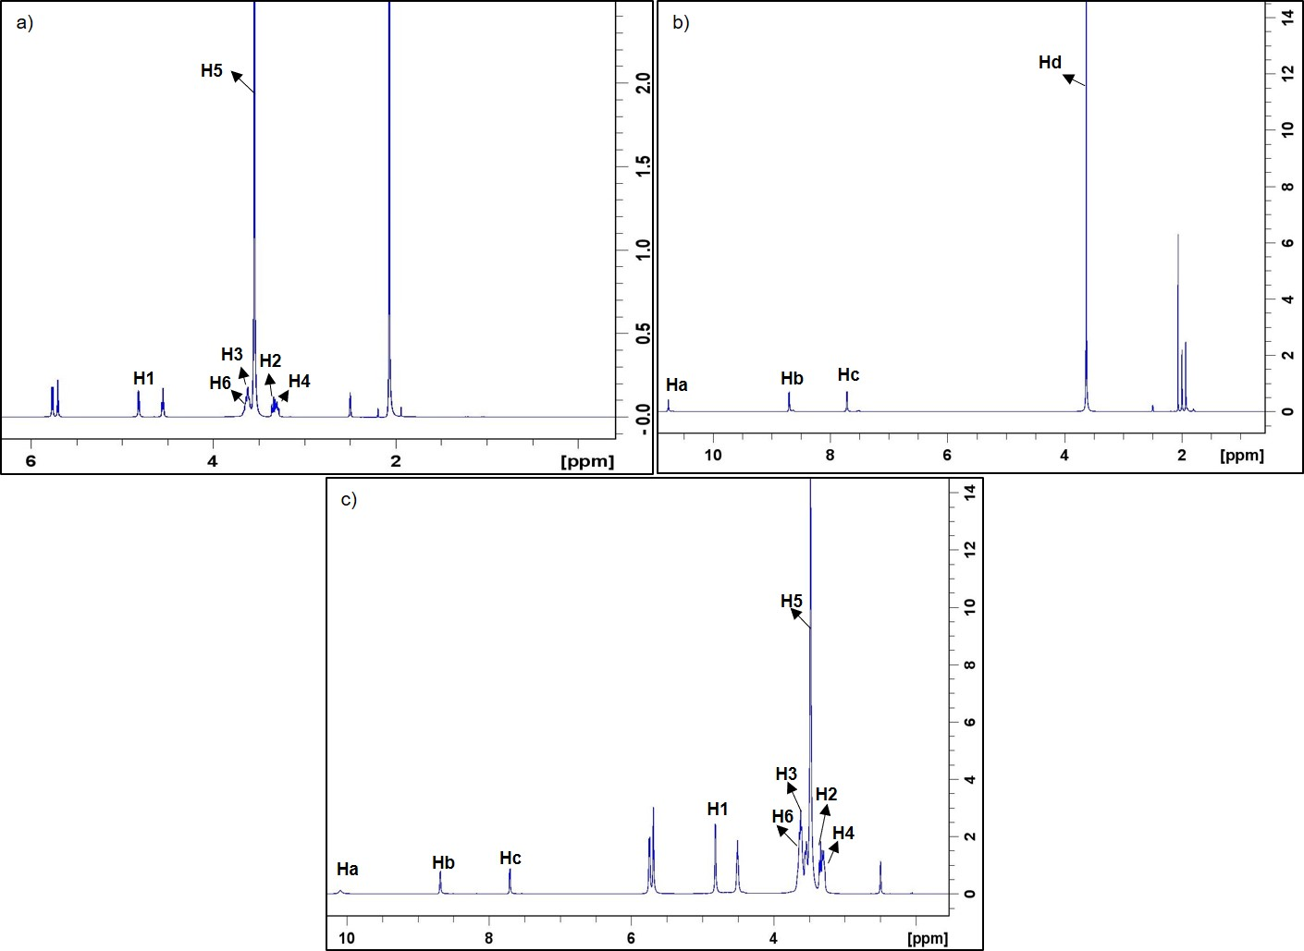
Figure 3. ¹H NMR spectra of (a) β-CD, (b) isoniazid, (c) β-CD/isoniazid

Table 1. Chemical shift corresponding to β-CD and isoniazid
Proton | β-Cyclodextrin  δ | Isoniazid  δ | Inclusion Complex  Δ | Induced Shift  Δδ
H1 | 4.8231 | - | 4.8234 | +0.0003
H2 | 3.3585 | - | 3.3600 | +0.0015
H3 | 3.6229 | - | 3.6220 | -0.0009
H4 | 3.3036 | - | 3.3210 | +0.0174
H5 | 3.6038 | - | 3.5591 | -0.0447
H6 | 3.6413 | - | 3.6404 | -0.0009
Ha | - | 10.1189 | 10.0926 | -0.0263
Hb | - | 8.6835 | 8.6936 | +0.0106
Hc | - | 7.7079 | 7.7148 | +0.0069
Hd | - | 3.6381 | - | -
*The bold values are referred to the highest induced shift for that proton

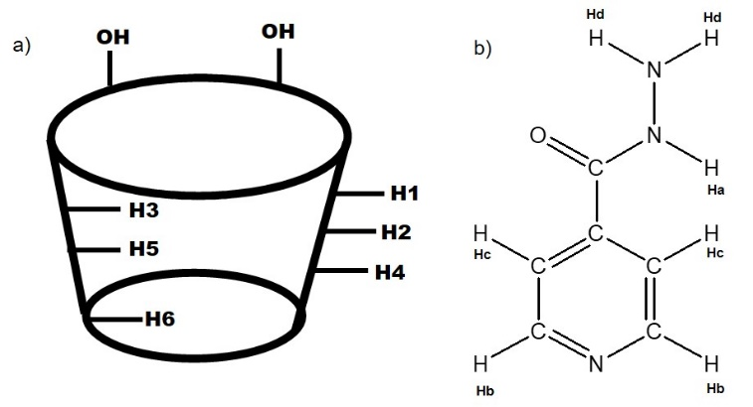
Figure 4. Structure of (a) β-CD and (b) isoniazid

NOESY NMR
The possible orientation of the isoniazid in the cavity of β-CD was obtained from ¹H NMR analysis. However, that obtained orientation was not definitive. The previous result was strongly supported by applying the NOESY NMR experiment to examine the configuration of isoniazid in the β-CD cavity by providing the geometry for the inclusion compound. The NOESY NMR spectra provided some significant spatial connection information between the host and guest molecules by observing intermolecular dipolar complex interactions. Figure 5 showed the contour plot of the NOESY spectrum at a section (9-10 ppm and 3-4 ppm) for the β-CD/isoniazid complex. From the figure, the cross peak was found between Ha and H3, H5 protons of isoniazid, and β-CD, respectively. By combining the information from ¹H NMR, a conclusion can be drawn that hydrazide moiety of isoniazid was penetrated the cavity of β-CD and forming the inclusion complex through hydrophobic interaction.

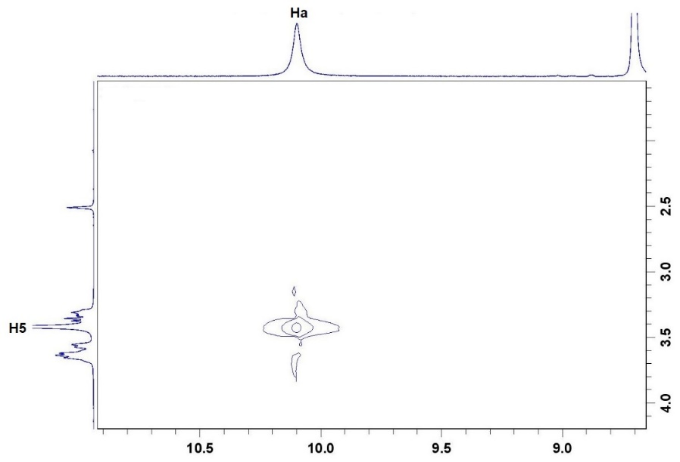
Figure 5. NOESY NMR of β-CD/isoniazid

Interaction between Isoniazid and β-CD in aqueous medium: UV-Vis
The extent of interaction between the β-CD and isoniazid was measured by UV-Vis absorbance through the determination of its stoichiometric ratios and the formation constants in an aqueous medium. Figure 6 showed the absorbances of isoniazid (0.01mM), β-CD (0.003M), and the inclusion complex of β-CD/isoniazid. The absorption band of isoniazid obtained a maximum peak at 262 nm, meanwhile, β-CD showed no absorbance due to the absence of any π-electrons or non-bonding electrons [21]. Upon the addition of isoniazid with β-CD, the absorption band of β-CD/isoniazid exhibited slightly blue-shifted to a shorter wavelength at 261 nm. The absorbance of β-CD/isoniazid complex also underwent the hyperchromic effect, increasing the value of absorbance. The effect was due to the presence of hydrogen bonding and hydrophobic interaction [22] between the β-CD and isoniazid. Figure 7 showed the absorbance intensity increased by increasing the β-CD concentrations in the acidic, basic, and natural condition (neutral pH). The spectra band at maximum peak indicated an increase of intensity due to the increases of molar absorptivity of isoniazid. This finding proved that the solubility of isoniazid was enhanced with the β-CD addition. The result revealed that the drug solubility is increased with the function of β-CD concentrations. It should be mentioned that the pH changes do not significantly affect the solubility of isoniazid. According to the literature, isoniazid has at least two acid values (pKa₁= 3.53, pKa₂ = 11.40) [23]. In this regard, the molecule can be in three possible forms: acidic cation, neutral unionized species and basic anion depending on the pH values. In the range of pH-values from 5 to 9, isoniazid has an uncharged molecular form and able to enter the cavity of β-CD and forming the inclusion complex.

Benesi-Hildebrand method is commonly conducted to analyze stoichiometry and equilibrium constants of nonbonded interactions [24]. Figure 8 showed the reciprocal plots to determine the stoichiometry ratio and formation constant of the inclusion complex in the natural, acidic and basic conditions. Referring to the R² (close to 1) values from the reciprocal plots in Figure 8, the stoichiometry ratios for the inclusion complex formation at the natural condition was 1:2, whereas 1:1 at acidic and basic conditions were obtained. The formation constant of complex at the natural, acidic, and basic conditions are shown in Table 2. The complex of β-CD/isoniazid in the different conditions exhibited different binding intensity, thus resulting in different values of formation constant. The highest formation constant in the natural condition might be due to strong interactivity between the 1:2 ratio of β-CD and isoniazid. However, in the acidic and basic conditions, the formation constant showed insignificant values. It revealed that the pH values influenced the binding strength between β-CD and isoniazid. This is because the selectivity of inclusion is associated with certain species of isoniazid.

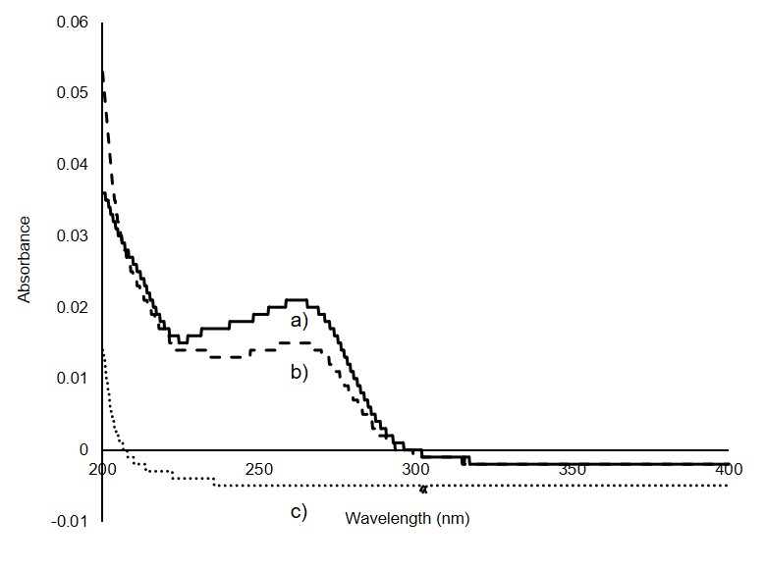
Figure 6. Absorption spectra of (a) β-CD/isoniazid complex, (b) isoniazid and (c) β-CD

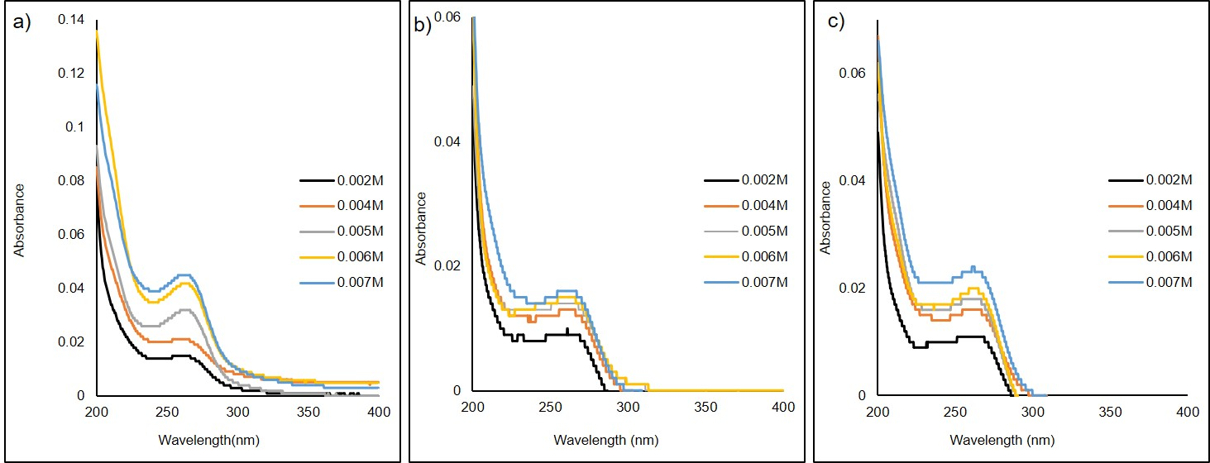

Figure 7. Absorption spectra of isoniazid with increasing concentration of β-CD for (a) pH 4, (b) pH 9 and (c) natural condition
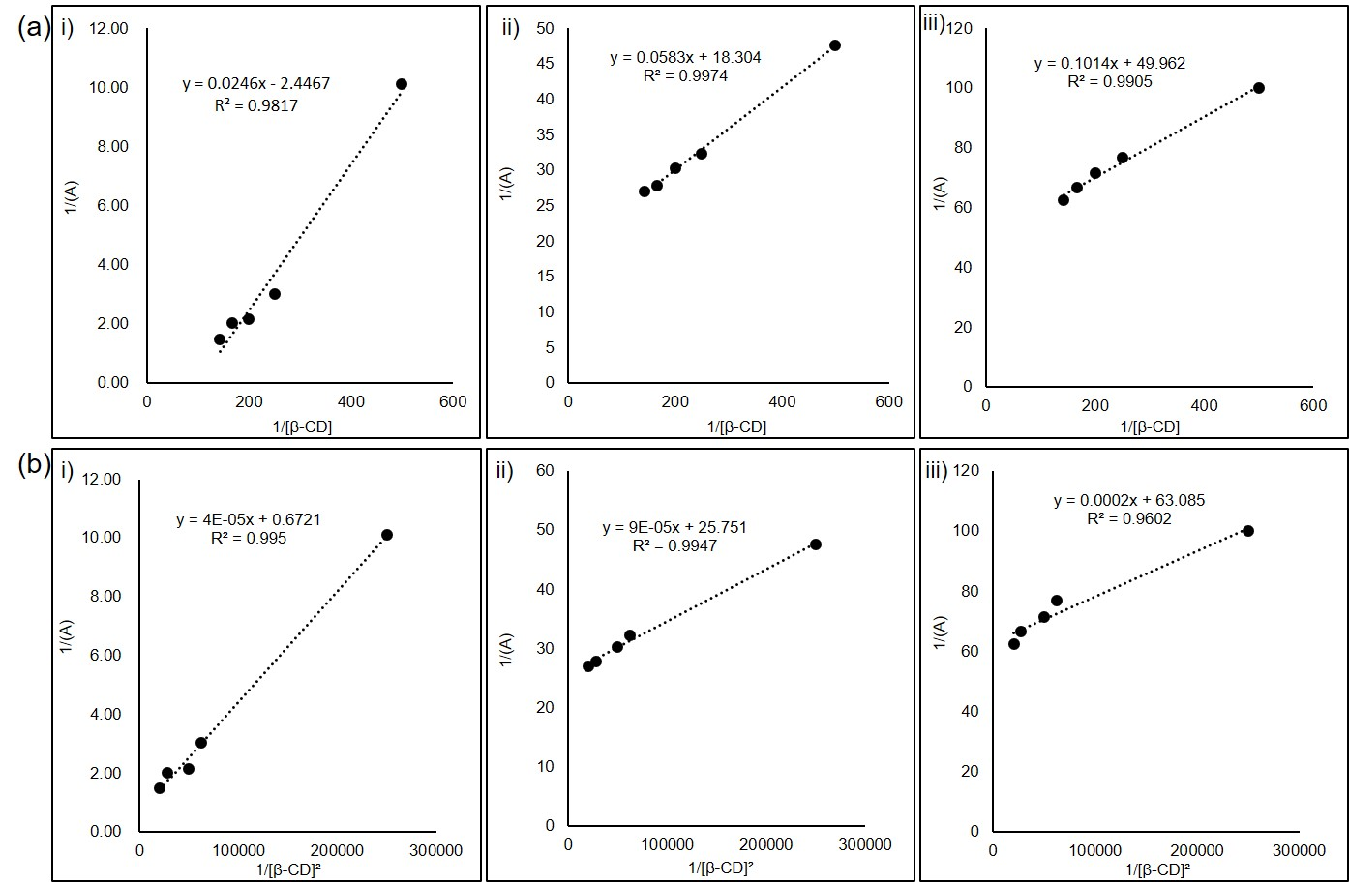

Figure 8. The reciprocal plots of (a) $\frac{1}{A}$ against $\frac{1}{[β-CD]}$ and (b) $\frac{1}{A}$ against $\frac{1}{[β-CD]^{2}}$ at i) natural condition, ii) pH 4 and iii) pH 9

Table 2. Formation constant (K) values for β-CD/isoniazid at various condition
pH | Formation Constant, K
Natural condition | 25000
4 | 17.15
9 | 9.86

Conclusion
In the present study, we have confirmed that the isoniazid is successfully complexed with β-CD using the kneading method. The inclusion complex was verified using FT-IR, TGA, and NMR. The present result exhibited that the isoniazid was partially entrapped into the β-CD cavity. The β-CD/isoniazid complex performed with 1:1 host-guest interaction at the acidic and basic conditions with a detectable formation constant of 17.15 and 9.86, respectively. However, the β-CD/isoniazid complex performed 1:2 host-guest interaction at the natural condition with a detectable formation constant of 25000 calculated from the Benesi-Hildebrand equation. Currently, we are investigating the possibility of this complex for future applications.

Acknowledgement
The work was supported by Ministry of Higher Education for FRGS Grant (203.PKIMIA.6711641) and Universiti Sains Malaysia for the Short-Term Grant (304/PKimia/6315106). Authors would like to thank Nur Hidayah Sazali (Universiti Sains Malaysia) for assisting analyze TGA samples.

References
- Teixeira, M. G., de Assis, J. V., Soares, C. G., Venâncio, M. F., Lopes, J. F., Nascimento Jr, C. S., Anconi, C.P., Carvalho, G.S., Lourenço, C.S., de Almeida, M.V. and Fernandes, S. A. (2014). Theoretical and experimental study of inclusion complexes formed by isoniazid and modified β-cyclodextrins: ¹H NMR structural determination and antibacterial activity evaluation. The Journal of Physical Chemistry B, 118(1): 81-93.
- de Assis, J. V., Teixeira, M. G., Soares, C. G., Lopes, J. F., Carvalho, G. S., Lourenço, M. C., De Almeida, M.V., de Almeida, W. B. and Fernandes, S. A. (2012). Experimental and theoretical NMR determination of isoniazid and sodium p-sulfonatocalix[n]arenes inclusion complexes. European Journal of Pharmaceutical Sciences, 47(3): 539-548.
- Braegelman, A. S. and Webber, M. J. (2019). Integrating stimuli-responsive properties in host-guest supramolecular drug delivery systems. Theranostics, 9(11): 3017.
- Eldehna, W. M., Fares, M., Abdel-aziz, M. M. and Abdel-aziz, H. A. (2015). Design, synthesis and antitubercular activity of certain nicotinic acid hydrazides. Molecules, 20(5): 8801-8806.
- Tom, L., Nirmal, C. R., Dusthackeer, A., Magizhaveni, B. and Kurup, M. R. P. (2020). Formulation and evaluation of β-cyclodextrin-mediated inclusion complexes of isoniazid scaffolds: molecular docking and in vitro assessment of antitubercular properties. New Journal of Chemistry, 44(11): 4467-4477.
- Gegia, M., Winters, N., Benedetti, A., Soolingen, D. Van and Menzies, D. (2016). Treatment of isoniazid-resistant tuberculosis with first-line drugs : A systematic review and meta-analysis. The Lancet Infectious Diseases, 3099(16): 1-12.
- Stagg, H. R., Lipman, M. C., Mchugh, T. D. and Jenkins, H. E. (2017). Isoniazid-resistant tuberculosis: A cause for concern? The International Journal of Tuberculosis and Lung Disease, 21(10): 129-139.
- Sup, Y. (2015). Challenges in the development of drugs for the treatment of tuberculosis. Brazilian Journal of Infectious Diseases, 17(1): 74-81.
- Prabu, S., Samad, N. A., Ahmad, N. A., Jumbri, K., Raoov, M., Rahim, N. Y. and Mohamad, S. (2020). Studies on the supramolecular complex of a guanosine with beta-cyclodextrin and evaluation of its anti-proliferative activity. Carbohydrate Research, 2020: 108138.
- Vyas, A., Saraf, S. and Saraf, S. (2008). Cyclodextrin based novel drug delivery systems. Journal of Inclusion Phenomena and Macrocyclic Chemistry, 62(1-2): 23-42.
- Saokham, P., Muankaew, C., Jansook, P. and Loftsson, T. (2018). Solubility of cyclodextrins and drug/cyclodextrin complexes. Molecules, 23(5): 1-15.
- Razak, S. A., Fariq, S., Syed, F., Abdullah, J. M. and Adnan, R. (2014). Characterization, phase solubility studies and molecular modeling of isoniazid and its β-cyclodextrin complexes. Journal of Chemical and Pharmaceutical Research, 6(11): 291-299.
- Razak, S. A., Yacob, S. F. F. S., Abdullah, J. M. and Adnan, R. (2015). Isoniazid and β-cyclodextrin complexes: A stability study in aqueous solution. Journal of Chemical Pharmaceutical Research, 7(7): 346-355.
- Teixeira, M. G., de Assis, J. V., Soares, C. G., Venâncio, M. F., Lopes, J. F., Nascimento Jr, C. S. and Fernandes, S. A. (2014). Theoretical and experimental study of inclusion complexes formed by isoniazid and modified β-cyclodextrins: 1H NMR structural determination and antibacterial activity evaluation. The Journal of Physical Chemistry B, 118(1): 81-93.
- Rahim, N. Y., Tay, K. S. and Mohamad, S. (2016). β-Cyclodextrin functionalized ionic liquid as chiral stationary phase of high-performance liquid chromatography for enantioseparation of β-blockers. Journal of Inclusion Phenomena and Macrocyclic Chemistry, 85(3-4): 303-315.
- Rahim, N. Y., Tay, K. S. and Mohamad, S. (2016). Chromatographic and spectroscopic studies on β -cyclodextrin functionalized ionic liquid as chiral stationary phase: Enantioseparation of flavonoids. Chromatographia, 79(21-22): 1445-1455.
- Rahim, N. Y., Tay, K. S. and Mohamad, S. (2018). Chromatographic and spectroscopic studies on β-cyclodextrin functionalized ionic liquid as chiral stationary phase: Enantioseparation of NSAIDs. Adsorption Science & Technology, 36(1-2): 130-148.
- Rahim, N. Y., Samad, F. H. and Rohisham, A. M. (2019). Spectroscopic studies of inclusion complex glipizide and β-cyclodextrin. Malaysian Journal of Analytical Sciences, 23(5): 789-798.
- Almeida, M. V. De, Fernandes, S. A. and Almeida, W. B. De. (2013). Theoretical and experimental study of inclusion complexes formed by isoniazid and modified β-cyclodextrins: ${}_{ }^{1}H$ NMR structural determination and antibacterial activity evaluation theoretical and experimental study of inclusion complexes formed by isoniazid. The Journal of Physical Chemistry B, 421(12): 1-33.
- Yang, L. J., Yang, B., Chen, W., Huang, R., Yan, S. J. and Lin, J. (2010). Host−guest system of nimbin and β-cyclodextrin or its derivatives: Preparation, characterization, inclusion mode, and solubilization. Journal of Agricultural and Food Chemistry, 58(15): 8545-8552.
- Wang, X., Luo, Z. and Xiao, Z. (2014). Preparation, characterization, and thermal stability of β-cyclodextrin/soybean lecithin inclusion complex. Carbohydrate Polymers, 101: 1027-1032.
- Singh, R., Bharti, N., Madan, J. and Hiremath, S. N. (2010). Characterization of cyclodextrin inclusion complexes—a review. Journal of Pharmaceutical Science and Technology, 2(3): 171-183.
- Blokhina, S. V., Ol’khovich, M. V., Sharapova, A. V., Volkova, T. V. and Perlovich, G. L. (2015). Solution thermodynamics of pyrazinamide, isoniazid, and p-aminobenzoic acid in buffers and octanol. The Journal of Chemical Thermodynamics, 91: 396-403.
- Çelik, S. E., Özyürek, M., Tufan, A. N., Güçlü, K. and Apak, R. (2011). Spectroscopic study and antioxidant properties of the inclusion complexes of rosmarinic acid with natural and derivative cyclodextrins. Spectrochimica Acta Part A: Molecular and Biomolecular Spectroscopy, 78(5): 1615-1624.

