
STUDIES ON THE PROPERTIES OF NATURAL RUBBER/POLY-3-HYDROXYBUTYRATE BLENDS PREPARED BY SOLVENT CASTING

(Kajian Mengenai Sifat Campuran Getah Asli/Poli-3-Hidroksibutirat yang Disediakan Melalui Kaedah Acuan Pelarut)

Asmaa’ Zainal Abidin, Noor Hana Hanif Abu Bakar*, Mohamad Abu Bakar

Nanoscience Research Laboratory, School of Chemical Sciences,
Universiti Sains Malaysia, 11800 USM Penang, Malaysia

*Corresponding author: hana_hanif@usm.my

Received: 18 September 2020; Accepted: 28 November 2020; Published: February 2021

Abstract
Bio-based polymer blends constituting of poly(3-hydroxybutyrate) (PHB) and natural rubber (NR), prepared via solvent casting technique have been studied. Various ratios of 80:20, 60:40, 40:60 and 20:80 (wt./wt.) of NR/PHB were investigated. The IR spectra of the blend samples did not show any chemical interaction between the components. X-ray diffraction (XRD) confirmed that the crystallinity of the samples increased as the ratio of PHB is increased in the blend. Thermal stability and thermal transition of the blend system were characterized by thermogravimetric analysis (TG and DTG) and differential scanning calorimetry (DSC). Thermal stability of the blend samples showed similar characteristics as the original polymers. Meanwhile, two separate glass transition temperatures were observed for the blends, indicating that NR and PHB are immiscible. Polarized optical microscopy (POM) revealed inconsistent growth of PHB spherulite in the blends after subjected to annealing. The results indicated that NR obstructs the regular arrangement of the ring banded spherulite.

Keywords: natural rubber, poly-3-hydroxybutyrate, blending, solvent casting, miscibility

Abstrak
Campuran biopolimer yang terdiri daripada poli-3-hidroksibutirat (PHB) dan getah asli (NR), telah dikaji dan disintesis melalui teknik acuan pelarut. Pelbagai nisbah 80:20, 60:40, 40:60 dan 20:80 (wt./wt.) NR/PHB telah dikaji. Spektrum IR bagi sampel campuran tidak menunjukkan interaksi kimia antara komponen. Pembelauan sinar-X (XRD) mengesahkan bahawa kristaliniti sampel meningkat apabila nisbah PHB meningkat dalam campuran. Kestabilan terma dan peralihan terma bagi sistem campuran telah dianalisis menggunakan termogravimetri (TG dan DTG) dan perbezaan pengimbasan kalorimetri (DSC). Kestabilan terma untuk sampel campuran menunjukkan ciri yang serupa dengan polimer asal. Sementara itu, terdapat dua suhu peralihan kaca untuk campuran yang menunjukkan bahawa NR dan PHB tidak dapat dicampur. Mikroskop optik polarisasi (POM) menunjukkan pertumbuhan sferulit PHB yang tidak konsisten dalam campuran setelah mengalami penyepuhlindapan. Hasil kajian menunjukkan bahawa NR menghalang susunan biasa sferulit berikat cincin.

Kata kunci: getah asli, poli-3-hidroksibutirat, campuran, acuan pelarut, keterlarutcampura

Introduction
Polymers have been used in all aspects of modern living, such as plastics, paper, textiles and cosmetic products. The production of polymeric materials has reached a quantum of 30 million tons each year [1]. Owing to its promising advantages, such as strength, low cost and durability, polymer science and engineering has rapidly developed as one of the fastest growing industries in the world. Generally, two or more different polymers can be combined to obtain a novel material with desirable features. With this goal, vast systems based on physical and chemical modification of polymer have been developed through polymer blends [2], graft [3], random [4], and block copolymerization [5].

Recently, the demand for bio-based polymers has found a niche in the polymer industry because of increasing environmental concerns. As an example, most disposed plastic materials remain persistent in the environment [6]. This is caused by their resistance to a biological breakdown. Thus, this occurrence has driven the search for biodegradable plastic materials. Poly-3-hydroxybutyrate (PHB) is a thermoplastic polymer belonging to the polyhydroxyalkanotae (PHA) family. It is a good candidate to replace non-biodegradable plastics due to its biodegradability, biocompatibility as well as processability [7]. Unfortunately, PHB is generally labelled as a weak and brittle material, displaying a short break elongation and low mechanical strength [8]. This limits its application. Hence, several approaches have been employed to modify PHB in order to widen its application range.

One of the successful approaches is the incorporation of hydroxyvalerate units into PHB during the fermentation process [9]. Another popular approach is blending PHB with other polymers capable of improving the inherent brittleness. Generally, PHB has been blended with numerous polymers ranging from natural to synthetic polymers. Studies on the blends of PHB with poly-caprolactone (PCL) [2, 10, 11], natural anionic polysaccharides [12], diglycidyl ether of bisphenol A (DGEBA) [8], poly-lactic acid (PLA) [13] and lignin [14] have been carried out. For instance, Cavalcante and co-workers investigated the miscibility and crystallinity of (PHB)/low molecular weight polycaprolactone (PCL), prepared through solvent casting [2]. The strength of PHB/PCL blends increased when compared to that of pristine PHB. Elastomer can also be blended with PHB to improve its properties. Natural rubber (NR) is an important class of natural elastomer which is extracted from rubber trees (Hevea brasiliensis) in latex form [15]. NR is an amorphous polymer with hydrophobic characteristic and high elasticity [15]. Bhatt and co-workers studied the blending of medium chain length polyhydroxyalkanoate (mcl-PHA) with different types of rubber such as natural rubber, nitrile rubber and butadiene rubber [16]. It was discovered that the thermal decomposition temperature of the blends increased compared to that of pristine PHA. This shows that the two polymers successfully interacted since there was a shift in the melting point of the newly synthesized polymer blend. This finding was also reported by previous studies which focused mostly on the biodegradation of PHA blend with different rubbers [16, 17]. They show that, the degradation of PHA enhances the degradation rate of natural rubber. Even though some reports were found on the blends of PHA/NR, so far, no studies have reported on the characteristic of NR/PHB blends. Hence, the present work attempted to explore the properties of blends which focus on PHB with NR prepared using different ratios.

Materials and Methods
Materials
Natural rubber latex was obtained from Malaysian Rubber Board, Kuala Lumpur. Poly-3-hydroxybutyrate (PHB) was purchased from BIOCYCLE (Brazil) and purified before use. The following chemicals such as chloroform (QRec, Malaysia) and methanol (QRec, Malaysia) were purchased and used as received. Meanwhile, liquid nitrogen was supplied from Well solution Sdn. Bhd.

Purification method of PHB and NR
PHB was purified by dissolution in chloroform. The mixture was stirred until a clear solution was obtained. It was then filtered and followed by precipitation using methanol. The resultant product was dried in a vacuum oven at 50 °C for 24 hours. Dry natural rubber (NR) was prepared using natural rubber latex (NRL). Natural rubber latex was dropped into acetone at room temperature, until a cloudy solution was obtained. The solution was removed after a while, leaving the NR coagulants which were washed again using acetone for a few times until a clear solution was achieved. Finally, the NR coagulants was dried in a vacuum oven at 40 ˚C until constant weight was reached.

Preparation of NR/PHB blends
The blends of NR and PHB with various compositions of 100:0, 20:80, 40:60, 60:40, 80:20 and 0:100 (wt./wt.) ratio were prepared via solvent casting technique. As much as 12.5 g of each pristine PHB and NR was dissolved separately in 500 mL chloroform. Subsequently various volumes of the stock solution (according to Table 1) were mixed for 1 hour. It was then cast onto a Teflon mould and dried at room temperature to ensure complete evaporation of the solvent.

Characterization
The as prepared samples (NR, PHB and various ratios of NR/PHB blends) were characterized by FTIR Perkin Elmer 2000 spectrometer. The sample was scanned on Attenuated Total Reflection (ATR) mode ranging from 4000 to 650 cm⁻¹. The samples were analyzed by placing a sample on the surface of a KBr disc surface and subjecting to IR scan. Meanwhile, the thermal behaviour of the samples was investigated using a Mettler Toledo DSC 800. The sample was first heated from 30 to 190 ˚C at a heating rate of 20 ˚C min⁻¹ under nitrogen atmosphere and held for 2 minutes. The sample was then quenched to -100˚C at a rate of 20 ˚C min⁻¹ and held for another 2 minutes. Finally, the sample was subjected to a second heating scan where it was again heated from -100 ˚C to 190 ˚C at a rate of 20 ˚C min⁻¹. Subsequently, the thermal stability of the as prepared samples was conducted using a Perkin Elmer STA 6000 simultaneous thermal analyser at a heating rate of 20 ˚C min⁻¹. The samples were heated from 30 ˚C to 900 ˚C under nitrogen flow and the weight change of the sample as a function of temperature was monitored.

The diffractogram of the crystalline polymer was obtained using X-ray diffraction (XRD) technique. The X-ray diffraction pattern of the sample was obtained using the Philips X’pert Pro Mrd Pw3040 X-ray diffractometer in the 2θ range 30˚-100˚. A Cu – Kα radiation (λ = 1.54 Å) was employed as the X-ray source. Besides that, the growths of spherulite of the prepared samples were monitored under an Olympus polarizing optical microscope equipped with a Linkam THMS hot stage. A sample was placed on a clean glass slide. Then, the sample was heated from 30 to 190 ˚C at a heating rate of 20 ˚C min⁻¹ and held for 2 minutes, before cooling to room temperature. The spherulite were allowed to grow during the cooling step and the images of the growing spherulite were acquired.

Table 1. Preparation of NR/PHB blends
NR/PHB  Ratio | Volume of 0.37 M NR  Stock Solution  (mL) | Volume of 0.25 M of PHB  Stock Solution  (mL)
100:0 | 40 | 0
80:20 | 32 | 8
60:40 | 24 | 16
40:60 | 16 | 24
20:80 | 8 | 32
0:100 | 0 | 40

Results and Discussion
Fourier Transform Infrared Spectroscopy
Figure 1 shows the FTIR spectra for PHB, NR, and a typical NR/PHB blend with 40:60 ratio, respectively. As can be seen in Figure 1(a), the main peak of PHB occurs at 1720 cm⁻¹, which is attributed to the carbonyl stretching. Besides that, the peak, which appears at 1100 cm⁻¹ is ascribed as C-O-C stretching vibration. The peaks at 2975 cm⁻¹ and 2937 cm⁻¹ correspond to the –C-H asymmetric and symmetric stretching, respectively. Meanwhile, peaks that occur at 1455 cm⁻¹, 1379 cm⁻¹, and 826 cm⁻¹ belong to the various CH₃ modes, such as asymmetric deformation, symmetric deformation as well as bending [18].

In contrast, the FTIR spectrum of pristine NR as shown in Figure 1(b) exhibits three significant peaks at 2962 cm⁻¹, 2921 cm⁻¹, and 2853 cm⁻¹. The first peak corresponds to the CH₃ asymmetric vibrations, while the other two depict asymmetry and symmetry -CH₂- as well as CH₃ vibrations. Additionally, the small peak, which appears at 1663 cm⁻¹ is due to the C=C stretching while another two sharp peaks at 1446 cm⁻¹ and 1376 cm⁻¹ correspond to the –CH₂ and CH₃ bending of NR. On the other hand, another significant peak at 836 cm⁻¹ represents =CH out of plane bending. The IR spectrum of NR exhibits similar features to those reported in previous works [19, 20].

The comparison of the spectra of NR/PHB blends with that of the pristine PHB and NR, confirms that peaks for both NR and PHB were present in the blends. This is presented in Figure 1(c). As an example, the main peaks attributed to PHB are observed at 1720 cm⁻¹, 1455 cm⁻¹, 1379 cm⁻¹, 2975 cm⁻¹, and 2937 cm⁻¹, respectively. Meanwhile, the peaks for NR are seen at 2853 cm⁻¹ as well as at 836 cm⁻¹ with no appearance of the C=C peak signal at 1663 cm⁻¹. This may be because the C=C peak overlaps with the C=O peak of PHB. In addition, as can be seen in Figure 1(c), the PHB peaks are more prominent compared to NR due to the PHB rich phase in the blends. No significant peak shifts and additional peaks are seen, suggesting that no interaction between NR and PHB occurred.

X-ray diffraction analysis
The prepared samples were further characterized by the X-ray diffraction technique. As illustrated in Figure 2(a), the pristine PHB exhibits six prominent peaks at 2θ values of 13.6˚, 17.3˚, 22.5˚, 26.8˚, 29.8˚, and 45.1˚. These peaks are indexed to the respective (0 2 0), (1 1 0), (1 0 1), (1 1 1), (1 2 1), (0 0 2), and (2 2 2) planes signifying a face centred cubic (fcc) phase of an orthorhombic unit cell. This is in agreement with previous studies that show PHB commonly crystallizes in an orthorhombic lattice structure [7, 18, 21]. On the other hand, NR displays a broad hump in the 2θ range of 10.0˚ to 30.0˚ characteristic of an amorphous polymer. A similar observation has been reported in other studies [22, 23].

For crystalline/amorphous polymer blends, the crystalline behaviour of the crystalline component can be influenced greatly and even prohibited when the content of the amorphous component is increased [24]. The comparison of the neat PHB and NR spectra with the spectra of the NR/PHB blends is shown in Figure 2(b). The results show that all peaks mentioned in NR and PHB are seen in the 80:20, 60:40, 40:60, and 20:80 ratios. In general, NR/PHB blends with ratios 80:20 and 60:40 show a broad pattern, which is similar to NR. Additionally, low intensities of PHB peaks are observed at 13.6˚, 17.3˚, 26.8˚, and 29.8˚ respectively. This may be attributed to the low amount of PHB in the blends and can be related to the low crystallinity of the samples when compared to the other ratios. The NR/PHB blends with ratios of 40:60 and 20:80, exhibit high intensity diffraction peaks at 2θ of 13.6˚ and 29.5˚. In addition, the broad peak of NR is reduced. This may indicate that crystallinity of the blends increases when PHB is the major phase and decreases when NR is the major phase.

Thermogravimetric analysis
The thermal stability of the polymer blends can be evaluated via the TG and DTG profiles. As can be seen in Figures 3(a) and (b), the TG and DTG profiles of pristine PHB, NR and various compositions of NR/PHB blends. The temperatures that correspond to the onset of weight loss (T_{onset}) and temperature at maximum degradation rate (T_{max}) are summarized in Table 2.
The PHB indicates a single weight loss in the range of 29 to 911 ºC. In addition, pristine PHB was stable up to 271.4 ºC, beyond which, it started to decompose and the T_{max} of PHB occurred at 285 ºC. This is due to the chain scission of PHB. In contrast, NR shows a single step of weight loss with T_{onset} at 359.6 ºC and the T_{max} occurred at 385.0 ºC. This can be attributed to the thermal decomposition of the polymer chain poly(cis-1,4-isoprene). After blending, similar weight loss trends were observed in the TG profiles of NR/PHB blends. This indicates the highly immiscible two-phase phenomenon of the blends. For instance, the T_{onset} for the first step of weight loss for 80:20, 60:40, 40:60, and 20:80 ratios occurred at 244.9 ºC, 260.0 ºC, 273.2 ºC and 281.2 ºC. These are ascribed to the degradation of PHB. As can be seen here, low T_{onset} values for 80:20 and 60:40 ratios were observed when compared to that of pure PHB. This trend may be due to the availability of less bulky PHB chains in the blends, which caused T_{onset} to occur earlier. Nevertheless, T_{max1} of NR/PHB blends show a similar trend with the pure PHB as tabulated in Table 2.

In contrast, the T_{onset} for the second stage of weight loss occurred at temperatures 364.4 ºC, 362.6 ºC, 357.0 ºC, and 367.8 ºC for the 80:20, 60:40, 40:60, and 20:80 ratios of NR/PHB blends respectively. These are attributed to the degradation of NR. Additionally, the T_{max2} of the NR/PHB blends show no significant difference with pure NR. It can be seen that the 20:80, 40:60, 60:40, and 80:20 ratios of NR/PHB blends showed T_{max2} values at 385 ºC, 385 ºC, 386 ºC, and 386 ºC respectively. Therefore, based on the results obtained, the thermal stability of NR/PHB blends remained the same as the pure polymer, which confirms that no interaction occurred in this system.

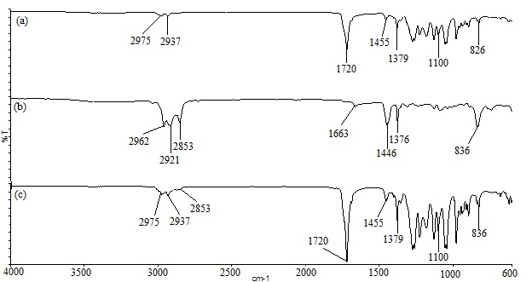
Figure 1. FTIR spectra of (a) purified PHB (b) pristine NR and (c) typical of 40:60 (wt./wt.) NR/PHB

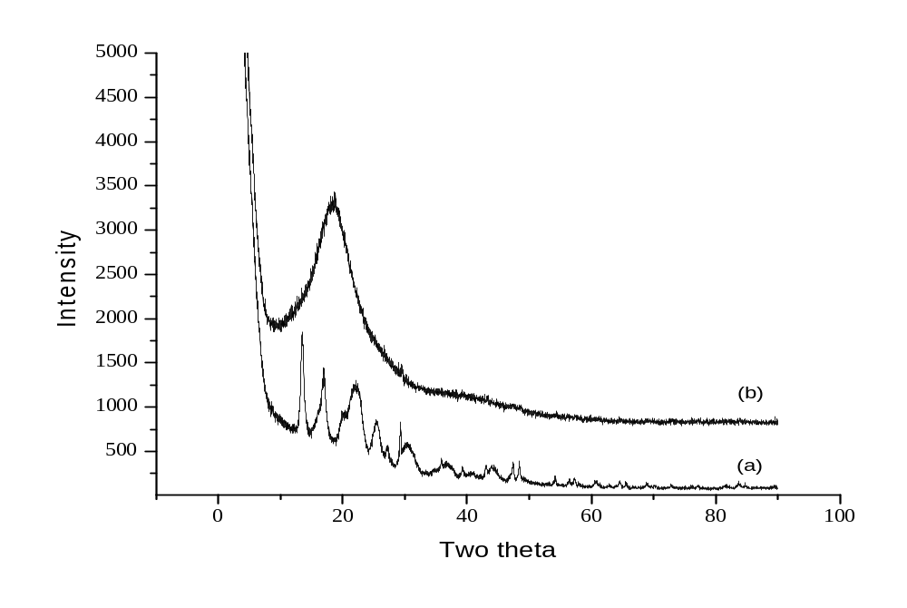
(a)
(ii)
(i)
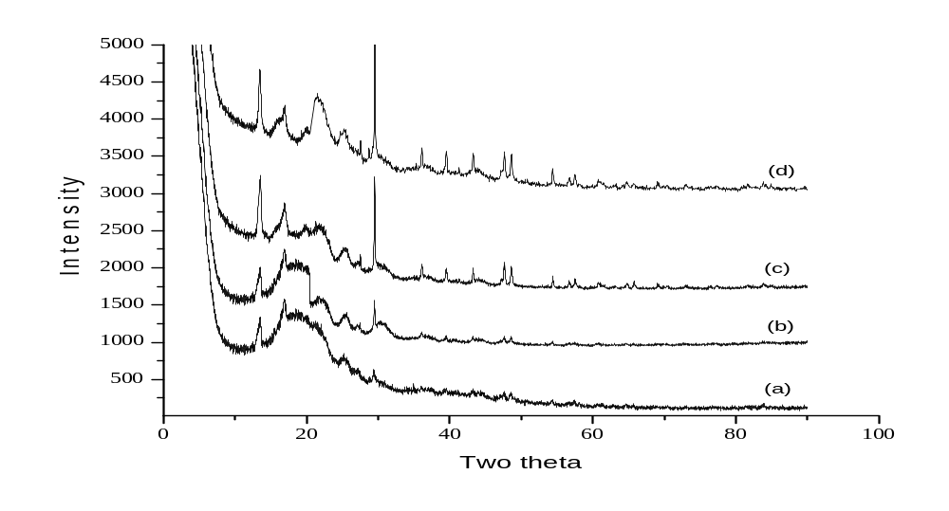
(b)
(iv)
(iii)
(ii)
(i)
Figure 2. XRD patterns of (a) pristine PHB (i) and NR (ii), while (b) NR/PHB blends with 80:20 (i) 60:40 (ii) 40:60 (iii) and 20:80 (iv) ratios of NR/PHB blends

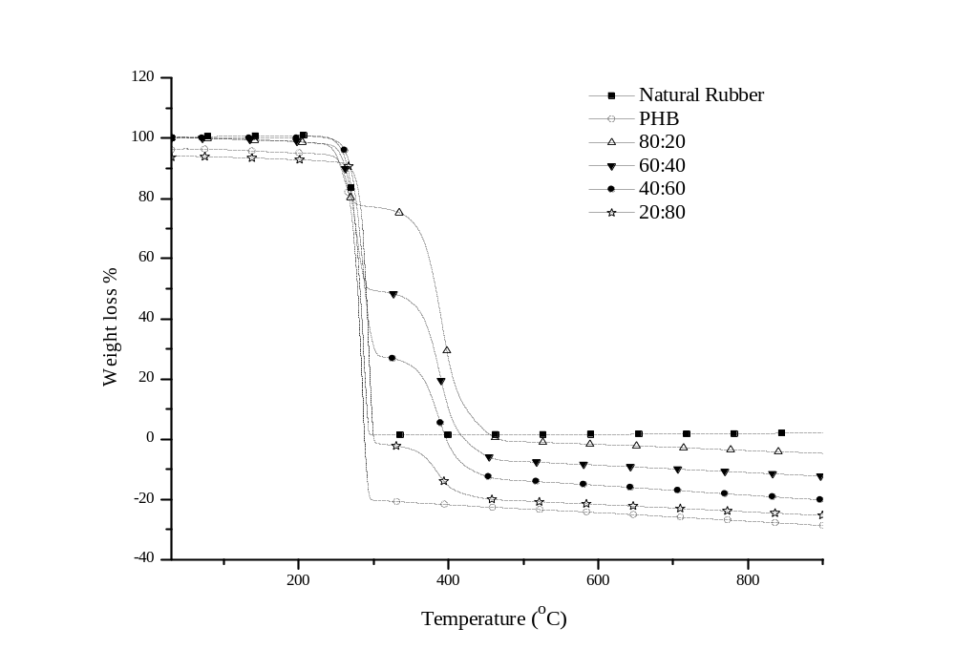
(a)

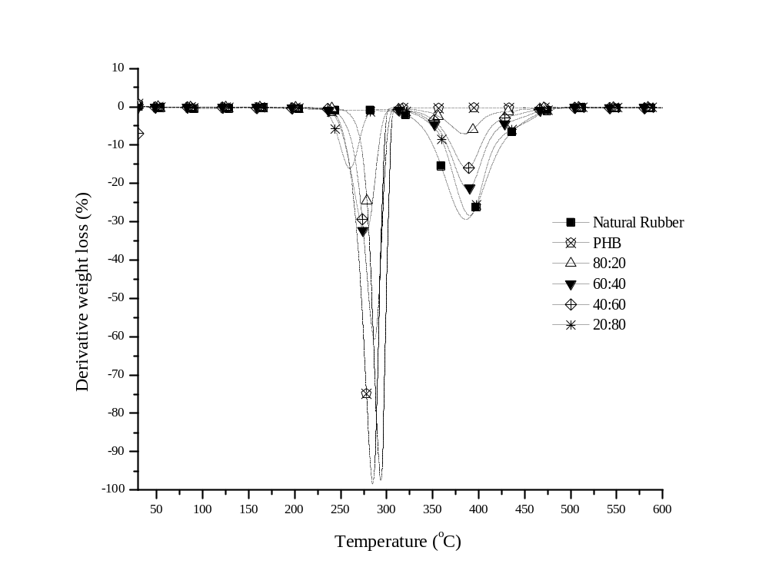
(b)
Figure 3. (a) TG and (b) DTG of the NR, PHB, and various composition of NR/PHB blends

Table 2. Thermal degradation of NR, PHB, and various composition of NR/PHB blends
NR/PHB | T_{onset} |  | T_{max}
NR/PHB | T_{onset1} | T_{onset2} | T_{max1} | T_{max2}
100:0 | 359.6 | - | 385 | -
80:20 | 244.9 | 364.4 | 288 | 385
60:40 | 260.0 | 362.6 | 285 | 385
40:60 | 273.2 | 357.0 | 286 | 386
20:80 | 281.2 | 367.8 | 280 | 386
0:100 | 271.4 | - | 285 | -

Differential scanning calorimetry
The thermal properties were investigated for pristine NR and PHB as well as the NR/PHB blends with various compositions. The thermograms of the samples are shown in Figure 4, while the thermal data including the glass transition temperature (T_{g}), crystallization temperature (T_{c}), melting temperature (T_{m}) and the calculated polymer’s crystallinity (χc) are listed in Table 3.

Pristine NR shows a T_{g} at -60.9 ºC with the absence of melting and a crystallization peak. This corresponds to the amorphous nature of NR, which causes the low T_{g} value. In contrast, the T_{g} of pristine PHB was clearly observed at 8.6 ºC with a T_{m} located at 172.1 ºC. It is interesting to note that the T_{c} peaks were undetectable in PHB and all the NR/PHB samples. Only an endothermic peak which is related to the melting of PHB was observed in the thermograms. The disappearance of the T_{c} peak in the second heating scan is attributed to the complete crystallization process during the cooling step [25]. Therefore, perfect lamellar crystals were formed during the second heating scan [25].

As can be seen in Table 3, the T_{m} values for 80:20, 60:40, 40:60, and 20:80 of NR/PHB blends occurred at 171.9 ºC, 169.4 ºC, 172.4 ºC, and 171.5 ºC respectively. These blends reveal a T_{m} peak similar to that of the neat PHB, which also indicate the non-interacting nature between the components. A contradicting observation was reported by a previous work [16]. The authors discovered that a medium chain length of PHA (mcl-PHA)/NR blends was successfully interacted since there was a shifting in T_{m} value for 15:85 ratio. This suggests that a variation in ratio of the polymers can promote interaction. This may be related to the long polymer chain of NR.

Subsequently, all the blends exhibited two distinct T_{g}. The appearance of two T_{g} values indicates the occurrence of phase separation as a result of the non-interacting nature of the two polymers. Furthermore, the T_{g} for NR/PHB blends prepared using 80:20, 60:40, 40:60, and 20:80 ratios showed similar T_{g} values as NR and PHB. It can be observed that, the T_{g} for 80:20, 60:40, 40:60, and 20:80 of NR/PHB ratio occurred at -60.1 ºC and 6.3 ºC, -61.6 ºC and 5.3 ºC, -60.2 ºC and 7.9 ºC as well as -61.0 ºC and 8.2 ºC respectively. As can be seen, T_{g} of PHB decreases with increasing NR content. This behaviour is possibly due to the disruption of the PHB chain by NR to a limited extent. In the meantime, the apparent T_{g} associated with NR remained the same across composition. Interestingly, a previous study also reported similar findings with the appearance of two T_{g} values when blending PHB with poly(ethylene-co-vinyl acetate) (EVA) [26]. However, only a single T_{g} was detected for PHB/EVA with a 10:90 ratio. Therefore, it can be concluded that the T_{g} values and miscibility of the polymer blends are strongly dependent on the blend compositions.

The DSC curves as shown in Figure 4, reveal the addition of NR into PHB interrupted the molecular attraction between PHB chains to some extent, thereby it inhibited cold crystallization to occur in all NR/PHB blends. This is depicted by the disappearance of the T_{c} peaks in the thermograms. Similar observation was reported in another study [27]. The degree of crystallinity (χc) of neat PHB and NR/PHB blends was calculated using Equation 1.

χc = ΔH_{m}/ΔH₁₀₀ ·W_{PHB} x 100% (1)

The values are summarized in Table 3. Pristine PHB exerts 55% of χc values, while for NR/PHB blend falls in the range of 47-17%. This trend is due to the amorphous nature of NR in the blends, which reduced the crystallinity of PHB. Similar to the XRD results, the crystallinity of the NR/PHB blends increased with an increase in the PHB content in the samples. For instance, NR/PHB blends with a ratio 20:80 displayed the highest χ_{c} value which is 47%. This is followed by NR/PHB blends with ratios 40:60, 60:40, and 80:20, which have decreasing χc values of 42%, 35.8%, and 17.8%, respectively.

To summarize, two T_{g} values with no shifting in the T_{m} of PHB indicate that phase separation occurred in NR/PHB blends. However, a previous study involving blends of PHB/ polycarbonate (PPC) shows contrary findings with the appearance of a single T_{g} and no significant change in the T_{m} peaks of PHB [24]. In general, it is difficult to deduce the miscibility of the blend based on the T_{g} values. Further confirmation of the miscibility of polymer blends can be carried out using the polarized optical microscopy, since the two polymers have different refractive indices.

Polarized optical microscopy
The morphologies of pristine NR, PHB, and the NR/PHB blends are shown in Figure 5. The properties of the prepared samples directly influence their respective morphologies. Therefore, the interplay between the evaporation of solvent, phase separation composition, and crystallization of PHB directly determines the morphologies of the blends.

As shown in Figure 5(a), the POM image of NR has an even and smooth surface due to its amorphous characteristic. In contrast, a neat PHB (Figure 5(b)) features large spherulites with closely ring bands. These spherulites are attributed to the crystalline properties of PHB. As for the blends, a single phase should be observed if PHB is miscible with NR. Otherwise, two phases are formed. Here, all compositions show heterogeneous phases. The presence of NR in the blends of NR/PHB results in spherulites with various sizes that vary depending on the blend’s composition. The addition of NR to PHB influences the crystallinity of PHB as it decreases the mobility of PHB segments and retards the crystal growth.

The morphology of the 80:20 NR/PHB ratio shows the appearance of PHB crystalline phase with no occurrence of spherulites. These globular PHB islands (refer to the arrow in Figure 5(c)) are dispersed in the amorphous phase of NR. This observation has been reported by Zhang and co-workers [24] where the minor droplets of PHB are dispersed in the amorphous polycarbonate (PPC) matrix when PPC is the major phase. Besides that, in this case, the absence of spherulites maybe due to the higher content of NR which covered the surface of the PHB crystal. Further decrease in the NR content, such as in the 60:40, 40:60, and 20:80 NR/PHB blends, reveals different morphologies, which have irregular shape and imperfect spherulites. In addition, the spherulite sizes are smaller and the boarders of the spherulites are not clearly seen compared to pure PHB. This phenomenon can be due to the occurrence of the degradation of PHB after the annealing process.

As can be seen from the 60:40 ratio, the phase separation is obvious with no clear banded structure detected in the spherulite. Since its content is only 40 wt.% in the blend, PHB crystallizes in a pattern as shown in Figure 5(d). In contrast, an uneven surface morphology is seen in the 40:60 ratio with a much denser nucleation and smaller size of spherulites compared to 60:40. This is due to rubber dispersed in the continuous PHB matrix. On the other hand, from Figure 5(f) of the 20:80 ratio, the growth of spherulites seems to have different rates, since there is a coexistence of large and small spherulites. This phenomenon corresponds to the inhomogeneity of PHB in the blends. Therefore, it can be summarized that, more imperfect spherulites were formed although with a smaller volume shown in 40:60 and 20:80 when the PHB was the major phase. Overall, the morphologies of NR/PHB blends prove a phase separation, which correspond to the immiscibility between NR and PHB. This result agrees well with the DSC findings. The lack of immiscibility between the polymers in this system can be ascribed to the bulkiness of the polymer chains which causes poor chain entanglement between the two polymers.

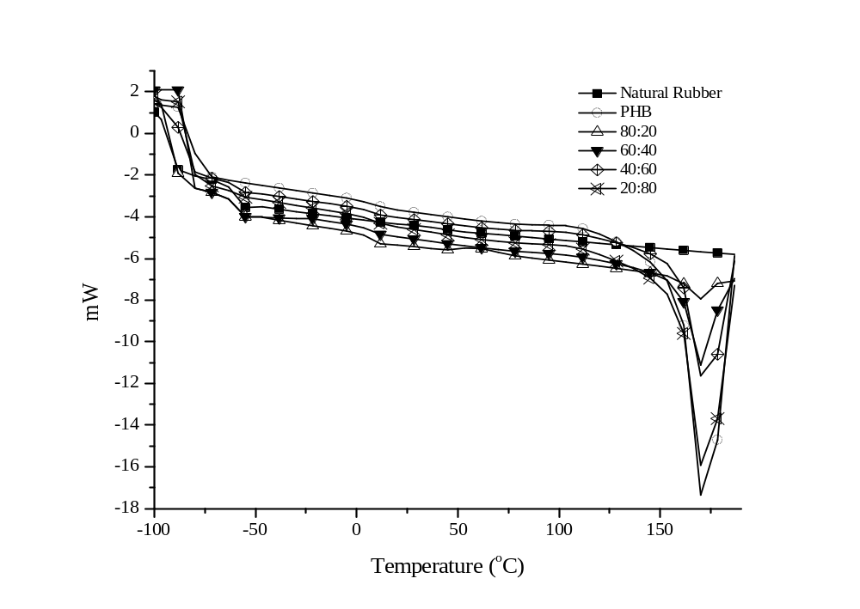
Figure 4. DSC thermogram for NR, PHB and various ratio of NR/PHB blends

Table 3. The thermal transition of NR, PHB and various NR/PHB blend
NR/PHB | 2nd Heating Scan
NR/PHB | T_{g1} (ºC) | T_{g2} (ºC) | T_{m} (ºC) | T_{C} (ºC) | χ_{c}
100:0 | -60.9 | - | - | - | -
80:20 | -60.1 | 6.3 | 171.9 | - | 17.8
60:40 | -61.6 | 5.3 | 169.4 | - | 35.8
40:60 | -60.2 | 7.9 | 172.4 | - | 42.0
20:80 | -61.0 | 8.2 | 171.5 | - | 47.0
0:100 | - | 8.6 | 172.1 | - | 55.0

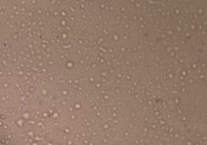  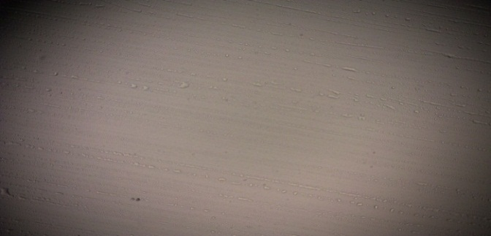  (c)  (a) | 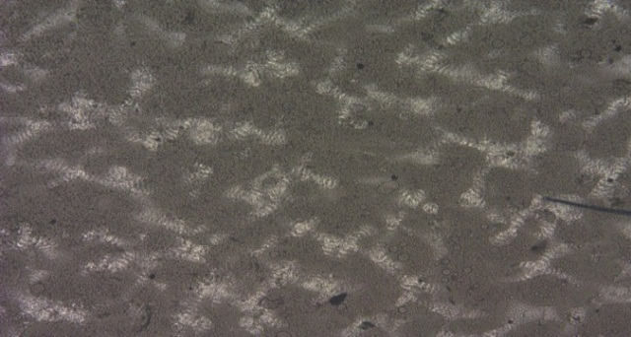  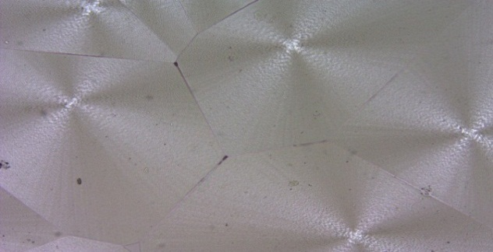  (d)  (b)
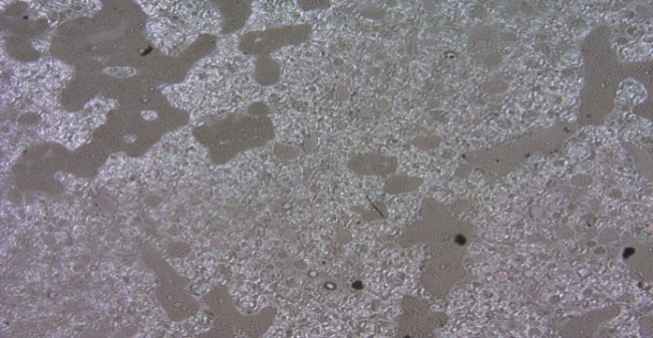  (e) | 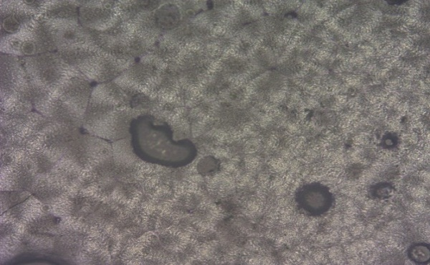  (f)
Figure 5. Polarized Optical Micrograph images (10x magnification) of (a) NR (b) PHB (c) 80:20 (d) 60:40 (e) 40:60 and (f) 20:80 of NR/PHB blend

Conclusion
In summary, this work describes a basic study on an amorphous/semi-crystalline blend system focusing on characterization of the blends in terms of morphology, crystallinity as well as thermal behaviour. Blending is the easiest, most effective and economical approach for obtaining new materials with improved physical and mechanical properties. The drawbacks of the parent components can be altered and tailored by choosing and varying the compositions of the blend and preparation parameters. Based on FTIR, blends of NR/PHB prepared in various compositions ranging from 20 to 80 wt.% of PHB, using solvent casting technique, has revealed that, no interaction occurred between NR and PHB since no shifting and additional peaks are observed. Besides that, the presence of NR has evident influence on the crystallization and spherulite morphology of PHB. The XRD patterns obtained show low crystallinity peaks were observed when the NR amount was increased. These results correlate with the degree of crystallinity from the DSC data. Besides that, DSC results indicated immiscibility of all compositions, due to the two distinct glass transition temperatures that are similar to pristine NR and PHB respectively. In addition, the TG data for NR/PHB blends shows similar characteristic of NR and PHB. Further confirmation of the immiscible system can be seen via the two-phase morphology from POM studies. The occurrence of immiscibility in this system is because of the high molecular weight of NR and PHB, leads to poor interfacial adhesion between the phases.

Acknowledgement
The authors would like to acknowledge the financial support from research grant scheme (FRGS 203/PKIMIA/6711596) and ministry of higher education for scholarship.

References
- Notario, B., Pinto, J., Rodriguez-Perez, M. A. (2016). Nanoporous polymeric materials: A new class of materials with enhanced properties. Progress in Materials Science, 78-79: 93-139.
- Cavalcante, M. P., Toledo, A. L. M. M., Rodrigues, E. J. R., Neto, R. P. C. and Tavares, M. I. B. (2017). Correlation between traditional techniques and TD-NMR to determine the morphology of PHB/PCL blends. Polymer Testing, 58:159-165.
- Golshaei, P. and Güven, O. (2017). Chemical modification of PET surface and subsequent graft copolymerization with poly(N-isopropylacryl amide). Reactive Functional Polymer, 118: 26-34.
- Mazzocchetti, L., Scandola, M. and Jiang, Z. (2012). Random copolymerization with a large lactone enhances aliphatic polycarbonate crystallinity. European Polymer Journal, 48:1883-1891.
- Ganji, F. and Abdekhodaie, M. J. (2010). The effects of reaction conditions on block copolymerization of chitosan and poly(ethylene glycol). Carbohydrate Polymer, 81: 799-804.
- Murugan, P., Han, L., Gan, C. Y., Maurer, F. H. J. and Sudesh, K. (2016). A new biological recovery approach for PHA using mealworm, Tenebrio molitor. Journal of Biotechnology, 239: 98-105.
- Arrieta, M. P., López, J., López, D., Kenny, J. M. and Peponi, L. (2016). Biodegradable electrospun bionanocomposite fibers based on plasticized PLA–PHB blends reinforced with cellulose nanocrystals. Industrial Crops Products, 93: 290-230.
- Tognana, S., Salgueiro, W. and Silva, L. (2016). Spherulitic growth and crystallization kinetics in PHB/DGEBA blends. Thermochimica Acta, 623:1-8.
- Cavalheiro, J. M. B.T., Raposo, R. S., de Almeida, M. C. M. D., Teresa Cesário, M., Sevrin, C., Grandfils, C. and da Fonseca, M. M. R. (2012). Effect of cultivation parameters on the production of poly(3-hydroxybutyrate-co-4-hydroxybutyrate) and poly(3-hydroxybutyrate-4-hydroxybutyrate-3-hydroxy valerate) by Cupriavidus necator using waste glycerol. Bioresource Technology, 111: 391-397.
- Hinüber, C., Häussler, L., Vogel, R., Brünig, H., Heinrich, G. and Werner, C. (2011). Hollow fibers made from a poly(3-hydroxybutyrate)/poly-ε-caprolactone blend. Express Polymer Letter, 5: 643-652.
- Garcia-Garcia, D., Ferri, J. M., Boronat, T., Lopez-Martinez, J., Balart, R. (2016). Processing and characterization of binary poly(hydroxybutyrate) (PHB) and poly(caprolactone) (PCL) blends with improved impact properties. Polymer Bulletin, 73: 3333-3350.
- Goonoo, N., Bhaw-Luximon, A., Passanha, P., Esteves, S., Schönherr, H. and Jhurry, D. (2017). Biomineralization potential and cellular response of PHB and PHBV blends with natural anionic polysaccharides. Materials Science Engineering C, 76:13-24.
- Arrieta, M. P., López, J., Rayón, E. and Jiménez, A. (2014). Disintegrability under composting conditions of plasticized PLA–PHB blends. Polymer Degradation and Stability, 108: 307-318.

- Mousavioun, P., Halley, P. J. and Doherty, W. O. S. (2013). Thermophysical properties and rheology of PHB/lignin blends. Industrial Crops Products, 50: 270-275.
- Pongsathit, S. and Pattamaprom, C. (2018). Irradiation grafting of natural rubber latex with maleic anhydride and its compatibilization of poly(lactic acid)/natural rubber blends. Radiation Physics and Chemistry 144: 13-20.
- Bhatt, R., Shah, D., Patel, K. C. and Trivedi, U. (2008) PHA-rubber blends: Synthesis, characterization and biodegradation. Bioresource Technology, 99: 4615-4620.
- Ramsay, B. A., Langlade, V., Carreau, P. J. and Juliana, A. (1993). Biodegradability and mechanical properties of poly-(f3-hydroxybutyrate-co-3-hydroxyvalerate)-starch blends. Applied and Environmental Microbiology, 59:1242-1246.
- Abdelwahab, M. A., Flynn, A., Chiou, B. S., Imam, S., Orts, W. and Chiellini, E. (2012). Thermal, mechanical and morphological characterization of plasticized PLA-PHB blends. Polymer Degradation and Stability 97: 1822-1828.
- Rolere, S., Liengprayoon, S., Vaysse, L., Sainte-Beuve, J. and Bonfils, F. (2015). Investigating natural rubber composition with Fourier transform infrared (FT-IR) spectroscopy: A rapid and non-destructive method to determine both protein and lipid contents simultaneously. Polymer Testing, 43:83-93.
- Li, C., Feng, C., Peng, Z., Gong, W. and Kong, L. (2013) Ammonium-assisted green fabrication of graphene/ natural rubber latex composite. Polymer Composite, 34: 88-95.
- Zhijiang, C., Yi, X., Haizheng, Y., Jia, J. and Liu, Y. (2016). Poly(hydroxybutyrate)/cellulose acetate blend nanofiber scaffolds: Preparation, characterization and cytocompatibility. Materials Science Engineering C, 58: 757-767.
- Abraham, E., Elbi, P. A., Deepa, B., Jyotishkumar, P., Pothen, L. A., Narine, S. S. and Thomas, S. (2012). X-ray diffraction and biodegradation analysis of green composites of natural rubber/nanocellulose. Polymer Degradation and Stability, 97: 2378-2387.
- Pazhooh, H. N., Bagheri, R. and Adloo, A. (2017). Fabrication of semi-conductive natural rubber nanocomposites with low copper nanoparticle contents. Polymer, 108:135-145.
- Zhang, S., Sun, X., Ren, Z., Li, H. and Yan, S. (2015) The development of a bilayer structure of poly(propylene carbonate)/poly(3-hydroxybutyrate) blends from the demixed melt. Physical Chemistry, 17: 32225-32231.
- Tan, W. L., Yaakob, N. N., Zainal Abidin, A., Abu Bakar, M. and Abu Bakar, N. H. H. (2016). Metal chloride induced formation of porous polyhydroxybutyrate (PHB) films: Morphology, Thermal properties and crystallinity. IOP Conference Series Materials Science Engineering,133: 1-11.
- Ma, P., Cai, X., Chen, M., Dong, W. and Lemstra, P. J. (2014). Partially bio-based thermoplastic elastomers by physical blending of poly(hydroxyalkanoate)s and poly(ethylene-co-vinyl acetate). Express Polymer Letter, 8: 517-527.
- Pachekoski, W. M., Agnelli, J. A. M. and Belem, L. P. (2009). Thermal, mechanical and morphological properties of poly (hydroxybutyrate) and polypropylene blends after processing. Materials Resource, 12: 159-164.

